Supplemental Table 1. Performance characteristics of simple logistic regression models from 2021 temporal validation cohort stratified by different screening capacities (10% to 90%), each of which would prioritize those predicted to have the highest risk based on the model. Outcomes include proliferative diabetic retinopathy, referable retinopathy and diabetic macular edema.
Proliferative Diabetic Retinopathy Outcome | % Screened | TruePositive | Sensitivity | Specificity | PPV | NPV | Type1 error | Type2 error | Threshold | N ByThreshold | Prevalence
 | 90% | 1,337 | 0.990 | 0.101 | 0.009 | 0.999 | 144,300 | 13 | 0.002 | 130,550 | 0.010
 | 80% | 1,327 | 0.983 | 0.202 | 0.010 | 0.999 | 128,128 | 23 | 0.002 | 116,045 | 0.011
 | 70% | 1,299 | 0.962 | 0.302 | 0.011 | 0.999 | 111,974 | 51 | 0.002 | 101,539 | 0.013
 | 60% | 1,255 | 0.930 | 0.403 | 0.013 | 0.999 | 95,836 | 95 | 0.003 | 87,034 | 0.014
 | 50% | 1,201 | 0.890 | 0.503 | 0.015 | 0.998 | 79,709 | 149 | 0.004 | 72,528 | 0.017
 | 40% | 1,133 | 0.839 | 0.604 | 0.018 | 0.998 | 63,595 | 217 | 0.005 | 58,023 | 0.019
 | 30% | 1,029 | 0.762 | 0.704 | 0.021 | 0.997 | 47,517 | 321 | 0.007 | 43,517 | 0.020
 | 20% | 892 | 0.661 | 0.804 | 0.028 | 0.996 | 31,472 | 458 | 0.012 | 29,012 | 0.031
 | 10% | 673 | 0.499 | 0.903 | 0.042 | 0.995 | 15,509 | 677 | 0.023 | 14,506 | 0.046
Referable Diabetic Retinopathy Outcome | % Screened | TruePositive | Sensitivity | Specificity | PPV | NPV | Type1 error | Type2 error | Threshold | N ByThreshold | Prevalence
 | 90% | 6,156 | 0.980 | 0.104 | 0.047 | 0.991 | 124,394 | 128 | 0.018 | 145,637 | 0.042
 | 80% | 6,015 | 0.957 | 0.207 | 0.052 | 0.991 | 110,030 | 269 | 0.022 | 129,455 | 0.046
 | 70% | 5,826 | 0.927 | 0.310 | 0.057 | 0.989 | 95,713 | 458 | 0.025 | 113,273 | 0.051
 | 60% | 5,557 | 0.884 | 0.413 | 0.064 | 0.987 | 81,477 | 727 | 0.029 | 97,091 | 0.057
 | 50% | 5,168 | 0.822 | 0.515 | 0.071 | 0.985 | 67,360 | 1,116 | 0.034 | 80,910 | 0.063
 | 40% | 4,713 | 0.750 | 0.616 | 0.081 | 0.982 | 53,310 | 1,571 | 0.041 | 64,728 | 0.073
 | 30% | 4,133 | 0.658 | 0.716 | 0.095 | 0.979 | 39,384 | 2,151 | 0.056 | 48,546 | 0.085
 | 20% | 3,357 | 0.534 | 0.815 | 0.116 | 0.975 | 25,655 | 2,927 | 0.084 | 32,364 | 0.103
 | 10% | 2,282 | 0.363 | 0.912 | 0.157 | 0.969 | 12,224 | 4,002 | 0.133 | 16,182 | 0.141
Diabetic Macular Edema Outcome | % Screened | TruePositive | Sensitivity | Specificity | PPV | NPV | Type1 error | Type2 error | Threshold | N ByThreshold | Prevalence
 | 90% | 1,787 | 0.978 | 0.101 | 0.013 | 0.997 | 140,497 | 41 | 0.011 | 142,284 | 0.012
 | 80% | 1,721 | 0.941 | 0.202 | 0.014 | 0.997 | 124,754 | 107 | 0.012 | 126,475 | 0.013
 | 70% | 1,621 | 0.887 | 0.302 | 0.015 | 0.996 | 109,045 | 207 | 0.014 | 110,666 | 0.015
 | 60% | 1,549 | 0.847 | 0.403 | 0.016 | 0.996 | 93,307 | 279 | 0.015 | 94,856 | 0.016
 | 50% | 1,473 | 0.806 | 0.504 | 0.019 | 0.996 | 77,574 | 355 | 0.017 | 79,047 | 0.019
 | 40% | 1,336 | 0.731 | 0.604 | 0.021 | 0.995 | 61,902 | 492 | 0.021 | 63,238 | 0.021
 | 30% | 1,168 | 0.639 | 0.704 | 0.025 | 0.994 | 46,260 | 660 | 0.028 | 47,428 | 0.025
 | 20% | 948 | 0.519 | 0.804 | 0.030 | 0.993 | 30,671 | 880 | 0.040 | 31,619 | 0.029
 | 10% | 651 | 0.356 | 0.903 | 0.041 | 0.992 | 15,159 | 1,177 | 0.058 | 15,810 | 0.041
For all three outcomes, logistic regression models perform at high sensitivity at multiple screening capacities. Specificity is inversely correlated to the percentage population screened and increases with prevalence of outcome. Abbreviations: Positive predictive value (PPV), Negative Predictive Value (NPV).
Supplemental Figure 1. Calibration plots.
Proliferative Diabetic Retinopathy
Referable Diabetic Retinopathy
Diabetic Macular Edema

Expected vs observed number events in a given risk quantile. Model overestimates number of events for all 3 outcomes (Proliferative Diabetic Retinopathy, Referable Diabetic Retinopathy, and Diabetic Macular Edema).

Supplemental Figure 2. Logistic regression model performance in Type 1 DM cohort

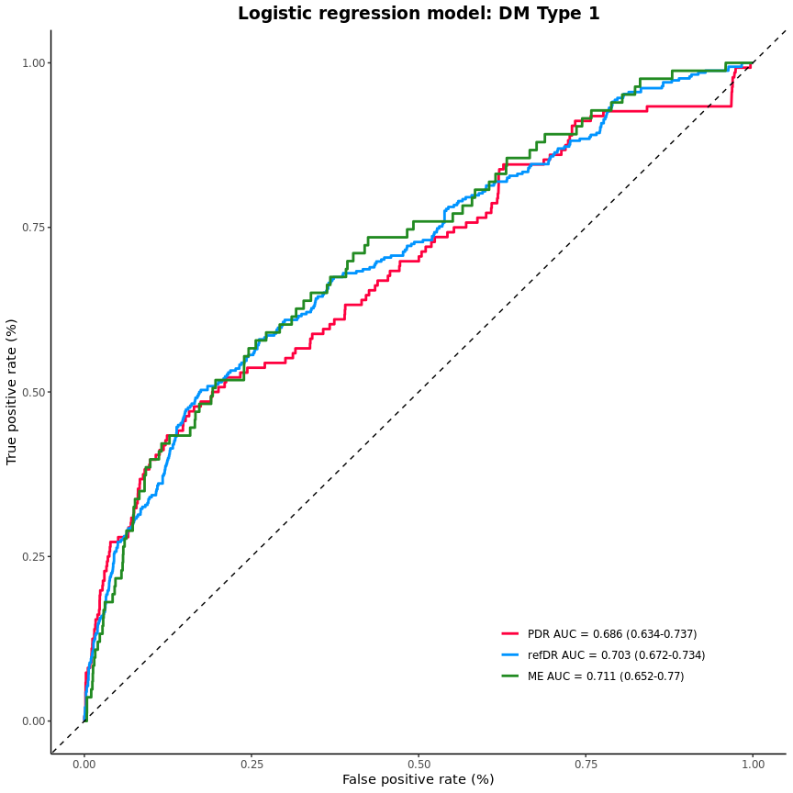
Abbreviations: PDR (proliferative diabetic retinopathy), AUC (area under the curve), refDR (referable diabetic retinopathy), ME (diabetic macular edema)

