SUPPLEMENTAL MATERIAL
Supplemental Appendix 1. Continuous Glucose Monitoring (CGM) Methods
Patients were provided with and trained on Dexcom G6® CGM device, which was activated at Week -1 to collect baseline CGM data. The CGM device was used in the unblinded mode with 2 set alarms at 70 mg/dL and at 55 mg/dL throughout the entire duration on the trial. The CGM fasting glucose data were documented by patients in eDiaries and used for titration decisions. At each office visit qualified site personnel uploaded the CGM data from the Dexcom G6 receiver to a specific study management suite. After successful data-upload a “data acceptability report” was run. The acceptability threshold was 70% of data captured during sessions. In case this value was below 70% a patient retraining was initiated immediately.
Daily fasting (prebreakfast) glucose measurements were recorded by the patients in the eDiary using the value displayed on their CGM device. Additional measurements using a blood glucose meter could have been collected as often as necessary, especially as needed to evaluate hypoglycemia symptoms.
Additional Statistical Analysis Considerations for CGM-Derived Measures
The CGM-derived derived measures were based on all days when at least 70% of the expected total measures were captured. The MMRM model with treatment, HbA1c strata (<8.5%, ≥8.5%), visit, and treatment by visit interaction as fixed effects and the baseline value of dependent variables as the covariate were used for the CGM-derived derived measures.

Supplemental Table 1. Study Inclusion and Exclusion Criteria
Inclusion Criteria
- Have a diagnosis of T1D for at least 1 year based on medical history with a fasting C-peptide ≤0.30 nmol/L at screening or before randomization
- Have been using MDIs without interruption for at least 3 months prior to screening
- No male contraception required except in compliance with specific local government study requirements
- Female patients:
  - Women of child-bearing potential who are abstinent or in a same sex relationship must agree to either remain abstinent or stay in a same sex relationship without sexual relationships with males
  - Otherwise, women of child-bearing potential participating must agree to use contraception for the entirety of the study
  - Women of child-bearing potential participating must test negative for pregnancy prior to initiation of treatment
- Are at least 18 years of age, at the time of signing the informed consent
- Have HbA1c values of 5.6% to 9.5% inclusive, as determined by the central laboratory at screening
- Have been treated with a stable regimen of once- or twice-daily insulin glargine (U-100 or U-300), insulin detemir, or insulin degludec (U-100 or U-200) for 3 months prior to screening
- Are currently treated with the same SC rapid-acting analog insulin (insulin lispro U-100 or U-200, insulin aspart, FiAsp, or insulin glulisine) in MDI for at least the last 30 days prior to screening
- Have a body mass index (BMI) ≤35 kg/m2, with no significant weight gain or loss in the past 3 months (≥5%)
- Are well-motivated, capable, and willing to learn how to self-inject treatment, maintain study diaries, wear study-provided CGM and use this device for therapeutic decision making, and must have a normal wake/sleep pattern, in the investigator’s opinion
- Are proficient in counting carbohydrates, adjusting meal- and correction boluses based on glucose readings, and adjusting insulin and dietary therapy during special situations in the investigator’s opinion
- Are willing and able to follow the visit schedule during the complete duration of the trial
Exclusion Criteria
- Have had more than 1 emergency room visit or hospitalization due to poor glucose control within 6 months prior to screening
- Have had any episodes of severe hypoglycemia and/or hypoglycemia unawareness within the 6 months prior to screening
- Have significant lipohypertrophy, lipoatrophy, scars, or h/o abscess in areas of injection
- Have vision or hearing loss that impairs recognition of CGM screens, alerts and alarms
- Cardiovascular (CV): have had any of the follow CV conditions: acute myocardial infarction, New York Heart Association Class III or IV heart failure (Section 10.6), or cerebrovascular accident (stroke)
- Gastrointestinal: have gastroparesis or have undergone gastric bypass (bariatric) surgery or restrictive bariatric surgery (e.g., Lap-Band®) prior to screening
- Hepatic: have acute or chronic hepatitis, or obvious clinical signs or symptoms of any other liver disease except non-alcoholic fatty liver disease (NAFLD), and/or have elevated liver enzyme measurements, as determined by the central laboratory at screening and as indicated below:
  - Total bilirubin level (TBL) >2x the upper limit of normal (ULN)
  - Alanine aminotransferase (ALT)/serum glutamic pyruvic transaminase (SGPT) >2.5x ULN
  - Aspartate aminotransferase (AST)/serum glutamic oxaloacetic transaminase (SGOT) >2.5x ULN
- Renal: have history of renal transplantation, are currently receiving renal dialysis, have serum creatinine >2.0 mg/dL (177 μmol/L) at screening, or have an estimated glomerular filtration rate (eGFR) of <30 mL/min/1.73 m²
- Have experienced significant weight loss or gain (>5%) in body weight in the 3 months prior to screening
- Have active or untreated malignancy or have been in remission from clinically significant malignancy (other than basal cell or squamous cell skin cancer) for less than 5 years or are at increased risk for developing cancer or a recurrence of cancer in the opinion of the investigator
- Have known hypersensitivity or allergy to any of the study medications or their excipients
- Have any other serious disease or condition (e.g., known drug or alcohol abuse/regular consumption or psychiatric disorder) that, in the opinion of the investigator, would pose a significant risk to the patient, preclude the patient from following and completing the protocol, or interfere with the interpretation of safety, efficacy, or PD data
- Have had a blood transfusion or severe blood loss within 3 months prior to screening or have any hematologic condition that may interfere with HbA1c measurement (e.g., hemoglobinopathy, hemolytic anemia, sickle-cell disease)
- Have fasting triglycerides >400 mg/dL or non-fasting triglycerides >600 mg/dL
- Are taking drugs that may significantly affect glycemic control (e.g., niacin [allowed if <1.0 g/day], bile acid sequestrants)
- Are receiving chronic (lasting longer than 14 consecutive days) systemic glucocorticoid therapy or intra-articular (but excluding topical, intraocular, intranasal, and inhaled preparations), or have received such therapy within 4 weeks immediately prior to screening with the exception of replacement therapy for adrenal insufficiency
- Are currently taking or have taken within the 3 months preceding screening, prescription or over-the-counter medications to promote weight loss. Patients who participate must agree not to initiate a diet and/or exercise program during the study with the intent of reducing body weight other than the lifestyle and dietary measures for diabetes treatment
- Are taking total daily dose of insulin >100 Units at the time of screening
- Are receiving any oral or injectable medication intended for the treatment of diabetes mellitus other than rapid-acting and basal analog insulin in MDI in the 90 days prior to screening
- Are using or have used blood pressure-lowering medication at a dose that has not been stable for 1 month prior to screening
- Are currently enrolled in any other clinical study involving an IP or any other type of medical research judged not to be scientifically or medically compatible with this study
- Have participated, within the last 30 days in a clinical trial involving an IP. If the previous IP has a long half-life, 3 months or 5 half-lives (whichever is longer) should have passed
- Have previously completed or withdrawn from this study or any other study investigating BIF.

Supplemental Table 2. Within- and Between- Day Glycemic Variability from CGM for 24-hour Time Period
Parameter |  | BIF |  | Degludec | Estimated Treatment Difference (90% CI)
 | n | Estimate (SE)a,b | n | Estimate (SE)a,b
Within-Day Variability
CV (%)
Baseline | 116 | 31.3 (0.50) | 123 | 31.0 (0.48)
Week 12-26 | 108 | 31.3 (0.34) | 118 | 30.6 (0.32) | 0.7 (-0.1, 1.5)
SD (mg/dL)
Baseline | 116 | 50.2 (1.04) | 123 | 48.0 (0.96)
Week 12-26 | 108 | 53.5 (0.73) | 118 | 50.7 (0.67) | 2.8 (1.2, 4.4)
Between-Day Variability
CV (%)
Baseline | 116 | 32.3 (0.55) | 123 | 31.4 (0.52)
Week 12-26 | 108 | 32.6 (0.40) | 118 | 32.6 (0.38) | 0.0 (-0.9, 0.9)
SD (mg/dL)
Baseline | 116 | 51.6 (1.14) | 123 | 48.6 (1.04)
Week 12-26 | 108 | 55.6 (0.78) | 118 | 53.9 (0.73) | 1.7 (-0.1, 3.5)
Abbreviations: ANOVA = analysis of variance; CI = confidence interval; CGM = continuous glucose monitoring; CV = Coefficient of Variation; MMRM = mixed model repeated measures; SD = standard deviation; SE = standard error. ªMMRM model for post-baseline measures: log(Actual Measurement) = log(Baseline) + Hemoglobin A1c Stratum at Baseline 1 + Treatment + Time + Treatment*Time (Type III sum of squares). Variance-Covariance structure (Actual Measurement) = Unstructured. ^{b}ANCOVA model for endpoint measures: log(Actual Measurement) = log(Baseline) + Hemoglobin A1c Stratum at Baseline 1 + Treatment (Type III sum of squares). ^{c}ANOVA model for baseline measures: log(Actual Measurement) = Treatment (Type III sum of squares).

Supplemental Table 3. Patient-Reported Hypoglycemia (Safety Population)
 | All Documented (24-hour daily) |  |  |  | Nocturnal Hypoglycemia (bedtime-waking)
 | n (%) | Event Rate (SE)ª event/patient/year | p-valueª |  | n (%) | Event Rate (SE)ª event/patient/year | p-valueª
Level 1 Hypoglycemia
BIF (n=139) | 135 (97.1) | 109.6 (8.0) |  |  | 126 (90.7) | 20.5 (1.7)
Degludec (n=126) | 123 (97.6) | 103.3 (8.4) |  |  | 118 (93.7) | 20.6 (.7)
Relative Rate (90% CI) |  | 1.06 (0.89, 1.27) | 0.677 |  |  | 0.99 (0.82, 1.20) | 0.953
Level 2 Hypoglycemia
BIF (n=139) | 121 (87.1) | 20.1 (2.1) |  |  | 95 (68.4) | 4.6 (0.5)
Degludec (n=126) | 107 (84.9) | 18.4 (2.0) |  |  | 84 (66.7) | 4.9 (0.6)
Relative Rate (90% CI) |  | 1.09 (0.86, 1.39) | 0.547 |  |  | 0.95 (0.71, 1.26) | 0.750

ªThe hypoglycaemia event rates were analysed by a negative binomial regression model.
Supplemental Table 4. Safety Summary
n (%) | Insulin Degludec (N=126) | BIFª (N=139)
Treatment-emergent adverse events | 58 (46.0) | 82 (59.0)
Serious adverse event | 4 (3.2) | 5 (3.6)
Death | 0 | 0
Hepatic Disorder Events | 1 (0.8) | 1 (0.7)
Injection Site Reactions | 2 (1.6) | 8 (5.8)
Hypersensitivity Reactions | 5 (4.0) | 9 (6.5)

BIF group included patients randomized to both BIF algorithims, the paper, non-digital algorithm and the discontinued digital algorithm.
Abbreviations: BIF, Basal Insulin Fc; N, number of subjects in the analysis population; n, number of subjects in the specified category.
Supplemental Figure 1. Study Design

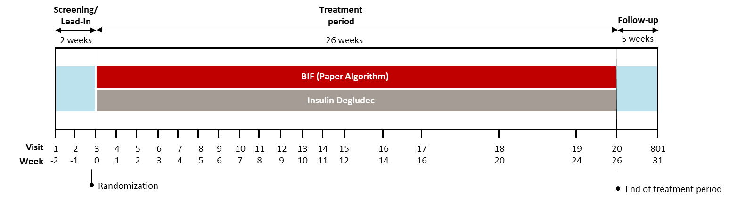

Supplemental Figure 2. Participant Disposition

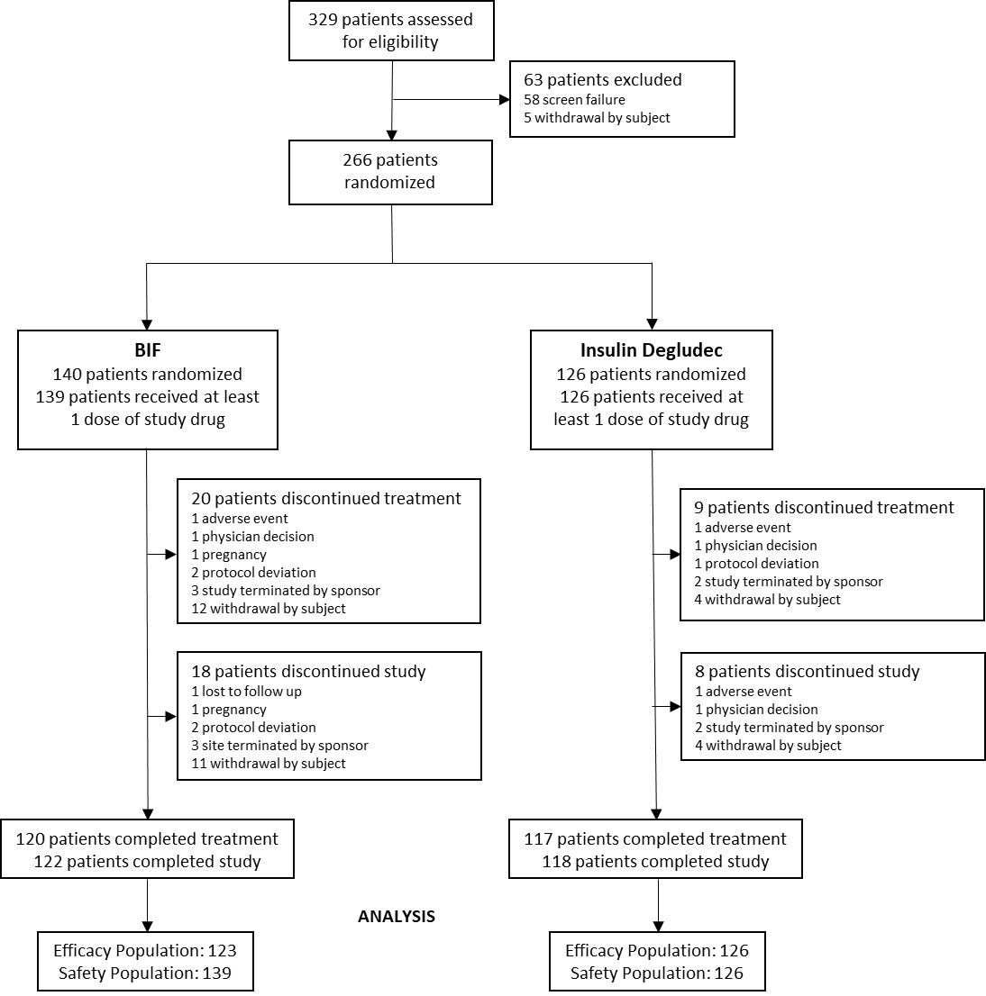
Supplemental Figure 3. Fasting serum glucose
Fasting serum glucose based on central laboratory over the course of the 26-week treatment period. Data presented as LSmean ±SE. *p<0.1 versus baseline; **p<0.001 versus baseline. Abbreviations: BIF, weekly basal insulin Fc; SE, standard error.

Supplemental Figure 4. Ambulatory glucose profiles
A

B

(A) Ambulatory glucose profiles for BIF (left) and insulin degludec (right) at baseline. (B Ambulatory glucose profiles for BIF (left) and insulin degludec (right) at Week 26. Data presented as median (red line).
Abbreviations: BIF, weekly basal insulin Fc.
Supplemental Figure 5. Insulin Dose
A

B
(A) Basal insulin dose over the course of the 26-week treatment period. Weekly BIF dose in red on the left and daily degludec in gray on the right. Data presented as the LSmean. (B) Rapid-acting insulin dose over the course of the 26-week treatment period. Data presented as LSmean ±SE. All timepoints for BIF and degludec had a significant change from baseline (p<0.1).
*p<0.1 BIF vs degludec.
Abbreviations: BIF, weekly basal insulin Fc; SE, standard error.

