C-reactive Protein, C-peptide, and Risk of First-time Cardiovascular Events and Mortality in Early Type 2 Diabetes: A Danish Cohort Study

SUPPLEMENTAL MATERIAL

Table of Contents
Supplementary Table 1. Definitions and codes used in this study. 3
Supplementary Table 2. Missing covariates for the serum hsCRP cohort. 7
EXPANDED RESULTS SECTION 8
Supplementary Table 3. Characteristics of the 7301 individuals with serum hsCRP measurements compared with the 5765 individuals with C-peptide measurement. 9
Supplementary Table 4. Crude incidence/mortality rates by serum hsCRP levels. 12
Supplementary Figure 1. Flow diagram of the study population. 13
Supplementary Figure 2. Serum hsCRP on a continuous scale and risk of cardiovascular events and all-cause mortality. 14
CARDIOVASCULAR EVENT SUBTYPES 15
Supplementary Figure 3. Subtypes of cardiovascular events: Continuous scale associations by serum hsCRP levels. 16
Supplementary Figure 4. Subtypes of cardiovascular events: Cumulative incidence curves by serum hsCRP levels. 17
Supplementary Figure 5. Hazard ratios for myocardial infarction by serum hsCRP levels. 18
Supplementary Figure 6. Hazard ratios for ischemic stroke by serum hsCRP levels. 19
Supplementary Figure 7. Hazard ratios for cardiovascular mortality by serum hsCRP levels. 20
Supplementary Figure 8. Hazard ratios for coronary revascularization by serum hsCRP levels. 21
Supplementary Figure 9. Hazard ratios for cardiovascular events and all-cause mortality by serum hsCRP levels in patients with low C-peptide levels (<1470 pmol/L). 22
Supplementary Figure 10. Hazard ratios for cardiovascular events and all-cause mortality by serum hsCRP levels in patients with high C-peptide levels (≥1470 pmol/L). 23
SENSITIVITY ANALYSES 24
Supplementary Figure 11. Complete case analysis: Hazard ratios for cardiovascular events and all-cause mortality by serum hsCRP levels. 25
Supplementary Figure 12. Cumulative incidence curves of cardiovascular events and all-cause mortality by serum hsCRP categories (>3 mg/L and ≤3 mg/L). 26
Supplementary Figure 13. Hazard ratios of cardiovascular events and all-cause mortality by serum hsCRP categories (>3 mg/L and ≤3 mg/L). 27
Supplementary Figure 14. Cumulative incidence curves of cardiovascular events and all-cause mortality by serum hsCRP categories (≥2 mg/L and <2 mg/L). 28
Supplementary Figure 15. Hazard ratios of cardiovascular events and all-cause mortality by serum hsCRP categories (≥2 mg/L and <2 mg/L). 29

Supplementary Table 1. Definitions and codes used in this study.
Registries | Variables | Definitions and Codes
The Danish Centre for Strategic Research in Type 2 Diabetes (DD2) cohort |  | A nationwide Danish cohort of individuals recently diagnosed with T2D. Cohort members have been enrolled continuously from general practitioners’ offices and hospital specialist outpatient clinics since November 1, 2010. In the DD2 biobank, fasting blood glucose, C-peptide, and mannose-binding lectin (MBL; µg/L) were available for the first 5277 (72%), 5765 (79%), and 7300 (100%) DD2 cohort patients, respectively.
 | -Serum hsCRP, mg/L  -Serum C-peptide, pmol/L  -Fasting blood glucose, mmol/L  -Serum MBL (µg/L)  -Waist circumference, cm  -Waist–hip ratio  -Body mass index (BMI, see below)  -Physical activity, days/week  -High alcohol consumption | -Continuous variable  -Continuous variable  -Continuous variable.  -Continuous variable  -Continuous variable  -Continuous variable, defined as >1.0 in men and >0.85 in women  -Categorical variable (0, 1-2, ≥3 days/week). Physical activity was defined as “number of days per week with a minimum of 30 minutes of physical activity.”  -High alcohol consumption was defined as >14 alcoholic drinks/week for women and 21/week for men.
Danish Diabetes Database of Adults (DDDA) |  | Information from a nationwide quality-of-care database was available for a subcohort of 5847 patients (~80%).  For all DDDA variables except height:  We used the measure taken closest to the DD2 enrollment date. All measures before or after DD2 enrollment were eligible for use. If a variable was measured on exactly the same number of days before and after the DD2 enrollment date, we used the measure prior to DD2 enrollment.
 | -Blood HbA1c, %  -Urine albumin:creatinine ratio  -Serum estimated glomerular filtration rate (eGFR), ml/min/1.73 m²  -Serum lipids, mmol/L  -Smoking  -Blood pressure, mmHg  BMI (see below) | -Continuous variable  -Continuous variable  -Continuous variable  -Continuous variables: total cholesterol, LDL, HDL, triglycerides  -Categorical variable: never, former, current (daily + occasionally)  -Continuous variables: systolic and diastolic blood pressure
Body mass index, kg/m²
 | Height | Data on height were available from 3 sources:  DD2 enrollment (2010 onwards), DDDA data (repeated measures), questionnaire data 2016 (self-reported).
 | BMI DD2 enrollment | Continuous variable  Weight:  If weight was recorded during the DD2 enrollment process (few), we used this weight; otherwise, we used the DDDA weight.  Height:  We did not expect height to change over time among the adults in our study.  Thus, we used available heights in the following hierarchical order: height obtained at DD2 enrollment, height obtained at DDDA enrollment, and questionnaire data obtained in 2016.
Diabetes duration |  | Time from first of the following events until the DD2 enrollment date: prescription of glucose-lowering drugs, first diabetes-related diagnosis in the Danish National Patient Registry, or DDDA registration. In the absence of information from a prior drug prescription, diabetes diagnosis from the DNPR, or DDDA registration, diabetes duration was set to “DD2 enrollment date = 0”.
Civil Registration System | -Age  -Sex | -Continuous variable  -Male/female
Danish Health Service Prescription database |  | For all prescription data, the relevant time period was around baseline (DD2 enrollment). The look-back period was 1 year prior to the DD2 enrollment date. Yes/no redemption of a drug prescription during the year prior to the index date.
 | -Anti-diabetic drugs | ATC: A10A, A10B
 | -Lipid-lowering drugs | ATC: C10
 | -Statins | ATC: C10AA, C10BA, C10BX
 | -Anti-hypertensive drugs | ATC: C02, C03A, C03B, C03D, C03E, C07, C08, C09A, C09B, C09C, C09D, C09X
 | -Anti-thrombotic drugs | B01AC04, B01AC06, B01AC07, B01AC22, B01AC24, B01AC30, N02BA01
ICD-10 and procedure codes used to identify outcomes from the Danish National Patient Registry or the Danish Registry of Causes of Death |  | First-time inpatient hospital admission (with a date after the index date) with one of the following ICD-10 or procedure codes as the primary or secondary discharge diagnosis:
 | Acute myocardial infarction | DI21
 | Ischemic stroke  Coronary revascularization | DI63, DI64  KFNA, KFNB, KFNC, KFND, KFNE, KFNF, KFNG, KFNH20
 | Cardiovascular death | DI00-DI99
 | Respiratory death | DJ00-99
 | Cancer death | DC00-99
Danish National Patient Registry |  | For all variables, the relevant time period was before DD2 enrollment (as a proxy for medical history prior to the diabetes diagnosis). Thus, the look-back period extended from the DD2 enrollment date back to 1994 (based on International Classification of Diseases, Tenth Revision, diagnosis codes).
 | Macrovascular complications | DI21, DI23, DI24, DT822A (ischemic heart disease); DT823 (acute ischemic heart disease with/without complications); DI20 (angina pectoris); DI25 (chronic ischemic heart disease); KFNA, KFNB, KFNC, KFND, KFNE, KFNF, KFNG, KFNH, KFNW, KFLF (coronary bypass or percutaneous coronary intervention); DI500, DI501, DI502, DI503, DI508, DI509, DI110, DI130, DI132, DI420, DI426, DI427, DI428, DI429 (heart failure); DI61 (cerebral bleeding); DI63, DI64, DI65, DI66 (cerebrovascular infarct); DG45 (transient cerebrovascular disease); DI672, DI678, DI679 (unspecified cerebrovascular disease); DI691, DI693, DI694, DI698 (previous cerebrovascular disease); KAAL10, KAAL11 (cerebral thrombolysis or thromboendarterectomy)  DE105, DE115, DE125, DE135, DE145 (diabetes with peripheral vascular complications); DI700, DI701, DI702, DI708, DI709, DI739, DI74, DN280, DK550, DK551, DH340, DH341, DH342; KNBQ, KNCQ, KNDQ, KNEQ, KNFQ, KNGQ, KNHQ, KPAE, KPAF, KPAH, KPAN, KPAP, KPAQ, KPAW99, KPAU74, KPBE, KPBF, KPBH, KPBN, KPBP, KPBQ, KPBW, KPGH10, KPCE, KPCF, KPCH, KPCN, KPCP, KPCQ, KPCW99, KPCW20, KPCU74, KPCU82, KPCU83, KPCU84, KPGE, KPGF, KPGH, KPGN, KPGP, KPGQ, KPGW99, KPGW20, KPEE, KPEF, KPEH, KPEN, KPEP, KPEQ, KPEW, KPFE, KPFH, KPFN, KPFP, KPFQ, KPFW, KPGH20, KPGH21, KPGH22, KPGH23, KPGH30, KPGH31, KPGH40, KPGH99, KPDU74, KPDU82, KPDU83, KPDU84, KPEU74, KPEU82, KPEU83, KPEU84, KPFU74, KPFU82, KPFU83, KPFU84, KPGU74, KPGU83, KPGU84, KPGU99 (peripheral/abdominal vascular disease)
Modified Charlson Comorbidity Index (CCI) |  | We categorized comorbidities according to CCI scores within the 10-year period before the DD2 enrollment date. Diabetes was not included in the CCI scoring system because it constituted the index disease for our cohort.
 | Score 1
 | Myocardial infarction | DI21, DI22, DI23
 | Congestive heart failure | DI50, DI110, DI130, DI132
 | Peripheral vascular disease | DI70, DI71, DI72, DI73, DI74, DI77
 | Cerebrovascular disease | DI60, DI61, DI62, DI63, DI64, DI65, DI66, DI67, DI68, DI69, DG45, DG46
 | Dementia | DF00, DF02, DF03, DF051, DG30
 | Chronic pulmonary disease | DJ40, DJ41, DJ42, DJ43, DJ44, DJ45, DJ46, DJ47, DJ60, DJ61, DJ62, DJ63, DJ64, DJ65, DJ66, DJ67, DJ684, DJ701, DJ703, DJ841, DJ920, DJ961, DJ982, DJ983
 | Connective tissue disease | DM05, DM06, DM08, DM09, DM30, DM31, DM32, DM33, DM34, DM35, DM36, DD86
 | Ulcer disease | DK221, DK25, DK26, DK27, DK28
 | Mild liver disease | DB18, DK700, D701, DK702, DK703, DK709, DK71, DK73, DK74, DK760
 | Score 2
 | Hemiplegia | DG81, DG82
 | Moderate to severe renal disease | D12, DI13, DN00, DN01, DN02, DN03, DN04, DN05, DN07, DN11, DN14, DN17, DN18, DN19, DQ61
 | Any tumor (except basocellular carcinoma) | C00–C75 (excluding C44)
 | Leukemia | DC91, DC92, DC93, DC94, DC95
 | Lymphoma | DC81, DC82, DC83, DC84, DC85, DC90, DC96
 | Score 3
 | Moderate to severe liver disease | DB150, DB160, DB162, DB190, DK704, DK72, DK766, DI85
 | Score 6
 | Metastatic solid tumor | DC76, DC77, DC78, DC79, DC80
 | AIDS | DB21, DB22, DB23, DB24

Supplementary Table 2. Missing covariates for the serum hsCRP cohort.
 | Serum hsCRP cohort
 | Missing, n (%) | Total
Sex | 0 (0.0) | 7301
Age | 0 (0.0) | 7301
Diabetes duration | 0 (0.0) | 7301
Waist circumference | 13 (0.2) | 7301
Waist–hip ratio | 11 (0.2) | 7301
BMI* | 569 (7.8) | 7301
Physical activity | <5† (0.0) | 7301
Alcohol consumption | 0 (0.0) | 7301
Smoking* | 1900 (26.0) | 7301
Systolic blood pressure* | 1774 (24.3) | 7301
Diastolic blood pressure* | 1774 (24.3) | 7301
CCI score | 0 (0.0) | 7301
Anti-diabetes drug use | 0 (0.0) | 7301
Lipid-lowering drug use | 0 (0.0) | 7301
Anti-hypertensive drug use | 0 (0.0) | 7301
Anti-thrombotic drug use | 0 (0.0) | 7301
Fasting blood glucose | 2028 (27.8) | 7301
HbA1C* | 1548 (21.2) | 7301
C-peptide | 1602 (21.9) | 7301
Albumin:creatinine ratio* | 2074 (28.4) | 7301
eGFR* | 2694 (36.9) | 7301
Total cholesterol* | 3964 (54.3) | 7301
LDL cholesterol* | 1763 (24.2) | 7301
HDL cholesterol* | 3949 (54.1) | 7301
Triglycerides* | 1849 (25.3) | 7301
MBL | <5† (0.0) | 7301
*By August 2018, a total of 5847 DD2 patients (80%) in the serum hsCRP cohort had been linked to the Danish Diabetes Database for Adults.
†Exact number of missing values too low to be displayed according to Danish data protection regulations.

EXPANDED RESULTS SECTION

Supplementary Table 3. Characteristics of the 7301 individuals with serum hsCRP measurements compared with the 5765 individuals with C-peptide measurement.
 | The hsCRP cohort |  |  |  |  | The c-peptide cohort
 | Total | Low hsCRP | Intermediate hsCRP | High hsCRP |  | Totalª | Low hsCRP | Intermediate hsCRP | High hsCRP
Total patients | 7301 | 2140 (29.3) | 2470 (33.8) | 2691 (36.9) |  | 5765 (100.0) | 1740 (30.5) | 1944 (34.1) | 2016 (35.4)
Age, years | 62.0 (53.0-68.8) | 63.3 (55.0–69.4) | 62.4 (53.9–68.9) | 60.5 (51.3–67.8) |  | 62.2 (53.4-68.8) | 63.5 (55.2-69.3) | 62.7 (54.4-68.9) | 60.9 (51.8-67.9)
Sex, men | 4274 (58.5) | 1420 (66.4) | 1483 (60.0) | 1371 (51.0) |  | 3354 (58.2) | 1135 (65.2) | 1161 (59.7) | 1022 (50.7)
Diabetes duration, years | 1.3 (0.3-2.9) | 1.5 (0.5–3.0) | 1.3 (0.4–3.0) | 1.0 (0.2–2.7) |  | 1.3 (0.3-2.7) | 1.4 (0.5-2.8) | 1.3 (0.4-2.7) | 1.0 (0.2-2.5)
Waist circumferenc, cm | 106 (97-116) | 100 (92–108) | 106 (97–115) | 112 (102–122) |  | 106 (97-116) | 100 (92-108) | 106 (97-115) | 111 (102-121)
Waist–hip ratio | 0.98 (0.92-1.04) | 0.97 (0.91–1.02) | 0.98 (0.92–1.04) | 0.99 (0.92–1.05) |  | 0.98 (0.92-1.04) | 0.97 (0.91-1.02) | 0.98 (0.92-1.04) | 0.98 (0.92-1.04)
BMI, kg/m² | 30.3 (26.9-34.3) | 27.9 (25.2–31.0) | 30.3 (27.1–33.8) | 32.8 (29.0–37.6) |  | 30.2 (26.9-34.2) | 27.9 (25.2-31.2) | 30.4 (27.1-33.8) | 32.7 (28.8-37.4)
Physical activity^{b}, days/week | 5 (3-8) | 5 (3–8) | 5 (3–8) | 4 (2–7) |  | 5 (3-8) | 5 (3–8) | 5 (3–8) | 4 (2–7)
High alcohol consumption^{c} | 475 (6.5) | 128 (6.0) | 172 (7.0) | 175 (6.5) |  | 390 (6.8) | 105 (6.0) | 141 (7.3) | 141 (7.0)
Smoking
Never | 2524 (46.7) | 866 (53.2) | 858 (46.4) | 800 (41.6) |  | 2157 (46.6) | 759 (53.5) | 725 (46.1) | 647 (40.9)
Former | 1848 (34.2) | 523 (32.1) | 647 (35.0) | 678 (35.3) |  | 1583 (34.2) | 445 (31.4) | 549 (34.9) | 573 (36.2)
Current | 1029 (19.1) | 240 (14.7) | 346 (18.7) | 443 (23.1) |  | 888 (19.2) | 214 (15.1) | 298 (19.0) | 362 (22.9)
Systolic blood pressure, mmHg | 130 (124-140) | 130 (124–140) | 130 (124–140) | 130 (124–140) |  | 130 (124-140) | 130 (124-140) | 130 (124-140) | 131 (124-141)
Diastolic blood pressure, mmHg | 80 (74-86) | 80 (73–85) | 80 (75–85) | 80 (75–87) |  | 80 (74-85) | 80 (73-85) | 80 (75-85) | 80 (75-87)
CCI score^{d}
0 | 5022 (68.8) | 1562 (73.0) | 1725 (69.8) | 1735 (64.5) |  | 3936 (68.3) | 1268 (72.9) | 1343 (69.1) | 1276 (63.3)
1-2 | 1884 (25.8) | 487 (22.8) | 622 (25.2) | 775 (28.8) |  | 1512 (26.2) | 397 (22.8) | 506 (26.0) | 596 (29.6)
3 | 395 (5.4) | 91 (4.2) | 123 (5.0) | 181 (6.7) |  | 317 (5.5) | 75 (4.3) | 95 (4.9) | 144 (7.1)
Anti-diabetes drug use | 6205 (85.0) | 1828 (85.4) | 2105 (85.2) | 2272 (84.4) |  | 4863 (84.4) | 1465 (84.2) | 1652 (85.0) | 1693 (84.0)
Lipid-lowering drug use | 5140 (70.4) | 1622 (75.8) | 1809 (73.2) | 1709 (63.5) |  | 4087 (70.9) | 1313 (75.5) | 1451 (74.6) | 1279 (63.4)
Anti-hypertensive drug use | 5241 (71.8) | 1463 (68.4) | 1818 (73.6) | 1960 (72.8) |  | 4179 (72.5) | 1186 (68.2) | 1459 (75.1) | 1491 (74.0)
Anti-thrombotic drug use | 2100 (28.8) | 680 (31.8) | 705 (28.5) | 715 (26.6) |  | 1774 (30.8) | 579 (33.3) | 601 (30.9) | 583 (28.9)
Fasting blood glucose, mmol/L | 7.1 (6.4-8.2) | 7.0 (6.2–7.9) | 7.2 (6.4–8.3) | 7.2 (6.5–8.5) |  | 7.1 (6.4-8.2) | 7.0 (6.2-7.9) | 7.2 (6.4-8.3) | 7.2 (6.5-8.4)
HbA1c (IQR) | 6.6 (6.2-7.2) | 6.5 (6.1–7.0) | 6.6 (6.2–7.2) | 6.7 (6.2–7.5) |  | 6.6 (6.1-7.2) | 6.4 (6.0-7.0) | 6.5 (6.1-7.1) | 6.7 (6.2-7.5)
C-peptide, pmol/L | 1157 (860-1565) | 964 (733–1304) | 1167 (891–1556) | 1329 (1010–1734) |  | 1156 (861-1564) | 964 (733-1304) | 1167 (892-1555) | 1329 (1010-1734)
Albumin:creatinine ratio, mg/g | 9 (4-22) | 8 (4–18) | 9 (4–22) | 10 (4–27) |  | 9 (4-22) | 8 (4-18) | 9 (4-23) | 10 (4-28)
eGFR, ml/min/1.73 m² | 89 (75-98) | 88 (75–98) | 88 (74–98) | 90 (75–100) |  | 89 (74-98) | 88 (75-97) | 88 (74-98) | 89 (75-100)
Total cholesterol, mmol/L | 4.3 (3.7-5.1) | 4.3 (3.6–5.0) | 4.4 (3.7–5.1) | 4.4 (3.8–5.2) |  | 4.3 (3.7-5.1) | 4.3 (3.6-5.0) | 4.4 (3.7-5.1) | 4.4 (3.8-5.2)
LDL cholesterol, mmol/L | 2.2 (1.7-2.8) | 2.1 (1.6–2.7) | 2.2 (1.7–2.8) | 2.3 (1.8–3.0) |  | 2.2 (1.7-2.8) | 2.1 (1.7-2.7) | 2.2 (1.7-2.8) | 2.3 (1.8-2.9)
HDL cholesterol, mmol/L | 1.2 (1.0-1.4) | 1.3 (1.0–1.6) | 1.2 (1.0–1.2) | 1.1 (1.0–1.4) |  | 1.2 (1.0-1.4) | 1.3 (1.1-1.6) | 1.2 (1.0-1.4) | 1.2 (1.0-1.4)
Triglycerides, mmol/L | 1.7 (1.2-2.4) | 1.4 (1.0–2.1) | 1.7 (1.2–2.4) | 1.8 (1.3–2.6) |  | 1.6 (1.2-2.4) | 1.4 (1.0-2.1) | 1.7 (1.2-2.4) | 1.8 (1.3-2.5)
Serum MBL, µg/L | 735 (224-1633) | 763 (228–1645) | 741 (227–1551) | 708 (217–1693) |  | 746 (231-1630) | 778 (231-1637) | 750 (247-1535) | 713 (213-1704)
Data are median (IQR) and n (%). Number of patients for each characteristic varied depending on availability of data (missing covariates are listed in Supplementary Table 2).
hsCRP, high-sensitivity C-reactive protein; IQR, interquartile range; CCI, Charlson Comorbidity Index; eGFR, estimated glomerular filtration rate; MBL, mannose-binding lectin
ªN=5,700 (99%) of the 5,765 patients with a C-peptide measurement also had hsCRP measured; these 5,700 patients are further stratified according to their hsCRP level
^{b}Days per week with a minimum of 30 minutes of physical activity.
^{c}High alcohol consumption was defined as >14/21 alcoholic drinks/week for women/men.
^{d}CCI (Charlson Comorbidity Index) score excluding diabetes.
Number of participants varied due to data availability (missing covariates are listed in Supplementary Table 2).

Supplementary Table 4. Crude incidence/mortality rates by serum hsCRP levels.
 |  | Cardiovascular events |  |  | All-cause mortality
 |  | Incidence rates (95% CI) |  |  |  | Mortality rates (95% CI)
Serum hsCRP (mg/L)
<1.0 |  | 9.4 (7.5–11.7) |  |  |  | 8.5 (6.9–10.5)
1.0–3.0 |  | 10.6 (8.8–12.9) |  |  |  | 11.4 (9.6–13.5)
>3.0 |  | 12.2 (10.3–14.5) |  |  |  | 18.0 (15.7–20.5)
Incidence/mortality rates per 1000 person-years among 7301 individuals with recent-onset type 2 diabetes and no history of cardiovascular events.
hsCRP, high-sensitivity C-reactive protein; CI: confidence interval.

7588 enrolled by end of 2016
Serum in biobank

1823 excluded:
214 withdrew consent
1609 enrolled after June 2015 when ……C-peptide was measured in the biobank
287 excluded:
214 withdrew consent
73 had no serum hsCRP measurements

5765 C-peptide
7301 hsCRP:
Analysis of hsCRP and mortality

5700 hsCRP + C-peptide:
Analysis of C-peptide and hsCRP interaction on mortality

736 excluded: prior CVE
894 excluded: prior CVE
6407 hsCRP, no prior CVE:
Analysis of hsCRP and CVE in individuals with no prior CVE
5029 C-peptide, no prior CVE

4970 hsCRP + C-peptide, no prior CVE: Analysis of C-peptide and hsCRP interaction on CVE in individuals with no prior CVE

Supplementary Figure 1. Flow diagram of the study population.

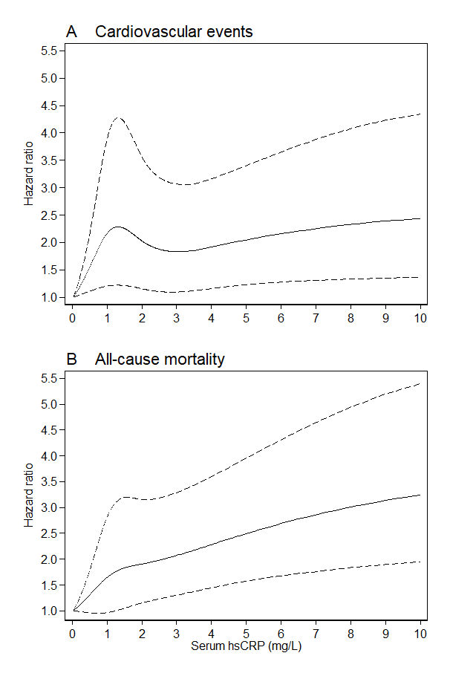
Supplementary Figure 2. Serum hsCRP on a continuous scale and risk of cardiovascular events and all-cause mortality. Cardiovascular events (A) and all-cause mortality (B). Solid lines indicate hazard ratios, and dashed lines indicate 95% confidence intervals. The continuous variable serum hsCRP was modeled with five restricted cubic splines.

CARDIOVASCULAR EVENT SUBTYPES

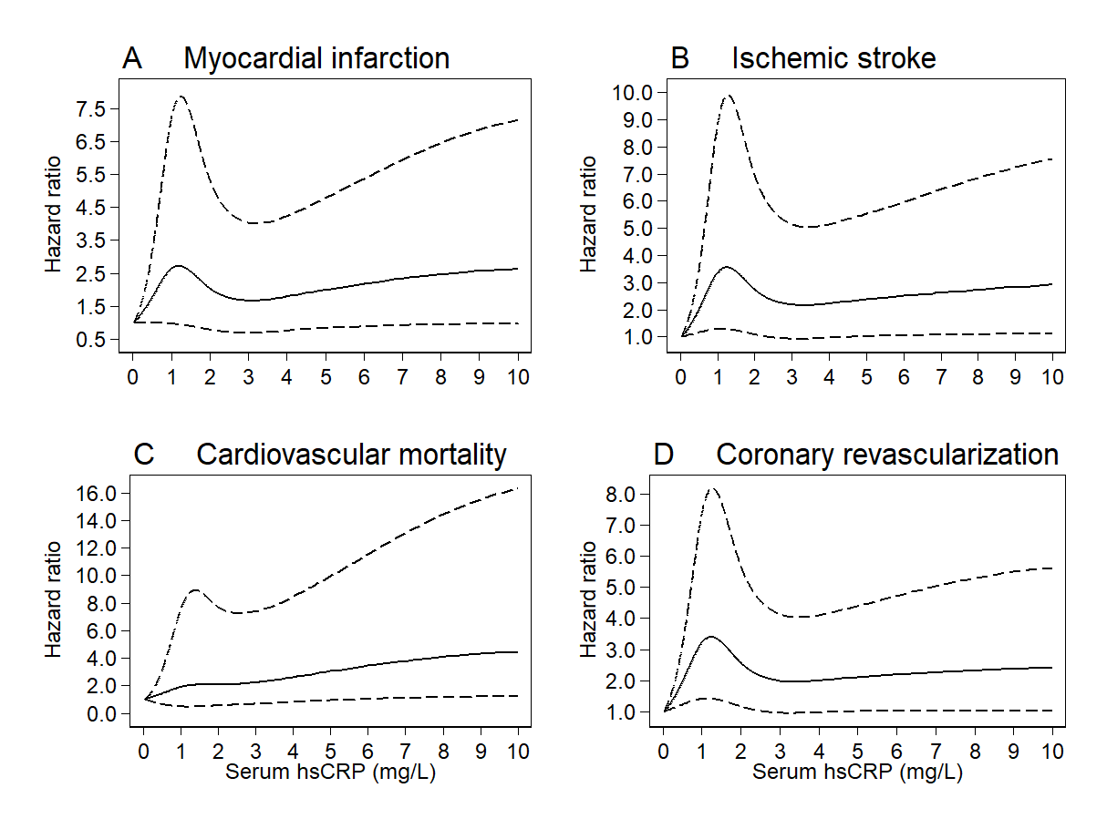

Supplementary Figure 3. Subtypes of cardiovascular events: Continuous scale associations by serum hsCRP levels.

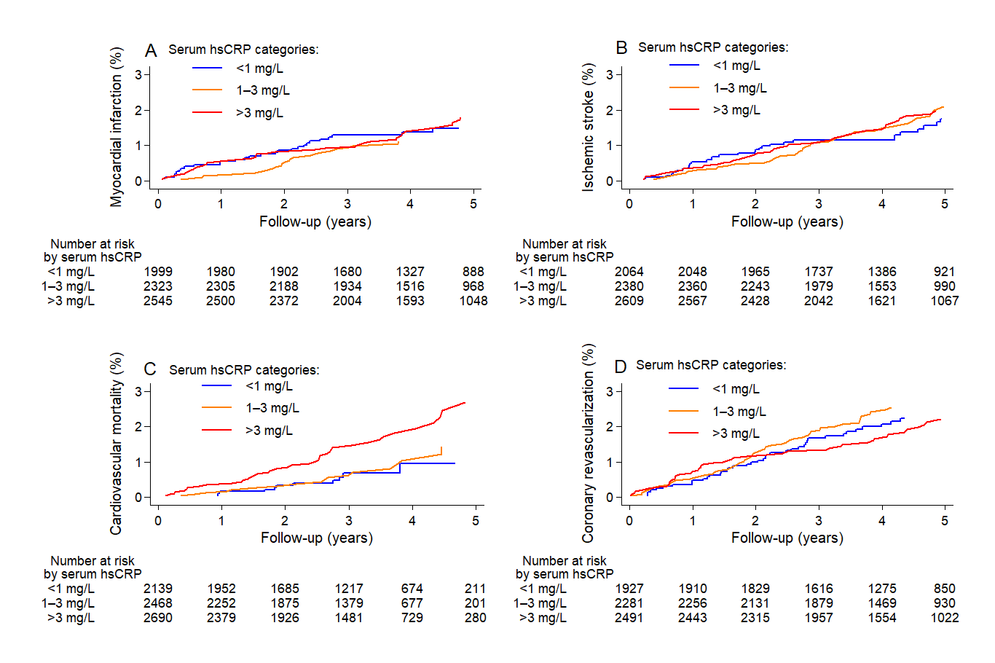

Supplementary Figure 4. Subtypes of cardiovascular events: Cumulative incidence curves by serum hsCRP levels.

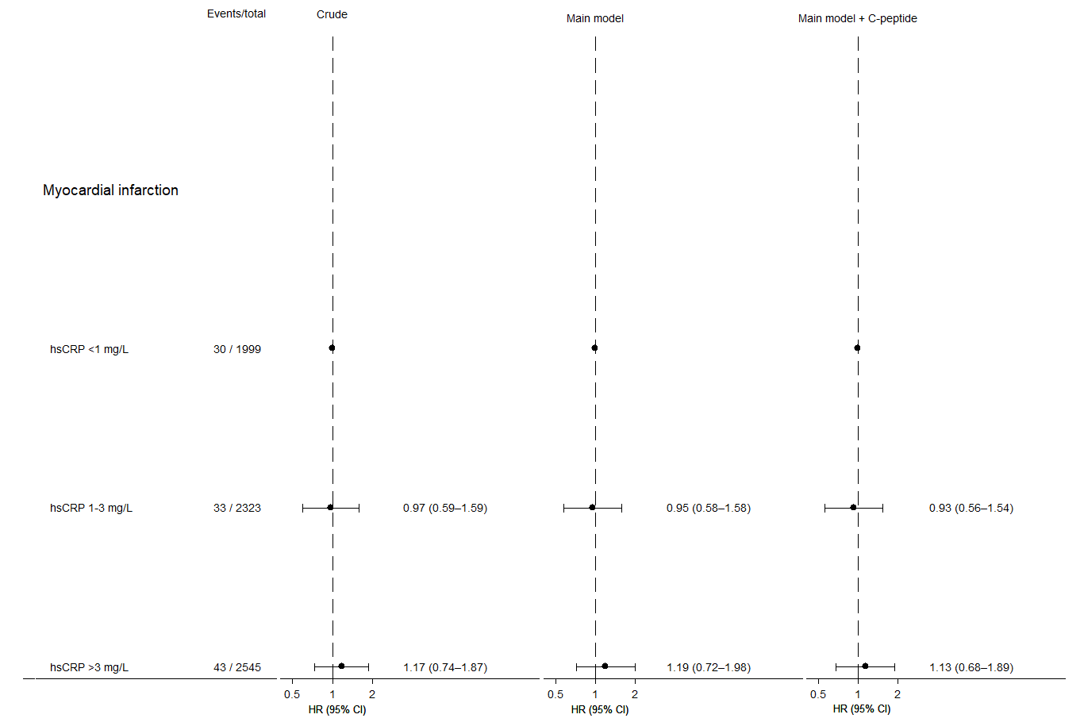

Supplementary Figure 5. Hazard ratios for myocardial infarction by serum hsCRP levels.

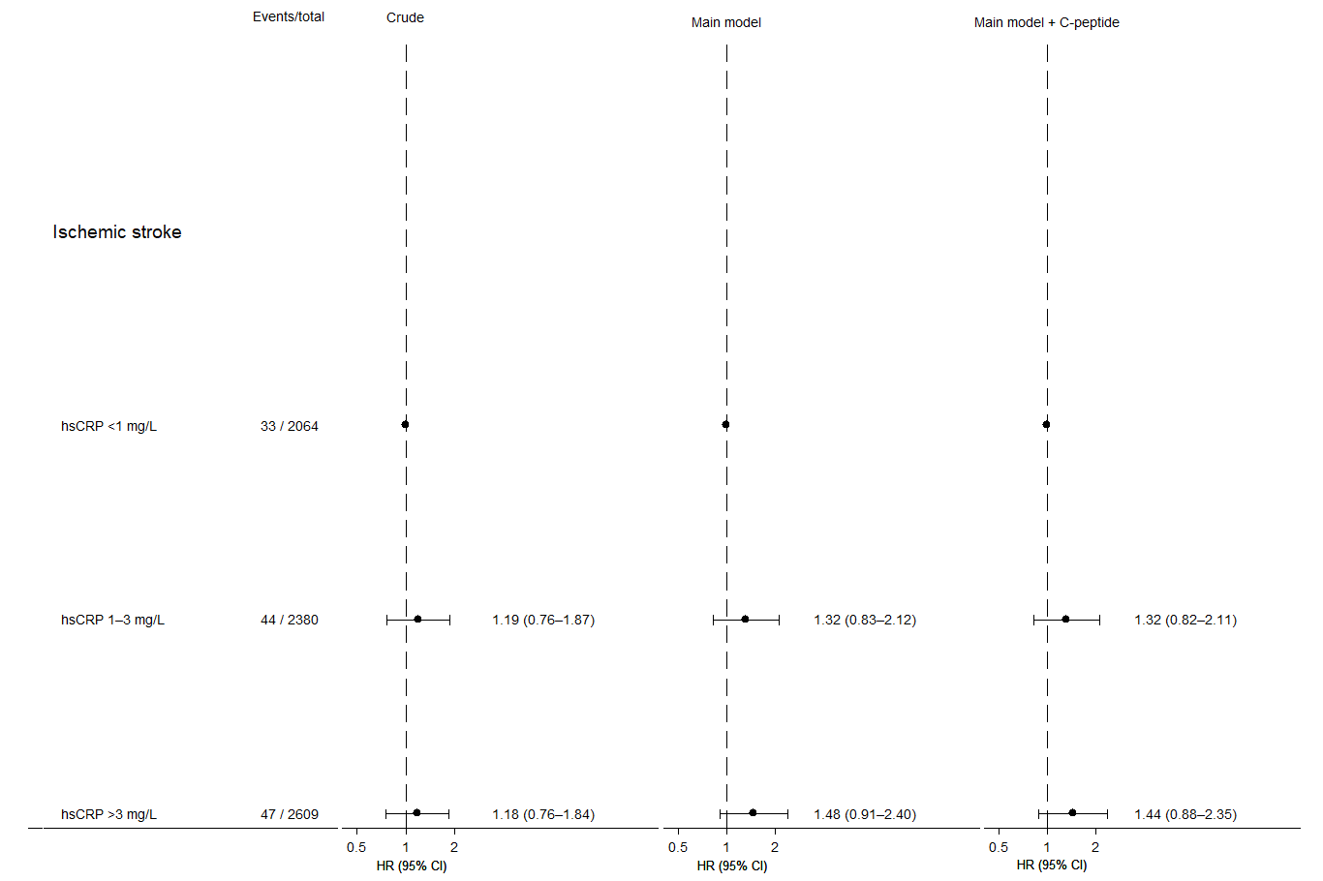

Supplementary Figure 6. Hazard ratios for ischemic stroke by serum hsCRP levels.
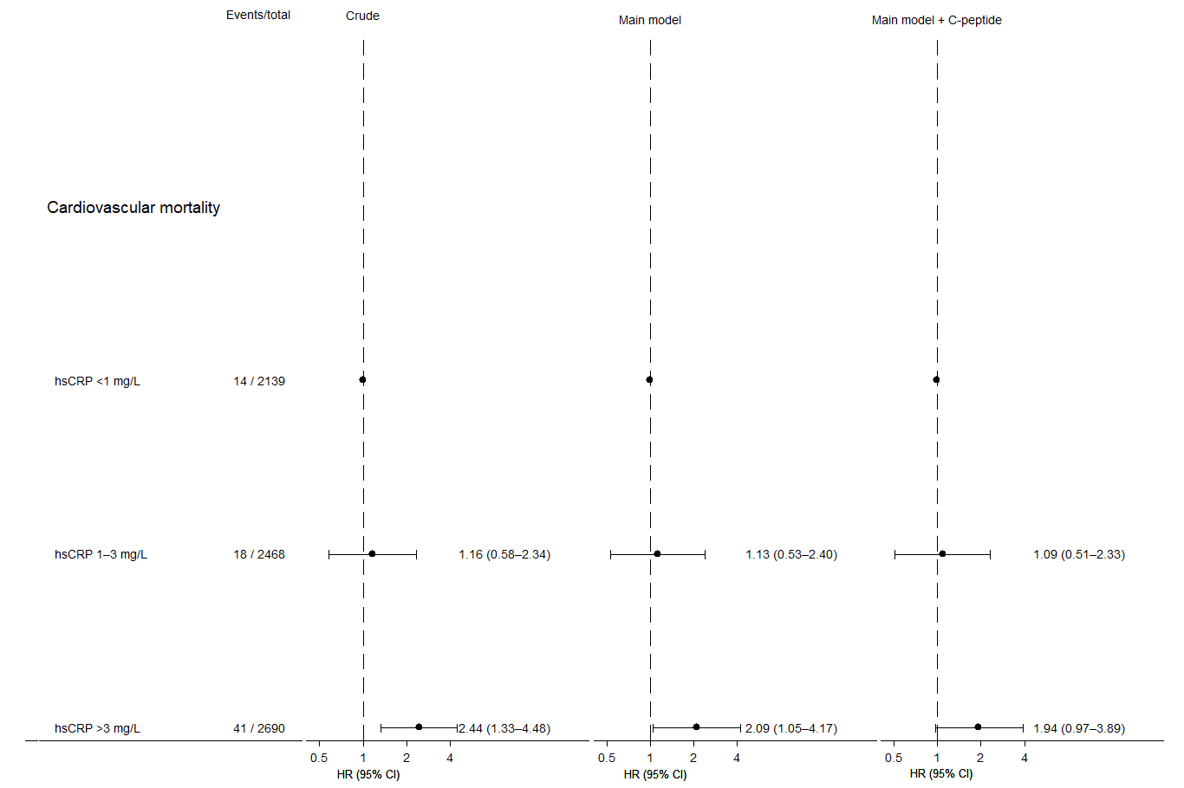

Supplementary Figure 7. Hazard ratios for cardiovascular mortality by serum hsCRP levels.
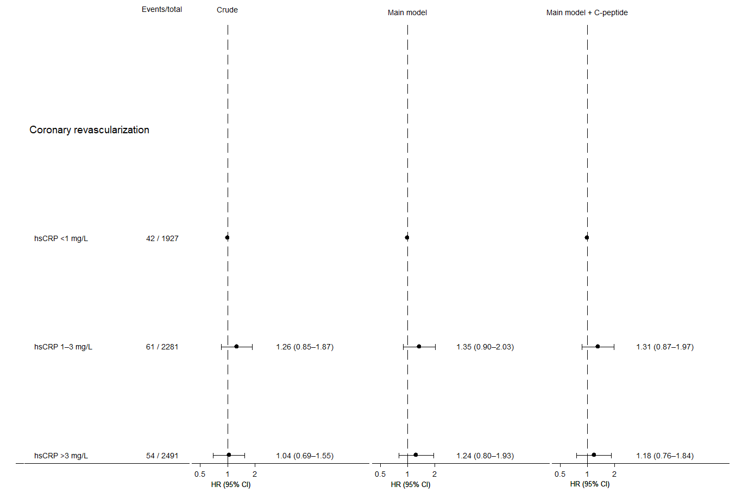

Supplementary Figure 8. Hazard ratios for coronary revascularization by serum hsCRP levels.

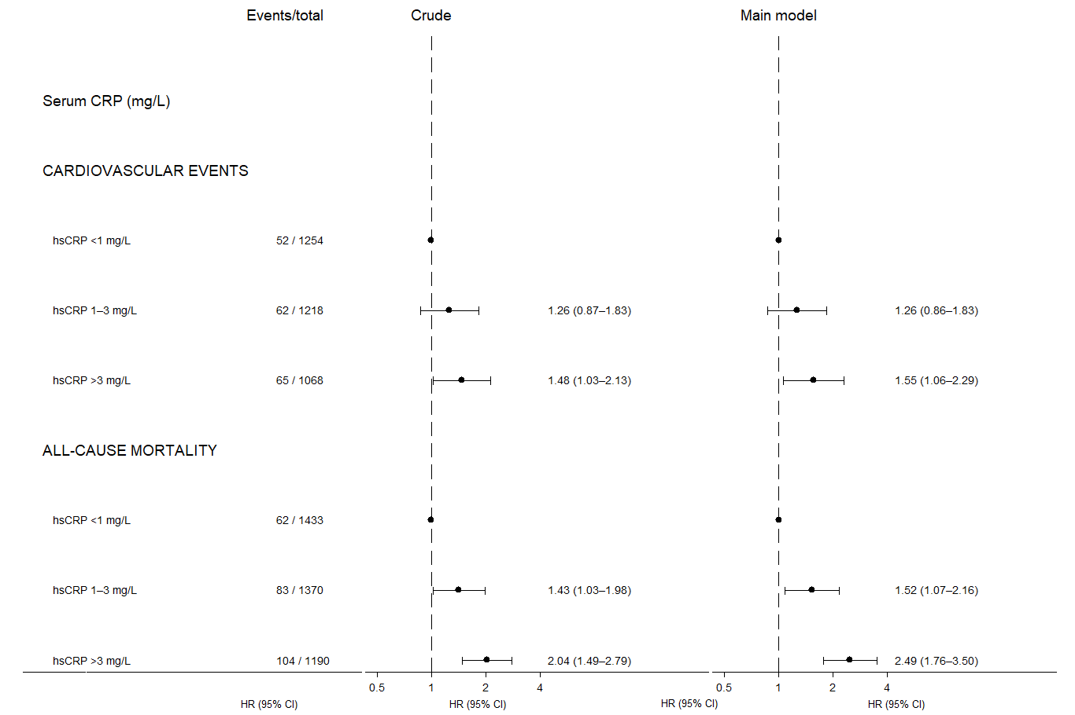

Supplementary Figure 9. Hazard ratios for cardiovascular events and all-cause mortality by serum hsCRP levels in patients with low C-peptide levels (<1470 pmol/L).

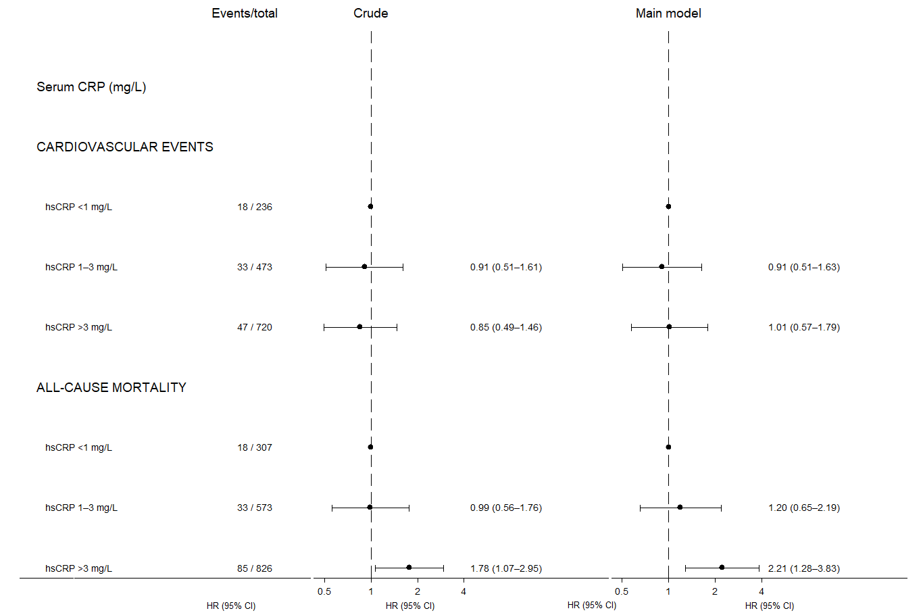

Supplementary Figure 10. Hazard ratios for cardiovascular events and all-cause mortality by serum hsCRP levels in patients with high C-peptide levels (≥1470 pmol/L).

SENSITIVITY ANALYSES

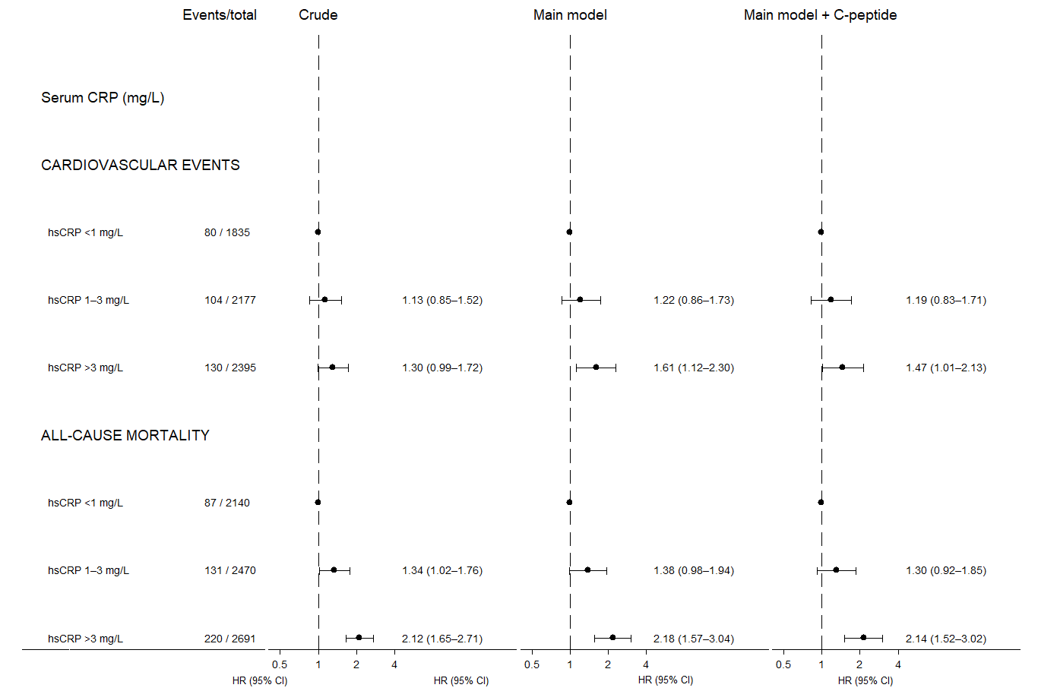

Supplementary Figure 11. Complete case analysis: Hazard ratios for cardiovascular events and all-cause mortality by serum hsCRP levels.

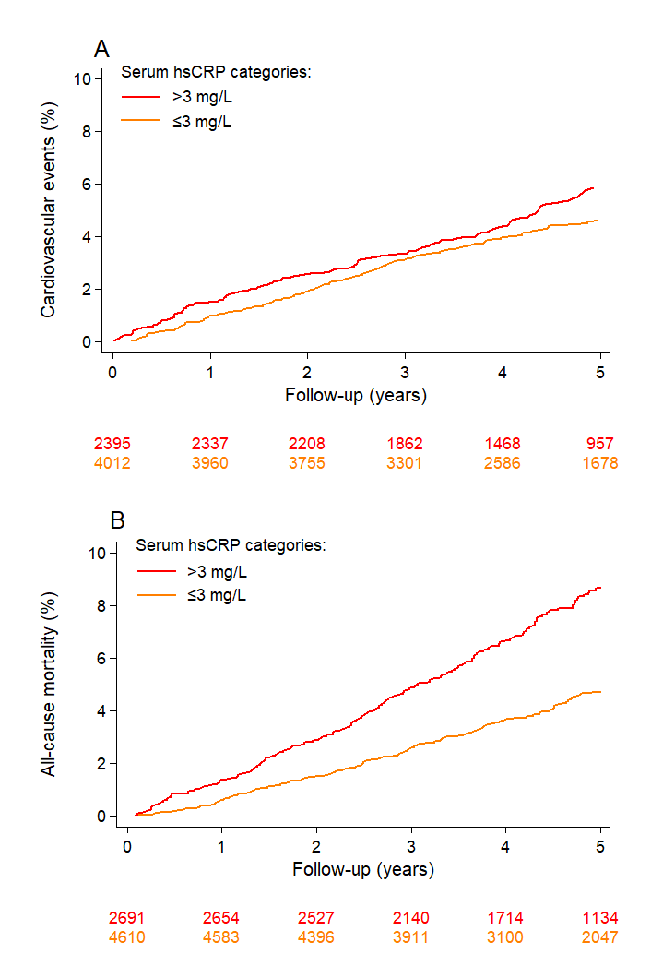

Supplementary Figure 12. Cumulative incidence curves of cardiovascular events and all-cause mortality by serum hsCRP categories (>3 mg/L and ≤3 mg/L).
Time-to-event curves of cardiovascular events (A) considering death as a competing risk and all-cause mortality (B), by serum hsCRP categories (>3 mg/L and ≤3 mg/L).

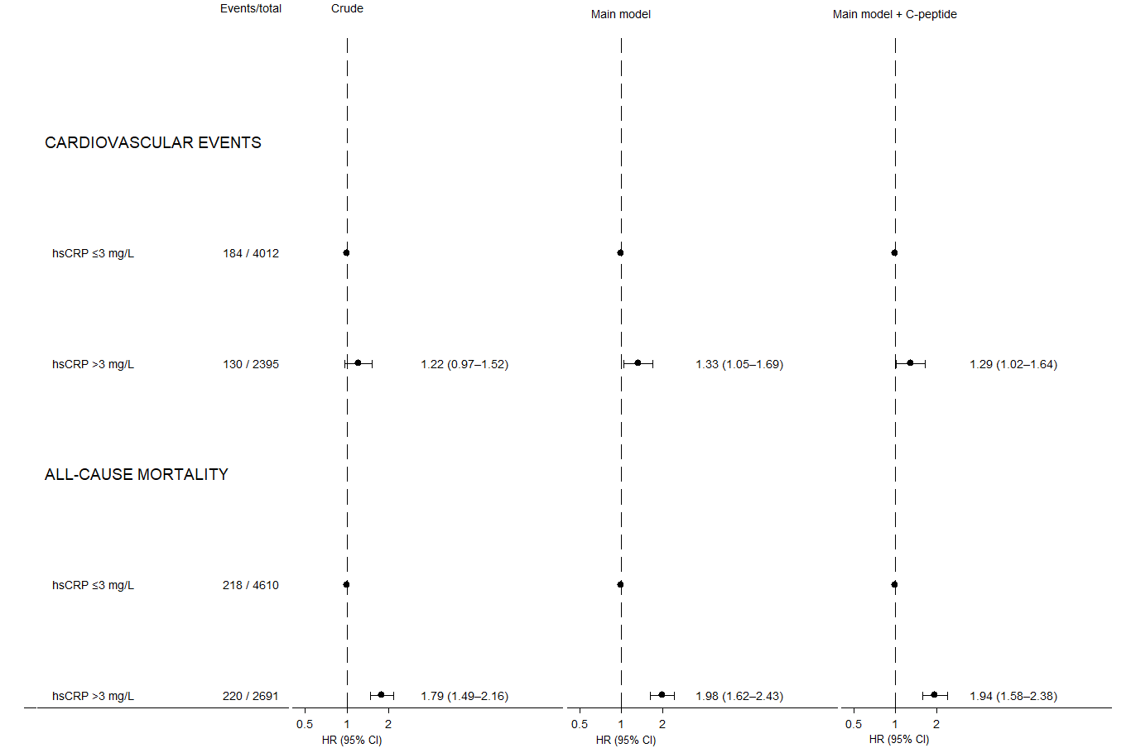

Supplementary Figure 13. Hazard ratios of cardiovascular events and all-cause mortality by serum hsCRP categories (>3 mg/L and ≤3 mg/L).
Serum hsCRP levels were stratified into two categories: >3 mg/L and ≤3 mg/L.

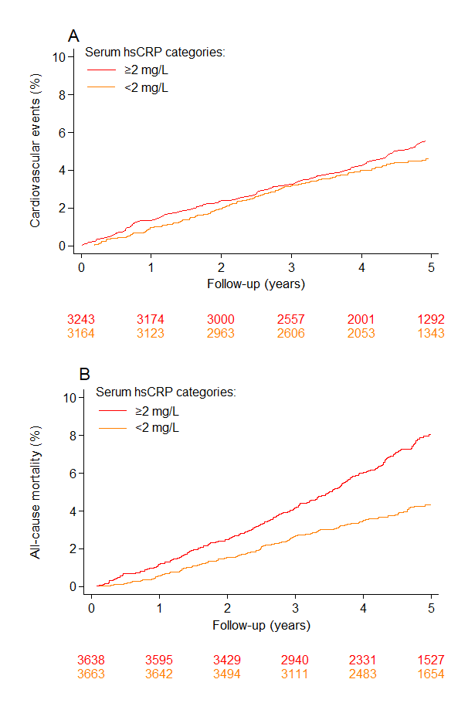

Supplementary Figure 14. Cumulative incidence curves of cardiovascular events and all-cause mortality by serum hsCRP categories (≥2 mg/L and <2 mg/L).
Time-to-event curves of cardiovascular events (A) considering death as a competing risk and all-cause mortality (B), by serum hsCRP categories (≥2 mg/L and <2 mg/L).

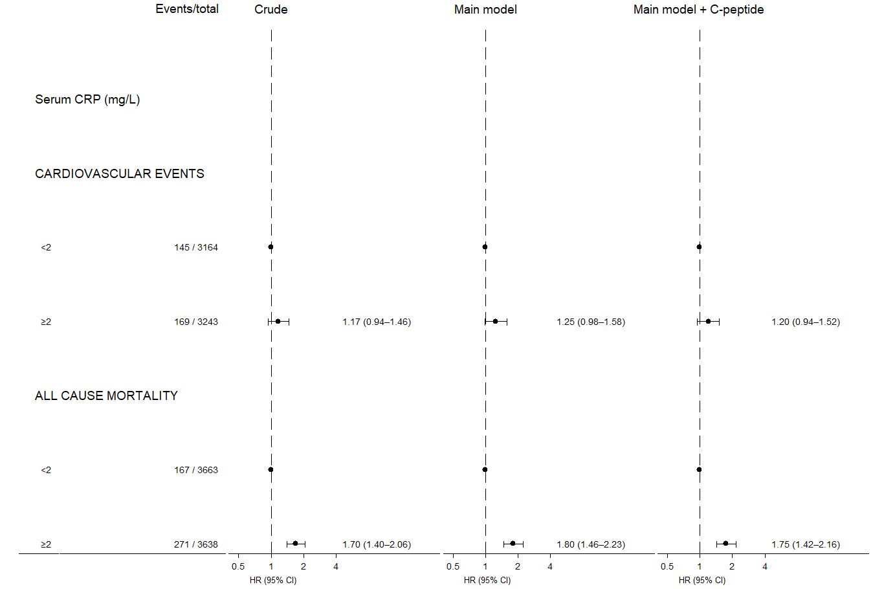

Supplementary Figure 15. Hazard ratios of cardiovascular events and all-cause mortality by serum hsCRP categories (≥2 mg/L and <2 mg/L).
Serum hsCRP levels were stratified into two categories: ≥2 mg/L and <2 mg/L.

