Supplemental online appendix

Additional methodological details
Participant training and support: Participants received extensive training prior to initiating the EMA and mobile cognitive tests, and coordinators continued to monitor responses and provide support throughout the 14-day EMA data collection period. During baseline training, participants reviewed each EMA question and accompanying response options with the research coordinator, to ensure their understanding of the questions and possible responses. In addition, participants reviewed instructions for each mobile cognitive test with the coordinator, and were able to practice each test during the training session with the coordinator observing their performance (via screen sharing). In their study kit, participants received a handbook which provided explanations of each EMA survey question and response options, troubleshooting tips for general phone operation and the EMA and mobile cognitive testing applications, and contact information for the research team. Participants were encouraged to review the handbook or reach out to their study coordinator at any time with questions or difficulties using any of the study devices.
During the 14-day study period, research coordinators monitored EMA completion rates and sent daily text messages either congratulating participants on their survey completion and encouraging continued adherence, or troubleshooting difficulties with survey completion. When daily monitoring revealed technical or scheduling difficulties in completing surveys, these were resolved through consultation with relevant team members and modifying EMA schedules as needed. In addition to daily text messages, research coordinators also completed scheduled check-in calls with each participant during the study period. The first call was required for all participants; follow-up check-in calls were conducted as needed for participants having difficulty completing the study protocol.
Cognitive data: Practice effects are common in ambulatory cognitive testing and they have the potential to bias results from within-person regression analyses (Sliwinski, Smyth, Hofer, and Stawski, 2006). To account for practice effects in the cognitive test scores, we applied individual detrending, a statistical procedure to remove systematic changes over time in repeated assessments. For each participant, we fitted a regression model regressing the cognitive scores on linear and quadratic time of study; we then subtracted the observed cognitive scores from the estimated curvilinear trend and added the participants mean score to preserve between-person differences in cognitive functioning (Wang, Hamaker, and Bergeman, 2012). The individually detrended scores were used in the analyses.
Glucose metrics: The glucose measure of nighttime % time <70 mg/dL were derived by dividing the number of glucose readings <70 mg/dL by the total number of readings obtained between the sleep and wake time for each individual and night, multiplied by 100. The analogous procedure was used to calculate nighttime % time >250 mg/dL. Nighttime glucose CV was calculated by dividing the standard deviation of glucose readings by the mean of glucose readings, multiplied by 100, for each individual and night.
References:
Sliwinski MJ, Smyth JM, Hofer SM, & Stawski RS (2006). Intraindividual coupling of daily stress and cognition. Psychology and aging, 21(3), 545-557.
Wang, L. P., Hamaker, E., & Bergeman, C. (2012). Investigating inter-individual differences in short-term intra-individual variability. Psychological methods, 17(4), 567-581.
Figure S1: Distributions of glucose metrics

Observed scores Within-person distribution Between-person distribution
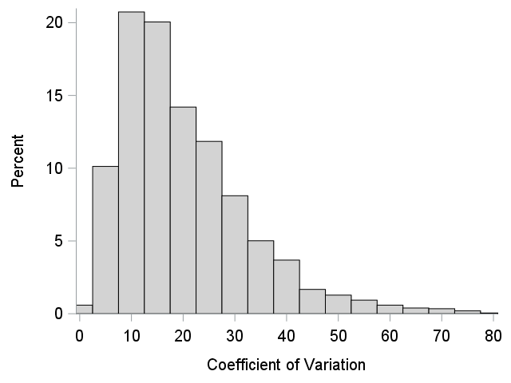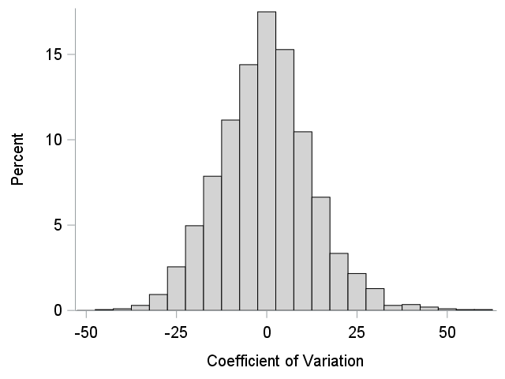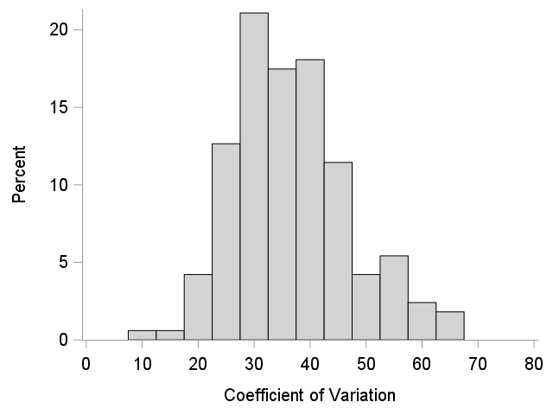
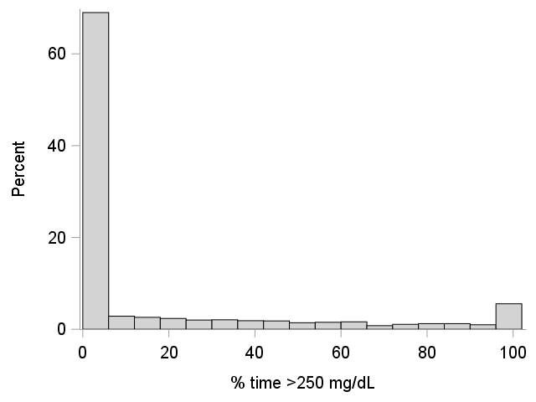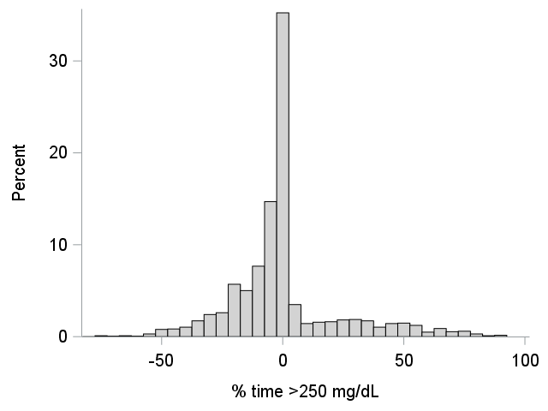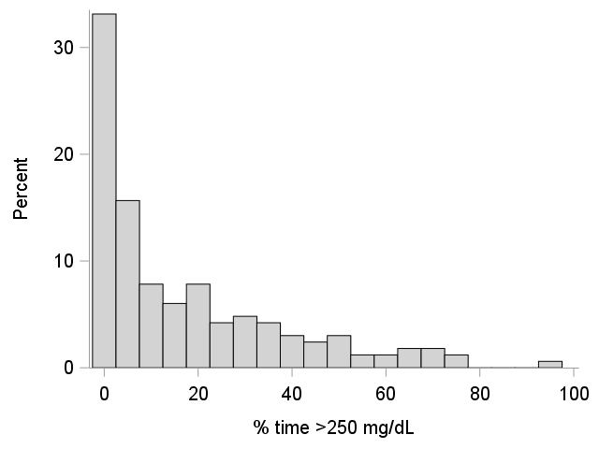
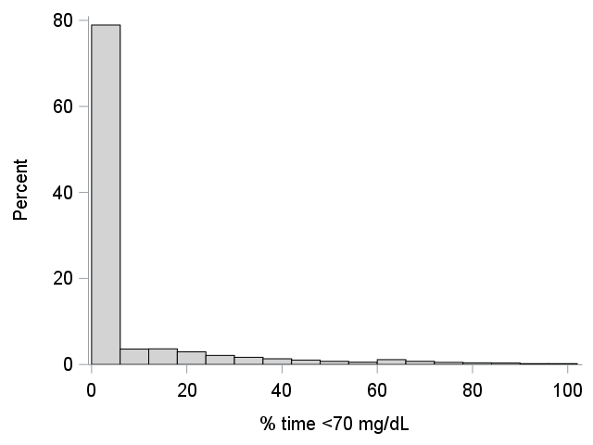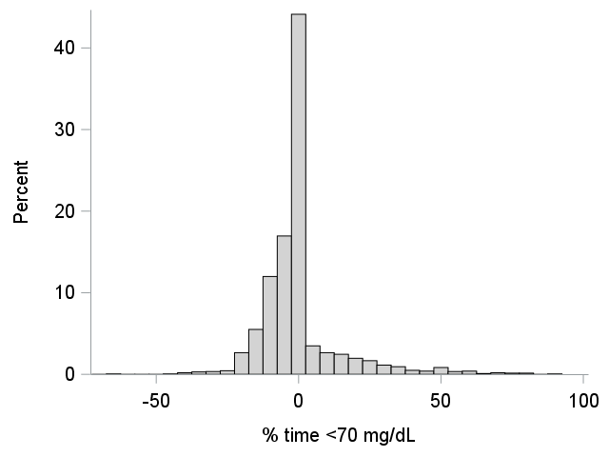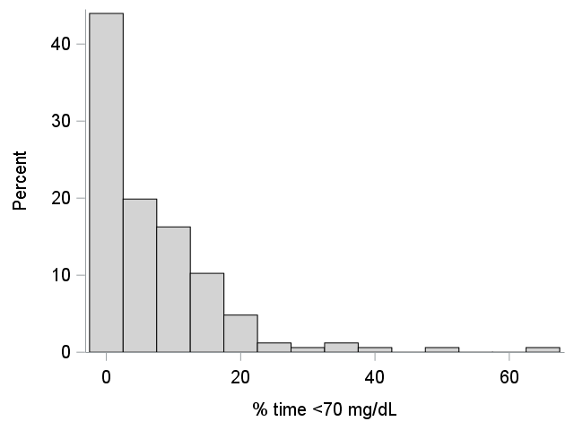

Figure S2. Distributions of functioning measures (cognition and physical activity)

Observed scores Within-person distribution Between-person distribution
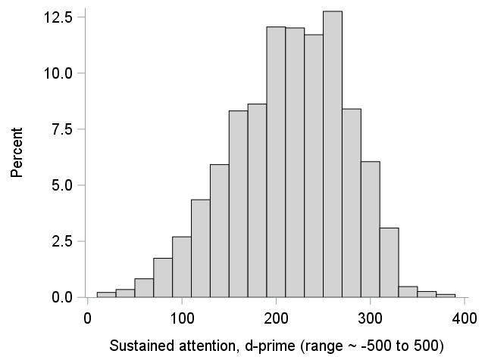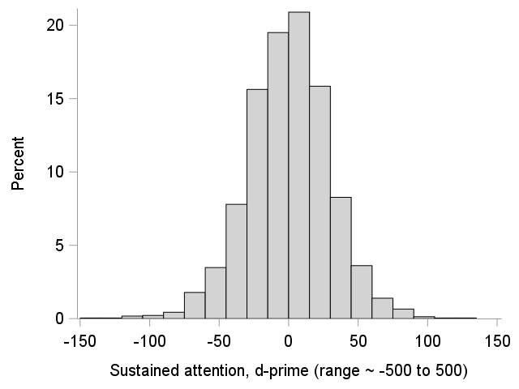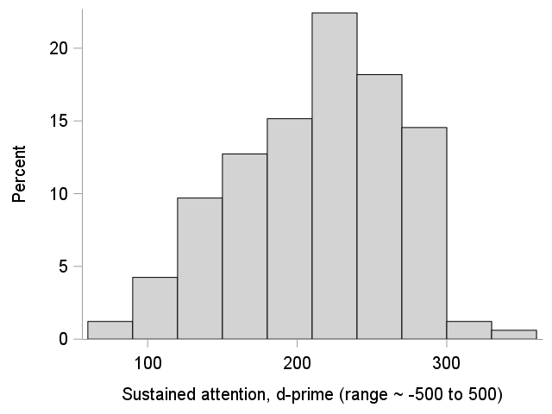
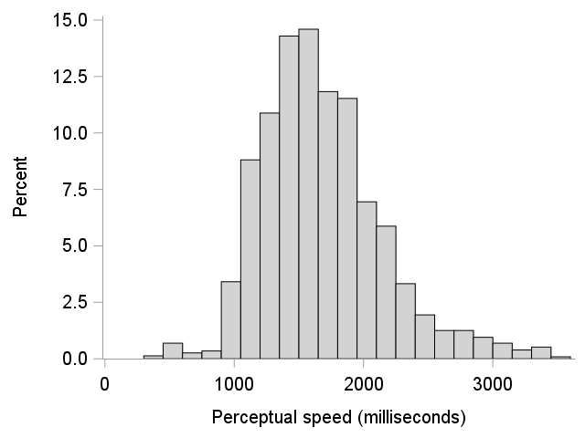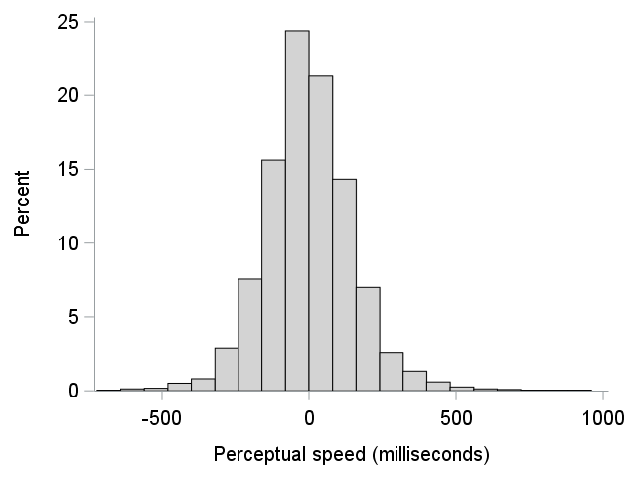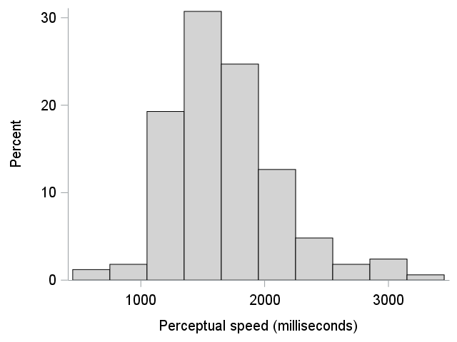
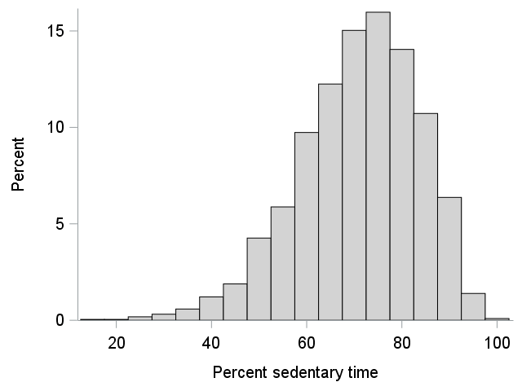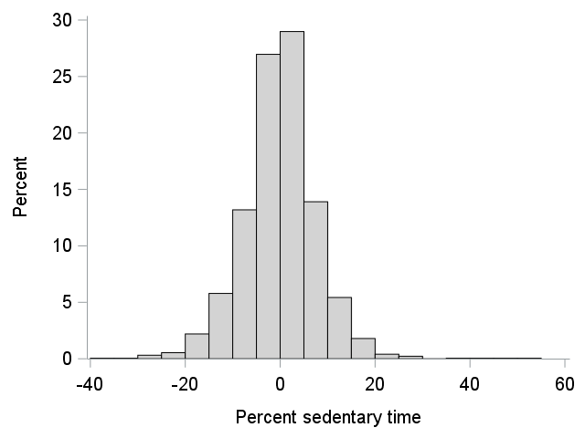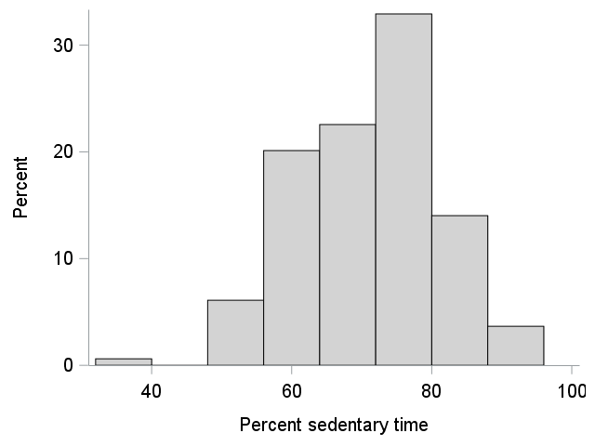
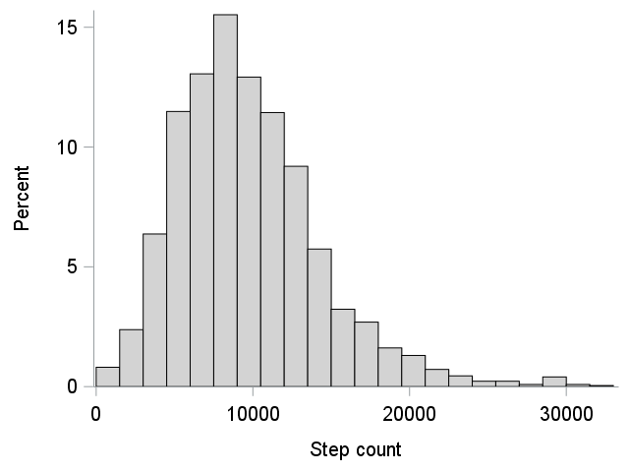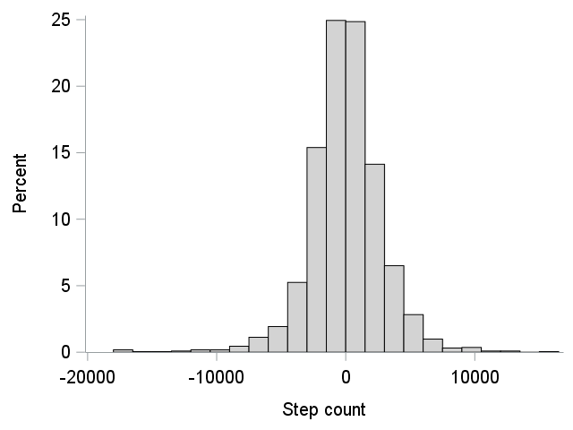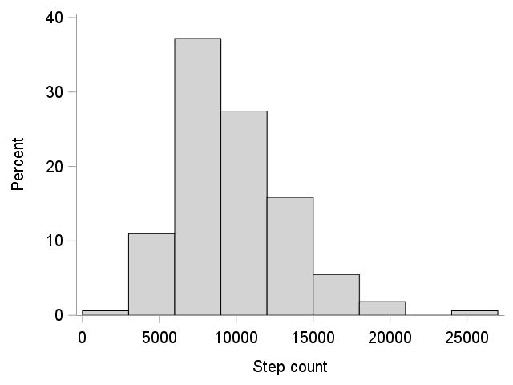
Figure S3. Distributions of functioning measures (activity participation)

Observed scores Within-person distribution Between-person distribution
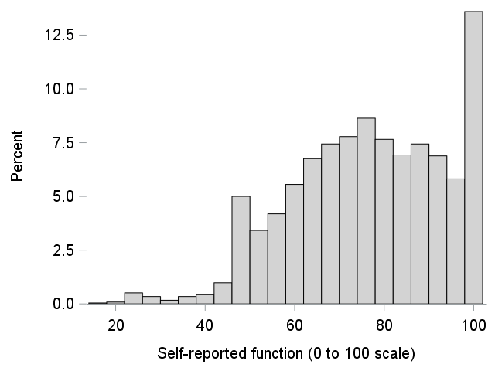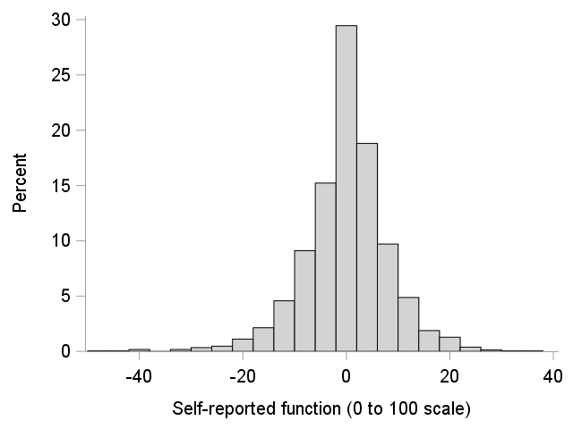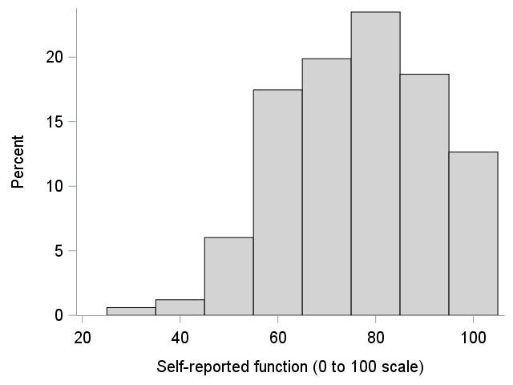
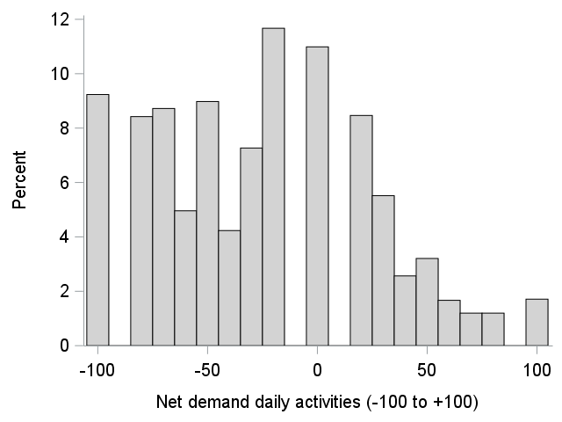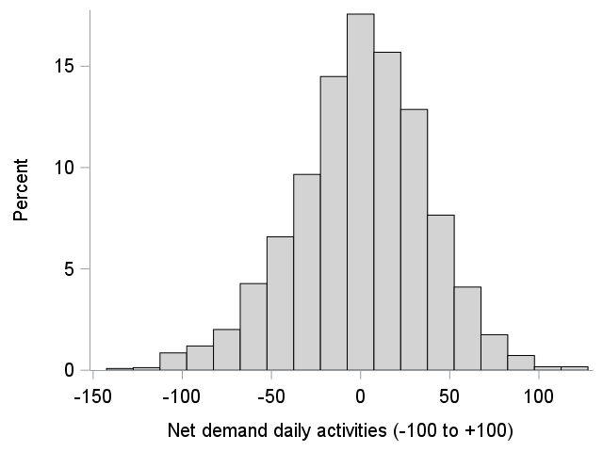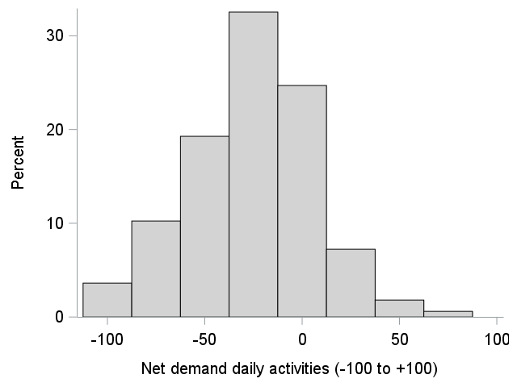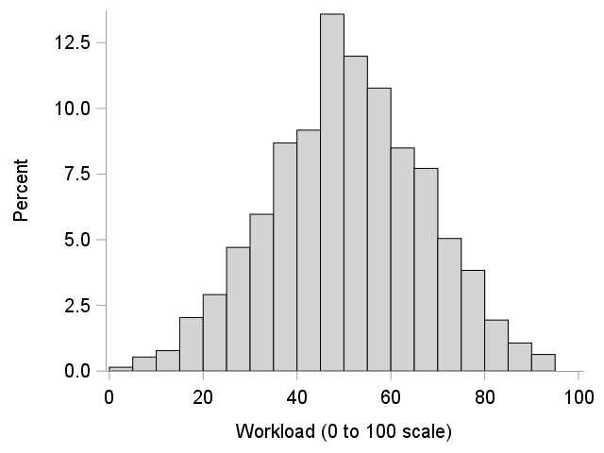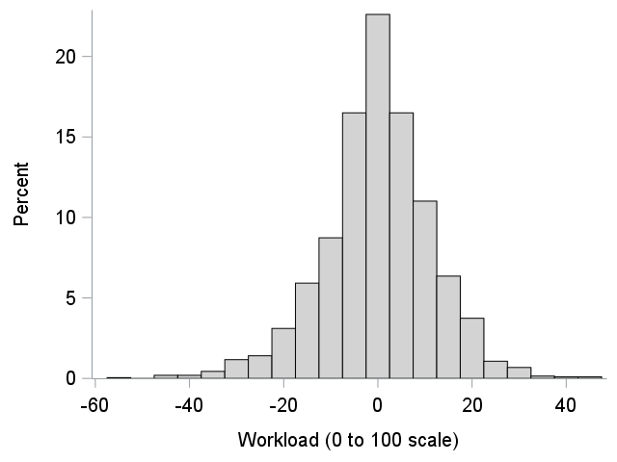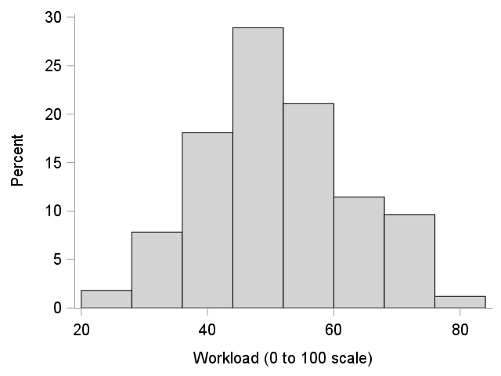

Figure S4. Moderation effects of overnight glucose metrics on next-day functioning by mean glucose levels
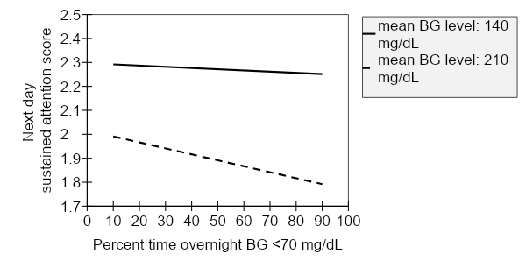
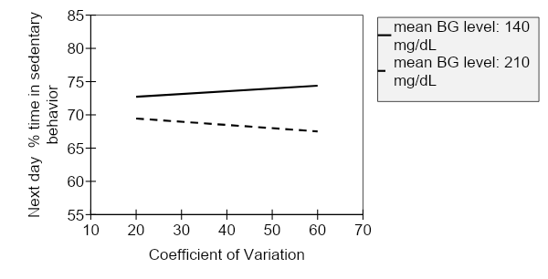
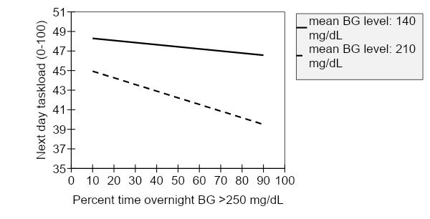

Figure S5. Moderation effects of overnight glucose metrics on next-day functioning by diabetes device use
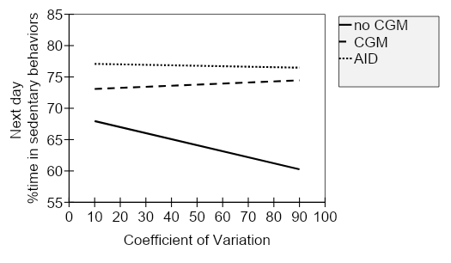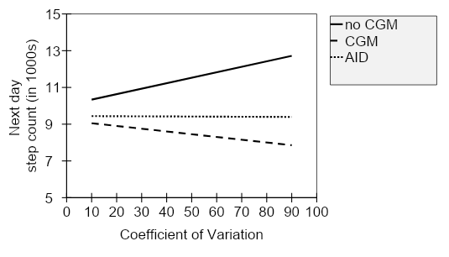

Table S1. Results of dynamic structural equation model examining within-person associations between nighttime glucose measures and next-day missing assessments
Type of | Variables |  | Estimate | 95% credible interval
parameter | Predictor variable | Dependent variable |  | Lower | Upper
Missed Ecological Momentary Assessments
Autoregressive | % missing | % missing | .155 | .082 | .229
Autoregressive | Coefficient of variation | Coefficient of variation | .081 | .018 | .153
Cross-lagged | % missing | Coefficient of variation | -.032 | -.090 | .037
Cross-lagged | Coefficient of variation | % missing | -.093 | -.193 | .010
Autoregressive | % missing | % missing | .183 | .108 | .257
Autoregressive | % time <70mg/dL | % time <70mg/dL | .211 | .127 | .293
Cross-lagged | % missing | % time <70mg/dL | -.040 | -.124 | .088
Cross-lagged | % time <70mg/dL | % missing | .080 | -.048 | .191
Autoregressive | % missing | % missing | .168 | .091 | .245
Autoregressive | % time >250mg/dL | % time >250mg/dL | .281 | .196 | .363
Cross-lagged | % missing | % time >250mg/dL | -.014 | -.144 | .133
Cross-lagged | % time >250mg/dL | % missing | -.021 | -.061 | .028
Missing sustained attention tasks
Autoregressive | % missing | % missing | .244 | .164 | .325
Autoregressive | Coefficient of variation | Coefficient of variation | .056 | -.008 | .141
Cross-lagged | % missing | Coefficient of variation | -.015 | -.064 | .031
Cross-lagged | Coefficient of variation | % missing | -.012 | -.135 | .092
Autoregressive | % missing | % missing | .242 | .169 | .321
Autoregressive | % time <70mg/dL | % time <70mg/dL | .204 | .116 | .303
Cross-lagged | % missing | % time <70mg/dL | .023 | -.035 | .081
Cross-lagged | % time <70mg/dL | % missing | .046 | -.133 | .204
Autoregressive | % missing | % missing | .248 | .163 | .333
Autoregressive | % time >250mg/dL | % time >250mg/dL | .279 | .190 | .359
Cross-lagged | % missing | % time >250mg/dL | -.096 | -.216 | .033
Cross-lagged | % time >250mg/dL | % missing | -.027 | -.068 | .022
Missing perceptual speed tasks
Autoregressive | % missing | % missing | .189 | .107 | .266
Autoregressive | Coefficient of variation | Coefficient of variation | .081 | .011 | .154
Cross-lagged | % missing | Coefficient of variation | -.009 | -.059 | .049
Cross-lagged | Coefficient of variation | % missing | -.065 | -.185 | .057
Autoregressive | % missing | % missing | .215 | .134 | .293
Autoregressive | % time <70mg/dL | % time <70mg/dL | .220 | .129 | .303
Cross-lagged | % missing | % time <70mg/dL | .028 | -.066 | .106
Cross-lagged | % time <70mg/dL | % missing | -.050 | -.192 | .081
Autoregressive | % missing | % missing | .216 | .133 | .298
Autoregressive | % time >250mg/dL | % time >250mg/dL | .292 | .213 | .374
Cross-lagged | % missing | % time >250mg/dL | -.070 | -.194 | .058
Cross-lagged | % time >250mg/dL | % missing | -.044 | -.092 | .010

Results of dynamic structural equation model examining lagged within-person associations between nighttime coefficient of variation (CV) and next-day functioning measures
Model fit information
Number of free parameters: 95
Information criteria:
Deviance (DIC): 61631.51
Estimated number of parameters (pD): 2437.59
Wald test of parameter constraints (cross-lagged effects of all 7 functioning variables on coefficient of variation tested against 0)
Value: 17.03
Degrees of freedom: 7
p-value: .017

Table S2: parameter estimates
Level / Type of parameter | Variables |  | Estimate | 95% credible interval
 |  |  |  | Lower | Upper
Level 1 (within person)
Autoregressive | Predictor variable | Dependent variable
 | Sustained attention | Sustained attention | .012 | -.038 | .061
 | Perceptual speed | Perceptual speed | .141 | .095 | .189
 | % time sedentary | % time sedentary | .173 | .134 | .212
 | Step count | Step count | .150 | .112 | .190
 | Self-reported function | Self-reported function | .366 | .316 | .414
 | Net demand daily activities | Net demand daily activities | .186 | .142 | .226
 | Task load | Task load | .264 | .219 | .308
 | Coefficient of variation | Coefficient of variation | .042 | -.005 | .098
Cross-lagged | Predictor variable | Dependent variable
 | Coefficient of variation | Sustained attention | -.150 | -.277 | -.029
 | Coefficient of variation | Perceptual speed | .331 | -.364 | .955
 | Coefficient of variation | % time sedentary | -.022 | -.057 | .014
 | Coefficient of variation | Step count | 4.57 | -8.72 | 16.88
 | Coefficient of variation | Self-reported function | .006 | -.028 | .040
 | Coefficient of variation | Net demand daily activities | -.219 | -.371 | -.069
 | Coefficient of variation | Task load | -.033 | -.087 | .022
 | Sustained attention | Coefficient of variation | .010 | -.007 | .027
 | Perceptual speed | Coefficient of variation | .002 | -.001 | .006
 | % time sedentary | Coefficient of variation | .023 | -.084 | .126
 | Step count | Coefficient of variation | .0002 | -.00009 | .0005
 | Self-reported function | Coefficient of variation | .052 | -.011 | .117
 | Net demand daily activities | Coefficient of variation | -.003 | .020 | .011
 | Task load | Coefficient of variation | .008 | -.036 | .051
Residual variances | Variable
 | Sustained attention |  | 956.77 | 898.66 | 1016.09
 | Perceptual speed |  | 25671.67 | 24199.06 | 27343.82
 | % time sedentary |  | 64.78 | 60.81 | 68.80
 | Step count |  | 8781227 | 8229164 | 9341630
 | Self-reported function |  | 67.64 | 63.81 | 72.10
 | Net demand daily activities |  | 1487.63 | 1402.13 | 1576.85
 | Task load |  | 178.57 | 167.52 | 191.50
 | Coefficient of variation |  | 125.60 | 117.67 | 134.75
Residual correlations | Variable A | Variable B
 | Sustained attention | Perceptual speed | .059 | .016 | .102
 | Sustained attention | % time sedentary | .052 | .008 | .095
 | Sustained attention | Step count | -.054 | -.096 | -.011
 | Sustained attention | Self-reported function | .051 | .008 | .090
 | Sustained attention | Net demand daily activities | .004 | -.038 | .048
 | Sustained attention | Task load | -.069 | -.117 | -.022
 | Perceptual speed | % time sedentary | -.050 | -.093 | -.007
 | Perceptual speed | Step count | .049 | .006 | .091
 | Perceptual speed | Self-reported function | .037 | -.008 | .079
 | Perceptual speed | Net demand daily activities | .057 | .011 | .099
 | Perceptual speed | Task load | .030 | -.021 | .081
 | % time sedentary | Step count | -.758 | -.776 | -.738
 | % time sedentary | Self-reported function | -.088 | -.136 | -.045
 | % time sedentary | Net demand daily activities | -.153 | -.195 | -.112
 | % time sedentary | Task load | -.192 | -.235 | -.146
 | Step count | Self-reported function | .086 | .039 | .130
 | Step count | Net demand daily activities | .193 | .150 | .235
 | Step count | Task load | .259 | .218 | .303
 | Self-reported function | Net demand daily activities | -.041 | -.083 | .001
 | Self-reported function | Task load | .001 | -.047 | .052
 | Net demand daily activities | Task load | .381 | .341 | .422
Level 2 (between person)
Means | Variable
 | Sustained attention |  | 213.19 | 203.99 | 221.63
 | Perceptual speed |  | 1671.05 | 1601.99 | 1744.71
 | % time sedentary |  | 70.95 | 69.25 | 72.54
 | Step count |  | 9628.4 | 9035.2 | 10248.8
 | Self-reported function |  | 76.19 | 73.63 | 78.40
 | Net demand daily activities |  | -25.53 | -30.66 | -20.54
 | Task load |  | 47.50 | 45.39 | 49.78
 | Coefficient of variation |  | 20.30 | 19.05 | 21.34
Variances | Variable
 | Sustained attention |  | 3227.52 | 2540.76 | 4144.06
 | Perceptual speed |  | 228195.40 | 178937.16 | 277453.69
 | % time sedentary |  | 106.45 | 85.52 | 136.86
 | Step count |  | 14700150 | 11105663 | 18294639
 | Self-reported function |  | 244.81 | 193.43 | 311.49
 | Net demand daily activities |  | 988.89 | 773.95 | 1310.81
 | Task load |  | 181.90 | 136.95 | 236.32
 | Coefficient of variation |  | 43.28 | 32.26 | 57.16
Correlations | Variable A | Variable B
 | Sustained attention | Perceptual speed | .194 | .023 | .341
 | Sustained attention | % time sedentary | .066 | -.115 | .235
 | Sustained attention | Step count | -.071 | -.241 | .113
 | Sustained attention | Self-reported function | .139 | -.023 | .303
 | Sustained attention | Net demand daily activities | -.063 | -.230 | .107
 | Sustained attention | Task load | -.104 | -.271 | .060
 | Perceptual speed | % time sedentary | -.162 | -.321 | -.006
 | Perceptual speed | Step count | .186 | .019 | .342
 | Perceptual speed | Self-reported function | -.095 | -.259 | .074
 | Perceptual speed | Net demand daily activities | .067 | -.114 | .235
 | Perceptual speed | Task load | -.121 | -.289 | .043
 | % time sedentary | Step count | -.822 | -.869 | -.757
 | % time sedentary | Self-reported function | .009 | -.184 | .175
 | % time sedentary | Net demand daily activities | -.437 | -.579 | -.280
 | % time sedentary | Task load | -.253 | -.400 | -.080
 | Step count | Self-reported function | .001 | -.172 | .179
 | Step count | Net demand daily activities | .428 | .266 | .578
 | Step count | Task load | .204 | .030 | .364
 | Self-reported function | Net demand daily activities | -.058 | -.232 | .121
 | Self-reported function | Task load | -.061 | -.244 | .120
 | Net demand daily activities | Task load | .358 | .189 | .503
 | Coefficient of variation | Sustained attention | -.158 | -.335 | .028
 | Coefficient of variation | Perceptual speed | -.038 | -.232 | .147
 | Coefficient of variation | % time sedentary | -.023 | -.209 | .170
 | Coefficient of variation | Step count | .024 | -.162 | .213
 | Coefficient of variation | Self-reported function | -.069 | -.260 | .123
 | Coefficient of variation | Net demand daily activities | -.002 | -.198 | .194
 | Coefficient of variation | Task load | .072 | -.116 | .261

Results of dynamic structural equation model examining lagged within-person associations between nighttime % time <70mg/dL and next-day functioning measures
Model fit information
Number of free parameters: 95
Information criteria:
Deviance (DIC): 45439.11
Estimated number of parameters (pD): 2426.63
Wald test of parameter constraints (cross-lagged effects of all 7 functioning variables on coefficient of variation tested against 0)
Value: 12.95
Degrees of freedom: 7
p-value: .073

Table S3: parameter estimates
Level / Type of parameter | Variables |  | Estimate | 95% credible interval
 |  |  |  | Lower | Upper
Level 1 (within person)
Autoregressive | Predictor variable | Dependent variable
 | Sustained attention | Sustained attention | .012 | -.038 | .061
 | Perceptual speed | Perceptual speed | .141 | .095 | .189
 | % time sedentary | % time sedentary | .173 | .134 | .212
 | Step count | Step count | .150 | .111 | .191
 | Self-reported function | Self-reported function | .366 | .315 | .411
 | Net demand daily activities | Net demand daily activities | .185 | .142 | .226
 | Task load | Task load | .265 | .219 | .309
 | % time <70mg/dL | % time <70mg/dL | .127 | .078 | .182
Cross-lagged | Predictor variable | Dependent variable
 | % time <70mg/dL | Sustained attention | -.143 | -.238 | -.055
 | % time <70mg/dL | Perceptual speed | .253 | -.242 | .717
 | % time <70mg/dL | % time sedentary | .010 | -.016 | .036
 | % time <70mg/dL | Step count | -2.95 | -12.46 | 6.38
 | % time <70mg/dL | Self-reported function | .005 | -.019 | .031
 | % time <70mg/dL | Net demand daily activities | .018 | -.096 | .134
 | % time <70mg/dL | Task load | -.004 | -.046 | .036
 | Sustained attention | % time <70mg/dL | .013 | -.011 | .035
 | Perceptual speed | % time <70mg/dL | .002 | -.002 | .006
 | % time sedentary | % time <70mg/dL | .112 | -.034 | .248
 | Step count | % time <70mg/dL | .0006 | .0001 | .0009
 | Self-reported function | % time <70mg/dL | .059 | -.025 | .145
 | Net demand daily activities | % time <70mg/dL | -.004 | -.026 | .016
 | Task load | % time <70mg/dL | .039 | -.021 | .097
Residual variances | Variable
 | Sustained attention |  | 955.02 | 897.38 | 1014.56
 | Perceptual speed |  | 25675.60 | 24200.70 | 27345.78
 | % time sedentary |  | 64.83 | 60.81 | 68.90
 | Step count |  | 8778563 | 8229802 | 9350728
 | Self-reported function |  | 67.66 | 63.84 | 72.04
 | Net demand daily activities |  | 1493.42 | 1407.71 | 1583.19
 | Task load |  | 178.63 | 167.71 | 191.44
 | % time <70mg/dL |  | 225.05 | 210.19 | 241.16
Residual correlations | Variable A | Variable B
 | Sustained attention | Perceptual speed | .060 | .017 | .103
 | Sustained attention | % time sedentary | .054 | .011 | .097
 | Sustained attention | Step count | -.055 | -.098 | -.013
 | Sustained attention | Self-reported function | .052 | .009 | .091
 | Sustained attention | Net demand daily activities | .008 | -.033 | .052
 | Sustained attention | Task load | -.068 | -.116 | -.021
 | Perceptual speed | % time sedentary | -.050 | -.093 | -.008
 | Perceptual speed | Step count | .049 | .006 | .091
 | Perceptual speed | Self-reported function | .037 | -.008 | .079
 | Perceptual speed | Net demand daily activities | .056 | .010 | .097
 | Perceptual speed | Task load | .030 | -.022 | .080
 | % time sedentary | Step count | -.758 | -.776 | -.738
 | % time sedentary | Self-reported function | -.089 | -.137 | -.045
 | % time sedentary | Net demand daily activities | -.151 | -.193 | -.111
 | % time sedentary | Task load | -.192 | -.235 | -.145
 | Step count | Self-reported function | .086 | .040 | .130
 | Step count | Net demand daily activities | .193 | .150 | .234
 | Step count | Task load | .259 | .217 | .303
 | Self-reported function | Net demand daily activities | -.041 | -.084 | .000
 | Self-reported function | Task load | .000 | -.047 | .052
 | Net demand daily activities | Task load | .381 | .342 | .422
Level 2 (between person)
Means | Variable
 | Sustained attention |  | 213.36 | 204.27 | 221.57
 | Perceptual speed |  | 1671.31 | 1602.65 | 1742.51
 | % time sedentary |  | 70.97 | 69.28 | 72.57
 | Step count |  | 9626.2 | 9040.2 | 10253.7
 | Self-reported function |  | 76.18 | 73.60 | 78.41
 | Net demand daily activities |  | -25.58 | -30.84 | -20.42
 | Task load |  | 47.47 | 45.45 | 49.71
 | % time <70mg/dL |  | 6.98 | 5.45 | 8.32
Variances | Variable
 | Sustained attention |  | 3232.55 | 2541.36 | 4141.15
 | Perceptual speed |  | 228411.26 | 179102.95 | 277719.56
 | % time sedentary |  | 106.54 | 85.46 | 136.71
 | Step count |  | 14685777 | 11050186 | 18321367
 | Self-reported function |  | 244.61 | 193.44 | 311.57
 | Net demand daily activities |  | 991.37 | 775.20 | 1316.37
 | Task load |  | 181.94 | 136.73 | 235.62
 | % time <70mg/dL |  | 60.80 | 44.33 | 82.60
Correlations | Variable A | Variable B
 | Sustained attention | Perceptual speed | .193 | .018 | .337
 | Sustained attention | % time sedentary | .067 | -.112 | .237
 | Sustained attention | Step count | -.073 | -.244 | .108
 | Sustained attention | Self-reported function | .138 | -.025 | .304
 | Sustained attention | Net demand daily activities | -.062 | -.231 | .107
 | Sustained attention | Task load | -.104 | -.271 | .061
 | Perceptual speed | % time sedentary | -.161 | -.322 | -.005
 | Perceptual speed | Step count | .185 | .018 | .340
 | Perceptual speed | Self-reported function | -.095 | -.259 | .074
 | Perceptual speed | Net demand daily activities | .066 | -.111 | .236
 | Perceptual speed | Task load | -.121 | -.288 | .041
 | % time sedentary | Step count | -.821 | -.869 | -.756
 | % time sedentary | Self-reported function | .009 | -.185 | .173
 | % time sedentary | Net demand daily activities | -.437 | -.578 | -.277
 | % time sedentary | Task load | -.254 | -.401 | -.082
 | Step count | Self-reported function | .003 | -.172 | .185
 | Step count | Net demand daily activities | .428 | .266 | .578
 | Step count | Task load | .203 | .031 | .365
 | Self-reported function | Net demand daily activities | -.059 | -.234 | .119
 | Self-reported function | Task load | -.061 | -.242 | .123
 | Net demand daily activities | Task load | .358 | .189 | .503
 | % time <70mg/dL | Sustained attention | .159 | -.042 | .345
 | % time <70mg/dL | Perceptual speed | .078 | -.125 | .263
 | % time <70mg/dL | % time sedentary | .155 | -.048 | .352
 | % time <70mg/dL | Step count | -.146 | -.331 | .063
 | % time <70mg/dL | Self-reported function | -.021 | -.230 | .168
 | % time <70mg/dL | Net demand daily activities | -.120 | -.310 | .089
 | % time <70mg/dL | Task load | -.099 | -.303 | .083

Results of dynamic structural equation model examining lagged within-person associations between nighttime % time >250mg/dL and next-day functioning measures
Model fit information
Number of free parameters: 95
Information criteria:
Deviance (DIC): 43364.50
Estimated number of parameters (pD): 2445.83
Wald test of parameter constraints (cross-lagged effects of all 7 functioning variables on coefficient of variation tested against 0)
Value: 14.95
Degrees of freedom: 7
p-value: .037

Table S4: parameter estimates
Level / Type of parameter | Variables |  | Estimate | 95% credible interval
 |  |  |  | Lower | Upper
Level 1 (within person)
Autoregressive | Predictor variable | Dependent variable
 | Sustained attention | Sustained attention | .008 | -.041 | .057
 | Perceptual speed | Perceptual speed | .143 | .096 | .190
 | % time sedentary | % time sedentary | .170 | .131 | .209
 | Step count | Step count | .148 | .111 | .188
 | Self-reported function | Self-reported function | .366 | .315 | .414
 | Net demand daily activities | Net demand daily activities | .185 | .142 | .227
 | Task load | Task load | .264 | .218 | .307
 | % time >250mg/dL | % time >250mg/dL | .178 | .130 | .235
Cross-lagged | Predictor variable | Dependent variable
 | % time >250mg/dL | Sustained attention | .043 | -.018 | .098
 | % time >250mg/dL | Perceptual speed | -.287 | -.627 | .004
 | % time >250mg/dL | % time sedentary | .020 | .004 | .036
 | % time >250mg/dL | Step count | -4.63 | -10.54 | 1.51
 | % time >250mg/dL | Self-reported function | .014 | -.002 | .029
 | % time >250mg/dL | Net demand daily activities | -.033 | -.102 | .037
 | % time >250mg/dL | Task load | -.010 | -.039 | .016
 | Sustained attention | % time >250mg/dL | .018 | -.021 | .054
 | Perceptual speed | % time >250mg/dL | .006 | -.002 | .013
 | % time sedentary | % time >250mg/dL | .170 | -.047 | .394
 | Step count | % time >250mg/dL | -.0002 | -.0008 | .0004
 | Self-reported function | % time >250mg/dL | .052 | -.080 | .187
 | Net demand daily activities | % time >250mg/dL | .003 | -.030 | .034
 | Task load | % time >250mg/dL | -.022 | -.112 | .074
Residual variances | Variable
 | Sustained attention |  | 958.81 | 900.71 | 1017.51
 | Perceptual speed |  | 25645.28 | 24156.11 | 27298.88
 | % time sedentary |  | 64.63 | 60.67 | 68.72
 | Step count |  | 8768513 | 8224909 | 9329507
 | Self-reported function |  | 67.58 | 63.76 | 71.96
 | Net demand daily activities |  | 1492.92 | 1407.18 | 1582.99
 | Task load |  | 178.65 | 167.59 | 191.26
 | % time >250mg/dL |  | 558.89 | 523.81 | 597.22
Residual correlations | Variable A | Variable B
 | Sustained attention | Perceptual speed | .059 | .017 | .103
 | Sustained attention | % time sedentary | .052 | .008 | .094
 | Sustained attention | Step count | -.053 | -.095 | -.010
 | Sustained attention | Self-reported function | .050 | .007 | .089
 | Sustained attention | Net demand daily activities | .008 | -.034 | .052
 | Sustained attention | Task load | -.067 | -.113 | -.019
 | Perceptual speed | % time sedentary | -.048 | -.091 | -.005
 | Perceptual speed | Step count | .047 | .005 | .089
 | Perceptual speed | Self-reported function | .038 | -.006 | .081
 | Perceptual speed | Net demand daily activities | .055 | .009 | .097
 | Perceptual speed | Task load | .029 | -.023 | .080
 | % time sedentary | Step count | -.758 | -.776 | -.738
 | % time sedentary | Self-reported function | -.092 | -.139 | -.049
 | % time sedentary | Net demand daily activities | -.150 | -.192 | -.108
 | % time sedentary | Task load | -.191 | -.235 | -.145
 | Step count | Self-reported function | .088 | .041 | .132
 | Step count | Net demand daily activities | .191 | .149 | .233
 | Step count | Task load | .259 | .217 | .303
 | Self-reported function | Net demand daily activities | -.041 | -.083 | .001
 | Self-reported function | Task load | .001 | -.047 | .053
 | Net demand daily activities | Task load | .381 | .341 | .422
Level 2 (between person)
Means | Variable
 | Sustained attention |  | 213.17 | 204.45 | 221.75
 | Perceptual speed |  | 1670.96 | 1599.77 | 1743.48
 | % time sedentary |  | 70.94 | 69.16 | 72.56
 | Step count |  | 9633.3 | 9060.0 | 10254.0
 | Self-reported function |  | 76.18 | 73.64 | 78.37
 | Net demand daily activities |  | -25.55 | -30.87 | -20.51
 | Task load |  | 47.53 | 45.48 | 49.82
 | % time >250mg/dL |  | 17.20 | 13.56 | 20.28
Variances | Variable
 | Sustained attention |  | 3228.71 | 2536.88 | 4121.82
 | Perceptual speed |  | 228494.76 | 179204.86 | 277784.66
 | % time sedentary |  | 106.29 | 85.19 | 136.87
 | Step count |  | 14766279 | 11081259 | 18451298
 | Self-reported function |  | 244.50 | 193.38 | 311.88
 | Net demand daily activities |  | 989.39 | 774.82 | 1311.58
 | Task load |  | 181.47 | 137.12 | 236.81
 | % time >250mg/dL |  | 396.59 | 308.45 | 512.36
Correlations | Variable A | Variable B
 | Sustained attention | Perceptual speed | .191 | .019 | .339
 | Sustained attention | % time sedentary | .066 | -.116 | .236
 | Sustained attention | Step count | -.075 | -.244 | .108
 | Sustained attention | Self-reported function | .139 | -.027 | .301
 | Sustained attention | Net demand daily activities | -.064 | -.232 | .104
 | Sustained attention | Task load | -.104 | -.273 | .057
 | Perceptual speed | % time sedentary | -.162 | -.320 | -.007
 | Perceptual speed | Step count | .190 | .023 | .347
 | Perceptual speed | Self-reported function | -.095 | -.261 | .073
 | Perceptual speed | Net demand daily activities | .067 | -.112 | .235
 | Perceptual speed | Task load | -.120 | -.290 | .042
 | % time sedentary | Step count | -.821 | -.869 | -.756
 | % time sedentary | Self-reported function | .010 | -.185 | .176
 | % time sedentary | Net demand daily activities | -.435 | -.577 | -.278
 | % time sedentary | Task load | -.256 | -.402 | -.080
 | Step count | Self-reported function | .000 | -.172 | .182
 | Step count | Net demand daily activities | .428 | .267 | .577
 | Step count | Task load | .203 | .027 | .366
 | Self-reported function | Net demand daily activities | -.058 | -.233 | .120
 | Self-reported function | Task load | -.062 | -.245 | .120
 | Net demand daily activities | Task load | .357 | .191 | .502
 | % time >250mg/dL | Sustained attention | -.347 | -.506 | -.179
 | % time >250mg/dL | Perceptual speed | -.128 | -.294 | .053
 | % time >250mg/dL | % time sedentary | -.140 | -.325 | .038
 | % time >250mg/dL | Step count | .033 | -.143 | .218
 | % time >250mg/dL | Self-reported function | -.081 | -.259 | .101
 | % time >250mg/dL | Net demand daily activities | .071 | -.129 | .240
 | % time >250mg/dL | Task load | .235 | .053 | .407

