SUPPLEMENTARY MATERIAL

Supplementary Figure 1. Promoter capture Hi-C interactions between promoters and the enhancer in FTO intron 1 in differentiated human skeletal muscle myotubes
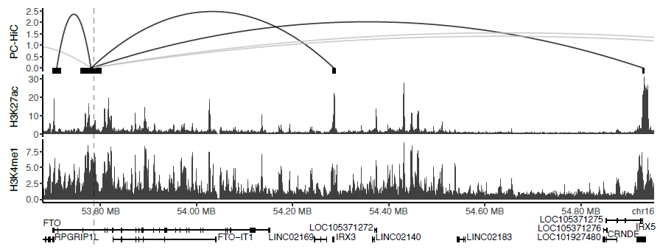

Supplementary Figure 1. Promoter Capture Hi-C (PC-HiC) in the FTO region in myotubes derived from human skeletal muscle cells. Significant PC-HiC interactions are illustrated with arches. The top y axis is the interaction enrichment score. Black bars indicate locations of promoter and enhancer PC-HiC fragments. Cis-regulatory activity was measured by H3K27ac ChIP-Seq. The position of rs9939609 is indicated by the dashed line.

Supplementary Table 1. Definition of register outcomes
Endpoint | ICD-8 | ICD-10
Peripheral Artery Disease | 25006, 4402, 4439 | E105, E115, E125, E135, E145, I702, I739
Hypertension | 400-404, 42600 | I10-I13, I15, I270, I674
Ischemic Heart Disease | 410, 412-414 | I20-I25, T822, Z951
Ischemic Stroke | 433-434, 436 | I63-I64
CVD any event | 0742, 0930, 25006, 2891-2893, 390-391, 3920, 393-396, 3970, 3979, 398, 400-404, 410, 412-414, 420-426, 42700, 42710, 450, 4272, 4275, 42792, 42798, 428, 42999, 430-431, 433-434, 436-438, 440-444, 447-448, 450-454, 456-457, 4580-4581, 4589, 7824 | E105, E115, E125, E135, E145, I00-I01, I020, I029, I05-I13, I15, I20-I28, I30-I52, I60-I74, I77-I83, I85-I89, I95, I97-I99, K550-K551, K559, T822, Z951
Type 2 Diabetes | 250 | E11

Supplementary Table 2. Interaction between FTO rs9939609 and insulin sensitivity and physical activity, respectively, on BMI
 | FTO effect, kg/m² | FTO effect, kg/m² | Effect modification, kg/m² | p
 | Low | High
PA | 0.68 (0.08) | 0.36 (0.05) | -0.32 (0.10) | 0.0013
IS | 0.61 (0.07) | 0.30 (0.05) | -0.31 (0.09) | 0.00028
Effect sizes (standard errors) and effect modifications were calculated with an additive genetic model adjusted for sex, age as a restricted cubic spline with four knots, and cohort. IS, insulin sensitivity; PA, physical activity.

Supplementary Table 3. Joint two-way interaction analyses of the effect of physical activity and insulin sensitivity on the association between FTO rs9939609 and BMI.
 | FTO effect, kg/m² | FTO effect, kg/m² | Effect modification, kg/m² | p
IS\PA | Low | High | PA
Low | 0.73 (0.09) | 0.53 (0.08) | -0.20 (0.09) | 0.023
High | 0.45 (0.08) | 0.25 (0.06) | IS
 |  |  | -0.28 (0.09) | 0.0011
Effect sizes (standard errors) and effect modifications were calculated with an additive genetic model adjusted for sex, age as a restricted cubic spline with four knots, and cohort. IS, insulin sensitivity; PA, physical activity.

Supplementary Table 4. Three-way interaction analysis of the effect of physical activity and insulin sensitivity on the association between FTO rs9939609 and BMI.
 | FTO effect, kg/m² | FTO effect, kg/m² | Effect modification, kg/m² | p
IS\PA | Low | High | PA
Low | 0.60 (0.12) | 0.60 (0.09) | 0.01 (0.15) | 0.964
High | 0.52 (0.10) | 0.22 (0.06) | IS
 |  |  | -0.08 (0.15) | 0.603
 |  |  | PA and IS
 |  |  | -0.30 (0.18) | 0.097
Effect sizes (standard errors) and effect modifications were calculated with an additive genetic model adjusted for sex, age as a restricted cubic spline with four knots, and cohort. The effect modifications for PA and IS, respectively, were estimated comparing the corresponding low-high group with the low-low reference, whereas the PA and IS effect modification was estimated as an addition to these individual effect modifications. IS, insulin sensitivity; PA, physical activity.

Supplementary Table 5. Association between FTO rs9939609 genotype and all-cause mortality and cardiometabolic disease outcomes
 | Basic adjustment |  | Basic + BMI adjustment
Outcome, n (all/events) | HR (95% CI) | p | HR (95% CI) | p_{BMI}
All-Cause Mortality (19,584/1,948) | 1.08 (1.01, 1.15) | 0.019 | 1.08 (1.01, 1.15) | 0.023
Peripheral Artery Disease (19,482/369) | 1.08 (0.93, 1.25) | 0.320 | 1.06 (0.92, 1.23) | 0.413
Hypertension (18,669/2,712) | 1.07 (1.01, 1.13) | 0.019 | 1.03 (0.97, 1.09) | 0.296
Ischemic Heart Disease (18,932/1,278) | 1.04 (0.96, 1.12) | 0.393 | 1.01 (0.94, 1.10) | 0.737
Ischemic Stroke (19,351/781) | 1.11 (1.01, 1.23) | 0.037 | 1.11 (1.00, 1.22) | 0.049
CVD any event (17,084/4,409) | 1.03 (0.99, 1.08) | 0.125 | 1.01 (0.97, 1.06) | 0.620
Type 2 Diabetes (19,282/726) | 1.18 (1.07, 1.31) | 0.0015 | 1.06 (0.96, 1.18) | 0.237
Hazard ratios (HR) with 95% confidence intervals (95% CI) and p-values were estimated with an additive genetic model with basic adjustment for sex, age-at-examination as a restricted cubic spline with four knots, and cohort (p) or additionally adjusting for BMI (as a restricted cubic spline with four knots; p_{BMI}).

Supplementary Table 6. Effect modification of insulin sensitivity and physical activity, respectively, on the association between FTO rs9939609 and all-cause mortality and cardiometabolic disease outcomes
 |  | HR (95% CI) | Effect modification (95% CI) | p
All-Cause Mortality
PA | Low | 1.12 (1.00, 1.26)
 | High | 1.07 (0.99, 1.15) | 0.95 (0.83, 1.10) | 0.504
IS | Low | 1.07 (0.97, 1.17)
 | High | 1.08 (0.99, 1.18) | 1.01 (0.89, 1.15) | 0.849
Hypertension
PA | Low | 1.14 (1.04, 1.26)
 | High | 1.04 (0.97, 1.11) | 0.91 (0.81, 1.02) | 0.111
IS | Low | 1.10 (1.01, 1.19)
 | High | 1.04 (0.96, 1.12) | 0.95 (0.85, 1.06) | 0.335
Ischemic Stroke
PA | Low | 0.91 (0.74, 1.11)
 | High | 1.20 (1.06, 1.34) | 1.32 (1.05, 1.66) | 0.019
IS | Low | 0.94 (0.80, 1.11)
 | High | 1.22 (1.08, 1.39) | 1.30 (1.05, 1.60) | 0.015
Type 2 Diabetes
PA | Low | 1.30 (1.09, 1.55)
 | High | 1.13 (0.99, 1.28) | 0.87 (0.70, 1.08) | 0.194
IS | Low | 1.21 (1.07, 1.36)
 | High | 1.05 (0.84, 1.32) | 0.87 (0.68, 1.12) | 0.283
Hazard ratios (HR) with 95% confidence intervals (95% CI), effect modifications and p-values were estimated with an additive genetic model with basic adjustment for sex, age-at-examination as a restricted cubic spline with four knots, and cohort. IS, insulin sensitivity; PA, physical activity.

Supplementary Table 7. Effect of physical activity and insulin sensitivity on FTO expression in muscle
Group |  | Sample size (n) | FTO expression | β (SE) | p | p_{rs9939609}
PA | Low | 31 | 8.12 (0.03) | -0.02 (0.02) | 0.402 | 0.387
 | High | 109 | 8.12 (0.01)
IS | Low | 46 | 8.11 (0.03) | 0.02 (0.02) | 0.334 | 0.219
 | High | 94 | 8.13 (0.01)
Mean (standard error, SE) of quantile normalized, log₂-transformed FTO expression according to PA or IS group. Differences in expression across PA and IS groups, respectively, were assessed with linear regression adjusting for age, BMI categorized as normal weight, overweight, or obesity, and 15 probabilistic estimations of expression residual factors (p), as well as additionally for the FTO rs9939609 genotype (p_{rs9939609}). IS, insulin sensitivity; PA, physical activity.

