ONLINE-ONLY SUPPLEMENTAL APPENDIX

CONTENTS

Additional Methodology……………………………………………………………………………………1

Figure S1. Study Design……………………………………………………………...…………………….2

Figure S2. Patient Disposition…………..………………………………………………………………….3

RESEARCH DESIGN AND METHODS:
Study design and participants This 28-week, Phase 1, multicenter, randomized, sponsor-, investigator-, and patient-blind, parallel-arm trial assessed the effect of tirzepatide 15 mg, semaglutide 1 mg and placebo on the clamp disposition index (primary endpoint) after 28 weeks of treatment in people with T2D on metformin (Figure S1). Key eligibility criteria included adults aged 20-74 years, inclusive, with T2D (HbA1c 7.0-9.5% if on metformin only or 6.5-9.0% if on metformin in combination with other oral antihyperglycemic medications) and a BMI 25-45 kg/m², inclusive. This trial was conducted in accordance with the International Conference on Harmonisation Guidelines for Good Clinical Practice and the Declaration of Helsinki. This study is registered with ClinicalTrials.gov (NCT03951753).

Randomization Eligible patients were randomized (3:3:2) to once-weekly subcutaneously administered tirzepatide (15 mg), semaglutide (1 mg, the highest approved dose at the time of the conduct of the trial), or placebo on Day 1 after completion of all baseline procedures and prior to dosing. Assignment to treatment arms was determined by a randomisation table, generated by a third-party organization. Access to treatment assignment prior to database lock was restricted to authorized personnel. Dosing was blinded to the sponsor, investigator, and the patient. All study site personnel except staff who prepared, dispensed, and administered study medication were blinded to treatment.

Procedures Total body mass was measured using electronic scales, coinciding with dose escalation of semaglutide or tirzepatide. Fat mass was measured by air displacement plethysmography (BOD POD®). Fat-free body mass was calculated by subtracting fat mass from total body mass. Overall appetite visual analog scale (VAS) score (Aitken RC. Proc R Soc Med 1969;62(10):989-993) was calculated as the average of four individual VAS ratings of hunger (“how hungry to do you feel?”), satiety (“how satisfied do you feel?”), fullness (“how full do you feel?”), and prospective food consumption (“how much do you think you could eat?”) (i.e., satiety + fullness + [100-prospective food consumption] + [100-hunger] / 4) (van Can J, et al. Int J Obes (Lond) 2014;38(6):784-793; Flint A, et al. Int J Obes 2000;24(1):38-48). A higher overall appetite score indicated less appetite and a lower score indicated more appetite. To determine total energy intake, ad libitum food intake was assessed during a 45-min buffet meal at noon by measuring the food intake as the grams of macronutrients (protein, fat, carbohydrate) consumed during that period.

Content of the Buffet
(kcal, protein, fat, carbohydrates expressed per 100 g of food item)
Food Item | Kcal | Protein (g) | Fat (g) | Carbohydrate (g)
Wheat rolls | 247 | 8.2 | 0.8 | 50.3
Multi grain rolls | 279 | 11.0 | 10.1 | 36.8
Croissants | 355 | 7.6 | 21.0 | 32.9
Black Bread | 189 | 6.0 | 1.8 | 33.0
Rye Buns | 246 | 9.6 | 1.3 | 48.0
Brown Bread | 221 | 7.6 | 1.3 | 42.0
Sunflower Bread | 229 | 6.5 | 6.9 | 30.0
Turkey Salami | 246 | 20.0 | 18.0 | 1.0
Turkey Breast, smoked | 115 | 23.0 | 2.0 | 1.0
Farm Ham | 105 | 21.0 | 1.4 | 1.3
Low fat ham | 111 | 22.0 | 4.8 | 1.0
Ham Sausage | 357 | 13.3 | 33.4 | 0.8
Liver Sausage | 245 | 16.5 | 19.6 | 1.1
Fine Liver Sausage | 329 | 13.8 | 30.2 | 0.6
Ham creme | 348 | 13.9 | 32.4 | 0.5
Pork Sausage | 275 | 16.2 | 23.7 | 0.4
Turkey Sausage | 209 | 13.0 | 17.0 | 1.0
Gouda | 340 | 23.0 | 27.5 | 0.0
Cheese, 30% fat | 273 | 30.0 | 17.0 | 0.0
Cheese with herb crust 50% fat | 347 | 21.5 | 28.5 | 1.0
Herb Quark 20% fat | 95 | 10.2 | 4.2 | 4.0
Cream cheese, low fat | 152 | 7.4 | 11.0 | 5.1
Cream cheese, double cream | 255 | 5.4 | 24.5 | 3.2
Jam (4 different flavors) | 257 | 0.3 | 0.1 | 63.0
Yoghurt (Strawberry, Blackberry, Maracuja) | 62 | 3.2 | 1.5 | 8.8
Yoghurt (white) | 61 | 3.3 | 3.5 | 4.0
Butter | 741 | 0.7 | 83.2 | 0.6
Quark, low fat | 71 | 13.2 | 0.3 | 3.2
Margarine, low fat, vegan | 360 | 0.0 | 40.0 | 0.0
Margarine, low fat, original | 530 | 0.0 | 60.0 | 0.0
Banana | 93 | 1.1 | 0.2 | 20.0
Apple | 65 | 0.3 | 0.0 | 14.4
Pear | 58 | 0.5 | 0.3 | 12.4
Cucumber | 14 | 0.6 | 0.2 | 1.8
Tomato | 20 | 0.9 | 0.2 | 2.6
Pepper (red) | 43 | 1.3 | 0.5 | 6.4
Milk, low fat | 48 | 3.4 | 1.6 | 4.8
Cream (for coffee) | 203 | 2.8 | 20.0 | 3.6
Orange Juice | 43 | 0.7 | 0.5 | 9.0
Apple Juice | 43 | 0.1 | 0.1 | 10.3
Blueberry pancake | 151 | 5.0 | 3.0 | 25.0
Tomato with Mozarella | 184 | 8.4 | 4.7 | 27.0
Scrambled Eggs | 154 | 11.0 | 11.2 | 2.3

Statistical analysis The post-hoc sample size calculation for calorie intake during ad libitum lunch assumes a treatment difference of -50 kcal and a SD of 250 kcal for tirzepatide versus semaglutide (effect size of 0.2). Based on a two-sample t test with a two-sided alpha level of 0.05, a sample size of 788 completers (394 per group) is estimated to provide approximately 80% power to show superiority of tirzepatide versus semaglutide. The post-hoc sample size calculation for fasting appetite VAS overall score assumes a treatment difference of 4 and a SD of 23 for tirzepatide versus semaglutide (effect size of 0.174). Based on a two-sample t test with a two-sided alpha level of 0.05, a sample size of 1040 completers (520 per group) is estimated to provide approximately 80% power to show superiority of tirzepatide versus semaglutide.

Figure S1. Study Design
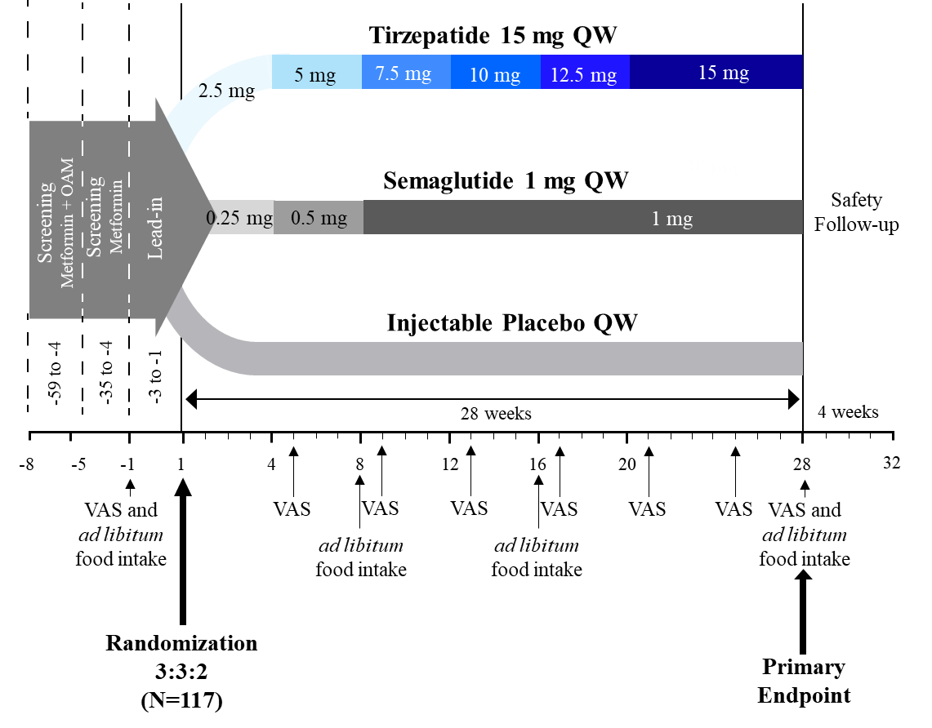
Assessments were done before randomization and at the end of study treatment. Primary endpoint data are published in Heise et al. Lancet Diabetes Endocrinol. 2022;10(6):418-429.

Figure S2. Patient Disposition

