Supplementary Figure S1. School Nurse Survey

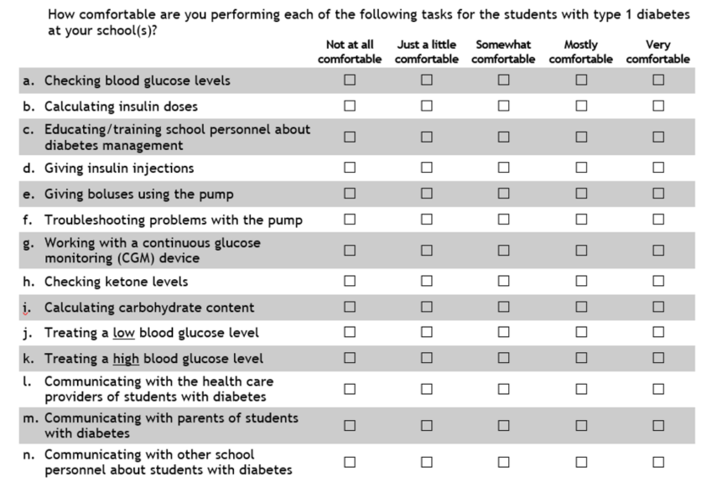

Supplementary Table S1. Educational content of School Nurse Program

Program | Topic | Presenter
General Diabetes Education | Etiology and pathophysiology of type 1 and type 2 diabetes in youth | MD
(2 sessions/year) | Current treatment plans and diabetes management tools for children and adolescents in the school setting | RN/NP
 | The role of food and nutrition in the management of diabetes | RD
 | What is optimal diabetes management and future opportunities | MD/NP/RN
 | Breakout Sessions (each participant selected 3 sessions to attend)
 | Food at school | RD
 | School planning 101 | RN/NP
 | Insulin pumps, meters and other technology | RN/NP
 | Troubleshooting challenging situations | MSW/PhD
 | Two perspectives: Q&A with a clinicians and a parent of a child with diabetes | MD/PhD/Parent
 | Type 2 diabetes and obesity in children | RD/RN/NP
Insulin Pump Education | Introduction to pump therapy | RN/NP
(1 session/year) | Realities of pump therapy in youth | MD
 | Carbohydrate counting and insulin dose calculations with the pump | RD
 | Troubleshooting the pump | RN/NP
 | Other diabetes technology: continuous glucose monitoring (CGM) | RN/NP
 | Pump readiness | MSW/PhD
 | Breakout Sessions (participants attended all sessions)
 | Pump basics | RN/NP
 | Does insulin pump therapy improve clinical outcomes? | RD/RN/NP
 | Advanced insulin pump dosing strategies | RN/NP
 | Managing exercise using an insulin pump | RN/NP

MD: Physician, RN: Nurse, NP: Nurse Practitioner, RD: Registered Dietician, MSW: Social Worker, PhD: Psychologist

