Online-Only Supplemental Material

Supplemental Survey Methods
Survey Instrument Development
The survey was developed using a participatory action research process. The following stakeholders formed the survey design team: three older adults with diabetes, two caregivers, two internal medicine physicians, two geriatricians, one endocrinologist, and one pharmacist. Team members met by video conference in three two-hour meetings to review relevant guidelines, define survey objectives and iteratively refine the content. To refine the survey for clarity, the survey was pilot-tested among three physicians (one general internist, one endocrinologist, and one medicine/pediatrics physician) using cognitive interviewing. All pilot-testers reported good understanding of the survey questions and minimal changes were made. The final survey was six pages and took approximately ten minutes to complete.

Sampling of Physicians
The American Medical Association (AMA) Physician Masterfile is a list of all practicing U.S. physicians maintained by the AMA. From the AMA Physician Masterfile, physicians were first selected on the basis of meeting inclusion criteria of practicing in the outpatient setting and being of one the targeted primary specialties: general medicine (internal medicine, family medicine / general practice, or medicine-pediatrics), geriatrics, or endocrinology. A random sample of the targeted size was then selected from each specialty category. The response rate was calculated as the number of responding physicians (eligible or ineligible) divided by the total number of surveys delivered.

Ascertainment of Physician Characteristics
The AMA Physician Masterfile provided data on physicians’ age, years in practice, and practice location. Physicians self-reported their demographics, primary specialty, and professional and practice characteristics. Self-reported data were used, rather than data from the AMA Masterfile, when both were available. For the 5.3% of respondents who selected multiple specialties, the primary specialty in the AMA Masterfile was used.

Survey Distribution
The survey was mailed on June 7, 2021 in hand-addressed envelopes that included a $10 Amazon gift card, a stamped return envelope, and the option to respond online using a secure Qualtrics form. The first mailing was sent on June 7, 2021, and two follow-up mailings to nonrespondents were sent at approximately 12-week intervals. Subsequently, nonrespondents were then sent three email broadcasts at two- to four-week intervals. Email were provided by the AMA Physician Masterfile and 88% of physicians had emails available.

Phone Calls to Nonrespondents
We placed phone calls to nonrespondents’ offices to ascertain physicians’ eligibility and whether the listed mailing address was accurate. For physicians who were ineligible, we documented reasons for ineligibility. We marked surveys as not able to be delivered if we were able to determine that they were mailed to an incorrect office address. If we were unable to reach the physician’s office, their eligibility status was not changed.

Supplemental Table S1. Multinomial logistic regression models for association between predictors of interest and physicians’ actions in the base case of clinical scenarios

Analysis | Predictors | Multi-level outcome
Association between the clinical scenario (1, 2, or 3) and how physicians modified hypoglycemia-causing medications | Predictor of interest:  - Clinical scenario  Adjusted for:  - Physician specialty | - Increase medication  - Decrease medication  - Stop medication  - Switch medication  - vs. No change (ref)
Association between physicians’ recommended HbA1c target for older adults with good health and how physicians modified glimepiride in scenario 1 (patient with good health) | Predictor of interest:  - Selected HbA1c target for older adults with good health relative to ADA guidelines (below, above, or at guidelines - reference)  Adjusted for:  - Physician specialty | - Decrease or stop medication  - Switch medication  - vs. No change or increase (ref)
Association between physicians’ recommended HbA1c target for older adults with complex health and how physicians modified insulin glargine in scenario 2 (patient with complex health) | Predictor of interest:  - Selected HbA1c target for older adults with complex health relative to ADA guidelines (below, above, or at guidelines - reference)  Adjusted for:  - Physician specialty | - Decrease or stop medication  - Switch medication  - vs. No change or increase (ref)
Association between physicians’ recommended HbA1c target for older adults with poor health and how physicians modified glipizide in scenario 3 (patient with poor health) | Predictor of interest:  - Selected HbA1c target for older adults with poor health relative to ADA guidelines (below, above, or at guidelines - reference)  Adjusted for:  - Physician specialty | - Decrease or stop medication  - Switch medication  - vs. No change or increase (ref)
Abbreviations: ADA, American Diabetes Association

Supplemental Figure S1. Flow diagram of survey responses

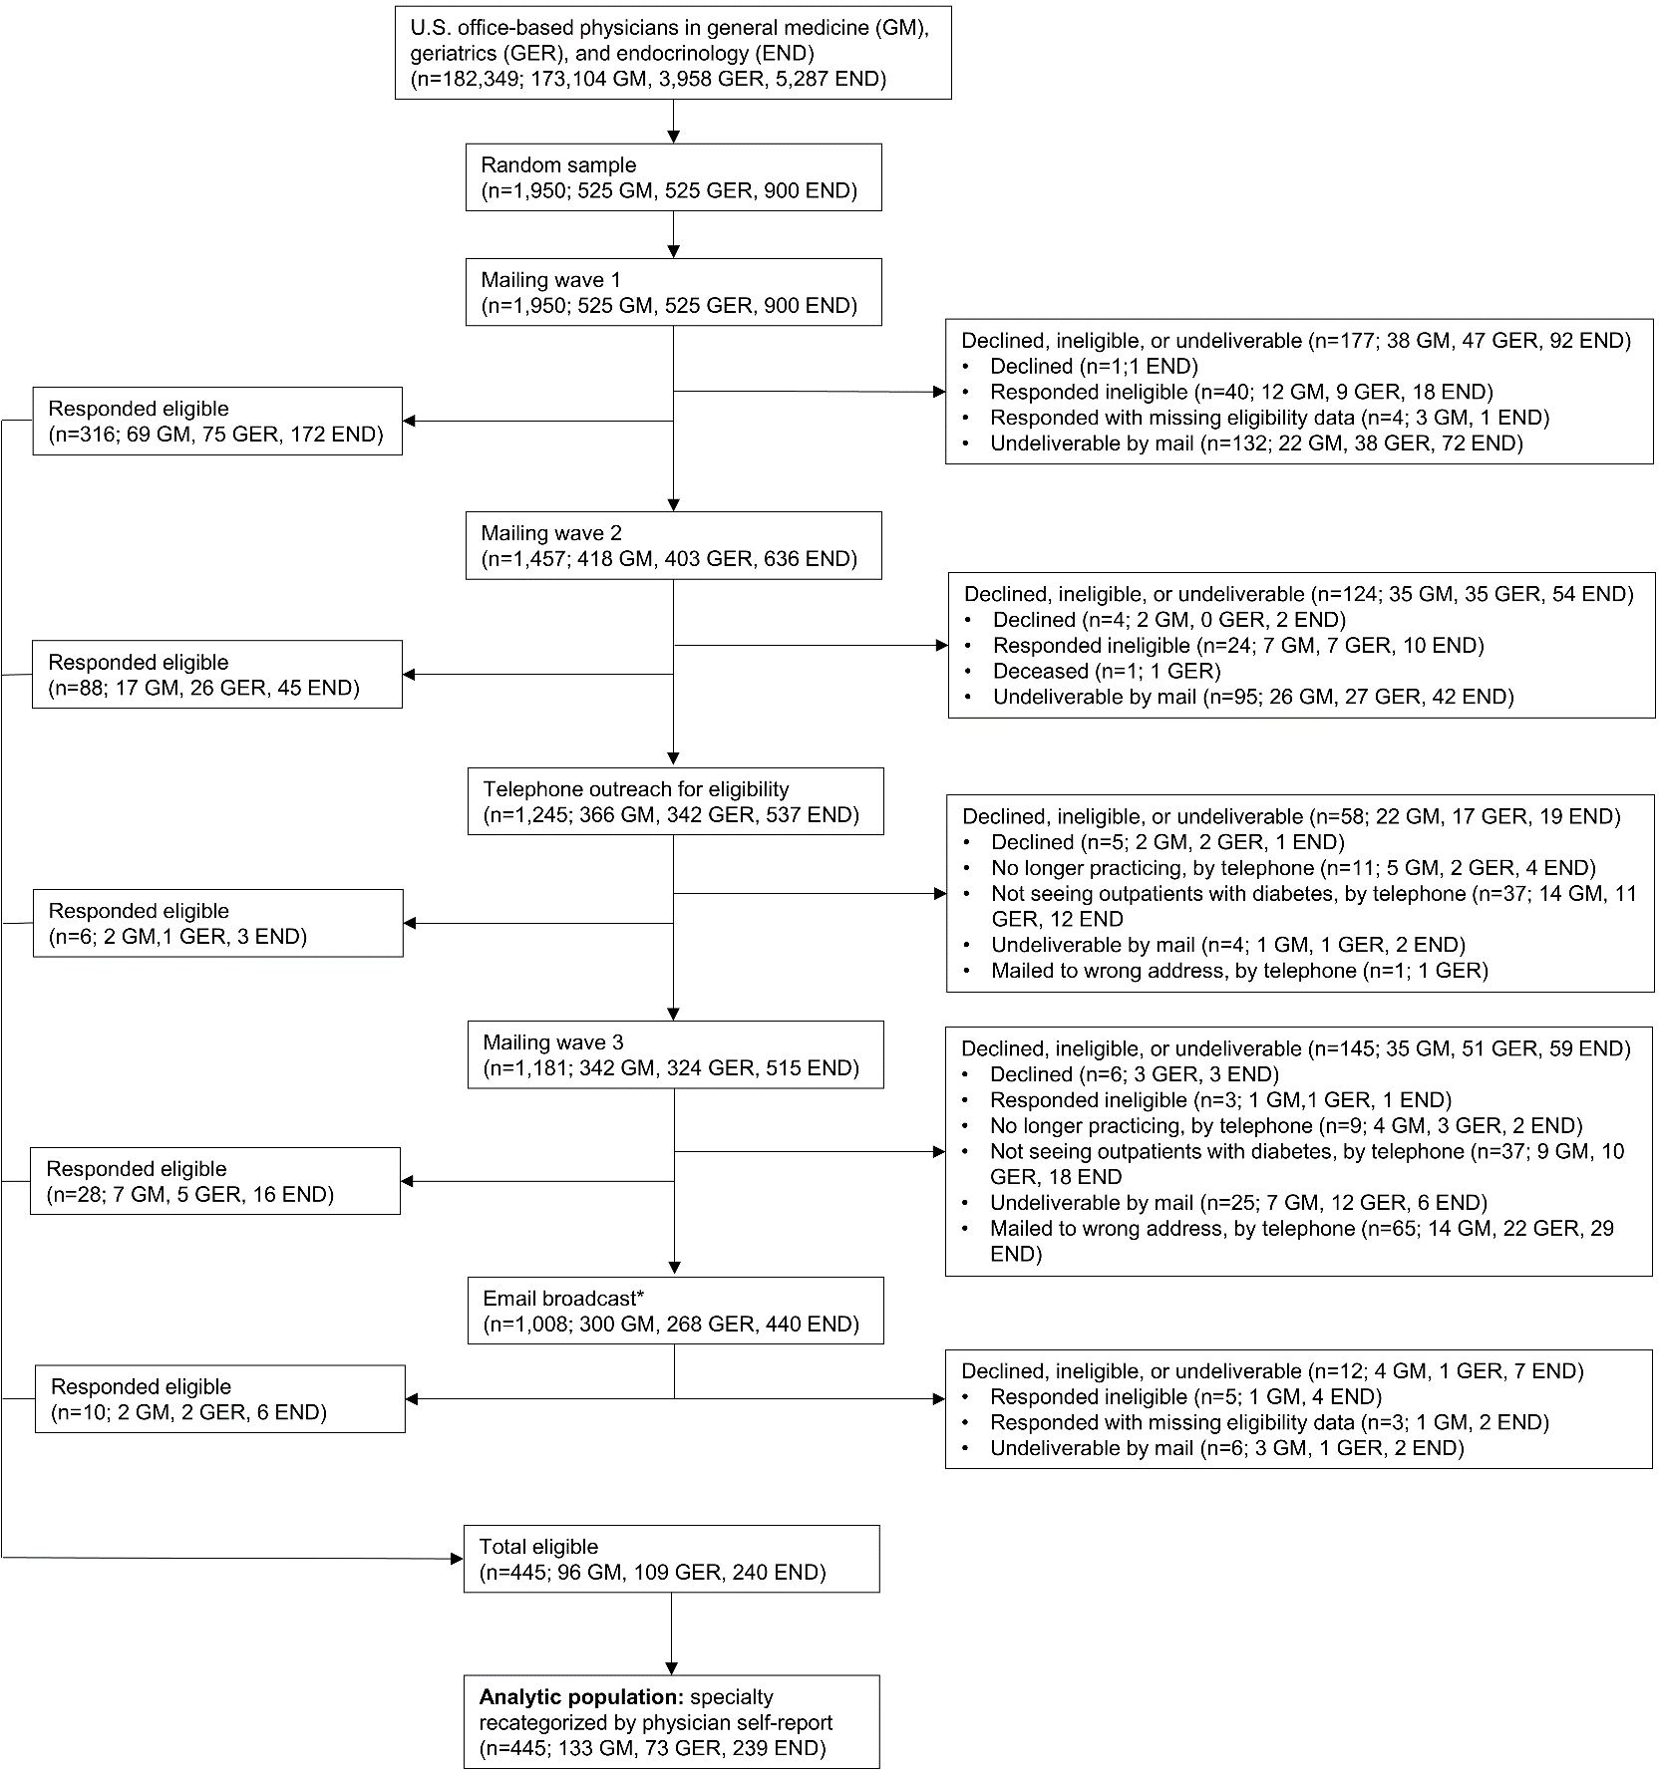

Abbreviations: GM, general medicine; GER, geriatrics; END, endocrinology.
* Email broadcast was sent to the 87% of nonrespondents with available email adresses after mailing wave 3.

Supplemental Table S2. Reasons for ineligibility among ineligible physicians (N=163)
Reason for ineligibility | N (%)
Not providing outpatient care to older adults with diabetes | 110 (67.5)
Retired or no longer practicing | 21 (12.9)
Not practicing independently (trainee or fellow) | 21 (12.9)
Primary specialty not general medicine, geriatrics or endocrinology | 10 (6.1)
Deceased | 1 (0.6)

Supplemental Table S3. Comparison of characteristics from the AMA Masterfile between respondents and non-respondents who received the survey
Characteristic | Respondents (eligible and ineligible) N=608 | Non-respondents  N=1,015 | p-value*
Age, years, mean (SD) | 53.2 (12.0) | 52.9 (11.8) | 0.64
Gender |  |  | 0.37
Female | 292 (48.0) | 511 (50.3)
Male | 316 (52.0) | 504 (49.7)
Years since residency graduation, mean (SD) | 26.1 (12.3) | 25.8 (11.7) | 0.77
Metropolitan statistical area category |  |  | 0.43
A: ≥ 1,000,000 | 415 (74.8) | 748 (77.9)
B: 999,999 - 250,000 | 92 (16.6) | 134 (14.0)
C: 249,000 - 100,000 | 45 (8.1) | 70 (7.3)
D: < 100,000 | 3 (0.5) | 8 (0.8)
Primary specialty category |  |  | 0.013
General medicine | 149 (24.5) | 304 (30.0)
Geriatrics | 152 (25.0) | 271 (26.7)
Endocrinology | 307 (50.5) | 440 (43.4)

Data are n (% of column).
* P-value compares characteristics by Chi-squared test or Wilcoxon rank sum test.

Supplemental Table S4. Characteristics of included physicians by primary specialty
Characteristic | General medicine  (N=133) | Geriatrics  (N=73) | Endocrinology (N=239) | p-value*
Age, years, mean (SD)† | 53.3 (11.5) | 50.9 (10.7) | 51.3 (12.5) | 0.19
Gender |  |  |  | 0.36
Female | 59 (44.4) | 41 (56.2) | 127 (53.1)
Male | 73 (54.9) | 31 (42.5) | 111 (46.4)
Other gender | 1 (0.8) | 1 (1.4) | 1 (0.4)
Race |  |  |  | 0.45
American Indian or Alaskan Native | 0 | 0 | 1 (0.4)
Asian | 31 (23.3) | 22 (30.1) | 54 (22.6)
Black or African American | 9 (6.8) | 2 (2.7) | 9 (3.8)
Native Hawaiian or other Pacific Islander | 0 | 1 (1.4) | 0
White | 86 (64.7) | 45 (61.6) | 159 (66.5)
Other race or multiple | 3 (2.3) | 0 | 6 (2.5)
No response | 4 (3.0) | 3 (4.1) | 10 (4.2)
Ethnicity |  |  |  | 0.76
Hispanic or Latino | 6 (4.5) | 5 (6.9) | 16 (6.7)
Not Hispanic or Latino | 124 (93.2) | 65 (89.0) | 213 (89.1)
No response | 3 (2.3) | 3 (4.1) | 10 (4.2)
Years in practice, mean (SD) † | 22.2 (12.3) | 18.9 (11.9) | 21.0 (12.2) | 0.11
Hours per week in direct clinical care |  |  |  | 0.25
<20 | 21 (15.6) | 18 (24.7) | 33 (13.8)
20-29 | 22 (16.5) | 17 (23.3) | 49 (20.5)
30-39 | 49 (36.8) | 23 (31.5) | 76 (31.8)
40+ | 39 (29.3) | 13 (17.8) | 75 (31.4)
No response | 2 (1.5) | 2 (2.7) | 6 (2.5)
Type of practice |  |  |  | 0.001
Private solo or group practice | 49 (36.8) | 16 (21.9) | 103 (43.1)
Hospital affiliated outpatient practice | 60 (45.1) | 34 (46.6) | 113 (47.3)
Health maintenance organization | 8 (6.0) | 8 (11.0) | 3 (1.3)
Community health center | 8 (6.0) | 4 (5.5) | 3 (1.3)
Non-federal government clinic | 1 (0.8) | 3 (4.1) | 4 (1.7)
Federal government clinic | 5 (3.8) | 5 (6.9) | 6 (2.5)
No response | 2 (1.5) | 3 (4.1) | 7 (2.9)
Practice location |  |  |  | <0.001
Urban | 45 (33.8) | 33 (45.2) | 105 (43.9)
Suburban | 57 (42.9) | 27 (37.0) | 115 (48.1)
Rural | 27 (20.3) | 9 (12.3) | 11 (4.6)
No response | 4 (3.0) | 4 (5.5) | 8 (3.4)
Percent of patients with insurance type, mean (SD)†
Private | 36.7 (22.6) | 17.9 (19.6) | 44.9 (17.8) | 0.001
Medicare | 38.3 (21.9) | 57.1 (27.3) | 38.1 (14.0) | 0.001
Medicaid, Medicare/Medicaid, or other state program | 18.3 (19.7) | 21.4 (23.0) | 13.5 (15.7) | 0.027
Uninsured or self-pay | 6.7 (14.5) | 3.6 (6.7) | 3.5 (6.0) | 0.004
Data are n (% of column) or mean (SD) where indicated.
* P-value compares characteristic across specialties by Chi-squared test or Kruskal Wallis test.
† There were 7.4% missing data for insurance type, and no missing data for age and years in practice.

Supplemental Table S5. Physicians’ action in the base case of clinical scenarios, by primary specialty

Scenario and action taken | General Medicine  (n=133) | Geriatrics  (n=73) | Endocrinology (n=239) | p-value*
Scenario 1 – good health, HbA1c 6.3% |  |  |  | 0.001
No change | 57 (42.9) | 29 (39.7) | 94 (39.3)
Increase | 1 (0.8) | 1 (1.4) | 0
Decrease | 39 (29.3) | 22 (30.1) | 55 (23.0)
Stop | 31 (23.3) | 19 (26.0) | 47 (19.7)
Switch | 5 (3.8) | 2 (2.7) | 43 (18.0)
Scenario 2 – complex health, HbA1c 7.3% |  |  |  | <0.001
No change | 95 (72.5) | 56 (77.8) | 153 (64.6)
Increase | 19 (14.5) | 4 (5.6) | 6 (2.5)
Decrease | 3 (2.3) | 6 (8.3) | 9 (3.8)
Stop | 0 | 0 | 0
Switch | 14 (10.7) | 6 (8.3) | 69 (29.1)
Scenario 3 – poor health, HbA1c 7.7% |  |  |  | <0.001
No change | 79 (61.2) | 42 (58.3) | 135 (57.7)
Increase | 6 (4.7) | 0 | 3 (1.3)
Decrease | 14 (10.9) | 7 (9.7) | 11 (4.7)
Stop | 12 (9.3) | 19 (26.4) | 23 (9.8)
Switch | 18 (14.0) | 4 (5.6) | 62 (26.6)
Data are n (% of column).
* P-value compares action taken across specialties by Chi-squared test

Supplemental Figure S2. Effect of a significant decline in the patient’s health on physicians’ modifications to sulfonylureas or insulin in three clinical scenarios

This stacked bar chart shows the percent of physicians deintensifying (decreasing or stopping), switching, or making no change or increasing the medication. Scenario 1 was a healthy patient with HbA1c 6.3% taking glimepiride. Scenario 2 was a patient with complex health and HbA1c 7.3% taking insulin glargine. Scenario 3 was a patient with poor health and HbA1c 7.7% taking glipizide. Shown is the base case of each scenario in which the patient reported no recent hypoglycemia or medication concerns, followed by variations in which the patient suffered a significant decline in health, which was different for each scenario.

Supplemental Table S6. Percent of physicians decreasing, stopping, or switching hypoglycemia-causing medications in clinical scenario variations (all scenarios combined), overall and by primary specialty
Scenario variation and action taken | Overall | General Medicine | Geriatrics | Endocrinology | p-value*
Mild hypoglycemia |  |  |  |  | <0.001
No change | 0.5 | 1.3 | 0 | 0.1
Increase | 0.1 | 0.3 | 0 | 0
Decrease | 33.9 | 34.5 | 38.7 | 32.3
Stop | 40.4 | 42.2 | 53.5 | 35.4
Switch | 25.1 | 21.7 | 7.8 | 32.3
Severe hypoglycemia |  |  |  |  | <0.001
No change | 1.4 | 2.0 | 2.3 | 0.7
Increase | 0.2 | 0.5 | 0 | 0
Decrease | 24.7 | 28.8 | 25.0 | 22.4
Stop | 46.4 | 45.3 | 62.5 | 42.0
Switch | 27.4 | 23.4 | 10.2 | 34.9
Hypoglycemia emergency department visit |  |  |  |  | <0.001
No change | 0.5 | 0.8 | 0 | 0.4
Increase | 0.1 | 0.3 | 0 | 0
Decrease | 19.1 | 22.5 | 21.2 | 16.7
Stop | 50.3 | 50.5 | 66.4 | 45.2
Switch | 30.1 | 26.0 | 12.4 | 37.7
Significant decline in health |  |  |  |  | <0.001
No change | 16.5 | 24.2 | 12.4 | 13.4
Increase | 0.6 | 1.8 | 0 | 0.1
Decrease | 21.4 | 14.5 | 23.0 | 24.8
Stop | 51.9 | 53.2 | 61.8 | 48.2
Switch | 9.6 | 6.4 | 2.8 | 13.4
Aged 90 years (vs. late 70’s) |  |  |  |  | <0.001
No change | 24.4 | 31.0 | 18.5 | 22.5
Increase | 0.4 | 1.3 | 0 | 0
Decrease | 19.6 | 16.3 | 25.0 | 19.7
Stop | 42.7 | 44.3 | 49.1 | 39.8
Switch | 13.0 | 7.1 | 7.4 | 18.0
Polypharmacy (10+ drugs) |  |  |  |  | <0.001
No change | 31.4 | 35.0 | 22.1 | 32.4
Increase | 0.8 | 2.3 | 0.5 | 0.1
Decrease | 13.0 | 10.7 | 18.4 | 12.7
Stop | 41.5 | 43.9 | 51.2 | 37.3
Switch | 13.2 | 8.2 | 7.8 | 17.6
Patient desires less medication |  |  |  |  | <0.001
No change | 34.8 | 40.9 | 28.5 | 33.3
Increase | 2.1 | 3.6 | 1.9 | 1.3
Decrease | 22.0 | 19.4 | 26.2 | 22.2
Stop | 27.2 | 29.4 | 37.9 | 22.2
Switch | 14.0 | 6.7 | 5.6 | 20.5
Patient desires tight glycemic control |  |  |  |  | <0.001
No change | 40.6 | 43.9 | 53.7 | 34.8
Increase | 11.7 | 18.5 | 12.0 | 7.9
Decrease | 8.1 | 8.0 | 11.1 | 7.2
Stop | 5.2 | 5.4 | 9.3 | 3.8
Switch | 34.4 | 24.4 | 13.9 | 46.2
Drug cost precludes switching |  |  |  |  | <0.001
No change | 51.0 | 55.6 | 41.5 | 51.4
Increase | 1.6 | 3.1 | 0 | 1.3
Decrease | 18.4 | 12.5 | 19.8 | 21.3
Stop | 28.9 | 28.8 | 38.7 | 25.8
Data are % of column.
* P-value compares action taken across specialties by Chi-squared test
Supplemental Table S7. Physicians’ recommended HbA1c target for patients with good, complex, and poor health, overall and by primary specialty

Recommended HbA1c target | Overall  (n=445) | General Medicine  (n=133) | Geriatrics  (n=73) | Endocrinology (n=239) | p-value*
Patients with good health |  |  |  |  | 0.023
<6.5% | 74 (17.0) | 25 (19.1) | 10 (14.3) | 39 (16.6)
<7.0% | 260 (59.6) | 81 (61.8) | 32 (45.7) | 147 (62.6)
<7.5% | 77 (17.7) | 17 (13.0) | 20 (28.6) | 40 (17.0)
<8.0% | 24 (5.5) | 7 (5.3) | 8 (11.3) | 9 (3.8)
<8.5% | 1 (0.2) | 1 (0.8) | 0 | 0
<9.0% | 0 | 0 | 0 | 0
No specific target | 0 | 0 | 0 | 0
Patients with complex health |  |  |  |  | 0.027
<6.5% | 2 (0.5) | 1 (0.8) | 0 | 1 (0.4)
<7.0% | 57 (13.0) | 23 (17.7) | 6 (8.3) | 28 (11.9)
<7.5% | 146 (33.3) | 44 (33.9) | 14 (19.4) | 88 (37.3)
<8.0% | 194 (44.3) | 50 (38.5) | 41 (56.9) | 103 (43.6)
<8.5% | 27 (6.2) | 7 (5.4) | 9 (12.5) | 11 (4.7)
<9.0% | 10 (2.3) | 5 (3.9) | 2 (2.8) | 3 (1.3)
No specific target | 2 (0.5) | 0 | 0 | 2 (0.9)
Patients with poor health |  |  |  |  | <0.001
<6.5% | 4 (0.9) | 3 (2.3) | 0 | 1 (0.4)
<7.0% | 13 (3.0) | 8 (6.2) | 1 (1.4) | 4 (1.7)
<7.5% | 34 (7.8) | 9 (6.9) | 5 (6.9) | 20 (8.5)
<8.0% | 161 (36.8) | 51 (39.2) | 15 (20.8) | 95 (40.4)
<8.5% | 95 (21.7) | 16 (12.3) | 17 (23.6) | 62 (26.4)
<9.0% | 63 (14.4) | 21 (16.2) | 17 (23.6) | 25 (10.6)
No specific target | 67 (15.3) | 22 (16.9) | 17 (23.6) | 28 (11.9)
Data are n (% of column)
* P-value compares HbA1c target category across specialties by Chi-squared test

Supplemental Table S8. Association between physicians’ selected HbA1c targets and decreasing or stopping hypoglycemia-causing medications in clinical scenarios

 | Physicians’ actions in scenario 1 – healthy patient, HbA1c 6.3%
HbA1c target for older adults with good health | Proportion of physicians decreasing or stopping | RRR (95% CI) for decreasing or stopping | p-value
Below guidelines | 22.9% | 0.29 (0.16-0.53) | <0.001
At guidelines (<7.0-7.5%) | 52.1% | (reference)
Above guidelines | 55.3% | 1.77 (0.66-4.72)
 | Physicians’ actions in scenario 2 – complex health, HbA1c 7.3%
HbA1c target for older adults with complex health | Proportion of physicians decreasing or stopping | RRR (95% CI) for decreasing or stopping | p-value
Below guidelines | 1.6% | 0.23 (0.06-0.82) | 0.06
At guidelines (<8.0%) | 6.9% | (reference)
Above guidelines | 2.3% | 0.39 (0.05-3.09)
 | Physicians’ actions in scenario 3 – poor health, HbA1c 7.7%
HbA1c target for older adults with poor health | Proportion of physicians decreasing or stopping | RRR (95% CI) for decreasing or stopping | p-value
Below guidelines | 9.0% | 0.25 (0.14-0.47) | <0.001
At guidelines (<8.5% or no target) | 27.1% | (reference)
Above guidelines | 35.6% | 1.34 (0.70-2.56)
Data shown are results of multinomial logistic regression models adjusted for physician specialty, comparing physicians’ selected HbA1c target relative to American Diabetes Association guidelines (predictor) with actions in clinical scenario of a patient with the same health status. Actions in clinical scenarios is a multi-level outcome: decreasing/stopping vs. switching vs. no change or increasing (reference outcome). Adjusted relative risk ratios (RRR) and adjusted proportions, obtained using predictive margins, are derived from the same model.

Supplemental Table S9. Association between physicians’ selected HbA1c targets and the frequency of switching hypoglycemia-causing medications in clinical scenarios

 | Physicians’ actions in scenario 1 – healthy patient, HbA1c 6.3%
HbA1c target for older adults with good health | Proportion of physicians switching | RRR (95% CI) for switching | p-value
Below guidelines | 19.1% | 1.56 (0.73-3.30) | 0.08
At guidelines (<7.0-7.5%) | 9.0% | (reference)
Above guidelines | 21.7% | 4.38 (1.07-17.86)
 | Physicians’ actions in scenario 2 – complex health, HbA1c 7.3%
HbA1c target for older adults with complex health | Proportion of physicians switching | RRR (95% CI) for switching | p-value
Below guidelines | 21.7% | 1.37 (0.81-2.31) | 0.10
At guidelines (<8.0%) | 16.2% | (reference)
Above guidelines | 32.0% | 2.46 (1.06-5.71)
 | Physicians’ actions in scenario 3 – poor health, HbA1c 7.7%
HbA1c target for older adults with poor health | Proportion of physicians switching | RRR (95% CI) for switching | p-value
Below guidelines | 21.4% | 0.87 (0.51-1.48) | 0.50
At guidelines (<8.5% or no target) | 19.5% | (reference)
Above guidelines | 11.1% | 0.56 (0.21-1.48)
Data shown are results of multinomial logistic regression models adjusted for physician specialty, comparing physicians’ selected HbA1c target relative to American Diabetes Association (ADA) guidelines (predictor) with actions in clinical scenario of a patient with the same health status. Actions in clinical scenarios is a multi-level outcome: decreasing/stopping vs. switching vs. no change or increasing (reference outcome). Adjusted relative risk ratios (RRR) and adjusted proportions, obtained using predictive margins, are derived from the same models.

