Electronic supplementary material

Methods

Assessment of T1D Genetic Risk score

We extracted DNA from all participants whole blood EDTA samples, and performed genotyping using illumine GSA2 genome wide genotyping array with 1,697,069 genotyped variants, including 748,291 with minor allele frequency <0.01 as previously described(1; 2). Genotyping was performed at Erasmus on an Ilumina Global screening array version 2 with preliminary quality control checks performed at Exeter University. The HLA haplotype score (HLA DR haplotype from tag variants) was added to the score of the remaining variants each multiplied by the natural log of the odds ratio and finally divided by the number of alleles. T1DGRS calculation was not performed if genotyping results were missing for either of the two alleles with the greatest weighting (DR3/DR4-DQ8 or HLA-DRB1-15) or if more than two of any other SNPs were missing(1).

ESM table 1: Baseline clinical characteristics of the entire StartRight study split by median age of diagnosis of those positive for ≥2 islet autoantibodies. Results shown are percentage for binary outcomes and mean for continuous data (95% CI). * Severe insulin deficiency defined as C-peptide <200pmol/l.
 | Diabetes diagnosed <=35, n=470 | Diabetes diagnosed >35, n=1,323 | p
Baseline characteristics
Age at diagnosis | 27.5 (27.0-28.0) | 51.7 (51.1-52.3) | <0.0001
Duration (months) | 4.4 (4.0-4.7) | 5.1 (4.9-5.3) | 0.0001
BMI kg/m² | 27.2 (26.5-27.8) | 30.6 (30.2-31.0) | <0.0001
Gender (male) | 54% (50-59) | 60% (57-62) | 0.03
White European | 87% (84-90) | 86% (84-88) | 0.8
Symptoms at presentation
Unintentional weight loss | 66% (61-70) | 43% (40-46) | <0.0001
Diabetic Ketoacidosis | 16% (12-19) | 7% (6-9) | <0.0001
Osmotic symptoms | 89% (87-92) | 75% (72-77) | <0.0001
Biochemistry at presentation
HbA1c at diagnosis mmol/mol | 98.1 (95.4-100.9) | 85.8 (84.1-87.5) | <0.0001
HbA1c at diagnosis % | 11.1 (10.8-11.4) | 10.0 (9.8-10.2) | <0.0001
Glucose at diagnosis mmol/l | 19.2 (18.3-20.1) | 18.4 (17.6-19.1) | 0.2
Management at presentation
Hospitalised at admission | 47% (42-51) | 27% (24-29) | <0.0001
Initial insulin | 76% (72-79) | 37% (35-40) | <0.0001
Initial tablets (+/- insulin) (%) | 25% (21-29) | 46% (43-48) | <0.0001
Recruitment characteristics
Geometric C-peptide pmol/l | 643.7 (591.1-701.1) | 1138.0 (1076.1-1203.4) | <0.0001
Geometric UCPCR (nmol/mmol) | 1.3 (1.2-1.4) | 1.9 (1.7-2.0) | <0.0001
Insulin deficiency at baseline* | 6% (4-9) | 4% (3-5) | 0.02
Reported type 1 at recruitment | 73% (69-77) | 31% (28-33) | <0.0001
Reported type 2 at recruitment | 19% (16-23) | 61% (58-64) | <0.0001
Insulin treatment at recruitment | 79% (75-83) | 40% (37-43) | <0.0001
Type 1 diabetes genetic risk score | 12.4 (12.2-12.6) | 10.9 (10.7-11.0) | <0.0001
On Insulin at two years follow up | 83% (79-86) | 43% (40-46) | <0.0001
Recruitment Autoantibody profile
Single antibody positive | 64% (60-68) | 29% (26-31) | <0.0001
Multi-Antibody positive | 41% (36-45) | 15% (13-16) | <0.0001
GADA | 57% (53-61) | 24% (22-26) | <0.0001
IA2A | 33% (29-38) | 13% (11-14) | <0.0001
ZNt8A | 36% (32-40) | 15% (13-17) | <0.0001
ESM table 2: Baseline clinical characteristics of the StartRight study split by those diagnosed as type 1 diabetes by study definitions (Multi-autoantibody positive or clinician diagnosed combined with a single positive islet autoantibody) and type 2 diabetes (Clinician diagnosed, initial treatment without insulin, and autoantibody negative). Results shown are percentage for binary outcomes and mean for continuous data (95% CI). * Severe insulin deficiency defined as C-peptide <200pmol/l

 | Type 1 Diabetes  n=565 | Type 2 Diabetes  n=715 | p
Baseline characteristics
Age at diagnosis | 38.6 (37.4-39.8) | 50.5 (49.6-51.4) | <0.0001
Duration (months) | 4.6 (4.3-4.9) | 5.6 (5.3-5.8) | <0.0001
BMI kg/m² | 25.0 (24.7-25.4) | 33.4 (32.9-34.0) | <0.0001
Gender (male) | 52% (47-56) | 57% (53-61) | 0.06
White European ethnicity | 91% (88-93) | 86% (83-88) | 0.01
Symptoms at presentation
Unintentional weight loss | 83% (80-86) | 16% (13-18) | <0.0001
Diabetic Ketoacidosis | 20% (17-23) | 0% (0-0) | <0.0001
Osmotic symptoms | 94% (92-96) | 62% (58-65) | <0.0001
Biochemistry at presentation
HbA1c at diagnosis mmol/mol | 104.3 (102.0-106.6) | 69.3 (67.5-71.1) | <0.0001
HbA1c at diagnosis % | 11.7 (11.5-11.9) | 8.5 (8.3-8.7) | <0.0001
Glucose at diagnosis mmol/l | 20.9 (20.1-21.8) | 12.1 (11.3-12.8) | <0.0001
Management at presentation
Hospitalised at admission | 51% (47-55) | 6% (4-7) | <0.0001
Initial insulin | 88% (86-91) | 0% (0-0) | <0.0001
Initial tablets (+/- insulin) (%) | 17% (14-20) | 62% (58-66) | <0.0001
Recruitment characteristics
Geometric C-peptide pmol/l | 429.0 (394.7-463.2) | 1786.1 (1699.5-1872.7) | <0.0001
Geometric UCPCR (nmol/mmol) | 1.0 (0.9-1.1) | 2.6 (2.4-2.8) | <0.0001
Insulin deficiency at baseline* | 11% (8-13) | 0% (0-1) | <0.0001
Reported type 1 at recruitment | 94% (92-96) | 0% (0-0) | <0.0001
Reported type 2 at recruitment | 3% (1-4) | 100% (100-100) | <0.0001
Insulin treatment at recruitment | 95% (94-97) | 1% (0-2) | <0.0001
Type 1 diabetes genetic risk score | 13.1 (12.9-13.2) | 10.1 (9.9-10.3) | <0.0001

ESM table 3: HLA and islet autoantibody distribution by age of diagnosis is those classified as having type 1 diabetes (either multi-autoantibody positive or clinician diagnosed combined with a single positive islet autoantibody). Results shown are percentage for binary outcomes (95% CI).
 | ≤35 Years (n=275) | >35 Years  (n=290) | p
≥1 copy of DR3-DQ2 | 49% (40-57) | 49% (40-57) | 0.99
≥1 copy of DR4-DQ8 | 47% (38-55) | 39% (30-48) | 0.08
HLA Breakdown
DR15-DQ6 | 2% (0-14) | 3% (0-14) | 0.8
DR3-DQ2/DR4-DQ8 | 18% (7-29) | 14% (2-25) | 0.2
DR4-DQ8/DR4-DQ8 | 6% (0-18) | 5% (0-17) | 0.8
DR3-DQ2/DR3-DQ2 | 9% (0-20) | 13% (2-24) | 0.09
DR4-DQ8/X | 23% (12-33) | 20% (9-31) | 0.4
DR3-DQ2/X | 22% (11-32) | 21% (10-31) | 0.8
X/X | 21% (10-31) | 24% (14-35) | 0.3
Islet Autoantibodies
GADA | 91% (88-95) | 90% (87-94) | 0.6
IA-2A | 54% (48-60) | 57% (51-63) | 0.5
ZNT8 | 60% (54-65) | 60% (54-65) | 0.99

ESM table 4: In adult-onset type 1 diabetes defined by multi-autoantibody positivity impact of BMI evaluated continuously using: linear regression for continuous variables, logistic regression for binary variables and using mixed effect models for annual change in Log C-peptide. (95% CI).

Continuous | β coefficient | P value
Age at diagnosis | 0.2 (-0.1, 0.5) | 0.3
HbA1c at diagnosis mmol/mol | -0.3 (-0.9, 0.3) | 0.3
Glucose at diagnosis mmol/l | 0.0 (-0.2, 0.3) | 0.8
Baseline geometric C-peptide pmol/l | 33 (21, 46) | <0.0001
Annual rate of decline of log UCPCR (nmol/mmol) | 0.00 (-0.01, 0.01) | 0.8
T1DGRS | -0.01 (-0.05, 0.04) | 0.8
Binary | Odds ratio | P value
Unintentional weight loss | 0.94 (0.89-0.99) | 0.02
Diabetic Ketoacidosis | 1.02 (0.97, 1.08) | 0.4
Osmotic symptoms | 1.08 (0.97, 1.20) | 0.2

ESM figure 1: Study flow chart

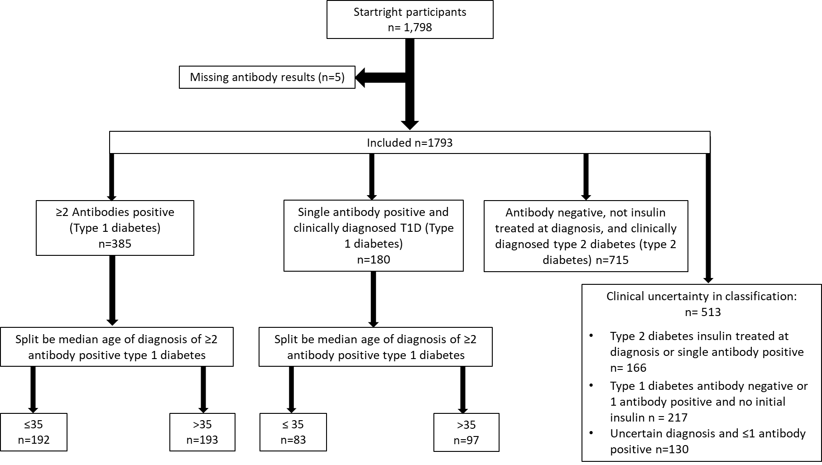

ESM figure 2: The percentage annual Loss of C-peptide measured by UCPCR by decile of age of diagnosis for those classified as having type 1 diabetes (either multi autoantibody positivity or clinician diagnosis confirmed by a single positive autoantibody). Error bars are 95% confidence intervals.

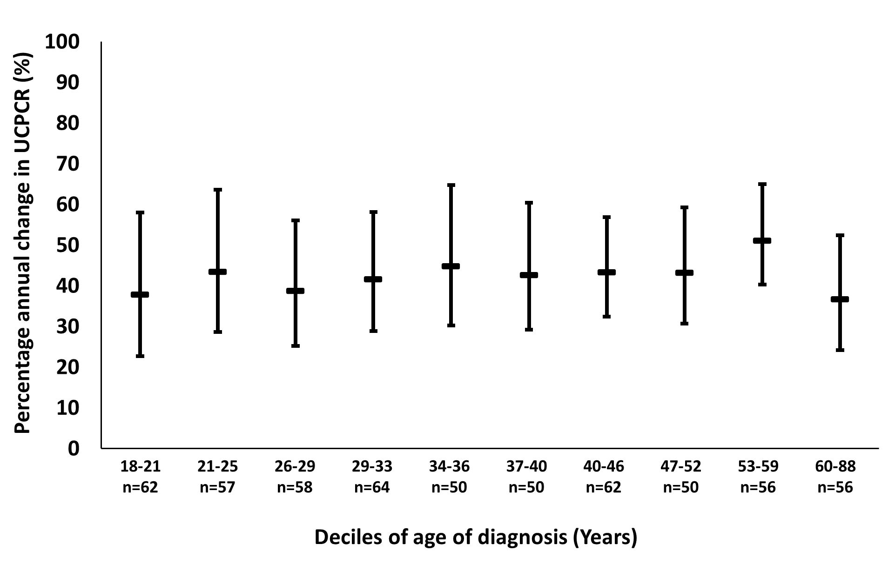
ESM figure 3: Loss of C-peptide measured by UCPCR (on log scale) in multi-antibody positivity participants split by insulin treatment received within 2 weeks of diagnosis. Error bars are 95% confidence intervals
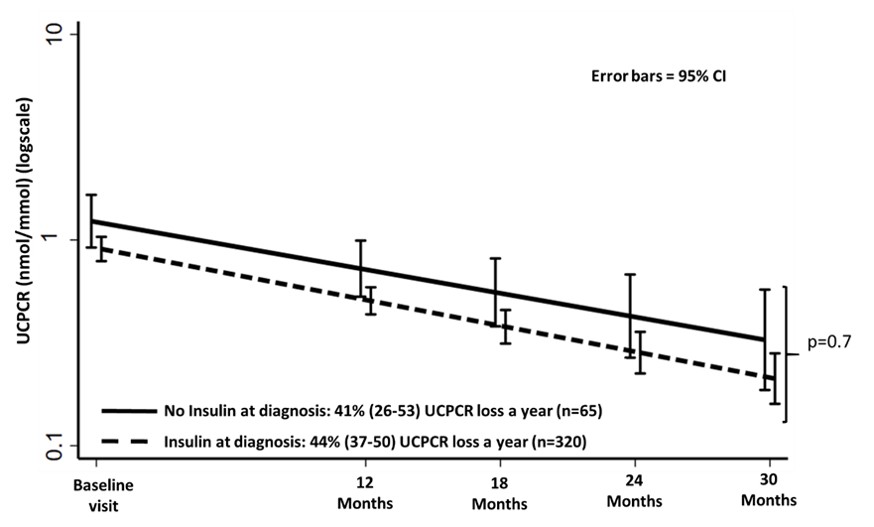

ESM figure 4: Type 1 diabetes genetic risk score (T1DGRS) in multi-antibody positivity participants split by insulin treatment received within 2 weeks of diagnosis. Mean and 95% confidence intervals shown.

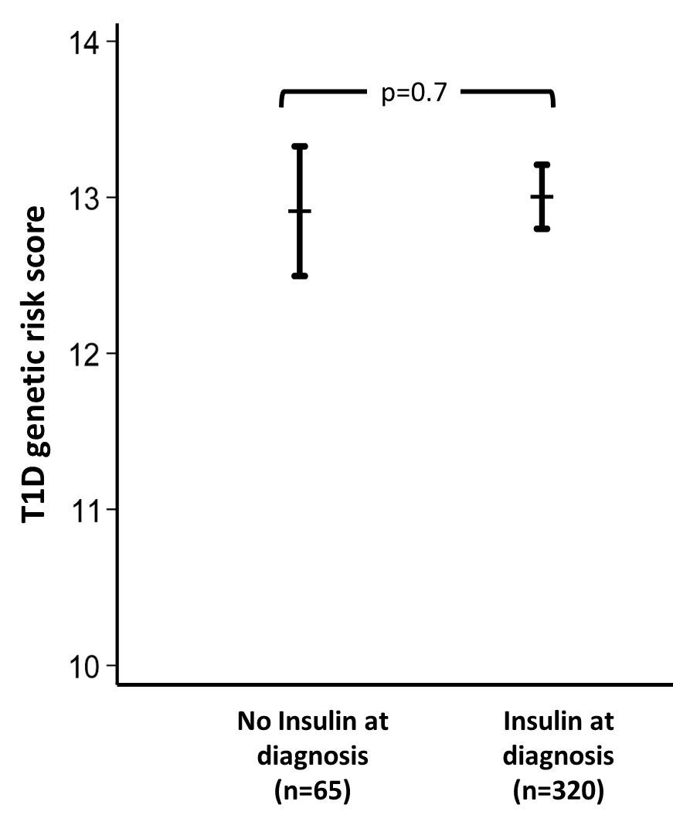

ESM figure 5: Loss of C-peptide measured by UCPCR (on log scale) in those with a clinical diagnosis of type 1 diabetes split by number of positive autoantibodies: ≥2 positive autoantibodies vs 1 positive autoantibody. Error bars are 95% confidence intervals
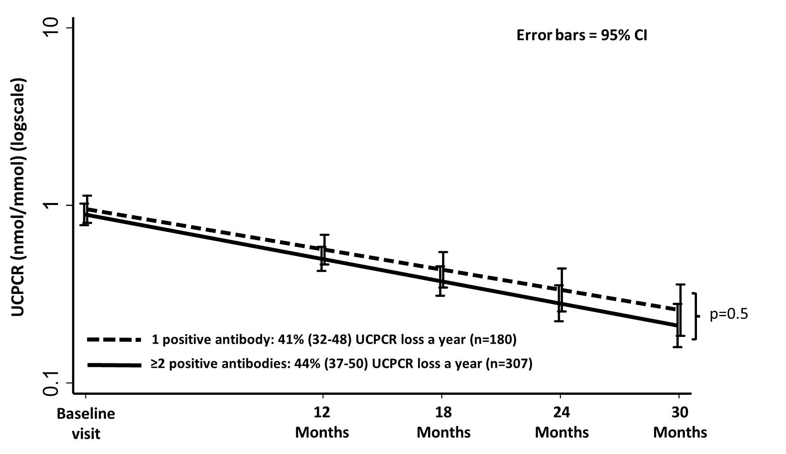

1. Oram RA, Sharp SA, Pihoker C, Ferrat L, Imperatore G, Williams A, Redondo MJ, Wagenknecht L, Dolan LM, Lawrence JM, Weedon MN, D'Agostino R, Hagopian WA, Divers J, Dabelea D. Utility of Diabetes Type-Specific Genetic Risk Scores for the Classification of Diabetes Type Among Multiethnic Youth. Diabetes Care 2022;45:1124-1131
2. Sharp SA, Rich SS, Wood AR, Jones SE, Beaumont RN, Harrison JW, Schneider DA, Locke JM, Tyrrell J, Weedon MN, Hagopian WA, Oram RA. Development and Standardization of an Improved Type 1 Diabetes Genetic Risk Score for Use in Newborn Screening and Incident Diagnosis. Diabetes Care 2019;42:200-207

