SUPPLEMENTARY APPENDIX

CONTENTS
Table S1—Baseline demographics and clinical characteristics (STEP 1) 2
Table S2—Baseline demographics and clinical characteristics (STEP 3) 3
Figure S1—UACR by week (STEP 2) 4
Figure S2—Urine albumin by week (STEP 2) 5
Figure S3—Mediation analysis of HbA_{1c}, body weight, and systolic blood pressure; semaglutide 2.4 mg dose (STEP 2) 6
Figure S4—Mediation analysis of HbA_{1c}, body weight, and systolic blood pressure; semaglutide 1.0 mg dose (STEP 2) 7
Figure S5—eGFR over time STEP 1–3 (using the CKD-EPI 2009 equation) 8
Figure S6—eGFR over time STEP 2 only (including semaglutide 1.0 mg; using the CKD-EPI 2009 equation) 9
Figure S7—eGFR over time (using the race-free CKD-EPI 2021 equation) 10
Supplementary references 11

Table S1—Baseline demographics and clinical characteristics (STEP 1)
 | Semaglutide 2.4 mg  n = 1,306 | Placebo  n = 655
Age, years | 46 (13) | 47 (12)
Sex, n (%)
Male | 351 (26.9) | 157 (24.0)
Female | 955 (73.1) | 498 (76.0)
Race, n (%)
White | 973 (74.5) | 499 (76.2)
Asian | 181 (13.9) | 80 (12.2)
Black or African American | 72 (5.5) | 39 (6.0)
Not Applicable | 38 (2.9) | 17 (2.6)
Other | 25 (1.9) | 8 (1.2)
American Indian or Alaskan Native | 17 (1.3) | 10 (1.5)
Native Hawaiian or Other Pacific Islander | 0 | 2 (0.3)
HbA_{1c}, mmol/mol | 38.9 (3.4) | 39.0 (3.6)
HbA_{1c}, % | 5.7 (0.3) | 5.7 (0.3)
Body weight, kg | 105.4 (22.1) | 105.2 (21.5)
BMI, kg/m² | 37.8 (6.7) | 38.0 (6.5)
eGFR, CKD-EPI, mL/min/1.73 m²
Mean (SD) | 97.9 (16.9) | 97.4 (16.7)
Distribution, n (%)*
≥90 | 887 (67.9) | 445 (67.9)
<90 | 419 (32.1) | 210 (32.1)
Blood pressure, mmHg*
Systolic blood pressure | 126 (14) | 127 (14)
Diastolic blood pressure | 80 (10) | 80 (10)
History of CVD, n (%) | 125 (9.6) | 68 (10.4)
SGLT2 inhibitor use, n (%) | 0 | 1 (0.2)
Agents acting on the renin-angiotensin system, n (%) | 311 (23.8) | 152 (23.2)
N = number of patients. Data are n (%) or mean ± SD, unless otherwise indicated. Data are for the full analysis set unless otherwise stated.
*Data are for the safety analysis set.
CKD-EPI, Chronic Kidney Disease Epidemiology Collaboration; CVD, cardiovascular disease; eGFR, estimated glomerular filtration rate; HbA_{1c}, glycated hemoglobin; SD, standard deviation; SGLT2, sodium glucose co-transporter 2.
Novo Nordisk data published in Wilding JPH, Batterham RL, Calanna S, et al. Once-weekly semaglutide in adults with overweight or obesity. N Engl J Med 2021;384:989.

Table S2—Baseline demographics and clinical characteristics (STEP 3)
 | Semaglutide 2.4 mg  n = 407 | Placebo  n = 204
Age, years | 46 (13) | 46 (13)
Sex, n (%)
Male | 92 (22.6) | 24 (11.8)
Female | 315 (77.4) | 180 (88.2)
Race, n (%)
White | 307 (75.4) | 158 (77.5)
Black or African American | 80 (19.7) | 36 (17.6)
Other | 11 (2.7) | 4 (2.0)
Asian | 5 (1.2) | 6 (2.9)
Native Hawaiian or Other Pacific Islander | 3 (0.7) | 0
American Indian or Alaskan Native | 1 (0.2) | 0
Not Applicable | 0 | 0
HbA_{1c}, mmol/mol | 39.3 (3.7) | 39.5 (3.7)
HbA_{1c}, % | 5.7 (0.3) | 5.8 (0.3)
Body weight, kg | 106.9 (22.8) | 103.7 (22.9)
BMI, kg/m² | 38.1 (6.7) | 37.8 (6.9)
eGFR, CKD-EPI, mL/min/1.73 m²
Mean (SD) | 98.6 (19.3) | 98.5 (19.3)
Distribution, n (%)*
≥90 | 280 (68.8) | 133 (65.2)
<90 | 127 (31.2) | 71 (34.8)
Blood pressure, mmHg*
Systolic blood pressure | 124 (15) | 124 (15)
Diastolic blood pressure | 80 (10) | 81 (10)
History of CVD, n (%) | 40 (9.8) | 23 (11.3)
SGLT2 inhibitor use, n (%) | 0 | 0
Agents acting on the renin-angiotensin system, n (%) | 95 (23.3) | 34 (16.7)
N = number of patients. Data are n (%) or mean ± SD, unless otherwise indicated. Data are for the full analysis set unless otherwise stated.
*Data are for the safety analysis set.
CKD-EPI, Chronic Kidney Disease Epidemiology Collaboration; CVD, cardiovascular disease; eGFR, estimated glomerular filtration rate; HbA_{1c}, glycated hemoglobin; SD, standard deviation; SGLT2, sodium glucose co-transporter 2.
Novo Nordisk data published in Wadden TA, Bailey TS, Billings LK, et al. Effect of subcutaneous semaglutide versus placebo as an adjunct to intensive behavioral therapy on body weight in adults with overweight or obesity: the STEP 3 randomized clinical trial. JAMA 2021;325:1403-141

Figure S1—UACR by week (STEP 2)
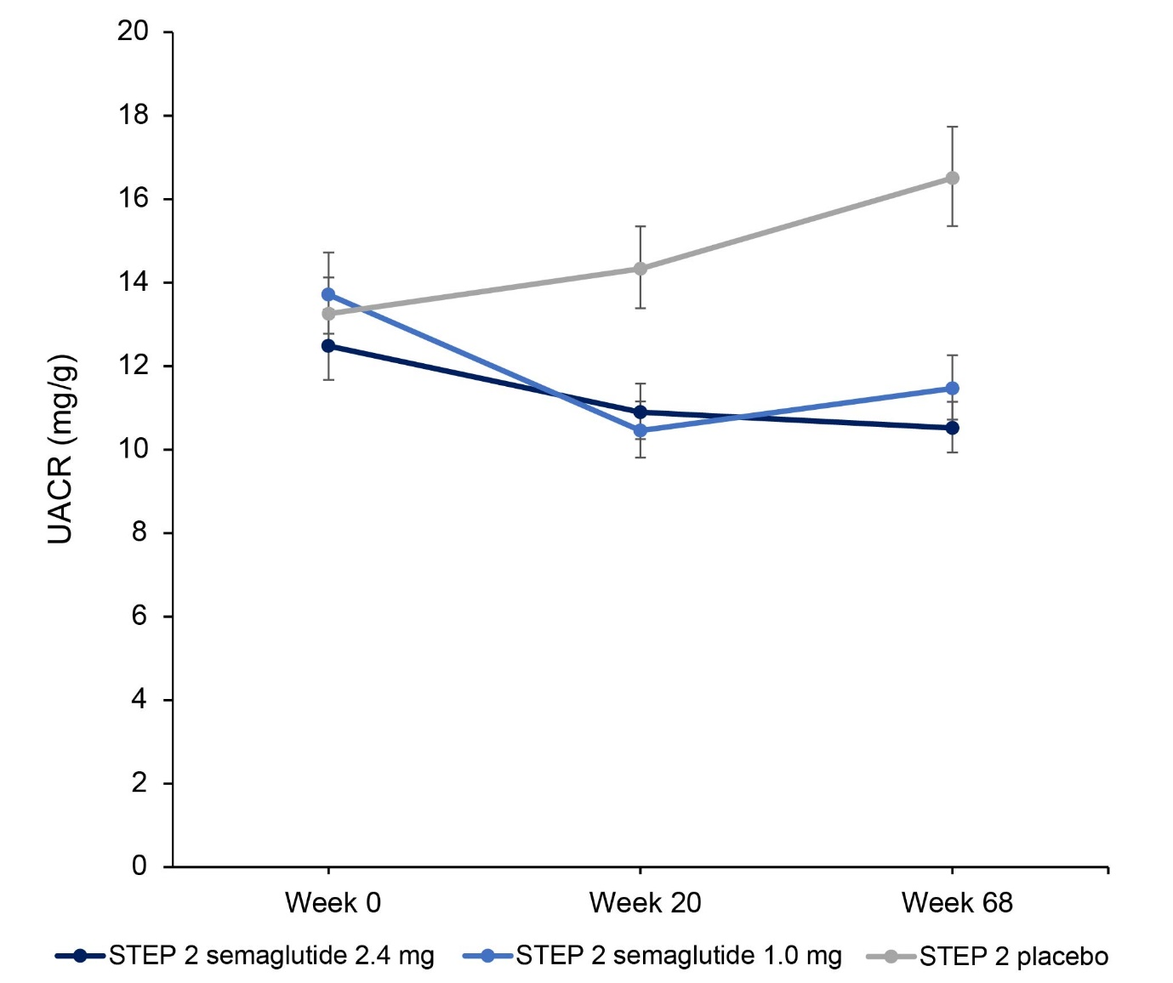
Observed data for the full analysis set from the on-treatment observation period (the time from the first dose of trial product to 14 days after the last dose of trial product, excluding any temporary interruptions in taking trial product). Data are geometric mean (CV) .
CV, coefficient of variation; UACR, urine albumin-to-creatinine ratio.

Figure S2—Urine albumin by week (STEP 2)
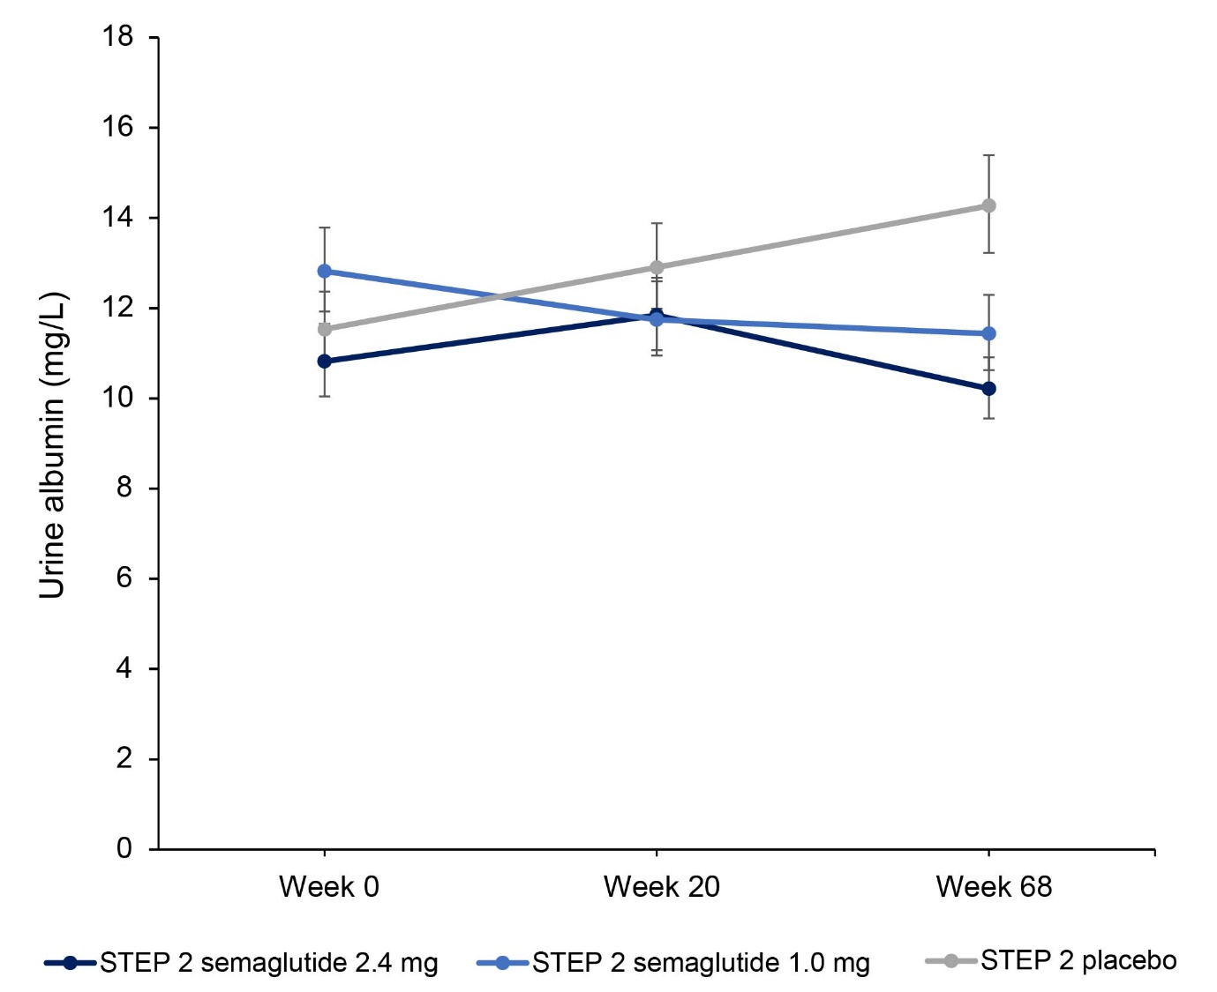
Observed data for the full analysis set from the on-treatment observation period (the time from the first dose of trial product to 14 days after the last dose of trial product, excluding any temporary interruptions in taking trial product). Data are geometric mean (CV).
CV, coefficient of variation.

Figure S3—Mediation analysis of HbA_{1c}, body weight, and systolic blood pressure; semaglutide 2.4 mg dose (STEP 2)
Estimated data for the full analysis set for the trial product estimand, which assessed the effect of treatment assuming participants continued taking randomized treatment for the planned study duration without rescue intervention. The analyses were based on data from the on-treatment observation period (the time from the first dose of trial product to 14 days after the last dose of trial product, excluding any temporary interruptions in taking trial product). A natural effects model was fitted using an imputation-based procedure (1), allowing for decomposition of the treatment effect estimates into natural direct and indirect effect estimates. The percent mediated was then calculated as the natural indirect effect divided by the total treatment effect, and the confidence interval obtained using Fieller’s method (2). Only data for the semaglutide 2.4 mg group are presented.
BP, blood pressure; CI, confidence interval; ETD, estimated treatment difference; HbA_{1c}, glycated hemoglobin.

Figure S4—Mediation analysis of HbA_{1c}, body weight, and systolic blood pressure; semaglutide 1.0 mg dose (STEP 2)
Estimated data for the full analysis set for the trial product estimand, which assessed the effect of treatment assuming participants continued taking randomized treatment for the planned study duration without rescue intervention. The analyses were based on data from the on-treatment observation period (the time from the first dose of trial product to 14 days after the last dose of trial product, excluding any temporary interruptions in taking trial product). A natural effects model was fitted using an imputation-based procedure (1), allowing for decomposition of the treatment effect estimates into natural direct and indirect effect estimates. The percent mediated was then calculated as the natural indirect effect divided by the total treatment effect, and the confidence interval obtained using Fieller’s method (2). Only data for the semaglutide 1.0 mg group are presented.
BP, blood pressure; CI, confidence interval; ETD, estimated treatment difference; HbA_{1c}, glycated hemoglobin.

Figure S5—eGFR over time STEP 1–3 (using the CKD-EPI 2009 equation)
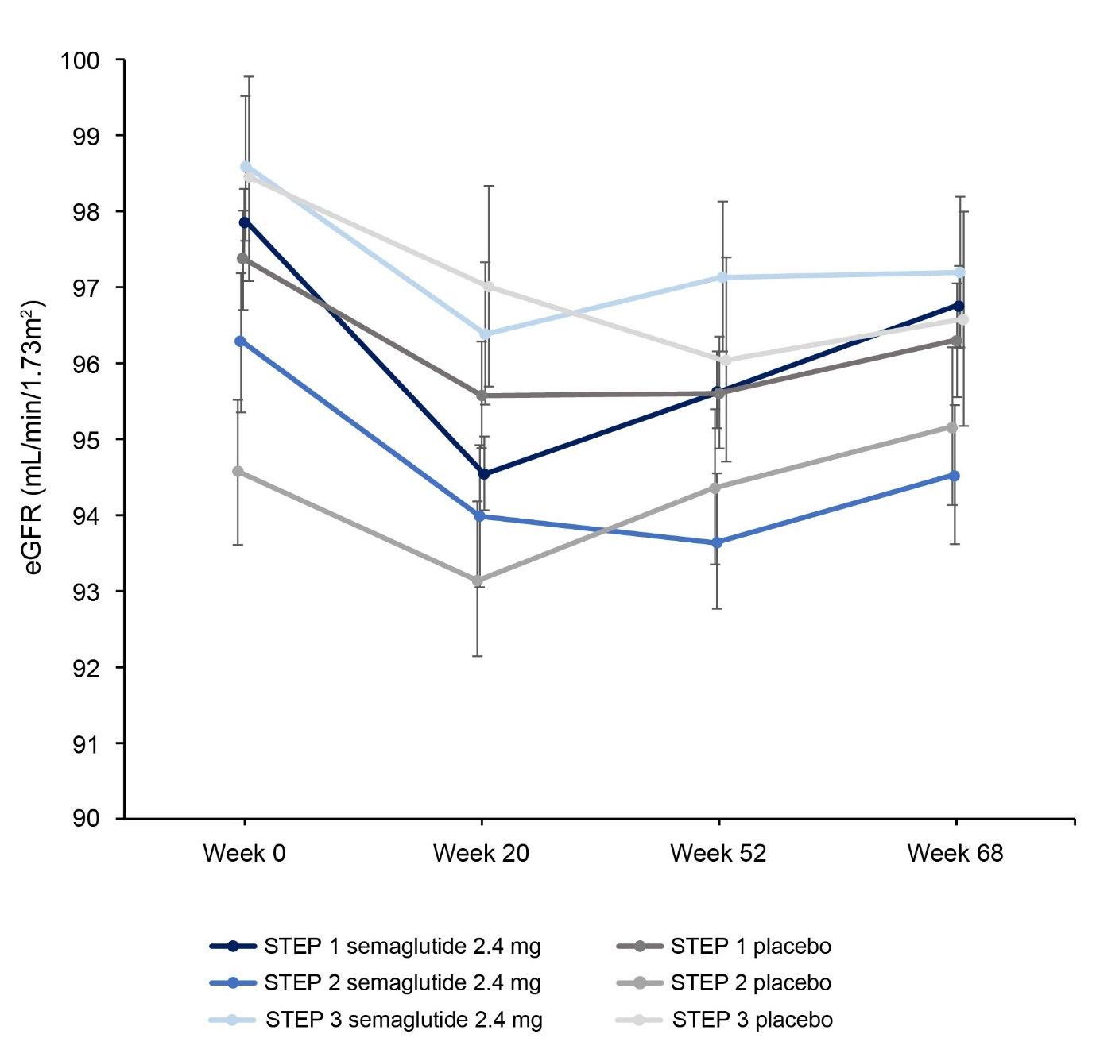
Observed data for the full analysis set from the on-treatment observation period (the time from the first dose of trial product to 14 days after the last dose of trial product, excluding any temporary interruptions in taking trial product). Data are arithmetic means ± standard error of the mean (SEM).
CKD-EPI, Chronic Kidney Disease Epidemiology Collaboration; eGFR, estimated glomerular filtration rate.

Figure S6—eGFR over time STEP 2 only (including semaglutide 1.0 mg; using the CKD-EPI 2009 equation)
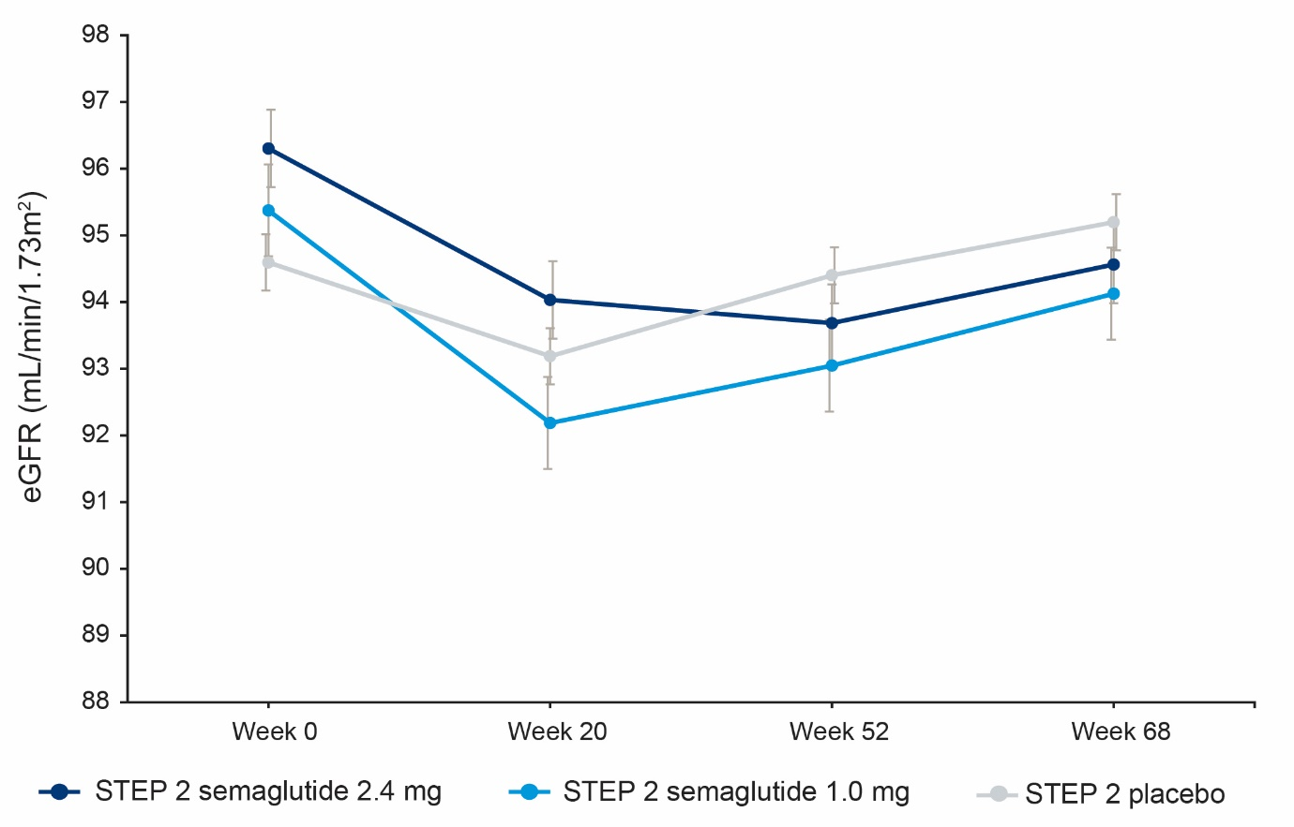

Observed data for the full analysis set from the on-treatment observation period (the time from the first dose of trial product to 14 days after the last dose of trial product, excluding any temporary interruptions in taking trial product). Data are arithmetic means ± standard error of the mean (SEM).
CKD-EPI, Chronic Kidney Disease Epidemiology Collaboration; eGFR, estimated glomerular filtration rate.

Figure S7—eGFR over time (using the race-free CKD-EPI 2021 equation)

Observed data for the full analysis set from the on-treatment observation period (the time from the first dose of trial product to 14 days after the last dose of trial product, excluding any temporary interruptions in taking trial product). Data are mean ± standard error of the mean (SEM).
CKD-EPI, Chronic Kidney Disease Epidemiology Collaboration; eGFR, estimated glomerular filtration rate.

Supplementary references
1. Vansteelandt S, Bekaert M, Lange T. Imputation strategies for the estimation of natural direct and indirect effects. Epidemiol Methods 2012;1:131-158
2. Fieller EC. The biological standardization of insulin. Supplement to the Journal of the Royal Statistical Society 1940;7:1-64

