Supplementary Table S1. Prevalence of obesity and diabetes at the Milwaukee VA
 | n | %
Milwaukee VA enrolled Veterans | 45,887 | 100
Veterans with BMI ≥ 30 | 21,400 | 47
Veterans with diagnosis of diabetes | 11,023 | 24
Veterans with diabetes and an A1c ≥ 8 % | 2,814 | 26
Veterans with diabetes and BMI ≥30 kg/m² | 6,572 | 60
Veterans with diabetes and BMI ≥ 30 kg/m² and A1c ≥8 % | 1,850 | 17
Data collected on September 1st 2021
Supplementary Table S2. Move! Program outcomes at the Milwaukee VA
 | All Patients  (n= 875) | Patients with A1c ≥ 8% (n= 270)
Average Weight loss change % | -1.64 | -1.59
Mean initial A1c | 5.95 | 9.21
Mean end A1c | 6.24 | 8.70
Mean A1c change (point %) | + 0.29 | -0.51
Data was compiled from 09/01/2017 until 09/01/2021

Supplementary Table S3. Results of the 10 pilot participants
Patient | Baseline Weight  (lbs) | Last weight  (lbs) | Weight loss (lbs) | % body weight change | Baseline A1c (%) | Last A1c (%) | Point A1c change % | Baseline daily Insulin doses | Last daily Insulin doses | % total daily insulin change | Month duration
1 | 327 | 283.9 | -43.1 | -13.18 | 8.1 | 7 | -1.1 | 170.0 | 40 | -76.47 | 12
2 | 340 | 313 | -27 | -7.94 | 8 | 7.7 | -0.3 | 150.0 | 112 | -25.33 | 6
3 | 260 | 222.4 | -37.6 | -14.46 | 7.2 | 6.8 | -0.4 | 171.0 | 71.4 | -58.25 | 12
4 | 295 | 276.2 | -18.8 | -6.37 | 10 | 7.9 | -2.1 | 330.0 | 200 | -39.39 | 9
5 | 289 | 256.1 | -32.6 | -11.29 | 7.3 | 6.2 | -1.1 | 110.0 | 88 | -20.00 | 12
6 | 238 | 226 | -12 | -5.04 | 9.4 | 7.2 | -2.2 | 160.0 | 37 | -76.88 | 8
7 | 223 | 182 | -41 | -18.39 | 8.4 | 6.9 | -1.5 | 80.0 | 20 | -75.00 | 11
8 | 202 | 179 | -23 | -11.39 | 8.2 | 6.9 | -1.3 | 48.0 | 0 | -100.00 | 10
9 | 170 | 162.9 | -7.1 | -4.18 | 9.5 | 8.5 | -1 | 328.0 | 120 | -63.41 | 9
10 | 245 | 227 | -18 | -7.35 | 8.7 | 7.4 | -1.3 | 66.0 | 61 | -7.58 | 8
Mean | 258.87 | 232.85 | -26.02 | -9.96 | 8.5 | 7.3 | -1.2 | 161.3 | 74.9 | -54.2 | 9.9
Insulin doses are shown as units per day
Supplementary Figure S1. Flowchart diagram of the pilot process. After patient enrolment, visits with each of the clinicians took place separately but individual patient progress or barriers were discussed in weekly virtual huddles.

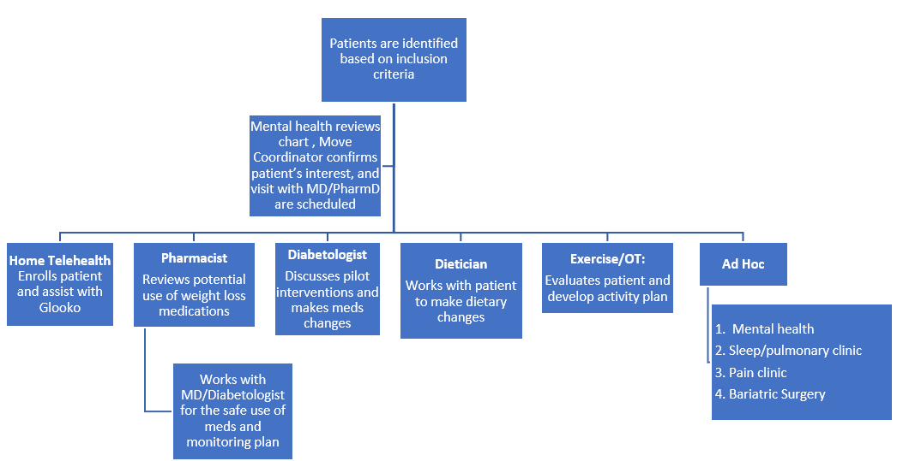

Supplementary Figure S2. Changes over time of A1c (A), Weight (B), and total daily insulin doses (C) per subject. Averages changes are summarized at the 3, 6, and 9 month mark for each graph.
