SUPPLEMENTAL MATERIAL

SUPPLEMENTARY FIGURES
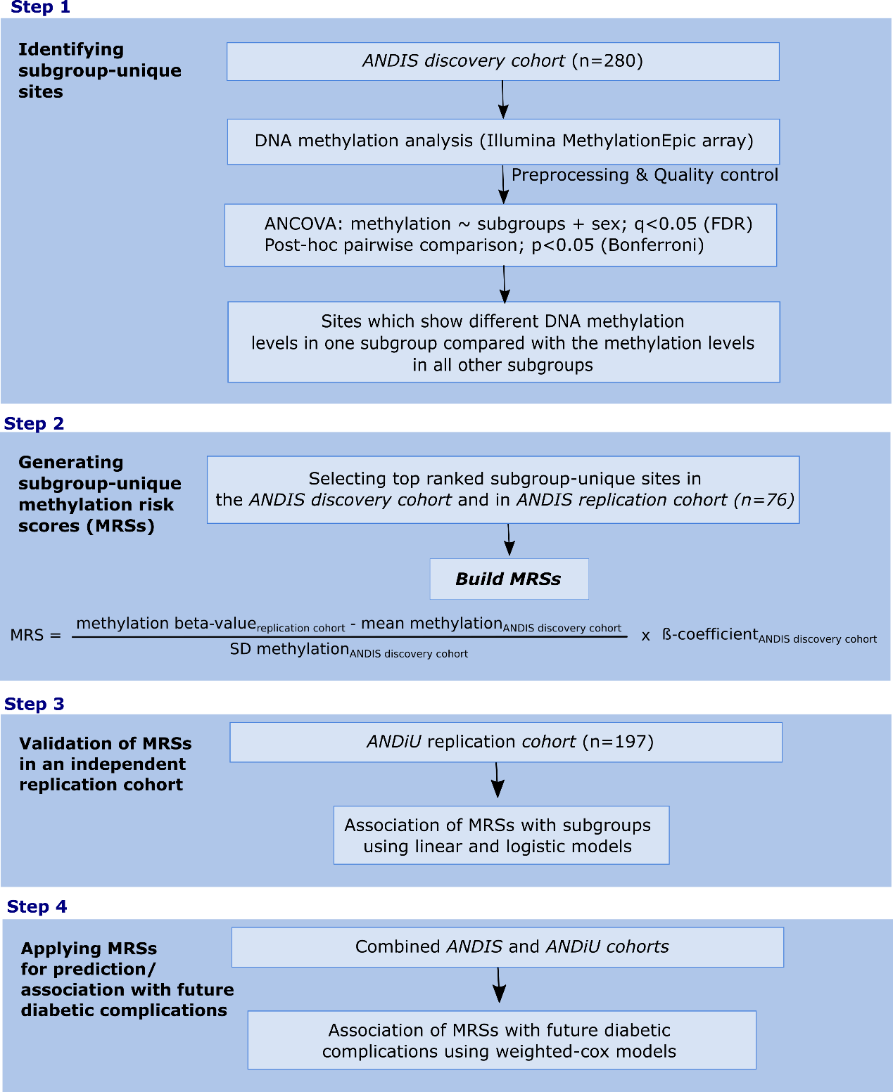
Figure S1. Study design. Flow-chart representing the analytical steps of this study. Step 1) Methylation sites, which differed between the type 2 diabetes subgroups after ANCOVA and post-hoc pairwise comparisons corrected for multiple testing in the ANDIS discovery cohort, were selected to identify subgroup-unique sites. Step 2) Then, these subgroup-unique sites were: i) first, rank-ordered based on their significance using q-values in the ANDIS discovery cohort; ii) second, selected starting with the highest rank (lowest q-value), and going down in rank until the best possible combination of sites based on its ability to discriminate between subjects with a particular diabetes subgroup and those without (using area under the curve, AUC), performing separate analyses in the ANDIS discovery cohort and the ANDIS replication cohort. These methylation sites were then used to generate subgroup-unique methylation risk scores (MRSs) using mean methylation, SD and ß-coefficients from the ANDIS discovery cohort and the methylation ß-values from the respective cohort. Step 3) was to validate the MRSs in the independent ANDiU replication cohort and step 4) was to associate the MRSs with future diabetic complications such as cardiovascular disease, chronic kidney disease and retinopathy in the combined ANDIS discovery, ANIDS replication and ANDiU replication cohort.
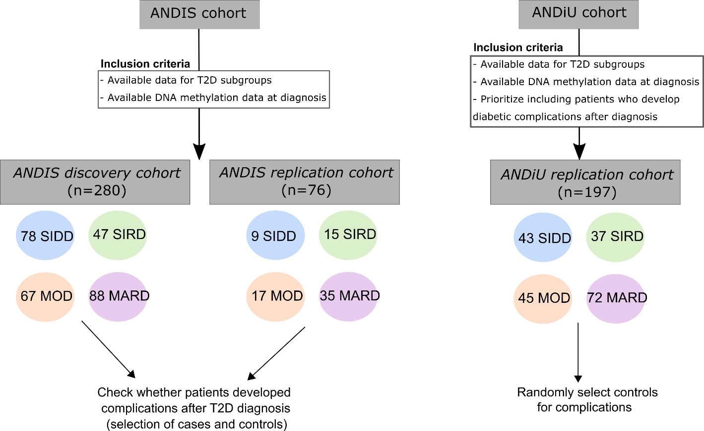

Figure S2. Flowchart showing the inclusion criteria and the selection of patients from the ANDIS discovery and the ANDIS and ANDiU replication cohorts. We included 280 and 76 type 2 diabetes (T2D) patients from the ANDIS discovery and ANDIS replication cohorts respectively, with available information for T2D subgroups, performed based on unsupervised clustering, and available DNA methylation data at diagnosis. Among the 280 patients in the ANDIS discovery cohort, 78 (29%) were labelled as SIDD (Severe Insulin Deficient Diabetes), 47 (16%) as SIRD (Severe Insulin Resistant Diabetes), 67 (24%) as MOD (Mild Obese Diabetes), and 88 (31%) as MARD (Mild Age-Related Diabetes). Among the 76 patients in the ANDIS replication cohort, 9 (12%) were labelled as SIDD, 15 (20%) as SIRD, 17 (22%) as MOD, and 35 (46%) as MARD. In ANDIS discovery and replication cohorts, we did not consider future diabetic complications (cardiovascular disease (CVD), chronic kidney disease (CKD) and retinopathy) as an inclusion criterion and we checked whether these patients developed complications after inclusion. However, due to low incidence rates of these complications in ANDIS, we decided to prioritize including patients who developed diabetic complications after registration in our ANDiU replication cohort to increase power in complication-related analyses. Therefore, in the ANDiU replication cohort we selected T2D patients with available data for T2D subgroups and available DNA methylation data at diagnosis and also we selected the ones who developed the first diabetic complication after diagnosis. We next randomly selected T2D patients as controls for complications for the ANDiU replication cohort. Among the 197 patients included in the ANDiU replication cohort, 43 (22%) were labelled as SIDD, 37 (19%) as SIRD, 45 (23%) as MOD, and 72 (36%) as MARD.

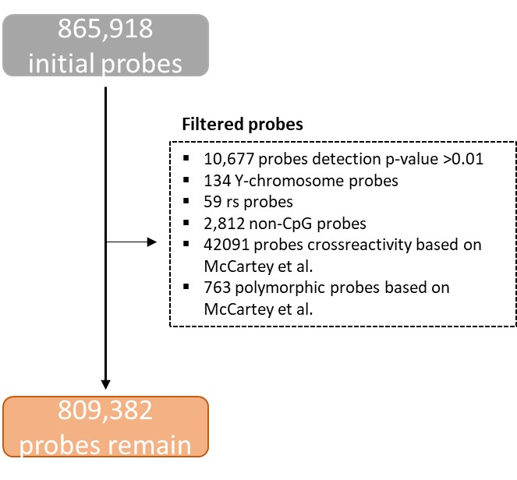

Figure S3. Flow of the filtering and quality control of probes for DNA methylation analysis in the ANDIS discovery cohort. Illumina MethylationEPIC array was used for the analysis of genome-wide DNA methylation in 280 individuals with type 2 diabetes from the ANDIS discovery cohort. 56,536 probes were filtered away based on the different criteria displayed in the figure. 809,382 probes remain for further bioinformatic analysis: normalization procedures, background correction, quantile normalization, BMIQ and Combat.

Figure S4. Differences of the subgroup-unique methylation risk scores (MRSs) between the four type 2 diabetes subgroups in the three cohorts: ANDIS discovery cohort (n=280), ANDIS replication cohort (n=76), ANDiU replication cohort (n=197). Differences in subgroup-unique MRSs were compared using ANOVA. The subgroup-unique MRS was higher in the corresponding subgroup (i.e. SIDD for SIDD-MRS, SIRD for SIRD-MRS, MOD for MOD-MRS, MARD for MARD-MRS) compared to patients belonging to other subgroups.
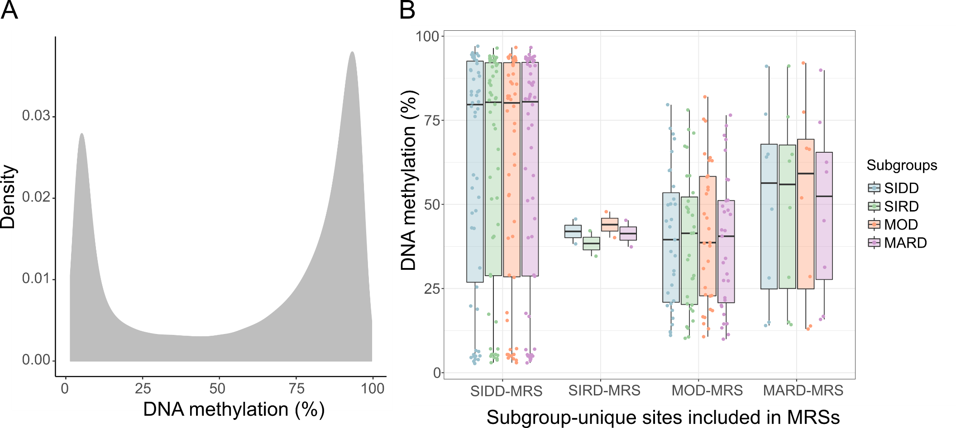

Figure S5. Distribution of epigenome-wide DNA methylation and DNA methylation of the sites included in the subgroup-unique methylation risk scores (MRSs) in the ANDIS discovery cohort. DNA methylation of all sites included in the MethylationEPIC array (A) showed a distribution leaning towards levels of 0 or 100%. The sites included in the subgroup-unique MRSs (B) displayed higher density of semi-methylated sites. Methylation patterns of the 54 SIDD-MRS sites showed a tendency of hypermethylation (high methylation), while the 2 SIRD-MRS sites, 31 MOD-MRS sites, and 200 MARD-MRS sites have intermediate methylation levels. Methylation of all subgroups follows the same distribution on the respective sites included in subgroup-unique MRSs.

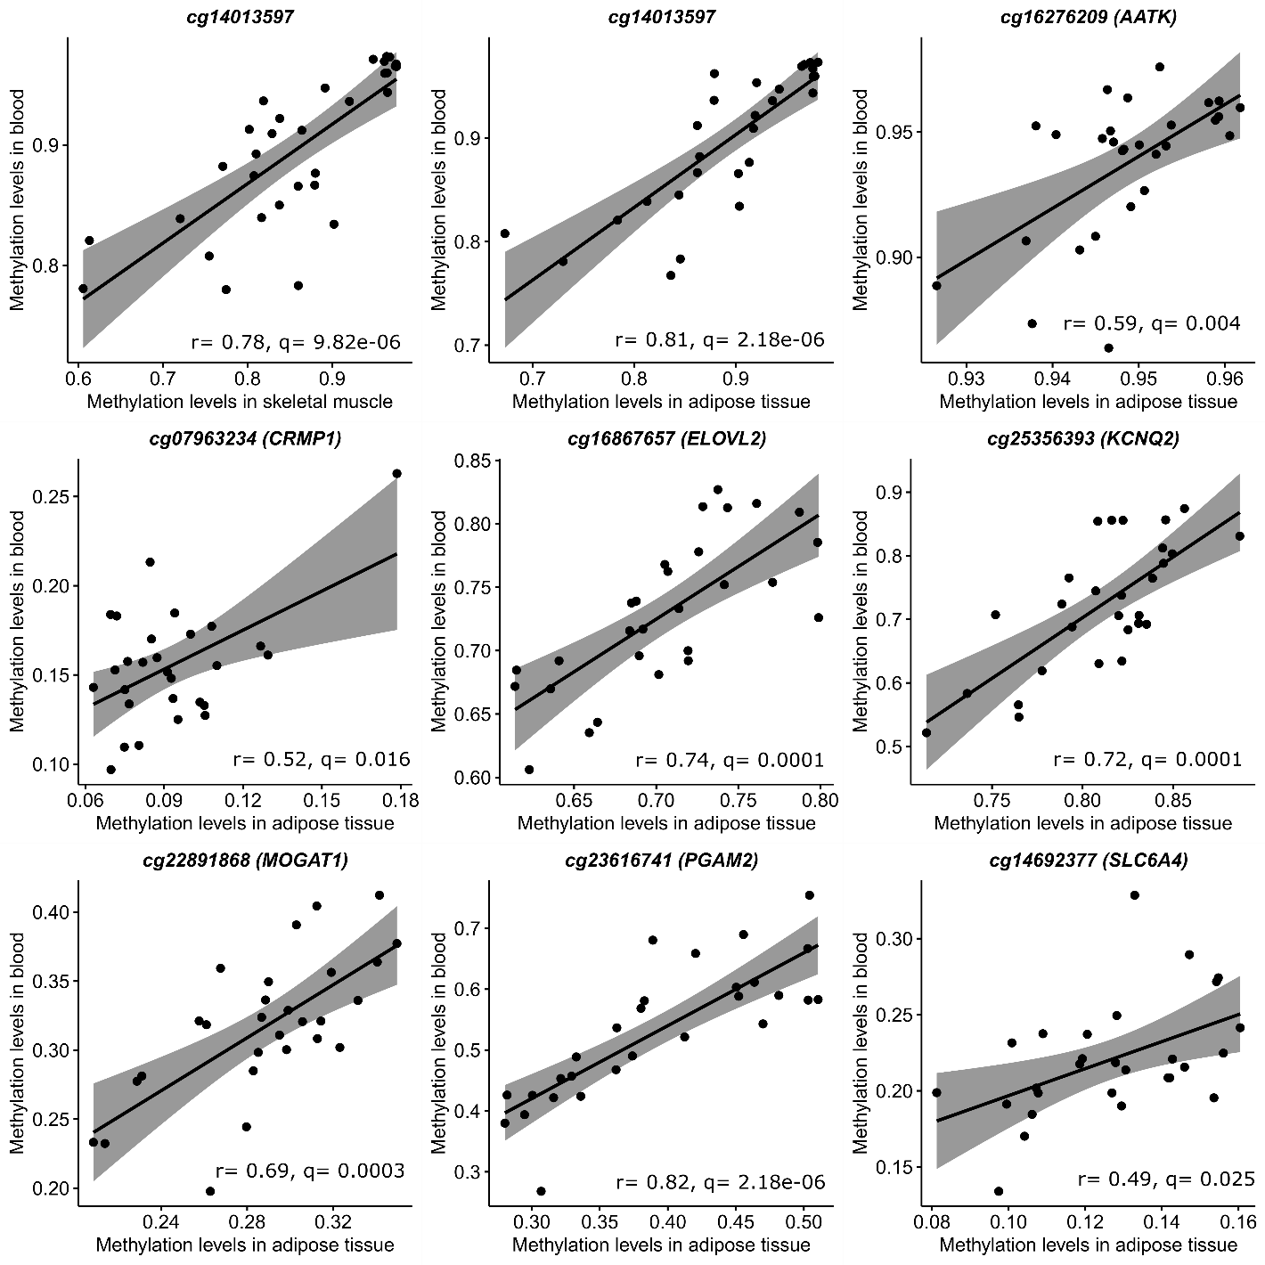

Figure S6. Cross-tissue DNA methylation of sites included in subgroup-unique methylation risk scores (MRSs) in different human tissues. The figure shows some correlations between DNA methylation of sites included in subgroup-unique MRSs in blood and DNA methylation of these sites in adipose tissue and skeletal muscle taken from the same subjects for these cell types from the Monozygotic Twin Cohort based on FDR below 5% (q<0.05).

SUPPLEMENTARY TABLES

Table S1. Clinical characteristics of the ANDIS discovery and replication cohorts and the ANDiU replication cohort by type 2 diabetes subgroups

 |  |  | ANDIS discovery cohort (n=280) |  |  |  |  | ANDIS replication cohort (n=76) |  |  |  |  | ANDiU replication cohort (n=197)
 |  |  | SIDD  (n=78) | SIRD  (n=47) | MOD  (n=67) | MARD  (n=88) | p | SIDD  (n=9) | SIRD  (n=15) | MOD  (n=17) | MARD  (n=35) | p | SIDD  (n=43) | SIRD  (n=37) | MOD  (n=45) | MARD  (n=72) | p
Age (years) | Mean  SD  Min  Max |  | 58.59^{a,b,c}  9.64  37  81 | 65.21^{d}  8.43  46  79 | 52.10^{f}  7.18  35  71 | 68.36  8.62  45  85 | 6.23e-22 | 59.22  10.17  45  73 | 64.33^{d}  7.31  47  73 | 49.47^{f}  7.40  37  70 | 66.91  9.37  49  91 | 2.19e-06 | 60.57^{a,b,c}  9.21  41  74 | 66.95^{d}  8.92  40  80 | 51.98^{f}  9.70  30  71 | 68.07  8.78  45  86 | 1.51e-13
Sex | Male %  Male (n) |  | 70.51  55 | 61.07  29 | 55.22  37 | 52.27  46 | 0.092 | 55.55  5 | 40  6 | 52.94  9 | 40  14 | 0.719 | 55.8  24 | 45.9  17 | 48.9  22 | 58.3  42 | 0.573
BMI (kg/m2) | Mean  SD  Min  Max |  | 29.07^{a,b}  4.61  20.38  40.57 | 34.69e  6.07  24.65  50.71 | 35.02^{f}  4.52  25.27  48.42 | 28.08  3.42  18.56  39.35 | 1.57e-20 | 27.20^{a,b}  3.39  23.36  34.28 | 32.04e  2.83  27.85  36.06 | 34.31^{f}  3.91  24.44  39.20 | 28.74  3.18  22.85  36.99 | 2.16e-06 | 29.73^{a,b}  4.33  20.55  39.47 | 35.02e  4.81  26.59  47.63 | 36.10^{f}  4.94  23.73  47.75 | 28.38  3.61  20.45  38.10 | 1.58e-16
HbA1c  (mmol/mol) | Mean  SD  Min  Max |  | 92.29^{a,b,c}  16.31  71.00  149.26 | 56.14  12.24  40.00  101.00 | 60.59  12.29  35.00  102.00 | 57.63  9.47  38.00  83.00 | 4.35e-33 | 86.65^{a,b,c}  16.51  60.00  113.00 | 56.87  11.05  45.00  84.00 | 54.84  11.72  36.41  79.00 | 52.73  6.66  36.00  72.00 | 8.01e-05 | 86.93^{a,b,c}  14.69  65.00  129.00 | 48.32  8.41  30.00  72.00 | 52.29^{f}  8.60  41.00  73.00 | 47.19  6.18  30.00  67.00 | 1.18e-22
HbA1c  (%) | Mean  SD  Min  Max |  | 10.59 ^{a,b,c}  1.49  9  16 | 7.29  1.12  6  11 | 7.70  1.12  5  11 | 7.42  0.87  6  10 | 4.35e-33 | 10.08 ^{a,b,c}  1.51  8  12 | 7.35  1.01  6  10 | 7.17  1.07  5  9 | 6.98  0.61  5  9 | 8.01e-05 | 10.10 ^{a,b,c}  1.34  8  14 | 6.57  0.77  5  9 | 6.94^{f}  0.79  6  9 | 6.47  0.57  5  8 | 1.18e-22
HOMA2-B | Mean  SD  Min  Max |  | 42.14^{a,b,c}  23.48  13.30  142.10 | 130.03^{d,e}  53.72  18.60  333.50 | 80.73  28.97  23.60  170.40 | 75.63  28.43  26.00  172.50 | 2.14e-27 | 39.21^{a,b,c}  19.48  20.20  74.40 | 160.0^{d,e}  63.86  103.8  331.1 | 86.22  33.53  36.20  145.80 | 80.63  25.82  39.60  148.70 | 5.09e-08 | 42.89^{a,b,c}  17.70  14.40  95.40 | 144.64^{d,e}  46.66  92.00  255.50 | 87.30  26.33  40.50  136.30 | 77.60  23.53  31.60  142.10 | 1.41e-25
HOMA2-IR | Mean  SD  Min  Max |  | 3.34^{a,c}  1.44  0.88  7.46 | 6.72^{d,e}  4.64  3.15  24.39 | 3.53^{f}  1.08  1.66  7.81 | 2.75  0.92  1.15  5.35 | 1.03e-20 | 3.02ª  0.95  1.04  4.10 | 5.60^{d, e}  1.97  2.65  9.52 | 3.63^{f}  1.11  1.40  5.52 | 2.80  1.03  1.03  5.32 | 1.16e-05 | 3.79^{a,c}  1.76  0.80  9.30 | 5.25^{d,e}  1.46  3.30  10.10 | 3.22^{f}  0.84  1.70  4.80 | 2.69  0.87  1.20  4.40 | 2.01e-16
Diabetes medication | Positive %  Positive(n) |  | 16.67  13 | 23.41  11 | 19.41  13 | 18.19  16 | 0.822 | 0  0 | 0  0 | 5.89  1 | 5.72  2 | 0.696 | 37.2  16 | 32.4  12 | 40.0  18 | 34.7  25 | 0.897
CVD | Positive %  Positive(n) |  | 18  14 | 47  22 | 12  8 | 40  35 | 6.98e-06 | 22  2 | 33  5 | 23  4 | 34  12 | 0.807 | 9  4 | 5  2 | 0  0 | 12  9 | 0.086
CKD | Positive %  Positive(n) |  | 13  10 | 23  11 | 6  4 | 24  21 | 0.010 | 11  1 | 40  6 | 6  1 | 20  7 | 0.095 | 17  8 | 32  12 | 9  4 | 14  10 | 0.032
Retinopathy | Positive %  Positive(n) |  | 11  9 | 6  3 | 1  1 | 6  5 | 0.103 | 11  1 | 7  1 | 6  1 | 3  1 | 0.778 | 16  7 | 19  7 | 13  6 | 18  13 | 0.897
Phenotypes were measured in the ANDIS cohort (All New Diabetics in Scania) and ANDiU cohort (All New Diabetics in Uppsala). Subgroups were previously defined as: SIDD: severe insulin-deficient diabetes, SIRD: severe insulin-resistant diabetes, MOD: mild obesity-related diabetes, MARD: mild age-related diabetes using data driven clustering¹. The proportion of type 2 diabetes (T2D) patients in each subgroup is similar to the number of T2D patients in each subgroup in the full ANDIS cohort¹ Patients who picked up diabetes medication from the pharmacy within 6 months before DNA methylation samples were considered as medication positive. Patients who developed future cardiovascular disease (CVD), or chronic kidney disease (CKD) or retinopathy were considered diabetic complications positive. P values for continuous variables were calculated using Kruskal-Wallis Test; for categorical variables we used Chi-squared test. P<0.05 was considered significant. q<0.05 after Dunn’s Post Hoc pairwise comparison corrected for multiple testing with Benjamini-Hochberg: (a: SIDD vs. SIRD, b: SIDD vs. MOD, c: SIDD vs. MARD, d: SIRD vs. MOD, e: SIRD vs. MARD, f: MOD vs. MARD) showing the specific pairwise phenotypical differences between subgroups.

Table S2. Clinical characteristics of the combined ANDIS discovery, ANDIS replication and ANDiU replication cohorts for analyses regarding cardiovascular disease (CVD)

 | Controls | Cases | p
N = 486 | 410 | 76
Sex (n(%) females) | 202 (49%) | 26 (34%) | 0.020*
Age (years) | 60.17 (10.99) | 65.82 (9.73) | 2.32e-5*
Age (min-max) | 30- 91 | 37 - 86
BMI (kg/m2) | 31.47 (5.31) | 30.24 (5.69) | 0.007*
BMI (min-max) | 20.45 – 49 | 19 - 51
HOMA2_B | 78.32 (41.32) | 88.93 (50.33) | 0.048
HOMA2-B (min-max) | 13.30 – 331 | 18.40 - 251.20
HOMA2_IR | 3.57 (2.02) | 3.59 (1.66) | 0.946
HOMA2-IR (min-max) | 0.8 - 24 | 1.04 - 10.31
Hba1c (mmol/mol) | 63.88 (19.68) | 62.32 (21.51) | 0.532
HbA1c (min-max) | 30 – 149 | 35 - 128
Diabetes medication (n(%) positive) | 88 (21%) | 26 (34%) | 0.024*
Follow up (days) | 1669.37 (623.43) | 695.61 (441.63) | < 2.2e-16*
follow up (min-max) | 4 - 2871 | 43 - 2015
Data are shown as mean (SD) or n (%). Patients with CVD events occurring before DNA samples were excluded in the analysis.
* p<0.05 was considered significant. Pearson’s Chi-squared test was used for categorical variables, Mann-Whitney U test for continuous variables.

Table S3. Clinical characteristics of the combined ANDIS discovery, ANDIS replication and ANDiU replication cohorts for analyses regarding chronic kidney disease (CKD)

 | Controls | Cases | p
N = 517 | 444 | 73
Sex (n(%) females) | 195 (44%) | 33 (45%) | 0.938
Age (years) | 60.15 (10.65) | 68.63 (7.94) | 2.88e-10*
Age (min-max) | 30 – 86 | 42 - 91
BMI (kg/m2) | 31.32 (5.43) | 30.37 (4.55) | 0.159
BMI (min-max) | 19 - 50.71 | 20.55 - 42.44
HOMA2_B | 77.78 (39.75) | 88.99 (51.15) | 0.033
HOMA2-B (min-max) | 14 - 331.10 | 13.30 - 255.50
HOMA2_IR | 3.60 (2.16) | 3.70 (1.56) | 0.687
HOMA2-IR (min-max) | 1.03 - 24.39 | 0.8 - 9.0
Hba1c (mmol/mol) | 62.79 (19.00) | 63.13 (19.58) | 0.889
HbA1c (min-max) | 30 - 144.04 | 37 - 129
Diabetes medication (n(%) positive) | 95 (22%) | 24 (33%) | 0.044*
Follow up days (mean (SD)) | 1646.32 (621.82) | 823.7 (584.73) | < 2.2e-16*
Follow up (min-max) | 4 - 2858 | 1 - 2234
Data are shown as mean (SD) or n (%). Patients with CKD events occurring before DNA samples were excluded in the analysis.
* p<0.05 was considered significant. Pearson’s Chi-squared test was used for categorical variables, Mann-Whitney U test for continuous variables.

Table S4. Clinical characteristics of the combined ANDIS discovery, ANDIS replication and ANDiU replication cohorts for analyses regarding retinopathy

 | Controls | Cases | p
N = 544 | 490 | 54
Sex (n(%) females) | 221 (45%) | 22 (41%) | 0.640
Age (years) | 61.76 (10.80) | 61.78 (11.38) | 0.992
Age (min-max) | 35 - 91 | 32.87 - 80.88
BMI (kg/m2) | 31.33 (5.32) | 30.58 (5.64) | 0.327
BMI (min-max) | 20.38 - 50.71 | 22.04 - 49.45
HOMA2-B | 82.60 (43.00) | 76.99 (58.17) | 0.382
HOMA2-B (min-max) | 16.90 - 331.10 | 13.30 - 333.50
HOMA2-IR | 3.65 (1.98) | 3.81 (3.25) | 0.604
HOMA2-IR (min-max) | 0.8 - 24.39 | 1.04 - 21.74
Hba1c (mmol/mol) | 62.52 (19.24) | 65.22 (21.97) | 0.336
HbA1c (min-max) | 35 - 144.04 | 40 - 128
Diabetes medication (n(%) positive) | 100 (20%) | 26 (48%) | 4.63e-06*
Follow up days | 1698.76 (590.64) | 969.07 (660.90) | 2.96e-13*
follow up (min-max) | 1461 - 2871 | 7 - 4600
Data are shown as mean (SD) or n (%). Patients with retinopathy occurring before DNA samples were excluded in the analysis.
* p<0.05 was considered significant. Pearson’s Chi-squared test was used for categorical variables, Mann-Whitney U test for continuous variables.

Table S5. Monozygotic Twin Cohort clinical characteristics

 | MZ twin cohort  (Skeletal muscle) |  | MZ twin cohort  (Adipose tissue)
 | Non-diabetics | T2D | Non-diabetics | T2D
N | 16 | 16 | 14 | 14
Age (years) | 66.94(8.05) | 66.94(8.05) | 68.14(8.24) | 68.14(8.24)
Sex (n(%) males) | 7(43.8) | 7(43.8) | 5(35.7) | 5(35.7)
BMI (kg/m2) | 29.87(6.30) | 31.85(6.32) | 29.64(6.89) | 31.83(7.13)
fP-glucose (mmol/L) | 6.09(0.61)* | 9.83(2.68)* | 6.16(0.56)* | 9.70(3.60)*
HbA1c (mmol/L) | 5.84(0.46)* | 7.55(1.85)* | 5.92(0.42)* | 7.47(2.01)*
Data are shown as mean (SD) or n (%). Skeletal muscle samples were available from 16 twin pairs discordant for type 2 diabetes (T2D), and from 14 twin pairs for adipose tissue.
* p<0.05, T2D vs. non-diabetics using Wilcoxon test.

Table S6. Subgroup-unique sites used to generate subgroup-unique methylation risk scores (MRSs) based on the best area under the curve (AUC) for the MRS to discriminate between subjects with a particular type 2 diabetes (T2D) subgroup and those without in both the ANDIS discovery and replication cohorts

 | Subgroup-unique sites included in the subgroup-unique MRS | AUC ANDIS discovery cohort | AUC ANDIS replication cohort
SIDD-MRS | 54 | 0.97 | 0.71
SIRD-MRS | 2 | 0.72 | 0.69
MOD-MRS | 31 | 0.88 | 0.89
MARD-MRS | 8 | 0.83 | 0.75
Subgroup-unique sites were rank ordered based on their significance in the ANDIS discovery cohort. AUCs were then generated using C-statistics for the subgroup-unique MRSs produced with data for the subgroup-unique sites in both the ANDIS discovery and the ANDIS replication cohort, systematically going down in rank for the subgroup-unique sites included in the MRSs until the best combination of AUC in both cohorts was found. Data of these 95 subgroup-unique sites in the ANDIS discovery cohort is presented in Table S9.

Table S7. DNA methylation levels of the 22,034 sites showing differences in methylation (q<0.05) between any of the four novel subgroups in the ANDIS discovery cohort
See Excel file Supplementary Table 7.xlxs

Table S8. DNA methylation levels of the 4,465 subgroup-unique sites in the ANDIS discovery cohort. A) DNA methylation levels of the 56 SIDD-unique sites; B) DNA methylation levels of the 74 SIRD-unique sites; C) DNA methylation levels of the 4,135 MOD-unique sites; D) DNA methylation levels of the 200 MARD-unique sites.
See Excel file Supplementary Table 8.xlxs

Table S9. DNA methylation levels of the 95 subgroup-unique sites included in the subgroup-unique methylation risk scores (MRSs) in the ANDIS discovery cohort. A) DNA methylation levels of the 54 SIDD-unique sites included in SIDD-MRS; B) DNA methylation levels of the 2 SIRD-unique sites included in SIRD-MRS; C) DNA methylation levels of the 31 MOD-unique sites included in MOD-MRS; D) DNA methylation levels of the 8 MARD-unique sites included in MARD-MRS.
See Excel file Supplementary Table 9.xlxs

Table S10. Association between subgroup-unique methylation risk scores (MRSs) and type 2 diabetes subgroups in ANDIS discovery cohort after adjusting for blood cell counts.

 | ANDIS discovery cohort
 | B-coeff (SE) | p
SIDD-MRS ~ SIDD/Non-SIDD + blood cells | 0.60 (0.03) | < 2e-16
SIRD-MRS ~ SIRD/Non-SIRD + blood cells | 0.04 (0.008) | 2.92e-06
MOD-MRS ~ MOD/Non-MOD + blood cells | 0.90 (0.10) | < 2e-16
MARD-MRS ~ MARD/Non-MARD + blood cells | 0.15 (0.01) | < 2e-16
Blood cells included in the model: CD8T, CD4T, monocytes, neutrophils, natural-killer cells (not B lymphocytes). There are 3 missing individuals who did not have blood cells count available.

Table S11. Association between subgroup-unique methylation risk scores (MRSs) with type 2 diabetes subgroups with/without adjusting for clinical variables in the independent ANDiU replication cohort (n=197).

 | ANDiU replication cohort
 | OR (95% CI) | p
SIDD/Non-SIDD ~ SIDD-MRS
Crude | 2.08 (1.43 to 3.13) | 2e-04
Adjusted for HbA1c | 0.83 (0.21 to 2.92) | 0.777
SIRD/Non-SIRD ~ SIRD-MRS
Crude | 1.61 (1.12 to 2.34) | 0.011
Adjusted for HOMA-IR | 1.47 (0.94 to 2.32) | 0.091
Adjusted for HOMA-B | 2.10 (1.18 to 3.97) | 0.015
MOD/Non-MOD ~ MOD-MRS
Crude | 6.06 (3.52 to 11.5) | 1.85e-09
Adjusted for BMI | 6.48 (3.48 to 13.5) | 5.41e-08
MARD/Non-MARD ~ MARD-MRS
Crude | 2.52 (1.78 to 3.70) | 6.72e-07
Adjusted for age | 1.84 (1.2 to 2.82) | 0.003
Odds ratios (OR) are shown per 1SD increase in MRSs. Multiple logistic regression models were adjusted for the primary variable that defined each of the subgroups.

 |  | Adjusted for sex and blood cell counts |  | Adjusted for sex
 |  | HR (95%CI) | p | HR (95%CI) | p
CVD (n=483) | SIDD-MRS | 0.72 (0.54-0.97) | 0.03 | 0.72 (0.54-0.97) | 0.032
 | SIRD-MRS | 1.34 (0.99-1.81) | 0.05 | 1.47 (1.15-1.89) | 0.002
 | MOD-MRS | 0.63 (0.46-0.86) | 0.004 | 0.65 (0.50-0.84) | 0.001
 | MARD-MRS | 1.53 (1.12-2.08) | 0.007 | 1.41 (1.10-1.81) | 0.007
CKD (n=514) | SIDD-MRS | 1.16 (0.82-1.63) | 0.41 | 1.04 (0.77-1.42) | 0.778
 | SIRD-MRS | 1.40 (0.95-2.05) | 0.09 | 1.55 (1.12-2.14) | 0.007
 | MOD-MRS | 0.56 (0.41-0.77) | 0.0004 | 0.50 (0.38-0.65) | 3.11e-07
 | MARD-MRS | 1.79 (1.28-2.51) | 0.0006 | 1.90 (1.46-2.48) | 1.72e-06
Diabetic retinopathy (n=541) | SIDD-MRS | 1.16 (0.68-1.98) | 0.58 | 1.12 (0.69-1.82) | 0.657
 | SIRD-MRS | 1.01 (0.57-1.78) | 0.98 | 1.04 (0.66-1.64) | 0.876
 | MOD-MRS | 0.67 (0.41-1.09) | 0.11 | 0.85 (0.60-1.22) | 0.389
 | MARD-MRS | 1.25 (0.79-1.97) | 0.33 | 1.03 (0.69-1.52) | 0.892
Table S12. Associations between subgroups-unique MRSs and the risk of developing diabetic complications during 8 years of follow-up (mean ~4.5 years) in the combined ANDIS discovery, ANDIS replication and ANDiU replication cohorts after adjusting for sex and/or for blood cell counts

Weighted cox regressions after adjusting for sex and/or blood cell types are shown. Blood cells included in the model: CD8T, CD4T, monocytes, neutrophils, natural-killer cells (not B lymphocytes). There are 3 missing individuals who did not have blood cells count available.

Table S13. Associations between subgroup-defining phenotypes and the risk of developing diabetic complications during 8 years of follow-up (mean ~4.5 years) in the combined ANDIS discovery, ANDIS replication and ANDiU replication cohorts.

 |  | HR (95%CI) | p
CVD (n=486) | Age | 1.04 (1.02-1.06) | 0.002
 | BMI | 0.96 (0.90-1.02) | 0.234
 | HbA1c | 0.99 (0.97-1.01) | 0.432
 | HOMA2-IR | 0.97 (0.83-1.15) | 0.762
 | HOMA2-B | 1.01 (1.0-1.01) | 0.005
CKD (n=517) | Age | 1.10 (1.07-1.13) | 1.94e-09
 | BMI | 0.95 (0.90-1.01) | 0.101
 | HbA1c | 1.02 (0.99-1.04) | 0.080
 | HOMA2-IR | 0.98 (0.89-1.07) | 0.631
 | HOMA2-B | 1.01 (1.0-1.02) | 0.016
Diabetic retinopathy (n=544) | Age | 1.02 (0.98-1.06) | 0.244
 | BMI | 0.97 (0.87-1.07) | 0.538
 | HbA1c | 1.02 (1.01-1.04) | 0.006
 | HOMA2-IR | 1.08 (0.94-1.25) | 0.283
 | HOMA2-B | 0.99 (0.98-1.01) | 0.966

One weighted-cox regression was performed for each complication including all subgroup-defining phenotypes. The data is presented as hazard ratios (HR) and 95% confidence intervals (CI). For cardiovascular disease (CVD) there are 410 controls and 76 cases (n=486), for chronic kidney disease (CKD) there are 444 controls and 73 cases (n=517), for diabetic retinopathy there are 490 controls and 54 cases (n=544). CVD was defined as having had either stroke (ICD-10 codes I60, I61, I63 and I64) or coronary events (ICD-10 codes I20-I21, I24, I251 and I253-I259). CKD was defined as having had an eGFR <60ml/min/1.73m2 for a minimum period of 90 days or a single measurement of eGFR <15ml/min/1.73m2. Diagnosis of diabetic retinopathy was based on fundus photographs (ICD-10 code E113).

Table S14. Associations between type 2 diabetes subgroups and the risk of developing diabetic complications during 8 years of follow-up (mean ~4.5 years) in the combined ANDIS discovery, ANDIS replication and ANDiU replication cohorts.

 | Type 2 diabetes subgroups
 |  | HR (95%CI) | p
CVD (n=486) | SIDD | 0.52 (0.26-1.02) | 0.055
 | SIRD | 1.47 (0.75-2.87) | 0.261
 | MOD | 0.39 (0.18-0.84) | 0.016
 | MARD | 2.49 (1.45-4.28) | 0.0009
CKD (n=517) | SIDD | 0.77 (0.35-1.69) | 0.518
 | SIRD | 1.46 (0.69-3.06) | 0.321
 | MOD | 0.08 (0.01-0.49) | 0.006
 | MARD | 2.49 (1.33-4.65) | 0.004
Diabetic retinopathy (n=544) | SIDD | 2.80 (1.23-6.41) | 0.014
 | SIRD | 1.19 (0.42-3.34) | 0.740
 | MOD | 0.34 (0.09-1.26) | 0.106
 | MARD | 0.61 (0.24-1.54) | 0.295

Sex-adjusted weighted cox regression models are shown. The data is presented as hazard ratios (HR) and 95% confidence intervals (CI). For cardiovascular disease (CVD) there are 410 controls and 76 cases (n=486), for chronic kidney disease (CKD) there are 444 controls and 73 cases (n=517), for diabetic retinopathy there are 490 controls and 54 cases (n=544). CVD was defined as having had either stroke (ICD-10 codes I60, I61, I63 and I64) or coronary events (ICD-10 codes I20-I21, I24, I251 and I253-I259). CKD was defined as having had an eGFR <60ml/min/1.73m2 for a minimum period of 90 days or a single measurement of eGFR <15ml/min/1.73m2. Diagnosis of diabetic retinopathy was based on fundus photographs (ICD-10 code E113).

Table S15. Areas under the curve (AUCs) showing the associations between subgroup-unique methylation risk scores, type 2 diabetes subgroups or clinical phenotypes and the development of future diabetic complications in the combined ANDIS discovery, ANDIS replication and ANDiU replication cohorts.

 | Subgroup-unique MRSs |  | Type 2 diabetes subgroups |  | Clinical phenotypes defining type 2 diabetes subgroups
 |  | AUC |  | AUC | AUC age | AUC BMI | AUC HbA1c | AUC HOMA-IR | AUC HOMA-B
CVD (n=486) | SIDD-MRS | 0.542 | SIDD | 0.532 | 0.653 | 0.587 | 0.550 | 0.490 | 0.558
 | SIRD-MRS | 0.644 | SIRD | 0.515 | 0.653 | 0.587 | 0.550 | 0.490 | 0.558
 | MOD-MRS | 0.651 | MOD | 0.586 | 0.653 | 0.587 | 0.550 | 0.490 | 0.558
 | MARD-MRS | 0.594 | MARD | 0.603 | 0.653 | 0.587 | 0.550 | 0.490 | 0.558
CKD (n=517) | SIDD-MRS | 0.548 | SIDD | 0.514 | 0.730 | 0.551 | 0.501 | 0.549 | 0.558
 | SIRD-MRS | 0.554 | SIRD | 0.563 | 0.730 | 0.551 | 0.501 | 0.549 | 0.558
 | MOD-MRS | 0.684 | MOD | 0.599 | 0.730 | 0.551 | 0.501 | 0.549 | 0.558
 | MARD-MRS | 0.672 | MARD | 0.550 | 0.730 | 0.551 | 0.501 | 0.549 | 0.558
Diabetic retinopathy (n=544) | SIDD-MRS | 0.558 | SIDD | 0.543 | 0.513 | 0.556 | 0.511 | 0.545 | 0.585
 | SIRD-MRS | 0.544 | SIRD | 0.513 | 0.513 | 0.556 | 0.511 | 0.545 | 0.585
 | MOD-MRS | 0.520 | MOD | 0.547 | 0.513 | 0.556 | 0.511 | 0.545 | 0.585
 | MARD-MRS | 0.508 | MARD | 0.509 | 0.513 | 0.556 | 0.511 | 0.545 | 0.585

For cardiovascular disease (CVD) there are 410 controls and 76 cases (n=486), for chronic kidney disease (CKD) there are 444 controls and 73 cases (n=517), for diabetic retinopathy there are 490 controls and 54 cases (n=544). CVD was defined as having had either stroke (ICD-10 codes I60, I61, I63 and I64) or coronary events (ICD-10 codes I20-I21, I24, I251 and I253-I259). CKD was defined as having had an eGFR <60ml/min/1.73m2 for a minimum period of 90 days or a single measurement of eGFR <15ml/min/1.73m2. Diagnosis of diabetic retinopathy was based on fundus photographs (ICD-10 code E113).

Table S16. Literature search on the 72 genes annotated to subgroup-unique sites included in methylation risk scores (MRSs). A) Extended table with all the results for the 72 genes B) Summary with all the results for the 72 genes.
See Excel file Supplementary Table 16.xlxs

