SUPPLEMENTAL MATERIAL

TITLE: Impact of severe acute respiratory syndrome coronavirus 2 (SARS-CoV-2) pandemic on diabetes care among a North Carolina patient population
Michael P. Bancks, PhD, Wake Forest School of Medicine
Meng-Yun Lin, PhD, Wake Forest School of Medicine
Alain Bertoni, MD, Wake Forest School of Medicine
Wendell M. Futrell, BS, Wake Forest School of Medicine
Zhixiu Liu, MA, Soterea Technology (Shanghai) Co., Ltd.
Brian Ostasiewski, BS, Wake Forest School of Medicine
Brian J. Wells, MD, Wake Forest School of Medicine
Amresh Hanchate, PhD, Wake Forest School of Medicine

Descriptions:
Supplemental Table S1. Current Procedural Terminology (CPT) codes used to define visit or diabetes care processes measures and definition of delayed care

Supplemental Table S2. Criteria for exclusion and corresponding number of individuals

Supplemental Table S3. Mean time interval between HbA1c testing for the three HbA1c tests most proximal prior to the start of the pandemic and first HbA1c test during the pandemic

Supplemental Table S4. Assessment of individual incidence of delayed HbA1c testing and mean time interval between HbA1c testing according to insulin use, area of residence, and American Community Survey population-level demographic and socioeconomic subgroups

Supplemental Table S5. Assessment of individual incidence of delayed retinal screening and mean time interval between retinal screening according to demographic and clinical subgroups

Supplemental Table S6. Assessment of individual incidence of delayed nephropathy evaluation and mean time interval between nephropathy evaluation according to demographic and clinical subgroups

Supplemental Table S7. Assessment of individual incidence of delayed retinal screening and mean time interval between retinal screening according to insulin use, area of residence, and American Community Survey population-level demographic and socioeconomic subgroups

Supplemental Table S8. Assessment of individual incidence of delayed nephropathy evaluation and mean time interval between nephropathy evaluation according to insulin use, area of residence, and American Community Survey population-level demographic and socioeconomic subgroups
Supplemental Table S9. Individual incidence of delayed diabetes care and mean time interval between diabetes care process measures including individuals with an EHR encounter, but not an outcome-specific encounter

Supplemental Figure S1. Illustration of the study design and example of determination of delay in HbA1c testing

Supplemental Figure S2. Frequency of overall retinal screening exams during three contiguous 12-month periods from March 1, 2018 to February 28, 2021

Supplemental Figure S3. Frequency of overall nephropathy evaluations during three contiguous 12-month periods from March 1, 2018 to February 28, 2021
Supplemental Table S1. Current Procedural Terminology (CPT) codes used to define visit or diabetes care processes measures

Process | Current Procedural Terminology (CPT) codes | Definition of delayed care
Evaluation & Management | 99201, 99202, 99203, 99204, 99205, 99206, 99207, 99208, 99209, 99210, 99211, 99212, 99213, 99214, 99215 | Not applicable
HbA1c testing | Not applicable (used presence of HbA1c measurement) | Delayed care: duration of more than 6 months since the most recent HbA1c measurement  Not delayed care: if the duration was 6 months or shorter since most recent HbA1c measurement
Retinal screening | 67028, 67030, 67031, 67036, 67039, 67040, 67041, 67042, 67043, 67101, 67105, 67107, 67108, 67110, 67113, 67121, 67141, 67145, 67208, 67210, 67218, 67220, 67221, 67227, 67228, 92002, 92004, 92012, 92014, 92018, 92019, 92134, 92201, 92202, 92225, 92226, 92227, 92228, 92230, 92235, 92240, 92250, 92260, S0620, S0621, S3000, 3072F, 2022F, 2024F, 2026F | Delayed care: duration of more than 12 months since the most recent retinal screening  Not delayed care: if the duration was 12 months or shorter since most recent retinal screening
Nephropathy evaluation | 81000, 81001, 81002, 81003, 81004, 81005, 82042, 82043, 82044, 84156, 3060F, 3061F, 3062F | Delayed care: duration of more than 12 months since the most recent nephropathy evaluation  Not delayed care: if the duration was 12 months or shorter since most recent nephropathy evaluation

Supplemental Table S2. Criteria for exclusion and corresponding number of individuals

Adults with diabetes as of 1/1/2019 | 65,629
 | Excluded
Excluded those who died by 3/1/2021 | 5,636
Excluded those without an E&M visit in EHR during pre-pandemic-year1 and pre-pandemic-year2 | 16,266
Excluded those without an HbA1c test in EHR during pre-pandemic-year 1 and pre-pandemic-year2 | 13,686
Excluded those without any encounter in EHR during pandemic year | 1,088
Excluded those without an HbA1c test during the pandemic year | 3,630

Supplemental Table S3. Mean time interval between HbA1c testing for the three HbA1c tests most proximal prior to the start of the pandemic and first HbA1c test during the pandemic

 | Time interval between tests (days)
 | Duration between HbA1c pre-pandemic tests 3 and 2: “penultimate pre-pandemic HbA1c test period” | Duration between HbA1c pre-pandemic tests 2 and 1: “ultimate pre-pandemic HbA1c test period” | Duration between HbA1c pre-pandemic test 1 and the first HbA1c test during the pandemic: “pre-pandemic to pandemic HbA1c test period”
Duration between tests, days (standard deviation) | 154.5 (77.7) | 156.7 (77.1) | 209.5 (101.8)
Difference in duration, days (95% CI) | -2.2 (-3.5, -0.9) | Reference | 54.2 (52.7, 55.7)

Supplemental Table S4. Assessment of individual incidence of delayed HbA1c testing and mean time interval between HbA1c testing according to insulin use, area of residence, and American Community Survey population-level demographic and socioeconomic subgroups

 |  | Incidence of delayed testing (%) |  | Time interval between tests (days)
Subgroup | N | Proportion with delay of last pre-pandemic test (reference) | Percentage-point change in proportion with delay of first test in pandemic period | Duration between last two pre-pandemic tests (reference time interval) | Excess time interval for first test in pandemic period
Insulin use | 7,750 | 31.2% [30.5%, 31.8%] | 24.3% [23.0%, 25.6%] | 157.1 [155.6, 158.5] | 53.6 [50.7, 56.5]
Area of Residence
Metropolitan | 20,102 | 40.5% [40.1%, 40.9%] | 21.3% [20.5%, 22.2%] | 173.0 [172.1, 173.9] | 49.2 [47.4, 51.0]
Micropolitan | 4,087 | 45.5% [44.6%, 46.4%] | 17.1% [15.3%, 18.9%] | 170.7 [168.9, 172.5] | 41.8 [38.1, 45.4]
Small town | 729 | 37.2% [35.0%, 39.3%] | 21.4% [17.1%, 25.7%] | 166.3 [161.5, 171.1] | 45.0 [35.4, 54.6]
Rural | 404 | 44.6% [41.8%, 47.3%] | 20.3% [14.7%, 25.9%] | 176.0 [170.0, 182.1] | 49.4 [37.3, 61.5]
ACS % of community identifies as NH-Black
<5% | 5,979 | 41.9% [41.2%, 42.7%] | 20.3% [18.8%, 21.8%] | 170.0 [168.4, 171.6] | 46.5 [43.3, 49.7]
5.1 - 20% | 10,232 | 40.3% [39.7%, 40.9%] | 20.3% [19.2%, 21.5%] | 168.9 [167.7, 170.1] | 47.4 [45.0, 49.8]
20.1 - 40% | 6,392 | 42.5% [41.8%, 43.3%] | 20.9% [19.4%, 22.3%] | 178.7 [177.1, 180.3] | 46.9 [43.7, 50.2]
>40% | 2,712 | 40.5% [39.4%, 41.7%] | 22.2% [19.9%, 24.5%] | 177.0 [174.3, 179.7] | 55.5 [50.2, 60.8]
ACS % of community identifies as Hispanic
<5% | 5,015 | 40.0% [39.2%, 40.8%] | 20.5% [18.9%, 22.1%] | 167.6 [165.9, 169.4] | 47.8 [44.4, 51.3]
5.1 - 15% | 17,213 | 41.0% [40.5%, 41.4%] | 20.6% [19.7%, 21.5%] | 171.6 [170.6, 172.5] | 46.8 [44.9, 48.7]
>15% | 3,087 | 45.0% [44.0%, 46.1%] | 21.4% [19.3%, 23.5%] | 185.8 [183.3, 188.3] | 54.5 [49.4, 59.5]
ACS % of community difficulty with English language
<1% | 5,648 | 41.9% [41.1%, 42.6%] | 18.9% [17.4%, 20.4%] | 169.7 [168.1, 171.3] | 44.3 [41.2, 47.5]
1.1 - 5% | 18,033 | 41.0% [40.6%, 41.5%] | 21.2% [20.3%, 22.1%] | 173.8 [172.8, 174.7] | 48.9 [47.0, 50.8]
>5.1% | 1,634 | 41.9% [40.4%, 43.3%] | 20.4% [17.5%, 23.3%] | 168.5 [165.4, 171.5] | 49.4 [43.2, 55.5]
ACS % of community unemployed
<2% | 2,165 | 42.9% [41.6%, 44.1%] | 18.5% [16.0%, 20.9%] | 171.4 [168.8, 174.1] | 44.4 [39.1, 49.7]
2.1-5% | 19,706 | 41.6% [41.2%, 42.0%] | 21.0% [20.2%, 21.8%] | 173.0 [172.1, 173.9] | 48.2 [46.4, 50.0]
>5.1% | 3,444 | 38.2% [37.2%, 39.3%] | 20.1% [18.0%, 22.1%] | 170.6 [168.4, 172.8] | 48.5 [44.1, 52.9]
ACS % of community living at or below poverty level
<10% | 4,861 | 43.6% [42.7%, 44.4%] | 20.0% [18.3%, 21.7%] | 175.2 [173.4, 177.0] | 46.1 [42.5, 49.7]
10.1-20% | 13,438 | 40.5% [40.0%, 41.0%] | 20.7% [19.7%, 21.7%] | 170.1 [169.1, 171.2] | 47.0 [44.9, 49.1]
>20.1% | 7,016 | 41.2% [40.5%, 41.9%] | 20.9% [19.5%, 22.3%] | 175.2 [173.6, 176.8] | 51.0 [47.9, 54.2]
ACS % of community uninsured
<10% | 5,600 | 43.0% [42.2%, 43.8%] | 18.4% [16.9%, 20.0%] | 173.8 [172.1, 175.4] | 44.0 [40.7, 47.2]
10.1-20% | 16,976 | 40.5% [40.0%, 40.9%] | 21.2% [20.4%, 22.1%] | 171.8 [170.8, 172.8] | 48.3 [46.4, 50.2]
>20.1% | 2,739 | 42.6% [41.5%, 43.7%] | 21.4% [19.2%, 23.7%] | 174.4 [171.9, 177.0] | 53.7 [48.7, 58.8]
*Abbreviations: ACS, American Community Survey; NH, non-Hispanic
†For HbA1c testing, a delayed test is defined as time-interval >180 days

Supplemental Table S5. Assessment of individual incidence of delayed retinal screening and mean time interval between retinal screening according to demographic and clinical subgroups

 |  | Incidence of delayed testing (%) |  | Time interval between tests (days)
Subgroup | N | Proportion with delay of last pre-pandemic test (reference) | Percentage-point change in proportion with delay of first test in pandemic period | Duration between last two pre-pandemic tests (reference time interval) | Excess time interval for first test in pandemic period
Age group
18-64 years | 606 | 36.5% [34.7%, 38.2%] | 11.1% [7.5%, 14.6%] | 222.8 [216.1, 229.5] | 63.3 [49.9, 76.6]
≥65 years | 1,276 | 36.1% [34.7%, 37.4%] | 13.5% [10.8%, 16.1%] | 237.4 [233.4, 241.5] | 65.5 [57.3, 73.7]
Gender
Women | 1,049 | 35.5% [34.0%, 37.0%] | 14.7% [11.7%, 17.7%] | 236.5 [231.7, 241.2] | 70.4 [60.9, 79.9]
Men | 833 | 37.1% [35.6%, 38.6%] | 10.2% [7.2%, 13.2%] | 228.0 [222.8, 233.2] | 57.7 [47.3, 68.0]
Race-ethnicity
NH-White | 1,282 | 39.3% [38.0%, 40.6%] | 11.9% [9.3%, 14.5%] | 241.3 [237.1, 245.5] | 60.1 [51.7, 68.5]
NH-Black | 460 | 28.3% [26.1%, 30.4%] | 14.1% [9.9%, 18.4%] | 212.3 [205.1, 219.6] | 77.7 [63.2, 92.3]
Hispanic | 69 | 27.5% [21.3%, 33.7%] | 17.4% [5.0%, 29.8%] | 200.2 [179.7, 220.7] | 81.3 [40.4, 122.3]
Other specified | 69 | 40.6% [35.6%, 45.6%] | 13.0% [3.0%, 23.1%] | 245.6 [229.0, 262.1] | 43.8 [10.7, 76.9]
Diabetes Type
Type 1 | 95 | 22.1% [17.0%, 27.2%] | 16.8% [6.7%, 27.0%] | 183.2 [164.5, 202.0] | 66.5 [28.9, 104.0]
Type 2 | 1,787 | 36.9% [35.8%, 38.0%] | 12.5% [10.3%, 14.7%] | 235.4 [231.8, 238.9] | 64.7 [57.5, 71.8]
Insurance status
Medicare | 1,426 | 35.8% [34.5%, 37.0%] | 13.8% [11.3%, 16.3%] | 235.9 [231.9, 239.9] | 66.7 [58.7, 74.6]
Private | 419 | 38.4% [36.3%, 40.5%] | 9.1% [4.9%, 13.3%] | 228.2 [220.5, 235.8] | 53.6 [38.3, 68.9]
Medicaid | 5 | NE‡ | NE‡ | NE‡ | NE‡
Uninsured | 24 | NE‡ | NE‡ | NE‡ | NE‡
HbA1c %
<7% (<53 mmol/mol) | 1,019 | 40.5% [39.1%, 42.0%] | 11.7% [8.8%, 14.6%] | 248.3 [243.7, 252.9] | 62.1 [52.8, 71.3]
7-7.9% (53-63 mmol/mol) | 421 | 36.1% [33.8%, 38.4%] | 14.7% [10.2%, 19.3%] | 230.0 [222.7, 237.4] | 69.9 [55.2, 84.6]
8-8.9% (64-74 mmol/mol) | 215 | 31.2% [28.1%, 34.2%] | 11.2% [5.1%, 17.2%] | 220.1 [210.2, 230.0] | 48.8 [29.0, 68.6]
≥9% (≥75 mmol/mol) | 225 | 21.8% [18.5%, 25.0%] | 14.7% [8.2%, 21.1%] | 180.8 [168.9, 192.6] | 80.8 [57.1, 104.5]
Elixhauser comorbidities
0-1 | 483 | 43.3% [41.2%, 45.3%] | 13.0% [9.0%, 17.1%] | 251.6 [245.3, 257.8] | 56.2 [43.6, 68.8]
2 to 4 | 989 | 36.0% [34.5%, 37.5%] | 11.8% [8.9%, 14.8%] | 232.1 [227.1, 237.1] | 66.0 [56.0, 76.1]
≥5 | 410 | 28.3% [25.9%, 30.7%] | 14.4% [9.6%, 19.2%] | 212.0 [204.4, 219.7] | 71.8 [56.4, 87.1]
*Abbreviations: HbA1c, glycated hemoglobin; NE, not estimable; NH, non-Hispanic
†For retinal screening exams, a delayed test is defined as time-interval >365 days
‡Estimates with small cell numbers were not estimated due to high variability in estimates

Supplemental Table S6. Assessment of individual incidence of delayed nephropathy evaluation and mean time interval between nephropathy evaluation according to demographic and clinical subgroups

 |  | Incidence of delayed testing (%) |  | Time interval between tests (days)
Subgroup | N | Proportion with delay of last pre-pandemic test (reference) | Percentage-point change in proportion with delay of first test in pandemic period | Duration between last two pre-pandemic tests (reference time interval) | Excess time interval for first test in pandemic period
Age group
18-64 years | 4,244 | 19.9% [19.0%, 20.8%] | 19.4% [17.7%, 21.2%] | 195.3 [192.2, 198.5] | 115.5 [109.2, 121.9]
≥65 years | 4,431 | 18.1% [17.2%, 18.9%] | 17.9% [16.2%, 19.5%] | 178.9 [175.9, 181.9] | 117.2 [111.2, 123.2]
Gender
Women | 4,907 | 17.3% [16.5%, 18.1%] | 19.4% [17.8%, 21.1%] | 180.5 [177.6, 183.5] | 121.1 [115.2, 127.1]
Men | 3,768 | 21.2% [20.2%, 22.1%] | 17.6% [15.7%, 19.4%] | 195.3 [192.0, 198.5] | 110.2 [103.7, 116.7]
Race-ethnicity
NH-White | 5,911 | 19.4% [18.7%, 20.2%] | 18.3% [16.8%, 19.8%] | 187.5 [184.9, 190.2] | 116.1 [110.9, 121.4]
NH-Black | 2,145 | 17.1% [15.9%, 18.3%] | 19.4% [17.0%, 21.9%] | 182.0 [177.6, 186.5] | 120.1 [111.2, 128.9]
Hispanic | 296 | 17.9% [14.5%, 21.3%] | 20.6% [13.8%, 27.4%] | 187.5 [175.8, 199.2] | 118.1 [94.7, 141.4]
Other specified | 309 | 25.2% [21.9%, 28.5%] | 17.5% [10.9%, 24.1%] | 207.7 [197.0, 218.4] | 96.5 [75.1, 117.8]
Diabetes Type
Type 1 | 407 | 24.3% [21.5%, 27.1%] | 18.7% [13.0%, 24.3%] | 207.3 [198.1, 216.6] | 101.5 [83.0, 120.0]
Type 2 | 8,268 | 18.7% [18.1%, 19.3%] | 18.6% [17.4%, 19.9%] | 185.9 [183.7, 188.2] | 117.1 [112.6, 121.6]
Insurance status
Medicare | 5,355 | 17.6% [16.8%, 18.3%] | 17.6% [16.1%, 19.1%] | 177.2 [174.5, 180.0] | 116.3 [110.8, 121.7]
Private | 2,984 | 21.9% [20.8%, 23.0%] | 20.5% [18.4%, 22.7%] | 206.0 [202.2, 209.7] | 114.9 [107.3, 122.5]
Medicaid | 66 | 12.1% [5.1%, 19.1%] | 21.2% [7.2%, 35.2%] | 137.0 [109.4, 164.7] | 168.3 [113.1, 223.6]
Uninsured | 247 | 15.4% [11.8%, 18.9%] | 18.6% [11.5%, 25.8%] | 178.0 [164.5, 191.6] | 125.0 [97.9, 152.1]
HbA1c %
<7% (<53 mmol/mol) | 4,659 | 20.1% [19.3%, 20.9%] | 17.3% [15.7%, 19.0%] | 189.6 [186.7, 192.5] | 111.7 [105.8, 117.5]
7-7.9% (53-63 mmol/mol) | 1,906 | 18.4% [17.1%, 19.7%] | 21.0% [18.4%, 23.7%] | 185.7 [181.0, 190.5] | 122.7 [113.2, 132.2]
8-8.9% (64-74 mmol/mol) | 923 | 19.0% [17.0%, 20.9%] | 18.0% [14.2%, 21.8%] | 190.3 [183.5, 197.0] | 114.4 [100.8, 127.9]
≥9% (≥75 mmol/mol) | 1,169 | 15.7% [14.0%, 17.3%] | 20.3% [16.9%, 23.6%] | 175.7 [169.6, 181.8] | 126.5 [114.3, 138.8]
Elixhauser comorbidities
0-1 | 1,910 | 25.9% [24.5%, 27.2%] | 18.0% [15.3%, 20.8%] | 219.5 [215.0, 224.0] | 104.4 [95.3, 113.5]
2 to 4 | 4,507 | 20.3% [19.4%, 21.1%] | 17.8% [16.0%, 19.5%] | 193.8 [190.8, 196.8] | 110.9 [104.8, 116.9]
≥5 | 2,258 | 10.6% [9.5%, 11.7%] | 20.9% [18.7%, 23.1%] | 145.6 [141.3, 150.0] | 137.5 [128.8, 146.3]
*Abbreviations: HbA1c, glycated hemoglobin; NH, non-Hispanic
†For nephropathy evaluation, a delayed test is defined as time-interval >365 days

Supplemental Table S7. Assessment of individual incidence of delayed retinal screening and mean time interval between retinal screening according to insulin use, area of residence, and American Community Survey population-level demographic and socioeconomic subgroups
 |  | Incidence of delayed testing (%) |  | Time interval between tests (days)
Subgroup | N | Proportion with delay of last pre-pandemic test (reference) | Percentage-point change in proportion with delay of first test in pandemic period | Duration between last two pre-pandemic tests (reference time interval) | Excess time interval for first test in pandemic period
Insulin use | 789 | 25.2% [23.6%, 26.9%] | 13.4% [10.1%, 16.8%] | 196.5 [190.8, 202.3] | 74.2 [62.7, 85.7]
Area of Residence
Metropolitan | 1,745 | 37.3% [36.2%, 38.4%] | 12.5% [10.3%, 14.7%] | 236.5 [232.9, 240.1] | 63.9 [56.8, 71.1]
Micropolitan | 109 | 20.2% [15.9%, 24.4%] | 14.7% [6.2%, 23.2%] | 179.4 [163.7, 195.2] | 75.2 [43.7, 106.7]
Small town | 11 | NE‡ | NE‡ | NE‡ | NE‡
Rural | 17 | NE‡ | NE‡ | NE‡ | NE‡
ACS % of community identifies as NH-Black
<5% | 297 | 36.4% [33.7%, 39.0%] | 10.8% [5.4%, 16.1%] | 231.2 [221.8, 240.6] | 61.6 [42.8, 80.4]
5.1 - 20% | 585 | 37.3% [35.4%, 39.1%] | 10.8% [7.1%, 14.5%] | 231.5 [225.2, 237.9] | 61.3 [48.6, 73.9]
20.1 - 40% | 726 | 37.5% [35.8%, 39.1%] | 15.0% [11.7%, 18.3%] | 239.7 [234.6, 244.8] | 64.1 [54.0, 74.3]
>40% | 274 | 30.3% [27.0%, 33.6%] | 12.8% [6.2%, 19.3%] | 218.5 [207.8, 229.3] | 77.3 [55.9, 98.7]
ACS % of community identifies as Hispanic
<5% | 283 | 38.9% [36.3%, 41.5%] | 11.3% [6.1%, 16.5%] | 234.1 [224.9, 243.3] | 68.1 [49.6, 86.5]
5.1 - 15% | 1,410 | 37.9% [36.6%, 39.1%] | 12.7% [10.2%, 15.2%] | 240.9 [236.9, 244.8] | 60.4 [52.5, 68.3]
>15% | 189 | 19.6% [16.4%, 22.8%] | 14.8% [8.4%, 21.3%] | 169.9 [157.7, 182.2] | 92.3 [67.8, 116.9]
ACS % of community difficulty with English language
<1% | 295 | 39.3% [36.7%, 41.9%] | 13.2% [8.0%, 18.4%] | 240.6 [231.7, 249.5] | 62.6 [44.8, 80.3]
1.1 - 5% | 1,387 | 35.7% [34.5%, 36.9%] | 12.4% [10.0%, 14.8%] | 230.0 [225.9, 234.0] | 64.0 [56.0, 72.1]
>5.1% | 200 | 35.0% [31.1%, 38.9%] | 14.0% [6.2%, 21.8%] | 240.3 [228.3, 252.3] | 72.9 [48.9, 96.9]
ACS % of community unemployed
<2% | 68 | 27.9% [23.4%, 32.5%] | 8.8% [-0.3%, 18.0%] | 199.6 [184.9, 214.3] | 37.4 [8.0, 66.8]
2.1-5% | 1,559 | 37.5% [36.4%, 38.7%] | 12.6% [10.4%, 14.9%] | 236.3 [232.5, 240.0] | 63.0 [55.5, 70.5]
>5.1% | 255 | 30.2% [26.7%, 33.7%] | 14.1% [7.2%, 21.1%] | 219.9 [208.8, 231.1] | 82.8 [60.5, 105.1]
ACS % of community living at or below poverty level
<10% | 474 | 39.2% [37.3%, 41.2%] | 13.5% [9.5%, 17.5%] | 244.2 [237.9, 250.5] | 63.0 [50.4, 75.6]
10.1-20% | 846 | 37.5% [35.9%, 39.0%] | 11.6% [8.4%, 14.7%] | 235.0 [229.8, 240.3] | 60.2 [49.7, 70.6]
>20.1% | 562 | 31.7% [29.6%, 33.8%] | 13.7% [9.5%, 17.9%] | 219.5 [212.6, 226.5] | 73.2 [59.3, 87.1]
ACS % of community uninsured
<10% | 494 | 39.1% [37.2%, 41.0%] | 13.2% [9.3%, 17.0%] | 242.0 [235.7, 248.2] | 62.8 [50.3, 75.2]
10.1-20% | 1,128 | 36.6% [35.3%, 38.0%] | 11.9% [9.2%, 14.6%] | 232.0 [227.4, 236.5] | 61.0 [51.9, 70.0]
>20.1% | 260 | 28.8% [25.5%, 32.2%] | 15.4% [8.6%, 22.2%] | 218.5 [207.5, 229.5] | 85.0 [63.0, 107.0]
*Abbreviations: ACS, American Community Survey; NE, not estimable; NH, non-Hispanic
†For retinal screening exams, a delayed test is defined as time-interval >365 days
‡Estimates with small cell numbers were not estimated due to high variability in estimates

Supplemental Table S8. Assessment of individual incidence of delayed nephropathy evaluation and mean time interval between nephropathy evaluation according to insulin use, area of residence, and American Community Survey population-level demographic and socioeconomic subgroups
 |  | Incidence of delayed testing (%) |  | Time interval between tests (days)
Subgroup | N | Proportion with delay of last pre-pandemic test (reference) | Percentage-point change in proportion with delay of first test in pandemic period | Duration between last two pre-pandemic tests (reference time interval) | Excess time interval for first test in pandemic period
Insulin use | 3,229 | 15.4% [14.5%, 16.4%] | 19.5% [17.6%, 21.5%] | 171.4 [167.8, 175.1] | 123.7 [116.4, 131]
Area of Residence
Metropolitan | 7,322 | 18.7% [18.0%, 19.3%] | 18.4% [17.1%, 19.7%] | 186.2 [183.9, 188.6] | 116.9 [112.1, 121.6]
Micropolitan | 1,090 | 21.0% [19.3%, 22.7%] | 20.5% [17.0%, 23.9%] | 191.7 [185.6, 197.9] | 115.2 [102.9, 127.5]
Small town | 159 | 23.3% [18.6%, 28.0%] | 15.1% [5.7%, 24.5%] | 204.3 [187.5, 221.0] | 92.9 [59.4, 126.3]
Rural | 104 | 13.5% [8.2%, 18.7%] | 22.1% [11.6%, 32.6%] | 158.0 [141.8, 174.1] | 131.0 [98.6, 163.3]
ACS % of community identifies as NH-Black
<5% | 1,751 | 20.5% [19.2%, 21.8%] | 16.3% [13.6%, 19.0%] | 194.0 [189.1, 198.9] | 104.6 [94.8, 114.4]
5.1 - 20% | 3,159 | 20.5% [19.5%, 21.5%] | 18.5% [16.4%, 20.5%] | 190.4 [186.8, 194.1] | 116.2 [108.9, 123.5]
20.1 - 40% | 2,630 | 16.7% [15.6%, 17.8%] | 21.4% [19.2%, 23.6%] | 179.3 [175.4, 183.2] | 127.1 [119.3, 134.9]
>40% | 1,132 | 17.8% [16.1%, 19.4%] | 16.3% [13.0%, 19.7%] | 184.1 [178.0, 190.1] | 110.5 [98.4, 122.6]
ACS % of community identifies as Hispanic
<5% | 1,602 | 19.9% [18.4%, 21.3%] | 17.8% [15.0%, 20.6%] | 193.9 [188.8, 199.0] | 102.9 [92.7, 113.1]
5.1 - 15% | 6,173 | 19.0% [18.3%, 19.8%] | 18.4% [17.0%, 19.9%] | 186.5 [184.0, 189.1] | 117.2 [112.1, 122.3]
>15% | 897 | 17.2% [15.2%, 19.1%] | 21.7% [17.9%, 25.6%] | 177.4 [170.1, 184.6] | 135.3 [120.8, 149.7]
ACS % of community difficulty with English language
<1% | 1,764 | 20.0% [18.7%, 21.4%] | 20.9% [18.2%, 23.6%] | 191.5 [186.7, 196.2] | 114.0 [104.5, 123.5]
1.1 - 5% | 6,156 | 19.1% [18.4%, 19.9%] | 18.1% [16.6%, 19.5%] | 186.7 [184.1, 189.4] | 118.2 [112.9, 123.4]
>5.1% | 752 | 15.6% [13.6%, 17.6%] | 17.8% [13.8%, 21.8%] | 178.2 [171.5, 184.8] | 107.6 [94.3, 120.9]
ACS % of community unemployed
<2% | 611 | 21.4% [19.1%, 23.8%] | 18.2% [13.5%, 22.8%] | 196.0 [187.9, 204.1] | 104.1 [87.9, 120.4]
2.1-5% | 6,858 | 18.5% [17.8%, 19.2%] | 19.3% [17.9%, 20.7%] | 185.0 [182.5, 187.5] | 119.5 [114.6, 124.4]
>5.1% | 1,203 | 20.4% [18.8%, 22.1%] | 15.0% [11.6%, 18.3%] | 193.4 [187.5, 199.3] | 105.0 [93.2, 116.8]
ACS % of community living at or below poverty level
<10% | 1,799 | 17.1% [15.8%, 18.5%] | 21.3% [18.6%, 24.0%] | 186.8 [182.3, 191.4] | 117.0 [107.9, 126.1]
10.1-20% | 4,321 | 20.2% [19.3%, 21.0%] | 17.8% [16.1%, 19.5%] | 190.8 [187.7, 193.9] | 113.9 [107.6, 120.1]
>20.1% | 2,552 | 18.3% [17.2%, 19.5%] | 18.2% [15.9%, 20.4%] | 180.4 [176.3, 184.6] | 120.3 [112.0, 128.6]
ACS % of community uninsured
<10% | 2,043 | 17.9% [16.6%, 19.1%] | 21.6% [19.1%, 24.1%] | 187.3 [183.0, 191.6] | 119.1 [110.5, 127.7]
10.1-20% | 5,568 | 19.6% [18.9%, 20.4%] | 17.8% [16.2%, 19.3%] | 187.4 [184.7, 190.2] | 116.2 [110.7, 121.8]
>20.1% | 1,061 | 17.8% [16.1%, 19.5%] | 17.5% [14.1%, 21.0%] | 183.6 [177.4, 189.7] | 112.2 [99.9, 124.4]
*Abbreviations: ACS, American Community Survey; NH, non-Hispanic
†For nephropathy evaluation, a delayed test is defined as time-interval >365 days

Supplemental Table S9. Individual incidence of delayed diabetes care and mean time interval between diabetes care process measures including individuals with an EHR encounter, but not an outcome-specific encounter

 |  | Incidence of delayed testing (%) [95% confidence interval] |  |  | Time interval between tests (days) [95% confidence interval]
Test | N | Proportion with delay of last pre-pandemic test (reference) | Percentage-point change in proportion with delay of first test in pandemic period | Number without a test during the pandemic year (%) | Duration between last two pre-pandemic tests (reference time interval) | Excess time interval for first test in pandemic period
HbA1c Testing | 28,953 | 42.9% [42.5%, 43.2%] | 23.8% [23.1%, 24.5%] | 3630 (12.5%) | 178.6 [177.7, 179.5] | 78.1 [76.3, 79.9]
Retinal Exam | 3,123 | 39.4% [38.5%, 40.4%] | 29.7% [27.9%, 31.6%] | 1241 (39.7%) | 243.5 [239.6, 247.4] | 154.7 [146.9, 162.5]
Nephropathy Evaluation | 15,731 | 25.9% [25.5%, 26.4%] | 39.7% [38.8%, 40.6%] | 7056 (44.9%) | 215.1 [213.2, 217.1] | 197.3 [193.4, 201.1]
*Abbreviations: HbA1c, glycated hemoglobin
†For HbA1c testing, a delayed test is defined as time-interval >180 days. For retinal screening exams and nephropathy evaluation, a delayed test is defined as time-interval >365 days. For patients without an outcome-specific evaluation during the pandemic, we set the date of test as the last date of study follow-up period (2/28/2021).

Supplemental Figure S1. Illustration of the study design and example of determination of delay in HbA1c testing

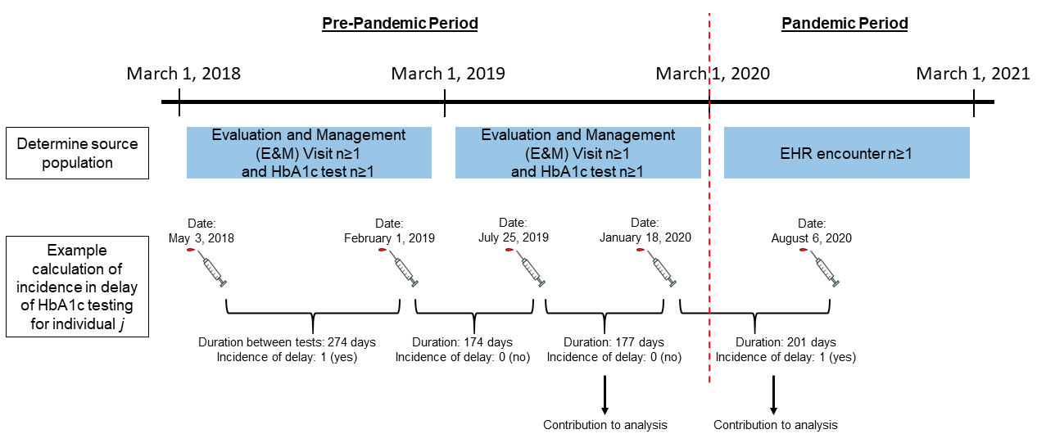

Supplemental Figure S2. Frequency of overall retinal screening exams during three contiguous 12-month periods from March 1, 2018 to February 28, 2021

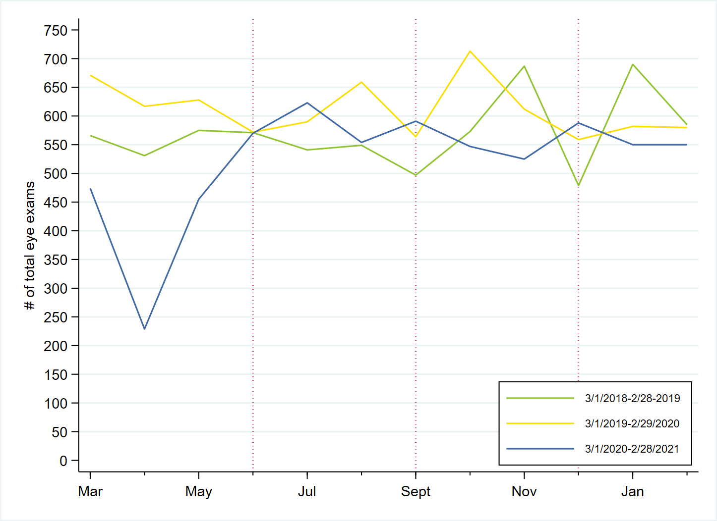
Month
Supplemental Figure S3. Frequency of overall nephropathy evaluations during three contiguous 12-month periods from March 1, 2018 to February 28, 2021

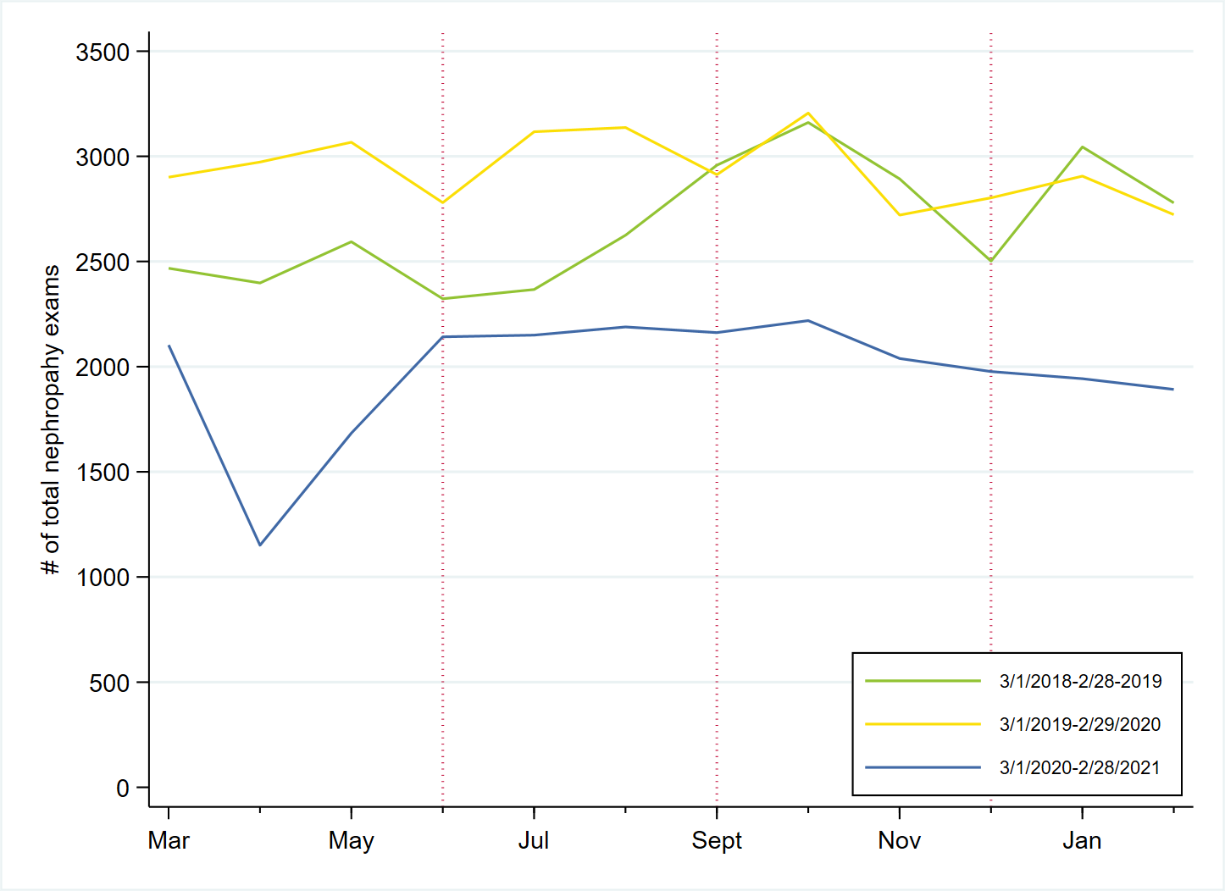
Month

