Supplementary Appendix

Description of Bariatric Cohort
The ENGAGE CVD cohort was assembled across 2009 - 2016 from a bariatric registry within a large integrated healthcare system serving the Southern California region of the US. This healthcare system had 4.2 million members, 14 hospitals, 200 medical offices, 5,700 physicians, and 23 bariatric surgeons at the time the cohort was assembled. Case ascertainment and verification for the bariatric registry and thus the ENGAGE CVD cohort was done in a variety of ways. Cases were included in the cohort in a stepwise fashion. The primary source was electronic reports from care managers at both internal healthcare system hospitals and contracted medical groups. These were compared to and augmented by electronic medical records and outside medical claims databases which were considered secondary data sources. If there was disagreement between the primary and secondary sources or the case only existed in a secondary source, the case was manually chart reviewed for confirmation. If necessary, the cases were adjudicated by bariatric surgeons employed by the healthcare system.
Cases were obtained from secondary sources using medical billing codes for bariatric operations. A full list of these billing codes is available upon request. Validation of cases obtained only through secondary sources found a 9% false positive rate. This rate was reduced to 7% if a diagnosis of obesity was required at the time of surgery. Of those cases from secondary sources that were verified as bariatric surgery, 96% had a diagnosis of obesity and 8% - 33% had incorrect procedure codes (i.e. they were verified as bariatric operations however they were not coded as the correct operation). The SG operations had the lowest error rates in coding and banding operations had the highest rates, with RYGB closer to SG error rates.
The selection process for the current study is shown in Figure S1 and is detailed in the main manuscript.
Diabetes Definition
For this study, we focused on patients with T2DM at the time of surgery, defined using the Surveillance, Prevention, and Management of Diabetes Mellitus (SUPREME DM) study which maximized both the capture and accuracy of patients with diabetes using electronic medical records (EMR).^{1,2} The SUPREME DM study included extensive validation of definitions for T2DM using only EMR across multiple healthcare systems in the U.S. The protocol for validation, which was used in the present study, is available from the study website.¹ The purpose of the paper was to show outcomes with surgery when real-world physicians made clinical decisions about the aftercare of patients with T2DM having surgery. To this end, the SUPREME DM T2DM definition was vetted by an advisory board of bariatric surgeons and a bariatrician co-investigator. This process of engagement is detailed in a previous publication.³

In addition, we also needed to use a valid definition of T2DM that could be created using existing, retrospective electronic medical records data. We did not have the resources and time to create and validate our own. The SUPREME DM definition was developed using 11 healthcare systems from the Healthcare Systems Research Network⁴ and electronic medical records for over 15 million patients served by these systems. We used their recommended approach to identify T2DM that used a complex algorithm that included all information available from laboratory results, medications, and diagnoses. We then applied a modified Klompas algorithm⁵ for Type 1 Diabetes Mellitus (T1DM) and removed patients who were positive for T1DM.

Main Analyses

Our primary analysis used Cox proportional hazards models to assess the relationship between weight loss after surgery and T2DM remission. Analysis time ran from the date of surgery until the date of remission, or the date of last weight measurement for patients who did not remit. Weight loss was included in the model as 5 binary time varying covariates, for membership in the following weight loss categories: >0 to ≤5%, >5 to ≤10%, >10 to ≤15%, >15 to ≤20%, >20 to ≤25%, >25 to ≤30%, >30%. Weight loss was calculated as the difference between weight at surgery, and last measured weight. The last measured weight was the weight at the time of remission for individuals who remitted.

The following covariates were included in all models: surgery type (RYGB indicator), sex (female indicator), race/ethnicity (indicators for Black, Hispanic, and Other [all other race categories and those missing race]), age, age squared, HBA1C (quartile indicators), DiaRem score (quartile indicators), Elixhauser score (quartile indicators), BMI (quartile indicators), weight at surgery (quartile indicators), BMI≥50 at surgery (indicator), drug use in year prior to surgery (indicators for aspirin and NSAIDS), drug use 3 months prior to surgery (indicators for aspirin and NSAIDs), number of diabetes drugs at surgery (indicators for 0, 1, and 2), drug use at surgery (indicators for dyslipidemia drugs and insulin), inpatient visits in year pre-surgery (indicator for above median), emergency department visits in year pre-surgery (indicator for above median), appointment attendance rate in year pre-surgery (indicator for above median), weight change in year pre-surgery (indicator for above median), and prior diagnosis indicators (hypertension, cirrhosis, sleep apnea, chronic kidney disease, serious mental condition, severe anxiety, mild to moderate anxiety).

Table S1 provides a descriptive analysis of the types of medications used for the patient cohort with T2DM at the time of surgery and the types of medications used for these patients during follow-up. The most frequently used medications at the time of surgery and in follow-up were Glipizide, Glyburide, and Insulin.

Subgroup Analyses

We also examined how the relationship between %TWL and T2DM remission varies across subsets of the population. Because the initial outcome findings suggested that there was an upper threshold for the effect of weight loss (>20% TWL) on initial T2DM remission, we used the following categories of %TWL to improve the stability of the subgroup models: 0 to < 5%, >5 to <10%, >10% to <15%, >15% to <20%, and >20%. We ran analyses that stratified the relationship by remission probability at surgery (high DiaRem score (≥8) vs low DiaRem score (≤7), Figure S1), binary use of insulin at surgery (Figure 2), four categories of race/ethnicity (White, Black, Hispanic, Other, Figure 3), BMI (≥50 vs <50, Figure S2), age (≥65 vs <65, Figure S3), and surgery type (RYGB vs SG, Figure S4). In each of these analyses, the group variables of interest were interacted with the five indicators for category of %TWL (0-5%, 5-10%, 10-15%, 15-20%, >20%). For example, the analysis of the relationship stratified by diabetes severity at surgery (Figure 2) included nine interactions, as compared to a reference group with low severity and 0-5% TWL.

In addition to the comparison of each indicator to the reference category noted in that figure (reported in the aforementioned figures), we also tested if the overall relationship between %TWL and T2DM remission varied significantly across the values of the group variable of interest. We did this with Wald tests of the joint hypothesis that the coefficients on the interaction variables are equal (the chi-squared statistics and p-values reflecting the joint significance of these tests are reported in supplementary Table S1). For example, for the analyses that stratify the relationship across insulin use (Figure 2), we tested the joint hypothesis that the five interaction variables for %TWL interacted with insulin use at surgery were equal to the five interactions between %TWL and insulin non-use at surgery. This hypothesis was rejected with a p-value<0.001.

References
- Surveillance, Prevention, and Management of Diabetes Mellitus. SUPREME-DM - Home. http://www.supreme-dm.org/index.html. Accessed on November 15, 2016.
- Nichols GA, Schroeder EB, Karter AJ, Gregg EW, Desai J, Lawrence JM, O'Connor PJ, Xu S, Newton KM, Raebel MA, Pathak RD, Waitzfelder B, Segal J, Lafata JE, Butler MG, Kirchner HL, Thomas A, Steiner JF. Trends in Diabetes Incidence Among 7 Million Insured Adults, 2006-2011: The SUPREME-DM Project. Am J Epidemiology. 2015; 181:32-39. PMID: 25515167.
- Coleman KJ, Fischer H, Arterburn DE, Barthold D, Barton LJ, Basu A, Courcoulas A, Crawford CL, Fedorka P, Kim B, Mun E, Murali S, Reynolds K, Suh K, Wei R, Yoon TK, Zane R. Effectiveness of gastric bypass versus gastric sleeve for cardiovascular disease: Protocol and baseline results for a comparative effectiveness study. JMIR Res Protoc. 2020 Apr 6;9(4):e14936. doi: 10.2196/14936. PMID: 32249757.
- Healthcare Systems Research Network. Mission and Vision. http://www.hcsrn.org/en/About/. Accessed on June 7, 2021.
- Klompas M, Eggleston E, McVetta J, Lazarus R, Li L, Platt R. Automated detection and classification of type 1 versus type 2 diabetes using electronic health record data. Diabetes Care. 2013; 36:914-21. PMID: 23193215.

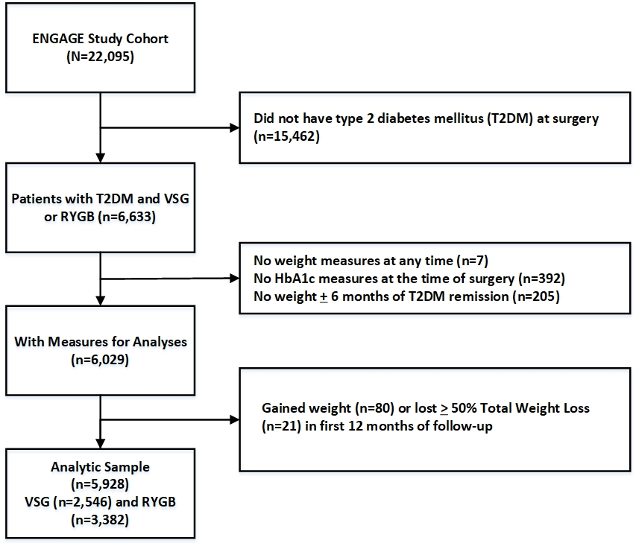
Figure S1. Selection process for study cohort.

Figure S2. – Association between type 2 diabetes (T2DM) remission and weight loss after bariatric surgery, stratified by DiaRem score at surgery (High DiaRem if ≥ 8, Low DiaRem if ≤ 7).

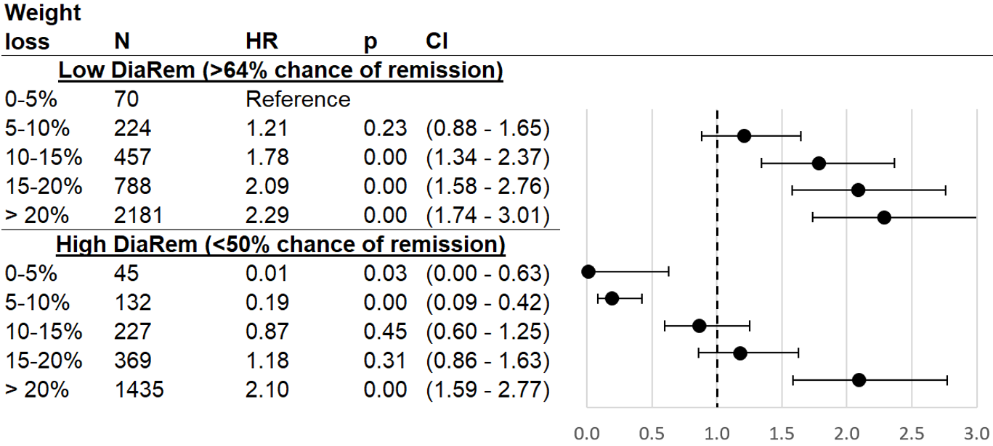
Cox proportional hazard model results for T2DM remission as related to percent of weight lost from surgery date until date of remission or censoring, as compared to patients who lost 0-5% of their surgery weight. %TWL was modeled as a time-varying covariate, interacted with binary DiaRem (high vs low). Sample is ENGAGE recipients of bariatric surgery who had T2DM at time of surgery and subsequently had their weight measured, had their weight measured at time of T2DM remission (if they remitted), and were not outliers (weight gain of >0% or weight loss of >50%). HR (hazard ratios) adjust for surgery type, sex, race/ethnicity, age, age squared, HBA1C (quartiles), Elixhauser score (quartiles), BMI (quartiles), weight at surgery (quartiles), BMI≥50 at surgery indicator, indicators for drug use in year and 3 months prior to surgery (aspirin, NSAIDs), number of diabetes drugs at surgery (indicators for 0, 1, and 2), drug use at surgery (dyslipidemia drugs, insulin), inpatient visits in year pre-surgery above median, emergency department visits in year pre-surgery above median, pre-surgery appointment attendance rate above median, pre-surgery weight change above median, and prior diagnosis indicators (hypertension, cirrhosis, sleep apnea, chronic kidney disease, serious mental condition, severe anxiety, mild to moderate anxiety). Abbreviations: HR (hazard ratio), CI (confidence interval), BMI (body mass index), TWL (total weight loss), T2DM (type 2 diabetes mellitus), RYGB (Roux-en-Y Gastric Bypass), DiaRem (Diabetes Remission Score), NSAIDS (non-steroidal anti-inflammatory drugs)

Figure S3. Association between type 2 diabetes (T2DM) remission and weight loss after bariatric surgery, stratified by body mass index (BMI).

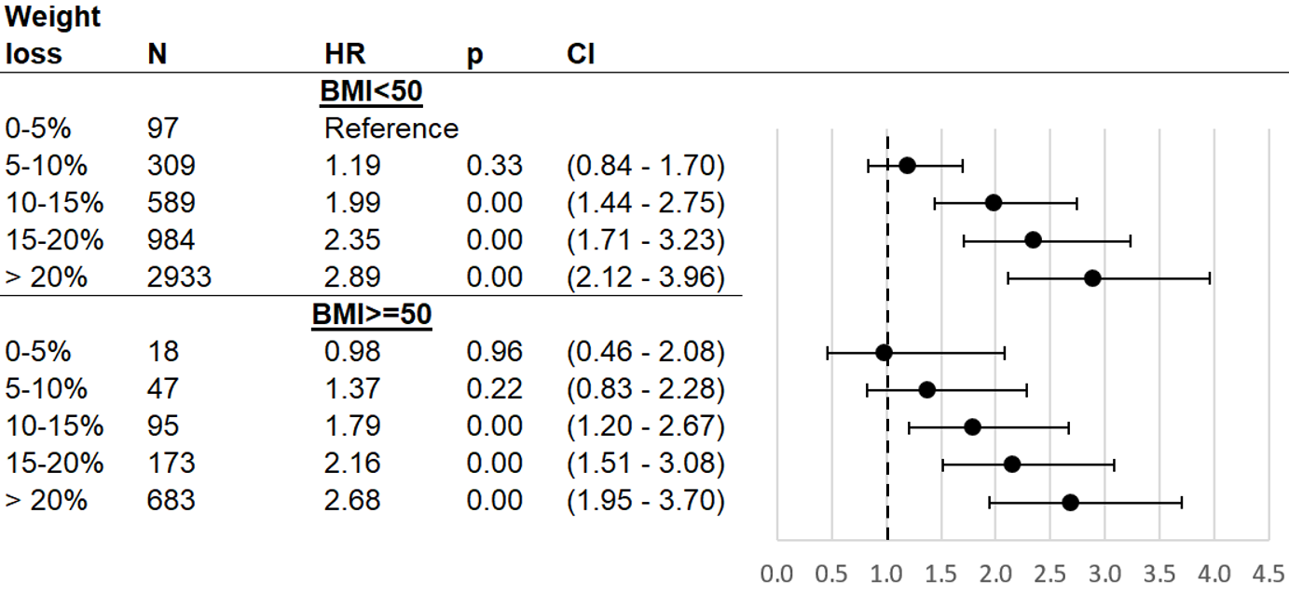
Cox proportional hazard model results for T2DM remission as related to percent of weight lost from surgery date until date of remission or censoring, as compared to patients who lost 0-5% of their surgery weight. %TWL was modeled as a time-varying covariate, interacted with binary BMI (<50 vs ≥50). Sample is ENGAGE recipients of bariatric surgery who had T2DM at time of surgery and subsequently had their weight measured, had their weight measured at time of T2DM remission (if they remitted), and were not outliers (weight gain of >0% or weight loss of >50%). HR (hazard ratios) adjust for surgery type, sex, race/ethnicity, age, age squared, HBA1C (quartiles), DiaRem score (quartiles), Elixhauser score (quartiles), weight at surgery (quartiles), indicators for drug use in year and 3 months prior to surgery (aspirin, NSAIDs), number of diabetes drugs at surgery (indicators for 0, 1, and 2), drug use at surgery (dyslipidemia drugs, insulin), inpatient visits in year pre-surgery above median, emergency department visits in year pre-surgery above median, pre-surgery appointment attendance rate above median, pre-surgery weight change above median, and prior diagnosis indicators (hypertension, cirrhosis, sleep apnea, chronic kidney disease, serious mental condition, severe anxiety, mild to moderate anxiety). Abbreviations: HR (hazard ratio), CI (confidence interval), BMI (body mass index), TWL (total weight loss), T2DM (type 2 diabetes mellitus), RYGB (Roux-en-Y Gastric Bypass), DiaRem (Diabetes Remission Score), NSAIDS (non-steroidal anti-inflammatory drugs)

Figure S4. Association between type 2 diabetes (T2DM) remission and weight loss after bariatric surgery, stratified by age.

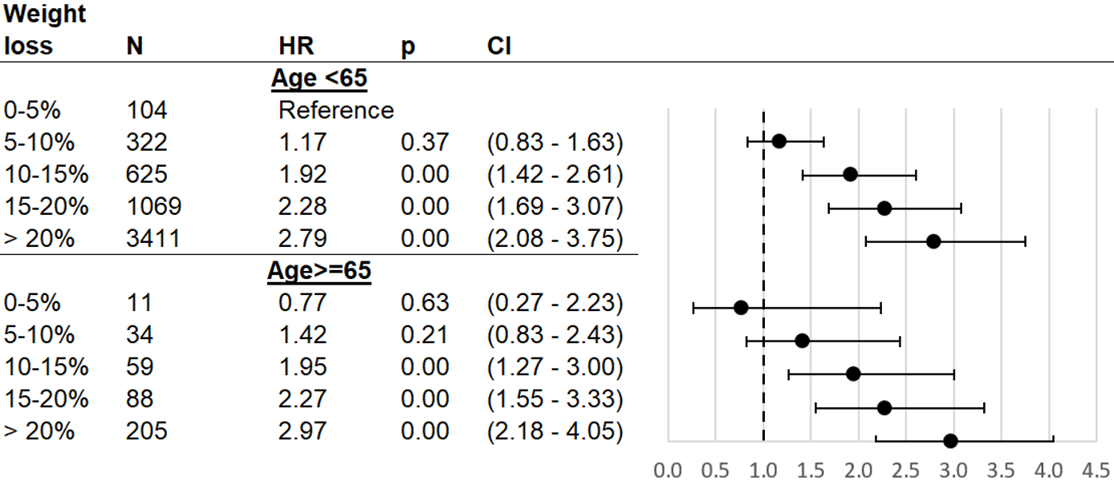
Cox proportional hazard model results for T2DM remission as related to percent of weight lost from surgery date until date of remission or censoring, as compared to patients who lost 0-5% of their surgery weight. %TWL was modeled as a time-varying covariate, interacted with binary age (< 65 vs. ≥65). Sample is ENGAGE recipients of bariatric surgery who had T2DM at time of surgery and subsequently had their weight measured, had their weight measured at time of T2DM remission (if they remitted), and were not outliers (weight gain of >0% or weight loss of >50%). HR (hazard ratios) adjust for surgery type, sex, race/ethnicity, HBA1C (quartiles), DiaRem score (quartiles), Elixhauser score (quartiles), BMI (quartiles), weight at surgery (quartiles), BMI≥50 at surgery indicator, indicators for drug use in year and 3 months prior to surgery (aspirin, NSAIDs), number of diabetes drugs at surgery (indicators for 0, 1, and 2), drug use at surgery (dyslipidemia drugs, insulin), inpatient visits in year pre-surgery above median, emergency department visits in year pre-surgery above median, pre-surgery appointment attendance rate above median, pre-surgery weight change above median, and prior diagnosis indicators (hypertension, cirrhosis, sleep apnea, chronic kidney disease, serious mental condition, severe anxiety, mild to moderate anxiety). Abbreviations: HR (hazard ratio), CI (confidence interval), BMI (body mass index), TWL (total weight loss), T2DM (type 2 diabetes mellitus), RYGB (Roux-en-Y Gastric Bypass), DiaRem (Diabetes Remission Score), NSAIDS (non-steroidal anti-inflammatory drugs).

Figure S5. Association between type 2 diabetes (T2DM) remission and weight loss after bariatric surgery, stratified by surgery type.
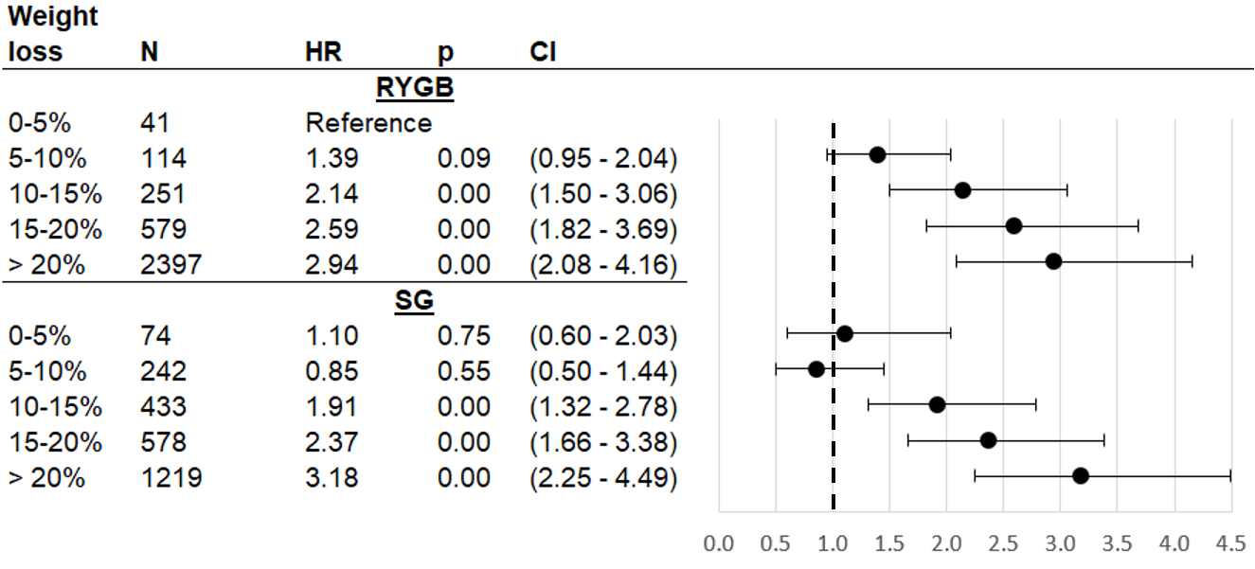Cox proportional hazard model results for T2DM remission as related to percent of weight lost from surgery date until date of remission or censoring, as compared to patients who lost 0-5% of their surgery weight. %TWL was modeled as a time-varying covariate, interacted with surgery type (RYGB vs SG). Sample is ENGAGE recipients of bariatric surgery who had T2DM at time of surgery and subsequently had their weight measured, had their weight measured at time of T2DM remission (if they remitted), and were not outliers (weight gain of >0% or weight loss of >50%). HR (hazard ratios) adjust for sex, race/ethnicity, age, age squared, HBA1C (quartiles), DiaRem score (quartiles), Elixhauser score (quartiles), BMI (quartiles), weight at surgery (quartiles), BMI≥50 at surgery indicator, indicators for drug use in year and 3 months prior to surgery (aspirin, NSAIDs), number of diabetes drugs at surgery (indicators for 0, 1, and 2), drug use at surgery (dyslipidemia drugs, insulin), inpatient visits in year pre-surgery above median, emergency department visits in year pre-surgery above median, pre-surgery appointment attendance rate above median, pre-surgery weight change above median, and prior diagnosis indicators (hypertension, cirrhosis, sleep apnea, chronic kidney disease, serious mental condition, severe anxiety, mild to moderate anxiety). Abbreviations: HR (hazard ratio), CI (confidence interval), BMI (body mass index), TWL (total weight loss), T2DM (type 2 diabetes mellitus), RYGB (Roux-en-Y Gastric Bypass), DiaRem (Diabetes Remission Score), NSAIDS (non-steroidal anti-inflammatory drugs), SG (gastric sleeve),
Figure S6. Association between type 2 diabetes (T2DM) remission and weight loss after bariatric surgery, with alternative weight loss categories.

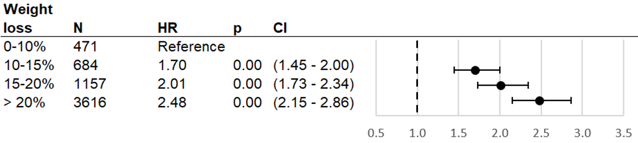
Cox proportional hazard model results for T2DM remission as related to percent of weight lost from surgery date until date of remission or censoring, as compared to patients who lost 0-10% of their surgery weight. %TWL was modeled as a time-varying covariate. Sample is ENGAGE recipients of bariatric surgery who had T2DM at time of surgery and subsequently had their weight measured, had their weight measured at time of T2DM remission (if they remitted), and were not outliers (weight gain of >0% or weight loss of >50%). HR (hazard ratios) adjust for surgery type, sex, race/ethnicity, age, age squared, HBA1C (quartiles), DiaRem score (quartiles), Elixhauser score (quartiles), BMI (quartiles), weight at surgery (quartiles), BMI≥50 at surgery indicator, indicators for drug use in year and 3 months prior to surgery (aspirin, NSAIDs), number of diabetes drugs at surgery (indicators for 0, 1, and 2), drug use at surgery (dyslipidemia drugs, insulin), inpatient visits in year pre-surgery above median, emergency department visits in year pre-surgery above median, pre-surgery appointment attendance rate above median, pre-surgery weight change above median, and prior diagnosis indicators (hypertension, cirrhosis, sleep apnea, chronic kidney disease, serious mental condition, severe anxiety, mild to moderate anxiety). Abbreviations: HR (hazard ratio), CI (confidence interval), BMI (body mass index), TWL (total weight loss), T2DM (type 2 diabetes mellitus), RYGB (Roux-en-Y Gastric Bypass), DiaRem (Diabetes Remission Score), NSAIDS (non-steroidal anti-inflammatory drugs).

Figure S7. Association between type 2 diabetes (T2DM) remission and weight loss after bariatric surgery, in a model without covariate adjustment.

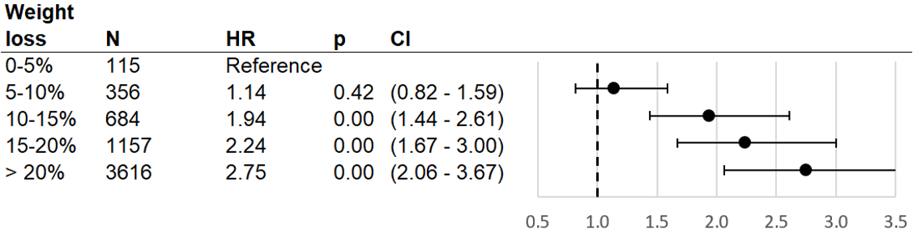
Cox proportional hazard model results for T2DM remission as related to percent of weight lost from surgery date until date of remission or censoring, as compared to patients who lost 0-5% of their surgery weight. %TWL was modeled as a time-varying covariate. Sample is ENGAGE recipients of bariatric surgery who had T2DM at time of surgery and subsequently had their weight measured, had their weight measured at time of T2DM remission (if they remitted), and were not outliers (weight gain of >0% or weight loss of >50%). Abbreviations: HR (hazard ratio), CI (confidence interval).

Figure S8. Association between type 2 diabetes (T2DM) remission and weight loss after bariatric surgery, in a model with parsimonious covariate adjustment.

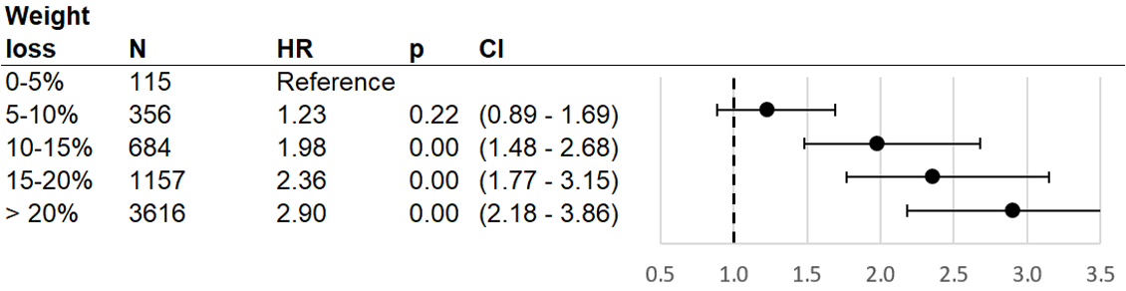
Cox proportional hazard model results for T2DM remission as related to percent of weight lost from surgery date until date of remission or censoring, as compared to patients who lost 0-5% of their surgery weight. %TWL was modeled as a time-varying covariate. Sample is ENGAGE recipients of bariatric surgery who had T2DM at time of surgery and subsequently had their weight measured, had their weight measured at time of T2DM remission (if they remitted), and were not outliers (weight gain of >0% or weight loss of >50%). HR (hazard ratios) adjust for sex, race/ethnicity, age, age squared, surgery type, BMI≥50 at surgery indicator, insulin use at surgery indicator, number of diabetes drugs at surgery (indicators for 0, 1, and 2), pre-surgery weight change above median indicator, HBA1C (quartiles), DiaRem score (quartiles), Elixhauser score (quartiles), weight at surgery (quartiles). Abbreviations: HR (hazard ratio), CI (confidence interval), BMI (body mass index), DiaRem (Diabetes Remission Score).

Figure S9. – Association between type 2 diabetes (T2DM) remission and weight loss after bariatric surgery, stratified by five categories of DiaRem score at surgery.

Cox proportional hazard model results for T2DM remission as related to percent of weight lost from surgery date until date of remission or censoring, as compared to patients who lost 0-5% of their surgery weight. %TWL was modeled as a time-varying covariate, interacted with five categories of DiaRem. Sample is ENGAGE recipients of bariatric surgery who had T2DM at time of surgery and subsequently had their weight measured, had their weight measured at time of T2DM remission (if they remitted), and were not outliers (weight gain of >0% or weight loss of >50%). HR (hazard ratios) adjust for surgery type, sex, race/ethnicity, age, age squared, HBA1C (quartiles), Elixhauser score (quartiles), BMI (quartiles), weight at surgery (quartiles), BMI≥50 at surgery indicator, indicators for drug use in year and 3 months prior to surgery (aspirin, NSAIDs), number of diabetes drugs at surgery (indicators for 0, 1, and 2), drug use at surgery (dyslipidemia drugs, insulin), inpatient visits in year pre-surgery above median, emergency department visits in year pre-surgery above median, pre-surgery appointment attendance rate above median, pre-surgery weight change above median, and prior diagnosis indicators (hypertension, cirrhosis, sleep apnea, chronic kidney disease, serious mental condition, severe anxiety, mild to moderate anxiety). Abbreviations: HR (hazard ratio), CI (confidence interval), BMI (body mass index), TWL (total weight loss), T2DM (type 2 diabetes mellitus), RYGB (Roux-en-Y Gastric Bypass), DiaRem (Diabetes Remission Score), NSAIDS (non-steroidal anti-inflammatory drugs)

Table S1. Types of diabetes medications used to define the T2DM cohort, and medications used after surgery.

Medication | Baseline | Follow-Up
GLIPIZIDE | 10340 | 1938
INSULIN ISOPHANE (HUMAN) | 9004 | 1790
INSULIN REGULAR (HUMAN) | 4558 | 839
INSULIN GLARGINE | 4220 | 807
GLYBURIDE | 2389 | 268
INSULIN ASPART | 2328 | 574
INSULIN ISOPHANE (HUMAN) INJ 100 UNIT/ML LILL | 1909 | 1335
GLIPIZIDE TAB 10 MG APOT | 1503 | 1936
INSULIN REGULAR (HUMAN) INJ 100 UNIT/ML LILL | 1270 | 1760
GLIPIZIDE TAB 5 MG APOT | 1227 | 3047
INSULIN NPH (HUMAN) (ISOPHANE) INJ 100 UNIT/ML LILL | 1187 | 3258
INSULIN ISOPHANE & REG (H | 876 | 167
GLIPIZIDE-METFORMIN HCL | 867 | 184
SITAGLIPTIN PHOSPHATE | 424 | 55
INSULIN LISPRO (HUMAN) INJ 100 UNIT/ML LILL | 328 | 512
INSULIN GLARGINE INJ 100 UNIT/ML SANO | 280 | 838
INSULIN LISPRO (HUMAN) | 210 | 203
INSULIN REGULAR (HUMAN) INJ 500 UNIT/ML LILL | 209 | 90
GLIPIZIDE-METFORMIN HCL TAB 5-500 MG TEVA | 170 | 311
GLYBURIDE TAB 5 MG TEVA | 146 | 183
MIGLITOL | 126 | 15
INSULIN ISOPHANE & REGULAR (HUMAN) INJ 100 UNIT/ML (70- LILL | 115 | 84
INSULIN DETEMIR | 103 | 46
INSULIN NPH ISOPHANE & REGULAR HUMAN INJ 100 UNIT/ML (7 LILL | 95 | 174
LINAGLIPTIN TAB 5 MG BOEH | 93 | 455
GLIMEPIRIDE | 71 | 2
INSULIN ASPART PROTAMINE | 69 | 4
INSULIN LISPRO (HUMAN) SOLN PEN-INJECTOR 100 UNIT/ML LILL | 61 | 155
PRAMLINTIDE ACETATE | 45 | 0
TOLAZAMIDE | 44 | 5
GLUCAGON (RDNA) FOR INJ KIT 1 MG LILL | 33 | 192
GLUCAGON HCL (RDNA) | 29 | 34
ACARBOSE | 29 | 8
INSULIN GLARGINE SOLN PEN-INJECTOR 100 UNIT/ML SANO | 28 | 77
INSULIN NPH (HUMAN) (ISOPHANE) SUSP PEN-INJECTOR 100 UN LILL | 25 | 357
GLIPIZIDE-METFORMIN HCL TAB 2.5-500 MG TEVA | 25 | 48
GLIPIZIDE TAB SR 24HR 10 MG GREE | 25 | 25
GLUCAGON (RDNA) | 24 | 17
INSULIN ISOPHANE (HUMAN) INJ 100 UNIT/M NOVO | 23 | 12
GLYBURIDE TAB 2.5 MG TEVA | 22 | 37
SITAGLIPTIN PHOSPHATE TAB 100 MG (BASE EQUIV) MERC | 22 | 2
GLIMEPIRIDE TAB 4 MG TEVA | 18 | 16
INSULIN GLARGINE INJ 100 UNIT/M SANO | 17 | 22
GLIPIZIDE TAB 5 MG MYLA | 16 | 25
GLYBURIDE-METFORMIN | 15 | 0
EMPAGLIFLOZIN TAB 25 MG BOEH | 15 | 147
GLIPIZIDE TAB 10 MG MYLA | 15 | 6
GLIPIZIDE-METFORMIN HCL TAB 5-500 MG WATS | 13 | 5
INSULIN LISPRO (HUMAN) INJ 100 UNIT/M LILL | 12 | 12
GLIPIZIDE-METFORMIN HCL TAB 2.5-250 MG TEVA | 11 | 30
INSULIN GLULISINE | 10 | 0
INSULIN ISOPHANE (HUMAN) SUSP PEN-INJECTOR 100 UNIT/ML LILL | 10 | 20
INSULIN ASPART INJ 100 UNIT/M NOVO | 10 | 17
EMPAGLIFLOZIN TAB 10 MG BOEH | 10 | 12
SITAGLIPTIN-METFORMIN HCL | 9 | 8
GLIMEPIRIDE TAB 2 MG TEVA | 8 | 16
INSULIN REGULAR (HUMAN) INJ 100 UNIT/M NOVO | 8 | 4
INSULIN DETEMIR INJ 100 UNIT/ML NOVO | 7 | 5
INSULIN REGULAR (HUMAN) INJ 500 UNIT/M LILL | 7 | 2
GLIPIZIDE TAB SR 24HR 5 MG GREE | 6 | 15
INSULIN ASPART PROT & ASPART (HUMAN) INJ 100 UNIT/ NOVO | 5 | 0
INSULIN LISPRO INJ 100 UNIT/ML LILL | 5 | 261
INSULIN DETEMIR SOLN PEN-INJECTOR 100 UNIT/ML NOVO | 5 | 8
GLIPIZIDE TAB SR 24HR 2.5 MG ACTA | 5 | 7
INSULIN ISOPHANE (HUMAN) INJ 100 UNIT/ML NOVO | 5 | 6
SITAGLIPTIN PHOSPHATE TAB 50 MG (BASE EQUIV) MERC | 5 | 4
ACARBOSE TAB 100 MG ROXA | 5 | 1
CANAGLIFLOZIN-METFORMIN HCL TAB 150-1,000 MG JANS | 4 | 0
PRAMLINTIDE ACETATE INJ 2700 MCG/2.7ML (1000 MCG/ML) (B AMYL | 4 | 0
SITAGLIPTIN PHOSPHATE TAB 50 MG MERC | 4 | 0
GLIMEPIRIDE TAB 1 MG TEVA | 4 | 30
GLIPIZIDE TAB SR 24HR 2.5 MG GREE | 4 | 7
INSULIN REGULAR (HUMAN) INJ 100 UNIT/ML NOVO | 4 | 4
LINAGLIPTIN | 4 | 3
SITAGLIPTIN PHOSPHATE TAB 100 MG MERC | 4 | 3
INSULIN LISPRO PROT & LISPRO (HUMAN) INJ 100 UNIT/M SUS LILL | 3 | 0
INSULIN LISPRO PROT & LISPRO (HUMAN) INJ 100 UNIT/ML (7 LILL | 3 | 0
GLYBURIDE TAB 1.25 MG TEVA | 3 | 38
CANAGLIFLOZIN TAB 100 MG JANS | 3 | 18
CANAGLIFLOZIN TAB 300 MG JANS | 3 | 18
ACARBOSE TAB 25 MG GLOB | 3 | 6
ACARBOSE TAB 25 MG STRI | 3 | 6
ACARBOSE TAB 50 MG ROXA | 3 | 2
ACARBOSE TAB 25 MG ACTA | 2 | 0
INSULIN LISPRO PROT & LISPRO (HUMAN) INJ 100 UNIT/ LILL | 2 | 0
ACARBOSE TAB 50 MG GLOB | 2 | 7
GLIPIZIDE-METFORMIN HCL TAB 5-500 MG ACTA | 2 | 4
ACARBOSE TAB 50 MG IMPA | 2 | 3
GLIPIZIDE-METFORMIN HCL TAB 2.5-500 MG MYLA | 2 | 2
ACARBOSE TAB 25 MG IMPA | 2 | 1
GLIPIZIDE-METFORMIN HCL TAB 2.5-500 MG 2.5-500M WATS | 2 | 1
ACARBOSE TAB 50 MG ACTA | 1 | 0
GLIPIZIDE-METFORMIN HCL TAB 2.5-500 MG ACTA | 1 | 0
INSULIN ASPART PROT & ASPART (HUMAN) INJ 100 UNIT/ML (7 NOVO | 1 | 0
INSULIN ISOPHANE (HUMAN) INJ 100 UNIT/M LILL | 1 | 0
MIGLITOL TAB 100 MG PFIZ | 1 | 0
PIOGLITAZONE HCL-GLIMEPIR | 1 | 0
PRAMLINTIDE ACETATE PEN-INJ 2700 MCG/2.7ML (1000 MCG/ML AMYL | 1 | 0
SITAGLIPTIN-METFORMIN HCL TAB 50-500 MG MERC | 1 | 0
INSULIN LISPRO SOLN PEN-INJECTOR 100 UNIT/ML LILL | 1 | 68
ACARBOSE TAB 50 MG ALVO | 1 | 23
INSULIN ASPART INJ 100 UNIT/ML NOVO | 1 | 7
ACARBOSE TAB 25 MG ROXA | 1 | 6
GLIPIZIDE TAB SR 24HR 5 MG ACTA | 1 | 6
GLIPIZIDE-METFORMIN HCL TAB 2.5-250 MG 2.5-250M TEVA | 1 | 3
ACARBOSE TAB 50 MG STRI | 1 | 1
GLIPIZIDE-METFORMIN HCL TAB 2.5-500 MG 2.5-500M MYLA | 1 | 1
INSULIN NPH & REGULAR SUSP PEN-INJ 100 UNIT/ML (70-30) LILL | 0 | 61
GLIPIZIDE TAB ER 24HR 5 MG ACTA | 0 | 25
ACARBOSE TAB 25 MG ALVO | 0 | 24
ACARBOSE TAB 100 MG ALVO | 0 | 17
DAPAGLIFLOZIN PROPANEDIOL TAB 5 MG (BASE EQUIVALENT) ASTR | 0 | 17
GLIPIZIDE TAB ER 24HR 10 MG ACTA | 0 | 14
TOLAZAMIDE TAB 500 MG MYLA | 0 | 13
INSULIN ASPART SOLN PEN-INJECTOR 100 UNIT/ML NOVO | 0 | 12
INSULIN REGULAR (HUMAN) SOLN PEN-INJECTOR 500 UNIT/ML LILL | 0 | 10
DIAZOXIDE SUSP 50 MG/ML TEVA | 0 | 9
LINAGLIPTIN-METFORMIN HCL TAB 2.5-1,000 MG BOEH | 0 | 9
INSULIN ISOPHANE & REGULAR SUSP PEN-INJ 100 UNIT/ML (70 LILL | 0 | 4
MIGLITOL TAB 25 MG PFIZ | 0 | 4
SITAGLIPTIN PHOSPHATE TAB 25 MG (BASE EQUIV) MERC | 0 | 4
ACARBOSE TAB 25 MG VIRT | 0 | 3
DIAZOXIDE SUSP 50 MG/ML GATE | 0 | 3
GLIPIZIDE TAB ER 24HR 2.5 MG ACTA | 0 | 3
GLIPIZIDE-METFORMIN HCL TAB 2.5-250 MG ACTA | 0 | 3
GLIPIZIDE-METFORMIN HCL TAB 2.5-250 MG WATS | 0 | 3
MIGLITOL TAB 50 MG PFIZ | 0 | 3
GLIMEPIRIDE TAB 2 MG ACCO | 0 | 2
GLIPIZIDE TAB ER 24HR 10 MG GREE | 0 | 2
ACARBOSE TAB 100 MG GLOB | 0 | 1
ACARBOSE TAB 25 MG WEST | 0 | 1
GLIMEPIRIDE TAB 1 MG ACCO | 0 | 1
GLIMEPIRIDE TAB 1 MG VIRT | 0 | 1
GLIPIZIDE TAB SR 24HR 10 MG ACTA | 0 | 1
GLUCAGON HCL (RDNA) FOR INJ 1 MG (BASE EQUIV) NOVO | 0 | 1
GLUCAGON HCL (RDNA) FOR INJ 1 MG NOVO | 0 | 1
INSULIN NPH (HUMAN) (ISOPHANE) INJ 100 UNIT/ML NOVO | 0 | 1

Table S2. Unadjusted T2DM remission rates per person-year for subgroups.

Weight loss | All | Low DiaRem | High DiaRem | No insulin use | Insulin use | White | Black | Hispanic | Other
0-5% | 0.05 | 0.10 | 0.00 | 0.09 | 0.00 | 0.03 | 0.10 | 0.06 | 0.04
5-10% | 0.09 | 0.19 | 0.01 | 0.17 | 0.01 | 0.11 | 0.12 | 0.06 | 0.09
10-15% | 0.21 | 0.40 | 0.05 | 0.34 | 0.05 | 0.19 | 0.24 | 0.21 | 0.16
15-20% | 0.32 | 0.64 | 0.10 | 0.59 | 0.09 | 0.30 | 0.33 | 0.34 | 0.27
> 20% | 0.39 | 0.70 | 0.20 | 0.62 | 0.20 | 0.39 | 0.37 | 0.41 | 0.42
20-25% | 0.42
25-30% | 0.41
>30% | 0.35
Weight loss | All | BMI<50 | BMI>=50 | Age<65 | Age>=65 | RYGB | SG
0-5% | 0.05 | 0.03 | 0.06 | 0.05 | 0.05 | 0.05 | 0.05
5-10% | 0.09 | 0.08 | 0.10 | 0.09 | 0.09 | 0.06 | 0.11
10-15% | 0.21 | 0.19 | 0.21 | 0.20 | 0.25 | 0.15 | 0.26
15-20% | 0.32 | 0.31 | 0.32 | 0.32 | 0.30 | 0.27 | 0.38
> 20% | 0.39 | 0.42 | 0.39 | 0.40 | 0.28 | 0.38 | 0.42
These are remission rates per person-year across categories of % total weight loss (TWL) in the analytic sample. Each cell corresponds to a subgroup individuals with %TWL noted in the row, and another characteristic noted in the column. Abbreviations: BMI (body mass index), TWL (total weight loss), T2DM (type 2 diabetes mellitus), RYGB (Roux-en-Y Gastric Bypass), DiaRem (Diabetes Remission Score), SG (gastric sleeve),

Table S3. Tests of heterogeneity in the relationships between %TWL and T2DM.

Comparison | Chi-squared | p
Age>=65 vs age<65 | 1.14 | 0.95
BMI>=50 vs BMI<50 | 1.42 | 0.92
Insulin vs no insulin | 79.18 | 0.00
Black vs White | 28.55 | 0.00
Hispanic vs White | 8.10 | 0.15
Other vs White | 1.14 | 0.95
Hispanic vs Black | 34.55 | 0.00
Other vs Black | 5.42 | 0.37
Other vs Hispanic | 0.62 | 0.99
DiaRem high vs DiaRem low | 79.91 | 0.00
RYGB vs SG | 22.93 | 0.00
Results of Wald tests of the joint hypothesis that the model coefficients on the interactions between the five categories of %TWL and one side of comparison group are equal to the coefficients on the interactions between the five categories of %TWL and the other side of the comparison group. P-values reflect the joint significance of a chi-squared test with 5 degrees of freedom. Abbreviations: BMI (body mass index), TWL (total weight loss), T2DM (type 2 diabetes mellitus), RYGB (Roux-en-Y Gastric Bypass), DiaRem (Diabetes Remission Score), SG (gastric sleeve),

Table S4. Associations between change in HBA1C and percent weight change, estimated in an OLS regression with individual fixed effects.

Weight loss | Coefficient | Standard error | p-value | 95% confidence interval | N
0-5% | Reference |  |  |  | 214
5-10% | -0.40 | 0.06 | 0.00 | (-0.51, -0.28) | 616
10-15% | -0.51 | 0.05 | 0.00 | (-0.60, -0.41) | 933
15-20% | -0.75 | 0.04 | 0.00 | (-0.85, -0.67) | 1030
> 20% | -1.13 | 0.03 | 0.00 | (-1.18, -1.08) | 2928
Results from ordinary least squares (OLS) regression with individual fixed effects, with dependent variable as the change in HbA1c after surgery. The percent change in weight was measured from the time of surgery to the time at which the last HbA1c measurement.

