The effect of dapagliflozin on albuminuria in the DECLARE-TIMI 58 trial
Ofri Mosenzon MD MSc¹, Stephen D Wiviott MD², Hiddo H J Heerspink PhD³, Jamie P Dwyer MD⁴, Avivit Cahn MD¹, Erica L Goodrich MS², Aliza Rozenberg MA¹, Meir Schechter MSc¹, Ilan Yanuv MSc¹, Sabina A Murphy MPH², Thomas A Zelniker MD MSc ^{2,5}, Ingrid A M Gause-Nilsson MD⁶, Anna Maria Langkilde MD⁶, Martin Fredriksson MD⁶, Peter A Johansson MSc⁶, Deepak L Bhatt MD MPH ², Lawrence A Leiter MD⁷, Darren K McGuire MD⁸, John P H Wilding MD⁹, Marc S Sabatine MD², Itamar Raz MD¹

¹ The Diabetes Unit, Department of Endocrinology and Metabolism, Hadassah Medical Center, The Faculty of Medicine, Hebrew University of Jerusalem, Jerusalem, Israel
² TIMI Study Group, Cardiovascular Division, Brigham and Women's Hospital and Harvard Medical School, Boston, MA, USA
³ University Medical Center Groningen, University of Groningen, Groningen, Netherlands and The George Institute for International Health, Sydney, Australia
⁴ Vanderbilt University Medical Center, Nashville, TN, USA.
⁵ Division of Cardiology, Medical University of Vienna, Austria
⁶ Bio Pharmaceuticals R&D, AstraZeneca Gothenburg, Sweden
⁷Li Ka Shing Knowledge Institute, St. Michael's Hospital, University of Toronto, Ontario, Canada
⁸Division of Cardiology, University of Texas Southwestern Medical Center, Dallas, TX, USA and Parkland Health and Hospital System
⁹Department of Cardiovascular and Metabolic Medicine, University of Liverpool, Liverpool, United Kingdom

Key words: Type 2 diabetes; Dapagliflozin; SGLT2i; Diabetic kidney disease; Prevention; Urinary albumin to creatinine ratio (UACR).

Running title: Albuminuria in the DECLARE-TIMI 58

Supplementary materials
Table S1: Distribution of categorical UACR at baseline and 6 months’ time points in dapagliflozin vs. placebo arm.
Visit | UACR categories | Dapagliflozin |  | Placebo
 |  | N | % | N | % | P-value
Baseline | ≤15 mg/g | 4381 | 54.0% | 4346 | 54.0% | 0.9899
 | 15-<30 mg/g | 1240 | 15.3% | 1244 | 15.4%
 | ≥30-≤300 mg/g | 1942 | 23.9% | 1915 | 23.8%
 | >300 mg/g | 555 | 6.8% | 549 | 6.8%
6 months | ≤15 mg/g | 4508 | 55.7% | 4168 | 51.8% | <0.0001
 | 15-<30 mg/g | 1317 | 16.3% | 1246 | 15.5%
 | ≥30-≤300 mg/g | 1853 | 22.9% | 2019 | 25.1%
 | >300 mg/g | 412 | 5.1% | 591 | 7.3%

Legends: Participants distribution within the UACR categories at baseline and at 6 months, among those with readings at both time points. Comparison between treatment arms was performed using the χ² test. UACR – Urinary Albumin to Creatinine Ratio

Figure S1: One time change in categorical UACR from baseline to end of trial (EOT) in dapagliflozin vs. placebo arm. A. Improvement in UACR categories B. Deterioration in UACR categories

- Improvement

- Deterioration

Figure S2: Deterioration in categorical albuminuria status over time (Kaplan-Meier estimate):
- New onset of >15 mg/g in patients with ≤15 mg/g at baseline
- New onset of >=30 mg/g in patients with <30 mg/g at baseline
- New onset of >300 mg/g in patients with <=300 mg/g at baseline
A-
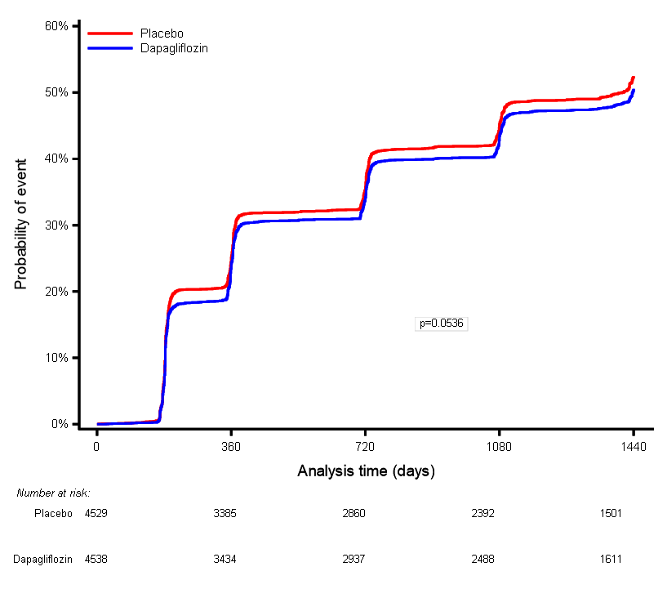
P=0.0536

B-
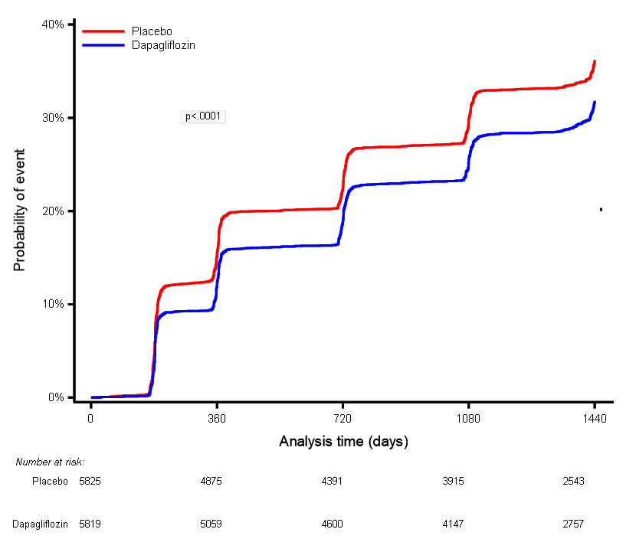

C-
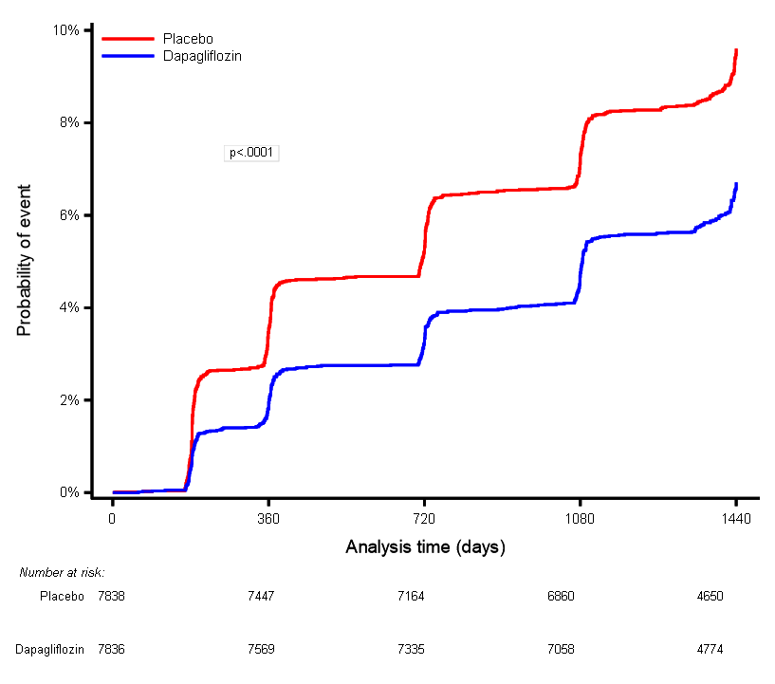
P<0.0001

