Influenza Vaccination is associated with Reduced Cardiovascular Mortality in Diabetes Mellitus. A Nationwide Cohort Study.

Authors
Daniel Modin; Brian Claggett; Lars Køber; Morten Schou; Jens Ulrik Stæhr Jensen; Scott D. Solomon; Orly Vardeny; Filip Krag Knop; Susanne Dam Nielsen; Michael Fralick; Christian Torp-Pedersen; Gunnar Gislason; Tor Biering-Sørensen

Supplemental Material

EXTENDED METHODS

Patient characteristics

We retrieved patient characteristics assessed at the beginning of each season (December 1) from the Danish National Patient Registry[1] using ICD-10 codes (Supplemental Table S2). All diagnoses from the Danish National Patient Register included in the Charlson comorbidity index have been validated with positive predictive values of 96% to 100%[2]. Information on medication use at the beginning of each season was retrieved from the Danish National Prescription Registry[3] and defined as at least 1 filled prescription up to 6 months prior to baseline. Household income and educational level at the beginning of each season was collected from the Danish National Population Registry[4]. To account for changes between seasons, patient age, vaccination status in previous season, comorbidities, medications and household income and were reassessed at each the beginning of each season.

REFERENCES
1. Schmidt M, Schmidt SAJ, Sandegaard JL, Ehrenstein V, Pedersen L, Sørensen HT. The Danish National Patient Registry: a review of content, data quality, and research potential. Clin Epidemiol. 2015 Nov 17;7:449–90.
2. Thygesen SK, Christiansen CF, Christensen S, Lash TL, Sørensen HT. The predictive value of ICD-10 diagnostic coding used to assess Charlson comorbidity index conditions in the population-based Danish National Registry of Patients. BMC Med Res Methodol. 2011 May 28;11:83.
3. Kildemoes HW, Sørensen HT, Hallas J. The Danish National Prescription Registry. Scand J Public Health. 2011 Jul;39(7 Suppl):38–41.
4. Pedersen CB. The Danish Civil Registration System. Scand J Public Health. 2011 Jul;39(7 Suppl):22–5.
5. Modin Daniel, Jørgensen Mads Emil, Gislason Gunnar, Jensen Jan Skov, Køber Lars, Claggett Brian, Hegde Sheila M., Solomon Scott D., Torp-Pedersen Christian, Biering-Sørensen Tor. Influenza Vaccine in Heart Failure. Circulation. 2019 Jan 29;139(5):575–86.
6. Kümler T, Gislason GH, Kirk V, Bay M, Nielsen OW, Køber L, Torp-Pedersen C. Accuracy of a heart failure diagnosis in administrative registers. Eur J Heart Fail. 2008 Jul;10(7):658–60.
7. Jørgensen ME, Hlatky MA, Køber L, Sanders RD, Torp-Pedersen C, Gislason GH, Jensen PF, Andersson C. β-Blocker–Associated Risks in Patients With Uncomplicated Hypertension Undergoing Noncardiac Surgery. JAMA Intern Med. 2015 Dec 1;175(12):1923–31.
8. Andersson C, Norgaard ML, Hansen PR, Fosbøl EL, Schmiegelow M, Weeke P, Olesen JB, Raunsø J, Jørgensen CH, Vaag A, Køber L, Torp-Pedersen C, Gislason GH. Heart failure severity, as determined by loop diuretic dosages, predicts the risk of developing diabetes after myocardial infarction: a nationwide cohort study. Eur J Heart Fail. 2010 Dec;12(12):1333–8.
9. Andersson C, Lyngbæk S, Nguyen CD, Nielsen M, Gislason GH, Køber L, Torp-Pedersen C. Association of clopidogrel treatment with risk of mortality and cardiovascular events following myocardial infarction in patients with and without diabetes. JAMA. 2012 Sep 5;308(9):882–9.

SUPPLEMENTAL TABLES

Table S1. Nationwide registries used in the present study

 | National Patient Registry | National Prescription Registry | National Population Registry | National Cause of Death Registry | National General Practitioners Reimbursement Registry
Created and established | 1977 | 1995 | 1976 | 1970 | 1990
Examples of data in the registries | Hospital diagnoses, hospital contacts, procedure codes | Filled prescriptions for all Danish citizens | Date of birth, sex, emigration status, household income and education level | Time and cause of death | Type and time of administration of all services in the general practice sector
Coding | ICD-10 | ATC-codes | N/A | ICD-10 | Unique governmental reimbursement codes
Data used in the present study | Patient comorbidities at the beginning of each season | Definition of Diabetes Mellitus and patient medication use at the beginning of each season | Age, sex, income and education level at the beginning of each season | Outcome (all-cause death, cardiovascular death, AMI and stroke death, incident cancer) and follow-up time | Vaccination exposure prior to each season
Data-linkage | Personal identification number | Personal identification number | Personal identification number | Personal identification number | Personal identification number

ATC; anatomical therapeutic chemical classification system. ICD-10; International Classification of Diseases 10th revision. AMI, acute myocardial infarction.

Table S2. Anatomical Therapeutic Chemical (ATC) Classification codes used for the definition of medication use.

Medication | ATC-code
Statin | C10AA
Renin-angiotensin system inhibitor | C09
Anti-thrombotic | B01
Beta blocker | C07
Diuretic | C03
Spironolactone | C03D
Digoxin | C01AA05
Calcium Antagonist | C08
Aspirin | B01AC06
Opioid | N02A
Antipsychotic | N05A
Antidepressant | N06A
Antiepileptic | N03A
Systemic glucocorticoid | H02AB
Proton-pump inhibitor | A02BC
Insulin | A10A
Aspirin | B01AC06
Anti-thrombotic | B01
Loop diuretic | C03CA01
Metformin | A10BA02
Sulfonylurea | A10BB
DPP-4 inhibitor | A10BH
SGLT2 inhibitor | A10BK
GLP-1 agonist | A10BJ
Glitazone | A10BG

Table S3. International Classification of Disease 10th revision (ICD-10) used for the definition of comorbidities.

Comorbidity | ICD-10 Codes
Acute myocardial infarction | I21-I22
Ischemic heart disease | I20-I25
Valvular disease | I34-I37
Cerebrovascular disease | I60-I69
Systemic embolus | I26, I74
Cancer | C00-C97
Atrial Fibrillation or flutter | I48
Heart failure | I50, I110, I130, I132
Chronic renal failure | N18, I12-I13
Anemia | D50, D62, D64
Chronic obstructive pulmonary disease | J42, J44
Peripheral vascular disease | I70, I74
Liver disease | K70-K77, B150, B160, B190
Rheumatic disease | M05-M06, M32-M34, M353
Peptic ulcer | K25-K27, K29

SUPPLEMENTAL FIGURE 1
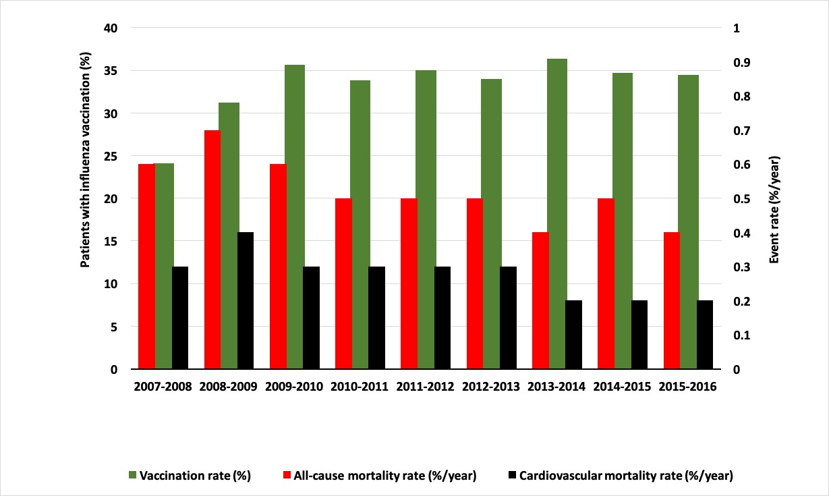

Legend: Vaccination coverage, all-cause mortality rate and cardiovascular mortality rate in each season included in the study. A season denotes the period December 1 until April 1 the following year. For example, in this figure, “2007-2008” denotes the period December 1, 2007 – April 1, 2008.
SUPPLEMENTAL FIGURE 2
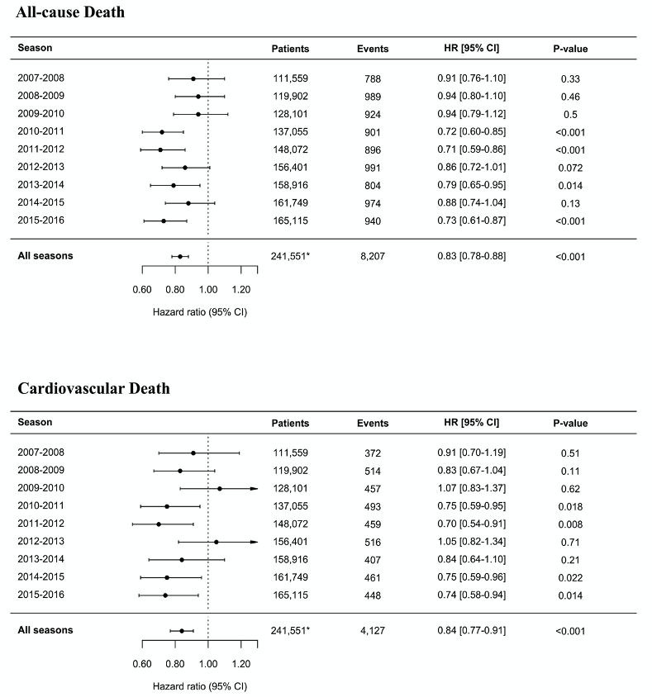
Legend: Landmark analyses assessing the association between influenza vaccination and outcome in each separate influenza season included in the study. In all analyses the reference is no vaccination in the given season. For each season, follow-up was counted from December 1 and ended on April 1 the next year, encompassing the period of high influenza activity in Denmark. The Cox regression models were adjusted for all variables displayed in Table 1. *Denotes the total number of unique patients included in the study when considering all seasons

