SUPPLEMENTARY

Full List of Participating Investigators
Steno Diabetes Center Copenhagen: Alexander Sidelmann Christensen (co-investigator), Filip K. Knop (co-investigator), Tina Vilsbøll (principal investigator, sponsor-investigator)
Steno Diabetes Center Aarhus: Alexander Sidelmann Christensen (co-investigator), Ulla Kampmann (principal investigator) and Julie Støy (co-investigator)

Analytical procedures
During meal tests, plasma glucose was measured bedside by the glucose oxidase method (YSI; Yellow Springs Instrument Model 2300 (Aarhus site) or 2900 (Copenhagen site) (Series Biochemistry Analyzers, Yellow Springs, OH, USA). C-peptide concentrations were measured with a two-sided electro chemiluminescence immunoassay (Siemens Healthcare, Ballerup, Denmark). Plasma concentrations of glucagon were measured by an in-house radioimmunoassay RIA as described previously (1). For the glucagon assay, plasma samples were extracted with ethanol (w70%) before assaying to eliminate unspecific interference. Plasma acetaminophen was measured based on amidase hydrolysis, oxidation and linking to tetrahydroquinoline, which produces a color shift measurable by reflectance photometry at 670 nm (Vitros 5.1 FS, Ortho-Clinical Diagnostics).
Supplementary Table S1. Study outline
Time (Weeks) | >-1 | -1 to 0 | 1 | 2 | 3 | 4 | 8 | 12 | 16 | 17 to 20 | 21 | 22 | 23 | 24 | 28 | 32 | 36
Screening | x
Randomization |  | x
Drug titration |  |  | x | x | x | x |  |  |  |  | x | x | x | x
Clinical visit + blood samples |  |  |  |  |  | x | x | x | x |  | x |  |  | x | x | x | x
Telephone call |  |  | x | x | x |  |  |  |  |  | x | x | x
CGM monitoring |  | x |  |  |  |  |  |  | x |  |  |  |  |  |  |  | x
Meal and bicycle test |  | x |  |  |  |  |  |  | x |  |  |  |  |  |  |  | x
Washout |  |  |  |  |  |  |  |  |  | x
CGM, continuous glucose monitoring

Supplementary Table S2. Specific HNF1A mutations of the study participants, self-reported episodes of hypoglycemia and HbA_{1c}
 |  | Baseline |  | Glimepiride + placebo |  |  | Glimepiride + linagliptin
ID | Mutation | Hba_{1c} | Glimepiride dose (mg) | Glimepiride dose (mg) | Hba_{1c} | Episodes of hypoglycemia(n) | Glimepiride dose (mg) | Hba_{1c} | Episodes of hypoglycaemia (n)
1 | Cys241Gly (2) | 7.2 (55) | 2.0 | 6.0 | 6.0 (42) | 0 | 6.0 | 5.9 (41) | 0
2 | Arg159Gln (3) | 7.2 (55) | 2.0 | 3.5 | 7.1 (54) | 2 | 3.5 | 7.5 (58) | 3
3* | Pro291fSinsC (4) | 7.2 (55) | 1.5 | N/A | N/A | N/A | N/A | N/A | N/A
4 | IVS4nt-2 (5) | 7.8 (62) | 0.5 | 2.0 | 6.3 (45) | 0 | 1.0 | 5.7 (39) | 0
5 | Pro291fsinsC | 8.1 (65) | 3.0 | 6.0 | 7.5 (58) | 0 | 3.0 | 7.9 (63) | 0
6 | Arg159Gln(3) | 8.5 (69) | 3.0 | 6.0 | 9.6 (81) | 0 | 3.0 | 8.0 (64) | 0
7 | Exon 2-10 deletion(6) | 7.6 (60) | 1.5 | 2.5 | 7.1 (54) | 0 | 1.5 | 6.8 (51) | 1
8 | Glu234Term (7) | 7.5 (58) | 1.5 | N/A | N/A | N/A | N/A | N/A | N/A
9 | Cys241Gly (2) | 6.6 (49) | 1.0 | 1.5 | 6.0 (42) | 0 | 1.0 | 6.0 (42) | 1
10 | Arg271Gln (8) *** His469Tyr | 7.4 (57) | 3.0 | 2.5 | 7.7 (61) | 1 | 1.5 | 5.9 (41) | 5
11 | Arg131Trp (9) | 6.8 (51) | 2.0 | 2.5 | 6.0 (42) | 1 | 2.5 | 5.5 (37) | 0
12 | Pro289fsinsC (10) | 7.1 (54) | 0.0 | 1.0 | 5.6 (38) | 0 | 0.5 | 5.5 (37) | 0
13 | Pro289fsinsC (10) | 7.2 (55) | 0.5 | 1.0 | 7.2 (55) | 1 | 1.0 | 7.0 (53) | 3
14 | Arg271Trp (11) | 6.9 (52) | 2.5 | 5.0 | 7.6 (60) | 2 | 4.5 | 6.5 (48) | 2
15 | Glu332Term (7) | 7.5 (59) | 1.0 | 1.5 | 7.0 (53) | 0 | 1.5 | 6.2 (44) | 1
16 | Pro291fSinsC (4) | 9.2 (77) | 3.0 | 6.0 | 7.7 (61) | 0 | 6.0 | 6.4 (46) | 0
17** | Pro291fSinsC (4) | 7.3 (56) | 0.5 | 1.5 | 6.2 (44) | 1 | N/A | N/A | N/A
18 | Asp135Asn (7) | 7.6 (60) | 3.5 | 6.0 | 8.8 (73) | 0 | 6.0 | 8.1 (65) | 0
19 | Val590fsinsA (5) | 6.6 (49) | 3.0 | 6.0 | 7.2 (55) | 0 | 4.0 | 6.0 (42) | 0
20**** | Pro291fSinsC (4) | 6.1 (43) | 1.0 | 1.5 | 5.8 (40) | 2 | 1.5 | 5.8 (40) | 0
Sum |  |  |  |  |  | 10 |  |  | 16

Mutation site/sequence, Hba1c, glimepiride dose and self-reported episodes of hypoglycemia in study participants. Episodes of hypoglycemia for glimepiride + placebo and glimepiride + linagliptin from the maintenance phase (week 5-15 and week 25-35). Values of glycated hemoglobin (HbA_{1c}) are % (mmol/mol). Glimepiride dose was reduced in the maintenance phase due to recurrent hypoglycemia in patient 3 (once) during treatment with glimepiride + placebo, and in patients 2 (once), 10 (twice) and 13 (once) during treatment with glimepiride + linagliptin.
* Patient 3 dropped out after randomization but before receiving allocated medication and is not part of the data analysis
** Patient 17 dropped out of the study before the first treatment period was completed. The HbA1c levels are from week 12 (8 weeks of stable therapy)
*** Patient with two mutations in the hepatocyte nuclear factor 1 alpha gene – Arg271Gln and His469Tyr (Arg271Gln is a well described pathogenic variant while the significance of His469Tyr is unknown)
**** Patient included with a HbA1c ≤ 6.5% (48≤ mmol/mol) due to recruitment difficulties (protocol deviation).

Supplementary Table S3. Patient level glimepiride dose and data from continuous glucose monitoring
 | Baseline |  |  |  | Glimepiride + placebo |  |  |  | Glimepiride + linagliptin
ID | Mean glucose (mM) | CV (%) | Glimepiride dose (mg) | Episodes of hypoglycemia (n (time %)) | Glimepiride dose (mg) | Mean glucose(mM) | CV (%) | Episodes of hypoglycemia (n (%)) | Glimepiride dose (mg) | Mean glucose (mM) | CV (%) | Episodes of hypoglycemia (n (time %))
1 | 10.0 | 26 | 2.0 | 0 (0) | 6.0 | 7.2 | 33 | 5 (2.3) | 6.0 | 7.6 | 23 | 0 (0.3)
2 | 10.0 | 25 | 2.0 | 0 (0) | 3.5 | 9.7 | 32 | 0 (0) | 3.5 | 9.8 | 34 | 1 (0.7)
3 | N/A | N/A | 1.5 | N/A | N/A | N/A | N/A | N/A | N/A | N/A | N/A | N/A
4 | 10.6 | 21 | 0.5 | 0 (0) | 2.0 | 7.3 | 33 | 3 (2.2) | 1.0 | 6.9 | 24 | 0 (0.1)
5 | 10.1 | 31 | 3.0 | 0 (0) | 6.0 | 8.6 | 25 | 1 (0.2) | 3.0 | 11.6 | 26 | 0 (0.0)
6 | 13.2 | 28 | 3.0 | 0 (0) | 6.0 | 14.1 | 26 | 0 (0) | 3.0 | 10.1 | 28 | 0 (0.0)
7 | 8.8 | 49 | 1.5 | 6 (6.5) | 2.5 | 7.3 | 32 | 4 (5.2) | 1.5 | 7.8 | 28 | 0 (0.0)
8 | 9.4 | 31 | 1.5 | 0 (0) | N/A | N/A | N/A | N/A | N/A | N/A | N/A | 0 (0.0)
9 | 9.5 | 23 | 1.0 | 0 (0) | 1.5 | 7.3 | 32 | 1 (0.3) | 1.0 | 7.1 | 19 | 0 (0.0)
10 | 10.4 | 35 | 3.0 | 2 (1.9) | 2.5 | 9.2 | 37 | 2 (4.6) | 1.5 | 7.9 | 34 | 2 (0.7)
11 | 7.6 | 24 | 2.0 | 0 (0) | 2.5 | 6.2 | 28 | 3 (0.9) | 2.5 | 6.5 | 29 | 2 (1.2)
12 | 8.9 | 22 | 0.0 | 0 (0) | 1.0 | 5.8 | 15 | 0 (0.2) | 0.5 | 6.6 | 21 | 0 (0.0)
13 | 10.3 | 27 | 0.5 | 0 (0) | 1.0 | 7.9 | 37 | 4 (3.8) | 1.0 | 9.3 | 33 | 2 (1.6)
14 | 11.8 | 30 | 2.5 | 0 (0) | 5.0 | 9.2 | 42 | 1 (0.2) | 4.5 | 7.9 | 39 | 1 (1.1)
15 | 9.5 | 32 | 1.0 | 0 (0) | 1.5 | 11.6 | 32 | 0 (0.0) | 1.5 | 7.8 | 34 | 0 (0.0)
16 | 10.3 | 26 | 3.0 | 0 (0) | 6.0 | 12.4 | 28 | 0 (0.0) | 6.0 | 11.1 | 29 | 0 (0.1)
17 | 6.9 | 21 | 0.5 | 0 (0) | 1.5 | N/A | N/A | N/A | N/A | N/A | N/A | N/A
18 | 10.5 | 21 | 3.5 | 0 (0) | 6.0 | 10.3 | 29 | 0 (0.0) | 6.0 | 10.4 | 31 | 0 (0.0)
19 | 7.3 | 26 | 3.0 | 0 (0) | 6.0 | 9.5 | 35 | 2 (4.2) | 4.0 | 7.5 | 19 | 0 (0.0)
20 | 7.6 | 20 | 1.0 | 0 (0) | 1.5 | 7.1 | 36 | 6 (3.3) | 1.5 | 5.6 | 22 | 7 (8.0)
Sum |  |  |  | 8 |  |  |  | 32 |  |  |  | 15

Patient-specific data from continuous glucose monitoring (CGM) on mean glucose, coefficient of variation (CV) and hypoglycemia. A hypoglycemic episode is defined as a plasma glucose < 4.0 mM in at least 20 consecutive minutes and time % shows percentage of total wear time in hypoglycemia during CGM.

Supplementary Table S4: Non-hypoglycemic Adverse Events
Adverse events | Glimepiride + placebo | Glimepiride + linagliptin
Acute otitis media | 1 | 0
Gastroenteritis | 4 | 2
Plantar fasciitis | 0 | 1
Rhinitis | 1 | 2
Stress | 1 | 0
Upper airway infection | 3 | 2
Urinary tract infection | 0 | 1
Vaginitis | 0 | 1
Vasovagal syncope | 1 | 0
Vertigo | 1 | 0
Total adverse events | 12 | 9

Data are counts.

Supplementary Figure S1. Study Design
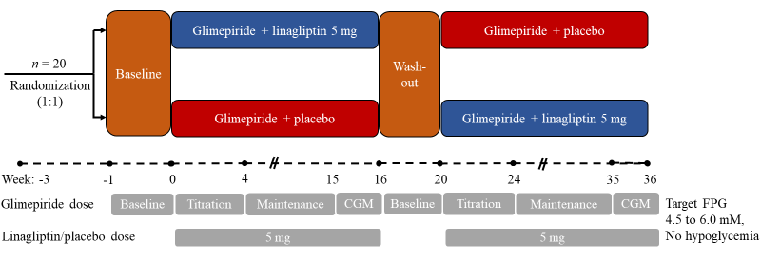
CGM, continuous glucose monitoring, FPG, fasting plasma glucose

Supplementary Figure S2. Patient Disposition

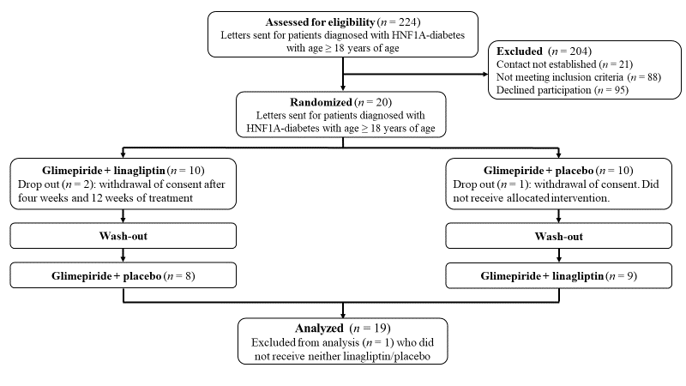

Supplementary Figure S3. Meal and Bicycle Test

Patients arrived in the clinical research facility after 10h of fasting for a combined meal and bicycle test at baseline and at end of treatments. Study medicine was taken at time -60 minute and liquid mixed meal with 1.5 g of acetaminophen served at time 0 min. At time 60 min to 90 min patients cycled with a target heart rate of 90 to 110 beats per minute. Blood was analyzed for plasma glucose, C-peptide and glucagon at all time points. Acetaminophen was not analyzed for time 120 minutes and 180 minutes, but on all other time points. For bedside measurement of plasma glucose, blood was collected into fluoride tubes and centrifuged immediately for 30 sec (room temperature, 7,500 g). For the analyses of glucagon, blood was collected in pre-chilled tubes (on ice) containing EDTA and a specific DPP-4 inhibitor (valine pyrrolidine, 0.01 mM, a gift from Novo Nordisk, Måløv, Denmark). For the analyses of C-peptide, blood was sampled in plain tubes for coagulation (20 min at room temperature). To analyze acetaminophen, blood was collected in pre-chilled tubes with heparin. All tubes were centrifuged for 15 min at 2,900 g and 4°C. Until analysis plasma samples for glucagon was stored at −20°C and serum samples for C-peptide and paracetamol at −80°C.

References Supplementary

1. Orskov C, Jeppesen J, Madsbad S, Holst JJ. Proglucagon products in plasma of noninsulin-dependent diabetics and nondiabetic controls in the fasting state and after oral glucose and intravenous arginine. J Clin Invest. 1991 Feb 1;87(2):415–23.
2. Hansen T, Eiberg H, Rouard M, Vaxillaire M, Møller AM, Rasmussen SK, et al. Novel MODY3 Mutations in the Hepatocyte Nuclear Factor-1α Gene: Evidence for a Hyperexcitability of Pancreatic β-cells to Intravenous Secretagogues in a Glucose-Tolerant Carrier of a P447L Mutation. Diabetes. 1997 Apr 1;46(4):726–30.
3. Vaxillaire M, Rouard M, Yamagata K, Oda N, Kaisaki PJ, Boriraj VV, et al. Identification of Nine Novel Mutations in the Hepatocyte Nuclear Factor 1 Alpha Gene Associated with Maturity-Onset Diabetes of the Young (MODY3). Hum Mol Genet. 1997 Apr 1;6(4):583–6.
4. Yamagata K, Oda N, Kaisaki PJ, Menzel S, Furuta H, Vaxillaire M, et al. Mutations in the hepatocyte nuclear factor-1α gene in maturity-onset diabetes of the young (MODY3). Nature. 1996 Dec 5;384(6608):455–8.
5. Johansen A, Ek J, Mortensen HB, Pedersen O, Hansen T. Half of Clinically Defined Maturity-Onset Diabetes of the Young Patients in Denmark Do Not Have Mutations in HNF4A, GCK, and TCF1. J Clin Endocrinol Metab. 2005 Aug 1;90(8):4607–14.
6. Ellard S, Thomas K, Edghill EL, Owens M, Ambye L, Cropper J, et al. Partial and whole gene deletion mutations of the GCK and HNF1A genes in maturity-onset diabetes of the young. Diabetologia. 2007 Nov 1;50(11):2313–7.
7. Colclough K, Bellanne‐Chantelot C, Saint‐Martin C, Flanagan SE, Ellard S. Mutations in the Genes Encoding the Transcription Factors Hepatocyte Nuclear Factor 1 Alpha and 4 Alpha in Maturity-Onset Diabetes of the Young and Hyperinsulinemic Hypoglycemia. Human Mutation. 2013;34(5):669–85.
8. Tonooka N, Tomura H, Takahashi Y, Onigata K, Kikuchi N, Horikawa Y, et al. High frequency of mutations in the HNF-1α gene in non-obese patients with diabetes of youth in Japanese and identification of a case of digenic inheritance. Diabetologia. 2002 Dec 1;45(12):1709–12.
9. Bjørkhaug L, Sagen JV, Thorsby P, Søvik O, Molven A, Njølstad PR. Hepatocyte Nuclear Factor-1α Gene Mutations and Diabetes in Norway. None. 2003 Feb 1;88(2):920–31.
10. Kawasaki E, Sera Y, Yamakawa K, Abe T, Ozaki M, Uotani S, et al. Identification and Functional Analysis of Mutations in the Hepatocyte Nuclear Factor-1α Gene in Anti-Islet Autoantibody-Negative Japanese Patients with Type 1 Diabetes. J Clin Endocrinol Metab. 2000 Jan 1;85(1):331–5.
11. Chèvre J-C, Hani EH, Boutin P, Vaxillaire M, Blanché H, Vionnet N, et al. Mutation screening in 18 Caucasian families suggest the existence of other MODY genes. Diabetologia. 1998 Aug 1;41(9):1017–23.

