Supplementary information

Telomere length measurements

DNA was extracted using phenol-chloroform methods. DNA (25 ng) was suspended in 10ul of either telomere or single copy gene human beta-globin (HBG) PCR reaction mixture. The telomere reaction mixture consisted of: 5 µl 2x Fast SYBR Green master mix (Life Technologies, Carlsbad, CA), 2 µl nuclease‐free water, 1 µl 1µM telomere forward primer (CGGTTTGTTTGGGTTTGGGTTTGGGTTTGGGTTTGGGTT), and 1 µl 3µM telomere reverse primer (GGCTTG CCTTACCCTTACCCTTACCCTTACCCTTACCCT). The HBG reaction consisted of: 5 µl same master mix, 2 µl water, 1 µl 3µM HBG forward primer (GCTTCTGACACAACTGTGTTCACTAGC), and 1 µl 7µM HBG reverse primer (CACCAACTTCATCCACGTTCACC). Both reactions lasted for 3min (95°C), followed by 40 cycles (15s, 95°C), for 1min at 56°C (telomere) or 58°C (HBG) on an Applied Biosystems ViiA™ 7 Real‐Time PCR System (Life Technologies Corporation, Carlsbad, CA) using 96-well plates. All primers were obtained from Integrated DNA Technologies (Singapore).

A no-template control (water, NTC) and a reference human sample (QC) were included in all plates to adjust for plate-to-plate variability (no more than ±1 cycle), and as the reference to calculate ∆∆Ct, separately. The QC sample was from a ~40-year-old male with hemochromatosis undergoing therapeutic venesection. All samples for telomere and HBG were performed in triplicate on the same plate. The ∆∆Ct was calculated as follows: ∆∆Ct = (Sample Mean HBG CT – Sample Mean Telomere CT) – (NTC (or QC) Mean HBG CT – NTC (or QC) Mean Telomere CT). The coefficients of variation (CV) of each sample was <2.5% and the inter-plate CVs of the telomere and HBG assays were 2.9% and 1.2%, respectively. The overall intra-plate CV was 1.2% for telomere length and 0.4% for HBG. Samples with CV >2.5% between replicates were repeated for both telomere and HBG measurements.

Since rLTL measurements do not reflect the actual (absolute) LTL, we were asked to test alternate commercially available methods. Although whole genome sequencing data could, in our view, provide the most accurate measure, these were unavailable to us at the time. A reference DNA sample with known absolute telomere length from a commercially available kit (ScienCell Research Laboratories, California, USA, Catalog #8918) was therefore utilized to calculate absolute telomere length in our samples. Using the qPCR method described earlier, serial dilution of the reference DNA was undertaken to develop a standard curve, which was used to extrapolate absolute telomere length based on Ct difference between telomere and single copy gene. This was used to calculate the absolute telomere length of the QC sample. We then extrapolated our rLTL QC/samples to obtain an estimated absolute telomere length for all other samples with rLTL measured.
Table S1. The comparison between all subjects and subjects without missing data
Variables | Entire dataset, including subjects with missing data (n=5349) | Sub-group of subjects without missing data (n=4138) | P value
Age (years) | 57.5 ± 13.3 | 57.9 ± 13.2 | 0.159
Sex (male, %) | 45.2% | 45.7% | 0.645
Smoking status
Current (%) | 13.1% | 12.9% | 0.853
Ever smoked (%) | 30.1% | 30.4% | 0.785
Duration of diabetes (years) | 7.1 ± 6.8 | 7.0 ± 6.8 | 0.446
BMI (kg/m2) | 25.3 ± 4.0 | 25.3 ± 4.1 | 0.636
SBP (mmHg) | 135.1 ± 21 | 135.1 ± 21.0 | 0.960
DBP (mmHg) | 75.5 ± 11.0 | 75.3 ± 11.0 | 0.355
HbA_{1c} (% / mmol/mol) | 7.6 ± 1.8 / 59.9 ± 19.7 | 7.6 ± 1.8 / 59.2 ± 19.5 | 0.108 / 0.105
FPG (mmol/L) | 8.6 ± 3.3 | 8.5 ± 3.3 | 0.356
TC (mmol/L) | 5.2 ± 1.2 | 5.1 ± 1.1 | 0.004
HDL-C (mmol/L) | 1.3 ± 0.4 | 1.3 ± 0.4 | 0.008
LDL-C (mmol/L) | 3.1 ± 1.0 | 3.1 ± 1.0 | 0.174
TG (mmol/L) | 1.4 (1.0-2.1) | 1.4 (1.0-2.0) | <0.001*
ACR (mg/mmol) | 2.3 (0.8-12.8) | 2.1 (0.8-11.7) | 0.203*
eGFR (mL/min/1.73 m²) | 4.6 ± 0.6 | 4.6 ± 0.6 | 0.867
Diagnosed comorbidity
Retinopathy (%) | 28.3% | 28.2% | 0.917
Neuropathy (%) | 20.8% | 20.6% | 0.835
Microalbuminuria (%) | 26.9% | 26.7% | 0.795
Macroalbuminuria (%) | 18.1% | 17.2% | 0.256
Use of medications
Lipid lowering drugs (%) | 18.8% | 20.1% | 0.131
Antihypertensive drugs (%) | 47.5% | 50.2% | 0.009
Oral antihyperglycemic drugs (%) | 66.8% | 71.8% | <0.001
Insulin use (%) | 17.0% | 16.8% | 0.785
RAS inhibitors (ACEIs or ARBs) (%) | 22.2% | 23.0% | 0.332
All data are expressed as mean ± SD, median (Q1-Q3) or proportion in %. *Natural logarithmic transformation was used in TG and ACR.
Abbreviation: BMI, body mass index; SBP, systolic blood pressure; DBP, diastolic blood pressure; HbA_{1c}, Hemoglobin A1c; FPG, fasting plasma glucose; TC, total cholesterol; TG, triglycerides; HDL-C, high-density lipoprotein cholesterol; LDL-C, low-density lipoprotein cholesterol; eGFR, estimated glomerular filtration rate; ACR, urinary albumin to creatinine ratio.
Table S2. The comparison of baseline characteristics between subjects with or without CVD at baseline
Variables | Total (n=5349) | Subjects without CVD at baseline (n=4541) | subject with CVD at baseline (n=808) | P value | P value (Adjusted for age and sex)
Age (years) | 57.5 ± 13.3 | 56.1 ± 13.2 | 65.7 ± 10.8 | <0.001 | -
Sex (male, %) | 45.2% | 44.5% | 49.1% | 0.015 | -
Smoking status
Current (%) | 13.1% | 13.3% | 11.6% | 0.196 | 0.861
Ever smoked (%) | 30.1% | 28.8% | 37.7% | <0.001 | 0.003
Duration of diabetes (years) | 7.1 ± 6.8 | 6.7 ± 6.6 | 9.3 ± 7.6 | <0.001 | <0.001
BMI (kg/m²) | 25.3 ± 4.0 | 25.3 ± 4.1 | 25.1 ± 3.7 | 0.159 | 0.245
SBP (mmHg) | 135.1 ± 21.0 | 133.9 ± 20.2 | 142.0 ± 23.5 | <0.001 | <0.001
DBP (mmHg) | 75.5 ± 11.0 | 75.8 ± 10.9 | 74.0 ± 11.4 | <0.001 | 0.005
HbA_{1c} (% / mmol/mol) | 7.6 ± 1.8 / 59.9 ± 19.7 | 7.6 ± 1.8 / 59.7 ± 19.7 | 7.7 ± 1.8 / 60.8 ± 19.5 | 0.130 / 0.130 | 0.069 / 0.069
FPG (mmol/L) | 8.6 ± 3.3 | 8.6 ± 3.3 | 8.6 ± 3.6 | 0.536 | 0.130
TC (mmol/L) | 5.2 ± 1.2 | 5.2 ± 1.1 | 5.1 ± 1.2 | 0.372 | 0.300
HDL-C (mmol/L) | 1.3 ± 0.4 | 1.3 ± 0.4 | 1.3 ± 0.4 | 0.001 | <0.001
LDL-C (mmol/L) | 3.1 ± 1.0 | 3.1 ± 1.0 | 3.0 ± 1.1 | 0.092 | 0.070
TG (mmol/L) | 1.4 (1.0-2.1) | 1.5 (1.1-2.2) | 1.5 (1.1-2.1) | <0.001* | 0.001*
eGFR (mL/min/1.73 m²) | 79.3 ± 26.1 | 82.1 ± 25.1 | 63.3 ± 25.8 | <0.001 | <0.001
ACR (mg/mmol) | 2.0 (0.8-10.1) | 2.0 (0.8-10.1) | 4.9 (1.1-42.0) | <0.001* | <0.001*
Diagnosed comorbidity
Retinopathy (%) | 28.3% | 25.8% | 42.5% | <0.001 | <0.001
Neuropathy (%) | 20.8% | 18.4% | 34.4% | <0.001 | <0.001
Microalbuminuria (%) | 25.9% | 25.80% | 26.60% | 0.564 | 0.173
Macroalbuminuria (%) | 17.5% | 15.4% | 28.8% | <0.001 | <0.001
Use of medications
Lipid lowering drugs (%) | 18.8% | 15.5 | 37.5% | <0.001 | <0.001
Antihypertensive drugs (%) | 47.5% | 43.1% | 72.2% | <0.001 | <0.001
Oral antihyperglycemic drugs (%) | 66.8% | 66.9% | 66.6% | 0.879 | 0.036
Insulin use (%) | 17.0% | 15.5% | 25.4% | <0.001 | <0.001
RAS inhibitors (ACEIs or ARBs) (%) | 22.2% | 19.8% | 35.6% | <0.001 | <0.001
rLTL | 4.6 ± 1.2 | 4.6 ± 1.2 | 4.3 ± 1.2 | <0.001 | <0.001
All data are expressed as mean ± SD, median (Q1-Q3) or proportion in %; All comparison was adjusted for the differences of age and sex by using either general linear model for continuous data or logistic regression model for categorical data; *natural logarithmic transformation was used in TG and ACR.
Abbreviation: BMI, body mass index; SBP, systolic blood pressure; DBP, diastolic blood pressure; HbA_{1c}, Hemoglobin A1c; FPG, fasting plasma glucose; TC, total cholesterol; TG, triglycerides; HDL-C, high-density lipoprotein cholesterol; LDL-C, low-density lipoprotein cholesterol; eGFR, estimated glomerular filtration rate; ACR, urinary albumin to creatinine ratio; rLTL, relative leukocyte telomere length.

Table S3. Pearson and partial correlation between rLTL and baseline characteristics
Baseline variables | Total cohort |  | Total cohort |  | Total cohort |  | Female |  | Male
 | N=5349 |  | adjusted for age |  | adjusted for age and sex |  | N=2930; adjusted for age |  | N=2419; adjusted for age
 | R | P value | r | P value | r | P value | r | P value | r | P value
Age (years) | -0.131 | <0.001 | n/a | n/a | n/a | n/a | n/a | n/a | n/a | n/a
Duration of diabetes (years) | -0.098 | <0.001 | -0.059 | <0.001 | -0.061 | <0.001 | -0.070 | <0.001 | -0.052 | 0.015
BMI (kg/m²) | 0.035 | 0.010 | 0.015 | 0.280 | 0.015 | 0.284 | -0.012 | 0.549 | 0.047 | 0.026
SBP (mmHg) | -0.121 | <0.001 | -0.074 | <0.001 | -0.075 | <0.001 | -0.080 | <0.001 | -0.072 | 0.001
DBP (mmHg) | -0.060 | <0.001 | -0.069 | <0.001 | -0.068 | <0.001 | -0.066 | 0.001 | -0.070 | 0.001
HbA_{1c} (%) | -0.079 | <0.001 | -0.082 | <0.001 | -0.082 | <0.001 | -0.063 | 0.001 | -0.105 | <0.001
FPG (mmol/L) | -0.085 | <0.001 | -0.083 | <0.001 | -0.083 | <0.001 | -0.067 | 0.001 | -0.104 | <0.001
TC (mmol/L) | -0.070 | <0.001 | -0.074 | <0.001 | -0.076 | <0.001 | -0.062 | 0.001 | -0.096 | <0.001
HDL-C (mmol/L) | 0.064 | <0.001 | 0.061 | <0.001 | 0.059 | <0.001 | 0.052 | 0.007 | 0.068 | 0.001
LDL-C (mmol/L) | -0.113 | <0.001 | -0.117 | <0.001 | -0.118 | <0.001 | -0.109 | <0.001 | -0.130 | <0.001
Ln(TG) | 0.004 | 0.766 | 0.006 | 0.682 | 0.005 | 0.694 | 0.009 | 0.637 | -0.003 | 0.879
Ln(ACR) | -0.117 | <0.001 | -0.082 | <0.001 | -0.083 | <0.001 | -0.065 | 0.001 | -0.102 | <0.001
eGFR (mL/min/1.73 m²) | 0.081 | <0.001 | -0.016 | 0.267 | -0.017 | 0.233 | -0.006 | 0.749 | -0.028 | 0.182

Abbreviation: rLTL, relative leukocyte telomere length; BMI, body mass index; SBP, systolic blood pressure; DBP, diastolic blood pressure; HbA_{1c}, Hemoglobin A1c; FPG, fasting plasma glucose; TC, total cholesterol; TG, triglycerides; HDL-C, high-density lipoprotein cholesterol; LDL-C, low-density lipoprotein cholesterol; eGFR, estimated glomerular filtration rate; ACR, urinary albumin to creatinine ratio. Natural logarithmic transformation was used in TG and ACR.

Table S4. Cox regression analysis showing relationship between Z-score of rLTL and other risk factors for incident CVD in type 2 diabetes
Variables (Z-score) | HR (95%CI) | P
rLTL | 1.180 (1.111-1.254) | <0.001
HbA_{1c} (%) | 1.195 (1.127-1.267) | <0.001
Age (years) | 1.519 (1.383-1.670) | <0.001
Sex (male) | 1.333 (1.150-1.545) | <0.001
Duration of diabetes (years) | 1.176 (1.110-1.245) | <0.001
Ever smoked | 1.363 (1.170-1.588) | <0.001
BMI (kg/m²) | 1.103 (1.034-1.176) | 0.003
SBP (mmHg) | 1.097 (1.027-1.172) | 0.006
LDL-C (mmol/L) | 1.105 (1.037-1.177) | 0.002
eGFR (mL/min/1.73 m²) | 0.866 (0.792-0.947) | 0.002
Ln (ACR) | 1.069 (1.012-1.130) | 0.017

HR, hazards ratio; rLTL, relative leukocyte telomere length; CVD, cardiovascular disease; BMI, body mass index; SBP, systolic blood pressure; HbA_{1c}, Hemoglobin A1c; LDL-C, low-density lipoprotein cholesterol; eGFR, estimated glomerular filtration rate; Ln(ACR), Ln transformation of urinary albumin to creatinine ratio.

Table S5. Competing Risk Regression analysis showing subdistribution HRs of rLTL for incident CVD
Subdistribution HRs | rLTL (each unit decrease)
 | sHR | P value
Model 1 | 1.233 (1.178-1.289) | <0.001
Model 2 | 1.183 (1.131-1.239) | <0.001
Model 3 | 1.164 (1.110-1.221) | <0.001
Model 4 | 1.145 (1.088-1.206) | <0.001

sHR, subdistribution hazards ratio; rLTL, relative leukocyte telomere length; CVD, cardiovascular disease.
Model 1: without adjustment. Model 2: adjusted for age and sex. Model 3: Model 2 + adjusted for duration of diabetes, BMI, SBP and ever smoked. Model 4: Model 3 + adjusted for HbA_{1c,} LDL-C, eGFR and Ln (ACR).

Table S6. Hazard ratio (95% CI) for incident cardiovascular diseases according to quartiles of rLTL
Telomere length | Events/Total (%) | Model 1 |  | Model 2 |  | Model 3 |  | Model 4
 |  | HR (95%CI) | P value | HR (95%CI) | P value | HR (95%CI) | P value | HR (95%CI) | P value
rLTL (each unit decrease) | 1140/4541 (25.1%) | 1.252 (1.195-1.311) | <0.001 | 1.186 (1.132-1.242) | <0.001 | 1.164 (1.110-1.221) | <0.001 | 1.141 (1.084-1.200) | <0.001
Q1(<3.853) | 377/1071 (35.2%) | 2.144 (1.802-2.551) | <0.001 | 1.800 (1.511-2.144) | <0.001 | 1.689 (1.416-2.013) | <0.001 | 1.559 (1.296-1.875) | <0.001
Q2(3.853-4.639) | 317/1116 (28.4%) | 1.680 (1.404-2.009) | <0.001 | 1.508 (1.260-1.805) | <0.001 | 1.417 (1.183-1.698) | <0.001 | 1.322 (1.094-1.598) | 0.004
Q3(4.640-5.326) | 252/1147 (22.0%) | 1.320 (1.095-1.592) | 0.004 | 1.177 (0.976-1.421) | 0.009 | 1.147 (0.950-1.386) | 0.154 | 1.111 (0.911-1.354) | 0.301
Q4(>5.326) | 194/1207 (16.1%) | 1.000 (Reference) |  | 1.000 (Reference) |  | 1.000 (Reference) |  | 1.000 (Reference)
P trend |  |  | <0.001 |  | <0.001 |  | <0.001 |  | <0.001
Female
rLTL (each unit decrease) | 559/2519 (22.2%) | 1.312 (1.227-1.404) | <0.001 | 1.245 (1.164-1.332) | <0.001 | 1.223 (1.141-1.310) | <0.001 | 1.182 (1.098-1.272) | <0.001
Q1(<3.853) | 196/589 (33.4%) | 2.267 (1.773-2.898) | <0.001 | 1.957 (1.529-2.504) | <0.001 | 1.826 (1.424-2.341) | <0.001 | 1.651 (1.274-2.140) | <0.001
Q2(3.853-4.639) | 149/628 (23.7%) | 1.579 (1.220-2.043) | 0.001 | 1.444 (1.115-1.870) | 0.005 | 1.327 (1.022-1.722) | 0.034 | 1.275 (0.971-1.673) | 0.080
Q3(4.640-5.326) | 119/639 (18.6%) | 1.251 (0.955-1.639) | 0.103 | 1.181 (0.902-1.547) | 0.227 | 1.114 (0.848-1.462) | 0.439 | 1.105 (0.831-1.468) | 0.493
Q4(>5.326) | 95/665 (14.3%) | 1.000 (Reference) |  | 1.000 (Reference) |  | 1.000 (Reference) |  | 1.000 (Reference)
P trend |  |  | <0.001 |  | <0.001 |  | <0.001 |  | <0.001
Male
rLTL (each unit decrease) | 581/2022 (28.7%) | 1.194 (1.120-1.273) | <0.001 | 1.136 (1.064-1.213) | <0.001 | 1.115 (1.044-1.191) | 0.001 | 1.102 (1.026-1.183) | 0.008
Q1(<3.853) | 181/484 (37.4%) | 2.020 (1.579-2.583) | <0.001 | 1.658 (1.293-2.125) | <0.001 | 1.555 (1.211-1.997) | 0.001 | 1.479 (1.136-1.926) | 0.004
Q2(3.853-4.639) | 168/488 (34.4%) | 1.784 (1.391-2.289) | <0.001 | 1.571 (1.222-2.018) | <0.001 | 1.483 (1.153-1.907) | 0.002 | 1.369 (1.048-1.786) | 0.021
Q3(4.640-5.326) | 133/508 (26.2%) | 1.390 (1.071-1.804) | 0.013 | 1.178 (0.906-1.531) | 0.220 | 1.162 (0.893-1.512) | 0.263 | 1.118 (0.846-1.477) | 0.432
Q4(>5.326) | 99/542 (18.3%) | 1.000 (Reference) |  | 1.000 (Reference) |  | 1.000 (Reference) |  | 1.000 (Reference)
P trend |  |  | <0.001 |  | <0.001 |  | <0.001 |  | 0.001

HR, hazards ratio; rLTL, relative leukocyte telomere length, categorized by quartiles of rLTL in whole cohort; CVD, cardiovascular disease; MI, myocardial infarction; CHD, coronary heart disease; CHF, congestive heart failure; CVA, cerebral vascular accident; PVD, peripheral vascular disease.
Model 1: without adjustment. Model 2: adjusted for age and sex. Model 3: Model 2 + adjusted for duration of diabetes, BMI, SBP and ever smoked. Model 4: Model 3 + adjusted for HbA_{1c,} LDL-C, eGFR and Ln (ACR). When conducting regression models in male/female group, the category variable of sex was excluded.

Table S7. Hazards ratio of rLTL in relation to sub-group analysis according to age category and specific CVD endpoints.
Outcomes | Events/total (%) | Hazards ratio (95% CI) |  | P value*
 |  | Unadjusted model | Fully adjusted model
Stratified by age
< 45 years | 110/931 (11.8%) | 1.195 (1.018-1.403) | 1.113 (0.935-1.323) | 0.227
45-59 years | 385/1704 (22.6%) | 1.233 (1.133-1.341) | 1.182 (1.080-1.295) | <0.001
60-74 years | 520/1565 (33.2%) | 1.199 (1.120-1.284) | 1.146 (1.063-1.236) | <0.001
75+ years | 125/341 (36.7%) | 1.113 (0.935-1.323) | 1.101 (0.942-1.289) | 0.228
Specific CVD endpoints
MI | 318/5236 (6.1%) | 1.192 (1.091-1.303) | 1.019 (0.922-1.125) | 0.716
CHD | 700/4967 (14.1%) | 1.256 (1.186-1.331) | 1.135 (1.065-1.210) | <0.001
CVA | 635/5196 (12.2%) | 1.229 (1.154-1.309) | 1.112 (1.039-1.191) | 0.002
CHF | 577/5234 (11.0%) | 1.253 (1.174-1.337) | 1.092 (1.018-1.172) | 0.014
PVD | 206/4996 (4.1%) | 1.128 (1.006-1.265) | 0.992 (0.873-1.127) | 0.905

* P value for full adjustment; rLTL, relative leukocyte telomere length; CVD, cardiovascular disease; MI, myocardial infarction; CHD, coronary heart disease; CHF, congestive heart failure; CVA, cerebral vascular accident; PVD, peripheral vascular disease.
Full adjusted model included age, sex, duration of diabetes, BMI, SBP, ever smoked, HbA_{1c,} LDL-C, eGFR and Ln (ACR).
Table S8. The interaction between relative telomere length and HbA_{1c} on incident CVD
Variables | HR (95%CI) | P value
rLTL (each unit decrease) | 1.719 (1.373-2.152) | <0.001
HbA_{1c} (%) | 0.870 (0.767-0.987) | 0.031
Age (years) | 1.034 (1.027-1.042) | <0.001
Sex (male) | 1.332 (1.149-1.545) | <0.001
Duration of diabetes (years) | 1.021 (1.012-1.030) | <0.001
Ever smoked | 1.353 (1.161-1.577) | <0.001
BMI (kg/m²) | 1.020 (1.004-1.036) | 0.015
SBP (mmHg) | 1.002 (0.999-1.006) | 0.185
LDL-C (mmol/L) | 1.104 (1.036-1.177) | 0.002
eGFR (mL/min/1.73 m²) | 0.997 (0.993-1.000) | 0.075
Ln (ACR) | 1.120 (1.080-1.163) | <0.001
Interaction of rLTL and HbA1c | 1.054 (1.025-1.084) | <0.001
HR, hazards ratio; rLTL, relative leukocyte telomere length; CVD, cardiovascular disease; BMI, body mass index; SBP, systolic blood pressure; HbA_{1c}, Hemoglobin A1c; LDL-C, low-density lipoprotein cholesterol; eGFR, estimated glomerular filtration rate; Ln(ACR), Ln transformation of urinary albumin to creatinine ratio.

Table S9. Cox regression showing the association between rLTL calculated based on QC materials and incident CVD
Variables | Model 1 |  | Model 2 |  | Model 3 |  | Model 4
 | HR (95% CI) | P | HR (95% CI) | P | HR (95% CI) | P | HR (95% CI) | P
rLTL (each unit decrease) | 1.331 (1.264-1.403) | <0.001 | 1.231 (1.166-1.299) | <0.001 | 1.208 (1.143-1.276) | <0.001 | 1.166 (1.100-1.237) | <0.001
 |  |  | 1.045 (1.040-1.050) | <0.001 | 1.035 (1.029-1.040) | <0.001 | 1.034 (1.027-1.041) | <0.001
Sex (male) |  |  | 1.476 (1.314-1.658) | <0.001 | 1.321 (1.147-1.521) | 0.024 | 1.330 (1.147-1.542) | <0.001
Duration of diabetes (years) |  |  |  |  | 1.033 (1.025-1.042) | <0.001 | 1.021 (1.012-1.030) | <0.001
Ever smoked |  |  |  |  | 1.415 (1.222-1.637) | <0.001 | 1.354 (1.161-1.578) | <0.001
BMI (kg/m²) |  |  |  |  | 1.023 (1.008-1.038) | 0.003 | 1.020 (1.004-1.036) | 0.013
SBP (mmHg) |  |  |  |  | 1.007 (1.004-1.010) | <0.001 | 1.002 (0.999-1.006) | 0.158
HbA_{1c} (%) |  |  |  |  |  |  | 1.088 (1.053-1.124) | <0.001
LDL-C (mmol/L) |  |  |  |  |  |  | 1.111 (1.042-1.185) | 0.001
eGFR (mL/min/1.73 m²) |  |  |  |  |  |  | 0.997 (0.994-1.001) | 0.130
Ln (ACR) |  |  |  |  |  |  | 1.122 (1.081-1.165) | <0.001

QC, reference human sample; HR, hazards ratio; rLTL, relative leukocyte telomere length; CVD, cardiovascular disease; BMI, body mass index; SBP, systolic blood pressure; HbA_{1c}, Hemoglobin A1c; LDL-C, low-density lipoprotein cholesterol; eGFR, estimated glomerular filtration rate; Ln(ACR), Ln transformation of urinary albumin to creatinine ratio.
Model 1: without adjustment. Model 2: adjusted for age and sex. Model 3: Model 2 + adjusted for duration of diabetes, BMI, SBP and ever smoked. Model 4: Model 3 + adjusted for HbA_{1c,} LDL-C, eGFR and Ln (ACR).
Table S10. Cox regression showing the association between estimated absolute telomere length and incident CVD
Variables | Model 1 |  | Model 2 |  | Model 3 |  | Model 4
 | HR (95% CI) | P | HR (95% CI) | P | HR (95% CI) | P | HR (95% CI) | P
log₂ (estimated absolute LTL) | 1.331 (1.264-1.403) | <0.001 | 1.231 (1.166-1.299) | <0.001 | 1.208 (1.143-1.276) | <0.001 | 1.166 (1.100-1.237) | <0.001
Age (years) |  |  | 1.045 (1.040-1.050) | <0.001 | 1.035 (1.029-1.040) | <0.001 | 1.034 (1.027-1.041) | <0.001
Sex (male) |  |  | 1.476 (1.314-1.658) | <0.001 | 1.321 (1.147-1.521) | <0.001 | 1.330 (1.147-1.542) | <0.001
Duration of diabetes (years) |  |  |  |  | 1.033 (1.025-1.042) | <0.001 | 1.021 (1.012-1.030) | <0.001
Ever smoked |  |  |  |  | 1.415 (1.222-1.637) | <0.001 | 1.354 (1.161-1.578) | <0.001
BMI (kg/m²) |  |  |  |  | 1.023 (1.008-1.038) | 0.003 | 1.020 (1.004-1.036) | 0.013
SBP (mmHg) |  |  |  |  | 1.007 (1.004-1.010) | <0.001 | 1.002 (0.999-1.006) | 0.158
HbA_{1c} (%) |  |  |  |  |  |  | 1.088 (1.053-1.124) | <0.001
LDL-C (mmol/L) |  |  |  |  |  |  | 1.111 (1.042-1.185) | 0.001
eGFR (mL/min/1.73 m²) |  |  |  |  |  |  | 0.997 (0.994-1.001) | 0.130
Ln (ACR) |  |  |  |  |  |  | 1.122 (1.081-1.165) | <0.001

HR, hazards ratio; estimated absolute LTL, absolute leukocyte telomere length calculated using reference DNA from the commercial kit; CVD, cardiovascular disease; BMI, body mass index; SBP, systolic blood pressure; HbA_{1c}, Hemoglobin A1c; LDL-C, low-density lipoprotein cholesterol; eGFR, estimated glomerular filtration rate; Ln(ACR), Ln transformation of urinary albumin to creatinine ratio.
Model 1: without adjustment. Model 2: adjusted for age and sex. Model 3: Model 2 + adjusted for duration of diabetes, BMI, SBP and ever smoked. Model 4: Model 3 + adjusted for HbA_{1c,} LDL-C, eGFR and Ln (ACR)
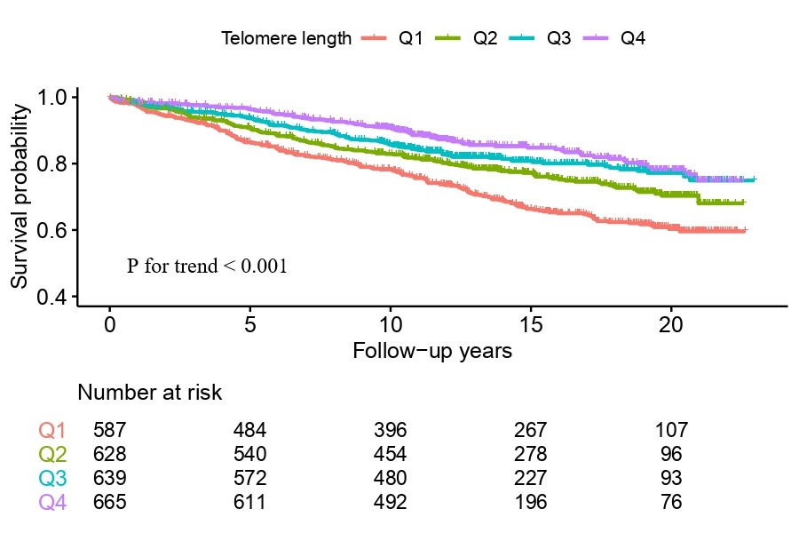
Figure S1. Cumulative survival curve of women without cardiovascular disease based on quartiles of relative telomere length. Women were categorized by quartiles of relative telomere length in whole cohort, Q1<3.853, Q2: 3.853-4.639, Q3 4.640-5.326, and Q4>5.326.
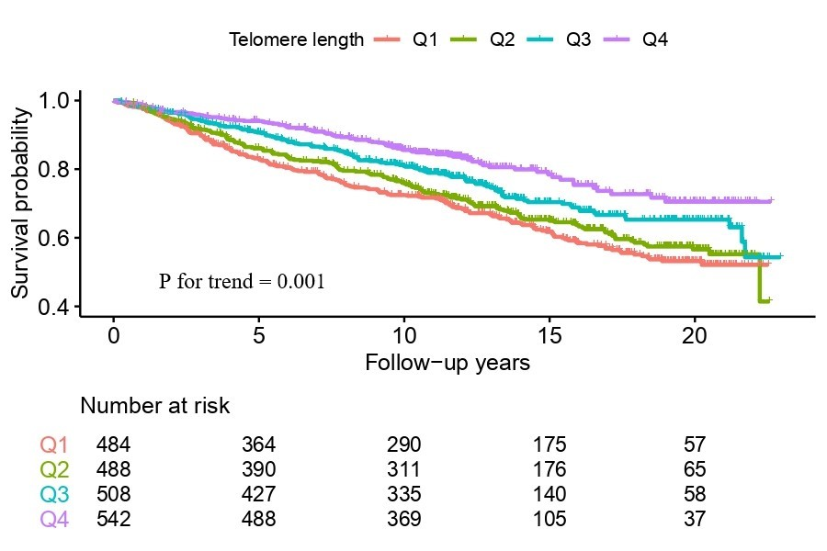
Figure S2. Cumulative survival curve of men without cardiovascular disease based on quartiles of relative telomere length. Men were categorized by quartiles of relative telomere length in whole cohort, Q1<3.853, Q2: 3.853-4.639, Q3 4.640-5.326, and Q4>5.326.

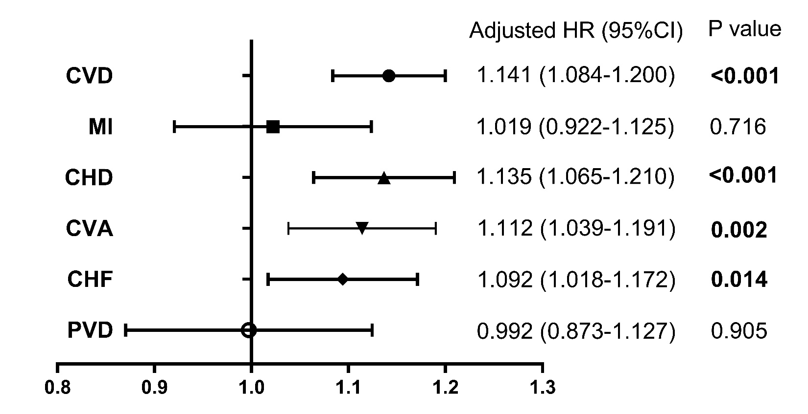
Figure S3. Forest plot showing the association between relative telomere length and combined cardiovascular disease endpoint and according to the subgroup endpoints of cardiovascular disease (CVD), including Myocardial infarction (MI), Coronary Heart Disease (CHD), cerebral vascular accident (CVA), congestive heart failure (CHF), and Peripheral vascular disease (PVD), after adjusting for age, sex, diabetes duration, smoking status, BMI, SBP, HbA_{1c}, LDL-C, eGFR, and Ln (ACR). Effects sizes per each unit decrease in relative telomere length are plotted as hazard ratios with 95% CI.

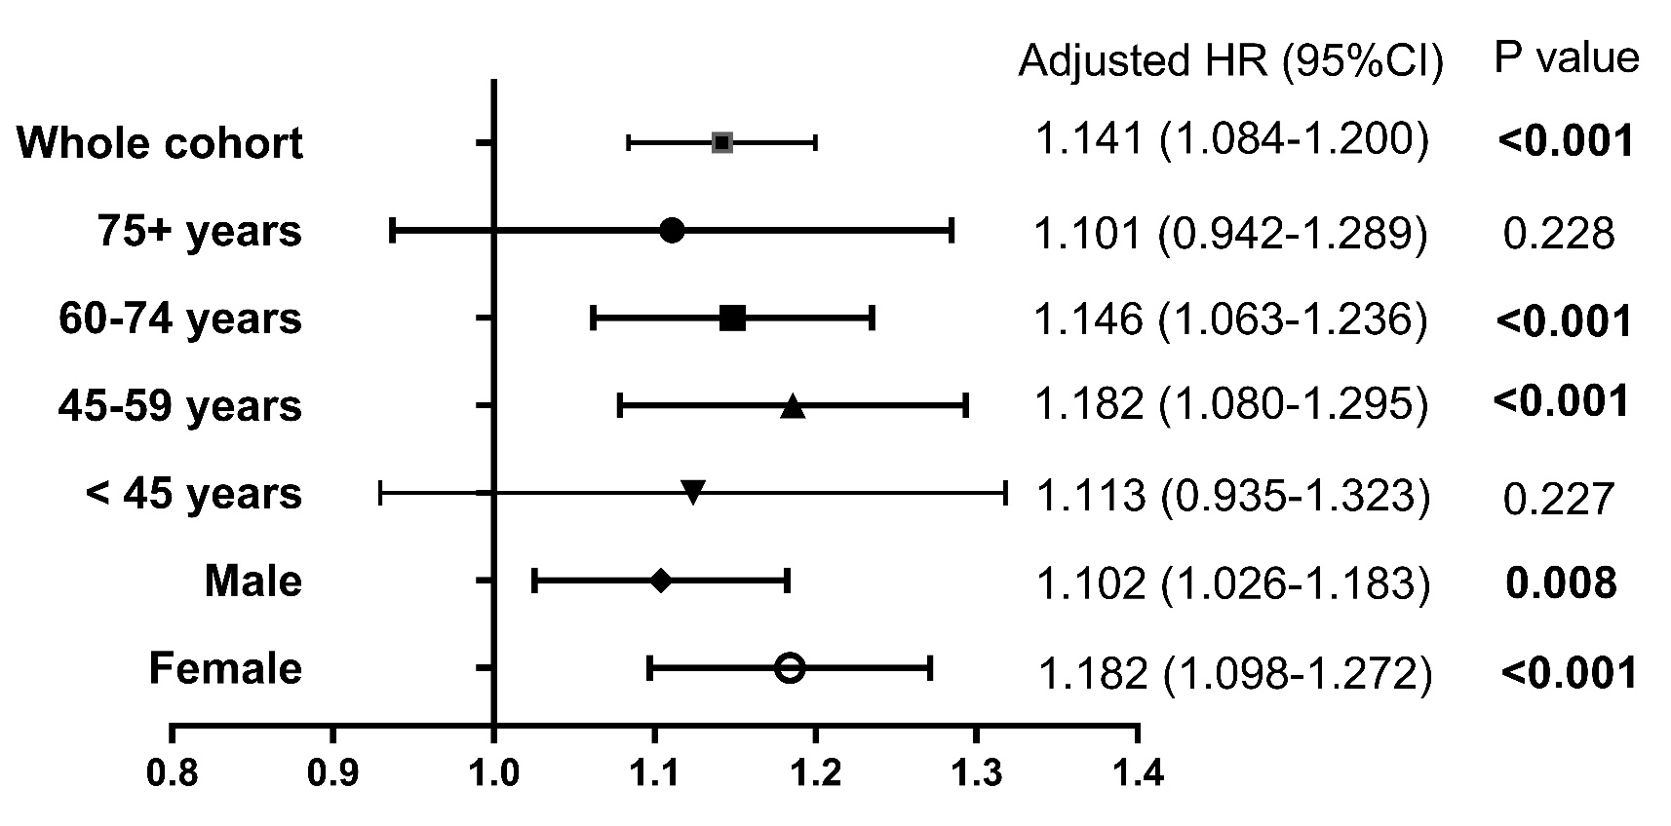
Figure S4. Forest plot showing the association between relative telomere length and cardiovascular disease endpoint according to age and sex category, after adjusting for age, sex, diabetes duration, smoking status, BMI, SBP, HbA_{1c}, LDL-C, eGFR, and Ln (ACR). When conducting analysis in age category/sex, age and sex were excluded separately. Effects sizes per each unit decrease in relative telomere length are plotted as hazard ratios with 95% CI.
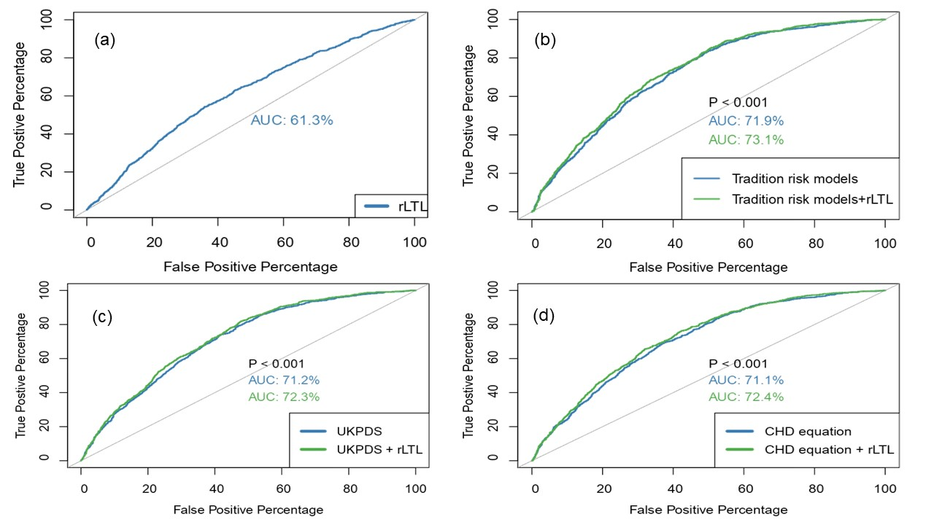
Figure S5: Receiver operating characteristic curve (ROC) for prediction of cardiovascular disease based on different models with or without inclusion of telomere length. rLTL: relative leukocyte telomere length; AUC: area under the curve. a) ROC with only rLTL included. AUC: 0.613(0.594-0.632); b) traditional risk models with or without inclusion of rLTL (AUC 0.731 (0.715-0.748) vs. 0.719 (0.702-0.358), P<0.001); c) risk factors from the United Kingdom Prospective Diabetes Study (UKPDS) risk engine with or without inclusion of rLTL(AUC 0.723(0.707-0.739) vs. 0.712(0.696-0.729), P<0.001); d) risk factors from the Hong Kong diabetes register (HKDR) coronary heart disease (CHD) risk equation with or without inclusion of rLTL (AUC 0.724(0.707-0.740) vs. 0.711(0.695-0.728), P<0.001).

