Supplementary Appendix
Impact of Acarbose on Incident Diabetes and Regression to Normoglycemia in People with Coronary Heart Disease and Impaired Glucose Tolerance: the ACE Study Group

Table S1: Participant Information Available Within the Last 12 Months of Follow-up 2
Table S2: Baseline Characteristics for the On-Treatment Cohort 3
Figure S1: Kaplan Meier Plots (On-Treatment Analysis)
A: Incident Diabetes 4
B: Regression to Normoglycemia (WHO criteria) 5
C: Regression to Normoglycemia (ADA criteria) 6

Table S1: Participant Information Available Within the Last 12 Months of Follow-up
 | Acarbose  N (%) | Placebo  N (%) | Total  N (%)
Randomized | 3272 | 3250 | 6522
Diagnosis of Diabetes | 436 (13.3%) | 513 (15.8%) | 946 (14.5%)
Normal OGTT (i.e., FPG < 7.0 mmol/l and 2HRG < 11.1 mmol/l) | 1396 (42.7%) | 1323 (40.7%) | 2719 (41.7%)
No OGTT but FPG < 7 mmol/l or unconfirmed FPG ≥ 7 mmol/l | 723 (22.1%) | 672 (20.7%) | 1394 (21.4%)
No OGTT or FPG | 717 (21.9%) | 742 (22.8%) | 1459 (22.4%)

Table S2: Baseline Characteristics for the On-Treatment Cohort
 | Acarbose | Placebo | P
N | 3254 | 3236
Age (years)* | 64.4 (8.1) | 64.3 (8.0) | 0.56
Females* | 871 (26.8) | 883 (27.3) | 0.64
Weight (kg)* | 70.0 (10.7) | 70.3 (11.0) | 0.27
BMI (kgm²)* | 25.3 (3.1) | 25.5 (3.1) | 0.051
Systolic BP (mmHg)* | 130 (14.3) | 129 (14.1) | 0.11
Diastolic BP (mmHg)* | 78 (9.2) | 78 (9.2) | 0.31
FPG (mmol/l)* | 5.5 (0.86) | 5.5 (0.78) | 0.48
2 hour PG (mmol/L)* | 9.3 (1.1) | 9.3 (1.1) | 0.99
HbA_{1c} (%)/mmol/mol* | 5.9 (0.8)/41 (8) | 5.9 (0.7)/41 (7) | 0.84
IGT only | 2686 (82.5) | 2651 (81.9) | 0.62
IGT + IFG | 568 (17.5) | 584 (18.1) | 0.53
Thiazide diuretic | 97 (3.0) | 91 (2.8) | 0.68
ACEi or ARB* | 1921 (59.1) | 1903 (58.9) | 0.82
Beta blocker* | 2131 (65.6) | 2152 (66.6) | 0.42
Calcium channel blocker* | 963 (29.6) | 935 (28.9) | 0.52
Statin* | 3023 (93.0) | 3017 (93.3) | 0.69
*data marked with an asterisk have been reported previously¹⁰; data are expressed as mean (SD) or N (%) unless otherwise noted. FPG – fasting plasma glucose; IGT – impaired glucose tolerance; IFG - Impaired fasting glucose (FPG 6.1-6.99 mmol/L); ACEi – Angiotensin converting enzyme inhibitor; ARB – angiotensin receptor blocker

Figure S1 A: Kaplan Meier plot of the time to incident diabetes (on-treatment analysis)
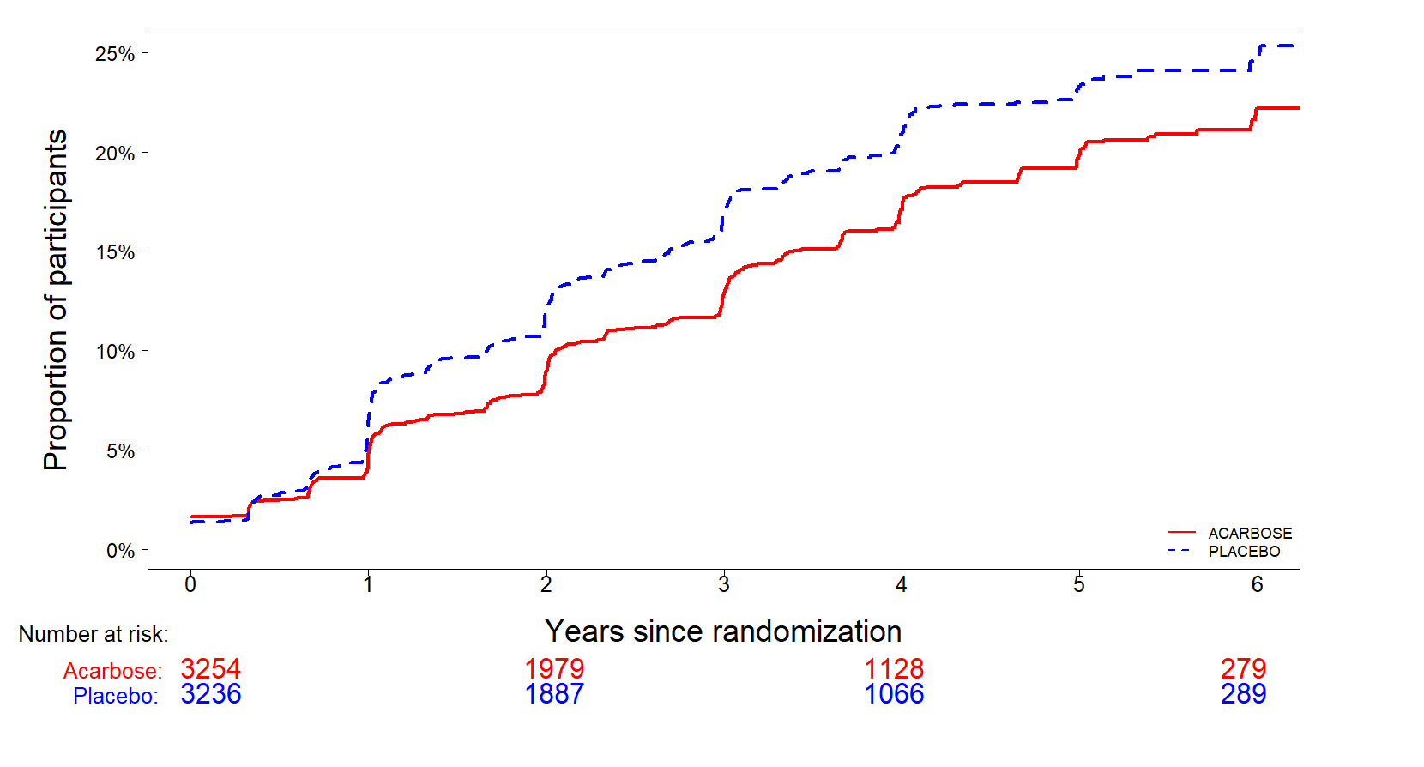
Figure S1 B: Kaplan Meier plots of the time to first occurrence of regression to normoglycemia using the WHO criteria for normoglycemia (on-treatment analysis)
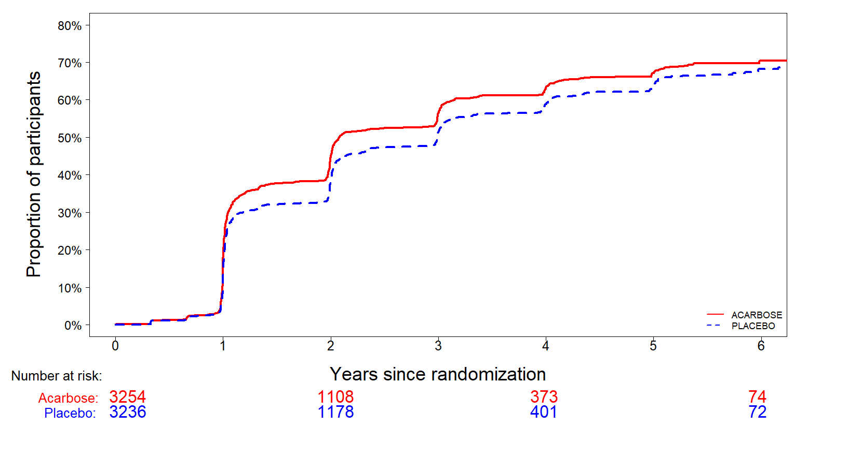

Figure S1 C: Kaplan Meier plots of the time to first occurrence of regression to normoglycemia using the ADA criteria for normoglycemia (on-treatment analysis) 