Supplemental Material

Transient Middle Cerebral Artery Occlusion (tMCAO)
Briefly, mice were anesthetized by 3% isoflurane, then maintained by 1.5 % isoflurane through a snout-mask throughout the surgery. Body temperature was maintained at 37–38 °C using a heated pad. Through midline incision, left common, external and internal carotid arteries were exposed. Through an incision in the left external carotid artery, a 15mm long, 7–0 silicone-coated monofilament (total diameter 0.17 - 0.18 mm) was inserted into the internal carotid artery until it could not be advanced any further and at least 8-10 mm of filament length has passed the carotid bifurcation thus blocking the origin of the middle cerebral artery. Then the wound was temporarily closed, blood glucose levels were measured (Supplemental data, Fig. 1) and mice were allowed to wake up. After 25 minutes mice were re-anesthetized, the wound reopened, and the occluding filament removed (total tMCAO time 30 mins). Additionally, the success of the stroke-induction was evaluated by scoring the severity of neurological deficits 1 hour after reperfusion and the next day after MCAO surgery using a 3-point system: 1 point for circling towards the paretic side, 1 point for right forelimb sensory deficit (left hanging from the table edge) and 1 point for hind limb sensory deficit. All animals used in the study reached minimum 2 points.
Stroke induction was considered unsuccessful when the occluding filament could not be advanced within the internal carotid artery beyond 7 mm from the carotid bifurcation. Additionally, the lack of neurological symptoms based on the neurological severity score was another indicator of “unsuccessful stroke”. Importantly, we have evaluated in each mouse the presence of stroke-brain damage histologically, after performing NeuN IHC.

Assessment of the recovery of forelimb sensori-motor function
The forelimb sensori-motor function was measured by upper-limb grip strength (1-5) using grip strength meter (Harvard apparatus, MA, USA) before, at 3 days and at 1-8 weeks after tMCAO. Briefly, mice were firmly held by the body and allowed to grasp the grid with the right forepaw. Mice were gently dragged backward until the grip was released. Ten trials were performed and the highest value was recorded as described previously (5). The forelimb sensori-motor function test was performed by an experimenter blinded to the treatment groups. This was not possible in the first weeks post-stroke only when comparing non-T2D versus T2D mice since the weight of the mice was unavoidable to be recognized.

Immunohistochemistry (IHC) and quantitative microscopy
Immunofluorescence staining was performed using free-floating method. Following primary antibodies were used; mouse anti-DCX (doublecortin) (1:200 dilution; #sc-271390; Santa Cruz Biotechnology), a marker for migrating neuroblasts; rabbit anti-NeuN (1:800 dilution; #ABN78; Merk-Millipore), a neuronal marker; rat anti-BrdU (Bromodeoxyuridine) (1:500 dilution; #ab6326; Abcam), a marker of cell proliferation; mouse anti-parvalbumin (PV) (1:1,000 dilution; # P3088; Sigma-Aldrich), a marker of parvalbumin-expressing interneuron, Goat anti-Iba1 (1:1000 dilution; #ab5076; Abcam), a marker of endogenous microglia, and Rabbit anti-CD68 (1:1000 dilution; #ab125212; Abcam), a marker of phagocytic microglia. A combination of rat anti-BrdU with rabbit anti-NeuN were employed to assess neurogenesis, respectively. Sections were incubated with primary antibodies overnight at 4 °C in a phosphate buffer containing 3% appropriate serum and 0.25% Triton X-100. Primary antibodies were detected by use Alexa 488- or Alexa 594-conjugated (Vector) or Cyanine3-conjugated (Thermo Fisher scientific) secondary antibodies (1:200 dilution). Sections were incubated with secondary antibodies for 2 h at room temperature (approximately 21 °C) in phosphate buffer containing 3% of the appropriate serum and 0.25% Triton X-100. For antigen retrieval 1 mM EDTA for 30 mins at 64 °C (for PV immunostaining), 10 mM citrate buffer at 95 °C for 15 mins (for DCX immunostaining) or 1 M HCl for 20 minutes at 64°C (for double staining with BrdU).

For quantitative microscopy, three consecutive brain sections spaced at 300 μm containing striatum (from Bregma 1 to 0.5 mm) were used. The first section was chosen based on an anatomical location along the rostra-caudal axis (approximately 1 mm from Bregma). The second and the third sections were 300 and 600 μm caudal from the first section respectively. For counting of PV+ interneurons and Iba-1+ cells the NewCast software (VisioPharm, Denmark) was used. Briefly, striatum or cortex on 3 coronal sections (described above) was delineated. Quantification were performed using 40x magnification. The counting frame was systematically moved in random direction (defined by the software) at preset intervals (defined by the experimenter) starting from random position (defined by the software), so that the random, but representative fraction of the region of interest was sampled. The total cell number from three sections was estimated using the following formula: Total number cells = Counted number x (Step area/Counting frame area) (6). Mean cell body volume of PV+ interneurons (a measure of potential cellular atrophy) was estimated using 40-50 random (experimenter-independent, software-determined random positions within the area of interest) cells from 3 sampled sections (6). The number of DCX-positive (DCX+) cells, CD68+, CD68/Iba-1 double positive cells and NeuN/BrdU double positive cells were manually counted under 40x magnification in striatum. Furthermore, to compensate for the stroke-induced tissue deformation, the number of Iba-1+ and Iba-1/CD68 double-positive cells in the ipsilateral striatum were then normalized to the area of the contralateral striatum. Double-staining was later verified using confocal microscopy. All cell counts and mean cell body volume analysis were performed by a blinded experimenter.
Stroke volume measurement
Stroke volume was determined as described previously (5, 7-10). Briefly, NeuN-labelled brain sections that contained stroke damage were displayed live on a computer monitor and the areas of the whole contralateral hemisphere (uninjured hemisphere) and the intact region of the ipsilateral hemisphere (injured hemisphere) were measured by using NewCast Software (Visiopharm). The measured area was multiplied by the distance between the sections to estimate the volume. The stroke volume was calculated by subtracting the volume of intact ipsilateral hemisphere from the volume of the whole contralateral hemisphere. Stroke volume was measured by an experimenter blinded to the identity of the groups.

Suppl. Fig. 1
Supplementary Figure 1 – Weight gain before stroke.
Body weight was measured at 7 months of SD (nonT2D) and HFD (T2D) exposure. The T2D group gained significantly more weight and became obese. Data is represented as Means ± SD. An unpaired t-test with Welch’s correction. **** denotes p<0,0001.

Suppl. Fig. 2

Supplementary Figure 2 – “Random fed” blood glucose levels at time of stroke.
Blood glucose was measured at time of tMCAO. No difference was observed between the groups. Data is represented as Means ± SD. An unpaired t-test with Welch’s correction revealed no significant difference in blood glucose levels between the non-diabetic and diabetic animals at time of tMCAO.

Suppl. Fig. 3

Supplementary Figure 3 – The effects of Linagliptin and Glimepiride on the number of neuronal myelin fiber bundles at 8 weeks after tMCAO surgery in diabetic study.
The number of neuronal myelin fiber bundles in the contralateral and ipsilateral striatum was quantified after Luxol Fast Blue (LFB) staining at 8 weeks post stroke. Data is represented as Means ± SD. Two-way ANOVA followed by Tukey’s test was performed. All groups showed a significant decrease in the number of myelinated fibers in the ipsilateral vs. contralateral striatum, however, no difference was found between groups. $, $$ and $$$ denote p<0.05, 0.01 and 0.001 respectively in ipsilateral vs own contralateral striatum.

Suppl. Fig. 4
Supplementary Figure 4 – Fasting GLP-1 levels at 8 weeks after tMCAo in the diabetic and non-diabetic study.
Levels of GLP-1 was analyzed from blood plasma from fasted animals at 8 weeks after tMCAo. Active GLP-1 levels in sham (A) and stroke (B) animals in the diabetic study, and non-diabetic (C) study. Data is represented as Means ± SD. Kruskal-Wallis test with Two-stage linear step-up procedure of Benjamini, Krieger and Yekutieli tests was performed to compare among groups. * and ** denote p<0.05 and p<0.01 respectively.

Suppl. Fig. 5
Supplementary Figure 5. DPP-4 levels at 8 weeks after tMCAo in the diabetic and non-diabetic study.
Levels of DDP-4 was analyzed from blood plasma from fasted animals at 8 weeks after tMCAo. DPP-4 levels in sham (A) and stroke (B) animals in the diabetic study, and non-diabetic (C) study. Data is represented as Means ± SD. Kruskal-Wallis test with Two-stage linear step-up procedure of Benjamini, Krieger and Yekutieli tests was performed to compare among groups. * denote p<0.05, ** denote p<0.01 and *** denote p<0.001.

Suppl. Fig 6
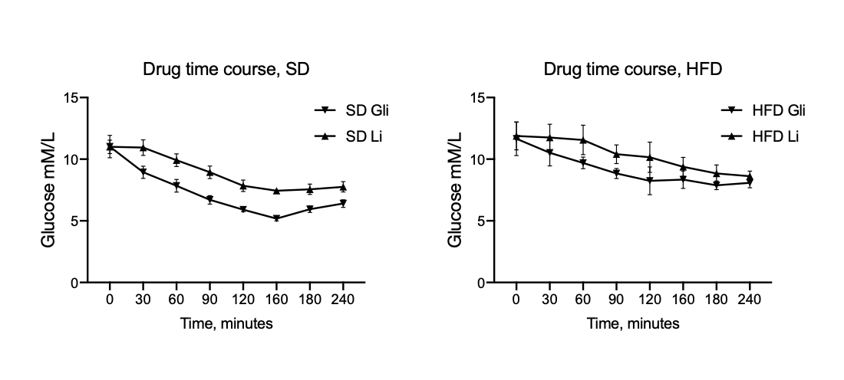
Supplementary Figure 6. The effect of Linagliptin and Glimepiride on random blood glucose up to 240 minutes after administration.
To avoid possible overdose leading to hypoglycemic episodes during the stroke study, Linagliptin and Glimepiride were tested in T2D and healthy mice in a pilot experiment. 10 mg/kg linagliptin and 2 mg/kg Glimepiride were administered orally to mice after 7 months of HFD or SD. Blood glucose was measured with a glucometer every 30 minutes for up to 240 minutes. The results show clear glycaemia-regulating effects of both drugs after acute administration. N=5 for each experimental group.
References
1. Kilic E, ElAli A, Kilic U, Guo Z, Ugur M, Uslu U, et al. Role of Nogo-A in neuronal survival in the reperfused ischemic brain. J Cereb Blood Flow Metab. 2010;30(5):969-84.
2. Reitmeir R, Kilic E, Kilic U, Bacigaluppi M, ElAli A, Salani G, et al. Post-acute delivery of erythropoietin induces stroke recovery by promoting perilesional tissue remodelling and contralesional pyramidal tract plasticity. Brain. 2011;134(Pt 1):84-99.
3. Doeppner TR, Kaltwasser B, Bahr M, Hermann DM. Effects of neural progenitor cells on post-stroke neurological impairment-a detailed and comprehensive analysis of behavioral tests. Front Cell Neurosci. 2014;8:338.
4. Ferrara A, El Bejaoui S, Seyen S, Tirelli E, Plumier JC. The usefulness of operant conditioning procedures to assess long-lasting deficits following transient focal ischemia in mice. Behavioural brain research. 2009;205(2):525-34.
5. Chiazza F, Tammen H, Pintana H, Lietzau G, Collino M, Nystrom T, et al. The effect of DPP-4 inhibition to improve functional outcome after stroke is mediated by the SDF-1alpha/CXCR4 pathway. Cardiovasc Diabetol. 2018;17(1):60.
6. Larsson M, Lietzau G, Nathanson D, Ostenson CG, Mallard C, Johansson ME, et al. Diabetes negatively affects cortical and striatal GABAergic neurons: an effect that is partially counteracted by exendin-4. Bioscience reports. 2016;36(6).
7. Darsalia V, Mansouri S, Ortsater H, Olverling A, Nozadze N, Kappe C, et al. Glucagon-like peptide-1 receptor activation reduces ischaemic brain damage following stroke in Type 2 diabetic rats. Clin Sci (Lond). 2012;122(10):473-83.
8. Darsalia V, Hua S, Larsson M, Mallard C, Nathanson D, Nystrom T, et al. Exendin-4 reduces ischemic brain injury in normal and aged type 2 diabetic mice and promotes microglial M2 polarization. PLoS One. 2014;9(8):e103114.
9. Darsalia V, Larsson M, Lietzau G, Nathanson D, Nystrom T, Klein T, et al. Gliptins-mediated neuroprotection against stroke requires chronic pre-treatment and is glucagon-like peptide-1 receptor independent. Diabetes Obes Metab. 2016.
10. Darsalia V, Ortsater H, Olverling A, Darlof E, Wolbert P, Nystrom T, et al. The DPP-4 inhibitor linagliptin counteracts stroke in the normal and diabetic mouse brain: a comparison with glimepiride. Diabetes. 2013;62(4):1289-96.

