**Supplementary Data**

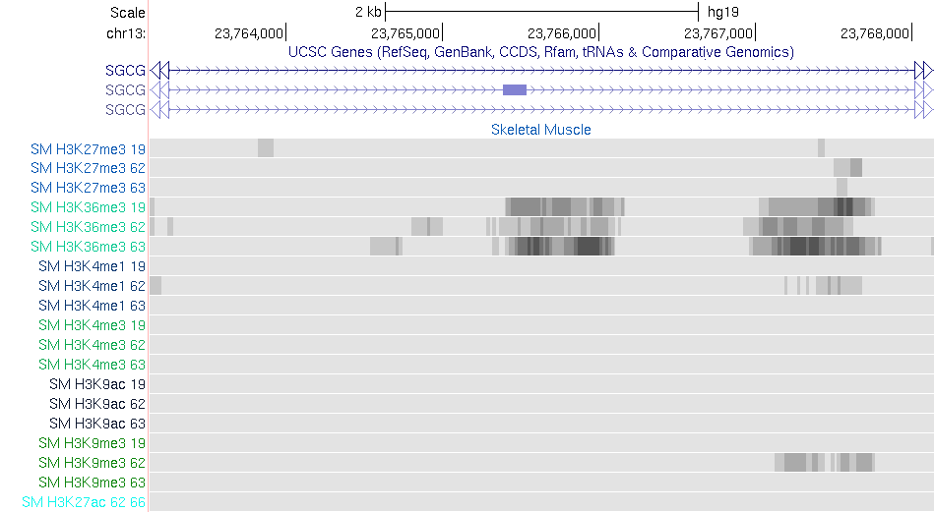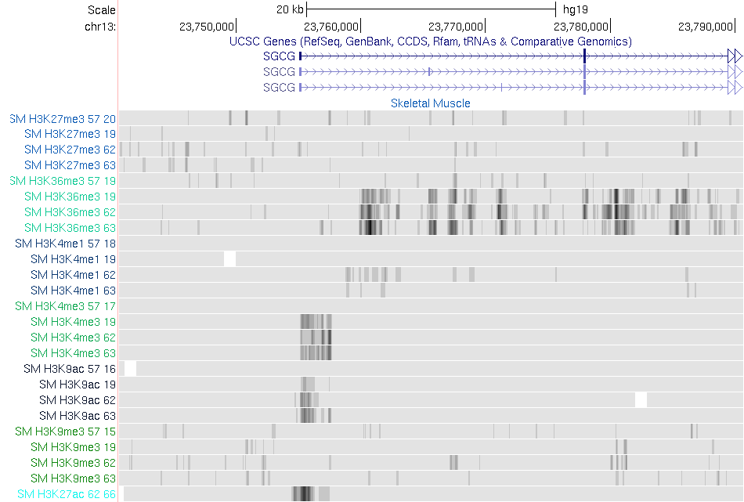**Supplementary Figure 1**

A

B

**Chromatin region overlapping rs679482 shows elevated H3K36 trimethylation**.

Public datasets were interrogated for histone modifications overlaying rs679482 in skeletal muscle; only H3K36me3 was observed in 3 distinct donors. In **A** a 5 kb window is shown whereas in **B**, a 50 kb window is shown for comparison; B also includes stomach mucosa data (top track in each set) as specificity control. H3K27 information (bottom teal track) was available from a single donor.

Vertical bars correspond to rs67948. Data were from the NIH Roadmap Epigenomics Project visualized via the epigenome browser (http://www.epigenomebrowser.org).

**Supplementary Figure 2**

|  |  |  |
| --- | --- | --- |
| **Clinical Characteristics** | | |
|  | **Sib-Pairs (N=20)** | **Matched Subjects (N=112)** |
| Height (in) | 64.4±2.4 | 64.4±2.3 |
| Initial weight (lb) | 240.6±48.6 | 239.9±49.2 |
| Age (yr) | 40.8±10.7 | 41.6±9.9 |
| Initial BMI (kg/m2) | 40.7±7.0 | 40.6±7.1 |
| Waist Circ (in) | 44.3±6.8 | 43.8±5.8 |

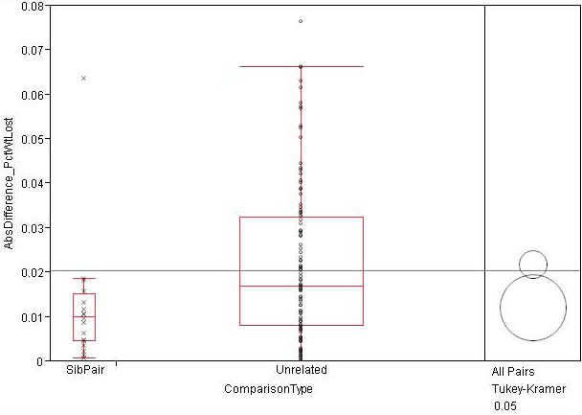

Analysis of 20 female sex matched sib-pairs having completed the program with 112 age and sex-matched unrelated individuals. Comparison for all pairs was performed using Tukey-Kramer HSD. Sibling pairs exhibit much greater similarity of weight loss in response to the behavioral intervention as compared to unrelated individuals (P = 0.007).

q alpha

1.97838 0.05

Abs(Dif)-LSD

Unrelated SibPair

Unrelated -00448 0.001582

SibPair 0.001582 -0.0106

Positive values show pairs of mean that are significantly different

**Supplementary Figure 3**



The distribution of pair-wise Identity By State (IBS) estimates using genome-wide genotype data in our discovery sample of 551 subjects demonstrating no evidence of cryptic relatedness (all IBS estimates < 0.05). We computed the IBS between each two individuals using Plink (v 1.9) and excluded one of each pair of individuals with an estimated, IBS > 0.05 prior to GWAS analysis.

**Supplementary Figure 4**

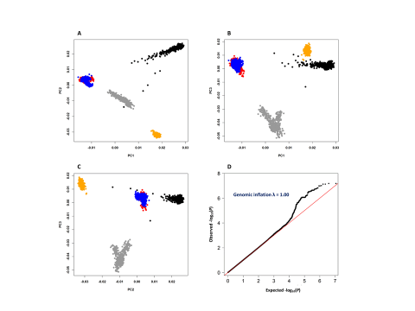

**A-C: Principal Component Analysis** (PCA) of subjects in the discovery GWAS sample and four population samples (African, European, South Asians and East Asians) from 1000 Genomes Project. Pair-wise plots are shown for the top 3 principal components (PC1, PC2 and PC3) based on our subjects (Red, N=551), Europeans (blue, N=503), Africans (black, N=661), South Asians (gray, N=489) and East Asians (orange,N=504); each point represents an individual. Our study subjects clustered with the European sample and are mainly hidden behind. **D: Quantile-quantile (Q-Q) plot of P-values from GWAS study**. The observed P-values (vertical axis) are plotted against the expected P-values of a null distribution (horizontal axis). The genomic inflation (λ) was 1.01 indicating lack of population structure and/or genotyping error.

**Supplementary Figure 5**

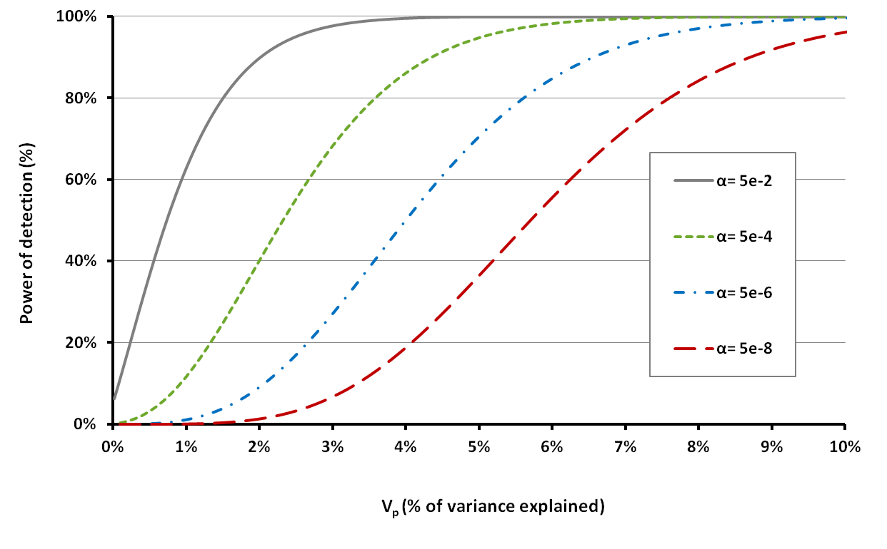

**Power of discovery sample to detect SNPs with different effect sizes (Vp).** Power analysis was done under the assumption of an additive mode of inheritance, N=551, and different levels of α(type I error). Vp indicates the percentage of phenotypic variance explained by a SNP. More information is provided in the Methods section.

**Supplementary Figure 6**

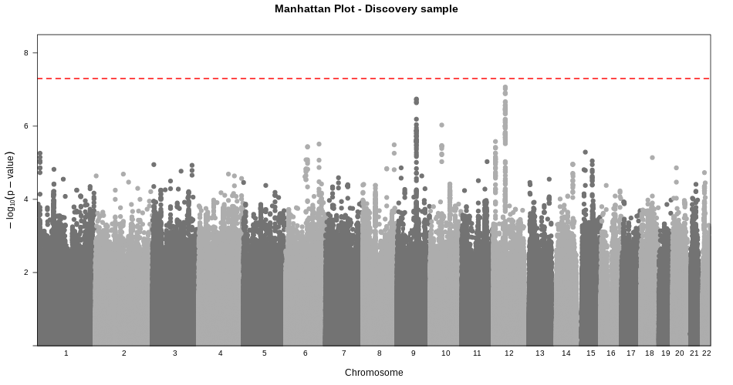

**Manhattan plot representing the findings from our GWAS analysis in the discovery sample.** Genome-wide significant threshold is shown as horizontal dashed red line at P = 5 x 10-8. Summary association statistics for independent SNPs (r2<0.2 and with P<5e-5) are available in **Table 2**.

**Supplementary Figure 7**

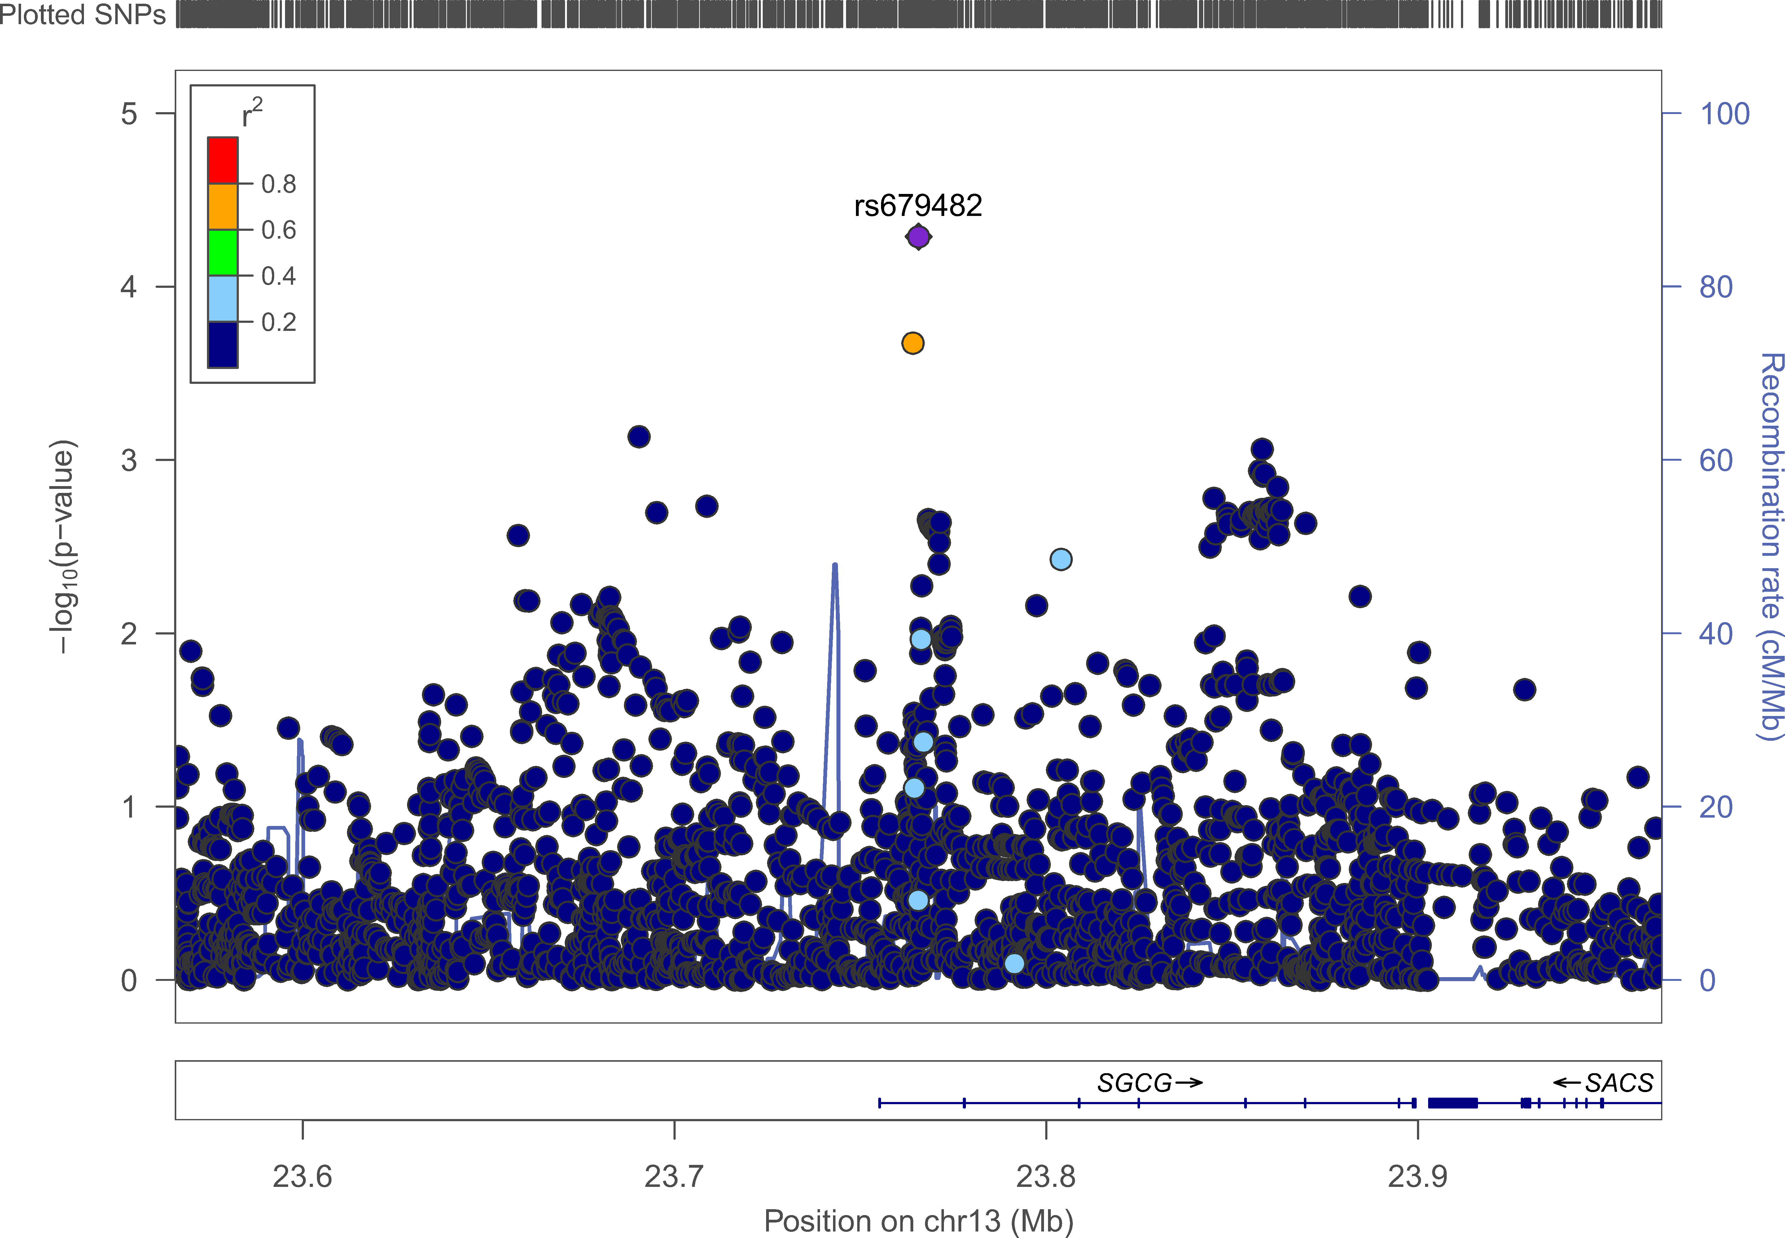

**Regional association and linkage disequilibrium plot of SGCG locus.** Linkage disequilibrium (r2) calculations were based on the European population from the 1000 Genomes reference panel. Genomic coordinates refer to the hg19 sequence assembly.

***Supplementary Table 1 - Joint effect of baseline characteristics on 26 week PWL***

|  |  |  |  |  |  |  |  |  |  |
| --- | --- | --- | --- | --- | --- | --- | --- | --- | --- |
| **Trait** | **Discovery** | | | **Replication** | | | **Combined Sample** | | |
| **Beta** | **SE** | P-value | **Beta** | **SE** | P-value | **Beta** | **SE** | P-value |
| **Sex** | 2.E-02 | 8.E-03 | 2.E-02 | 2.E-02 | 5.E-03 | 1.E-05 | 2.E-02 | 4.E-03 | **8.E-07** |
| **Age** | 4.E-05 | 2.E-04 | 9.E-01 | -4.E-04 | 2.E-04 | 1.E-02 | -3.E-04 | 1.E-04 | **2.E-02** |
| **Initial weight** | 2.E-05 | 5.E-05 | 6.E-01 | -2.E-05 | 3.E-05 | 6.E-01 | -8.E-06 | 3.E-05 | 8.E-01 |
| **Height** | 3.E-04 | 1.E-03 | 8.E-01 | 6.E-04 | 7.E-04 | 4.E-01 | 5.E-04 | 6.E-04 | 3.E-01 |

***Supplementary Table 2 - Summary statistics for the top significant SNPs (with r2<0.2 and P<5e-5) in the discovery sample and their associations in the exploratory sample.***

|  |  |  |  |  |  |  |  |  |  |  |  |  |  |  |
| --- | --- | --- | --- | --- | --- | --- | --- | --- | --- | --- | --- | --- | --- | --- |
| Chr | bp | SNP | | | Discovery sample | | | | Exploratory sample | | | | Annotation | |
| rsID | A1 | Freq | N | Beta | SE | P | N | Beta | SE | P | Type | Gene(s) |
| 13 | 23765635 | rs679482 | A | 0.12 | 521 | -0.38 | 0.09 | 3.36E-05 | 529 | -0.25 | 0.09 | 6.96E-03 | intronic | SGCG |
| 15 | 66957475 | rs11071909 | T | 0.15 | 547 | 0.36 | 0.08 | 7.28E-06 | 567 | 0.14 | 0.08 | 8.61E-02 | intergenic | LCTL,SMAD6 |
| 13 | 22799567 | rs74036744 | C | 0.09 | 549 | -0.43 | 0.10 | 3.01E-05 | 441 | -0.26 | 0.22 | 2.25E-01 | intronic | LINC00540 |
| 10 | 50235335 | rs2254754 | G | 0.19 | 544 | -0.36 | 0.07 | 6.85E-07 | 575 | -0.01 | 0.07 | 8.95E-01 | intronic | VSTM4 |
| 15 | 37375303 | rs62045828 | T | 0.32 | 534 | 0.31 | 0.07 | 4.02E-06 | 535 | -0.04 | 0.07 | 5.15E-01 | intronic | MEIS2 |
| 4 | 1.27E+08 | rs625968 | A | 0.12 | 533 | -0.41 | 0.09 | 1.68E-05 | 520 | -0.09 | 0.09 | 3.18E-01 | intergenic | MIR2054,INTU |
| 9 | 82916625 | rs7044097 | T | 0.18 | 548 | -0.42 | 0.08 | 1.24E-07 | 535 | 0.18 | 0.08 | 1.62E-02 | intergenic | TLE4,TLE1 |
| 13 | 1.05E+08 | rs1764773 | G | 0.13 | 551 | -0.38 | 0.09 | 2.40E-05 | 564 | -0.20 | 0.09 | 2.74E-02 | intergenic | MIR548AS,DAOA-AS1 |
| 4 | 1.53E+08 | rs17027958 | C | 0.12 | 551 | 0.41 | 0.10 | 1.92E-05 | 495 | 0.03 | 0.11 | 8.05E-01 | intergenic | PET112,FBXW7 |
| 8 | 1.34E+08 | rs2929937 | A | 0.40 | 535 | 0.29 | 0.06 | 2.54E-06 | 412 | 0.03 | 0.07 | 7.01E-01 | intronic | WISP1 |
| 1 | 1.11E+08 | rs79065693 | G | 0.03 | 535 | 0.84 | 0.20 | 2.40E-05 | 565 | -0.16 | 0.17 | 3.53E-01 | intergenic | CD53,LRIF1 |
| 20 | 15729314 | rs6043508 | C | 0.17 | 551 | -0.36 | 0.08 | 1.13E-05 | 564 | -0.01 | 0.08 | 8.63E-01 | intronic | MACROD2 |
| 15 | 31825155 | rs111649246 | G | 0.08 | 535 | -0.49 | 0.11 | 1.30E-05 | 539 | 0.01 | 0.12 | 9.13E-01 | intronic | OTUD7A |
| 1 | 1.2E+08 | rs838537 | T | 0.01 | 535 | 1.04 | 0.26 | 7.20E-05 | 561 | 0.22 | 0.24 | 3.52E-01 | intergenic | WARS2,HAO2 |

***Supplementary Table 3 - Genotype frequencies of rs679482 and deviation from Hardy-Weinberg Equilibrium (HWE) in discovery, replication and combined sample.1***

|  |  |  |  |  |  |  |  |  |  |
| --- | --- | --- | --- | --- | --- | --- | --- | --- | --- |
| **Study** | **SNP** | **A1** | **A2** | **A1 Freq** | **Type** | **Genotypes** | | | **P**  (χ², df=1) |
| AA | AC | CC |
| **Discovery** | rs679482 | A | C | 0.12 | O | 11 | 118 | 397 | 0.18 |
| E | 8 | 111 | 407 |
| **Replication** | rs679482 | A | C | 0.11 | O | 23 | 252 | 1056 | 0.07 |
| E | 16 | 261 | 1054 |
| **Combined** | rs679482 | A | C | 0.12 | O | 34 | 370 | 1453 | 0.07 |
| E | 27 | 392 | 1438 |

*1 We estimated the deviation from HWE by comparing the distribution of observed (O) genotypes and expected (E) genotypes using Pearson's chi-squared test, more information is available in Methods section.*

***Supplementary Table 4 - Association of rs679482*** ***with weight loss does not differ by sex***

|  |  |  |  |  |  |  |
| --- | --- | --- | --- | --- | --- | --- |
| Trait | Discovery sample | | | Replication sample | | |
| Beta | SE | P-value | Beta | SE | P-value |
| Age(yrs) | -0.002 | 0.004 | 6.59E-01 | -0.01 | 0.002 | 7.70E-03 |
| Sex-female | -0.44 | 0.11 | 5.55E-05 | -0.46 | 0.07 | 4.40E-12 |
| rs679482-A | -0.45 | 0.17 | 6.68E-03 | -0.29 | 0.07 | 2.80E-05 |
| Sex:rs679482 | 0.12 | 0.19 | 5.43E-01 | -0.13 | 0.13 | 3.21E-01 |

***(For Supplementary Table 5 see EXCEL data sheet)***

|  |  |  |  |  |  |  |  |  |  |
| --- | --- | --- | --- | --- | --- | --- | --- | --- | --- |
| ***Supplementary Table 6. Top association search results for rs679482 derived from publicly available GWAS data*** | | | | | | | | | |
| Trait | PMID | SNP | A1 | A2 | Beta | SE | P | N |
| Omega 6 fatty acids | 27005778 | rs679482 | A | C | 0.079834 | 0.019019 | 2.82E-05 | 13504 |
| Esterified cholesterol | 27005778 | rs679482 | A | C | 0.072633 | 0.019028 | 1.55E-04 | 13495 |
| 18:2, linoleic acid | 27005778 | rs679482 | A | C | 0.070789 | 0.019022 | 2.19E-04 | 13526 |
| Body mass index | UKBB | rs679482 | A | C | -0.01226 | 0.00378 | 5.98E-04 | 336107 |
| 1,6-anhydroglucose | 24816252 | rs679482 | A | C | -0.0357 | 0.0109 | 0.001034 | 3422 |