Supplementary Table 1. Study termination times and reasons. Unwell defined as nausea, headache or vomiting.

Participant | Dapagliflozin visit duration minutes | Reason for termination | Placebo visit duration minutes | Reason for termination
1 | 540 | Midnight | 480 | Patient’s choice
2 | 190 | Decreased pH | 300 | Unwell
3 | 210 | Unwell | 180 | Unwell
4 | 540 | Patient’s choice | 480 | Increased glucose
5 | 480 | Patient’s choice | 540 | Patient’s choice
6 | 360 | Unwell | 480 | Unwell
7 | 480 | Decreased pH | 270 | Increased glucose
8 | 540 | Increased BOHB | 540 | Unwell
9 | 360 | Decreased pH | 600 | End
10 | 180 | Decreased pH | 600 | End
11 | 540 | Unwell | 480 | Unwell
12 | 600 | END | 420 | Unwell

Supplemental Table 2- Patient characteristics with BMI grouping.

 | Dapagliflozin BMI <27 kg/m² | Dapagliflozin BMI >27 kg/m² | Placebo BMI <27 kg/m² | placebo BMI >27 kg/m² | BMI <27 Dapa vs Placebo P Value | BMI >27 Dapa vs Placebo P Value
Age (y) | 34.4±1.9 | 49.4±1.5* | 34.6±1.9 | 49.4±1.5*
BMI (kg/m²) | 22.5±0.4 | 31.4±0.3** | 22.9±0.4 | 31.4±0.4**
Hb_{A1c} (mmol/mol) | 61±1.2 | 59±1.6 | 61±1.2 | 59±1.6
Duration of diabetes | 18.7±5.4 | 29.8±5.6 | 18.7±5.4 | 29.8±5.6
C peptide concentration (nmol/L) | 0.08±0.01 | 0.12±0.02 | 0.08±0.01 | 0.12±0.03 | 0.628 | 0.268
NEFA concentration (mmol/L) at arrival (-120 min) | 0.61±0.05 | 0.28±0.04 | 0.45±0.03 | 0.26±0.03 | 0.328 | 0.693
NEFA Concentration (mmol/L) at baseline (0 min) | 0.77±0.04 | 0.39±0.04* | 0.60±0.04 | 0.29±0.02* | 0.116 | 0.282
Insulin infusion rate at baseline (mU/kg/min) | 0.92±0.07 | 1.58±0.17 | 1.05±0.04 | 1.52±0.11 | 0.520 | 0.838
Insulin concentration (pmol/L) at arrival (-120 min) | 165±16 | 311±27 | 175±13 | 390±38* | 0.941 | 0.198
Insulin concentration (pmol/L) at baseline (0 min) | 154±22 | 298±25 | 159±11 | 341±39* | 0.924 | 0.316
AUC₀₋₁₂₀ insulin concentration (pmol/L*min) | 12985±1572 | 26117±2585 | 13436±914 | 29215±3727* | 0.941 | 0.344
Glucagon concentration (ng/L) at arrival (-120 min) | 37.5±1.1 | 48.5±3.4 | 27.8±0.4 | 45.5±3.3* | 0.007 | 0.398
Glucagon concentration (ng/L) at baseline (0 min) | 35.3±1.1 | 36.5±2.3 | 25.5±0.5 | 39.3±3.5 | 0.010 | 0.490
AUC₀₋₁₂₀ glucagon concentration (ng/L*min) | 4561±151 | 4686±273 | 3401±47 | 4876±426 | 0.018 | 0.791
Glucagon to insulin ratio at arrival (-120 min) | 0.31±0.03 | 0.17±0.01 | 0.23±0.03 | 0.13±0.01 | 0.344 | 0.569
Glucagon to insulin ratio at baseline (0 min) | 0.37±0.03 | 0.14±0.01† | 0.19±0.01 | 0.12±0.01 | 0.009 | 0.856
Significance between BMI groups, P value * <0.05; †<0.01, **<0.001

Supplementary figures
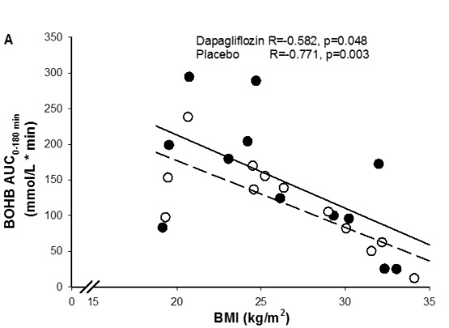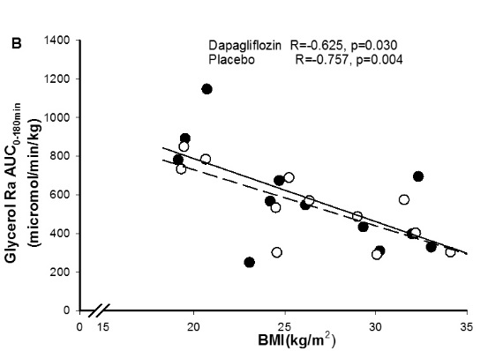
Supplement Figure 1. Inverse correlation between BMI and BOHB AUC and Glycerol Ra AUC. Dapagliflozin closed symbols and placebo open symbols.

Supplement Figure 2. Glucagon/insulin ratio. All subjects completed 180 minutes of each metabolic study (n=12). By 480 min n=5. Dapagliflozin closed symbols and placebo open symbols.

Supplement Figure 3. Correlation between BOHB and NEFA concentration at baseline and BOHB AUC and NEFA AUC. Dapagliflozin closed symbols and placebo open symbols.

Supplement Figure 4. Spot urine ketones (n=12) and urine glucose excretion rate (n=6) (micromol/kg/min). Dapagliflozin closed symbols and placebo open symbols.

