Supplementary Online Content
Perkovic V, et al. Effects of linagliptin on cardiovascular and kidney outcomes in people with normal and reduced kidney function: secondary analysis of the CARMELINA randomized trial

Section | Content | Page
A | Adjudicated kidney outcomes in CARMELINA – definitions and procedures | 2
B | Pre-and post-hoc defined kidney outcomes | 4
C | Baseline characteristics by eGFR categories by <30, 30-45, 45-60 and ≥60 ml/min/1.73m² and <60 vs ≥60 ml/min/1.73m² | 5
D | Trial metrics by eGFR categories <30, 30-45, 45-60 and ≥60 ml/min/1.73m² | 7
E | Placebo-group incidence rates for CV, HF and renal outcomes by eGFR categories <30, 30-45, 45-60 and ≥60 ml/min/1.73m² | 8
F | Effects of linagliptin versus placebo on cardiovascular, heart failure and mortality outcomes by renal function categories eGFR < vs ≥ 60 ml/min/1.73m² and sensitivity and robustness analysis of the key kidney outcome | 9
G | Albuminuria changes and changes in eGFR slopes | 12
H | Effect on HbA1c and post-baseline introduction of glucoselowering medications by baseline eGFR | 18
I | Hypoglycemia and adverse events by baseline eGFR | 20

A. Adjudicated kidney outcomes in CARMELINA – definitions and procedures
Defintions and procedures for adjudication of: 1) Renal death, 2) Sustained ESKD, 3) Sustained decrease of eGFR of 40% or more and 4) Sustained decrease of eGFR of 50% or more
1) Renal death
The following events was classified as Renal death, i.e., when they satisfied the following
criteria:

1. The patient dies,

AND

2. Renal replacement therapy (RRT) has not been initiated (although clinically indicated,
e.g. death due to progressive kidney failure occurs before RRT can be introduced.

3. RRT has been discontinued due to patient withdrawal:

a. The patient refuses RRT or withdraws from chronic RRT, e.g. the caring physician
and the patient (or legal representative) decide to withhold the regular course of
chronic RRT,

AND

b. There is no other likely cause of death

If RRT is not provided, for instance, due to terminal cancer then cause of death is cancer and
not renal death since the more proximal cause of death is cancer and not withdrawal.
Similarly, if someone dies after refusing RRT due to trauma then renal death cannot be
diagnosed. If RRT is discontinued due to hemodynamic instability (such as Heart Failure),
then cause of death is cardiovascular and not renal.

2) Sustained ESKD
At the time of developing this charter, there were no universally-accepted guidelines that clearly define the clinical onset of ESKD. Therefore, the definitions outlined below served to identify and establish events as ESKD:
  - Transplantation will be classified as ESKD when the patient undergoes kidney transplantation.
  - Peritoneal dialysis or hemodialysis, is necessary for at least 30 days and not known to recover at 90 days. At the termination of the trial, 30 days of RRT without reasonable chance of renal recovery will be taken as evidence of ESKD.
  - RRT may be indicated for symptomatic uremia (eGFR <15 + symptoms) or asymptomatic advanced uremia (eGFR <10) but RRT may not be available or affordable or the subject may not elect RRT. In such instances ESKD will be diagnosed even without initiation of RRT. If these conditions are not met, the treating nephrologist must provide documentation for the need for RRT. If at a visit after 30 days if the condition is documented, ESKD is diagnosed.
The date of onset of ESKD is the date of start of RRT if applicable or when the condition was first documented in the clinical database.

If an event is classified as ESKD by the CECR and subsequently the patient elects to withdraw from RRT without demonstrating a recovery in eGFR or signs and symptoms, the CECR decision should not be rescinded.

When a regular course of RRT has not been documented for 60 days or more, questions may arise regarding whether the event was acute or chronic in nature. If a subject is unable to continue for 60 or more days after initiating chronic RRT due to receiving a renal transplant or the subject dying the event will be classified as ESKD, and the date when RRT was initiated will be considered the date of the event.

3) Sustained decrease of eGFR of 40% or more
For the purposes of this adjudication, sustained decrease in eGFR of 40% or higher (i.e., equal to 40% and above but less than 50%) from baseline (Randomization Visit) is defined by evidence of at least two or more consecutive laboratory assessments demonstrating the decrease and by decrease of eGFR to below 60 ml/min. The confirmatory sample is expected to be collected within 4-8 weeks from the initial assessment showing decrease of 40%. However, if the only confirmatory assessment is outside of the window, it will be accepted by CECR and used for decision making.
CECR will only adjudicate positively cases with no confirmatory assessment when:
- decrease happened at trial end or
- due to patient’s death after the initial decrease

4) Sustained decrease of eGFR of 50% or more
For the purposes of this adjudication, sustained decrease in eGFR of 50% or higher (i.e., equal to 50% and above) from baseline (Randomization Visit) is defined by evidence of at least two or more consecutive laboratory assessments demonstrating the decrease and by decrease of eGFR to below 60 ml/min. The confirmatory sample is expected to be collected within 4-8 weeks from the initial assessment showing decrease of 50%. However, if the only confirmatory assessment is outside of the window, it will be accepted by CECR and used for decision making.

CECR will only adjudicate positively cases with no confirmatory assessment when:
- decrease happened at trial end or
- due to patient’s death after the initial decrease

Section B.

Table B1. List of presented kidney outcomes according to being pre-or post-hoc defined.
 | Predefined | Post-hoc defined
Renal death, sustained ESKD or sustained decrease of 40% or more in eGFR from baseline | X
Renal death, sustained ESKD or sustained decrease of 50% or more in eGFR from baseline | X
Renal death, sustained ESKD or sustained decrease of 30% or more in eGFR from baseline accompanied by eGFR <60 ml/min/m² | X
Renal death, sustained ESKD, sustained eGFR <10 ml/min/m² | X
Renal death, sustained ESKD, sustained increase of serum creatinine ≥ 2-fold from baseline, accompanied by eGFR of < 60 mL/min/1.73m² | X
Renal death, sustained ESKD | X
Sustained ESKD | X
Albuminuria-related outcomes
Progression of albuminuria (defined as change from normalbuminuria at baseline to micro- or macroalbuminuria or as change from microalbuminuria to macroalbuminuria). | X
Regression to normalbuminuria defined as UACR < 30 mg/g in patients with micro- or macroalbuminuria at baseline |  | X
Sustained regression to normalbuminuria defined as UACR < 30 mg/g in patients with micro- or macroalbuminuria at baseline | X
Regression to normo- or microalbuminuria in patients with macroalbuminuria at baseline |  | X
Sustained regression to normo- or microalbuminuria in patients with macroalbuminuria at baseline | X
UACR reduction of ≥ 30 % from baseline |  | X
Sustained UACR reduction of ≥ 30 % from baseline | X
UACR reduction of ≥ 50 % from baseline |  | X
Sustained UACR reduction of ≥ 50 % from baseline |  | X
Urine albumin creatinine ratio (UACR) change from baseline over time | X
GFR-related outcomes
Overall eGFR slope from baseline to last value on-treatment | X
eGFR slope in subgroups by renal function |  | X
Acute eGFR slope changes (baseline to week 12) |  | X
Chronic eGFR slope changes (week 12 to last value on treatment) |  | X

Section C.
Table C1 Baseline characteristics (n [%], mean [SD] unless otherwise stated) by GFR categories <60 and ≥60 ml/min/1.73m²
 | eGFR < 60 | eGFR ≥ 60 | Total
N (%) | 4348 (62.3) | 2631 (37.7) | 6979 (100)
Age, years | 67.7 (8.9) | 62.8 (8.6) | 65.9 (9.1)
Male | 2574 (59.2) | 1816 (69.0) | 4390 (62.9)
Region
Europe (incl South-Africa) | 1685 (38.8) | 1249 (47.5) | 2934 (42.0)
Latin America | 1398 (32.2) | 912 (34.7) | 2310 (33.1)
North America | 897 (20.6) | 283 (10.8) | 1180 (16.9)
Asia | 368 (8.5) | 187 (7.1) | 555 (8.0)
eGFR (MDRD), mL/min/1.73 m² | 38.2 (11.2) | 81.6 (16.7) | 54.6 (25.0)
<30 | 1063 (24.4) | 0 | 1062 (15.2)
< 15 | 21 (0.5) | 0 | 21 (0.3)
UACR, mg/g, median (25th−75th percentile) | 208  (42-1005) | 126  (46 – 412) | 162  (44−728)
UACR*
<30 mg/g | 908 (20.9) | 484 (18.4) | 1392 (19.9)
30−300 mg/g | 1547 (35.6) | 1347 (51.2) | 2894 (41.5)
>300 mg/g | 1891 (43.5) | 799 (30.4) | 2690 (38.5)
HbA1c, % | 7.9 (1.0) | 8.0 (1.0) | 8.0 (1.0)
HbA1c, mmol/mol | 62.8 (10.8) | 64.3 (11.2) | 63.4 (11.0)
Diabetes duration, years | 16.4 (9.7) | 12.0 (8.4) | 14.8 (9.5)
BMI, kg/,² | 31.5 (5.4) | 30.9 (5.1) | 31.3 (5.3)
SBP/DBP, mmHg | 141 (19)/77 (11) | 139 (16)/79 (10) | 141 (18)/78 (10)
Heart failure | 1139 (26.2) | 734 (27.9) | 1873 (26.8)
Insulin | 2880 (66.2) | 1171 (44.5) | 4051 (58.0)
Metformin | 1718 (39.5) | 2090 (79.4) | 3808 (54.6)
Sulfonylurea | 1212 (27.9) | 1030 (39.1) | 2242 (32.1)
Any antihypertensives | 4219 (97.0) | 2472 (94.0) | 6691 (95.9)
ACE inhibitors or ARBs | 3525 (81.1) | 2133 (81.1) | 5658 (81.1)
Statins | 3178 (73.1) | 1840 (69.9) | 5018 (71.9)
UACR: Data missing for 3 (0.0%) participants: 2 (0.1%) linagliptin and 1 (0.0%) placebo. ACE angiotensin-converting enzyme, ARB angiotensin-receptor blocker, ASA acetylsalisylic acid, BMI body-mass index, eGFR estimated glomerular filtration rate, HbA1c glycated hemoglobin A1c, MDRD Modification of Diet in Renal Disease study equation, UACR urinary albumin-to-creatinine ratio.

Section D. Trial metrics by renal function
Table D1. Observation and treatment times (years), and retention metrics, by randomized treatment groups and renal function (based on MDRD formula [ml/min/1.73m²]).
 | eGFR < 30 |  | eGFR 30-45 |  | eGFR 45-60 |  | eGFR ≥ 60 |  | Overall
 | Lina | PBO | Lina | PBO | Lina | PBO | Lina | PBO | Lina | PBO
n | 516 | 546 | 994 | 944 | 690 | 658 | 1294 | 1337 | 3494 | 3485
Observation time, years (median, IQR) | 2.2 (1.6, 3.0) | 2.2 (1.5, 2.9) | 2.3 (1.7, 3.1) | 2.3 (1.7, 3.1) | 2.3 (1.6, 3.0) | 2.3 (1.7, 3.1) | 2.2 (1.6, 2.7) | 2.1 (1.6, 2.7) | 2.2 (1.6, 3.0) | 2.2 (1.6, 3.0)
Treatment exposure, years (median, IQR) | 1.8 (1.2, 2.5) | 1.7 (1.2, 2.5) | 2.0 (1.2, 2.8) | 2.0 (1.2, 2.7) | 2.0 (1.3, 2.6) | 1.9 (1.2, 2.6) | 1.9 (1.3, 2.5) | 1.9 (1.2, 2.5) | 1.9 (1.2, 2.6) | 1.9 (1.2, 2.5)
Vital status available at trial end, n (%) | 513  (99.4) | 544  (99.6) | 992 (99.8) | 940 (99.6) | 690 (100) | 653 (99.2) | 1292  (99.8) | 1334  (99.8) | 3487 (99.8) | 3471 (99.6)
Complete follow-up for 3P-MACE, n (%) | 508  (98.4) | 533 (97.6) | 986 (99.2) | 930 (98.5) | 680 (98.6) | 644 (97.9) | 1284 (99.2) | 1323 (99.0) | 3458 (99.0) | 3430 (98.4)
Premature trial medication discontinuation, n (%) | 95 (18.4) | 116 (21.2) | 275 (27.7) | 284 (30.1) | 159 (23.0) | 171 (26.0) | 208 (16.1) | 273 (20.4) | 834 (23.9) | 955 (27.4)

Lina; linagliptin, PBO; placebo, IQR; 1st quartile , 3rd quartile, 3P-MACE; CV death, non-fatal myocardial infarction, or non-fatal stroke.

Section E.
Figure E1. Placebo-group incidence rates for cardiovascular, heart-failure hospitalization (HHF) and renal outcomes by eGFR categories <30 (G≥4), 30-45 (G3b), 45-60 (G3a) and ≥60 (G≤2) ml/min/1.73m²
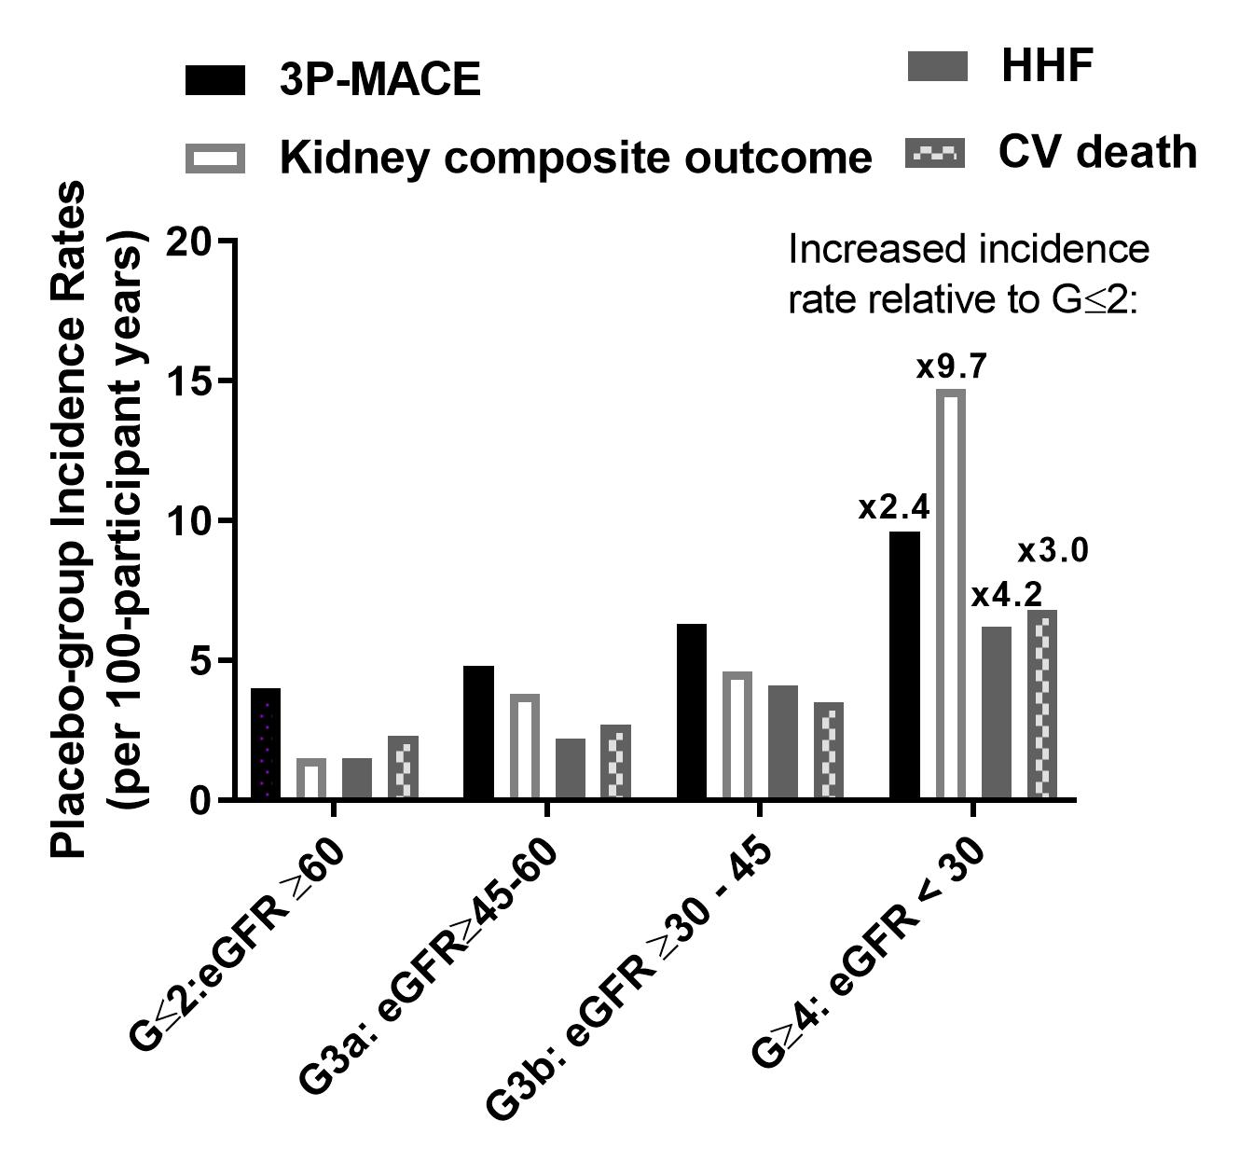

Section F.
Figure F1. Effects of linagliptin versus placebo on cardiovascular, heart failure, mortality and kidney outcomes by renal function categories eGFR < vs ≥ 60 ml/min/1.73m²

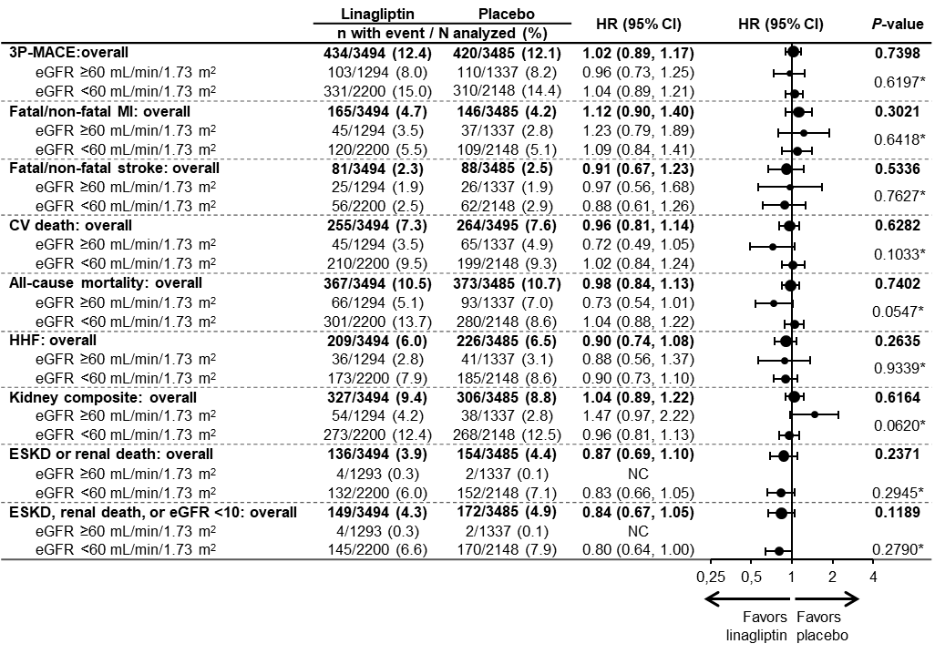
*:denotes p-value of subgroup-by-treatment interaction test. NC – not calculated (too few events).

Figure F2. Sensitivity analysis of time to first occurrence of renal death, sustained ESKD or sustained decrease of ≥40% in eGFR from baseline. Cox regression model.
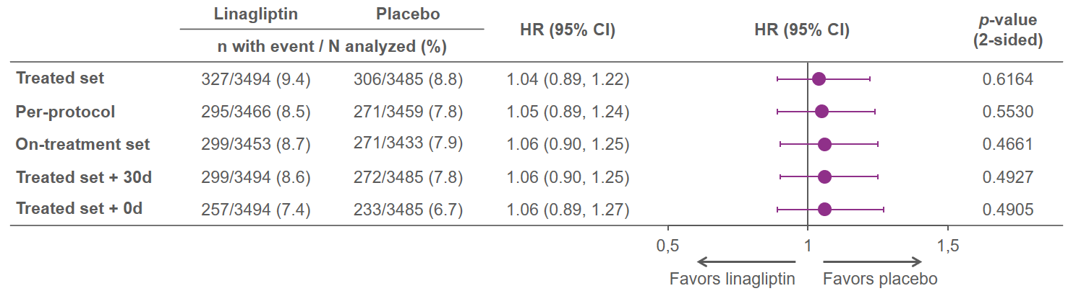
Figure F3. Robustness analysis of time to first occurrence of composite kidney endpoints with other cut-offs for sustained decrease in eGFR or doubling of se-creatinine. Cox regression model.
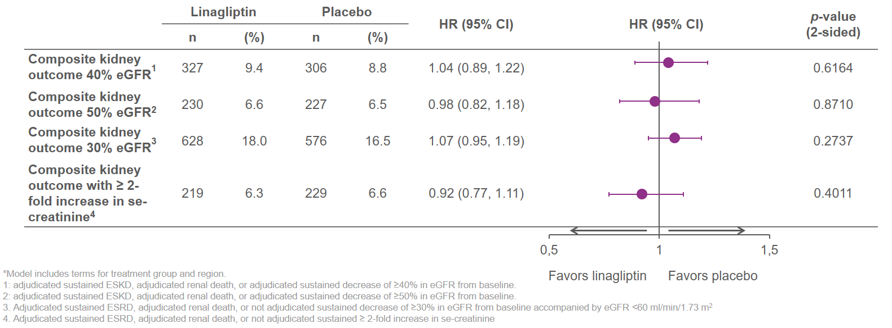
Figure F4. Time to first occurrence of sustained ESKD or renal death for linagliptin versus placebo
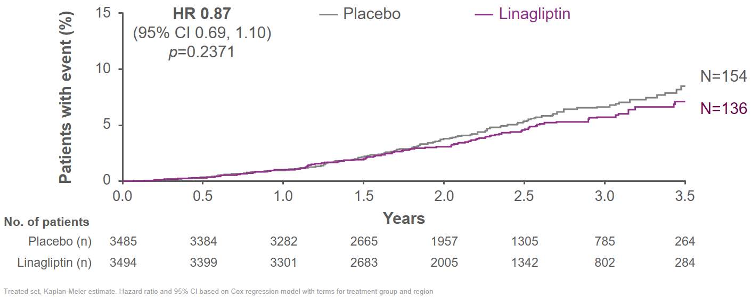
Figure F5. Time to first sustained eGFR (MDRD) <10 ml/min/m2, sustained ESRD, renal death for linagliptin versus placebo
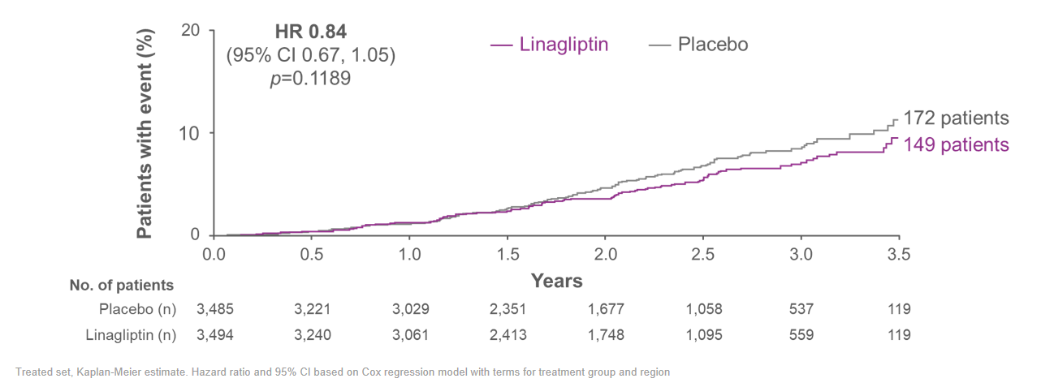

Section G Albuminuria changes and changes in eGFR slopes
Fig G1 Geometric mean over time and ratio of relative change in albuminuria for linagliptin versus placebo
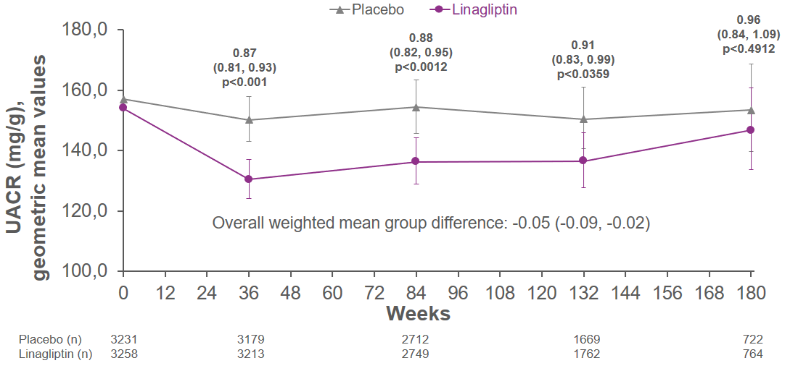
UACR – urine albumin-creatinine ratio Based on MMRM model adjusting for treatment, region, baseline UACR value, week, treatment-by-week interaction and baseline UACR value-by-week interaction.UACR is log10 transformed prior to analysis within the MMRM model and results were back-transformed to the original scale. OC all. Baseline values are descriptive

Fig G2 Geometric mean relative changes in albuminuria by eGFR category from baseline for linagliptin verus placebo 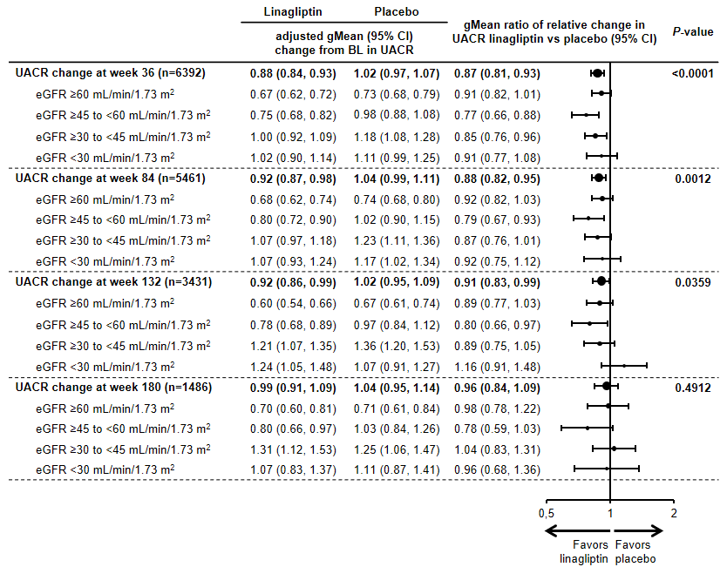
Table G1. Time to albuminuria regression for linagliptin versus placebo
 | Linagliptin |  | Placebo |  | Hazard Ratio  (95% CI) | P-value
 | n (%) | Rate/100  patient-years | n (%) | Rate/100  patient-years
First regression to normoalbuminuria (UACR < 30 mg/g) | 631 (22.6) | 11.52 | 538 (19.3) | 9.71 | 1.20 (1.07, 1.34) | 0.0021
≥60 mL/min/1.73m² | 338 (31.9) | 17.25 | 326 (30.0) | 16.46 | 1.06 (0.91, 1.23) | 0.0315  (p-for interaction)
≥45 to <60 mL/min/1.73m² | 135 (23.3) | 11.85 | 87 (15.7) | 7.49 | 1.62 (1.23, 2.12)
≥30 to <45 mL/min/1.73m² | 118 (16.4) | 7.95 | 85 (12.5) | 5.77 | 1.39 (1.05, 1.84)
<30 mL/min/1.73m² | 40 (9.2) | 4.47 | 40 (8.6) | 4.32 | 1.02 (0.66, 1.59)
Sustained regression to normoalbuminuria (UACR < 30 mg/g) | 445 (15.9) | 8.88 | 391 (14.0) | 7.97 | 1.12 (0.98, 1.28) | 0.0997
≥60 mL/min/1.73m² | 252 (23.8) | 13.65 | 250 (23.0) | 13.64 | 1.00 (0.84, 1.19) | 0.0179  (p-for interaction)
≥45 to <60 mL/min/1.73m² | 94 (16.2) | 8.69 | 57 (10.3) | 5.47 | 1.68 (1.21, 2.33)
≥30 to <45 mL/min/1.73m² | 78 (10.9) | 5.89 | 56 (8.2) | 4.43 | 1.30 (0.93, 1.84)
<30 mL/min/1.73m² | 21 (4.8) | 2.76 | 28 (6.0) | 3.65 | 0.76 (0.43, 1.33)
First regression to normo- or microalbuminuria (UACR ≤ 300 mg/g) | 467 (35.1) | 19.84 | 433 (31.9) | 17.53 | 1.14 (1.00, 1.30) | 0.0523
≥60 mL/min/1.73m² | 211 (52.0) | 33.37 | 196 (49.9) | 32.35 | 1.03 (0.85, 1.25) | 0.4299  (p-for interaction)
≥45 to <60 mL/min/1.73m² | 106 (40.0) | 23.71 | 107 (35.3) | 19.35 | 1.25 (0.96, 1.64)
≥30 to <45 mL/min/1.73m² | 99 (26.5) | 13.55 | 72 (21.1) | 10.38 | 1.32 (0.97, 1.78)
<30 mL/min/1.73m² | 51 (17.7) | 9.38 | 58 (18.2) | 9.39 | 1.00 (0.69, 1.46)
Sustained regression to normo or microalbuminuria | 365 (27.4) | 17.03 | 348 (25.7) | 15.93 | 1.08 (0.93, 1.25) | 0.3137
≥60 mL/min/1.73m² | 172 (42.4) | 28.12 | 161 (41.0) | 27.83 | 1.01 (0.81, 1.25) | 0.1599  (p-for interaction)
≥45 to <60 mL/min/1.73m² | 81 (30.6) | 18.93 | 84 (27.7) | 16.38 | 1.21 (0.89, 1.64)
≥30 to <45 mL/min/1.73m² | 82 (22.0) | 12.57 | 56 (16.4) | 9.40 | 1.31 (0.93, 1.84)
<30 mL/min/1.73m² | 30 (10.4) | 6.65 | 47 (14.7) | 9.44 | 0.72 (0.46, 1.14)
Time to first UACR reduction of ≥30 % from BL | 1594 (57.0) | 38.71 | 1460 (52.5) | 33.94 | 1.14 (1.06, 1.22) | 0.0003
≥60 mL/min/1.73m² | 681 (64.2) | 46.03 | 638 (58.8) | 41.54 | 1.12 (1.00, 1.24) | 0.3156  (p-for interaction)
≥45 to <60 mL/min/1.73m² | 344 (59.4) | 41.41 | 290 (52.4) | 32.38 | 1.27 (1.09, 1.49)
≥30 to <45 mL/min/1.73m² | 365 (50.8) | 32.68 | 322 (47.2) | 28.14 | 1.16 (1.00, 1.34)
<30 mL/min/1.73m² | 204 (46.7) | 29.55 | 210 (45.4) | 28.96 | 1.01 (0.83, 1.23)
Sustained UACR reduction of ≥ 30 % from baseline | 1231 (44.0) | 29.26 | 1161 (41.7) | 27.92 | 1.05 (0.97, 1.14) | 0.2072
≥60 mL/min/1.73m² | 550 (51.8) | 36.13 | 532 (49.0) | 34.94 | 1.04 (0.92, 1.17) | 0.2782  (p-for interaction)
≥45 to <60 mL/min/1.73m² | 260 (44.9) | 29.04 | 224 (40.5) | 25.39 | 1.17 (0.98, 1.40)
≥30 to <45 mL/min/1.73m² | 278 (38.7) | 24.71 | 244 (35.8) | 22.36 | 1.10 (0.93, 1.31)
<30 mL/min/1.73m² | 143 (32.7) | 21.51 | 161 (34.8) | 24.33 | 0.89 (0.71, 1.11)
Time to first UACR reduction of ≥ 50 % from BL | 1279 (45.8) | 27.43 | 1145 (41.1) | 23.84 | 1.15 (1.07, 1.25) | 0.0004
≥60 mL/min/1.73m² | 556 (52.4) | 33.14 | 533 (49.1) | 31.38 | 1.07 (0.95, 1.20) | 0.2101  (p-for interaction)
≥45 to <60 mL/min/1.73m² | 280 (48.4) | 29.43 | 231 (41.8) | 23.06 | 1.28 (1.08, 1.53)
≥30 to <45 mL/min/1.73m² | 292 (40.7) | 23.10 | 234 (34.3) | 18.26 | 1.27 (1.07, 1.50)
<30 mL/min/1.73m² | 151 (34.6) | 19.63 | 147 (31.7) | 17.90 | 1.09 (0.87, 1.37)
Sustained UACR reduction of ≥ 50 % from BL | 949 (34.0) | 18.25 | 872 (31.3) | 16.67 | 1.10 (1.00, 1.21) | 0.0394
≥60 mL/min/1.73m² | 444 (41.8) | 23.77 | 430 (39.6) | 23.01 | 1.04 (0.91, 1.18) | 0.4757  (p-for interaction)
≥45 to <60 mL/min/1.73m² | 198 (34.2) | 18.40 | 170 (30.7) | 15.55 | 1.21 (0.98, 1.48)
≥30 to <45 mL/min/1.73m² | 203 (28.3) | 14.37 | 167 (24.5) | 12.00 | 1.20 (0.98, 1.47)
<30 mL/min/1.73m² | 104 (23.8) | 12.33 | 105 (22.7) | 11.98 | 1.03 (0.78, 1.35)
Patients already meeting the respective condition/endpoint at baseline are excluded from the respective endpoint analysis. HR based on Cox regression analyses in patients treated with ≥1 dose of study drug.

Figure G3. Time to first occurrence of albuminuria progression for linagliptin versus placebo overall, adjusted for time-dependent change in HbA1c, and in a landmark analysis considering week 12 as start date.
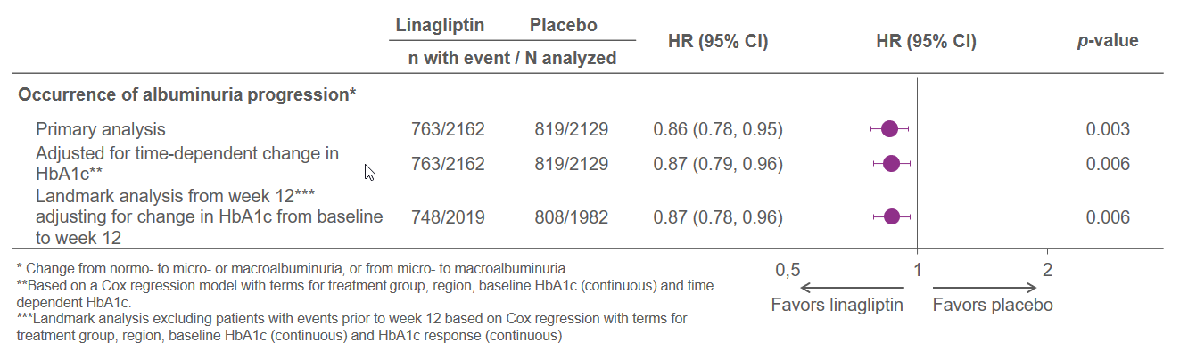
Figure G4 eGFR slopes (MDRD) from BL to week 12 and week 12 to end of treatment overall for linagliptin versus placebo
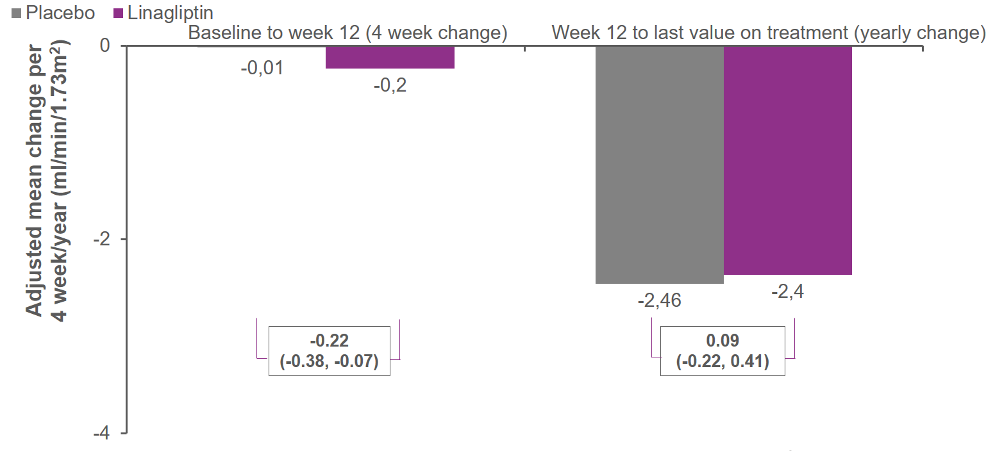
Figure G5 eGFR slopes (MDRD) from BL to week 12 and week 12 to end of treatment by eGFR categories for linagliptin versus placebo
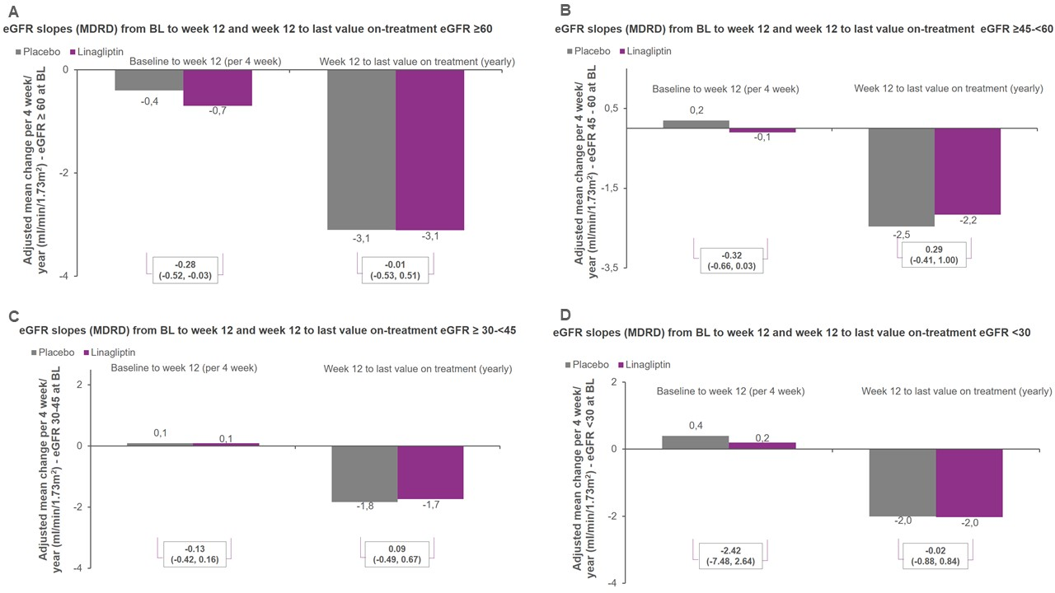
Section H. Effect on HbA1c and new onset glucose lowering therapies by GFR group

Table H1. Weighted average mean difference (95% CI) in HbA1c between linagliptin and placebo treated groups

 | G≥4  eGFR <30 | G3b  eGFR 30-<45 | G3a  eGFR 45-<60 | G≤2  eGFR ≥60 | Total
N | 1062 | 1938 | 1348 | 2631 | 6979
Difference in HbA1c, % | -0.37%  (-0.54, -0.20) | -0.35%  (-0.47, -0.22) | -0.44%  (-0.59, -0.30) | -0.33%  (-0.43, -0.22) | -0.36%  (-0.42, -0.29)
Difference in HbA1c, mmol/mol | −4.01  (−5.86, −2.16) | −3.78  (−5.12, −2.44) | −4.83  (−6.43, −3.23) | −3.56 (−4.70, −2.42) | −3.93  (−4.64, −3.22)

Table H2. New onset glucose lowering therapies post baseline
Shown are n (percentages) of patients with glucose-lowering medication initiated after first trial administration and without previous (either ongoing or discontinued) prescription of the same preferred name according to standardized drug groupings. Dose increases are not considered. Hazard ratios (HR) for time to first initiation of the corresponding antidiabetic medication are based on a Cox regression model,
 | Patients with new therapy/  patients analyzed |  | Hazard ratio | (95% CI) | p-value
 | Linagliptin | Placebo
Any glucose-lowering therapy
All | 783/3494 (22.4%) | 970/3485 (27.8%) | 0.76 | (0.69, 0.84) | <0.001
≥60 mL/min/1.73m² | 251/1294 (19.4%) | 326/1337 (24.4%) | 0.75 | (0.64, 0.89) | 0.7378  (p-for interaction)
≥45 to <60 mL/min/1.73m² | 171/690 (24.8%) | 196/658 (29.8%) | 0.79 | (0.65, 0.98)
≥30 to <45 mL/min/1.73m² | 251/994 (25.3%) | 290/944 (30.7%) | 0.79 | (0.67, 0.93)
<30 mL/min/1.73m² | 110/516 (21.3%) | 158/546 (28.9%) | 0.68 | (0.53, 0.86)
Insulin therapy
All | 509/3494 (14.6%) | 628/3485 (18.0%) | 0.78 | (0.70, 0.88) | <0.001
≥60 mL/min/1.73m² | 123/1294 (9.5%) | 190/1337 (14.2%) | 0.64 | (0.51, 0.80) | 0.1308  (p-for interaction)
≥45 to <60 mL/min/1.73m² | 117/690 (17.0%) | 117/658 (17.8%) | 0.95 | (0.73, 1.23)
≥30 to <45 mL/min/1.73m² | 173/994 (17.4%) | 195/944 (20.7%) | 0.83 | (0.67, 1.02)
<30 mL/min/1.73m² | 96/516 (18.6%) | 126/546 (23.1%) | 0.77 | (0.59, 1.00)
Glucose-lowering medications excluding insulin
All | 375/3494 (10.7%) | 482/3485 (13.8%) | 0.75 | (0.66, 0.86) | <0.001
≥60 mL/min/1.73m² | 154/1294 (11.9%) | 181/1337 (13.5%) | 0.85 | (0.69, 1.06) | 0.0681  (p-for interaction)
≥45 to <60 mL/min/1.73m² | 86/690 (12.5%) | 103/658 (15.7%) | 0.78 | (0.59, 1.04)
≥30 to <45 mL/min/1.73m² | 110/994 (11.1%) | 139/944 (14.7%) | 0.74 | (0.57, 0.95)
<30 mL/min/1.73m² | 25/516 (4.8%) | 59/546 (10.8%) | 0.42 | (0.27, 0.68)

Section I. Hypoglycemia and adverse events by eGFR categories
Figure I1. Incidence rate ratios and rates per 100 patient-years for hypoglycamia overall and by eGFR categories for linagliptin versus placebo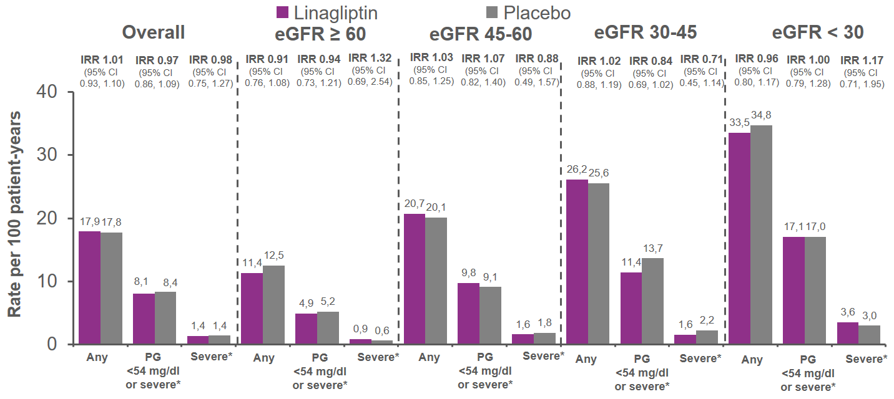
*Requiring the assistance of another person to actively administer carbohydrate, glucagon or other resuscitative actions Treated set. MedDRA version used for reporting: 20.1. AEs occurring between first study drug intake until 7 days after last permanent study drug stop. eGFR, estimated glomerular filtration rate. IRR; incidence rate ratio. PG; plasma glucose.
Figure I2. Incidence rate ratios and rates per 100 patient-years for hypoglycamia by eGFR < 60 and ≥ 60 ml/min/1.73m² for linagliptin versus placebo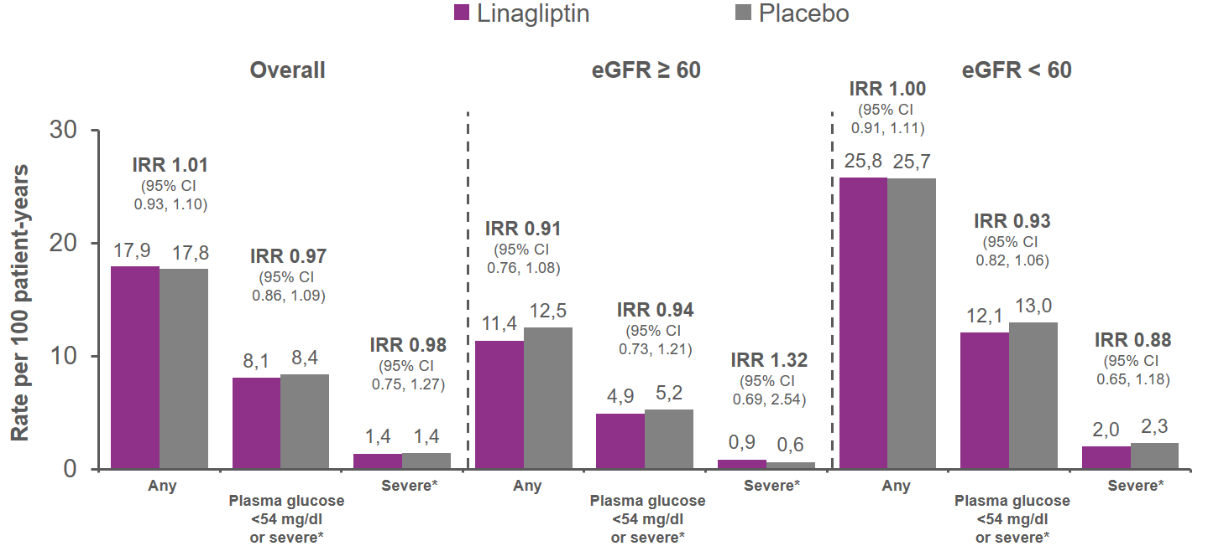
*Requiring the assistance of another person to actively administer carbohydrate, glucagon or other resuscitative actions Treated set. MedDRA version used for reporting: 20.1. AEs occurring between first study drug intake until 7 days after last permanent study drug stop. eGFR, estimated glomerular filtration rate. IRR; incidence rate ratio.

Table I1. Occurrence of adverse events as reported by investigators across eGFR-categories.
 | eGFR < 30 |  | GFR 30-45 |  | eGFR 45-60 |  | eGFR ≥ 60 |  | Overall
N (%) overall | 1062 (100) |  | 1938 (100) |  | 1348 (100) |  | 2631 (100) |  | 6979 (100)
N/treatment group | LINA  (n=516) | PBO  (n=546) | LINA  (n=994) | PBO  (n=944) | LINA  (n=690) | PBO  (n=658) | LINA  (n=1294) | PBO  (n=1337) | LINA  (n=3494) | PBO  (n=3485)
One or more adverse event (AE) | 440 (85.3) | 472 (86.4) | 832 (83.7) | 817 (86.5) | 558 (80.9) | 524 (79.6) | 867 (67.0) | 910 (68.1) | 2697 (77.2) | 2723 (78.1)
One or more serious AEs | 271 (52.5) | 305 (55.9) | 407 (40.9) | 431 (45.7) | 261 (37.8) | 241 (36.6) | 354 (27.4) | 366 (27.4) | 1293 (37.0) | 1343 (38.5)
AE leading to discontinuation | 95 (18.4) | 116 (21.2) | 130 (13.1) | 117 (12.4) | 64  (9.3) | 59 (9.0) | 70  (5.4) | 110  (8.2) | 359 (10.3) | 402 (11.5)
Decreased appetite† | 3  (0.6) | 3  (0.5) | 6  (0.6) | 5  (0.5) | 9  (1.3) | 4  (0.6) | 7  (0.5) | 3  (0.2) | 25  (0.7) | 15  (0.4)
Dehydration† | 4  (0.8) | 3  (0.5) | 12  (1.2) | 2  (0.2) | 8  (1.2) | 3  (0.5) | 3  (0.2) | 5  (0.4) | 27  (0.8) | 13  (0.4)
Acute Kidney injury† | 31 (6.0) | 35  (6.4) | 31  (3.1) | 37 (3.9) | 20  (2.9) | 14 (2.1) | 14  (1.1) | 16  (1.2) | 96  (2.7) | 102  (2.9)
Renal impairment† | 35 (6.8) | 44  (8.1) | 27  (2.7) | 29 (3.1) | 15  (2.2) | 12 (1.8) | 9  (0.7) | 8  (0.6) | 86  (2.5) | 93  (2.7)
Chronic kidney disease† | 43 (8.3) | 26 (4.8) | 31 (3.1) | 32 (3.4) | 11 (1.6) | 9 (1.4) | 6  (0.5) | 4  (0.3) | 91  (2.6) | 71  (2.0)
Kidney failure† | 33 (6.4) | 24 (4.4) | 22  (2.2) | 21 (2.2) | 10  (1.4) | 6 (0.9) | 4  (0.3) | 11  (0.8) | 69  (2.0) | 62  (1.8)
End stage renal disease† | 30 (5.8) | 35  (6.4) | 6  (0.6) | 8 (0.8) | 0  (0) | 2 (0.3) | 2  (0.2) | 0  (0) | 38  (1.1) | 45  (1.3)
Proteinuria† | 6 (1.2) | 5  (0.9) | 1  (0.1) | 8 (0.8) | 3  (0.4) | 3 (0.5) | 7  (0.5) | 14  (1.0) | 17  (0.5) | 30  (0.9)
Adverse events are classified based on MedDRA version 20.1 and include AEs from patients treated with ≥1 dose of study drug until ≤7 days after the last intake of study medication.†Based on individual MedDRA PT.

