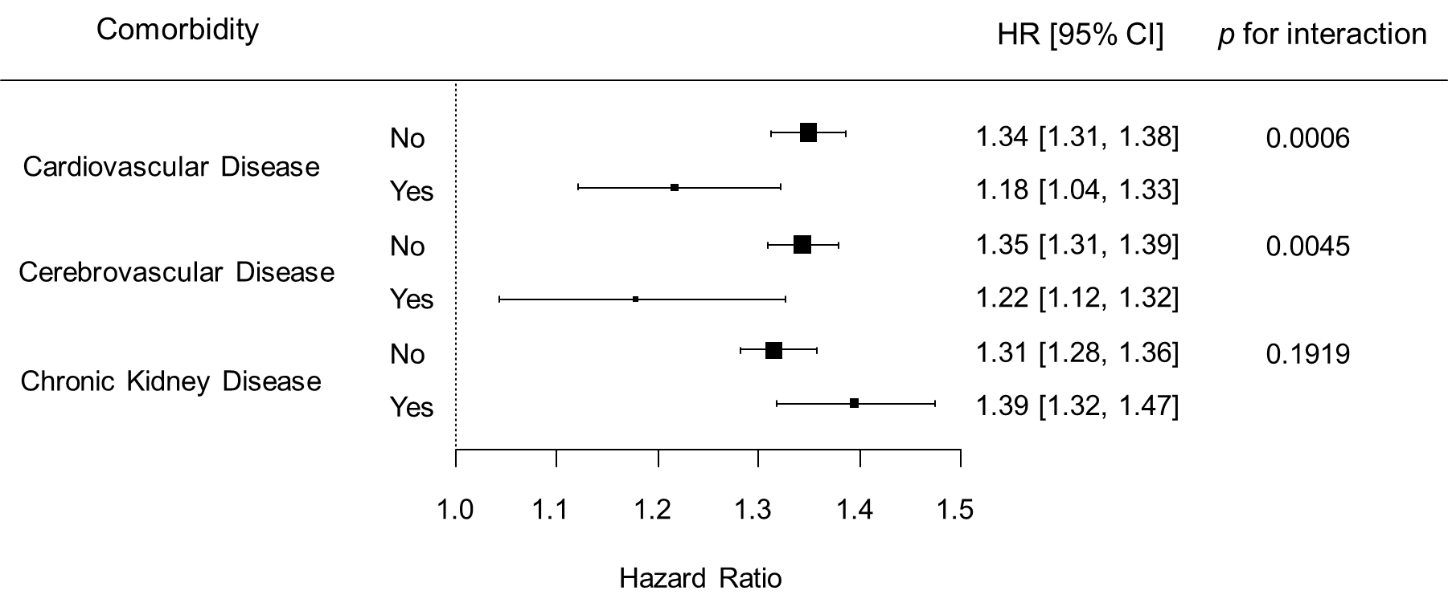
Supplemental figure 1. Subgroup analysis by comorbidity in diabetes subjects.

