ONLINE SUPPLEMENTAL MATERIAL
Supplemental Figure S1: Unadjusted health care costs per person-years among those aged ≥ 65 years, by type of service and income quintile

Supplemental Figure S2: Unadjusted health care costs per person-years among those aged 20-64, by type of service and income quintile

Supplemental Figure S3: Age- and sex-adjusted all cause survival in adults under age 65 (A) and aged 65 years and older (B), by socioeconomic status (SES)
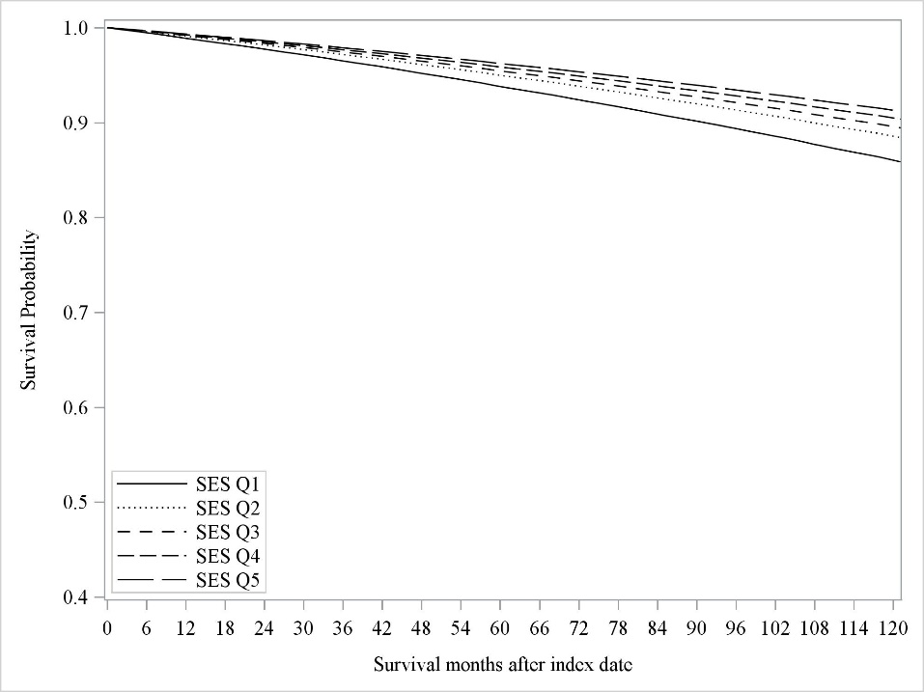
A.

B.

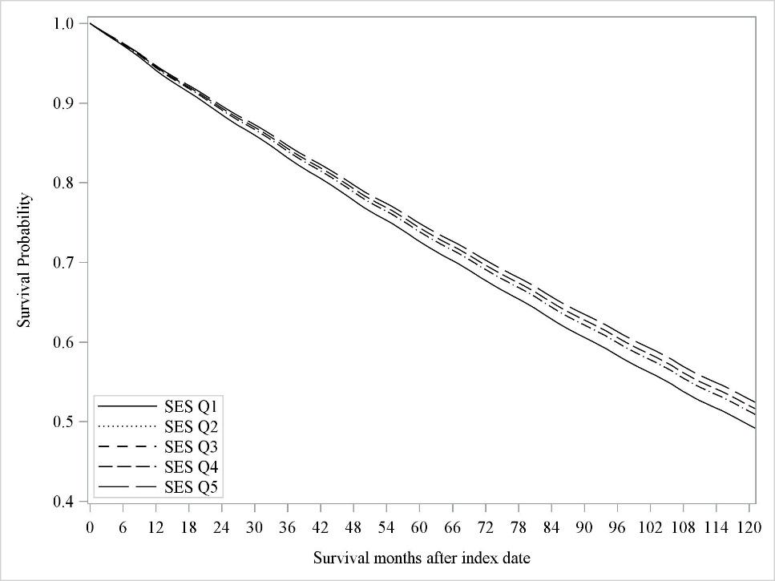
B.

Q=Quintile
Supplemental Table S1: Diagnostic and procedure codes for baseline cardiovascular disease from hospitalization recordsª
Variable Name | Baseline Clinical Condition | Diagnostic codes ^{b} |  | Procedure codes
 |  | ICD9 | ICD10 | CCP | CCI
Coronary Artery Disease | Acute myocardial infarction | 410.x | I21, I22,
 | Percutaneous coronary intervention |  |  | 48.02, 48.03, 48.09 | 1IJ50 or 1IJ57GQ
 | Coronary artery bypass graft surgery |  |  | 48.11-48.19, 48.1 | 1IJ76
Cerebrovascular Disease | Stroke | 431, 434, 436 | I61, I63, and I64

ª Based on hospital records or physicians’ services claims within the 5-year period prior to index (April 1, 1999-March 31, 2004).
^{b} The Canadian Institute of Health Information (CIHI) Hospital Discharge Abstract Database used the International Classification of Diseases, 9th revision (ICD9) coding for diagnoses and Canadian Classification of Procedures (CCP) coding for procedures prior to April 1, 2002; and ICD10 coding/Canadian Classification of Health Interventions (CCI) thereafter.

