SUPPLEMENTAL MATERIAL

Figure 1: Participant flow chart
Figure 2: Scatter plots with error bars depicting mean and 95% confidence intervals for cold detection threshold (CDT), warm detection threshold (WDT) and mechanical pain sensitivity (MPS) for each study group.
Figure 3: Histograms depicting number (n, absent and present) of subjects with wind-up ratio (WUR) and dynamic mechanical sensitivity (DMS) or allodynia for each patient group (*p<0.05).
Figure 4: Scatter plots with error bars depicting mean and 95% confidence intervals for cold pain threshold (CPT), Heat pain threshold (HPT) for each study group.
Figure 5: Scatter plot demonstrating Pearson’s correlation coefficient between NTSS-6 and functional connectivity between the primary somatosensory cortex to frontal orbital cortex.

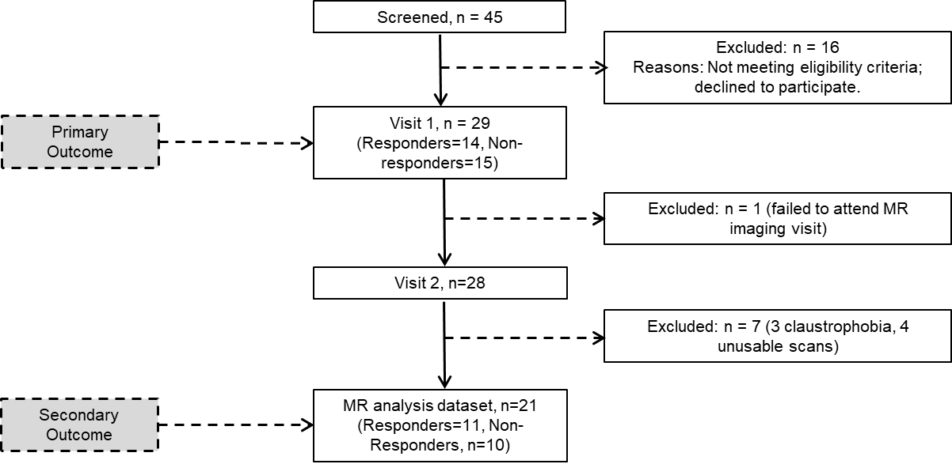

Figure 1: Participant flow chart

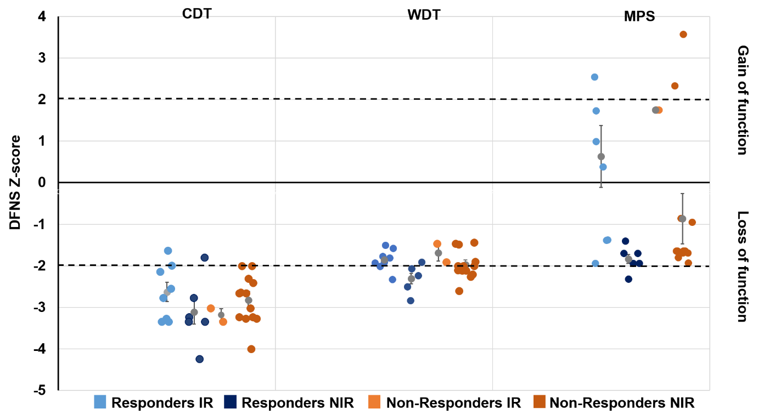

Figure 2: Scatter plots with error bars depicting mean and 95% confidence intervals for cold detection threshold (CDT), warm detection threshold (WDT) and mechanical pain sensitivity (MPS) for each study group.
* *
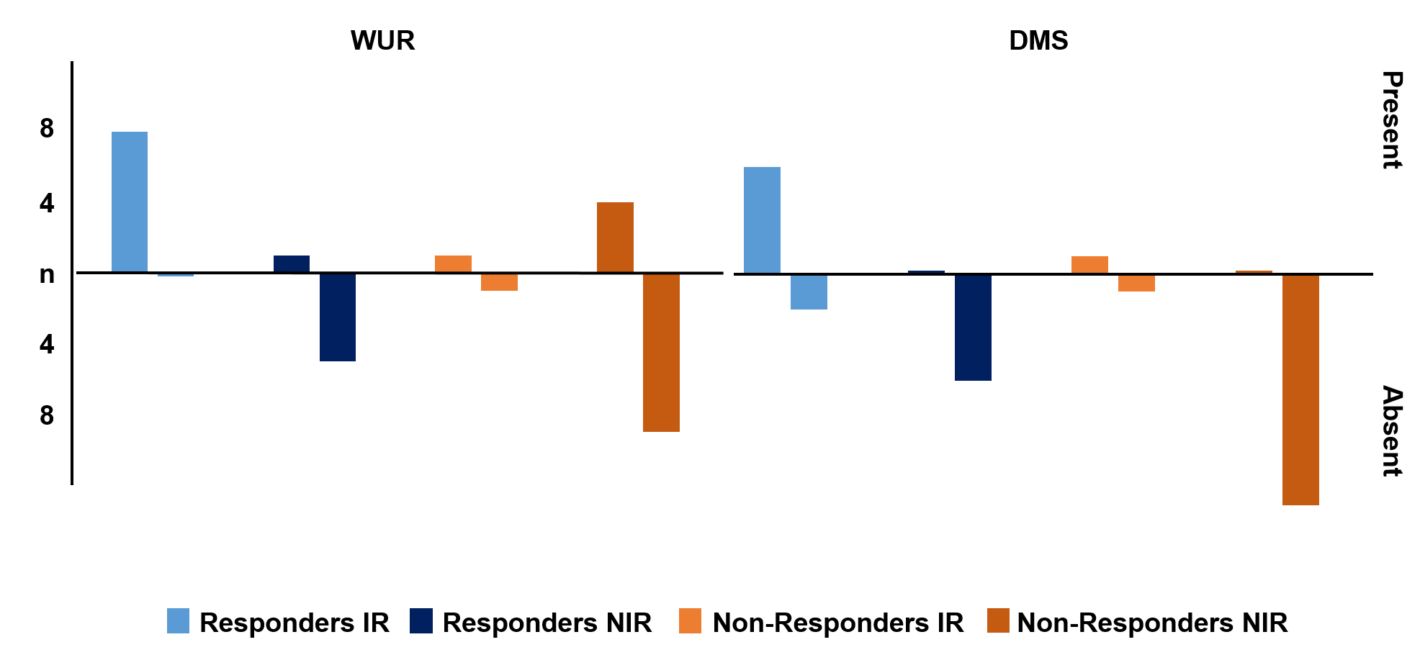

Figure 3: Histograms depicting number (n, absent and present) of subjects with wind-up ratio (WUR) and dynamic mechanical sensitivity (DMS) or allodynia for each patient group (*p<0.05).

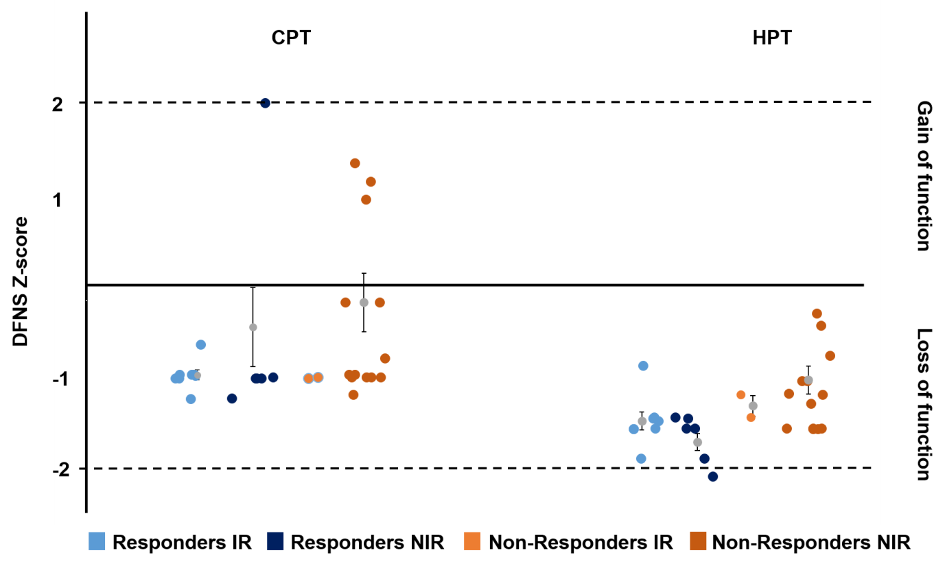

Figure 4: Scatter plots with error bars depicting mean and 95% confidence intervals for cold pain threshold (CPT), Heat pain threshold (HPT) for each study group.

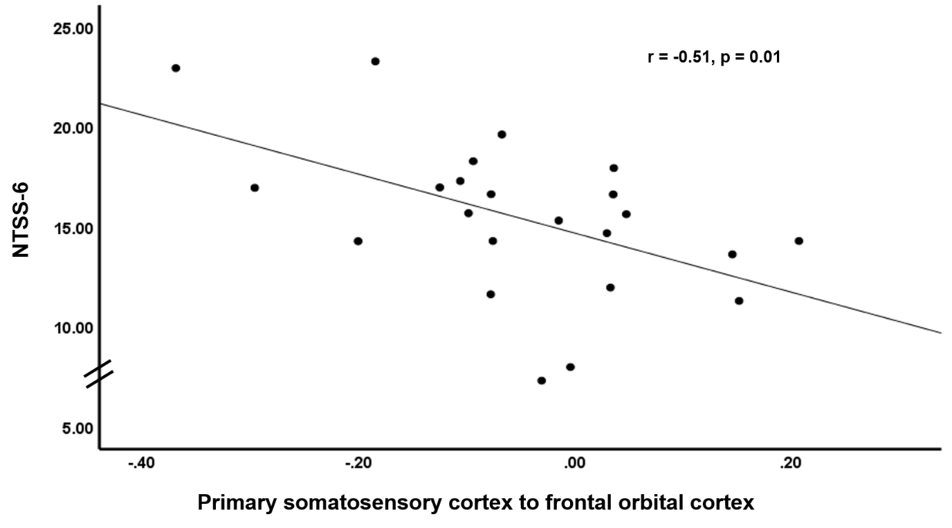

Figure 5: Scatter plot demonstrating Pearson’s correlation coefficient between NTSS-6 and functional connectivity between the primary somatosensory cortex to frontal orbital cortex.

