Supplementary material

Supplementary Table 1. Dose titration schedule
Median* fasting (pre-breakfast) SMPG | Current basal insulin dose | Dose adjustment of Gla-300 or Gla-100
Above target range
- >180 mg/dL (>10.0 mmol/L) | <15 U/day | +2 U
 | ≥15 U/day | +4 U
No evidence of severe hypoglycemia†
Above target range
- >130–180 mg/dL | <15 U/day | +1 U
(>7.2–10.0 mmol/L) | ≥15 U/day | +2 U
No evidence of severe hypoglycemia†
In target range
- 90–130 mg/dL (5.0–7.2 mmol/L) | n/a | No change of BI dose
No evidence of severe hypoglycemia†
Below target range
- <90 mg/dL (<5.0 mmol/L) | <15 U/day | −1 U
 | ≥15 U/day | −2 U
In case of hypoglycemia |  | Doses may be reduced at any time
- Hypoglycemia is reported | <15 U/day | −1 U
Without explanation, e.g. unexpected exercise | ≥15 U/day | −2 U
- Severe hypoglycemia |  | In addition to dose reduction, upward titration may be stopped for 1 week
Neurological symptoms, assistance required
*Median = the middle value of fasting (pre-breakfast) SMPG out of the three values from last 3 days including the current day. †Severe hypoglycemia defined as a child/adolescent with altered mental status and inability to self-care, is semiconscious or unconscious, or in coma with or without convulsions, who may require parenteral therapy (glucagon or glucose).
SMPG, self-monitored plasma glucose

Supplementary Table 2. Tanner puberty stage classification
 | Classification of sexual maturity in girls
Stage | Pubic hair | Stage | Breasts
P1 | Preadolescent | B1 | Preadolescent
P2 | Sparse, lightly pigmented, straight, medial border of labia | B2 | Breast and papilla elevated as small mound; areolar diameter increased
P3 | Darker, beginning to curl, increased amount | B3 | Breast and areola enlarged, no contour separation
P4 | Coarse, curly, abundant but amount less than adult | B4 | Areola and papilla from secondary mound
P5 | Adult feminine triangle, spread to medial surface of thighs | B5 | Mature; nipple projects, areola part of general breast contour
 | Classification of sexual maturity in boys
Stage | Pubic hair | Stage | Testes
P1 | None | T1 | Preadolescent
P2 | Scanty, long, slightly pigmented | T2 | Enlarged scrotum, pink texture altered
P3 | Darker, starts to curl, small amount | T3 | Larger
P4 | Resembles adult type, but less in quantity; coarse, curly | T4 | Larger, scrotum dark
P5 | Adult distribution, spread to medial surface of thighs | T5 | Adult size
 | Evaluation by stage |  | Classification
 | P1, B1, T1 |  | Pre-pubertal
 | P2–P4, B2–B4, T2–T4 |  | Adolescent
 | P5, B5, T5 |  | Adult
Categorization was straightforward if B or T was equal to P. In case of discordance, the lower score prevailed (e.g. P=1 and B/T = 2 or vice versa was classified as prepubertal; P=5 and B/T = 4 or vice versa was classified as adolescent).
B, breasts; P, pubic hair; T, testes

Supplementary Table 3. Efficacy outcomes in the 12-month randomized period (6-month randomized period and 6-month extension period) (ITT population)
Efficacy outcomes at Week 52 | Gla-300 | Gla-100
 | (N=233) | (N=230)
HbA_{1c}, %
Mean (SD) | 8.61 (1.53) | 8.63 (1.31)
LS mean change (SE) | −0.051 (0.085) | 0.022 (0.083)
LS mean difference (95% CI) | −0.073 (−0.306 to 0.160)
The 12-month randomized period is defined as the time from the randomization date to the study end, regardless of treatment discontinuation.
CI, confidence interval; SD, standard deviation; SE, standard error

Supplementary Table 4. Safety outcomes in the 12-month study period (6-month treatment period and 6-month safety extension period) (safety population)
Safety outcomes in the | Incidence: n (%) |  |  | Event rates: E (R),
12-month TEAE period* | Relative risk (95% CI) |  |  | Rate ratio (95% CI)
 | Gla-300 |  | Gla-100 | Gla-300 |  |  | Gla-100
 | (N=233) |  | (N=228) | (N=233) |  |  | (N=228)
Hypoglycemia
Anytime (24 h) documented (≤70 mg/dL [≤3.9 mmol/L]) or severe | 231 (99.1) |  | 224 (98.2) | 18289 (81.70) |  |  | 17268 (79.63)
 | 1.01 (0.99–1.03) |  |  | 1.02 (0.86–1.20)
Nocturnal documented (≤70 mg/dL [≤3.9 mmol/L]) or severe (00:00–05:59 h) | 193 (82.8) |  | 176 (77.2) | 1767 (7.89) |  |  | 1481 (6.83)
 | 1.07 (0.98–1.17) |  |  | 1.13 (0.90–1.42)
Anytime (24 h) severe | 20 (8.6) |  | 25 (11.0) | 36 (0.16) | 38 (0.18)
 | 0.78 (0.45–1.36) |  |  | 0.93 (0.47–1.87)
Hyperglycemia with ketosis
Preferred Term
Participants with ≥1 TEAE of hyperglycemia with ketosis | 22 (9.4) | 36 (15.8) |  | 58 (0.26) | 64 (0.30)
Hyperglycemia with ketosis
Biochemical
Any hyperglycemia with ketosis (SMPG ≥252 mg/dL [≥14 mmol/L] and ketone ≥1.5 mmol/L) | 23 (9.9) | 31 (13.6) |  | 379 (1.69)† | 178 (0.82)‡
Sensitivity analysis§
Any hyperglycemia with ketosis (SMPG ≥252 mg/dL [≥14 mmol/L] and ketone ≥1.5 mmol/L) |  |  |  | 79 (0.35) | 91 (0.42)
Adverse Events:
Participants with
Any TEAE | 167 (71.7) | 168 (73.7) |  | 673 (3.01) | 606 (2.79)
Any treatment emergent SAE | 35 (15.0) | 31 (13.6) |  | 52 (0.23) | 44 (0.20)
Any TEAE leading to death | 1 (0.4) | 0 |  | 2 (0.01) | 0
Any TEAE leading to permanent treatment discontinuation | 3 (1.3) | 3 (1.3) |  | 5 (0.02) | 3 (0.01)
*The 12-month TEAE period was defined as the period from first basal insulin treatment up to two days after the last treatment dose. †One participant in the Gla-300 group presented with 300 events of hyperglycemia with ketosis (SMPG ≥252 mg/dL [≥14 mmol/L] and ketone ≥1.5 mmol/L) ‡One participant in the Gla-100 group presented with 87 events of hyperglycemia with ketosis (SMPG ≥252 mg/dL [≥14 mmol/L] and ketone ≥1.5 mmol/L). §Ad-hoc sensitivity analysis for number of biochemical events (excluding 2 participants with >30 events of hyperglycemia with ketosis).
CI, confidence interval; E(R), number of events (event rate per participant-year); ITT, intent-to-treat; SAE, serious adverse event; SMPG, self-monitored plasma glucose; TEAE, treatment-emergent adverse event

Supplementary Table 5. Incidence and event rates of hyperglycemia with ketosis during the main 6-month treatment period (safety population)
 | Gla-300 |  | Gla-100
 | (N=233) |  | (N=228)
Preferred Term* | Number of participants | Number of events | Number of participants | Number of events
 | (%) | (events per participant-year) | (%) | (events per participant-year)
Hyperglycemia with ketosis | 15 (6.4) | 34 (0.30) | 27 (11.8) | 46 (0.41)
Ketosis | 15 (6.4) | 33 (0.29) | 23 (10.1) | 41 (0.37)
Diabetic ketoacidosis† | 1 (0.4) | 1 (0.01) | 4 (1.8) | 5 (0.04)
*A single descriptor for a defined medical condition or area of interest, defined by MedDRA. †Incidence and event rates of diabetic ketoacidosis were reported as SAEs
MedDRA, Medical Dictionary for Regulatory Activities; SAE, serious adverse event; TEAE, treatment emergent adverse event

Supplementary Figure 1. Participant flow diagram during the main 6-month treatment period and 6-month safety extension period
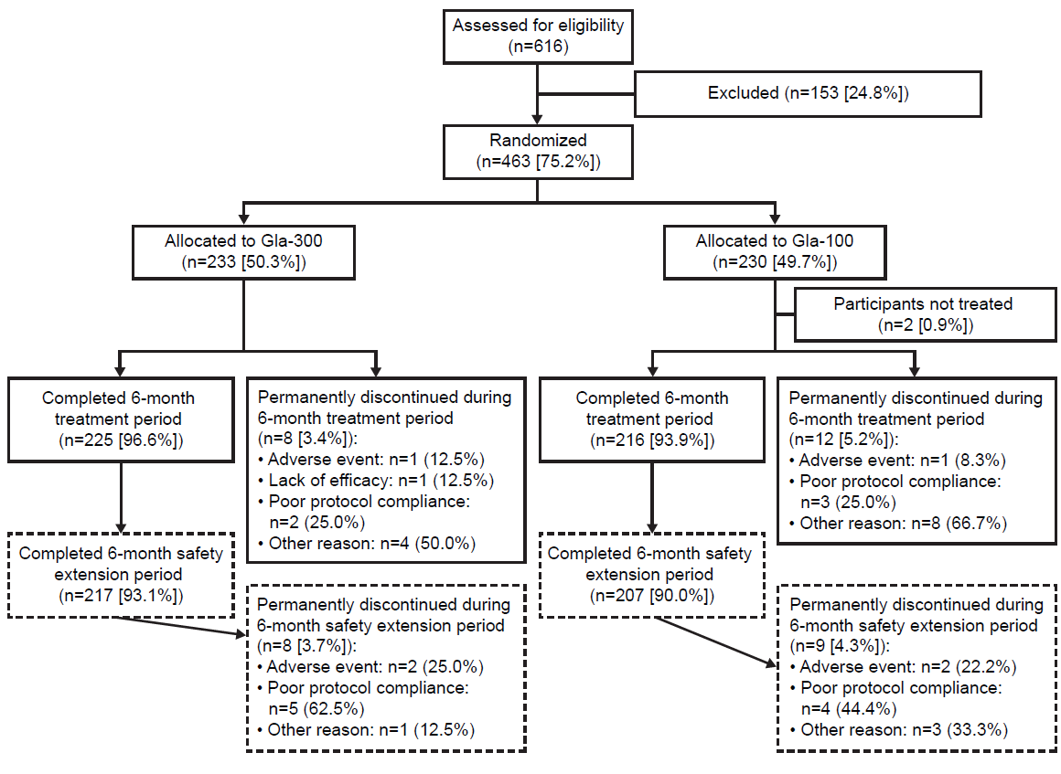

Supplementary Figure 2. Time course of mean daily total, basal, and mealtime insulin dose over the entire 12-month study (safety population)
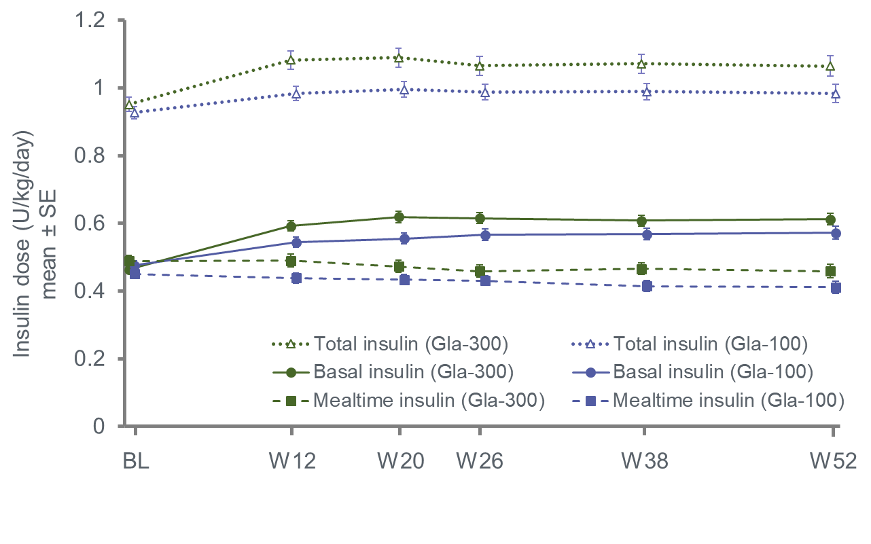

Supplementary Figure 3. (A) Relative risk of participants experiencing anytime and nocturnal hypoglycemia and (B) rate ratios of anytime and nocturnal hypoglycemia, for Gla-300 versus Gla-100, during the main 6-month treatment period (safety population)
A)
A)
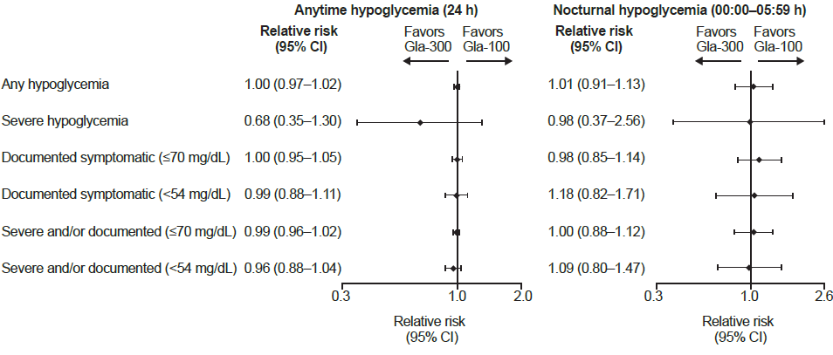
B)
B)
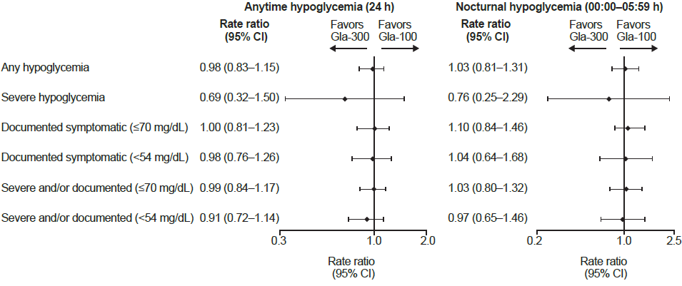
CI, confidence interval

Supplementary Figure 4. Cumulative mean number of hypoglycaemia events per participant at any time of day (24 h) during the entire 12-month treatment period: (A) severe or documented (≤70 mg/dL [≤3.9 mmol/L]) events; (B) severe events (safety population)

