Supplemental Material

Table of content

Table S1. Continuous glucose monitoring data. 2
Table S2. Cardiorespiratory measures. 3
Figure S1. CONSORT diagram. 4
Figure S2. 5

Table S1. Continuous glucose monitoring data.
 | Fructose  (n=14) | Water  (n=14) | Paired difference  [95% CI]  (n=14) | p value
48 hours pre-exercise  Mean glucose (mmol/L)  CV of glucose concentration (%)  Time below range (<3.9 mmol/L) (%)  Time in range (3.9-10 mmol/L) (%)  Time above range (>10 mmol/L) (%) | 8.8 ± 2.0  31.9 ± 8.8  3.5 ± 3.5  68.7 ± 21.1  27.8 ± 22.1 | 8.5 ± 1.5  35.0 ± 6.4  4.2 ± 3.4  64.8 ± 13.8  31.0 ± 16.1 | 0.3 [-0.8; 1.5]  -3.1 [-9.0; 2.9]  -0.6 [-3.0; 1.9]  4.2 [-8.8; 17.3]  -3.7 [-17.2; 9.8] | 0.55  0.28  0.63  0.49  0.56
24 hours post-exercise  Mean glucose (mmol/L)  CV of glucose concentration (%)  Time below range (<3.9 mmol/L) (%)  Time in range (3.9-10 mmol/L) (%)  Time above range (>10 mmol/L) (%) | 8.6 ± 2.5  32.7 ± 11.7  6.5 ± 14.2  63.0 ± 23.2  30.5 ± 25.4 | 8.6 ± 1.6  31.5 ± 10.9  4.6 ± 9.9  65.1 ± 19.3  30.3 ± 20.2 | 0.2 [-1.2; 1.6]  0.1 [-7.3; 7.6]  0.5 [-8.9; 9.7]  -1.9 [-19.9; 16.2]  1.4 [-16.9; 19.6] | 0.79  0.97  0.90  0.83  0.88
Data are presented as mean±SD, or mean [95% CI]. CV, coefficient of variation.

Table S2. Cardiorespiratory measures.
 | Fructose  (n=14) | Water  (n=14) | Paired difference  [95% CI]  (n=14) | p value
Power (Watts) | 138.2 ± 40.7 | 138.2 ± 40.7 | 0 | -
VO₂ (mL/min/kg) | 26.4 ± 5.1 | 26.0 ± 5.3 | 0.4 [-0.7; 1.5] | 0.43
Heart rate♯ (bpm) | 141.3 ± 13.7 | 141.8 ± 13.6 | 0.0 [-3.8; 3.9] | 0.98
Borg visual analogue scale† | 13.1 ± 2.1 | 12.6 ± 1.5 | 0.6 [-0.4; 1.6] | 0.22
Substrate oxidation at rest  CHO oxidation (g/min)  CHO oxidation (%)  Fat oxidation (g/min)  Fat oxidation (%) | 0.30 ± 0.09  64.4 ± 16.2  0.07 ± 0.03  35.6 ± 16.3 | 0.19 ± 0.10  43.4 ± 19.9  0.11 ± 0.03  56.6 ± 19.4 | 0.12 [0.08; 0.16]  22.2 [15.4; 29.0]  -0.04 [-0.05; -0.02]  -22.3 [-29.1; -15.4] | <0.001  <0.001  <0.001  <0.001
Substrate oxidation during exercise  CHO oxidation (g/min)  CHO oxidation (%)  Fat oxidation (g/min)  Fat oxidation (%) | 2.26 ± 0.49  81.7 ± 13.6  0.24 ± 0.19  18.3 ± 13.6 | 2.23 ± 0.58  83.9 ± 16.4  0.20 ± 0.23  16.1 ± 16.4 | 0.05 [-0.24; 0.33]  -1.5 [-7.8; 4.8]  0.03 [-0.06; 0.12]  1.5 [-4.8; 7.8] | 0.73  0.61  0.48  0.61
Data are presented as mean±SD, or mean [95% CI]. ♯n=13, as the heart rate monitor was defective during one visit. †The mean Borg visual analogue scale was assessed after 20 minutes of exercise. bpm, beats per minute; CHO, carbohydrate.

Figure S1. CONSORT diagram.
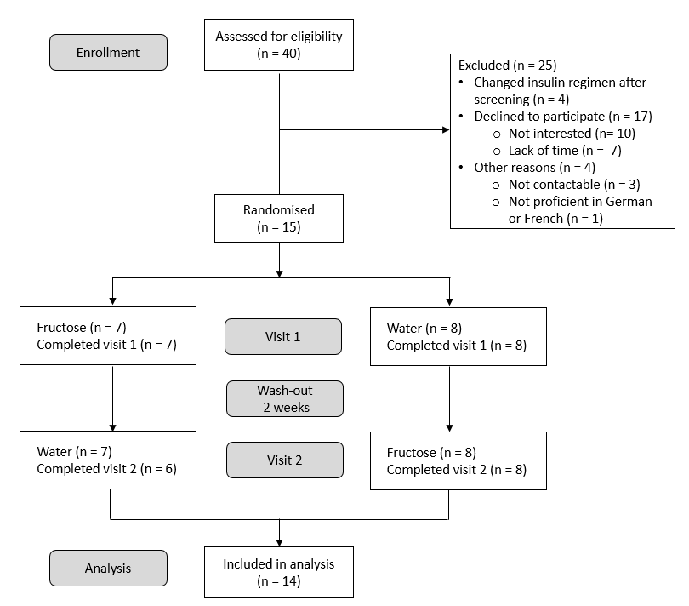

One patient was excluded from the analysis due to interruption of the second visit.

Figure S2. Scatter plot illustrating the delta in sensor glucose (Fructose-Water) (y-axis) over the course of exercise (x-axis). A positive value indicates a higher sensor glucose value in the fructose versus the water condition. Values after a hypoglycaemic event in one of the two conditions are not displayed. In one participant, sensor data were not available during exercise due to connectivity issues.
