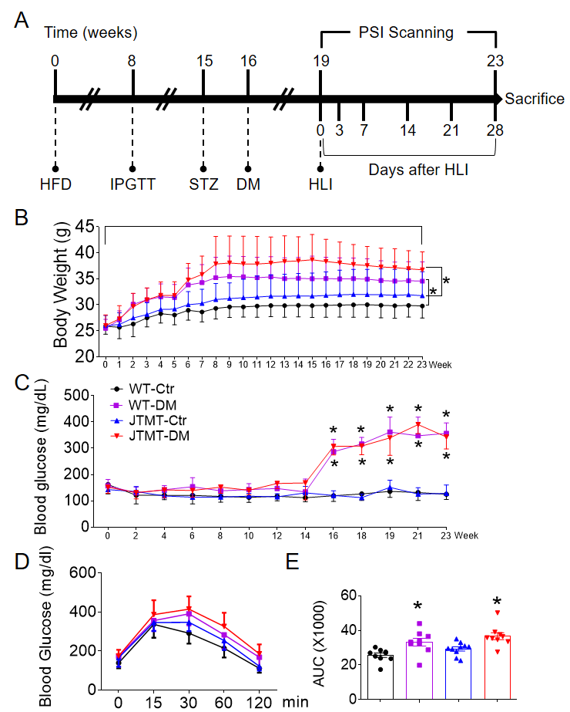
Figure S1. Timeline of type 2 diabetes and diabetic hind limb ischemia (HLI) induction. JTMT and WT male mice at age of 8-10 weeks were fed with high fat diet (HFD, Research Diets 12492, 60% kcal from fat) or normal diet (ND, Research Diets 12450B, 10% kcal from fat) for 23 weeks (A). Body weight was monitored every week (B) and blood glucose levels were monitored every other week (C). After 8 weeks on HFD, intraperitoneal glucose tolerance test (IPGTT) was performed to confirm the glucose intolerant status (D, E). After 15 weeks on HFD, HFD feeding mice with glucose intolerance were injected a single dose of streptozocin (STZ, 100mg/kg, Sigma, St. Louis, MO) in 0.1 mol/L sodium citrate buffer (pH 4.5) to induce insulin deficiency and hyperglycemia. Seven days after the injection of STZ, mice with blood glucose levels ≥ 250 mg/dL were considered diabetic (C). Mice feeding with ND were injected a single dose of 0.1 mol/L sodium citrate buffer (pH 4.5) as controls. Four weeks after STZ injection, the mice were used for HLI induction (A). Data shown in graphs represent the mean±SD. n≥9 mice per group. * P<0.05, vs respective controls of WT and JTMT. Ctrl, control; DM, type 2 diabetes mellitus.
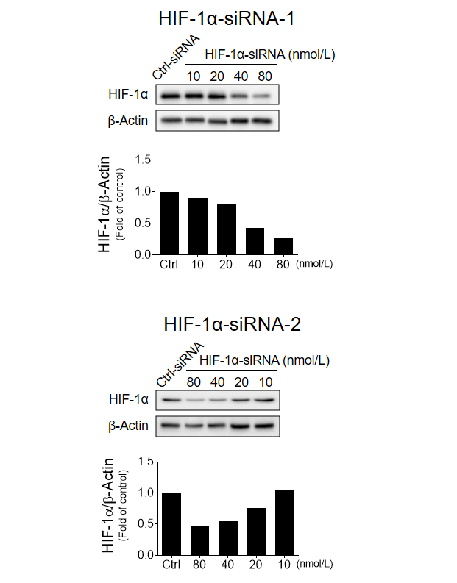
Figure S2. Optimizing the dose of hypoxia-inducible factor 1α (HIF-1α) siRNA. To knockdown HIF-1α expression in early bone marrow endothelial progenitor cells (BM-EPCs) from JTMT mice, two different specific siRNAs (HIF-1α-siRNA-1 and HIF-1α-siRNA-2) against mouse HIF-1α, alone with Silencer Select Negative Control were transfected into EPCs. HIF-1α-siRNAs dose-dependently interfered HIF-1α expression detected by Western blot assay. β-actin was used as loading control. Accordingly, 80 nmol/L was chosen for ex vivo studies.

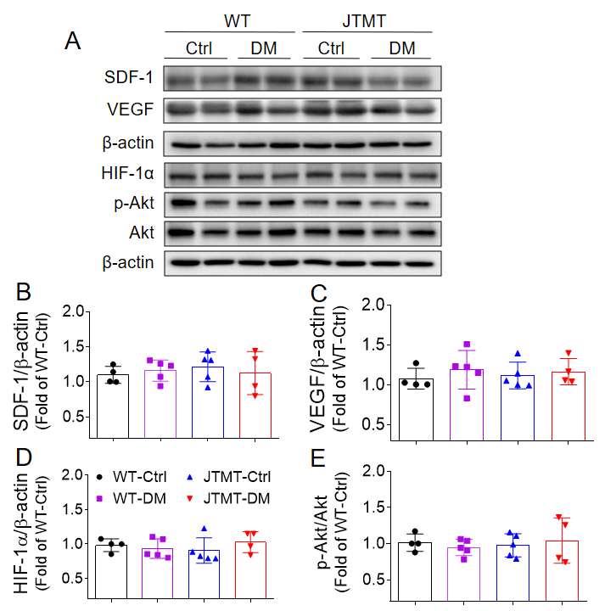
Figure S3. The expression of pro-angiogenic factors in the contralateral non-ischemic gastrocnemius muscle in WT and JTMT mice. Type 2 diabetes was induced as described in Figure 1. At day 3 after HLI surgery, the expression of stromal cell-derived factor 1 (SDF-1, A, B), vascular endothelial growth factor (VEGF, A, C) and hypoxia-inducible factor 1α (HIF-1α, A, D), and phosphorylation of protein kinase B (Akt, A, E) in the contralateral non-ischemic gastrocnemius muscle were detected by Western blot, and β-actin was used as loading control. Data shown in graphs represent the mean±SD. n≥4 mice per group. Ctrl, control; DM, diabetes mellitus.

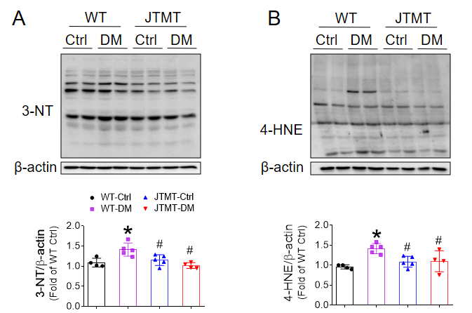
Figure S4. Endothelial MT overexpression alleviates oxidative stress in diabetic HLI. Type 2 diabetes was induced as described in Figure 1. At day 3 after HLI surgery, the gastrocnemius muscle lysis was used to evaluate the levels of oxidative damage markers 3-nitroryrosine (3-NT, A) and 4-hydroxynonenal (4-HNE, B) by Western blot. β-actin was used as loading control. Data shown in graphs represent the mean±SD. n≥4 mice per group. * P<0.05, vs WT-Ctrl; # P<0.05, vs WT-DM.

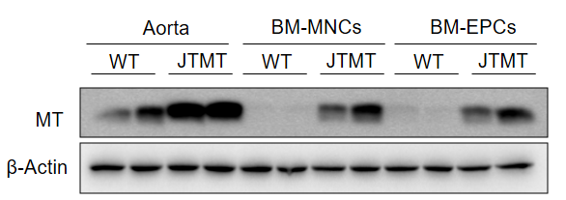
Figure S5. Expression of MT in different tissues. The expression of MT in aorta, bone marrow mononuclear cells (BM-MNCs) and BM-endothelial progenitor cells (EPCs) from WT and JTMT mice was detected by Western blot.

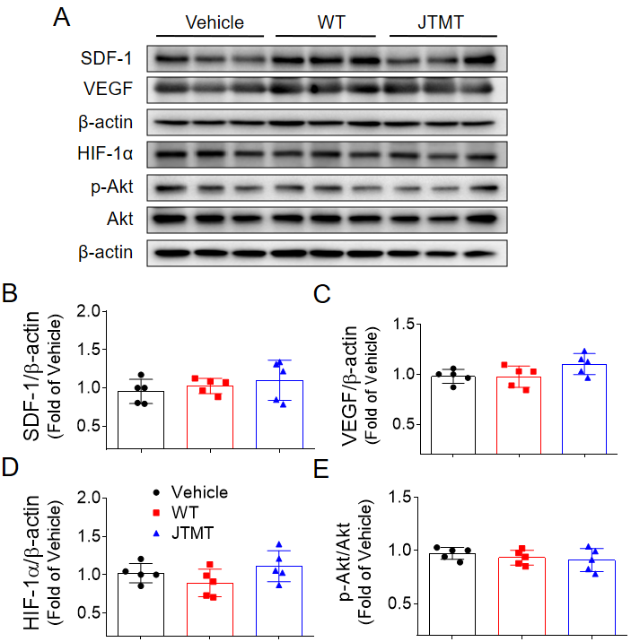
Figure S6. The expression of pro-angiogenic factors in the contralateral non-ischemic gastrocnemius muscle in db/db mice infused with WT-MNCs and JTMT-MNCs. BM-MNCs transplantation was performed as described in Figure 3. At day 7 after HLI surgery, the expression of stromal cell-derived factor 1 (SDF-1, A, B), vascular endothelial growth factor (VEGF, A, C) and hypoxia-inducible factor 1α (HIF-1α, A, D), and phosphorylation of protein kinase B (Akt, A, E) in the contralateral non-ischemic gastrocnemius muscle were detected by Western blot, and β-actin was used as loading control. Data shown in graphs represent the mean±SD. N=5 mice per group.

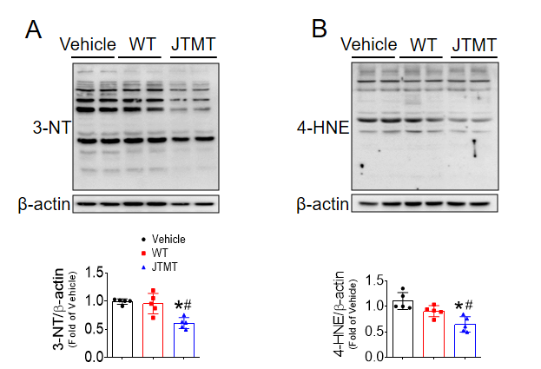
Figure S7. MT overexpressing bone marrow-derived mononuclear cells (BM-MNCs) transplantation alleviates oxidative stress in db/db diabetic mice with HLI. BM-MNCs transplantation was performed as described in Figure 3. At day 7 after HLI surgery, the gastrocnemius muscle lysis was used to evaluate the levels of oxidative damage markers 3-NT (A) and 4-HNE (B) by Western blot. β-actin was used as loading control. Data shown in graphs represent the mean±SD. n=5 mice per group. * P<0.05, vs Vehicle; # P<0.05, vs WT.

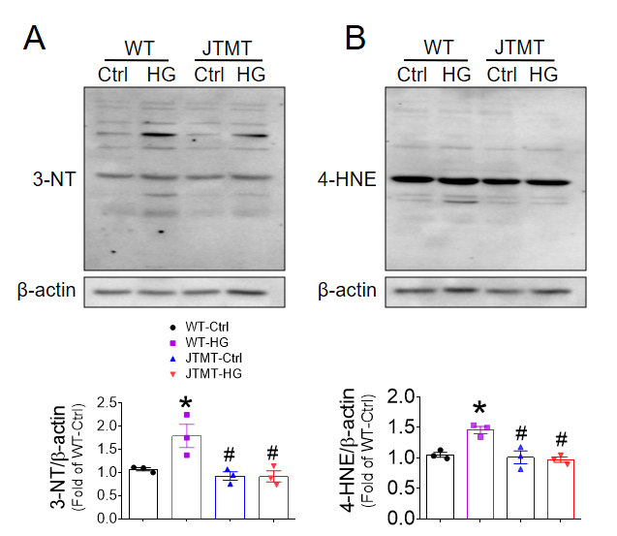
Figure S8. Endothelial MT overexpression protects EPCs from high glucose (HG) and hypoxia-induced oxidative stress. BM EPCs from WT and JTMT mice were exposed to HG (25 mmol/L) and hypoxia for 24 h, the equivalent concentration of mannitol was used as osmotic control (Ctrl). The oxidative damage was evaluated by Western blot assay of 3-NT (A) and 4-HNE expression (B). β-actin was used as loading control. Three independent experiments were performed. Data shown in graphs represent the mean±SD. * P<0.05, vs WT-Ctrl; # P<0.05, vs WT-HG.

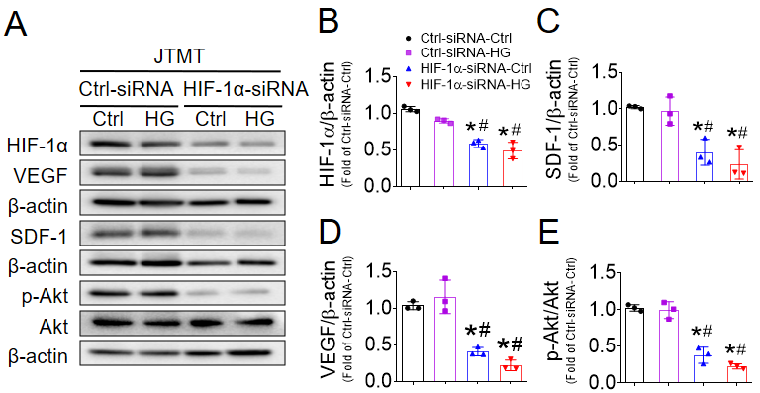
Figure S9. Knockdown of HIF-1α abolishes MT overexpression protecting EPCs from HG and hypoxia-impaired HIF-1α/SDF-1/Akt signaling. BM EPCs from JTMT mice were transfected a second specific siRNA (Figure S2) against HIF-1α for 48 h, the Silencer Select Negative Control was used as control siRNA (Ctrl-siRNA). Then the transfected EPCs were exposed to HG (25 mmol/L) and hypoxia for additional 24 h, the equivalent concentration of mannitol was used as osmotic control (Ctrl). The expression of hypoxia-inducible factor 1α (HIF-1α, A, B), stromal cell-derived factor 1 (SDF-1, A, C), vascular endothelial growth factor (VEGF, A, D), and phosphorylation of protein kinase B (Akt, A, E) was tested by Western blot. β-actin was used as loading control. Three independent experiments were performed. Data shown in graphs represent the mean±SD. * P<0.05, vs Ctrl-siRNA-Ctrl; # P<0.05, vs Ctrl-siRNA-HG.

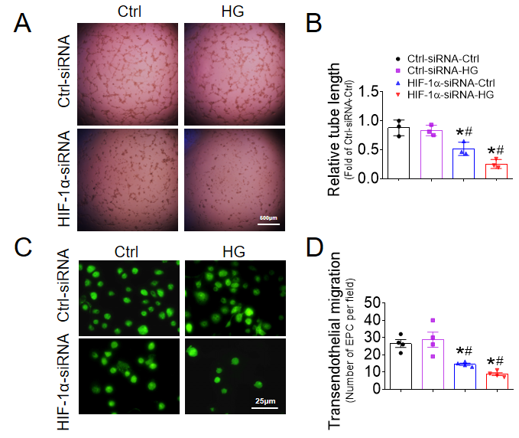
Figure S10. Knockdown of HIF-1α abolishes MT overexpression protecting EPCs against HG and hypoxia-induced EPC dysfunction. BM-EPCs from JTMT mice were transfected a second specific siRNA (Figure S2) against hypoxia-inducible factor 1α (HIF-1α) for 48 h, the Silencer Select Negative Control was used as control siRNA (Ctrl-siRNA). Then the transfected EPCs were exposed to HG (25 mmol/L) and hypoxia for additional 24 h, the equivalent concentration of mannitol was used as osmotic control (Ctrl). The angiogenic function was evaluated by tube formation assay (A, B). The migration capability was evaluated by transendothelial migration assay (C, D). At least three independent experiments were performed. Data shown in graphs represent the mean±SD. * P<0.05, vs Ctrl-siRNA-Ctrl; # P<0.05, vs Ctrl-siRNA-HG.

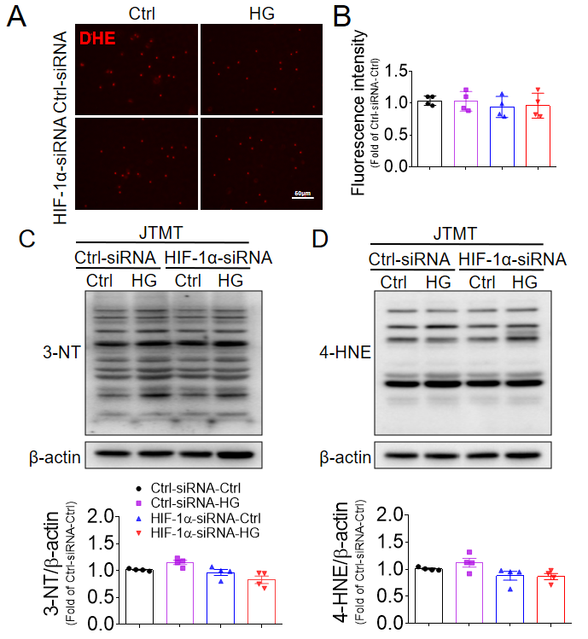
Figure S11. Knockdown of HIF-1α does not affect MT overexpressing EPCs resistance to HG and hypoxia-induced oxidative stress. BM-EPCs from JTMT mice were transfected a second specific siRNA (Figure S2) against HIF-1α for 48 h, the Silencer Select Negative Control was used as control siRNA (Ctrl-siRNA). Then the transfected EPCs were exposed to HG (25 mmol/L) and hypoxia for additional 24 h, the equivalent concentration of mannitol was used as osmotic control (Ctrl). The oxidative damage was evaluated by dihydroethidium (DHE) stain of superoxide production (A, B) and Western blot assay of 3-NT (C) and 4-HNE (D) expression. Four independent experiments were performed. Data shown in graphs represent the mean±SD.

Table S1. Human subject information
Description | Health Subjects  (n=6, mean ± SD) | Type 2 Diabetes  (n=6, mean ± SD) | P value
Age (years) | 52.75 ± 3.467 | 51.33 ± 3.473 | P=0.3281
Sex, male/female (%) | 3/3 (50%) | 3/3 (50%)
Height (cm) | 158.67 ± 3.601 | 159.08 ± 7.477 | P=0.8635
Weight (kg) | 56.375 ± 5.398 | 67.917 ± 4.757 | P<0.0001
BMI (kg/m2) | 22.17 ± 1.814 | 27.03 ± 1.602 | P<0.0001
Systolic blood pressure (mmHg) | 108.17 ± 9.666 | 133.92 ± 9.070 | P<0.0001
Diastolic blood pressure (mmHg) | 68.33 ± 7.608 | 93.75 ± 9.006 | P<0.0001
HbA1C (%) | 4.18 ± 0.652 | 10.41 ±1.500 | P<0.0001
HbA1C (mmol/mol) | 22 ± 7.1 | 90 ±16.4 | P<0.0001
Fasting blood glucose (mmol/L) | 5.43 ± 0.624 | 15.86 ± 4.228 | P<0.0001
Triglyceride (mmol/L) | 0.93 ± 0.255 | 3.12 ± 0.868 | P<0.0001
Total Cholesterol (mmol/L) | 3.90 ± 0.604 | 5.63 ± 1.040 | P<0.0001
LDL-Cholesterol (mmol/L) | 2.16 ± 0.497 | 3.70 ± 0.824 | P<0.0001
HDL-Cholesterol (mmol/L) | 1.35 ± 0.243 | 0.84 ± 0.193 | P<0.0001
BMI, body mass index; HbA1c, hemoglobin A1C; LDL, low-density lipoprotein; HDL, high-density lipoprotein.
`

