Online Supplement

Efficacy and safety of short- and long-acting GLP-1 receptor agonists on a background of basal insulin in type 2 diabetes: A meta-analysis

Jessica Annalena Huthmacher, M.D.¹, Juris J. Meier, M.D.¹, Michael A. Nauck, M.D.¹
¹ Diabetes Division, Katholisches Klinikum Bochum, St. Josef-Hospital, Ruhr-University Bochum, Bochum, Germany

Supplementary Table S 1. Detailed presentation of search terms used for the PubMed search to identify studies included in the present meta-analysis comparing the efficacy and safety of glucagon-like peptide-1 receptor agonists in combination with basal insulin.
Search terms* | Total results | Included publications
((Exenatide) AND insulin) AND (trial OR trials) | 494 | 2
((Taspoglutide) AND Insulin) AND (trial OR trials) | 15 | 0
((Semaglutide) AND Insulin) AND (trial OR trials) | 44 | 1
((Albiglutide) AND insulin) AND (trial OR trials) | 42 | 0
((Dulaglutide) AND Insulin) AND (trial OR trials) | 61 | 1
(((Lixisenatide) AND Insulin) AND (trial OR trials)) | 121 | 4
(((LixiLan OR iGlarLixi)) AND (trial OR trials)) | 24 | 3
((Liraglutide) AND Insulin) AND (trial OR trials) | 465 | 1
((IDegLira) AND (trial OR trials)) | 40 | 2
Sum: | 1306 | 14

The Advanced Search Builder of PubMed was used and all search terms were entered and searched in “all fields”, the only limitation used was a publication date until 31 December 2018.

Details regarding data extraction.
The following details were transferred into dedicated forms: Details on the publication; GLP-1 RA used; dosage; basal insulin employed; free or fixed-dose combination; baseline patient characteristics like age, sex distribution, diabetes duration, body-mass index, blood pressure, pulse rate, insulin dose, duration of previous insulin therapy, HbA_{1c}, fasting plasma glucose, background glucose-lowering medication; self-measured plasma glucose profiles with values before and after breakfast, lunch, and dinner; study characteristics like study duration, insulin dose titration after starting therapy with a GLP-1 RA; at study end, HbA_{1c}, fasting plasma glucose, body weight, insulin doses, self-measured plasma glucose profiles with values before and after breakfast, lunch, and dinner were recorded as well as the differences to baseline (and their 95 % confidence intervals); in addition, the proportion of patients reporting nausea, vomiting, diarrhea, any hypoglycemic episode, severe hypoglycemic episodes, any adverse drug reaction, and premature discontinuation of drug treatment for any reason and in relation to adverse events were recorded.

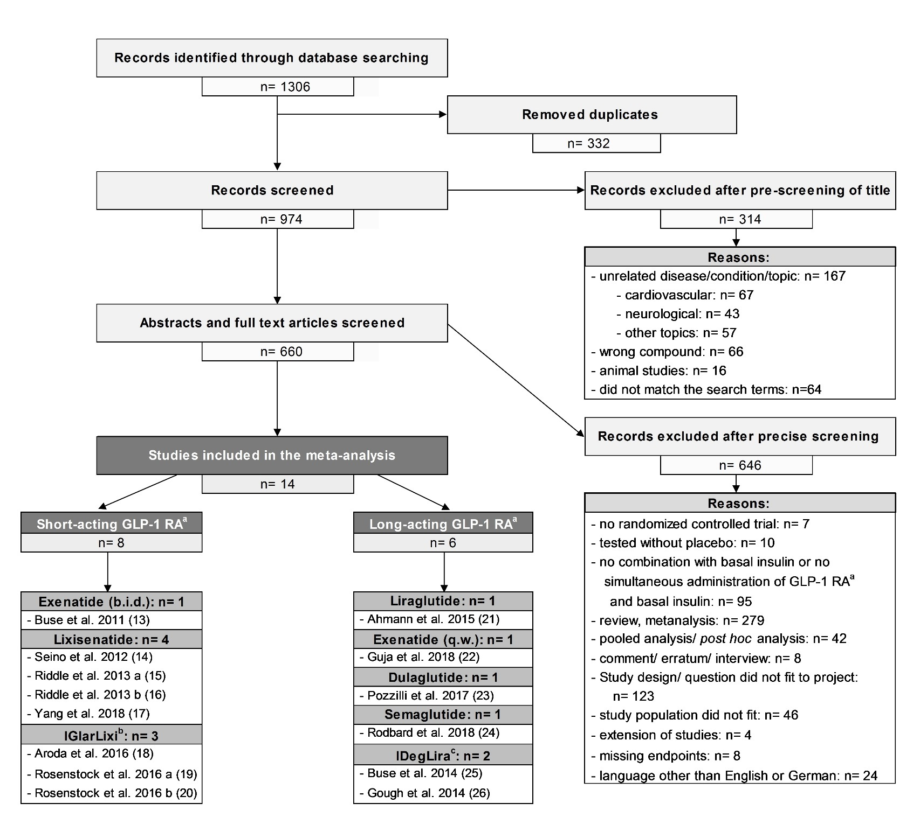

Supplementary Figure S 1. Flow diagram (according to the Prisma statement) of search process, selection end exclusion of publications, which were identified through a systemic PubMed search and included in the present meta-analysis comparing efficacy and safety of short- and long-acting glucagon-like peptide-1 receptor agonists in combination with basal insulin.
ª GLP-1 RA: Glucagon-like peptide-1 receptor agonist/s; ^{b} Fixed-dose combination of lixisenatide and insulin glargine; ^{c} Fixed-dose combination of insulin degludec and liraglutide; b.i.d.: twice daily; q.w.: once weekly

Supplementary Table S 2. ‘Jadad Score’ estimating the study quality of the randomized controlled trials included in the present meta-analysis comparing efficacy and safety of short- and long-acting glucagon-like peptide-1 receptor agonists in combination with basal insulin.
Study/publication | Clinical trials registration number | Study described as randomized | Study described as double blind | Withdrawals and dropouts described | Appropriate description of details regarding randomization and double blinding | Either randomization or double blinding inappropriate (- 1 point) | Sum
Short-acting glucagon-like peptide-1 receptor agonists added to basal insulin
Buse et al. 2011 (13) | NCT00765817 | 1 | 1 | 1 | 1 | 0 | 4
Seino et al. 2012 (14) | NCT00866658 | 1 | 1 | 1 | 1 | 0 | 4
Riddle et al. 2013 a (15) | NCT00715624 | 1 | 1 | 1 | 1 | 0 | 4
Riddle et al. 2013 b (16) | NCT00975286 | 1 | 1 | 1 | 1 | 0 | 4
Yang et al. 2018 (17) | NCT01632163 | 1 | 1 | 1 | 1 | 0 | 4
Aroda et al. 2016 (18) | NCT02058160 | 1 | 0 | 1 | 1 | 0 | 3
Rosenstock et al. 2016 a (19) | NCT02058147 | 1 | 0 | 1 | 1 | 0 | 3
Rosenstock et al. 2016 b (20) | NCT01476475 | 1 | 0 | 1 | 1 | 0 | 3
All short-acting GLP-1 RA (Mean ± SEMª) |  | 1.0 ± 0.0 | 0.63 ± 0.18 | 1.0 ± 0.0 | 1.0 ± 0.0 | 0.0 ± 0.0 | 3.63 ± 0.18^{b}
Long-acting glucagon-like peptide-1 receptor agonists added to basal insulin
Ahmann et al. 2015 (21) | NCT01617434 | 1 | 1 | 1 | 1 | 0 | 4
Guja et al. 2018 (22) | NCT02229383 | 1 | 1 | 1 | 1 | 0 | 4
Pozzilli et al. 2017 (23) | NCT02152371 | 1 | 1 | 1 | 1 | 0 | 4
Rodbard et al. 2018 (24) | NCT02305381 | 1 | 1 | 1 | 1 | 0 | 4
Buse et al. 2014 (25) | NCT01392573 | 1 | 1 | 1 | 1 | 0 | 4
Gough et al. 2014 (26) | NCT01336023 | 1 | 0 | 1 | 1 | 0 | 3
All long-acting GLP-1 RA (Mean ± SEMª) |  | 1.0 ± 0.0 | 0.83 ± 0.17 | 1.0 ± 0.0 | 1.0 ± 0.0 | 0.0 ± 0.0 | 3.50 ± 0.22^{b}

ª standard error of the mean
^{b} There is no significant difference between study quality estimated with the ‘Jadad Score’ between short- and long-acting glucagon-like peptide-1 receptor agonists (p-value: 0.65)

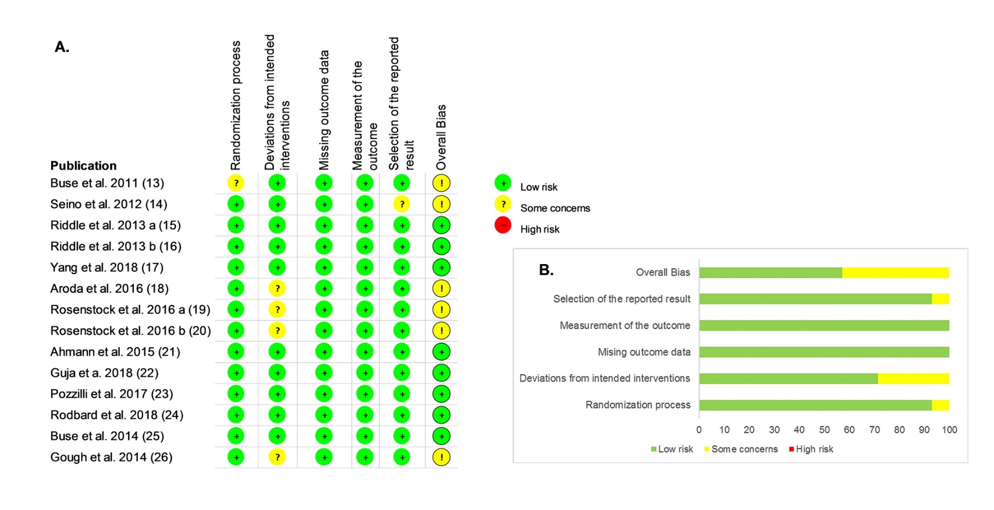
Supplementary Figure S 2: Assessment of risk of bias A. regarding single studies and B. summarizing all included publications as assessed with the Risk of Bias 2.0 tool from the Cochrane Collaboration for studies included in the present meta-analysis comparing efficacy and safety of short- and long-acting glucagon-like peptide-1 receptor agonists in combination with basal insulin.

Supplementary Table 3. Detailed presentation of methods for the survey of adverse events used in the trials that are included in the present meta-analysis comparing efficacy and safety of short- and long-acting glucagon-like peptide-1 receptor agonists in combination with basal insulin
Study/publication | Spontaneous reporting | Questionnaire | Focussed questioning¹ | No information available
Short-acting glucagon-like peptide-1 receptor agonists added to basal insulin
Buse et al. 2011 (13) | X* |  | X
Seino et al. 2012 (14) | X
Riddle et al. 2013 a (15) | X
Riddle et al. 2013 b (16) | X
Yang et al. 2018 (17) |  | X
Aroda et al. 2016 (18) | X
Rosenstock et al. 2016 a (19) |  |  |  | X
Rosenstock et al. 2016 b (20) |  |  |  | X
All short-acting GLP-1 RAs# (∑) | 5 | 1 | 1 | 2
Long-acting glucagon-like peptide-1 receptor agonists added to basal insulin
Ahmann et al. 2015 (21) | X
Guja et al. 2018 (22) | X
Pozzilli et al. 2017 (23) |  |  |  | X
Rodbard et al. 2018 (24) |  |  |  | X
Buse et al. 2014 (25) |  |  |  | X
Gough et al. 2014 (26) | X
All long-acting GLP-1 Ras (∑) | 3 | 0 | 0 | 3
Overall (∑)
 | 8 | 1 | 1 | 5

Supplementary Table S 4. Detailed presentation of the individual trial group’s patient characteristics from studies included in the present meta-analysis comparing the efficacy and safety of glucagon-like peptide-1 receptor agonists in combination with basal insulin.
Study/ publication | Number of patients |  | Age [Years] |  | Sex ratio n female/male  (% female) |  | BMI [kg/m²] |  | Duration of diabetes [Years] |  | Duration of insulin therapy [Years]
 | GLP-1 RA ª | Placebo/ Insulin only ^{b} | GLP-1 RA | Placebo/ Insulin only | GLP-1 RA | Placebo/ Insulin only | GLP-1 RA | Placebo/ Insulin only | GLP-1 RA | Placebo/ Insulin only | GLP-1 RA | Placebo/ Insulin only
Short-acting glucagon-like peptide-1 receptor agonists added to basal insulin
Buse et al. 2011 (13) | 137 | 122 | 59 ± 9 | 59 ± 10 | 67/70 (48.9) | 44/78 (36.1) | 33.8 ± 5.8 | 33.1 ± 6.2 | 12 ± 7 | 12 ± 7 | Inclusion criteria > 3 m
Seino et al. 2012 (14) | 154 | 157 | 59 ± 10 | 58 ± 10 | 85/69 (55.2) | 77/80 (49.0) | 25.4 ± 3.7 | 25.2 ± 3.9 | 14 ± 8 | 14 ± 8 | 3 ± 4 | 3 ± 4
Riddle et al. 2013 a (15) | 328 | 167 | 57 ± 10 | 57 ± 10 | 182/146 (55.5) | 85/82 (50.9) | 31.9 ± 6.2 | 32.6 ± 6.3 | 13 ± 7 | 12 ± 6 | 3 ± 3 | 3 ± 3
Riddle et al. 2013 b (16) | 223 | 223 | 56 ± 10 | 56 ± 10 | 114/109 (51.1) | 110/113 (49.3) | 32.0 ± 6.6 | 31.7 ± 6.0 | 10 ± 6 | 9 ± 6 | 0 ± 0 ^{c} | 0 ± 0 ^{c}
Yang et al. 2018 (17) | 223 | 223 | 54 ± 10 | 56 ± 9 | 118/105 (52.9) | 125/98 (56.1) | 27.5 ± 4.4 | 27.9 ± 4.5 | 10 ± 6 | 10 ± 6 | 2 ± 2 | 2 ± 2
Aroda et al. 2016 * (18) | 366 | 365 | 60 ± 9 | 60 ± 9 | 201/165 (54.9) | 188/177 (51.5) | 31.3 ± 4.3 | 31.0 ± 4.2 | 12 ± 7 | 12 ± 7 | 3 ± 3 | 3 ± 3
Rosenstock et al. 2016 a * (19) | 468 | 466 | 58 ± 10 | 58 ± 9 | 247/221 (52.8) | 230/236 (49.4) | 31.6 ± 4.4 | 31.7 ± 4.5 | 9 ± 6 | 9 ± 6 | 0 ± 0 ^{c} | 0 ± 0 ^{c}
Rosenstock et al. 2016 b * (20) | 161 | 162 | 57 ± 10 | 57 ± 9 | 81/80 (50.3) | 77/85 (47.5) | 32.2 ± 4.8 | 32.0 ± 4.4 | 6 ± 4 | 7 ± 5 | 0 ± 0 ^{c} | 0 ± 0 ^{c}
All short-acting GLP-1 RAs | 2060 | 1885 | 58 ± 10 | 58 ± 10 | 1095/965 (53.2) | 936/949 (49.7) | 31.0 ± 5.1 | 30.9 ± 4.9 | 11 ± 6 | 11 ± 6 | - | -
Long-acting glucagon-like peptide-1 receptor agonists added to basal insulin
Ahmann et al. 2015 (21) | 225 | 225 | 59 ± 9 | 58 ± 11 | 105/120 (46.7) | 89/136 (39.6) | 32.3 ± 5.6 | 32.3 ± 5.7 | 12 ± 7 | 12 ± 7 | Inclusion criteria > 8 w
Guja et al. 2018 (22) | 231 | 230 | 58 ± 9 | 58 ± 10 | 117/114 (50.6) | 123/107 (53.5) | 33.3 ± 6.1 | 34.1 ± 6.6 | 12 ± 7 | 11 ± 6 | Inclusion criteria > 6 w
Pozzilli et al. 2017 (23) | 150 | 150 | 60 ± 10 | 61 ± 10 | 65/85 (43.3) | 62/88 (41.3) | 32.8 ± 4.9 | 32.6 ± 4.9 | 13 ± 8 | 13 ± 8 | 2 ± 0 | 2 ± 0
Rodbard et al. 2018 (24) | 131 | 133 | 59^{d} | 59 ^{d} | 54/77 (41.2) | 62/71 (46.6) | 32.0 ^{d} | 31.8 ^{d} | 14 ^{d} | 13 ^{d} | Inclusion criteria > 90 d
Buse et al. 2014 * (25) | 199 | 199 | 57 ± 9 | 58 ± 11 | 88/111 (44.2) | 94/105 (47.2) | 33.6 ± 6.0 | 33.8 ± 6.0 | 10 ± 6 | 11 ± 7 | Inclusion criteria > 90 d
Gough et al. 2014 * (26) | 833 | 413 | 55 ± 10 | 55 ± 10 | 398/435 (47.8) | 213/200 (51.6) | 31.2 ± 5.2 | 31.2 ± 5.3 | 7 ± 5 | 7 ± 5 | 0 ± 0 ^{c} | 0 ± 0 ^{c}
All long-acting GLP-1 RAs | 1769 | 1350 | 57 ± 10 | 57 ± 10 | 827/942 (46.7) | 643/707 (47.6) | 32.1 ± 5.5 | 32.5 ± 5.7 | 10 ± 6 | 11 ± 6 | - | -
P-value for the difference between short- and long-acting glucagon-like peptide-1 receptor agonists
 | 0.031 | < 0.0001 | 0.86 | 0.86 | 0.0020 | 0.46 | 0.71 | 0.59 | 0.76 | > 0.9999 | - | -

Data are presented as mean ± standard deviation, unless it is otherwise identified; m: months; w: weeks; d: days; ª GLP-1 RA: Glucagon-like peptide-1 receptor agonist/s; ^{b} The studies that examined the efficacy of fixed-dose combination of GLP-1 RA and basal insulin (*) only had insulin in their comparator group and no combination of insulin and placebo like the other studies comparator’s did that examined the efficacy of free-dose combinations of GLP-1 RA and basal insulin; ^{c} Insulin naïve patients; ^{d} Standard deviation was not published and could not be calculated from published data.

Supplementary Table S 5. Detailed presentation of the individual trial groups HbA_{1c} and fasting plasma glucose at baseline and trial end from studies included in the present meta-analysis comparing the efficacy and safety of glucagon-like peptide-1 receptor agonists in combination with basal insulin.
Study/ publication | Baseline HbA_{1c} [%] (mmol/mol) |  | HbA_{1c} at study end [%] (mmol/mol) |  |  | Baseline fasting plasma glucose [mmol/l] |  | Fasting plasma glucose at study end [mmol/l]
 | GLP-1 RAª | Placebo/ Insulin only^{b} | GLP-1 RA | Placebo/ Insulin only | P -value | GLP-1 RA | Placebo/ Insulin only | GLP-1 RA | Placebo/ Insulin only | P -value
Short-acting glucagon-like peptide-1 receptor agonists added to basal insulin
Buse et al. 2011 (13) | 8.3 ± 0.9 (67 ± 10) | 8.5 ± 1.0 (69 ± 11) | 6.6 ± 2.1 (49 ± 23) | 7.5 ± 2.1 (58 ± 23) | < 0.001 | 7.9 ± 2.1 | 8.3 ± 2.3 | 6.3 ^{c} | 6.8^{c} | 0.630
Seino et al. 2012 (14) | 8.5 ± 0.7 (69 ± 8) | 8.5 ± 0.8 (69 ± 9) | 7.8 ± 1.4 (62 ± 15) | 8.6 ± 1.3 (70 ± 14) | < 0.0001 | 7.7 ± 2.3 | 7.8 ± 2.3 | 7.1^{c} | 8.0^{c} | 0.0187
Riddle et al. 2013 a (15) | 8.4 ± 0.9 (68 ± 10) | 8.4 ± 0.9 (68 ± 10) | 7.8 ± 1.2 (62 ± 13) | 8.1 ± 1.2 (65 ± 13) | 0.0002 | 8.1 ± 2.8 | 8.0 ± 2.7 | 8.0 ± 3.0 | 8.0 ± 2.7 | 0.7579
Riddle et al. 2013 b (16) | 7.6 ± 0.5 (60 ± 5) | 7.6 ± 0.5 (60 ± 5) | 7.0 ± 0.8 (53 ± 9) | 7.3 ± 0.9 (56 ± 10) | < 0.0001 | 6.6 ± 1.7 | 6.7 ± 2.0 | 6.6 ± 1.8 | 6.9 ± 1.9 | 0.5142
Yang et al. 2018 (17) | 7.9 ± 0.7 (63 ± 8) | 7.9 ± 0.7 (63 ± 8) | 7.4 ± 1.1 (57 ± 12) | 7.9 ± 1.0 (63 ± 11) | < 0.0001 | 7.1 ± 2.1 | 6.9 ± 1.8 | 7.3 ± 2.2 | 7.6 ± 2.4 | 0.0650
Aroda et al. 2016 * (18) | 8.1 ± 0.7 (65 ± 8) | 8.1 ± 0.7 (65 ± 8) | 6.9 ± 0.9 (52 ± 10) | 7.5 ± 0.9 (58 ± 10) | < 0.0001 | 7.3 ± 1.9 | 7.3 ± 2.1 | 6.8 ± 2.3 | 6.7 ± 2.1 | 0.495
Rosenstock et al. 2016 a * (19) | 8.1 ± 0.7 (65 ± 8) | 8.1 ± 0.7 (65 ± 8) | 6.5 ± 0.8 (48 ± 9) | 6.8 ± 0.8 (51 ± 9) | < 0.0001 | 9.9 ± 2.3 | 9.8 ± 2.2 | 6.3 ± 1.5 | 6.5 ± 1.8 | 0.10
Rosenstock et al. 2016 b * (20) | 8.1 ± 0.8 (65 ± 9) | 8.0 ± 0.8 (64 ± 9) | 6.3 ± 0.7 (45 ± 8) | 6.5 ± 0.6 (48 ± 7) | 0.01 | 9.8 ± 2.2 | 9.4 ± 2.2 | 6.3^{c} | 6.1^{c} | 0.2940
All short-acting GLP-1 RAs | 8.1 ± 0.7 (65 ± 8) | 8.1 ± 0.7 (65 ± 8) | 7.0 ± 1.1 (53 ± 12) | 7.4 ± 1.1 (57 ± 12) | < 0.0001 | 8.3 ± 2.3 | 8.2 ± 2.2 | 6.9 ± 2.2 | 7.0 ± 2.1 | 0.15
Long-acting glucagon-like peptide-1 receptor agonists added to basal insulin
Ahmann et al. 2015 (21) | 8.2 ± 0.8 (66 ± 9) | 8.3 ± 0.9 (67 ± 10) | 6.9 ± 1.1 (52 ± 12) | 8.2 ± 1.3 (66 ± 14) | < 0.0001 | 8.3 ± 2.9 | 8.2 ± 2.9 | 6.9 ± 2.1 | 8.0 ± 2.3 | < 0.0001
Guja et al. 2018 (22) | 8.5 ± 0.9 (69 ± 10) | 8.5 ± 0.9 (69 ± 10) | 7.6 ± 1.2 (60 ± 13) | 8.2 ± 1.1 (66 ± 12) | < 0.001 | 8.2 ± 3.1 | 8.1 ± 2.6 | 7.4 ± 2.6 | 7.8 ± 2.7 | 0.028
Pozzilli et al. 2017 (23) | 8.4 ± 0.9 (68 ± 10) | 8.3 ± 0.8 (67 ± 9) | 6.9 ± 1.1 (52 ± 12) | 7.7 ± 1.1 (61 ± 12) | < 0.001 | 8.7 ± 2.6^{d} | 8.7 ± 2.6^{d} | 5.8 ± 1.6^{d} | 6.7 ± 2.7^{d} | < 0.001
Rodbard et al. 2018 (24) | 8.3^{c} (67^{c}) | 8.4^{c} (67^{c}) | 6.5 ± 1.2 (48 ± 13) | 8.3 ± 1.2 (67 ± 13) | < 0.0001 | 8.5 ± 2.8 | 8.6 ± 2.8 | 6.3 ± 2.6 | 8.2 ± 2.6 | < 0.0001
Buse et al. 2014 * (25) | 8.7 ± 0.7 (72 ± 8) | 8.8 ± 0.7 (73 ± 8) | 6.9 ± 1.2 (52 ± 13) | 8.0 ± 1.4 (64 ± 15) | < 0.0001 | 9.7 ± 2.9 | 9.6 ± 3.1 | 6.2 ± 2.3 | 7.0 ± 2.6 | 0.0019
Gough et al. 2014 * (26) | 8.3 ± 0.9 (67 ± 10) | 8.3 ± 1.0 (67 ± 11) | 6.4 ± 1.0 (46 ± 11) | 6.9 ± 1.1 (52 ± 12) | < 0.0001 | 9.2 ± 2.4 | 9.4 ± 2.7 | 5.6 ± 1.8 | 5.8 ± 2.3 | 0.16
All long-acting GLP-1 RAs | 8.4 ± 0.9 (68 ± 10) | 8.4 ± 0.9 (68 ± 10) | 6.7 ± 1.1 (50 ± 12) | 7.8 ± 1.2 (62 ± 13) | < 0.0001 | 8.9 ± 2.7 | 8.9 ± 2.8 | 6.2 ± 2.1 | 7.1 ± 2.5 | < 0.0001

Data are presented as mean ± standard deviation, unless it is otherwise identified; ª GLP-1 RA: Glucagon-like peptide-1 receptor agonist/s; ^{b} The studies that examined the efficacy of fixed-dose combination of GLP-1 RA and basal insulin (*) only had insulin in their comparator group and no combination of insulin and placebo like the other studies comparators did that examined the efficacy of free-dose combinations of GLP-1 RA and basal insulin; ^{c}Standard deviation was not published and could not be calculated out of published data; ^{d}Data is presented as fasting serum glucose.

Supplementary Table S 6. Detailed presentation of the individual trial groups body weight and insulin dose at baseline and trial end from studies included in the present meta-analysis comparing the efficacy and safety of glucagon-like peptide-1 receptor agonists in combination with basal insulin.
Study/ publication | Baseline body weight [kg] |  | Body weight at study end [kg] |  |  | Insulin dose at study start [U/d] |  | Insulin dose at study end [U/d]
 | GLP-1  RA ª | Placebo/ Insulin only ^{b} | GLP-1 RA | Placebo/ Insulin only | P -value | GLP-1 RA | Placebo/ Insulin only | GLP-1 RA | Placebo/ Insulin only | P -value
Short-acting glucagon-like peptide-1 receptor agonists added to basal insulin
Buse et al. 2011 (13) | 95.4 ± 20.4 | 93.4 ± 21.2 | 93.6^{c} | 96.3 ^{c} | < 0.001 | 49.5 ± 29.9 | 47.4 ± 25.4 | 62.5 ^{c} | 67.4 ^{c} | 0.03
Seino et al. 2012 (14) | 65.9 ± 13.0 | 65.6 ± 12.5 | 65.6 ^{c} | 65.7 ^{c} | 0.0857 | 24.9 ± 14.0 | 24.1 ± 14.2 | 23.5 ^{c} | 24.0 ^{c} | 0.0019
Riddle et al. 2013 a (15) | 87.1 ± 20.0 | 88.9 ± 20.8 | 86.0 ± 20.0 | 89.0 ± 21.0 | < 0.0001 | 54.0 ± 34.0 | 58.0 ± 35.0 | 50.0 ± 28.0 | 57.0 ± 35.0 | 0.012
Riddle et al. 2013 b (16) | 87.3 ± 21.8 | 86.8 ± 20.4 | 87.5 ± 22.3 | 87.5 ± 20.7 | 0.0012 | 43.4 ± 18.9 | 44.2 ± 19.9 | 46.7 ± 23.8 | 50.4 ± 26.4 | 0.03
Yang et al. 2018 (17) | 74.2 ± 14.1 | 74.6 ± 13.3 | 73.1 ± 13.8 | 74.6 ± 13.3 | < 0.0001 | 39.9 ± 19.2 | 37.5 ± 16.1 | 37.8 ± 18.7 | 36.8 ± 16.0 | 0.0033
Aroda et al. 2016 * (18) | 87.7 ± 14.4 | 87.1 ± 14.8 | 87.5 ± 14.4 | 88.0 ± 15.1 | < 0.0001 | 35.0 ± 9.2 | 35.2 ± 8.6 | 46.7 ± 12.6 | 46.7 ± 12.5 | 0.736
Rosenstock et al. 2016 a * (19) | 89.4 ± 17.2 | 89.8 ± 16.3 | 89.2 ± 17.3 | 90.7 ± 16.0 | < 0.0001 | 10.0 ± 0.0^{d} | 10.0 ± 0.0^{d} | 39.8 ± 14.9 | 40.3 ± 14.9 | < 0.0001
Rosenstock et al. 2016 b * (20) | 90.1 ± 17.6 | 91.6 ± 16.7 | 88.9 ^{c} | 92.0 ^{c} | < 0.0001 | 10.0 ± 0.0^{d} | 10.0 ± 0.0^{d} | 36.0 ^{c} | 39.0 ^{c} | Not available
All short-acting GLP-1 RAs | 85.9 ± 17.5 | 85.8 ± 16.8 | 85.3 ± 17.6 | 86.5 ± 16.9 | 0.03 | 36.0 ± 18.8 | 34.1 ± 16.1 | 44.0 ± 19.7 | 45.2 ± 20.0 | 0.06
Long-acting glucagon-like peptide-1 receptor agonists added to basal insulin
Ahmann et al. 2015 (21) | 90.2 ± 20.0 | 91.9 ± 19.3 | 86.7 ± 4.1 | 91.5 ± 3.9 | < 0.0001 | 40.5 ± 24.7 | 40.5 ± 21.1 | 35.2 ^{c} | 39.7 ^{c} | < 0.0001
Guja et al. 2018 (22) | 94.2 ± 20.2 | 94.1 ± 19.5 | 93.1 ± 20.0 | 94.3 ± 20.0 | < 0.001 | 50.4 ± 21.5 | 51.0 ± 24.4 | 51.9 ± 24.3 | 54.2 ± 26.9 | 0.068
Pozzilli et al. 2017 (23) | 93.3 ± 17.5 | 92.6 ± 17.1 | 91.4 ^{c} | 91.4 ^{c} | < 0.001 | 40.7 ± 23.1 | 36.6 ± 21.5 | 51.0 ± 24.5 | 65.0 ± 24.5 | <0.001
Rodbard et al. 2018 (24) | 92.5 ^{c} | 89.9 ^{c} | 86.1 ± 4.0 | 88.5 ± 4.0 | < 0.0001 | 37.4 ^{c} | 36.6 ^{c} | 31.5 ^{c} | 35.2 ^{c} | < 0.0001
Buse et al. 2014 * (25) | 95.4 ± 19.0 | 93.5 ± 20.0 | 92.7 ^{c} | 93.5 ^{c} | < 0.0001 | 16.0 ± 0.0^{d} | 16.0 ± 0.0^{d} | 45.0 ± 1.0 | 45.0 ± 1.0 | 1.00
Gough et al. 2014 * (26) | 87.2 ± 19.0 | 87.4 ± 19.2 | 86.7 ^{c} | 89.0 ^{c} | < 0.0001 | 10.0 ± 0.0^{d} | 10.0 ± 0.0^{d} | 38.0 ± 13.0 | 53.0 ± 28.0 | < 0.0001
All long-acting GLP-1 RAs | 90.4 ± 19.2 | 91.1 ± 19.2 | 88.6 ± 12.9 | 91.2 ± 12.9 | < 0.0001 | 32.6 ± 15.1 | 30.8 ± 14.2 | 41.4 ± 16.1 | 50.1 ± 24.2 | < 0.0001

Data are presented as mean ± standard deviation, unless it is otherwise identified; ª GLP-1 RA: Glucagon-like peptide-1 receptor agonist/s; ^{b} The studies that examined the efficacy of fixed-dose combination of GLP-1 RA and basal insulin (*) only had insulin in their comparator group and no combination of insulin and placebo like the other studies comparators did that examined the efficacy of free-dose combinations of GLP-1 RA and basal insulin; ^{c} Standard deviation was not published and could not be calculated out of published data; ^{d} Standard dose of starting insulin as per trial-protocol defined.

Supplementary Table S 7. Overview of HbA_{1c} target achievement in the studies included in the present meta-analysis comparing efficacy and safety of short- and long-acting glucagon-like peptide-1 receptor agonists in combination with basal insulin.
Study/publication | Number of patients |  | Achievement of HbA_{1c} target < 7.0% |  | Achievement of HbA_{1c} target ≤ 6.5%
 | GLP-1 RAª | Placebo | GLP-1 RA  n (%) | Placebo  n (%) | GLP-1 RA  n (%) | Placebo  n (%)
Short-acting glucagon-like peptide-1 receptor agonists added to basal insulin
Buse et al. 2011 (13) | 137 | 122 | 82 (60.0) | 43 (35.0) | 55 (40.0) | 15 (12.0)
Seino et al. 2012 (14) | 154 | 157 | 55 (35.6) | 8 (5.2) | 27 (17.8) | 2 (1.3)
Riddle et al. 2013 a (15) | 328 | 167 | 93 (28.3) | 20 (12.0) | 48 (14.5) | 6 (3.8)
Riddle et al. 2013 b (16) | 223 | 223 | 125 (56.0) | 87 (39.0) | 71 (32.0) | 36 (16.0)
Yang et al. 2018 (17) | 223 | 223 | 83 (37.3) | 50 (22.3) | 30 (13.6) | 13 (5.9)
Aroda et al. 2016 (18) | 366 | 365 | 201 (55.0) | 110 (30.0) | 124 (34.0) | 51 (14.0)
Rosenstock et al. 2016 a (19) | 468 | 466 | 345 (73.7) | 277 (59.4) | 261 (55.8) | 184 (39.5)
Rosenstock et al. 2016 b (20) | 161 | 162 | 135 (84.0) | 126 (78.0) | 116 (72.0) | 105 (65.0)
All short-acting GLP-1 RAs | 2060 | 1885 | 1119 (54.3)* | 720 (38.2) | 733 (35.6)* | 412 (21.9)
Long-acting glucagon-like peptide-1 receptor agonists added to basal insulin
Ahmann et al. 2015 (21) | 225 | 225 | 133 (59.2) | 32 (14.0) | 97 (42.9) | 8 (3.6)
Guja et al. 2018 (22) | 231 | 230 | 75 (32.5) | 17 (7.4) | No data available
Pozzilli et al. 2017 (23) | 150 | 150 | 100 (66.7) | 50 (33.3) | 75 (50.0) | 25 (16.7)
Rodbard et al. 2018 (24) | 131 | 133 | 103 (79.0) | 15 (11.0) | 80 (61.0) | 7 (5.0)
Buse et al. 2014 (25) | 199 | 199 | 120 (60.3) | 46 (23.1) | 90 (45.2) | 26 (13.1)
Gough et al. 2014 (26) | 833 | 413 | 675 (81.1) | 268 (65.0) | 583 (70.0) | 194 (47.0)
All long-acting GLP-1 RAs | 3829 | 3235 | 1207 (68.2)*,† | 428 (31.7) | 924 (60.1)*,¶ | 260 (23.2)‡
ª Glucagon-like peptide-1 receptor agonist/s; * Difference between GLP-1 RA and Placebo is significant, p < 0.0001; † Difference between short- and long-acting GLP-1 RAs in combination with basal insulin versus basal insulin ± placebo is significant. ¶: HbA_{1c} target < 7.0%: p = 0.03; ‡: HbA_{1c} target ≤ 6.5%: p = 0.001.

Supplementary Table S 8. Detailed presentation of basal insulin titration and overview of change in basal insulin dose for the individual trial groups of studies included in the present meta-analysis comparing the efficacy and safety of glucagon-like peptide-1 receptor agonists in combination with basal insulin.
Study/publication | Trial du-ration [weeks] | Basal insulin titration | Pre-trial basal insulin use | ∆ Insulin dose [U/d]
 |  |  |  | GLP-1  RA ª | Placebo/ Insulin only ^{b} | p-value
Short-acting glucagon-like peptide-1 receptor agonists added to basal insulin
Buse et al. 2011 (13) | 30 | treatment phase: stable dose for 5 weeks, thereafter insulin titration once a week (week 5-10) respectively every two weeks (week 10-30) - target FPG < 5.6 mmol/l, initial dose reduction of 20 % for patients with  HbA_{1c} < 8.0 % (64 mmol/mol) | yes | 13.0 ± 23.9 | 20.0 ± 22.5 | 0.03
Seino et al. 2012 (14) | 24 | treatment phase: administration of stable pre-trial insulin dose ± 20%, dose reduction of 20% for patients with HbA_{1c} < 7.5 % (58 mmol/mol) at screening, (further adjustments in case of hypoglycemia or hyperglycemia) | yes | -1.4 ± 5.7 | -0.1 ± 5.5 | 0.0019
Riddle et al. 2013 a (15) | 24 | treatment phase: administration of stable insulin dose ± 20 %, initial basal insulin dose reduction of 20% for patients with HbA_{1c} < 7.5 % (58 mmol/mol) at screening and dose increase up to pre-trial dose week 4-12 if tolerable, after week 12 no modulations on insulin dose were allowed unless hypoglycemia occurred | yes | -5.6 ± 23.5 | -1.9 ± 20.6 | 0.012
Riddle et al. 2013 b (16) | 24 | run-in phase (12 weeks): initiation of basal insulin and weekly titration, treatment phase: insulin titration - target fasting SMPG 4.4-5.6 mmol/l) | no | 3.1 ± 19.4 | 5.3 ± 19.4 | 0.03
Yang at al. 2018 (17) | 24 | run-in phase (8 weeks): insulin titration - target SMPG 4.4-5.6 mmol/l, basal insulin dose reduction of 20 % for patients with HbA_{1c} 7.0-7.5 % (53-58 mmol/mol) one week before randomization, treatment phase: stable basal insulin dose (± 20 %) | yes | -3.0 ± 6.0 | -1.9 ± 6.0 | 0.0033
Aroda et al. 2016 (18) | 30 | run-in phase (6 weeks): insulin titration, treatment phase: stable dose for 2 weeks, after that weekly insulin titration - target fasting SMPG 4.4-5.6 mmol/l, maximum insulin dose 60 U/d | yes | 10.6 ± 11.5 | 10.9 ± 11.5 | 0.736
Rosenstock et al. 2016 a (19) | 30 | treatment phase: weekly insulin titration - target self-measured FPG 4.4-5.6 mmol/l, maximum insulin dose 60 U/d | no | 29.8 ^{c} | 30.3 ^{c} | < 0.0001
Rosenstock et al. 2016 b (20) | 24 | treatment phase: insulin titration - target FPG 4.4-5.6 mmol/l, maximum dose 60 U/d for the IGlarLixi group, no upper limit for the insulin glargine group | no | 26.0 ^{c} | 29.0 ^{c} | Not available
Long-acting glucagon-like peptide-1 receptor agonists added to basal insulin
Ahmann et al. 2015 (21) | 26 | treatment phase: stable pre-trial dose of insulin, adjustments in case of hypoglycemia, initial basal insulin dose reduction of 20 % for patients with HbA_{1c} < 8.0 % (64 mmol/mol) at baseline and dose increase up to pre-trial dose during week 3-8 | yes | -5.3 ^{c} | -0.8 ^{c} | < 0.0001
Guja et al. 2018 (22) | 28 | run in phase (8 weeks) and treatment phase: insulin titration - target FPG 4.0-5.5 mmol/l | yes | 1.6 ± 12.2 | 3.6 ± 12.1 | 0.068
Pozzilli et al. 2017 (23) | 28 | run-in phase: weekly insulin titration, stabilization phase (week 1-4 of treatment): twice weekly adjustments of insulin dose - stable dose if HbA_{1c} > 8.0 % (64 mmol/mol), dose reduction of 20 % if HbA_{1c} < 8.0 % (64 mmol/mol), further adjustment only in case of hypoglycemia, week 4-24 of treatment: unlimited insulin titration | yes | 13.0 ± 24.5 | 26.0 ± 24.5 | < 0.001
Rodbard et al. 2018 (24) | 30 | treatment phase: insulin dose should be kept stable if possible, initial basal insulin dose reduction of 20 % for patients with HbA_{1c} < 8.0 % (64 mmol/mol) at baseline and dose increase during week 10-16 | yes | -5.9 ^{c} | -1.4 ^{c} | < 0.0001
Buse et al. 2014 (25) | 26 | treatment phase: biweekly insulin titration - target self-measured prebreakfast fasting plasma glucose 4.0-5.0 mmol/l, maximum insulin dose 50U/d for both groups | yes | 29.0 ^{c} | 29.0 ^{c} | 1.0
Gough et al. 2014 (26) | 26 | treatment phase: insulin titration two times a week - target prebreakfast self-measured plasma glucose 4.0-5.0 mmol/l, maximum dose of insulin for IDegLira group 50U/d, no upper limit for the insulin degludec group | no | 28.0 ^{c} | 43.0 ^{c} | <0.0001
Data are presented as mean ± standard deviation unless it is otherwise stated; Abbreviations: FPG: fasting plasma glucose; SMPG: self-measured plasma glucose; IGlarLixi: fixed-dose combination of Lixisenatide and insulin glargine; IDegLira: fixed-dose combination of insulin degludec and Liraglutide; ª GLP-1 RA: Glucagon-like peptide-1 receptor agonist/s;
^{b} The studies that examined the efficacy of fixed-dose combination of GLP-1 RA and basal insulin (*) only had insulin in their comparator group and no combination of insulin and placebo like the other studies comparators did that examined the efficacy of free-dose combinations of GLP-1 RA and basal insulin; ^{c} Standard deviation was not published and could not be calculated out of published data

Supplementary Table S 9. Detailed presentation of used compounds and background medication during the studies included in the present meta-analysis comparing the efficacy and safety of glucagon-like peptide-1 receptor agonists in combination with basal insulin.
Study/ publication | Basal insulin | Background medication during trial  (percentage of patients)
Short-acting glucagon-like peptide-1 receptor agonists added to basal insulin
Buse et al. 2011 (13) | Insulin glargine 100% | Metformin (70%); Pioglitazone (3%); Metformin + pioglitazone (12%)  None (15%)
Seino et al. 2012 (14) | Insulin glargine 60%  Insulin detemir 27%  NPH insulin 13%  Premixed insulin <1% | Sulfonylureas (70%)  None (30%)
Riddle et al. 2013 a (15) | Insulin glargine 50%  Insulin detemir 9%  NPH insulin 40%  Premixed insulin 2% | Metformin (79%)  None (21%)
Riddle et al. 2013 b (16) | Insulin glargine 100% | Metformin (88%); Metformin + thiazolidinedione (12%)
Yang et al. 2018 (17) | Insulin glargine 83%  Insulin detemir 6%  NPH insulin 11.2% | Metformin (89%)  None (11%)
Aroda et al. 2016 (18) | Insulin glargine 100% | Metformin (no percentage available)  None (no percentage available)
Rosenstock et al. 2016 a (19) | Insulin glargine 100% | Metformin (100%)
Rosenstock et al. 2016 b (20) | Insulin glargine 100% | Metformin (100%)
Long-acting glucagon-like peptide-1 receptor agonists added to basal insulin
Ahmann et al. 2015 (21) | Insulin glargine 67%  Insulin detemir 33% | Metformin (93%),  None (7%)
Guja et al. 2018 (22) | Insulin glargine 100% | Metformin (87%), None (13%)
Pozzilli et al. 2017 (23) | Insulin glargine 100% | Metformin (88%), None (12%)
Rodbard et al. 2018 (24) | Insulin glargine 52%,  Insulin detemir 21%  Insulin degludec 13%  NPH insulin 15% | Metformin (83%),  None (17%)
Buse et al. 2014 (25) | Insulin degludec 100% | Metformin (100%)
Gough et al. 2014 (26) | Insulin degludec 100% | Metformin (83%), Metformin + pioglitazone (17%)
Abbreviations: GLP-1 RA: glucagon-like peptide-1 receptor agonist; b.i.d.: twice daily; q.w.: once weekly; NPH: neutral protamine Hagedorn

Study/ publication | Risk difference [%] | 95% Confidence interval | Weight [%] | Z-value | P-value | Risk difference [%], 95% CI
Achievement of HbA_{1c} target ≤ 6.5%
Buse et al. 2011 (13) | 28.0 | 18.0; 38.0 | 10.54 | 5.47 | < 0.0001 | 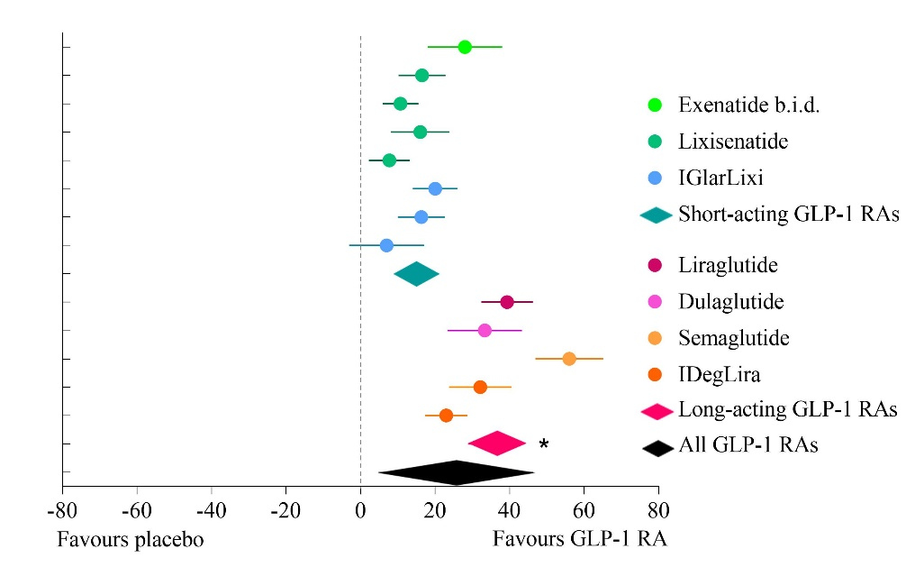
Seino et al. 2012 (14) | 16.5 | 10.2; 22.8 | 13.06 | 5.14 | < 0.0001
Riddle et al. 2013 a (15) | 10.7 | 5.9; 15.5 | 13.98 | 4.38 | < 0.0001
Riddle et al. 2013 b (16) | 16.0 | 8.2; 23.8 | 12.07 | 4.03 | 0.0001
Yang et al. 2018 (17) | 7.7 | 2.2; 13.2 | 13.59 | 2.76 | 0.0057
Aroda et al. 2016 (18) | 20.0 | 14.0; 26.0 | 13.24 | 6.51 | < 0.0001
Rosenstock at al. 2016 a (19) | 16.3 | 10.0; 22.6 | 13.04 | 5.05 | < 0.0001
Rosenstock et al. 2016 b (20) | 7.0 | -3.1; 17.1 | 10.49 | 1.36 | 0.17
All short-acting GLP-1 RAs | 15.1 | 9.3; 20.9 | - | 5.13 | < 0.0001
Ahmann et al. 2015 (21) | 39.3 | 32.4; 46.2 | 21.29 | 11.15 | < 0.0001
Pozzilli et al. 2017 (23) | 33.3 | 23.3; 43.3 | 17.77 | 6.54 | < 0.0001
Rodbard et al. 2018 (24) | 56.0 | 46.9; 65.1 | 18.74 | 12.01 | < 0.0001
Buse et al. 2014 (25) | 32.1 | 23.7; 40.5 | 19.64 | 7.53 | < 0.0001
Gough et al. 2014 (26) | 23.0 | 17.3; 28.7 | 22.56 | 7.86 | < 0.0001
All long-acting GLP-1 RAs | 36.3 | 28.8; 43.7 | - | 9.51 | < 0.0001
All GLP-1 RAs | 25.5 | 4.8; 46.3 | - | 2.41 | 0.016
* Difference between short- and long-acting GLP-1 RAs: ∆ -21.2, 95% CI: -31.7; -10.6, p-value: 0.001
Heterogeneity of all GLP-1 RAs: Q-value: 151.65; df (Q): 12; P-value: < 0.0001; I²: 92.09 %; Tau²: 0.01

Supplementary Figure S 3: Achievement of HbA1c target ≤ 6.5 % in the trials used in the present meta-analysis comparing efficacy and safety of short- and long-acting glucagon-like peptide-1 receptor agonists in combination with basal insulin. Data is presented as risk difference between short-acting or long-acting GLP-1 RAs# and basal insulin with basal insulin ± placebo. Guja et al. (2018) is missing because of absence of data.
# Glucagon-like peptide-1 receptor agonists

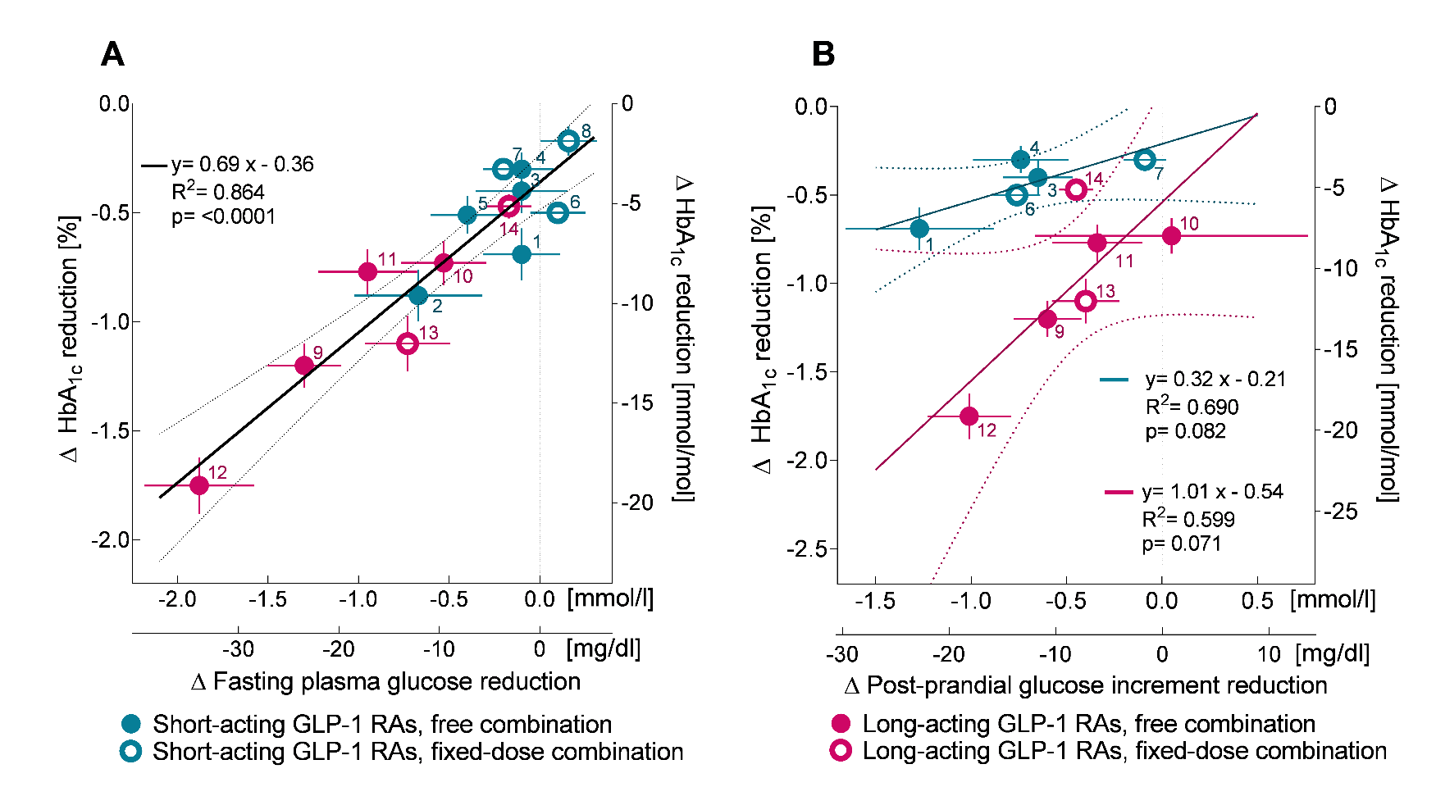

Supplementary Figure S 4. Relationship between effects on fasting plasma glucose and on post-prandial glycemic increments and on HbA_{1c}. Linear regression analysis relating the reduction in fasting plasma glucose to HbA_{1c} reduction (A) and relating reductions in postprandial glucose increments to reductions in HbA_{1c} (B). Data points are plotted ± SEM. Straight lines depict the regression line, dotted lines represent the 95 % confidence limits for the regression line. Regression analysis indicated that the slopes relating differences in reduction of fasting (A) or post-prandial (B) glucose concentrations and reductions in HbA_{1c} were not significant (p = 0.16-0.94), and that the y-axis intercepts for fasting glucose reductions were not significantly different (p = 0.99), whereas they were significantly different in the case of post-prandial glucose reductions (p = 0.0033). Therefore, in panel A, a common regression line ± confidence interval is shown (in black), whereas in panel B, separate regression lines ± confidence intervals are shown for short- (blue) and long-acting (purple) GLP-1 RAs. Some studies (n = 3) could not be included in the figure and analysis of the linear regression of HbA_{1c} and postprandial glucose increment reduction (B) because of missing data: Seino et al. 2012 (14); Yang et al. 2018 (17); Rosenstock et al. 2016 b (20). Numbers next to symbols indicate the publication that this data point has been taken from (the numbers of references in brackets refer to the reference list in the main manuscript): 1: Buse et al. 2011 (13); 2: Seino et al. 2012 (14); 3: Riddle et al. 2013 a (15); 4: Riddle et al. 2013 b (16); 5: Yang et al. 2018 (17); 6: Aroda et al. 2016 (18); 7: Rosenstock et al. 2016 a (19); 8: Rosenstock et al. 2016 b (20); 9: Ahmann et al. 2015 (21); 10: Guja et al. 2018 (22); 11: Pozzilli et al. 2017 (23); 12: Rodbard et al. 2018 (24); 13: Buse et al. 2014 (25); 14: Gough et al. 2014 (26).
Supplementary Table S 10. Overview of hypoglycemia that occurred in the studies included in the present meta-analysis comparing efficacy and safety of short- and long-acting glucagon-like peptide-1 receptor agonists in combination with basal insulin.
Study/publication | Definition of hypoglycemia |  | Number of patients |  | Symptomatic hypoglycemia |  | Severe hypoglycemia
 | Symptomatic | Severe | GLP-1 RAª | Placebo | GLP-1 RAª n (%) | Placebo n (%) | GLP-1 RAª n (%) | Placebo n (%)
Short-acting glucagon-like peptide-1 receptor agonists added to basal insulin
Buse et al. 2011 (13) | BG < 3.0 mmol/l | Assistance needed or loss of consciousness or seizure and BG < 3.0 mmol/l with prompt recovery after treatment (glucose/ glucagon) | 137 | 122 | 34(24.8) | 35 (28.7) | 0 (0.0) | 1 (0.8)
Seino et al. 2012 (14) | PG < 3.3 mmol/l | Assistance needed and PG < 2.0 mmol/l | 154 | 157 | 66 (42.9) | 37 (23.6) | 0 (0.0) | 0 (0.0)
Riddle et al. 2013 a (15) | PG < 3.3 mmol/l | Assistance needed and PG < 2.0 mmol/l | 328 | 167 | 91 (27.7) | 36 (21.6) | 4 (1.2) | 0 (0.0)
Riddle et al. 2013 b (16) | PG < 3.3 mmol/l | Assistance needed and PG < 2.0 mmol/l | 223 | 223 | 50 (22.4) | 30 (13.5) | 1 (0.4) | 0 (0.0)
Yang et al. 2018 (17) | PG < 3.3 mmol/l | Assistance needed and PG < 2.0 mmol/l | 223 | 223 | 20 (9.0) | 20 (9.0) | 0 (0.0) | 0 (0.0)
Aroda et al. 2016 (18) | PG < 3.9 mmol/l | Assistance needed | 366 | 365 | 146 (39.9) | 155 (42.5) | 4 (1.1) | 1 (0.3)
Rosenstock et al. 2016 a (19) | PG < 3.9 mmol/l | Assistance needed | 468 | 466 | 120 (25.6) | 110 (23.6) | 0 (0.0) | 1 (0.2)
Rosenstock et al. 2016 b (20) | PG < 3.9 mmol/l | No details published | 161 | 162 | 35 (21.7) | 37 (22.8) | 0 (0.0) | 0 (0.0)
All short-acting glucagon-like peptide-1 receptor agonists |  |  | 2060 | 1885 | 562 (27.3) | 460 (24.4) | 9 (0.4) | 3 (0.2)
Long-acting glucagon-like peptide-1 receptor agonists added to basal insulin
Ahmann et al. 2015 (21) | PG < 3.1 mmol/l | Assistance needed | 225 | 225 | 41 (18.2) | 28 (12.4) | 0 (0.0) | 0 (0.0)
Guja et al. 2018 (22) | GL < 3.0 mmol/l | Assistance needed or loss of consciousness or seizure or coma with prompt recovery after treatment (glucose/ glucagon) and GL < 3.0 mmol/l | 231 | 230 | 13 (5.6) | 13 (5.7) | 0 (0.0) | 0 (0.0)
Pozzilli et al. 2017 (23) | PG < 3.9 mmol/l | Assistance needed | 150 | 150 | 53 (35.3) | 45 (30.0) | 1 (0.7) | 0 (0.0)
Rodbard et al. 2018 (24) | PG < 3.1 mmol/l | Assistance needed | 131 | 133 | 14 (10.7) | 7 (5.3) | 2 (1.5) | 1 (0.8)
Buse et al. 2014 (25) | PG < 3.1 mmol/l | Assistance needed | 199 | 199 | 48 (24.1) | 49 (24.6) | 1 (0.5) | 0 (0.0)
Gough et al. 2014 (26) | PG < 3.1 mmol/l | Assistance needed | 833 | 413 | 263 (31.6) | 159 (38.5) | 3 (0.4) | 2 (0.5)
All long-acting glucagon-like peptide-1 receptor agonists ^{b} |  |  | 1769 | 1350 | 432 (24.4) | 301 (22.3) | 7 (0.4) | 3 (0.2)
All glucagon-like peptide-1 receptor agonists (short and long-acting) |  |  | 3829 | 3235 | 994 (26.0)*,† | 761 (23.5) | 16 (0.4) | 6 8 (0.2)
Abbreviations: BG: blood glucose; PG: plasma glucose; GL: glucose level; CI: Confidence interval; ª: Glucagon-like peptide-1 receptor agonist/s; *: Significant difference (p = 0.020) vs. insulin alone; †: Significant difference (p = 0.048) to short-acting GLP-1 RAs; there were no significant differences within the placebo/insulin only study arms or regarding severe hypoglycemia.

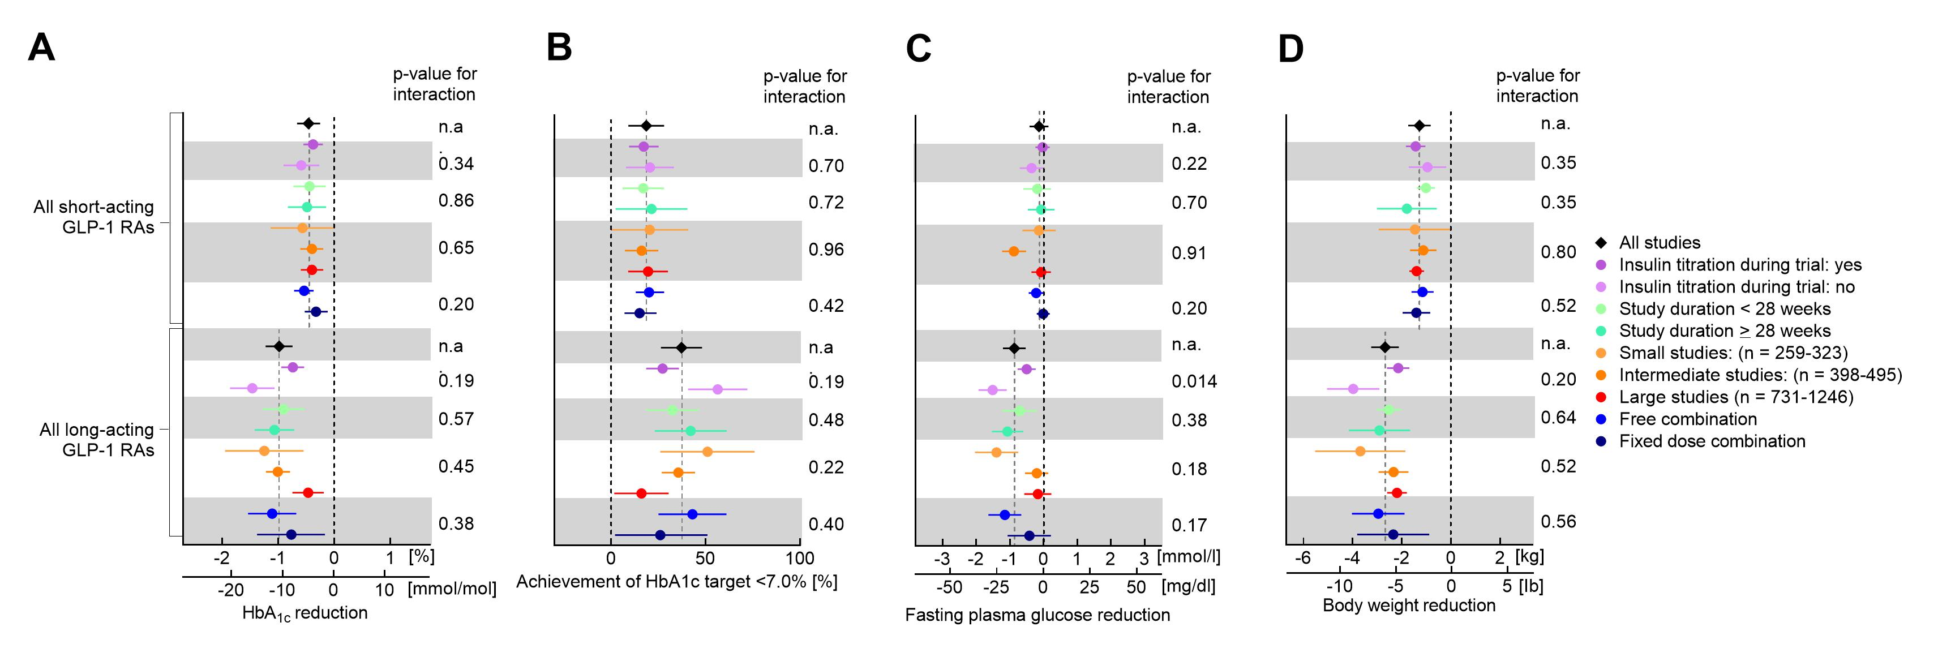
Supplementary Figure S 6. Subgroup analysis of HbA_{1c} reduction (A), achievement of HbA1c target <7.0% (B), fasting plasma glucose reduction (C) and bodyweight reduction (D) and for studies included in the present meta-analysis presented separately for studies with short- and long-acting glucagon-like peptide-1 receptor agonists in combination with basal insulin. Interaction p-values are presented for each subgroup comparison; n.a., not applicable. See Supplementary Table 11 for details on the comparison of free and fixed-dose combinations.

Supplementary Table S 11. Overview of results studies using free- or fixed-dose combinations of glucagon-like peptide-1 receptor agonists and basal insulin grouped by studying short- and long-acting GLP-1 RAs in studies examined in the present meta-analysis.
Kind of GLP-1 RA* | Combination of GLP-1 RA and basal insulin | Raw results |  |  |  |  | Difference between short- and long-acting GLP-1 RAs |  |  | Interaction
 |  | Number of studies | Difference in means | 95% Confidence interval | Z - value | P - value | ∆ | 95% Confidence interval | P-value | P-value
A. HbA_{1c} reduction [%]
Short-acting | free combination# | 5 | -0.54 | -0.72; -0.37 | -6.07 | < 0.0001 | -0.57 | -1.08; -0.05 | 0.035 | 0.38
Long-acting |  | 4 | -1.11 | -1.54; -0.68 | -5.04 | < 0.0001
Short-acting | fixed-dose combination# | 3 | -0.33 | -0.53; -0.12 | -3.12 | 0.0018 | -0.45 | -1.30; 0.40 | 0.19
Long-acting |  | 2 | -0.77 | -1.38; -0.17 | -2.51 | 0.012
 |  | Number of studies | Risk difference | 95% Confidence interval | Z - value | P - value | ∆ | 95% Confidence interval | P-value | InteractionP-value
B. Achievement of HbA₁ target < 7.0 % [%]
Short-acting | free combination | 5 | 20 | 13; 28 | 5.73 | < 0.0001 | 22 | 1; 43 | 0.040 | 0.40
Long-acting |  | 4 | 43 | 25; 61 | 4.77 | < 0.0001
Short-acting | fixed-dose combination | 3 | 15 | 7; 24 | 3.54 | 0.00040 | 11 | -24; 46 | 0.39
Long-acting |  | 2 | 26 | 2; 51 | 2.09 | 0.037
 |  | Number of studies | Difference in means | 95% Confidence interval | Z - value | P - value | ∆ | 95% Confidence interval | P-value | InteractionP-value
C. Fasting plasma glucose reduction [mmol/l]
Short-acting | free combination | 5 | -0.22 | -0.44; -0.01 | -2.01 | 0.045 | -0.92 | -1.52; -0.33 | 0.008 | 0.17
Long-acting |  | 4 | -1.15 | -1.64; -0.66 | -4.60 | < 0.0001
Short-acting | fixed-dose combination | 3 | -0.01 | -0.20; 0.18 | -0.11 | 0.92 | -0.41 | -1.29; 0.47 | 0.23
Long-acting |  | 2 | -0.42 | -1.07; 0.22 | -1.29 | 0.19
D. Body weight reduction [kg]
Short-acting | free combination | 5 | -1.16 | -1.61; -0.71 | -5.08 | < 0.0001 | -1.80 | -3.09; -0.51 | 0.013 | 0.56
Long-acting |  | 4 | -2.96 | -4.03; -1.89 | -5.40 | < 0.0001
Short-acting | fixed-dose combination | 3 | -1.41 | -1.97; -0.85 | -4.92 | < 0.0001 | -0.94 | -3.07; 1.19 | 0.25
Long-acting |  | 2 | -2.35 | -3.82; -0.89 | -3.15 | 0.0016
*: Glucagon-like peptide-1 receptor agonists # free-dose or fixed-dose combination of basal insulin and GLP-1 RA. Fixed-dose combinations are IGlarLixi: fixed-dose combination of lixisenatide and insulin glargine and IDegLira: fixed-dose combination of insulin degludec and liraglutide
Supplementary Table S 12. Analysis of robustness of results for HbA_{1c} reduction in the present meta-analysis comparing efficacy and safety of short- and long-acting glucagon-like peptide-1 receptor agonists in combination with basal insulin.
Analysis omitting results from study/publication: | Kind of GLP-1 RA* | Raw results for HbA_{1c} reduction [%] |  |  |  | Heterogeneity statistics |  |  |  |  | Difference between short- and long-acting GLP-1 RAs [%]
 |  | Difference in means | 95% Confidence interval | Z- value | P-value | Q-value | df(Q) | P-value | I² | Tau² | ∆ | 95% Confidence interval | P-value
None | short-acting | -0.46 | -0.67; -0.26 | -4.42 | < 0.0001 | 44.6 | 7 | < 0.0001 | 84.3 | 0.030 | -0.53 | -0.88; -0.18 | 0.0063
 | long-acting | -0.99 | -1.23; -0.75 | -8.03 | < 0.0001 | 110.0 | 5 | < 0.0001 | 95.5 | 0.196
Buse et al. 2011 (13) | short-acting | -0.43 | -0.65; -0.21 | -3.86 | 0.00011 | 38.5 | 6 | < 0.0001 | 84.4 | 0.028 | -0.56 | -0.92; -0.20 | 0.0061
 | long-acting | -0.99 | -1.23; -0.74 | -8.00 | < 0.0001 | 110.2 | 5 | < 0.0001 | 95.5 | 0.195
Seino et al. 2012 (14) | short-acting | -0.41 | -0.62; -0.19 | -3.78 | 0.00016 | 27.5 | 6 | 0.00012 | 78.2 | 0.018 | -0.58 | -0.93; -0.23 | 0.0039
 | long-acting | -0.99 | -1.22; -0.75 | -8.28 | < 0.0001 | 110.0 | 5 | < 0.0001 | 95.5 | 0.195
Riddle et al. 2013 a (15) | short-acting | -0.47 | -0.69; -0.24 | -4.09 | < 0.0001 | 44.6 | 6 | < 0.0001 | 86.5 | 0.034 | -0.52 | -0.90; -0.14 | 0.011
 | long-acting | -0.99 | -1.24; -0.74 | -7.79 | < 0.0001 | 110.0 | 5 | < 0.0001 | 95.5 | 0.195
Riddle et al. 2013 b (16) | short-acting | -0.48 | -0.71; -0.26 | -4.15 | < 0.0001 | 42.6 | 6 | < 0.0001 | 85.9 | 0.034 | -0.51 | -0.89; -0.13 | 0.013
 | long-acting | -0.99 | -1.24; -0.74 | -7.69 | < 0.0001 | 110.0 | 5 | < 0.0001 | 95.5 | 0.195
Yang et al. 2018 (17) | short-acting | -0.45 | -0.68; -0.23 | -3.93 | < 0.0001 | 42.9 | 6 | < 0.0001 | 86.0 | 0.033 | -0.54 | -0.92; -0.16 | 0.0094
 | long-acting | -0.99 | -1.24; -0.20 | -7.76 | < 0.0001 | 110.0 | 5 | < 0.0001 | 95.5 | 0.195
Aroda et al. 2016 (18) | short-acting | -0.46 | -0.70; -0.22 | -3.74 | 0.00018 | 39.6 | 6 | < 0.0001 | 84.9 | 0.037 | -0.53 | -0.93; -0.13 | 0.013
 | long-acting | -0.99 | -1.25; -0.73 | -7.41 | < 0.0001 | 110.0 | 5 | < 0.0001 | 95.5 | 0.195
Rosenstock et al. 2016 a (19) | short-acting | -0.49 | -0.73; -0.25 | -3.99 | < 0.0001 | 39.2 | 6 | < 0.0001 | 84.7 | 0.037 | -0.5 | -0.90; -0.10 | 0.018
 | long-acting | -0.99 | -1.25; -0.73 | -7.42 | < 0.0001 | 110.0 | 5 | < 0.0001 | 95.5 | 0.195
Rosenstock et al. 2016 b (20) | short-acting | -0.50 | -0.73; -0.28 | -4.42 | < 0.0001 | 31.3 | 6 | < 0.0001 | 80.8 | 0.024 | -0.49 | -0.86; -0.12 | 0.014
 | long-acting | -0.99 | -1.23; -0.74 | -7.89 | < 0.0001 | 110.0 | 5 | < 0.0001 | 95.5 | 0.195
Ahmann et al. 2015 (21) | short-acting | -0.46 | -0.66; -0.26 | -4.54 | < 0.0001 | 44.6 | 7 | < 0.0001 | 84.3 | 0.030 | -0.48 | -0.84; -0.12 | 0.014
 | long-acting | -0.49 | -1.20; -0.69 | -7.19 | < 0.0001 | 92.1 | 4 | < 0.0001 | 95.7 | 0.206
Guja et al. 2018 (22) | short-acting | -0.46 | -0.67; -0.25 | -4.29 | < 0.0001 | 44.6 | 7 | < 0.0001 | 84.3 | 0.030 | -0.58 | -0.97; -0.19 | 0.0069
 | long-acting | -1.04 | -1.31; -0.77 | -7.49 | < 0.0001 | 109.5 | 4 | < 0.0001 | 96.4 | 0.247
Pozzilli et al. 2017 (23) | short-acting | -0.46 | -0.67; -0.25 | -4.29 | < 0.0001 | 44.6 | 7 | < 0.0001 | 84.3 | 0.030 | -0.57 | -0.96; -0.18 | 0.0077
 | long-acting | -1.03 | -1.30; -0.76 | -7.43 | < 0.0001 | 109.9 | 4 | < 0.0001 | 96.4 | 0.245
Rodbard et al. 2018 (24) | short-acting | -0.46 | -0.62; -0.29 | -5.42 | < 0.0001 | 44.6 | 7 | < 0.0001 | 84.3 | 0.030 | -0.38 | -0.68; -0.08 | 0.018
 | long-acting | -0.48 | -1.05; -0.63 | -7.72 | < 0.0001 | 51.3 | 4 | < 0.0001 | 92.2 | 0.101
Buse et al. 2014 (25) | short-acting | -0.46 | -0.67; -0.26 | -4.41 | < 0.0001 | 44.6 | 7 | < 0.0001 | 84.3 | 0.030 | -0.51 | -0.88; -0.14 | 0.012
 | long-acting | -0.97 | -1.23; -0.70 | -7.19 | < 0.0001 | 103.9 | 4 | < 0.0001 | 96.2 | 0.215
Gough et al. 2014 (26) | short-acting | -0.46 | -0.63; -0.29 | -5.30 | < 0.0001 | 44.6 | 7 | < 0.0001 | 84.3 | 0.030 | -0.64 | -0.95; -0.33 | 0.00085
 | long-acting | -1.10 | -1.32; -0.88 | -9.64 | < 0.0001 | 48.6 | 4 | < 0.0001 | 91.8 | 0.139
*: Glucagon-like peptide-1 receptor agonists

Supplementary Table S 13. Analysis of robustness of results for achieving HbA_{1c} target < 7.0 % in the present meta-analysis comparing efficacy and safety of short- and long-acting glucagon-like peptide-1 receptor agonists in combination with basal insulin.
Analysis omitting results from study/publication: | Kind of GLP-1 RA* | Raw results for achievement of HbA1c target < 7.0 % [%] |  |  |  | Heterogeneity statistics |  |  |  |  | Difference between short- and long-acting GLP-1 RAs
 |  | Difference in means | 95% Confidence interval | Z- value | P-value | Q-value | df(Q) | P-value | I² | Tau² | ∆ | 95% Confidence interval | P-value
None | short-acting | 18.6 | 9.1; 28.0 | 3.85 | 0.0001 | 23.6 | 7 | 0.0013 | 70.4 | 0.004 | 18.6 | 2,6; 34,7 | 0.026
 | long-acting | 37.2 | 26.3; 48.1 | 6.70 | < 0.0001 | 115.4 | 5 | < 0.0001 | 95.7 | 0.034
Buse et al. 2011 (13) | short-acting | 17.7 | 7.5; 27.9 | 3.40 | 0.0006 | 22.3 | 6 | 0.0010 | 73.0 | 0.004 | 19.5 | 2,5; 36,4 | 0.028
 | long-acting | 37.2 | 26.1; 48.3 | 6.58 | < 0.0001 | 115.4 | 5 | < 0.0001 | 95.7 | 0.034
Seino et al. 2012 (14) | short-acting | 16.9 | 6.7; 27.0 | 3.26 | 0.0011 | 14.2 | 6 | 0.027 | 57.9 | 0.002 | 20.3 | 3,3; 37,3 | 0.023
 | long-acting | 37.2 | 26.3; 48.1 | 6.66 | < 0.0001 | 115.4 | 5 | < 0.0001 | 95.7 | 0.034
Riddle et al. 2013 a (15) | short-acting | 18.9 | 0.3; 29.6 | 3.47 | 0.0005 | 23.3 | 6 | 0.0007 | 74.3 | 0.005 | 18.3 | 0,7; 35,9 | 0.042
 | long-acting | 37.2 | 0.3; 48.7 | 6.36 | < 0.0001 | 115.4 | 5 | < 0.0001 | 95.7 | 0.034
Riddle et al. 2013 b (16) | short-acting | 18.8 | 0.3; 29.2 | 3.53 | 0.0004 | 23.6 | 6 | 0.0006 | 74.5 | 0.005 | 18.4 | 1,3; 35,6 | 0.037
 | long-acting | 37.2 | 0.3; 48.5 | 6.48 | < 0.0001 | 115.4 | 5 | < 0.0001 | 95.7 | 0.034
Yang et al. 2018 (17) | short-acting | 19.1 | 0.3; 29.5 | 3.57 | 0.0004 | 23.0 | 6 | 0.0008 | 74.0 | 0.005 | 18.2 | 0,9; 35,4 | 0.041
 | long-acting | 37.2 | 0.3; 48.5 | 6.46 | < 0.0001 | 115.4 | 5 | < 0.0001 | 95.7 | 0.034
Aroda et al. 2016 (18) | short-acting | 17.6 | 0.3; 28.1 | 3.29 | 0.0010 | 19.2 | 6 | 0.0039 | 68.7 | 0.004 | 19.6 | 2,2; 37,1 | 0.031
 | long-acting | 37.2 | 0.3; 48.5 | 6.46 | < 0.0001 | 115.4 | 5 | < 0.0001 | 95.7 | 0.034
Rosenstock et al. 2016 a (19) | short-acting | 19.2 | 0.3; 30.0 | 3.50 | 0.0005 | 21.6 | 6 | 0.0014 | 72.3 | 0.005 | 18.0 | 0,3; 35,8 | 0.047
 | long-acting | 37.2 | 0.3; 48.8 | 6.31 | < 0.0001 | 115.4 | 5 | < 0.0001 | 95.7 | 0.034
Rosenstock et al. 2016 b (20) | short-acting | 20.3 | 0.3; 30.5 | 3.93 | < 0.0001 | 15.0 | 6 | 0.021 | 59.9 | 0.002 | 16.9 | 0,0; 33,7 | 0.0495
 | long-acting | 37.2 | 0.3; 48.2 | 6.66 | < 0.0001 | 115.4 | 5 | < 0.0001 | 95.7 | 0.034
Ahmann et al. 2015 (21) | short-acting | 18.6 | 0.2; 28.0 | 3.85 | 0.0001 | 23.6 | 7 | 0.0013 | 70.4 | 0.004 | 17.0 | 0,0; 34,1 | 0.0503
 | long-acting | 35.6 | 0.4; 47.5 | 5.84 | < 0.0001 | 103.5 | 4 | < 0.0001 | 96.1 | 0.038
Guja et al. 2018 (22) | short-acting | 18.6 | 0.2; 28.3 | 3.72 | 0.0002 | 23.6 | 7 | 0.0013 | 70.4 | 0.004 | 21.2 | 3,4; 38,9 | 0.023
 | long-acting | 39.7 | 0.4; 52.1 | 6.28 | < 0.0001 | 110.1 | 4 | < 0.0001 | 96.4 | 0.044
Pozzilli et al. 2017 (23) | short-acting | 18.6 | 0.2; 28.3 | 3.75 | 0.0002 | 23.6 | 7 | 0.0013 | 70.4 | 0.004 | 19.4 | 1,8; 37,0 | 0.034
 | long-acting | 37.9 | 0.4; 50.1 | 6.10 | < 0.0001 | 115.4 | 4 | < 0.0001 | 96.5 | 0.039
Rodbard et al. 2018 (24) | short-acting | 18.5 | 0.1; 25.4 | 5.29 | < 0.0001 | 23.6 | 7 | 0.0013 | 70.4 | 0.004 | 12.4 | 0,0; 24,8 | 0.0497
 | long-acting | 30.9 | 0.2; 39.5 | 7.03 | < 0.0001 | 43.6 | 4 | < 0.0001 | 90.8 | 0.015
Buse et al. 2014 (25) | short-acting | 18.6 | 0.2; 28.3 | 3.73 | 0.0002 | 23.6 | 7 | 0.0013 | 70.4 | 0.004 | 18.7 | 0,9; 36,4 | 0.041
 | long-acting | 37.2 | 0.4; 49.5 | 5.93 | < 0.0001 | 114.2 | 4 | < 0.0001 | 96.5 | 0.040
Gough et al. 2014 (26) | short-acting | 18.5 | 0.2; 26.5 | 4.58 | < 0.0001 | 23.6 | 7 | 0.0013 | 70.4 | 0.004 | 23.2 | 9,0; 37,4 | 0.004
 | long-acting | 41.7 | 0.3; 51.8 | 8.11 | < 0.0001 | 60.4 | 4 | < 0.0001 | 93.4 | 0.026
*: Glucagon-like peptide-1 receptor agonists

Supplementary Table S 14. Analysis of robustness of results for fasting plasma glucose reduction in the present meta-analysis comparing efficacy and safety of short- and long-acting glucagon-like peptide-1 receptor agonists in combination with basal insulin.
Analysis omitting results from study/publication: | Kind of GLP-1 RA* | Raw results for fasting plasma glucose reduction [mmol/l] |  |  |  | Heterogeneity statistics |  |  |  |  | Difference between short- and long-acting GLP-1 RAs [mmol/l]
 |  | Difference in means | 95% Confidence interval | Z- value | P-value | Q-value | df(Q) | P-value | I² | Tau² | ∆ | 95% Confidence interval | P-value
None | short-acting | -0.1 | -0.4; 0.2 | -0.94 | 0.35 | 10.1 | 7 | 0.18 | 30.6 | 0.014 | -0.8 | -1.3; -0.3 | 0.0037
 | long-acting | -0.9 | -1.2; -0.5 | -5.04 | < 0.0001 | 43.5 | 5 | < 0.0001 | 88.5 | 0.345
Buse et al. 2011 (13) | short-acting | -0.1 | -0.5; 0.2 | -0.89 | 0.38 | 10.1 | 6 | 0.12 | 40.5 | 0.021 | -0.8 | -1.3; -0.3 | 0.0066
 | long-acting | -0.9 | -1.2; -0.5 | -4.89 | < 0.0001 | 43.5 | 5 | < 0.0001 | 88.5 | 0.345
Seino et al. 2012 (14) | short-acting | -0.1 | -0.4; 0.2 | -1.15 | 0.56 | 7.4 | 6 | 0.28 | 19.2 | 0.007 | -0.8 | -1.3; -0.3 | 0.0048
 | long-acting | -0.9 | -1.2; -0.5 | -4.92 | < 0.0001 | 43.5 | 5 | < 0.0001 | 88.5 | 0.345
Riddle et al. 2013 a (15) | short-acting | -0.1 | -0.5; 0.2 | -0.90 | 0.37 | 10.1 | 6 | 0.12 | 40.5 | 0.020 | -0.8 | -1.3; -0.3 | 0.0061
 | long-acting | -0.9 | -1.2; -0.5 | -4.92 | < 0.0001 | 43.5 | 5 | < 0.0001 | 88.5 | 0.345
Riddle et al. 2013 b (16) | short-acting | -0.1 | -0.5; 0.2 | -0.88 | 0.38 | 10.1 | 6 | 0.12 | 40.5 | 0.022 | -0.8 | -1.3; -0.3 | 0.0072
 | long-acting | -0.9 | -1.2; -0.5 | -4.84 | < 0.0001 | 43.5 | 5 | < 0.0001 | 88.5 | 0.345
Yang et al. 2018 (17) | short-acting | -0.1 | -0.4; 0.2 | -0.58 | 0.53 | 7.7 | 6 | 0.26 | 22.3 | 0.009 | -0.8 | -1.3; -0.3 | 0.0058
 | long-acting | -0.9 | -1.2; -0.5 | -5.06 | < 0.0001 | 43.5 | 5 | < 0.0001 | 88.5 | 0.345
Aroda et al. 2016 (18) | short-acting | -0.2 | -0.5; 0.1 | -1.08 | 0.28 | 8.0 | 6 | 0.24 | 25.1 | 0.011 | -0.7 | -1.2; -0.2 | 0.015
 | long-acting | -0.9 | -1.2; -0.5 | -4.86 | < 0.0001 | 43.5 | 5 | < 0.0001 | 88.5 | 0.345
Rosenstock et al. 2016 a (19) | short-acting | -0.1 | -0.5; 0.2 | -0.76 | 0.45 | 9.0 | 6 | 0.17 | 33.2 | 0.019 | -0.8 | -1.4; -0.2 | 0.0089
 | long-acting | -0.9 | -1.2; -0.5 | -4.70 | < 0.0001 | 43.5 | 5 | < 0.0001 | 88.5 | 0.345
Rosenstock et al. 2016 b (20) | short-acting | -0.2 | -0.5; 0.1 | -1.15 | 0.25 | 6.7 | 6 | 0.35 | 10.6 | 0.004 | -0.7 | -1.2; -0.2 | 0.013
 | long-acting | -0.9 | -1.2; -0.5 | -4.92 | < 0.0001 | 43.5 | 5 | < 0.0001 | 88.5 | 0.234
Ahmann et al. 2015 (21) | short-acting | -0.1 | -0.4; 0.1 | -1.00 | 0.32 | 10.1 | 7 | 0.18 | 30.6 | 0.014 | -0.7 | -1.2; -0.2 | 0.0083
 | long-acting | -0.8 | -1.1; -0.4 | -4.34 | < 0.0001 | 31.4 | 4 | < 0.0001 | 87.3 | 0.324
Guja et al. 2018 (22) | short-acting | -0.1 | -0.4; 0.2 | -0.92 | 0.36 | 10.1 | 7 | 0.18 | 30.6 | 0.014 | -0.8 | -1.3; -0.3 | 0.0071
 | long-acting | -0.9 | -1.3; -0.6 | -4.84 | < 0.0001 | 43.2 | 4 | < 0.0001 | 90.7 | 0.431
Pozzilli et al. 2017 (23) | short-acting | -0.1 | -0.4; 0.2 | -0.93 | 0.35 | 10.1 | 7 | 0.18 | 30.6 | 0.014 | -0.8 | -1.3; -0.3 | 0.0065
 | long-acting | -0.9 | -1.2; -0.5 | -4.52 | < 0.0001 | 42.2 | 4 | < 0.0001 | 90.5 | 0.399
Rodbard et al. 2018 (24) | short-acting | -0.1 | -0.4; 0.1 | -1.05 | 0.29 | 10.1 | 7 | 0.184 | 30.6 | 0.014 | -0.6 | -1.0; -0.2 | 0.011
 | long-acting | -0.7 | -1.0; -0.4 | -4.44 | < 0.0001 | 26.0 | 4 | < 0.0001 | 84.6 | 0.233
Buse et al. 2014 (25) | short-acting | -0.1 | -0.4; 0.2 | -0.92 | 0.36 | 10.1 | 7 | 0.18 | 30.6 | 0.014 | -0.8 | -1.3; -0.3 | 0.0072
 | long-acting | -0.9 | -1.3; -0.5 | -4.63 | < 0.0001 | 43.3 | 4 | < 0.0001 | 90.8 | 0.435
Gough et al. 2014 (26) | short-acting | -0.1 | -0.3; 0.1 | -1.14 | 0.25 | 10.1 | 7 | 0.18 | 30.6 | 0.014 | -0.9 | -1.3; -0.5 | 0.00039
 | long-acting | -1.0 | -1.3; -0.8 | -6.95 | < 0.0001 | 15.7 | 4 | < 0.0001 | 74.6 | 0.177
*: Glucagon-like peptide-1 receptor agonists

Supplementary Table S 15. Analysis of robustness of results for body weight reduction in the present meta-analysis comparing efficacy and safety of short- and long-acting glucagon-like peptide-1 receptor agonists in combination with basal insulin.
Analysis omitting results from study/publication: | Kind of GLP-1 RA* | Raw results for body weight reduction [kg] |  |  |  | Heterogeneity statistics |  |  |  |  | Difference between short- and long-acting GLP-1 RAs [kg]
 |  | Difference in means | 95% Confidence interval | Z- value | P-value | Q-value | df(Q) | P-value | I² | Tau² | ∆ | 95% Confidence interval | P-value
None | short-acting | -1.3 | -1.7; -0.8 | -5.49 | < 0.0001 | 23.3 | 7 | 0.0015 | 70.0 | 0.171 | -1.4 | -2.2; -0.6 | 0.0024
 | long-acting | -2.7 | -3.3; -2.1 | -9.43 | < 0.0001 | 37.3 | 5 | < 0.0001 | 86.6 | 0.760
Buse et al. 2011 (13) | short-acting | -1.1 | -1.6; -0.7 | -4.98 | < 0.0001 | 13.6 | 6 | 0.034 | 56.0 | 0.084 | -1.6 | -2.4; -0.8 | 0.00082
 | long-acting | -2.7 | -3.2; -2 | -9.96 | < 0.0001 | 37.3 | 5 | < 0.0001 | 86.6 | 0.760
Seino et al. 2012 (14) | short-acting | -1.4 | -1.9; -1.0 | -5.96 | < 0.0001 | 11.2 | 6 | 0.831 | 46.3 | 0.065 | -1.3 | -2.1; -0.5 | 0.0040
 | long-acting | -2.7 | -3.2; -2.2 | -9.87 | < 0.0001 | 37.3 | 5 | < 0.0001 | 86.6 | 0.760
Riddle et al. 2013 a (15) | short-acting | -1.3 | -1.8; -0.8 | -4.90 | < 0.0001 | 23.1 | 6 | 0.0075 | 74.1 | 0.209 | -1.4 | -2.3; -0.5 | 0.0047
 | long-acting | -2.7 | -3.3; -2.1 | -9.05 | < 0.0001 | 37.3 | 5 | < 0.0001 | 86.6 | 0.760
Riddle et al. 2013 b (16) | short-acting | -1.3 | -1.9; -0.8 | -5.13 | < 0.0001 | 21.8 | 6 | 0.0013 | 72.5 | 0.199 | -1.4 | -2.3; -0.5 | 0.0046
 | long-acting | -2.7 | -3.3; -2.1 | -9.08 | < 0.0001 | 37.3 | 5 | < 0.0001 | 86.6 | 0.760
Yang et al. 2018 (17) | short-acting | -1.3 | -1.8; -0.8 | -4.85 | < 0.0001 | 23.3 | 6 | 0.0069 | 74.3 | 0.225 | -1.4 | -2.3; -0.5 | 0.0053
 | long-acting | -2.7 | -3.3; -2.1 | -8.90 | < 0.0001 | 37.3 | 5 | < 0.0001 | 86.6 | 0.760
Aroda et al. 2016 (18) | short-acting | -1.3 | -1.8; -0.8 | -4.77 | < 0.0001 | 22.3 | 6 | 0.0011 | 73.1 | 0.212 | -1.4 | -2.3; -0.5 | 0.0050
 | long-acting | -2.7 | -3.3; -2.1 | -8.97 | < 0.0001 | 37.3 | 5 | < 0.0001 | 86.6 | 0.760
Rosenstock et al. 2016 a (19) | short-acting | -1.3 | -1.8; -0.8 | -4.82 | < 0.0001 | 22.5 | 6 | 0.0098 | 73.3 | 0.207 | -1.4 | -2.3; -0.5 | 0.0047
 | long-acting | -2.7 | -3.3; -2.1 | -9.03 | < 0.0001 | 37.3 | 5 | < 0.0001 | 86.6 | 0.760
Rosenstock et al. 2016 b (20) | short-acting | -1.3 | -1.8; -0.8 | -4.91 | < 0.0001 | 22.7 | 6 | 0.0091 | 73.5 | 0.195 | -1.4 | -2.3; -0.5 | 0.0042
 | long-acting | -2.7 | -3.3; -2.1 | -9.17 | < 0.0001 | 37.3 | 5 | < 0.0001 | 86.6 | 0.760
Ahmann et al. 2015 (21) | short-acting | -1.3 | -1.7; -0.8 | -5.46 | < 0.0001 | 23.3 | 7 | 0.015 | 70.0 | 0.171 | -1.3 | -2.2; -0.4 | 0.0063
 | long-acting | -2.6 | -3.2; -2.0 | -8.33 | < 0.0001 | 34.2 | 4 | < 0.0001 | 88.3 | 0.867
Guja et al. 2018 (22) | short-acting | -1.3 | -1.7; -0.8 | -5.75 | < 0.0001 | 23.3 | 7 | 0.0015 | 70.0 | 0.171 | -1.6 | -2.4; -0.8 | 0.0012
 | long-acting | -2.9 | -3.5; -2.3 | -9.77 | < 0.0001 | 27.6 | 4 | < 0.0001 | 85.5 | 0.715
Pozzilli et al. 2017 (23) | short-acting | -1.3 | -1.8; -0.8 | -5.33 | < 0.0001 | 23.3 | 7 | 0.0015 | 70.0 | 0.171 | -1.4 | -2.3; -0.5 | 0.0047
 | long-acting | -2.7 | -3.4; -2.1 | -8.59 | < 0.0001 | 37.3 | 4 | < 0.0001 | 89.3 | 0.945
Rodbard et al. 2018 (24) | short-acting | -1.3 | -1.6; -0.9 | -7.07 | < 0.0001 | 23.3 | 7 | 0.0015 | 70.0 | 0.171 | -1.0 | -1.6; -0.4 | 0.0058
 | long-acting | -2.3 | -2.8; -1.9 | -9.76 | < 0.0001 | 10.5 | 4 | 0.033 | 61.9 | 0.170
Buse et al. 2014 (25) | short-acting | -1.3 | -1.8; -0.8 | -5.31 | < 0.0001 | 23.3 | 7 | 0.0015 | 70.0 | 0.171 | -1.4 | -2.3; -0.5 | 0.0049
 | long-acting | -2.7 | -3.4; -2.1 | -8.46 | < 0.0001 | 37.3 | 4 | < 0.0001 | 89.3 | 0.985
Gough et al. 2014 (26) | short-acting | -1.3 | -1.8; -0.8 | -5.28 | < 0.0001 | 23.3 | 7 | 0.0015 | 70.0 | 0.171 | -1.5 | -2.4; -0.6 | 0.0034
 | long-acting | -2.8 | -3.5; -2.2 | -8.50 | < 0.0001 | 35.1 | 4 | < 0.0001 | 88.6 | 1.174
*: Glucagon-like peptide-1 receptor agonists

Supplementary Table S 16. Analysis of robustness of results for adverse events in the present meta-analysis comparing efficacy and safety of short- and long-acting glucagon-like peptide-1 receptor agonists in combination with basal insulin.
Analysis omitting results from study/publication: | Number of patients |  | Nausea |  | Vomiting |  | Diarrhea |  | Symptomatic hypoglycemia# |  | Severe hypoglycemia#
 | GLP-1 RA  n (%) | Placebo  n (%) | GLP-1 RA  n (%) | Placebo  n (%) | GLP-1 RA n (%) | Placebo  n (%) | GLP-1 RA  n (%) | Placebo  n (%) | GLP-1 RA  n (%) | Placebo  n (%) | GLP-1 RA  n (%) | Placebo  n (%)
Short-acting GLP-1 RAs
None | 2060 | 1885 | 410 (19.9)* | 73 (3.9) | 158 (7.7)* | 24 (1.3) | 137 (7.5) | 66 (4.0) | 562 (27.3)* | 460 (24.4) | 9 (0.4) | 3 (0.2)
Buse et al. 2011 (13) | 1923 | 1763 | 354 (18.4)* | 63 (3.6) | 133 (6.9)* | 19 (1.1) | 63 (3.3) * | 36 (2.0) | 528 (27.5)* | 425 (24.1) | 9 (0.5) | 2 (0.1)
Seino et al. 2012 (14) | 1906 | 1728 | 349 (18.3)* | 66 (3.8) | 130 (6.8)* | 21 (1.2) | 127 (6.7) | 62 (3.6) | 496 (26.0) | 423 (24.5) | 9 (0.5) | 3 (0.2)
Riddle et al. 2013 a (15) | 1732 | 1718 | 324 (18.7)* | 59 (3.4) | 131 (7.6)* | 23 (1.3) | 113 (6.5) | 57 (3.3) | 471 (27.2) | 424 (24.7) | 5 (0.3) | 3 (0.2)
Riddle et al. 2013 b (16) | 1837 | 1662 | 349 (19.0)* | 62 (3.7) | 137 (7.5)* | 21 (1.3) | 122 (6.6) | 59 (3.5) | 512 (27.9)* | 430 (25.9) | 8 (0.4) | 3 (0.2)
Yang et al. 2018 (17) | 1837 | 1662 | 359 (19.5)* | 61 (3.7) | 133 (7.2)* | 22 (1.3) | 137 (7.5) | 66 (4.0) | 542 (29.5)* | 440 (26.5) | 9 (0.5) | 3 (0.2)
Aroda et al. 2016 (18) | 1694 | 1520 | 372 (22.0)* | 71 (4.7) | 145 (8.6)* | 22 (1.4) | 121 (7.1) | 56 (3.7) | 416 (24.6) | 305 (20.1) | 5 (0.3) | 2 (0.1)
Rosenstock et al. 2016 a (19) | 1592 | 1419 | 365 (22.9)* | 56 (3.9) | 143 (9.0)* | 17 (1.2) | 95 (6.0) | 46 (3.2) | 442 (27.8)* | 350 (24.7) | 9 (0.6) | 2 (0.1)
Rosenstock et al. 2016 b (20) | 1899 | 1723 | 398 (21.0)* | 73 (4.2) | 154 (8.1)* | 23 (1.3) | 132 (7.0) | 60 (3.5) | 527 (27.8)* | 423 (24.6) | 9 (0.5) | 3 (0.2)
Long-acting GLP-1 RAs
None | 1769 | 1350 | 170 (9.6)* | 46 (3.4) | 77 (4.9)* | 15 (1.3) | 130 (7.3) | 53 (3.9) | 432 (24.4)* | 301 (22.3) | 7 (0.4) | 3 (0.2)
Ahmann et al. 2015 (21) | 1544 | 1125 | 138 (8.9)* | 30 (3.5) | 57 (3.7)* | 13 (1.2) | 116 (7.5) | 42 (3.7) | 391 (25.3) | 273 (24.3) | 7 (0.5) | 3 (0.3)
Guja et al. 2018 (22) | 1538 | 1120 | 176 (11.4)* | 37 (3.3) | 76 (4.9)* | 12 (1.1) | 129 (8.4) | 45 (4.0) | 419 (27.2) | 288 (25.7) | 7 (0.5) | 3 (0.3)
Pozzilli et al. 2017 (23) | 1619 | 1200 | 170 (10.5)* | 44 (3.7) | 68 (4.2)* | 15 (1.3) | 123 (7.6) | 47 (3.9) | 379 (23.4)* | 256 (21.3) | 6 (0.4) | 3 (0.3)
Rodbard et al. 2018 (24) | 1638 | 1217 | 166 (10.1)* | 40 (3.3) | 62 (3.8)* | 11 (0.9) | 131 (8.0) | 51 (4.2) | 418 (25.5) | 294 (24.2) | 5 (0.3) | 2 (0.2)
Buse et al. 2014 (25) | 1570 | 1151 | 175 (11.1)* | 39 (3.4) | 77 (4.9)* | 15 (1.3) | 127 (8.1) | 46 (4.0) | 384 (24.5) | 252 (21.9) | 6 (0.4) | 3 (0.3)
Gough et al. 2014 (26) | 936 | 937 | 115 (12.3)* | 31 (3.3) | 45 (4.8)* | 9 (1.0) | 74 (7.9) | 34 (3.6) | 169 (18.1)* | 142 (15.2) | 7 (0.4) | 3 (0.2)
Abbreviation: GLP-1 RA: glucagon-like peptide-1 receptor agonists; *: Difference between short- and long-acting GLP-1 RAs + basal insulin is significant p < 0.05; †: Detailed definitions of hypoglycemia are presented in Supplementary Table S 9.

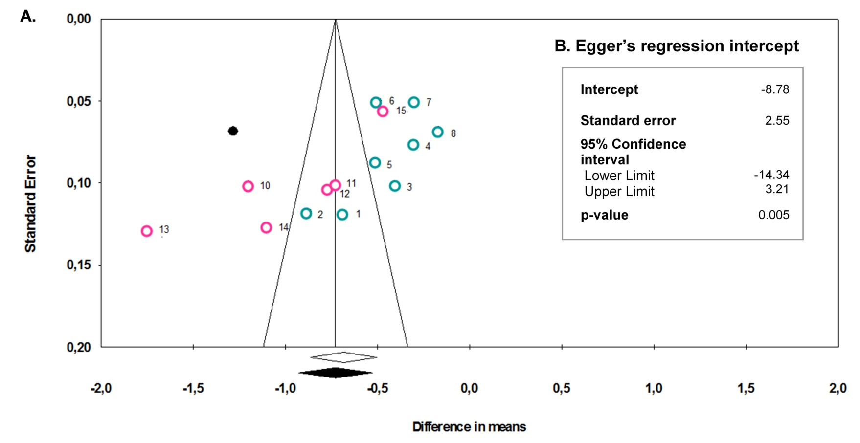

Supplementary Figure S 7. Funnel plot (A) and Egger’s regression intercept (B) for the difference in means of HbA_{1c} reduction [%] (glucagon-like peptide-1 receptor agonists versus placebo) from studies included in the present meta-analysis comparing efficacy and safety of short- and long-acting glucagon-like peptide-1 receptor agonists in combination with basal insulin. Empty symbols show the included studies and their point estimate, the filled black symbols show imputed publications and the adjusted point estimate using the ‘Trim and Fill’ method of Duval and Tweedie. Studies with short-acting glucagon-like peptide-1 receptor agonists (GLP-1 RA) are presented as blue rings, studies with long-acting GLP-1 RA as pink rings.(Random effects plotted). Black lines indicated 95% confidence interval of mean point estimate (center line). A difference in means of 1% HbA_{1c} equates a difference in means of 10.93 mmol/mol. Numbers next to symbols indicate the publication that this data point has been taken from (the numbers of references refer to the reference list in the main manuscript): 1: Buse et al. 2011 (13); 2: Seino et al. 2012 (14); 3: Riddle et al. 2013 a (15); 4: Riddle et al. 2013 b (16); 5: Yang et al. 2018 (17); 6: Aroda et al. 2016 (18); 7: Rosenstock et al. 2016 a (19); 8: Rosenstock et al. 2016 b (20); 10: Ahmann et al. 2015 (21); 11: Guja et al. 2018 (22); 12: Pozzilli et al. 2017 (23); 13: Rodbard et al. 2018 (24); 14: Buse et al. 2014 (25); 15: Gough et al. 2014 (26). All reference numbers refer to the list in the main manuscript.

Supplementary Table S 17: Detailed presentation of the heterogeneity statistics for short- and long-acting glucagon-like peptide-1 receptor agonists and the main endpoints of the present meta-analysis comparing the efficacy and safety of glucagon-like peptide-1 receptor agonists in combination with basal insulin.
Heterogeneity regarding meta-analysis of results concerning | Q-value | Df (Q) | P-value | I² | Tau²
A. HbA_{1c} reduction
Short-acting GLP-1 RAs* | 44.6 | 7 | < 0.0001 | 84.3 | 0.03
Long-acting GLP-1 RAs | 110.0 | 5 | < 0.0001 | 95.5 | 0.20
B. Achievement of HbA_{1c} target < 7.0%
Short-acting GLP-1 RAs | 23.6 | 7 | 0.0013 | 70.4 | 0.004
Long-acting GLP-1 RAs | 115.4 | 5 | < 0.0001 | 95.7 | 0.03
C. Achievement of HbA_{1c} target ≤ 6.5%
Short-acting GLP-1 RAs | 21.4 | 7 | 0.003 | 67.3 | 0.002
Long-acting GLP-1 RAs | 38.9 | 4 | < 0.0001 | 89.7 | 0.01
D. Fasting plasma glucose reduction
Short-acting GLP-1 RAs | 10.1 | 7 | 0.18 | 30.6 | 0.01
Long-acting GLP-1 RAs | 43.5 | 5 | < 0.0001 | 88.5 | 0.34
E. Body weight reduction
Short-acting GLP-1 RAs | 23.3 | 7 | 0.002 | 70.0 | 0.17
Long-acting GLP-1 RAs | 37.3 | 5 | < 0.0001 | 86.6 | 0.76
*: Glucagon-like peptide-1 receptor agonists; Df: degrees of freedom; P-value: Probability of absence of significant heterogeneity

