ONLINE SUPPLEMENTARY DATA:
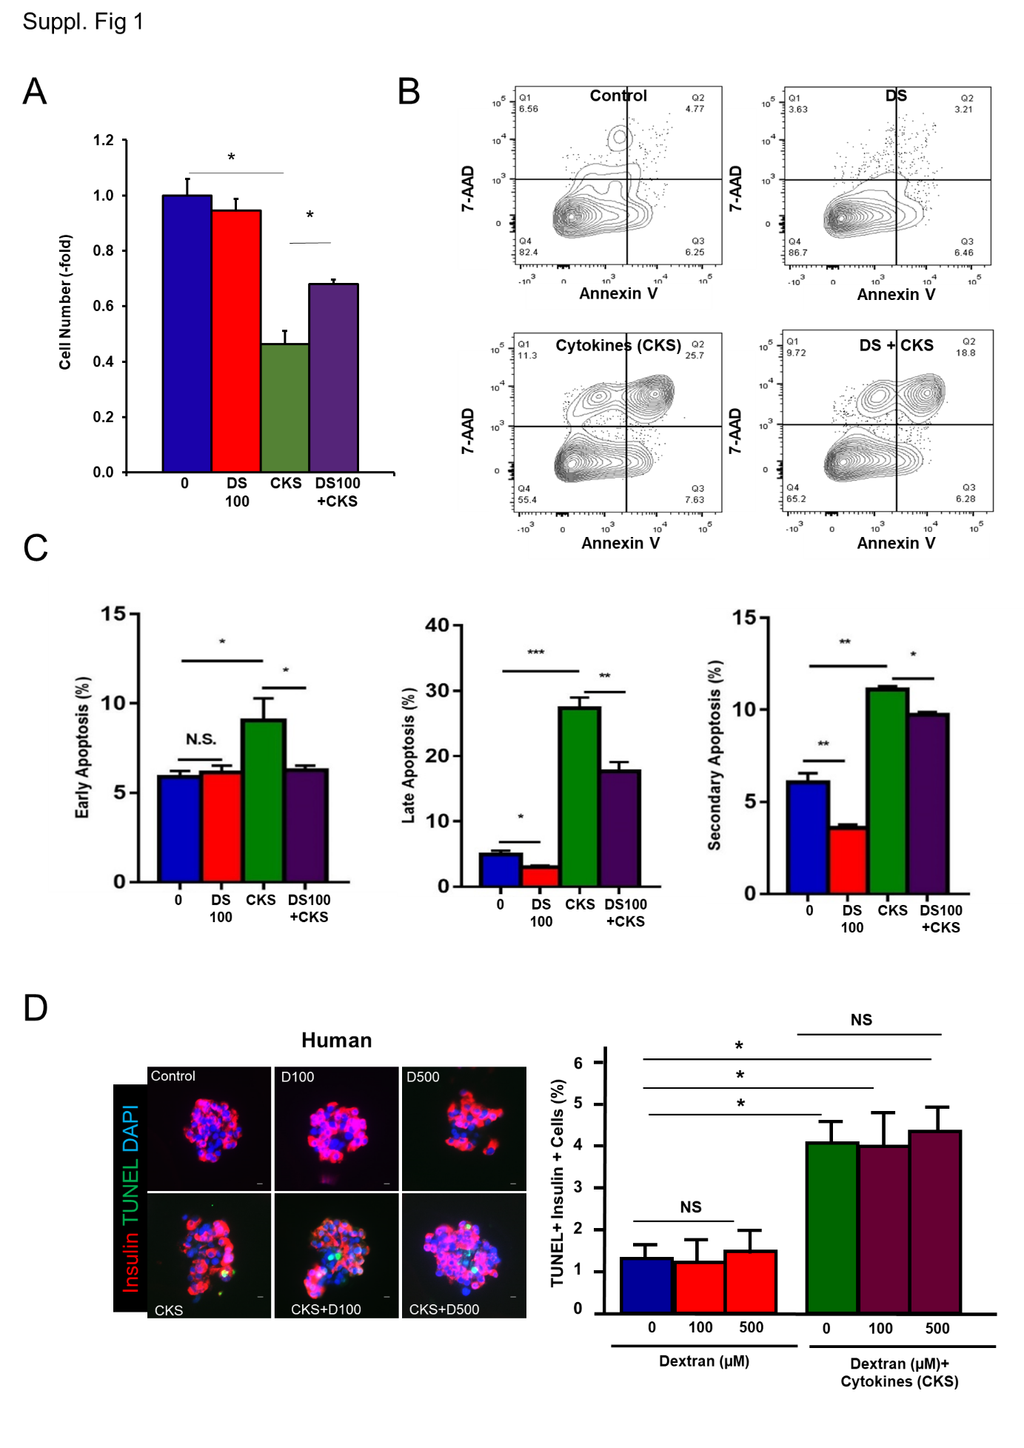
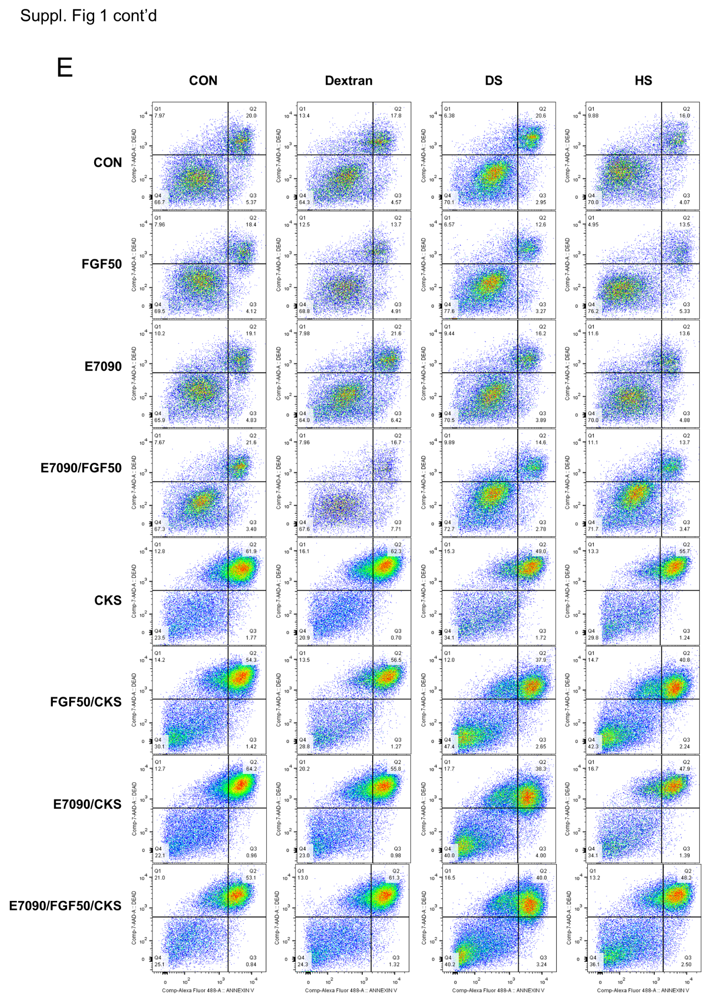
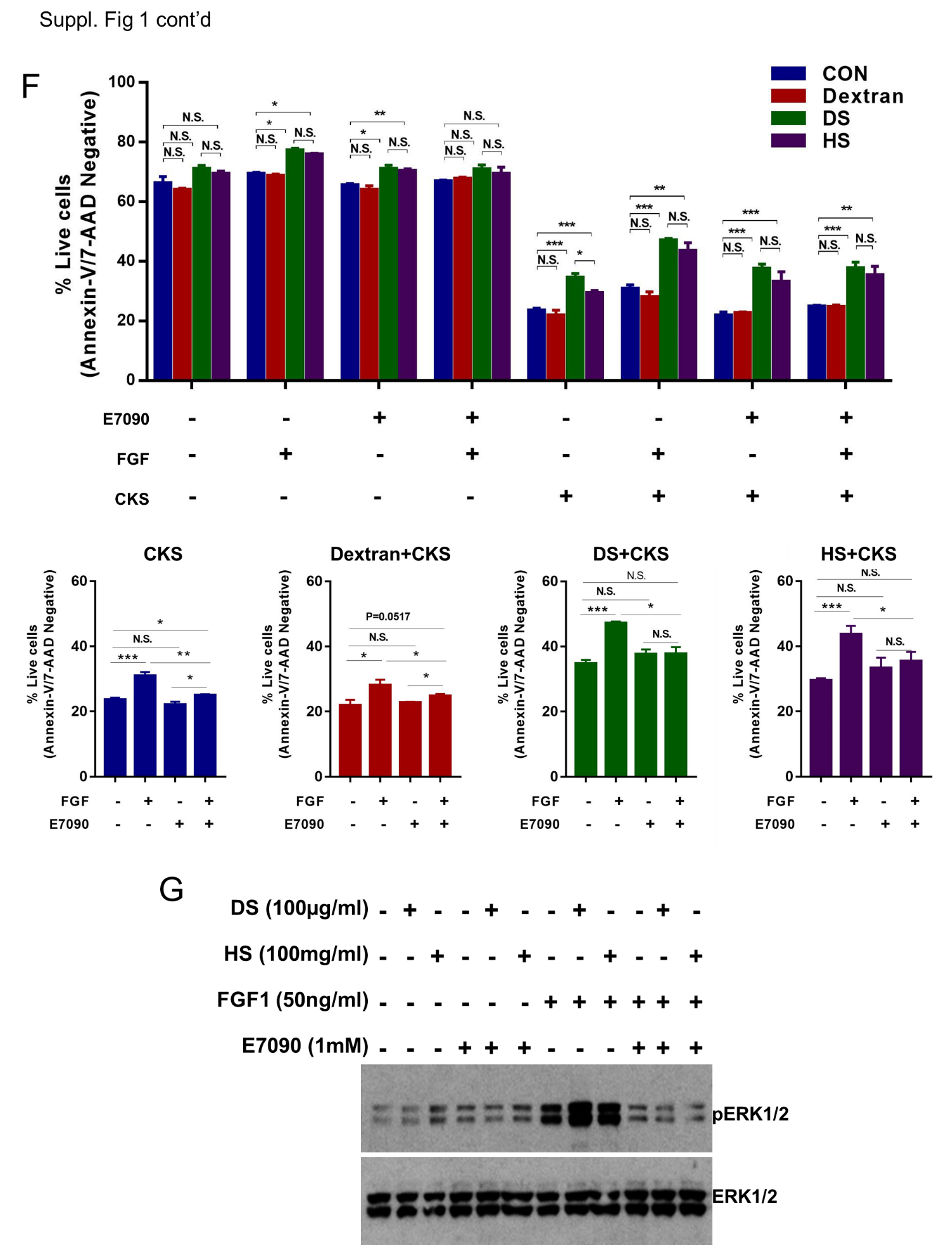
Supplementary Figure 1. Protective effect of DS on cytokine-induced INS-1 cell death. (A) Quantification of INS-1 cell number after treatment for 24h with cytokines (50 units/mL IL-1β, 500 units/mL TNFα, and 500 units/mL IFNγ) and/or 100µM DS. Values are means±SEM. *p<0.05. (B) Representative contour plots from flow cytometry analysis of INS-1 cells treated with cytokines and 100µM DS for 24h and stained for Annexin-V and 7-AAD. (C) Quantification of three experiments in triplicate depicting the number of cells in early (Q3) and late apoptosis (Q2) and secondary necrosis (Q1). Values are means±SEM. *p<0.05, **p<0.01, ***p<0.001 by one-way ANOVA with Tukey’s multiple comparison test. (D) Representative photomicrographs of human islet cells treated with cytokines and non-sulfated dextran for 24h and stained for DAPI (blue), insulin (red) and TUNEL (green). Scale bars represent 10µm. Quantification of TUNEL+ β-cells in human islet cells treated with 100 or 500µM dextran and/or cytokines (100 units/mL IL-1β, 1,000 units/mL TNFα, and 1,000 units/mL IFNγ) for 24h. Values are mean±SEM of one experiment out of two experiments with identical results performed in triplicate with two different human islet preparations. *p<0.05 and NS (not significantly different) by one-way ANOVA with Tukey’s multiple comparison test. (E) Representative contour plots from flow cytometry analysis of INS-1 cells treated for 48h with 1µM E7090 and then 24h with 100µg/ml DS, dextran or heparan sulfate (HS), and 50ng/ml FGF and stained for Annexin-V and 7-AAD. (F) Quantification of three experiments in triplicate as in (E) depicting the percentage of live cells of the total number of cells (Q4). Values separated per treatment (control, dextran, DS and HS) and cytokines are shown below for comparisons. Values are means±SEM. *p<0.05, **p<0.01, ***p<0.001 by one-way ANOVA with Tukey’s multiple comparison test. (G) Representative western blots for phospho-ERK1/2 and total ERK1/2 in INS-1 cells following treatment with 100µg/ml DS or heparan sulfate (HS), 50ng/ml FGF1 and 1µM E7090 (selective inhibitor of the tyrosine kinase activities of FGFR1, -2, and -3) for 30 min. Three experiments were performed with similar results.

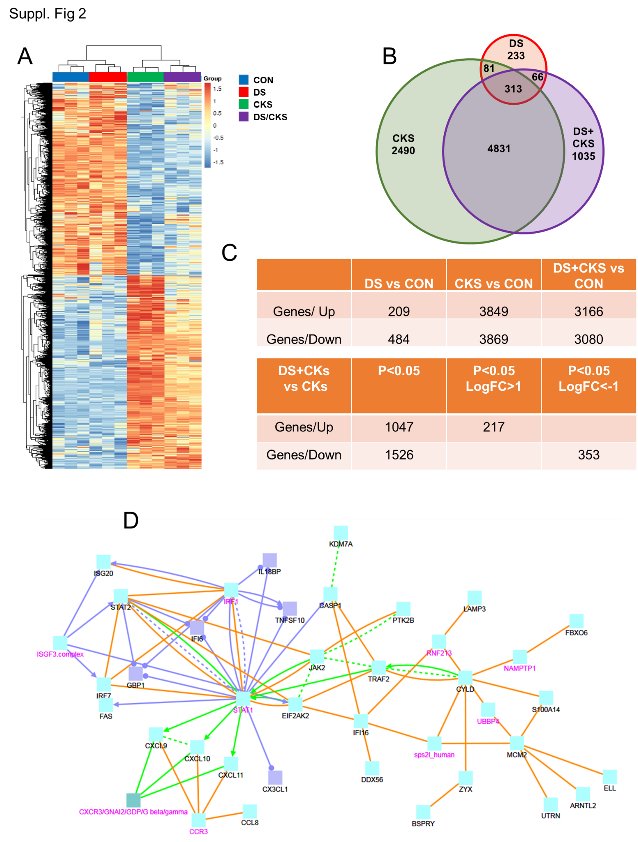
Supplementary Figure 2. DS effects on transcriptional regulation in human islets treated with cytokines. (A) Heat map of differentially expressed genes in human islets treated with vehicle (control), 100 µM DS, cytokines (100 units/mL IL-1β, 1,000 units/mL TNF-α, and 1,000 units/mL IFN-γ) or DS+cytokines for 24h. (B) Venn diagram illustrates unique and common genes differentially regulated in human islets treated as in A. (C) Table with the number of differentially expressed genes upregulated and downregulated in human islets from three different human islet preparations treated with cytokines and 100µM DS and cytokines. Upper table indicates the number of significant differentially expressed genes in DS, cytokines (CKS)- and DS+CKS-treated human islets compared with vehicle treated islets (CON). Lower table depicts significant differentially upregulated and downregulated genes in CKS vs DS+CKS-treated islets and of those, the number of genes that are significantly upregulated by more than two-fold and significantly downregulated by more than 50%. (D) Ingenuity network plot illustrating inflammation pathways that are altered in human islets treated with cytokines+DS compared with cytokines alone. Gene nodes are displayed and blue/purple symbolizes downregulation of the gene, while red represents upregulation of gene expression. The significance of up/down regulation is represented by color intensity. The more significant changed genes are marked in pink.

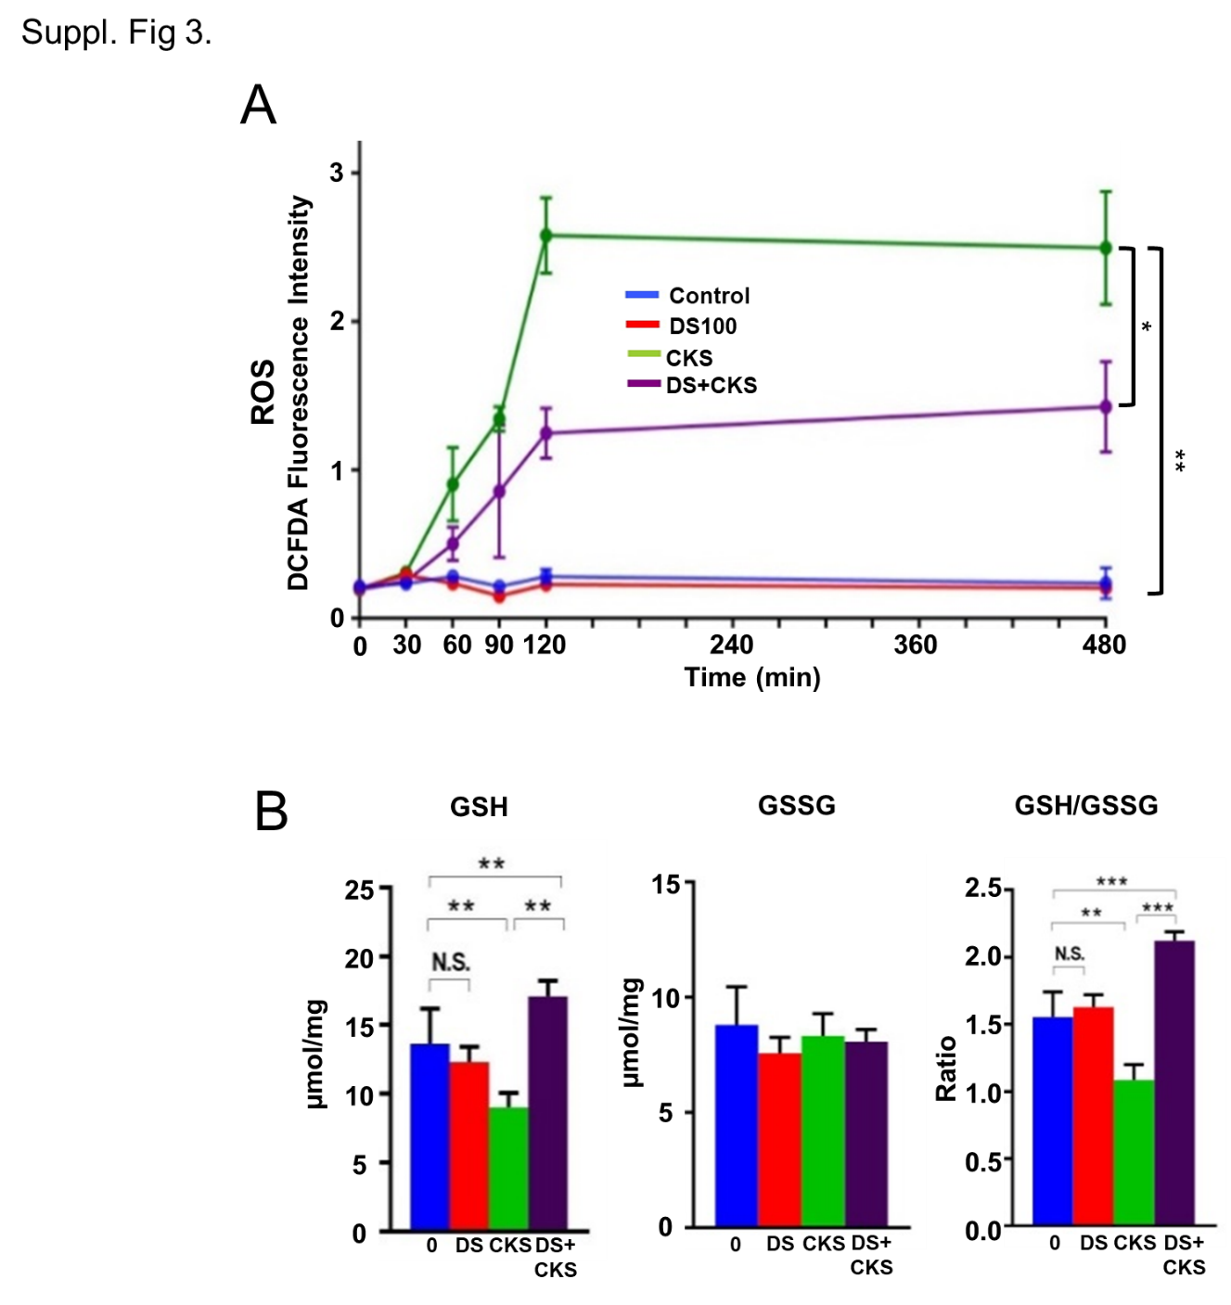
Supplementary Figure 3. DS decreases ROS levels and enhances GSH/GSSG ratios on cytokine-treated INS-1 cells. (A) Quantification of intracellular ROS levels in INS-1 cells measured at different time points after 24h treatment with cytokines and 100µM DS. Values are means±SEM of three different experiments in quintuplicate. *p<0.05, **p<0.01 by two-way ANOVA with Tukey’s multiple comparison test. (B) Quantification of GSH, GSSG and GSH/GSSG ratios in INS-1 cells treated with cytokines and 100µM DS. Values are means±SEM of three experiments in quintuplicate. **p<0.01, ***p<0.001 and NS (not significantly different) by one-way ANOVA with Tukey’s multiple comparison test.

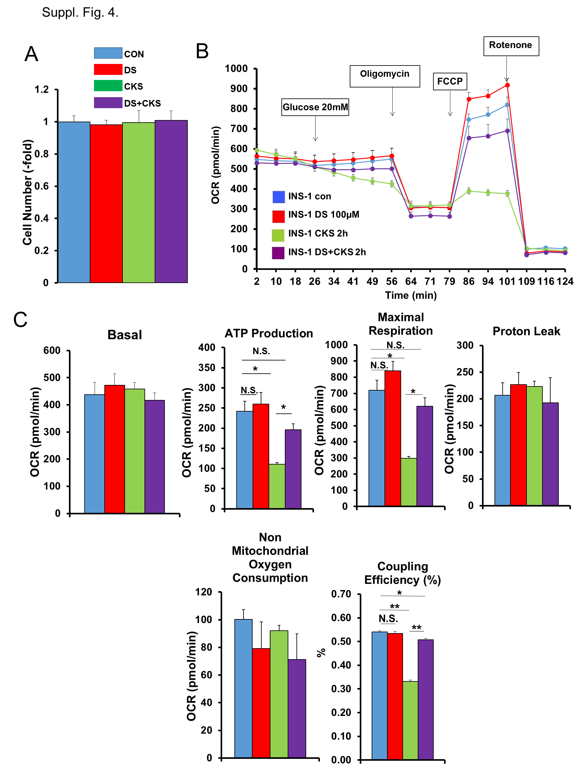
Supplementary Figure 4. DS improves mitochondrial bioenergetics in INS-1 cells treated with cytokines. (A) INS-1 cell number after treatment with 100µM DS and cytokines (50 units/mL IL-1β, 500 units/mL TNFα, and 500 units/mL IFNγ) for 2h. No differences were observed at this short time point. (B) Seahorse analysis of OXPHOS. Oxygen consumption rates (OCR) of INS-1 cells treated with 100µM DS and cytokines (50 units/mL IL-1β, 500 units/mL TNFα, and 500 units/mL IFNγ) for 2h were measured in real-time under basal conditions, glucose stimulation and in response to indicated mitochondrial inhibitors. Values are means±SEM of three different experiments in triplicate. (C) Average of basal OCR for the first 20 min and (D) analysis of mitochondrial functions (ATP production, maximal respiration, proton leak, non-mitochondrial oxygen consumption and coupling efficiency) were analyzed as indicated by the manufacturer. Mean±SEM of three different experiments in triplicate. *p<0.05, **p<0.01, ***p<0.001. and NS (not significantly different) by one-way ANOVA with Tukey’s multiple comparison test.

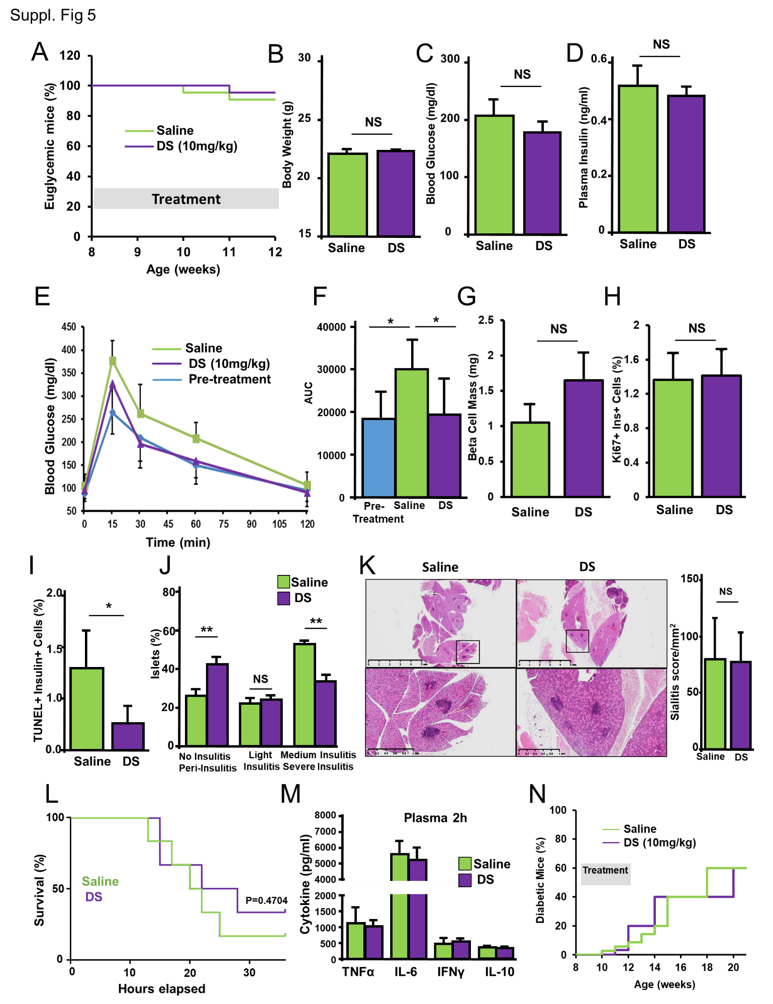
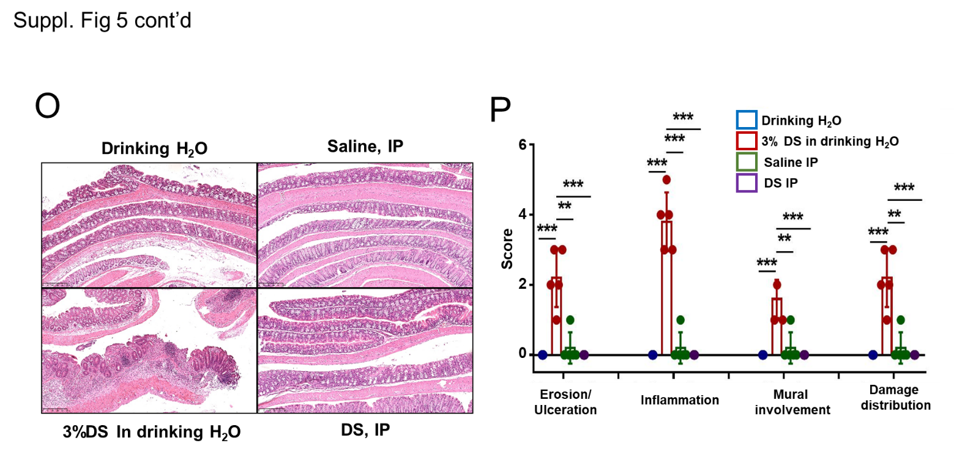
Supplementary Figure 5. DS treatment of pre-diabetic NOD female mice. (A) Percentage of euglycemic female NOD mice (blood glucose < 250mg/dl) daily treated with 10 mg/kg DS (n=10) or saline (n=10) ip for four weeks. (B) Body weight, (C) blood glucose, (D) plasma insulin, (E) intraperitoneal glucose tolerance test and (F) area under the curve calculated from the glucose tolerance tests in these mice before and after the four-week treatment. Values are means±SEM. *p<0.05 by one-way ANOVA with Tukey’s multiple comparison test. (G) ß-cell mass and (H) β-cell proliferation as %Ki67+ β-cells in the saline and DS-treated female NOD mice indicated in panel A. Values are means±SEM. (I) ß-cell death as TUNEL+ β-cells, and (J) islet infiltration levels (insulitis) in the saline- and DS-treated female NOD mice indicated in A. Values are means±SEM. *p<0.05 by two-tailed unpaired Student t test. (K) Representative images of submandibular salivary glands from female NOD mice treated daily ip with 10mg/kg DS or saline (n=4/group) for four weeks. These include higher magnification images (boxes) (lower). Quantification of the number of foci (areas with 50 or more infiltrated cells) per mm² of salivary gland tissue (sialitis score) in these mice is shown below. NS (not significantly different) by two-tailed unpaired Student t test and Mann-Whitney test. Scale bars represent 5 or 1mm. (L) DS (10mg/kg) daily ip treatment for four weeks does not significantly protect C57BL6N female mice from LPS-induced lethality (n=6/group) or (M) the increase in plasma levels of cytokines (n=3/group). Values are means±SEM. Survival and cytokine levels were statistically analyzed by Kaplan-Meier and two-tailed unpaired Student t test, respectively. (N) Percentage of diabetic female NOD mice (blood glucose > 250mg/dl) after four weeks of daily treatment with 10 mg/kg DS (n=10) or saline (n=10). Four weeks after DS or saline treatment, animals did not receive any other treatment and blood glucose levels were monitored weekly. (O) Representative images of colon from female NOD mice treated with 10mg/kg DS or saline daily ip for four weeks, untreated control mice (drinking water) and mice given 3% DS in the drinking water for seven days and stained for hematoxylin and eosin. Scale bars represent 250µm. (P) Histological grading of colitis and corresponding scores (in parenthesis) analyzing erosion/ulceration: 5–10% (1); 20–30% (2); 40–50% (3); 60–70 (4); 80–90(5); 100% (6); inflammation severity: minimal (1); mild (2);moderate (3); severe (4); very severe (5); mural involvement: mucosa (1); submucosa (2); tunica muscularis (3); serosa (transmural) (4); transmural reaching mesentery (steatitis) (5); and damage distribution: 25% (1); 26–50% (2); 51–75% (3);.75% (4). Values are means±SEM of n=5 mice per group. **p<0.01, ***p<0.001. and NS not significantly different by one-way ANOVA with Tukey’s multiple comparison test.
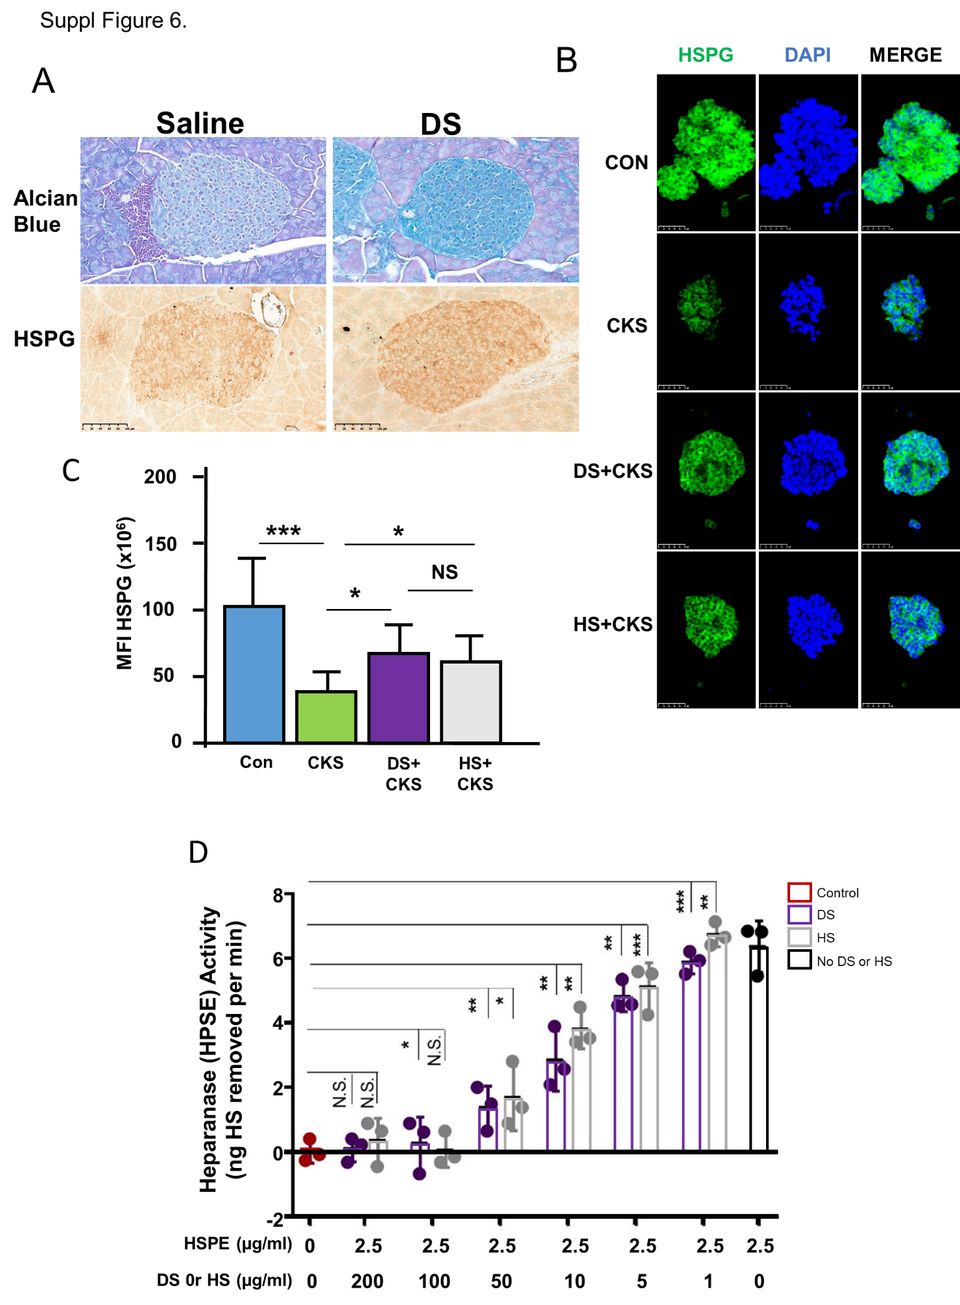
Supplementary Figure 6. Effect of DS on HS/HSPG expression in islets and heparanase activity. (A) Representative images depicting the detection of HS and HSPG in pancreatic islets of female NOD mice treated daily ip with 10mg/kg DS or saline for four weeks by in situ Alcian blue histochemistry and immunohistochemistry using anti-HSPG antibody. Scale bars represent 100µm. (B) Representative images depicting HSPG staining in human islets treated with 100 µM DS, cytokines (100 units/mL IL-1β, 1,000 units/mL TNF-α, and 1,000 units/mL IFN-γ) or DS+cytokines for 24h. Scale bars represent 50µm. (C) Quantification of 20 islets in three different human islet preparations from (B). Values are means±SEM. *p<0.05, ***p<0.001, and NS (not significantly different) by one-way ANOVA with Tukey’s multiple comparison test. (D) Heparanase activity measured in the presence of HS or DS and assessed with the heparanase assay kit from amsbio. Values are means±SEM. *p<0.05, **p<0.01, ***p<0.001, and NS (not significantly different) by two-way ANOVA with Bonferroni’s multiple comparisons test.

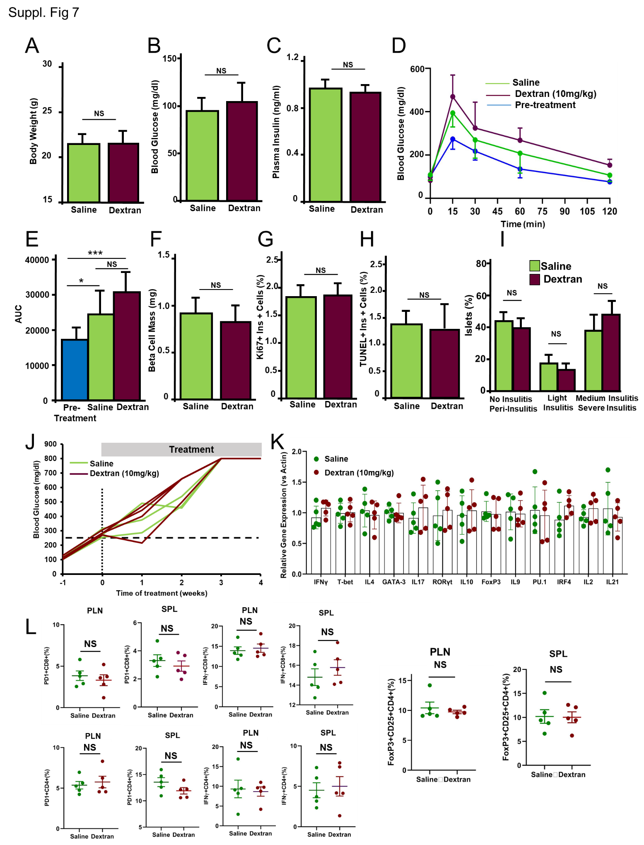
Supplementary Figure 7. Dextran treatment of pre-diabetic NOD female mice. Nine-week-old female NOD mice were treated daily ip with 10 mg/kg dextran (n=5) or saline (n=5) for four weeks. (A) Body weight, (B) blood glucose, (C) plasma insulin, (D) intraperitoneal glucose tolerance test and (E) area under the curve calculated from the glucose tolerance tests in these mice before and after treatment. Values are means±SEM. *p<0.05, ***p<0.001 and NS (not significantly different) by one-way ANOVA with Tukey’s multiple comparison test. (F) ß-cell mass and (G) β-cell proliferation as %Ki67+ β-cells, (H) ß-cell death as TUNEL+ β-cells, and (I) islet infiltration levels (insulitis) in the saline- and dextran-treated female NOD mice indicated above. Values are means±SEM. NS (not significantly different) by one-way ANOVA with Tukey’s multiple comparison test. (J) Individual weekly blood glucose levels of female diabetic NOD mice treated daily ip with 10 mg/kg dextran (n=4) or saline (n=3) with a blood glucose level at onset between 250-350 mg/dl. Initiation of treatment is marked with a vertical dotted line and blood glucose of 250mg/dl is marked with a horizontal dashed line. (K) mRNA expression by real time PCR of multiple genes involved in immune activation and regulation in spleen cells from pre-diabetic NOD mice treated daily ip for four weeks with saline (n=5) or 10 mg/kg dextran (n=5). (L) Flow cytometry analysis of the percentage of PD-1+CD4+, PD-1+CD8+, INFγ+CD4+, INFγ+CD8+ cells from single cell suspensions of the spleen (SPL) and pancreatic lymph nodes (PLN) from pre-diabetic NOD mice treated for four weeks with saline (n=5) or dextran (n=5) and stimulated in vitro with anti-CD3 and anti-CD28. Percentage of Foxp3+CD25+CD4+ cells in these immune compartments of saline or dextran-treated mice. Individual values and means±SEM are represented for every experimental group. NS (not significantly different) by one-way ANOVA with Tukey’s multiple comparison test.

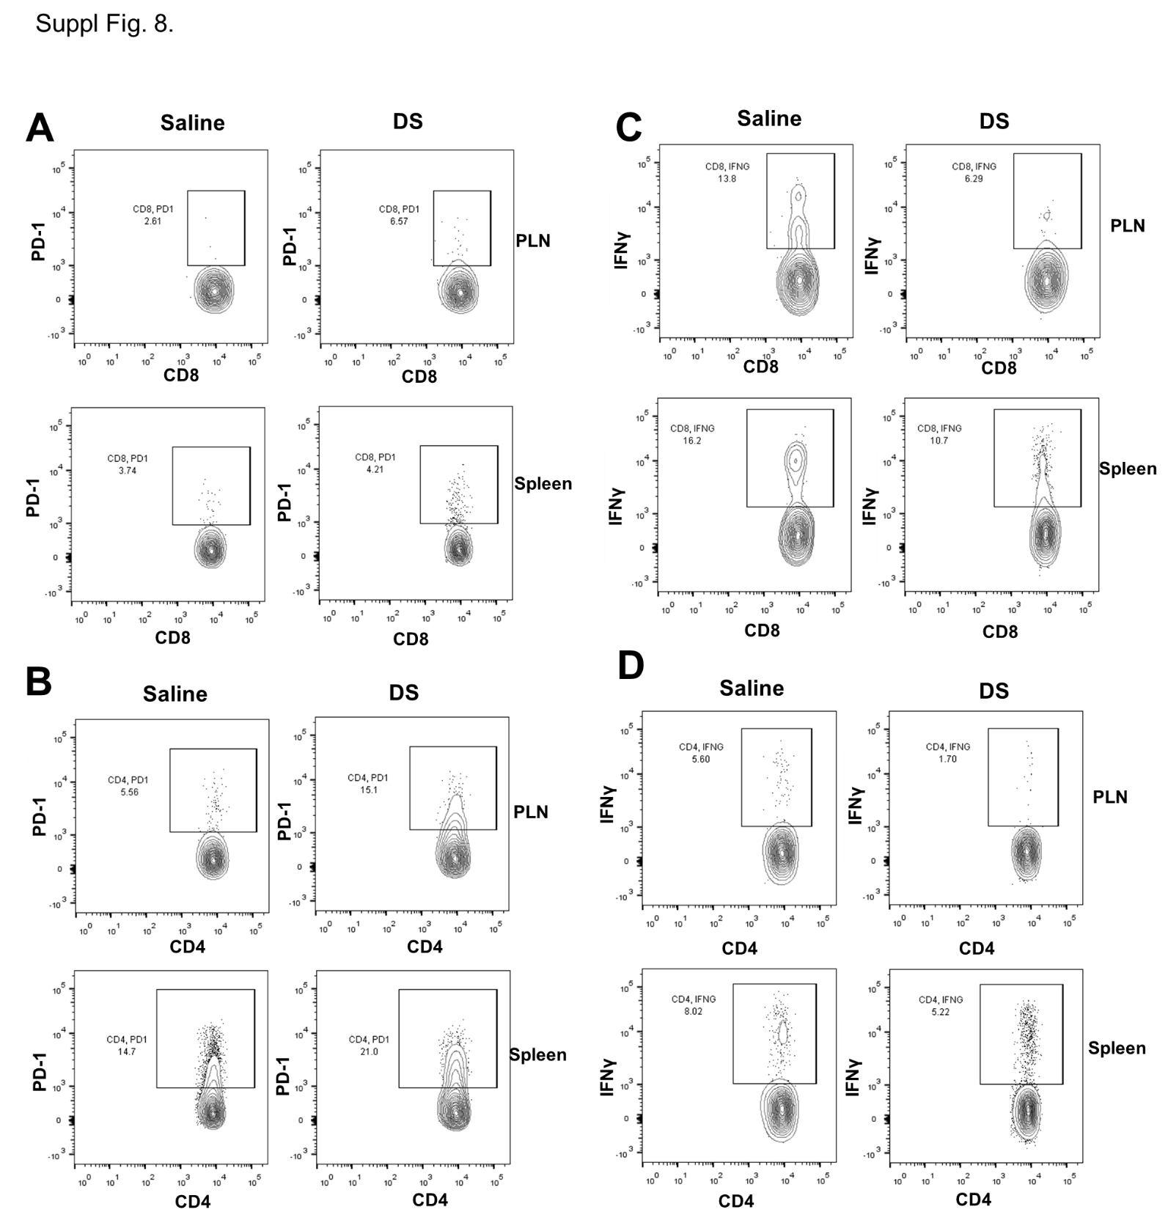
Supplementary Figure 8. Effect of DS in vivo treatment on the expression of IFNγ and PD-1 in CD4+ and CD8+ cells in NOD mice. Representative contour plots from flow cytometry analysis of cells from spleens (SPL) and pancreatic lymph nodes (PLN) of pre-diabetic NOD mice treated with 10mg/kg DS for 4 weeks. (A) PD-1 CD8+ cells, (B) PD-1 CD4+ cells, (C) IFNγ CD8+ cells and (D) IFNγ CD4+ cells. Quantification of several mice is depicted in Fig. 6.

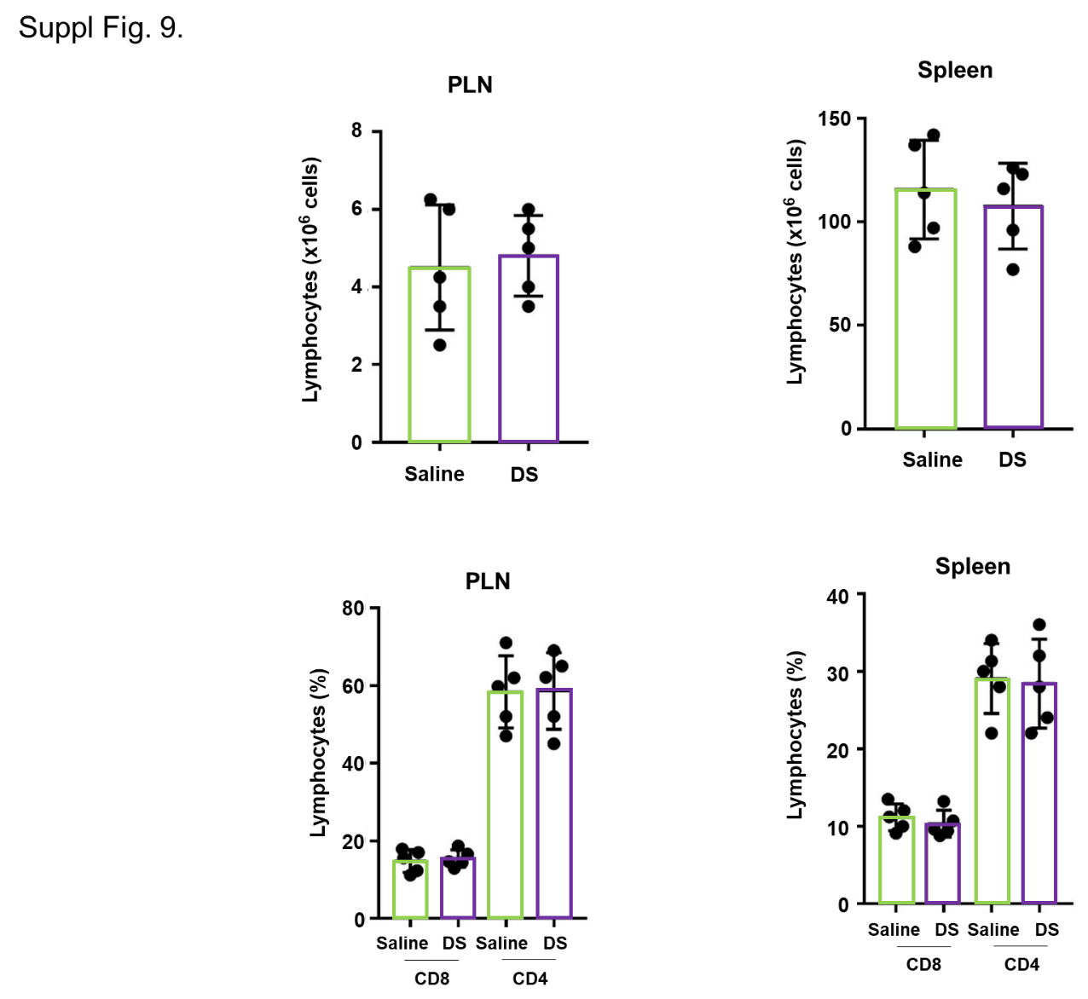
Supplementary Figure 9. DS treatment did not alter the numbers of total lymphocytes in spleen and pancreatic lymph nodes. Quantitation of total number of lymphocytes and CD4+ and CD8+ cell populations in spleen (SPL) and pancreatic lymph nodes (PLN) in NOD mice treated with saline or 10mg/kg DS for 4 weeks. Individual values and means±SEM are represented for every experimental group.

ADDITIONAL ONLINE SUPPLEMENTARY DATA:
Studies on salivary glands. Ten-week old NOD female mice (The Jackson Laboratory) were injected daily ip with saline or 10mg/kg DS for four weeks. At the end of the treatment, submandibular salivary glands were harvested, fixed in 10% neutral buffered formalin for 24h and stained with hematoxylin and eosin. Eight sequential sections of each gland, with 40µm intervals, were imaged at 10X objective in an EVOS M5000 microscope. Area of the submandibular salivary glands was calculated with Image J and the number of inflammatory foci (50 or more mononuclear cells per focal infiltration of salivary gland) per mm² of tissue (sialitis score) was calculated in mice treated with either saline or DS. The distribution of foci within the glands was heterogeneous so whole sections rather than a selected area unit were examined and data are expressed as the mean number of foci per mm2 of tissue (36).
Septic-shock studies. Ten-week old C57BL6N female mice (Charles River) were injected daily ip with saline or 10mg/kg DS for four weeks. At the end of the treatment, mice (n=3/group) were challenged with 10 µg/g body weight LPS ip and killed 2h after LPS challenge. Plasma levels of cytokines (TNFα, IL6, IL10 and IFNγ) were measured by ELISA (ThermoFisher). Another set of mice (n=6 per group) were followed for 36 hours after LPS challenge and survival was recorded (37).
Colitis studies. Ten-week old NOD female mice (The Jackson Laboratory) were injected daily ip with saline or 10mg/kg DS for four weeks (n=5/group). Another set of mice were given drinking water or 3%DS in the drinking water for 7 days (n=5/group). Intestines were harvested, fixed with 10% neutral-buffered formalin and stained for hematoxylin and eosin, and histological grading of colitis was performed (38).
Western blot analysis of FGF signaling. INS-1 cells were treated with 1µM E7090 for 48 hours, then incubated with 100µM DS or HS for 2 hours and finally stimulated with 50ng of FGF1 for 30 minutes. Cell protein extracts were analyzed by Western blotting with antibodies against pERK and ERK (Cell Signaling).
Alcian blue histochemistry and HSPG staining. For Alcian blue staining, pancreas from NOD mice were fixed in 10% neutral-buffered formalin, followed with paraffin embedding. Sections (5µm) were deparaffinized and hydrated, incubated in 3% acetic acid and then stained in Alcian Blue solution (ph 5.8) for 30 minutes and counterstained with 1% safranin for 30 seconds. For the HSPG staining, primary anti-HSPG antibody (Abcam) was detected with the Vectastain Elite ABC HRP and DAB kits (Vector) or FITC-conjugated streptavidin (Biolegend).
Heparanase Activity. For measurement of heparanase activity, the heparanase assay kit from amsbio (cat# Ra001-BE-K) was used. Briefly, 2.5µg/ml of heparanase was incubated with different doses of DS or HS (as indicated in the figure) for 2 hours at 4°C. Next, these mixtures were added to wells coated with biotinylated HS, and the plate was incubated at 37°C for 1 hour on a plate shaker. After addition of strep-HRP and peroxidase substrate, absorbance was read on a spectrophotometer (SpectraMaxM2e) at 650nm.
Supplementary Table 1. List of antibodies used for these studies.
Anti-insulin antibody (Dako, catalog #A0564)
Anti-Jak2 antibody (Cell Signaling, catalog #3230)
Anti-phospho-STAT1 antibody (Cell Signaling, catalog #9177)
Anti-phospho-SAPK/JNK antibody (Cell Signaling, catalog #9251)
Anti-phospho-p65 antibody (Cell Signaling, catalog #3031s)
Anti-phospho-p38 antibody (Cell Signaling, catalog #9211)
Anti-NOS2 antibody (Santa Cruz, C-11, catalog #sc-7271)
Anti-CHOP Mouse mAb (Invitrogen, catalog #MA1-250, clone 9C8)
Anti-α-Tubulin Mouse mAb (DM1A) (Millipore catalog #CP06)
Anti-CD8-FITC (ebioscience, catalog #53-0081-80, clone 53-6.7)
Anti-CD4-Pacific blue antibody (Biolegend, catalog #100428, clone GK1.5)
Anti-IFNγ PE antibody (eBioscience, catalog #12-7311-82, clone XMG1.2)
Anti-PD-1 APC antibody (Biolegend , catalog #135209, clone 29F.1A12)
Anti-CD25 PerCP-Cy5.5 antibody (Biolegend, catalog #101912, clone 3C7)
Anti-FoxP3 PE antibody (eBioscience, catalog #12-5773-80, clone FJK-16s)
Anti-Phospho-STAT1 Alexa Fluor 488 antibody (Biolegend cat#686409, clone A15158B)
Anti-CD3 antibody (Abcam, catalog #ab5690)
Anti-CD45 (B220) Mouse mAb (eBioscience, catalog #14-0451-82, clone 30-F11)
Anti-mouse PD-L1 mAb (BioXCell, catalog #BE0101, clone 10F.9G2, rat IgG2b)
Anti-C-Peptide Alexa Fluor® 647 (BD Pharmingen, catalog #565831, clone U8-424)
Ultra-LEAF™ Purified anti-mouse CD3 Antibody (Biolegend, cat# 100238, clone 17A2)
Ultra-LEAF™ Purified anti-mouse CD28 Antibody (Biolegend, cat# 102115, clone 37.51)
Anti-phERK1/2 antibody (Cell Signaling, cat# 4376)
Anti-ERK1/2 antibody (Cell Signaling, cat# 9102)
Anti-Syndecan 2/HSPG antibody (Abcam, cat#ab205884)

Supplementary Table 2. Human islet preparations used in these studies.
Checklist for Reporting Human Islet Preparations Used in Research
 | Adapted from Hart NJ, Powers AC (2018) Progress, challenges, and suggestions for using human islets to understand islet biology and human diabetes. Diabetologia https://doi.org/10.1007/s00125-018-4772-2.
Manuscript DOI: https://doi.org/10.2337/[insert manuscript submission number] (Example, https://doi.org/10.2337/db18-1234)
Title: Dextran Sulfate Protects Pancreatic Beta Cells, Reduces Autoimmunity and Ameliorates Type 1 Diabetes
Author list: Geming Lu, Francisco Rausell-Palamos, Jiamin Zhang, Zihan Zheng, Tuo Zhang, Shelley Valle, Carolina Rosselot, Cecilia Berrouet, Patricia Conde, Matthew P. Spindler, John G. Graham, Dirk Homann, Adolfo Garcia-Ocaña
Corresponding author:  Adolfo Garcia-Ocana | Email address: adolfo.garcia-ocana@mssm.edu
Islet preparation | 1 | 2 | 3 | 4 | 5 | 6 | 7 | 8 | 9 | 10
 | MANDATORY INFORMATION
Unique identifier | HP-17188 | HP-17348 | HP-17281 | HP-17250 | HP-17245 | HP-17263 | HP-17321 | HP-17292 | HP-20003 | HP-20030
Donor age (years) | 56 | 53 | 55 | 32 | 41 | 33 | 25 | 56 | 42 | 67
Donor sex (M/F) | F | M | M | M | F | M | M | M | M | M
Donor BMI (kg/m²) | 22.0 | 26 | 30 | 26.2 | 18.3 | 30.8 | 25.6 | 13.7 | 37.3 | 22.5
Donor HbA_{1c} or other measure of blood glucose control | 5.30% | 5.30% | 5.60% | 4.90% | 5.50% | 5.70% | 5.70% | 5% | 5.6% | 5.5%
Origin/source of islets^{b} | PRODO | PRODO | PRODO | PRODO | PRODO | PRODO | PRODO | PRODO | PRODO | PRODO
Islet isolation center | PRODO, Aliso Viejo, CA | PRODO, Aliso Viejo, CA | PRODO, Aliso Viejo, CA | PRODO, Aliso Viejo, CA | PRODO, Aliso Viejo, CA | PRODO, Aliso Viejo, CA | PRODO, Aliso Viejo, CA | PRODO, Aliso Viejo, CA | PRODO, Aliso Viejo, CA | PRODO, Aliso Viejo, CA
Donor history of diabetes? Yes/No | NO | NO | NO | NO | NO | NO | NO | NO | NO | NO
 | If Yes, complete the next two lines if this information is available
Diabetes duration (years)
Glucose-lowering therapy at time of death^{c}
 | RECOMMENDED INFORMATION
Donor cause of death | Stroke | Head trauma | Head trauma | Head trauma | Stroke | Head trauma | Head trauma | Stroke | Stroke | Stroke
Warm ischaemia time (h) | unk. | unk. | unk. | unk. | unk. | unk. | unk. | unk. | unk. | unk.
Cold ischaemia time (h) | unk. | unk. | unk. | unk. | unk. | unk. | unk. | unk. | unk. | unk.
Estimated purity (%) | 90% | 90% | 90% | 90% | 90% | 90% | 90% | 90% | 90% | 90%
Estimated viability (%) | 95% | 95% | 95% | 95% | 95% | 95% | 95% | 95% | 95% | 95%
Total culture time (h)^{d} | 120h | 120h | 120h | 120h | 120h | 120h | 120h | 120h | 120h | 120h
Glucose-stimulated insulin secretion or other functional measurement^{e} | GSIS insulin secretion index 4.27 |  |  | GSIS insulin secretion index 3.39 | GSIS insulin secretion index 3.76
Handpicked to purity? Yes/No | Yes | Yes | Yes | Yes | Yes | Yes | Yes | Yes | Yes | Yes
Additional notes
ªIf you have used more than eight islet preparations, please complete additional forms as necessary
^{b}For example, IIDP, ECIT, Alberta IsletCore
^{c}Please specify the therapy/therapies
^{d}Time of islet culture at the isolation center, during shipment and at the receiving laboratory
^{e}Please specify the test and the results
unk. = unknown

Supplementary Table 3. Primer sequences for the real time PCR studies.
Gene name | Forward primer sequence | Reverse primer sequence
mouse IFN-γ | TTCTTCAGCAACAGCAAGGC | TCAGCAGCGACTCCTTTTCC
mouse T-bet | TTCCCATTCCTGTCCTTCAC | CCACATCCACAAACATCCTG
mouse IL4 | AACGAGGTCACAGGAGAAGG | TCTGCAGCTCCATGAGAACA
mouse GATA-3 | GGAAACTCCGTCAGGGCTA | AGAGATCCGTGCAGCAGAG
mouse IL17 | TCTCCACCGCAATGAAGACC | CACACCCACCAGCATCTTCT
mouse RORgt | TGAGGCCATTCAGTATGTGG | CTTCCATTGCTCCTGCTTTC
mouse IL10 | ATAACTGCACCCACTTCCCA | GGGCATCACTTCTACCAGGT
mouse Foxp3 | CCTGCCTTGGTACATTCGTG | TGTTGTGGGTGAGTGCTTTG
mouse IL9 | CATCAGTGTCTCTCCGTCCCAACTGATG | GATTTCTGTGTGG CATTGGTCAG
mouse Pu.1 | CACGTCAGAGGCAACGCTAA | ACCATTTGTTACACCTCTCCAGTCA
mouse IRF4 | AGTCCCTTATTCTTTCACTTCATTTCCTTCC | GGAAGGAAATGAAGTGAAAGAATAAGGGACT
mouse IL2 | TTGTGCTCCTTGTCAACAGC | CTGGGGAGTTTCAGGTTCCT
mouse IL21 | CGCCTCCTGATTAGACTTCG | GCCCCTTTACATCTTGTGGA
mouse IL-1b | GCACTACAGGCTCCGAGATGAAC | TTGTCGTTGCTTGGTTCTCCTTGT
mouse TNF-a | GCCACCACGCTCTTCTGTCT | GGTCTGGGCCATAGAACTGATG
mouse CXCL9 | TGCACGATGCTCCTGCA | AGGTCTTTGAGGGATTTGTAGTGG
mouse CXCL10 | GACGGTCCGCTGCAACTG | GCTTCCCTATGGCCCTCATT
mouse Ubiquitin | TGGCTATTAATTATTCGGTCTGCAT | CCGAAGCAAACATCACATTCA
human PDX1 | ACCAAAGCTCACGCGTGGAAA | TGATGTGTCTCTCGGTCAAGTT
human MafA | GAGTCACAGCATGAGTCGCT | GGCTTCGACCTCCAAGGAAC
human PAX6 | GGTTGGTATCCGGGGACTTC | TCCGTTGGAACTGATGGAGT
human Cyclophilin | TACGGGTCCTGGCATCTTGT | CCATTTGTGTTGGGTCCAGC

