Online Supplemental Material

Table of Contents
The International Diabetes Closed Loop (iDCL) Trial Study Group (site investigators noted): 2
Supplemental Figure S1. Enrollment, Randomization, Treatment Received, Follow Up 4
Supplemental Figure S2. TIR Scatterplot of last 13 weeks of Preceding RCT vs. 13 weeks of Randomized by Treatment Group 5
Supplemental Figure S3. TIR Scatterplot of last 13 weeks of Preceding RCT vs. 13 weeks of Randomized by Treatment Group – Excluding Periods of Study-wide Suspension of Device Use 6
Supplemental Table S1A: CGM-Measured Outcomes during Daytime (6am-12mn) 7
Supplemental Table S1B: CGM-Measured Outcomes during Nighttime (12mn – 6am) 9
Supplemental Table S2: Subgroup Analysis for Outcomes of CGM-Measured Percent Time in Range 70-180 mg/dL 11
Supplemental Table S3: HbA1c Results 13
Supplemental Table S4: Insulin, Weight, and Body Mass Index 14
Supplemental Table S5: Safety Outcomes 15

The International Diabetes Closed Loop (iDCL) Trial Study Group (site investigators noted):

University of Virginia, Center for Diabetes Technology, Charlottesville, VA: Sue Brown (PI), Boris Kovatchev (Grant PI), Stacey Anderson (PI), Emma Emory, Mary Voelmle, Katie Conshafter, Kim Morris, Mary Oliveri, Linda Gondor-Fredrick, Harry Mitchell, Kayla Calvo, Christian Wakeman, Marc Breton
Joslin Diabetes Center, Harvard Medical School, Boston, MA: Lori Laffel (PI), Elvira Isganaitis (I), Louise Ambler-Osborn (I), Emily Flint, Kenny Kim, Lindsay Roethke
Sansum Diabetes Research Institute, Santa Barbara, CA: Jordan Pinsker (PI), Mei Mei Church (I), Camille Andre, Molly Piper
Division of Endocrinology, Diabetes, Icahn School of Medicine at Mount Sinai, New York City, NY: Carol Levy (PI), David Lam (I), Grenye O’Malley (I), Camilla Levister (I), Selassie Ogyaadu, Jessica Lovett
Division of Endocrinology, Diabetes, Metabolism, and Nutrition, Department of Internal Medicine, Mayo Clinic, Rochester MN: Yogish C. Kudva (PI), Vinaya Simha (I), Vikash Dadlani, Shelly McCrady-Spitzer, Corey Reid, Kanchan Kumari
Barbara Davis Center for Diabetes, University of Colorado, Anschutz Medical Campus, Aurora, CO: R. Paul Wadwa (PI), Greg Forlenza (I), G. Todd Alonso (I), Robert Slover (I), Emily Jost, Laurel Messer, Cari Berget, Lindsey Towers, Alex Rossick-Solis
Department of Pediatrics, Division of Pediatric Endocrinology and Diabetes, Stanford University School of Medicine: Bruce Buckingham (PI), Laya Ekhlaspour (I), Tali Jacobson, Marissa Town, Ideen Tabatabai, Jordan Keller, Evalina Salas
John A. Paulson School of Engineering and Applied Sciences, Harvard University, Cambridge, MA: Francis Doyle III, Eyal Dassau
Jaeb Center for Health Research: John Lum, Roy Beck, Samantha Passman, Tiffany Campos, Dan Raghinaru, Craig Kollman, Carlos Murphy, Nandan Patibandla, Sarah Borgman
National Institute of Diabetes, Digestive, and Kidney Diseases (NIDDK): Guillermo Arreza-Rubin (Project Scientist), Thomas Eggerman (Program Officer), Neal Green
iDCL Steering Committee Members: Boris Kovatchev, Sue Brown, Stacey Anderson, Marc Breton, Lori Laffel, Jordan Pinsker, Carol Levy, Yogish C. Kudva, R. Paul Wadwa, Bruce Buckingham, Francis Doyle III, Eric Renard, Claudio Cobelli, Yves Reznik, Guillermo Arreza-Rubin, John Lum, Roy Beck

Central Laboratory - University of Minnesota Advanced Research and Diagnostic Laboratory: Robert Janicek, Deanna Gabrielson
Data Safety Monitoring Board (DSMB): Steven H. Belle (Chair), Jessica Castle; Jennifer Green, Laurent Legault, Steven M. Willi, Carol Wysham, Thomas Eggerman (DSMB Executive Secretary for NIDDK)

Supplemental Figure S1. Enrollment, Randomization, Treatment Received, Follow Up
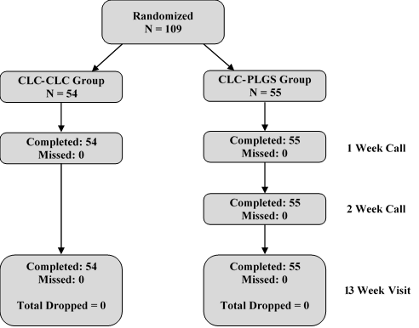

Supplemental Figure S2. TIR Scatterplot of last 13 weeks of Preceding RCT vs. 13 weeks of Randomized by Treatment Group
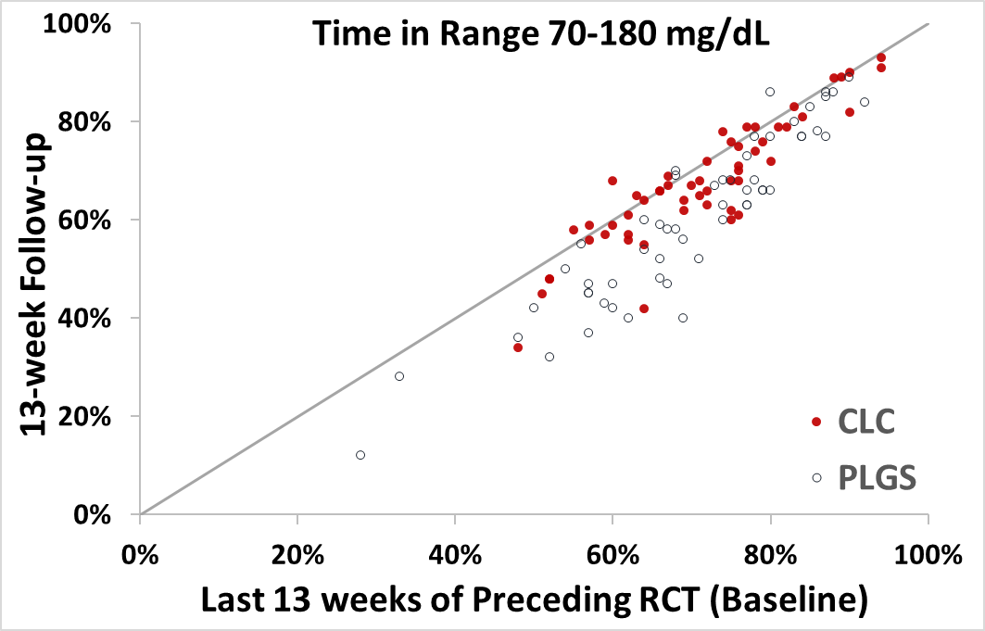

Supplemental Figure S3. TIR Scatterplot of last 13 weeks of Preceding RCT vs. 13 weeks of Randomized by Treatment Group – Excluding Periods of Study-wide Suspension of Device Use
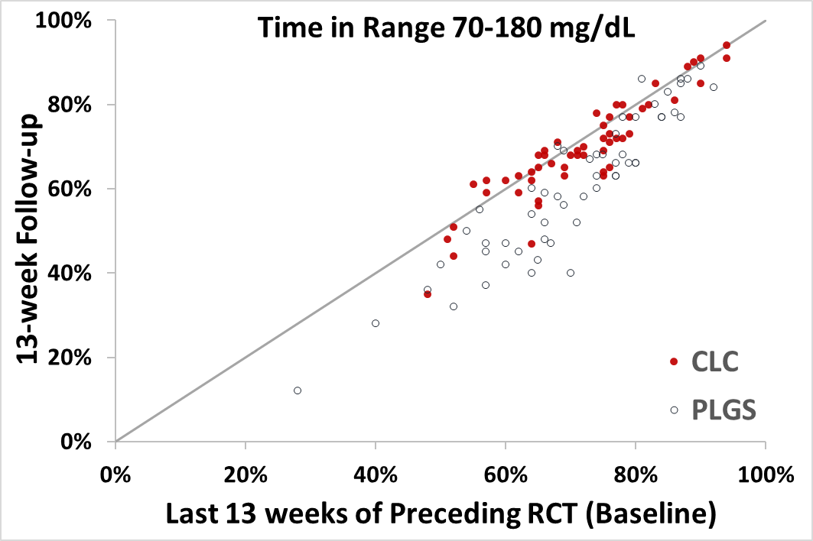

Supplemental Table S1A: CGM-Measured Outcomes during Daytime (6am-12mn)
 | Baseline  (Last 13 weeks of Preceding RCT) |  | 13-week Follow-up
 | CLC  N=54 | PLGS  N=55 | CLC  N=54 | PLGS  N=55 | Risk-Adjusted  Difference  (95% CI) | P-value
Hours of Sensor Data  median (IQR) | 1592 (1555, 1603) | 1574 (1538, 1595) | 1538 (1472, 1618) | 1515 (1457, 1579) | NA | NA
Overall Control
% in Target 70-180 mg/dL mean ± SD | 69.5% ± 12.2% | 68.5% ± 13.8% | 66.5% ± 13.5% | 60.8% ± 17.3% | +4.7% (+2.4%, +6.9%) | <0.001
% in Target 70-140 mg/dL mean ± SD | 43.4% ± 12.9% | 43.2% ± 12.5% | 41.3% ± 13.5% | 37.1% ± 14.4% | +3.9% (+1.7%, +6.2%) | 0.0062
Mean Glucose mg/dL  mean ± SD | 158 ± 19 | 160 ± 24 | 162 ± 22 | 170 ± 30 | -6 (-10, -2) | 0.0022
Standard Deviation mg/dL  mean ± SD | 53 ± 11 | 55 ± 13 | 55 ± 12 | 60 ± 15 | -2 (-4, 0) | 0.03
Coefficient of Variation  mean ± SD | 33% ± 4% | 34% ± 5% | 34% ± 5% | 35% ± 5% | 0 (0, 0) | 0.62
Hypoglycemia
% Below 54 mg/dL  median (IQR) | 0.14% (0.04%, 0.30%) | 0.21% (0.05%, 0.42%) | 0.18% (0.05%, 0.39%) | 0.18% (0.07%, 0.46%) |  | 0.73
mean ± SD | 0.19% ± 0.18% | 0.30% ± 0.38% | 0.26% ± 0.24% | 0.31% ± 0.33% | +0.01% (-0.07%, +0.09%)
% Below 60 mg/dL  median (IQR)  mean ± SD | 0.35% (0.17%, 0.66%)  0.45% ± 0.37% | 0.44% (0.13%, 0.90%)  0.60% ± 0.66% | 0.42% (0.17%, 0.92%)  0.59% ± 0.51% | 0.42% (0.16%, 1.02%)  0.65% ± 0.59% | +0.06% (-0.07%, +0.2%) | 0.36
% Below 70 mg/dL  median (IQR)  mean ± SD | 1.16% (0.76%, 1.83%)  1.39% 0.97% | 1.41% (0.67%, 2.40%)  1.63% ± 1.31% | 1.41% (0.57%, 2.69%)  1.78% ± 1.36% | 1.57% (0.67%, 2.73%)  1.84% ± 1.40% | +0.17% (-0.13%, +0.47%) | 0.26
Low Blood Glucose Index  median (IQR) | 0.41 (0.29, 0.60) | 0.44 (0.29, 0.70) | 0.47 (0.25, 0.80) | 0.49 (0.32, 0.92) | 0 (-0.07, +0.07) | 0.99
mean ± SD | 0.46 ± 0.27 | 0.51 ± 0.31 | 0.54 ± 0.34 | 0.59 ± 0.36
Hypoglycemic Event Rate per Week*  median (IQR) | 2.9 (1.7, 4.2) | 3.2 (1.4, 5.1) | 2.9 (1.4, 5.5) | 3.6 (1.8, 5.2) | +0.2 (-0.3, +0.7) | 0.49
mean ± SD | 3.2 ± 2.1 | 3.6 ± 2.7 | 3.7 ± 2.5 | 3.9 ± 2.8
Hyperglycemia
% Above 180 mg/dL  median (IQR) | 29% (22%, 38%) | 29% (18%, 38%) | 33% (21%, 40%) | 37% (23%, 51%) | -5% (-7%, -3%) | <0.001
mean ± SD | 29% ± 12% | 30% ± 14% | 32% ± 14% | 37% ± 18%
% Above 250 mg/dL  median (IQR)  mean ± SD | 5.4% (2.6%, 9.9%)  7.3% ± 6.1% | 5.5% (2.6%, 10.7%)  8.7% ± 9.6% | 7.4% (3.1%, 11.9%)  8.8% ± 7.8% | 9.2% (3.7%, 16.2%)  12.6% ± 12.5% | -2.0% (-3.4%, -0.5%) | 0.01
% Above 300 mg/dL  median (IQR) | 1.3% (0.4%, 3.3%) | 1.3% (0.5%, 3.6%) | 1.7% (0.4%, 3.7%) | 1.9% (0.7%, 5.9%) | -0.7% (-1.7%, +0.2) | 0.14
mean ± SD | 2.3% ± 2.6% | 3.3% ± 5.4% | 3.0% ± 3.9% | 5.1% ± 7.5%
High Blood Glucose Index  median (IQR) | 6.4 (4.6, 8.3) | 6.1 (4.1, 8.4) | 7.3 (4.7, 9.0) | 7.4 (5.1, 11.3) | -1.1 (-1.7, -0.4) | 0.001
mean ± SD | 6.6 ± 2.9 | 7.1 ± 4.2 | 7.2 ± 3.6 | 8.9 ± 5.4
*At least 15 consecutive minutes <70 mg/dL

Supplemental Table S1B: CGM-Measured Outcomes during Nighttime (12mn – 6am)
 | Baseline  (Last 13 weeks of Preceding RCT) |  | 13-week Follow-up
 | CLC  N=54 | PLGS  N=55 | CLC  N=54 | PLGS  N=55 | Risk-Adjusted  Difference  (95% CI) | P-value
Hours of Sensor Data  median (IQR) | 534 (524, 540) | 536 (524, 542) | 512 (495, 544) | 514 (486, 532) | NA | NA
Overall Control
% in Target 70-180 mg/dL mean ± SD | 76.0% ± 11.6% | 74.4% ± 15.5% | 70.8% ± 12.4% | 59.3% ± 18.6% | +10.1% (+6.5%, +13.6%) | <0.001
% in Target 70-140 mg/dL mean ± SD | 49.6% ± 12.4% | 49.5% ± 16.5% | 44.1% ± 12.5% | 37.1% ± 16.2% | +7.1% (+3.7%, +10.5%) | <0.001
Mean Glucose mg/dL  mean ± SD | 151 ±17 | 153 ± 23 | 157 ± 19 | 171 ± 31 | -12 (-17, -7) | <0.001
Standard Deviation mg/dL  mean ± SD | 47 ± 12 | 50 ± 15 | 52 ± 12 | 60 ± 15 | -6 (-9, -3) | <0.001
Coefficient of Variation  mean ± SD | 31% ± 6% | 32% ± 6% | 33% ± 5% | 35% ± 6% | -2% (-3%, 0%) | 0.06
Hypoglycemia
% Below 54 mg/dL  median (IQR) | 0.15% (0.03%, 0.33%) | 0.17% (0.02%, 0.38%) | 0.19% (0.05%, 0.53%) | 0.21% (0.03%, 0.51%) |  | 0.22
mean ± SD | 0.25% ± 0.30% | 0.30% ± 0.41% | 0.37% ± 0.57% | 0.29% ± 0.33% | +0.10% (-0.06%, +0.27%)
% Below 60 mg/dL  median (IQR)  mean ± SD | 0.29% (0.12%, 0.57%)  0.45% ± 0.47% | 0.33% (0.08%, 0.79%)  0.57% ± 0.69% | 0.39% (0.12%, 0.88%)  0.68% ± 0.97% | 0.38% (0.18%, 0.91%)  0.62% ± 0.64% | +0.12% (-0.16%, +0.41%) | 0.39
% Below 70 mg/dL  median (IQR)  mean ± SD | 0.94% (0.44%, 1.74%)  1.22% ± 0.97% | 1.02% (0.39%, 2.19%)  1.39% ± 1.37% | 1.28% (0.56%, 2.42%)  1.67% ± 1.62% | 1.38% (0.48%, 2.77%)  1.83% ± 1.73% | -0.02% (-0.56%, +0.51%) | 0.93
Low Blood Glucose Index  median (IQR) | 0.35 (0.22, 0.58) | 0.37 (0.25, 0.66) | 0.42 (0.22, 0.70) | 0.47 (0.27, 0.89) |  | 0.51
mean ± SD | 0.42 ±0.29 | 0.47 ± 0.33 | 0.52 ± 0.40 | 0.60 ± 0.46 | -0.05 (-0.17, +0.09)
Hypoglycemic Event Rate per Week*  median (IQR) | 1.6 (0.9, 3.1) | 2.0 (0.6, 3.8) | 2.3 (1.1, 4.3) | 2.5 (1.2, 4.6) |  | 0.47
mean ± SD | 2.2 ± 1.6 | 2.4 ± 2.1 | 2.6 ± 1.7 | 3.0 ± 2.3 | -0.2 (-0.8, +0.4)
Hyperglycemia
% Above 180 mg/dL  median (IQR) | 22% (15%, 29%) | 20% (11%, 36%) | 27% (20%, 33%) | 38% (23%, 54%) | -10% (-14%, -6%) | <0.001
mean ± SD | 23% ± 12% | 24% ± 16% | 28% ± 13% | 39% ± 19%
% Above 250 mg/dL  median (IQR)  mean ± SD | 3.1% (1.3%, 6.8%)  5.0% ± 5.4% | 3.1% (1.2%, 9.6%)  6.8% ± 7.8% | 5.7% (2.2%, 8.9%)  7.0% ± 6.5% | 9.7% (4.0%, 21.5%)  13.6% ± 12.4% | -4.3% (-6.4%, -2.2%) | <0.001
% Above 300 mg/dL  median (IQR) | 0.7% (0.1%, 2.1%) | 0.7% (0.1%, 3.2%) | 1.3% (0.2%, 2.9%) | 2.5% (0.9%, 8.3%) | -1.6% (-2.7%, -0.5%) | 0.0047
mean ± SD | 1.6% ± 2.3% | 2.5% ± 4.0% | 2.3% ± 3.4% | 5.2% ± 6.3%
High Blood Glucose Index  median (IQR) | 4.8 (3.7, 6.2) | 4.9 (2.6, 8.3) | 6.1 (4.0, 7.5) | 8.1 (5.1, 13.0) | -2.2 (-3.1, -1.3) | <0.001
mean ± SD | 5.2 ± 2.7 | 5.8 ± 3.9 | 6.4 ± 3.1 | 9.2 ± 5.3
*At least 15 consecutive minutes <70 mg/dL

Supplemental Table S2: Subgroup Analysis for Outcomes of CGM-Measured Percent Time in Range 70-180 mg/dL
 | % Time in Range 70-180 mg/dL
Baseline Factors | CLC Group  (N)  Baseline/  Post Randomization | PLGS Group  (N)  Baseline/  Post Randomization | P-value for interaction
Overall | (54) 71.1%/ 67.6% | (55) 70.0%/60.4%
HbA1c |  |  | <0.001
≤7.5% (≤58 mmol/mol) | (39) 75.3%/72.3% | (43) 74.8%/65.3%
>7.5% (>58 mmol/mol) | (15) 60.2%/55.5% | (12) 52.7%/42.7%
% Time Below 70mg/dL |  |  | <0.001
≤1% | (24) 68.4%/64.3% | (21) 69.4%/58.6%
>1% | (30) 73.3%/70.3% | (34) 70.3%/61.5%
% Above 180 mg/dL |  |  | <0.001
≤40% | (46) 74.1%/70.6% | (44) 75.0%/65.7%
>40% | (8) 53.8%/50.5% | (11) 50.0%/39.0%
% in Range 70-180 mg/dL |  |  | <0.001
≤60% | (9) 54.4%/51.5% | (12) 50.7%/39.4%
>60% | (45) 74.5%/70.8% | (43) 75.4%/66.3%
Age |  |  | 0.20
14-24 years | (17) 63.6%/59.6% | (22) 62.1%/51.6%
25-71 years | (37) 74.6%/71.3% | (33) 75.2%/66.2%
Gender |  |  | 0.76
Female | (28) 72.9%/68.3% | (25) 71.5%/61.4%
Male | (26) 69.2%/66.8% | (30) 68.7%/59.6%
Race (White)ª |  |  | 0.02
No | (7) 63.7%/57.5% | (7) 71.8%/60.4%
Yes | (46) 72.2%/69.2% | (46) 70.1%/61.2%
BMI |  |  | 0.58
≤25 | (22) 70.0%/66.5% | (26) 68.3%/58.3%
>25 | (32) 71.9%/68.4% | (29) 71.5%/62.3%
Income^{b} |  |  | >0.99
<$100,000 | (13) 73.4%/68.8% | (18) 72.0%/60.1%
≥$100,000 | (29) 71.4%/68.4% | (26) 66.7%/57.2%
Education^{c} |  |  | 0.54
≤ Bachelor’s Degree | (34) 72.7%/69.9% | (31) 69.1%/59.0%
≥ Master’s Degree | (19) 69.5%/64.7% | (24) 71.2%/62.2%
Insurance^{d} |  |  | 0.87
Private | (49) 70.9%/67.7% | (51) 70.2%/60.9%
Other | (2) 73.6%/63.2% | (3) 62.7%/46.0%
None | (2) 75.4%/68.4% | 0
Hypoglycemia Awareness Score |  |  | 0.29
≤1 | (27) 72.7%/70.8% | (33) 66.2%/56.5%
>1 | (27) 69.5%/64.4% | (22) 75.6%/66.3%
Hypoglycemia Fear  Total Score |  |  | 0.10
<Median | (22) 72.7%/68.4% | (32) 70.4%/62.5%
≥Median | (32) 70.0%/67.1% | (23) 69.4%/57.5%
Site |  |  | 0.49
A | (8) 75.1%/72.0% | (7) 63.6%/52.7%
B | (8) 71.0%/66.5% | (8) 65.8%/55.5%
C | (8) 71.8%/68.3% | (7) 76.2%/67.0%
D | (7) 73.7%/70.5% | (8) 80.8%/71.4%
E | (7) 66.6%/64.0% | (9) 72.8%/65.0%
F | (8) 66.2%/63.6% | (8) 57.0%/48.3%
G | (8) 73.1%/68.2% | (8) 73.2%/62.2%
ª One patient in the CLC-CLC group and two in the CLC-PLGS group did not provide race information.
^{b} Twelve patients in the CLC-CLC group and 11 in the CLC-PLGS group did not provide income information.
^{c} Highest level completed by patient, or by primary caregiver if patient <18 years old. One patient in the CLC-CLC group did not provide education information.
^{d} One patient in the CLC-CLC group and one in the CLC-PLGS group did not provide insurance information.

Supplemental Table S3: HbA1c Results
 | CLC  N=54 | PLGS  N=55 | Difference  (95% CI) | P-value
HbA1c at Start of Preceding RCT: % (mmol/mol)  mean±SD | 7.48% ± 1.10%  (58 ± 12) | 7.35% ± 0.83%  (57 ± 9.1)
HbA1c at Start of This Study (Baseline): % (mmol/mol)  mean±SD | 7.05% ± 0.78%  (54 ± 8.5) | 7.06% ± 0.77%  (54 ± 8.4)
HbA1c at 13 Weeks: % (mmol/mol)  mean±SD | 7.18% ± 0.80%  (55 ± 8.7) | 7.53% ± 1.14%  (59 ± 12.5) | -0.34% (-0.57%, -0.11%)  [-3.7 (-6.2, -1.2] | 0.0035
HbA1c <7.0% (<53 mmol/mol) at 13 Weeks n (%) | 23 (43%) | 15 (27%) | 13% (-6%, 32%) | 0.05
HbA1c <7.5% (<58 mmol/mol) at 13 Weeks n (%) | 35 (65%) | 32 (58%) | 9% (-14%, 31%) | 0.20
HbA1c Improvement by >0.5% (>5.5 mmol/mol) from Baseline to 13 Weeks n (%) | 1 (2%) | 2 (4%)
HbA1c Improvement by >1.0% (10.9 mmol/mol) from Baseline to 13 Weeks n (%) | 0 | 0
HbA1c Relative Improvement by >10% (>86 mmol/mol) from Baseline to 13 Weeks n (%) | 0 | 0
HbA1c Improvement by >1.0% (>10.9 mmol/mol) from Baseline to 13 Weeks or HbA1c <7.0% (<53 mmol/mol) at 13 Weeks n (%) | 23 (43%) | 15 (27%) | 13% (-6%, 32%) | 0.05

Supplemental Table S4: Insulin, Weight, and Body Mass Index
 | Start of This Study (Baseline) |  | At 13-week Follow-up
 | CLC  N=54 | PLGS  N=55 | CLC  N=54 | PLGS  N=55 | Difference  (95% CI) | P-value
Total Daily Insulin (per Kg)  median (IQR) | N = 54  0.59 (0.49, 0.86) | N = 54  0.68 (0.46, 0.93) | N = 53  0.62 (0.50, 0.84) | N = 55  0.67 (0.48, 0.88) | -0.02 (-0.05, 0.01) | 0.25
Basal: Bolus Ratio  median (IQR) | N = 54  0.9 (0.7, 1.2) | N = 54  0.8 (0.6, 1.2) | N = 53  1.0 (0.8, 1.2) | N = 55  0.9 (0.6, 1.3) | +0.10 (-0.06, +0.25) | 0.21
Weight (kg)  median (IQR) | N = 54  77.2 (66.3, 93.4) | N = 55  73.0 (65.5, 87.8) | N = 54  79.2 (65.9, 93.4) | N = 55  72.8 (65.8, 87.8) | +0.3 (-0.4, +1.1) | 0.39
Body Mass Index (kg per m²)  median (IQR) | N = 54  25.7 (23.4, 30.0) | N = 55  25.1 (22.6, 28.5) | N = 54  25.6 (23.3, 29.2) | N = 55  25.1 (23.1, 28.1) | +0.1 (-0.2, +0.3) | 0.48

Supplemental Table S5: Safety Outcomes
 | 13-week Follow-up
 | CLC  N=54 | PLGS  N=55
All Adverse Events - count | 0 | 3
Severe Hypoglycemia Events - n(%) of participants [# of events) | 0 | 0
Diabetic Ketoacidosis Events- n(%) of participants [# of events) | 0 | 0
Serious Adverse Events Related to Study Device n(%) of participants [# of events) | 0 | 0
Other Serious Adverse Events -n(%) of participants [# of events) | 0 | 0
Hyperglycemia/Ketosis Events without DKA -n(%) of participants [# of events) | 0 | 3
Glycated Hemoglobin Worsening by >0.5% (>5.5 mmol/mol) -n (%) of participants | 8 (15%) | 20 (36%)
CGM-Measured Hypoglycemic Event^{d} Rate per Week  median (IQR) | 0.4 (0.1, 0.9) | 0.5 (0.1, 0.9)
CGM-Measured Hyperglycemic Event^{e} Rate per Week  median (IQR) | 1.6 (0.5, 3.1) | 2.3 (0.9, 5.3)
Days with At Least One Ketone Measurement >1.0 mmol/L n (% of days) | 5 (0.10%) | 1 (0.02%)

