Mannose-binding Lectin and Risk of Cardiovascular Events and Mortality in Type 2 Diabetes: A Danish Cohort Study

SUPPLEMENTAL MATERIAL

Table of Contents
Supplementary Table 1. Definitions and codes used in this study. 5
Supplementary Table 2. Allele frequencies of the six SNPs in the MBL2 gene. 9
Supplementary Table 3. Missing covariates for the serum MBL and MBL expression genotype cohorts. 11
EXPANDED RESULTS SECTION 12
Supplementary Figure 1. Flow diagram of the study population. 13
Supplementary Table 4. Characteristics of DD2 cohort members at baseline by MBL expression genotype category. 14
Supplementary Table 5. Incidence/mortality rates per 1,000 person-years among 7305 individuals with T2D according to MBL categories. 15
Supplementary Table 6. Haplotypes and serum MBL levels in 3043 individuals with T2D according to low, intermediate, and high MBL expression genotypes. 16
SUBTYPES OF CARDIOVASCULAR EVENTS 17
Supplementary Figure 2. Risk of Myocardial Infarction by Serum MBL Levels. 17
Supplementary Figure 3 Time-to-Event Curves of Myocardial Infarction by Serum MBL and MBL Expression Genotype Categories. 18
Supplementary Figure 4. Hazard Ratios of Myocardial Infarction by Serum MBL and MBL Expression Genotype Categories. 19
Supplementary 20
Supplementary Figure 6. Time-to-Event Curves of Ischemic Stroke by Serum MBL and MBL Expression Genotype Categories. 21
Supplementary Figure 7. Hazard Ratios of Ischemic Stroke by Serum MBL and MBL Expression Genotype Categories. 22
Supplementary Figure 8. Risk of Cardiovascular Mortality by Serum MBL Levels. 23
Supplementary Figure 9. Time-to-Event Curves of Cardiovascular Mortality by Serum MBL and MBL Expression Genotype Categories. 24
Supplementary Figure 10. Hazard Ratios of Cardiovascular Mortality by Serum MBL and MBL Expression Genotype Categories. 25
Supplementary Figure 11. Risk of Coronary Revascularization by Serum MBL Levels. 26
Supplementary Figure 12. Time-to-Event Curves of Coronary Revascularization by Serum MBL and MBL Expression Genotype Categories. 27
Supplementary Figure 13. Hazard Ratios of Coronary Revascularization by Serum MBL and MBL Expression Genotype Categories. 28
Supplementary Figure 14. Risk of Unstable Angina Pectoris by Serum MBL Levels. 29
Supplementary Figure 15. Time-to-Event Curves of Unstable Angina Pectoris by Serum MBL and MBL Expression Genotype Categories. 30
Supplementary Figure 16. Hazard Ratios of Unstable Angina Pectoris by Serum MBL and MBL Expression Genotype Categories. 31
Supplementary Figure 17. Genotype–phenotype association. 32
SENSITIVITY ANALYSES 33
Supplementary Figure 18. Risk of Cardiovascular Events by Serum MBL Levels Excluding Individuals with CRP>10 mg/L. 34
Supplementary Figure 19. Time-to-Event Curves of Cardiovascular Events by Serum MBL and MBL Expression Genotype Categories Excluding Individuals with CRP>10 mg/L. 35
Supplementary Figure 20. Hazard Ratios of Cardiovascular Events by Serum MBL and MBL Expression Genotype Categories Excluding Individuals with CRP>10 mg/L. 36
Supplementary Figure 21. Risk of All-cause Mortality by Serum MBL Levels Excluding Individuals with CRP>10 mg/L. 37
Supplementary Figure 22. Time-to-Event Curves of All-cause Mortality by Serum MBL and MBL Expression Genotype Categories Excluding Individuals with CRP>10 mg/L. 38
Supplementary Figure 23. Hazard Ratios of All-cause Mortality by Serum MBL and MBL Expression Genotype Categories Excluding Individuals with CRP>10 mg/L. 39
Supplementary Figure 24. Risk of Cardiovascular Events by Serum MBL Levels Excluding Individuals with Diabetes Duration >1 year. 40
Supplementary Figure 25. Time-to-Event Curves of Cardiovascular Events by Serum MBL and MBL Expression Genotype Excluding Individuals with diabetes duration >1year. 41
Supplementary Figure 26. Hazard Ratios of Cardiovascular Events by Serum MBL and MBL Expression Genotype Excluding Individuals with diabetes duration >1 year. 42
Supplementary Figure 27. Risk of All-cause Mortality by Serum MBL Levels Excluding Individuals with Diabetes Duration >1 year. 43
Supplementary Figure 28. Time-to-Event Curves of All-cause Mortality by Serum MBL and MBL Expression Genotype Excluding Individuals with Diabetes Duration >1year. 44
Supplementary Figure 29. Hazard Ratios of All-cause Mortality by Serum MBL and MBL Expression Genotype Excluding Individuals with Diabetes Duration >1 year. 45
Supplementary Figure 30. Risk of Cardiovascular Events by Serum MBL Levels Excluding Individuals with Any Previous Cardiovascular Disease. 46
Supplementary Figure 31. Time-to-Event Curves of Cardiovascular Events by Serum MBL and MBL Expression Genotype Excluding Individuals with Any previous Cardiovascular Disease. 47
Supplementary Figure 32. Hazard Ratios of Cardiovascular Events by Serum MBL and MBL Expression Genotype Excluding Individuals with Any Previous Cardiovascular Disease. 48
References 49

Supplementary Table 1. Definitions and codes used in this study.
Registries | Variables | Definitions and Codes
The Danish Centre for Strategic Research in Type 2 Diabetes (DD2) cohort |  | A nationwide Danish cohort of individuals recently diagnosed with T2D. Cohort members have been enrolled continuously from general practitioners’ offices and hospital specialist outpatient clinics since November 1, 2010. Concerning specific biomarkers in the DD2 biobank, fasting blood glucose, C-peptide, and hs-CRP (mg/L) were available for the first 5277 (72%), 5703 (78%), and 7300 (100%) DD2 cohort patients, respectively.
 | -Serum high-sensitivity C-reactive protein (hs-CRP, mg/L)  -C-peptide, pmol/L  -Physical activity, days/week  -Fasting blood glucose, mmol/L  -Waist circumference, cm  -Waist–hip ratio  -BMI (see below) | -Continuous variable. hs-CRP was determined by in-house Time Resolved Immuno-fluorometric Assay, as previously described⁴. Samples were diluted 1000-fold and measured in duplicate. Intra- and interassay coefficients of variation were <5% and <6%, respectively.  -Continuous variable  -Categorical variable (0, 1–2, ≥3 days/week). Physical activity was defined as “number of days per week with a minimum of 30 minutes of physical activity.”  -Continuous variable  -Continuous variable  -Continuous variable, defined as >1.0 in men and >0.85 in women
The Danish Diabetes Database of Adults (DDDA) |  | A nationwide quality-of-care database were available for a subcohort of 5847 patients (~80%).  For all DDDA variables except height:  We used the measure closest to the DD2 enrollment date. All measures before or after DD2 enrollment were eligible for use. If a variable was measured exactly the same number of days before and after the DD2 enrollment date, we used the measure prior to DD2 enrollment.
 | -Blood pressure, mmHg  -Lipids, mmol/L  -HbA1c, %  -Smoking  -Albumin:creatinine ratio  -eGFR, ml/min/1.73 m²  -BMI (see below) | -Continuous variables: systolic and diastolic blood pressure  -Continuous variables: LDL, HDL, triglycerides, total cholesterol  -Continuous variable  -Categorical variable: never, former, current (daily + occasionally)  -Continuous variable  -Continuous variable
BMI, kg/m²
 | Height | Data on height were available from 3 sources:  DD2 enrollment (2010 onwards), DDDA data (repeated measures), questionnaire data 2016 (self-reported).
 | BMI DD2 enrollment | Continuous variable  Weight:  If weight was recorded during the DD2 enrollment process (few), we used this weight; otherwise, we used the DDDA weight.  Height:  We did not expect height to change over time among the adults in our study.  Thus, we used available heights in the following hierarchical order: height obtained at DD2 enrollment, height obtained at DDDA enrollment, and questionnaire data obtained in 2016.
Diabetes duration |  | Time from first of the following events until the DD2 enrollment date: prescription of glucose-lowering drugs, first diabetes-related diagnosis in the Danish National Patient Registry, or DDDA registration. In the absence of information from a prior drug prescription, diabetes diagnosis from the DNPR, or DDDA registration, diabetes duration was set to DD2 enrollment date = 0.
The Civil Registration System | -Age  -Sex | -Continuous variable  -Male/female
The Danish Health Service Prescription database |  | For all prescription data, the relevant time period was around baseline (DD2 enrollment). The look-back period was 1 year prior to the DD2 enrollment date. Yes/no redemption of a drug prescription during the year prior to the index date.
 | -Anti-diabetic drugs | ATC: A10A, A10B
 | -Lipid-lowering drugs | ATC: C10
 | -Statins | ATC: C10AA, C10BA, C10BX
 | -Anti-hypertensive drugs | ATC: C02, C03A, C03B, C03D, C03E, C07, C08, C09A, C09B, C09C, C09D, C09X
 | -Anti-thrombotic drugs | B01AC04, B01AC06, B01AC07, B01AC22, B01AC24, B01AC30, N02BA01
ICD-10 and procedure codes used to identify CVE from the Danish National Patient Registry or the Danish Registry of Causes of Death |  | First-time inpatient hospital admission (with a date after the index date) with one of the following ICD-10 or procedure codes as primary or secondary discharge diagnosis:
 | Acute myocardial infarction | DI21
 | Combined ischemic stroke | DI63, DI64
 | Cardiovascular death | DI00-DI99
 | Coronary revascularization | KFNA, KFNB, KFNC, KFND, KFNE, KFNF, KFNG, KFNH20,
 | Unstable angina pectoris | DI200
The Danish National Patient Registry |  | For all variables, the relevant time period was before DD2 enrollment (as a proxy for medical history prior to the diabetes diagnosis). Thus, the look-back period extended from the DD2 enrollment date back to 1994 (based on International Classification of Diseases, Tenth Revision, diagnosis codes).
 | Any macrovascular complications | DI21, DI23, DI24, DT822A (ischemic heart disease); DT823 (acute ischemic heart disease with/without complications); DI20 (angina pectoris); DI25 (chronic ischemic heart disease); KFNA, KFNB, KFNC, KFND, KFNE, KFNF, KFNG, KFNH, KFNW, KFLF (coronary bypass or percutaneous coronary intervention); DI500, DI501, DI502, DI503, DI508, DI509, DI110, DI130, DI132, DI420, DI426, DI427, DI428, DI429 (heart failure); DI61 (cerebral bleeding); DI63, DI64, DI65, DI66 (cerebrovascular infarct); DG45 (transient cerebrovascular disease); DI672, DI678, DI679 (unspecified cerebrovascular disease); DI691, DI693, DI694, DI698 (previous cerebrovascular disease); KAAL10, KAAL11 (cerebral thrombolysis or thromboendarterectomy)  (Abdominal- and peripheral vascular disease);  DE105, DE115, DE125, DE135, DE145 (diabetes with peripheral vascular complications); DI700, DI701, DI702, DI708, DI709, DI739, DI74, DN280, DK550, DK551, DH340, DH341, DH342 (peripheral/abdominal vascular disease); KNBQ, KNCQ, KNDQ, KNEQ, KNFQ, KNGQ, KNHQ, KPAE, KPAF, KPAH, KPAN, KPAP, KPAQ, KPAW99, KPAU74, KPBE, KPBF, KPBH, KPBN, KPBP, KPBQ, KPBW, KPGH10, KPCE, KPCF, KPCH, KPCN, KPCP, KPCQ, KPCW99, KPCW20, KPCU74, KPCU82, KPCU83, KPCU84, KPGE, KPGF, KPGH, KPGN, KPGP, KPGQ, KPGW99, KPGW20, KPEE, KPEF, KPEH, KPEN, KPEP, KPEQ, KPEW, KPFE, KPFH, KPFN, KPFP, KPFQ, KPFW, KPGH20, KPGH21, KPGH22, KPGH23, KPGH30, KPGH31, KPGH40, KPGH99, KPDU74, KPDU82, KPDU83, KPDU84, KPEU74, KPEU82, KPEU83, KPEU84, KPFU74, KPFU82, KPFU83, KPFU84, KPGU74, KPGU83, KPGU84, KPGU99 (vascular surgery)
Modified Charlson Comorbidity Index |  | We categorized comorbidities according to the Charlson Comorbidity Index (CCI) within the 10-year period before the DD2 enrollment date. Diabetes was not included in the CCI scoring system because it constituted the index disease for our cohort.
 | Score 1
 | Myocardial infarction | DI21, DI22, DI23
 | Congestive heart failure | DI50, DI110, DI130, DI132
 | Peripheral vascular disease | DI70, DI71, DI72, DI73, DI74, DI77
 | Cerebrovascular disease | DI60, DI61, DI62, DI63, DI64, DI65, DI66, DI67, DI68, DI69, DG45, DG46
 | Dementia | DF00, DF02, DF03, DF051, DG30
 | Chronic pulmonary disease | DJ40, DJ41, DJ42, DJ43, DJ44, DJ45, DJ46, DJ47, DJ60, DJ61, , DJ62, , DJ63, , DJ64, , DJ65, , DJ66, , DJ67, DJ684, DJ701, DJ703, DJ841, DJ920, DJ961, DJ982, DJ983
 | Connective tissue disease | DM05, DM06, DM08, DM09, DM30, DM31, DM32, DM33, DM34, DM35, DM36, DD86
 | Ulcer disease | DK221, DK25, DK26, DK27, DK28
 | Mild liver disease | DB18, DK700, D701, DK702, DK703, DK709, DK71, DK73, DK74, DK760
 | Score 2
 | Hemiplegia | DG81, DG82
 | Moderate to severe renal disease | D12, DI13, DN00, DN01, DN02, DN03, DN04, DN05, DN07, DN11, DN14, DN17, DN18, DN19, DQ61
 | Any tumor (except basocellular carcinoma) | C00–C75, (excluding C44)
 | Leukemia | DC91, DC92, DC93, DC94, DC95
 | Lymphoma | DC81, DC82, DC83, DC84, DC85, DC90, DC96
 | Score 3
 | Moderate to severe liver disease | DB150, DB160, DB162, DB190, DK704, DK72, DK766, DI85
 | Score 6
 | Metastatic solid tumor | DC76, DC77, DC78, DC79, DC80
 | AIDS | DB21, DB22, DB23, DB24

Supplementary Table 2. Allele frequencies of the six SNPs in the MBL2 gene.
SNP | Genotype* | Serum MBL† | DD2 cohort |  |  | ExAC database‡ |  |  | gnomeAD database‡
 |  | µg/L | N (%) | HWE |  | N (%) | HWE |  | N (%) | HWE
Promoter region
rs11003125 | HH | 1333 (761–2375) | 408 (13.4) |  |  | NA |  |  | 1081 (14.1)
(-550 G>C) | LH | 889 (321–1816) | 1411 (46.4) | 0.97 |  | NA | NA |  | 3647 (47.4) | 0.45
 | LL | 404 (68–1254) | 1224 (40.2) |  |  | NA |  |  | 2964 (38.5)
rs7096206 | YY | 828 (281–1997) | 1857 (61.0) |  |  | NA |  |  | 4594 (59.7)
(-221 G>C) | XY | 835 (73–1432) | 1035 (34.0) | 0.66 |  | NA | NA |  | 2700 (35.0) | 0.69
 | XX | 253 (102–594) | 151 (5.0) |  |  | NA |  |  | 407 (5.3)
rs7095891§ | QQ | 1807 (1046–2579) | 152 (5.0) |  |  | NA |  |  | 304 (3.9)
(c.+4 C>T) | PQ | 1087 (416–2036) | 986 (32.4) | 0.10 |  | NA | NA |  | 2563 (33.3) | 0.12
 | PP | 546 (118–1381) | 1905 (62.6) |  |  | NA |  |  | 4841 (62.8)
Exon 1
rs5030737 | AA | 909 (274–1851) | 2653 (87.1) |  |  | 28,503 (85.4) |  |  | 55,308 (85.8)
(p. Arg52Cys) | AD (or AO) | 344 (26–748) | 367 (12.1) | 0.01 |  | 4632 (13.9) | 0.03 |  | 8743 (13.6) | 0.39
 | DD (or OO) | 10 (10–10) | 23 (0.8) |  |  | 221 (0.7) |  |  | 363 (0.6)
rs1800451 | AA | 1188 (597–2071) | 2224 (73.1) |  |  | 32,115 (96.4) |  |  | 62,059 (96.4)
(p. Gly54Asp) | AB (or AO) | 203 (18–331) | 754 (24.8) | 0.91 |  | 1198 (3.6) | 0.41 |  | 2308 (3.6) | 0.45
 | BB (or OO) | 10 (10–10) | 65 (2.1) |  |  | 14 (0.0) |  |  | 25 (0.0)
rs1800450 | AA | 826 (250–1716) | 2948 (96.9) |  |  | 24,337 (73.0) |  |  | 47,173 (73.3)
(p. Gly57Glu) | AC (or AO) | 181 (10–313) | 94 (3.1) | 0.78 |  | 8285 (24.8) | 0.54 |  | 15836 (24.6) | 0.18
 | CC (or OO) | 10 (10–10) | 1 (0.0) |  |  | 724 (2.2) |  |  | 1387 (2.1)
Abbreviations: DD2, the Danish Centre for Strategic Research in Type 2 Diabetes; HWE, Hardy–Weinberg equilibrium
NA=not available or not applicable because the ExAC database spans only exome sequences and thus does not cover the promoter region.
* The major alleles of the three SNPs in exon 1 are all referred to as the A allele, while the minor alleles (B, C, and D) are collectively referred to as the O allele.
† Serum MBL is expressed as median (interquartile range).
‡The Exome Aggregation Consortium (ExAC) spans 60,706 exome sequences and the Genome Aggregation Database (gnomAD) spans 125,748 exome sequences and 15,708 whole-genome sequences from unrelated individuals sequenced as part of various disease-specific and population genetic studies (URL: http://exac.broadinstitute.org/ and https://gnomad.broadinstitute.org/) [August 2019].
Because of differences in allele frequencies across different populations, we present only information for the European non-Finnish population from the ExAC and gnomAD databases, comprising around half of the total population sequenced.
§Previously known as rs12780112.
A minor deviation was observed for rs5030737 because of a slightly higher number of rare homozygotes than expected. We believe that this results from chance. However, even if this resulted from a minor genotyping error, potential misclassification of the MBL expression genotype (based on the seven haplotypes) is unlikely to be extensive and would possibly bias the results toward the null hypothesis.

Supplementary Table 3. Missing covariates for the serum MBL and MBL expression genotype cohorts.
 | Serum MBL cohort |  | MBL expression genotype cohort
 | Missing, n (%) | Total | Missing, n (%) | Total
Sex | 0 (0.0) | 7305 | 0 (0.0) | 3043
Age | 0 (0.0) | 7305 | 0 (0.0) | 3043
Diabetes duration | 0 (0.0) | 7305 | 0 (0.0) | 3043
Waist circumference | 13 (0.18) | 7305 | <5** (0.2) | 3043
Waist–hip ratio | 11 (0.15) | 7305 | <5** (0.2) | 3043
BMI* | 569 (7.79) | 7305 | 245 (8.05) | 3043
Physical activity | <5† (0.0) | 7305 | 0 (0.0) | 3043
Smoking* | 1900 (26.01) | 7305 | 612 (20.11) | 3043
Systolic blood pressure* | 1774 (24.28) | 7305 | 547 (17.98) | 3043
Diastolic blood pressure* | 1774 (24.28) | 7305 | 547 (17.98) | 3043
CCI score | 0 (0.0) | 7305 | 0 (0.0) | 3043
Anti-diabetes drug use | 0 (0.0) | 7305 | 0 (0.0) | 3043
Lipid-lowering drug use | 0 (0.0) | 7305 | 0 (0.0) | 3043
Anti-hypertensive drug use | 0 (0.0) | 7305 | 0 (0.0) | 3043
Anti-thrombotic drug use | 0 (0.0) | 7305 | 0 (0.0) | 3043
Fasting blood glucose | 2028 (27.76) | 7305 | 368 (12.09) | 3043
HbA1C* | 1548 (21.19) | 7305 | 486 (15.97) | 3043
C-peptide | 1602 (21.93) | 7305 | 24 (0.79) | 3043
Albumin:creatinine ratio* | 2074 (28.39) | 7305 | 653 (21.46) | 3043
eGFR* | 2693 (36.87) | 7305 | 1024 (33.65) | 3043
Total cholesterol* | 3966 (54.29) | 7305 | 1244 (40.88) | 3043
LDL cholesterol* | 1763 (24.13) | 7305 | 550 (18.07) | 3043
HDL cholesterol* | 3951 (54.09) | 7305 | 1245 (40.91) | 3043
Triglycerides* | 1849 (25.31) | 7305 | 572 (18.80) | 3043
hs-CRP | 5 (0.07) | 7305 | 56 (1.84) | 3043
*By August 2018, a total of 5847 DD2 patients (80%) in the serum MBL cohort and 2597 DD2 patients (85%) in the MBL genotype cohort had been linked to the Danish Diabetes Database for Adults.
†Exact number of missing too low to be displayed according to Danish data protection regulations.

EXPANDED RESULTS SECTION

283 were excluded:
214 withdrew their consent
69 had no serum MBL measurements

DD2 patients withdrawed their enrollment
issing MBL data.
N = 69

7588 individuals were enrolled with a blood sample stored in the biobank

7305 individuals with serum MBL measurement

2990 individuals with MBL genotype and serum MBL measurements

3116 available for genetic analyses

3043 were genotyped for the six SNPs* in the MBL2 gene

73 failed genotyping for one or more of the six SNPs in the MBL2 gene

DD2 patients withdrawed their enrollment
issing MBL data.
N = 69

Supplementary Figure 1. Flow diagram of the study population.
*The six SNPs in the MBL2 gene were: rs11003125, rs7096206, rs7095891, rs5030737, rs1800451, and rs1800450.

Supplementary Table 4. Characteristics of DD2 cohort members at baseline by MBL expression genotype category.
 | Low MBL expression genotype | Intermediate MBL expression genotype | High MBL expression genotype
Total, N (%) | 446 (14.7) | 939 (30.8) | 1658 (54.5)
Male sex, n (%) | 277 (62.1) | 533 (56.8) | 944 (56.9)
Median age (IQR), years | 61.3 (52.5–68.3) | 61.3 (52.9–67.7) | 62.0 (53.3–68.1)
Median diabetes duration (IQR), years | 0.8 (0.2–2.2) | 0.8 (0.2–2.0) | 0.8 (0.3–2.1)
Median waist circumference (IQR), cm | 104 (96–114) | 105 (96–116) | 106 (97–116)
Median waist–hip ratio (IQR) | 0.97 (0.92–1.03) | 0.97 (0.91–1.04) | 0.97 (0.92–1.03)
Median BMI (IQR), kg/m² | 29.7 (26.6–33.8) | 30.4 (27.0–34.1) | 30.3 (26.8–34.3)
Physical activity* (IQR), days/week | 3 (2–7) | 3 (1–7) | 3 (2–7)
Smoking, n (%)
Never | 158 (45.0) | 382 (51.2) | 667 (50.0)
Former | 131 (37.3) | 220 (29.5) | 416 (31.2)
Current | 62 (17.7) | 144 (19.3) | 251 (18.8)
Median systolic blood pressure (IQR), mmHg | 130 (124–140) | 130 (124–140) | 130 (124–140)
Median diastolic blood pressure (IQR), mmHg | 80 (74–85) | 80 (74–85) | 80 (75–86)
CCI score†, n (%)
0 | 296 (66.4) | 636 (67.7) | 1129 (68.1)
1–2 | 125 (28.0) | 253 (26.9) | 430 (25.9)
3 | 25 (5.6) | 50 (5.3) | 99 (6.0)
Anti-diabetes drug use, n (%) | 356 (79.8) | 784 (83.5) | 1388 (83.7)
Lipid-lowering drug use, n (%) | 295 (66.1) | 652 (69.4) | 1176 (70.9)
Anti-hypertensive drug use, n (%) | 306 (68.6) | 663 (70.6) | 1201 (72.4)
Anti-thrombotic drug use, n (%) | 122 (27.4) | 309 (32.9) | 551 (33.2)
Median fasting blood glucose (IQR), mmol/L | 7.2 (6.4–8.3) | 7.0 (6.3–8.2) | 7.1 (6.4–8.3)
Median HbA1c (IQR), % | 6.5 (6.2–7.1) | 6.5 (6.1–7.2) | 6.5 (6.1–7.1)
Median HbA1c (IQR), mmol/mol | 48 (44–54) | 48 (43–55) | 48 (43–54)
Median C-peptide (IQR), pmol/L | 1114 (837–1539) | 1143 (846–1558) | 1191 (908–1595)
Median albumin/creatinine ratio (IQR), mg/g | 9 (4–22) | 9 (4–22) | 9 (4–25)
Median eGFR (IQR), ml/min/1.73 m² | 91 (79–101) | 90 (76–99) | 88 (74–98)
Median total cholesterol (IQR), mmol/L | 4.3 (3.6–5.1) | 4.5 (3.8–5.2) | 4.3 (3.7–5.1)
Median LDL cholesterol (IQR), mmol/L | 2.2 (1.8–2.9) | 2.3 (1.8–2.9) | 2.2 (1.8–2.8)
Median HDL cholesterol (IQR), mmol/L | 1.2 (1–1.4) | 1.2 (1–1.5) | 1.2 (1–1.5)
Median triglycerides (IQR), mmol/L | 1.5 (1.1–2.3) | 1.6 (1.1–2.3) | 1.6 (1.2–2.4)
Median hs-CRP (IQR), mg/L | 1.8 (0.7–4.3) | 2.0 (0.8–4.1) | 1.9 (0.8–4.6)
MBL: mannose-binding lectin; IQR: interquartile range; CCI: Charlson Comorbidity Index; eGFR, estimated Glomerular Filtration Rate; hs-CRP: high-sensitivity C-reactive protein
*Days per week with minimum 30 minutes of physical activity
†CCI score excluding diabetes
Number of participants varies because of availability of data (see Supplementary Table 2 for missing covariates).

Supplementary Table 5. Incidence/mortality rates per 1,000 person-years among 7305 individuals with T2D according to MBL categories.
 |  | Cardiovascular Events |  |  | All-cause mortality
 |  | Incidence rates (95% CI) |  |  |  | Mortality rates (95% CI)
Serum MBL (µg/L)
≤100 |  | 14.9 (11.9–18.7) |  |  |  | 13.7 (11.0–17.0)
101–1000 |  | 8.2 (6.7–10.0) |  |  |  | 11.5 (9.8–13.4)
>1000 |  | 12.6 (10.8–14.8) |  |  |  | 14.0 (12.2–16.1)
MBL expression genotype
Low |  | 13.3 (9.3–19.0) |  |  |  | 12.5 (8.9–17.6)
Intermediate |  | 9.3 (6.9–12.5) |  |  |  | 13.8 (11.0–17.2)
High |  | 13.3 (11.0–16.1) |  |  |  | 13.4 (11.3–15.9)

Supplementary Table 6. Haplotypes and serum MBL levels in 3043 individuals with T2D according to low, intermediate, and high MBL expression genotypes.
Haplotype | Number (%) | Median serum MBL concentration (µg/L)
All low MBL expression genotypes | 446 (14.7) | 10 (10–26)
LXPA/LYQC | 19 (0.6) | 10 (10–42)
LXPA/LYPB | 180 (5.9) | 10 (10–20)
LXPA/HYPD | 99 (3.3) | 28 (10–80)
LYPB/LYPB | 63 (2.1) | 10 (10–10)
LYPB/LYQC | 14 (0.5) | 10 (10–10)
LYPB/HYPD | 40 (1.3) | 10 (10–10)
LYPB/LYPD* | <10 (0.3) | 116
LYQC/LYQC* | <10 (0.3) | 10
LYQC/HYPD* | <10 (0.3) | 10 (10–12)
HYPD/HYPD | 23 (0.8) | 10 (10–10)
All intermediate MBL expression genotypes | 939 (30.9) | 321 (199–545)
LXPA/LXPA | 151 (5.0) | 253 (102–594)
HYPA/LYPB | 285 (9.4) | 313 (225–407)
LYPA/LYPB | 56 (1.8) | 195 (115–297)
LYQA/LYPB | 172 (5.7) | 259 (179–338)
HYPA/LYQC | 27 (0.9) | 293 (210–402)
LYPA/LYQC* | <10 (0.3) | 292 (244–488)
LYQA/LYQC | 22 (0.7) | 247 (197–358)
HYPA/HYPD | 109 (3.6) | 740 (501–1050)
LYPA/HYPD | 35 (1.2) | 441 (276–746)
LYQA/HYPD | 75 (2.5) | 631 (465–832)
LYQA/LYPD* | <10 (0.3) | 873
All high MBL expression genotypes | 1658 (54.5) | 1527 (974–2394)
HYPA/HYPA | 276 (9.1) | 1911 (1185–2974)
HYPA/LYPA | 98 (3.2) | 2010 (1381– 2611)
HYPA/LYQA | 347 (11.4) | 2022 (1349–2888)
HYPA/LXPA | 400 (13.1) | 1162 (784–1714)
LYPA/LYPA* | <10 (0.3) | 2571 (1141–2738)
LYPA/LYQA | 67 (2.2) | 1785 (1151–2706)
LYPA/LXPA | 86 (2.8) | 1157 (613–1812)
LYQA/LYQA | 129 (4.2) | 2025 (1317–2769)
LYQA/LXPA | 250 (8.2) | 1129 (716–1643)
*Exact number of haplotypes too low to be displayed according to Danish data protection regulations.

SUBTYPES OF CARDIOVASCULAR EVENTS
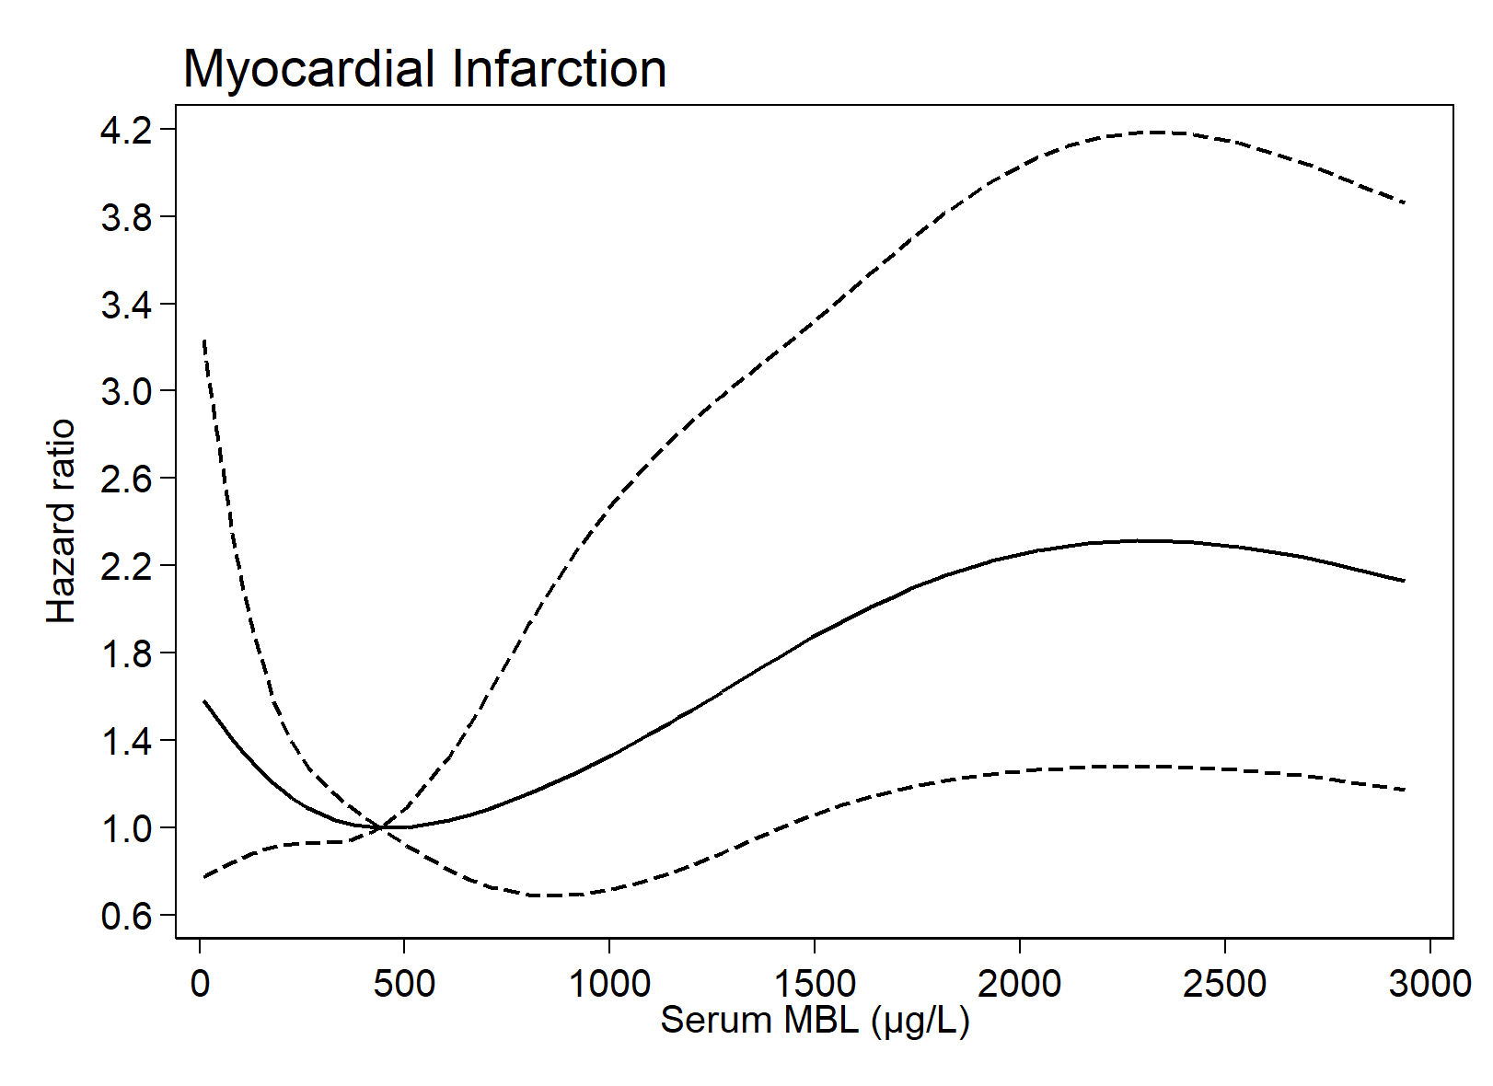

Supplementary Figure 2. Risk of Myocardial Infarction by Serum MBL Levels.

Supplementary Figure 3 Time-to-Event Curves of Myocardial Infarction by Serum MBL and MBL Expression Genotype Categories.
Time-to-event curves of myocardial infarction (considering death as a competing risk) divided into 3 groups of serum MBL (left) in 6871 individuals with type 2 diabetes. Right panel shows the association between low, intermediate, and high MBL expression genotypes in 2848 individuals with type 2 diabetes.

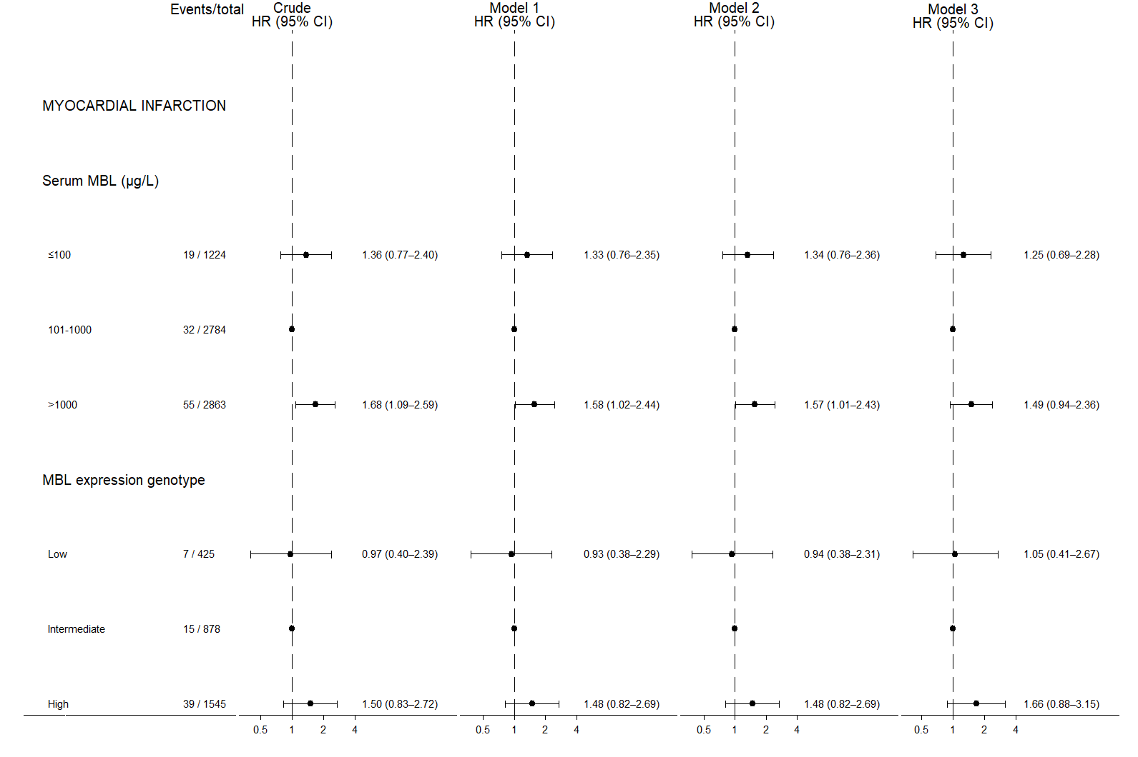

Supplementary Figure 4. Hazard Ratios of Myocardial Infarction by Serum MBL and MBL Expression Genotype Categories.

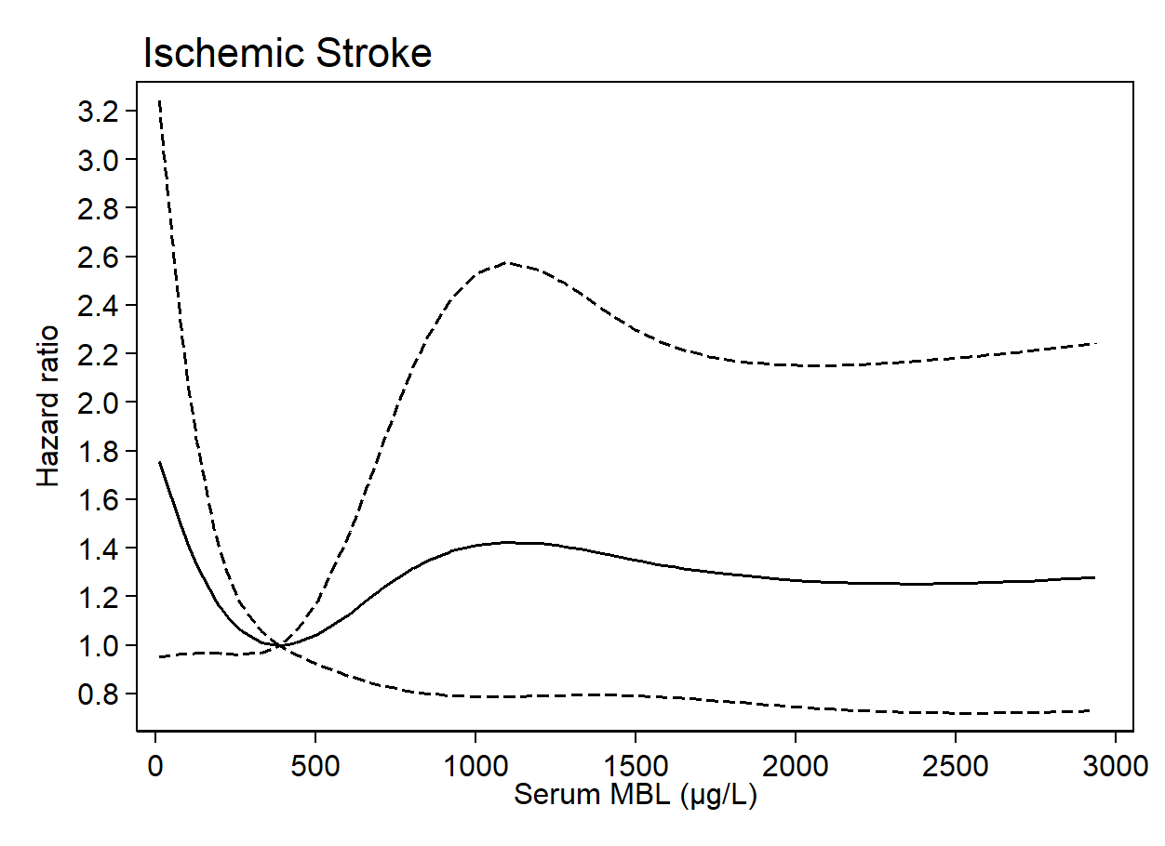

Supplementary Figure 5. Risk of Ischemic Stroke by Serum MBL Levels.

Supplementary Figure 6. Time-to-Event Curves of Ischemic Stroke by Serum MBL and MBL Expression Genotype Categories.
Time-to-event curves of ischemic stroke (considering death as a competing risk) divided into 3 groups of serum MBL (left) in 7057 individuals with type 2 diabetes. Right panel shows the association between low, intermediate, and high MBL expression genotypes in 2933 individuals with type 2 diabetes.

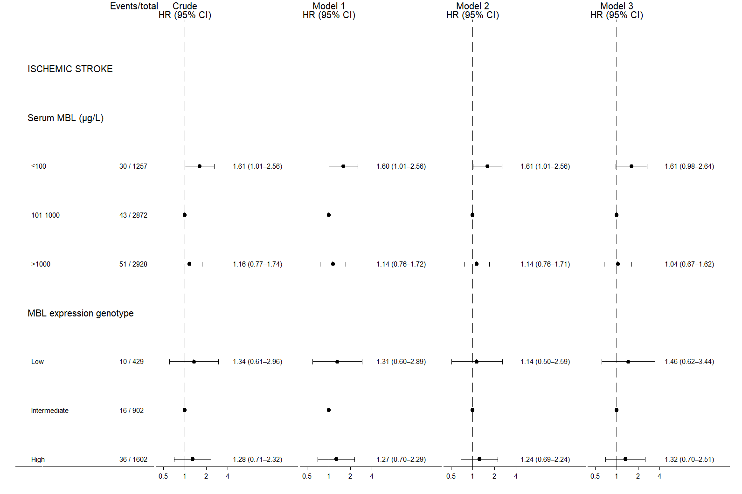

Supplementary Figure 7. Hazard Ratios of Ischemic Stroke by Serum MBL and MBL Expression Genotype Categories.
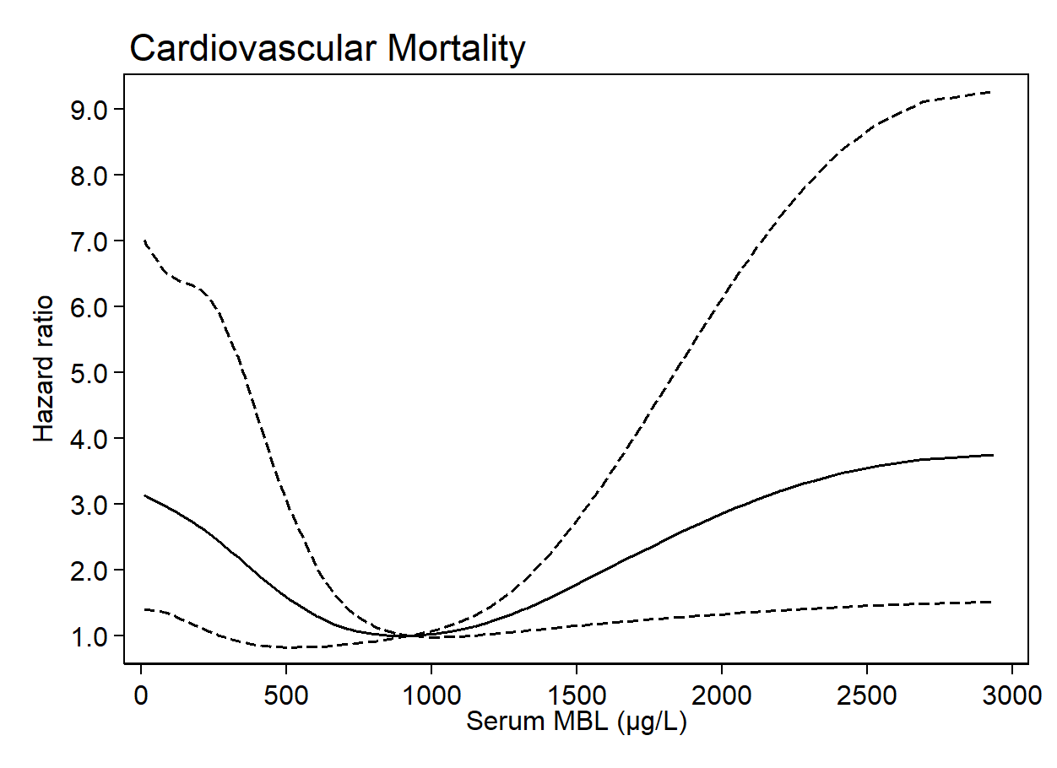

Supplementary Figure 8. Risk of Cardiovascular Mortality by Serum MBL Levels.

Supplementary Figure 9. Time-to-Event Curves of Cardiovascular Mortality by Serum MBL and MBL Expression Genotype Categories.
Time-to-event curves of cardiovascular mortality (considering death from other courses as a competing risk) divided into 3 groups of serum MBL (left) in 7301 individuals with type 2 diabetes. Right panel shows the association between low, intermediate, and high MBL expression genotypes in 3041 individuals with type 2 diabetes.

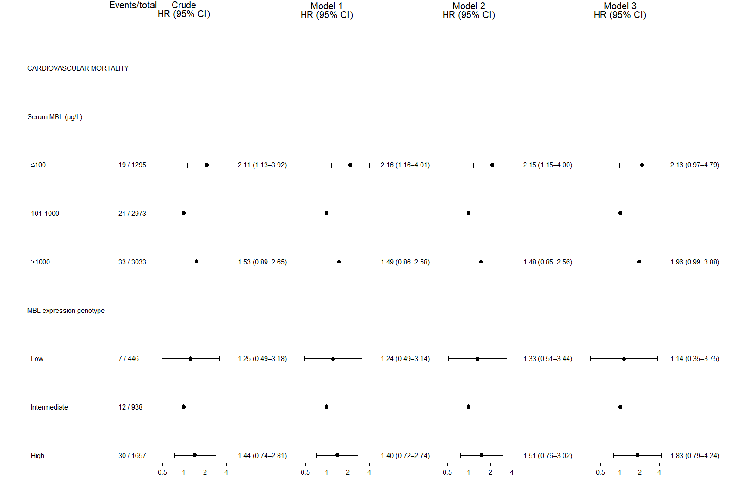

Supplementary Figure 10. Hazard Ratios of Cardiovascular Mortality by Serum MBL and MBL Expression Genotype Categories.
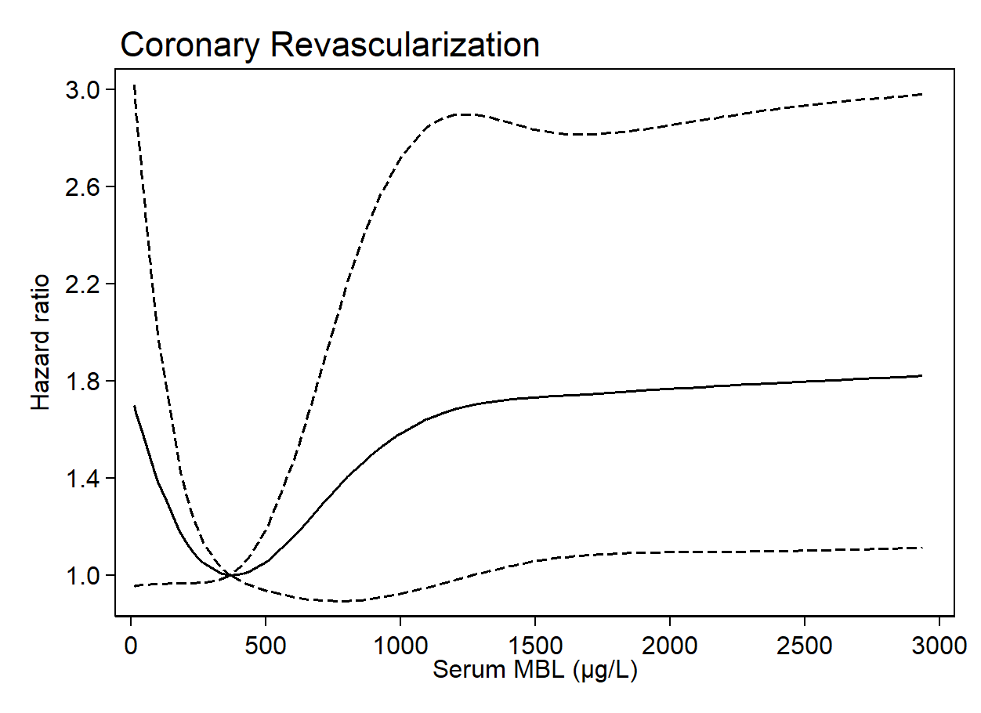

Supplementary Figure 11. Risk of Coronary Revascularization by Serum MBL Levels.

Supplementary Figure 12. Time-to-Event Curves of Coronary Revascularization by Serum MBL and MBL Expression Genotype Categories.
Time-to-event curves of coronary revascularization (considering death as a competing risk) divided into 3 groups of serum MBL (left) in 6703 individuals with type 2 diabetes. Right panel shows the association between low, intermediate, and high MBL expression genotypes in 2785 individuals with type 2 diabetes.

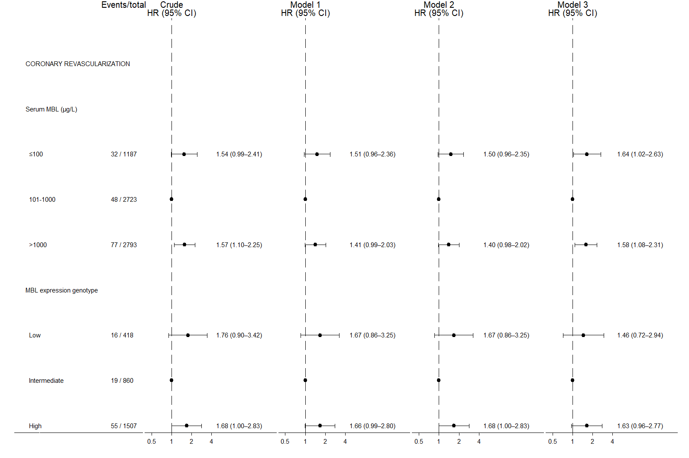

Supplementary Figure 13. Hazard Ratios of Coronary Revascularization by Serum MBL and MBL Expression Genotype Categories.

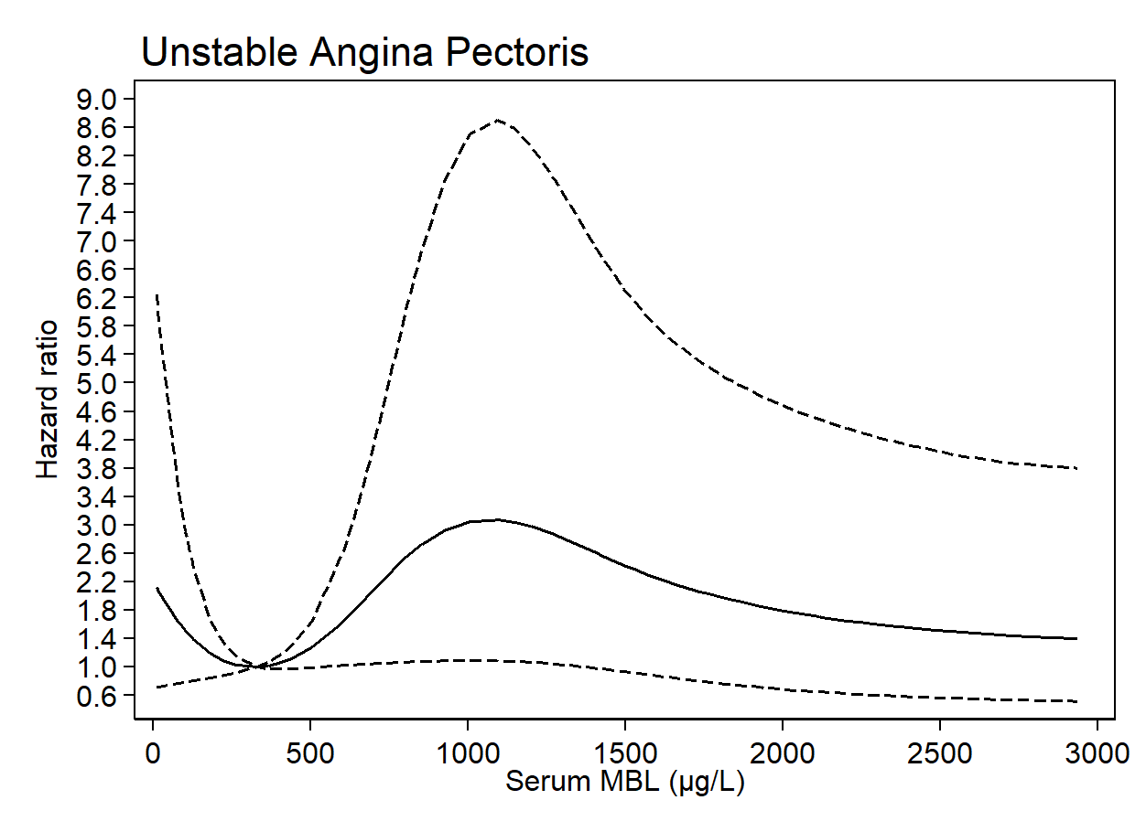

Supplementary Figure 14. Risk of Unstable Angina Pectoris by Serum MBL Levels.

Supplementary Figure 15. Time-to-Event Curves of Unstable Angina Pectoris by Serum MBL and MBL Expression Genotype Categories.
Time-to-Event curves of unstable angina pectoris (considering death as a competing risk) divided into 3 groups of serum MBL (left) in 7142 individuals with type 2 diabetes. Right panel shows the association between low, intermediate, and high MBL expression genotypes in 2981 individuals with type 2 diabetes.

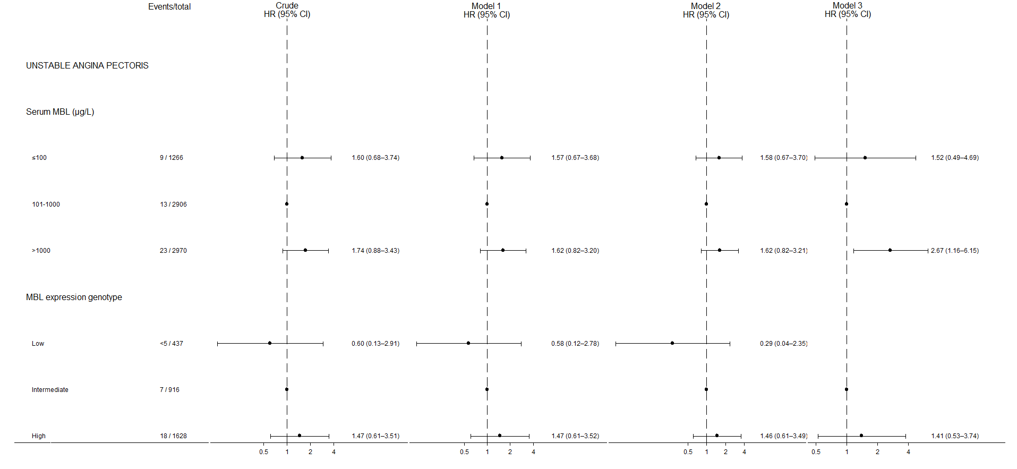

Supplementary Figure 16. Hazard Ratios of Unstable Angina Pectoris by Serum MBL and MBL Expression Genotype Categories.
<5 = Exact number of events too low to be displayed according to Danish data protection regulations.

Supplementary Figure 17. Genotype–phenotype association.
Serum MBL levels according to MBL expression genotypes. R² is the coefficient of determination. Cuzick’s non-parametric test for trend (P<1×10⁻³⁰⁰).

SENSITIVITY ANALYSES
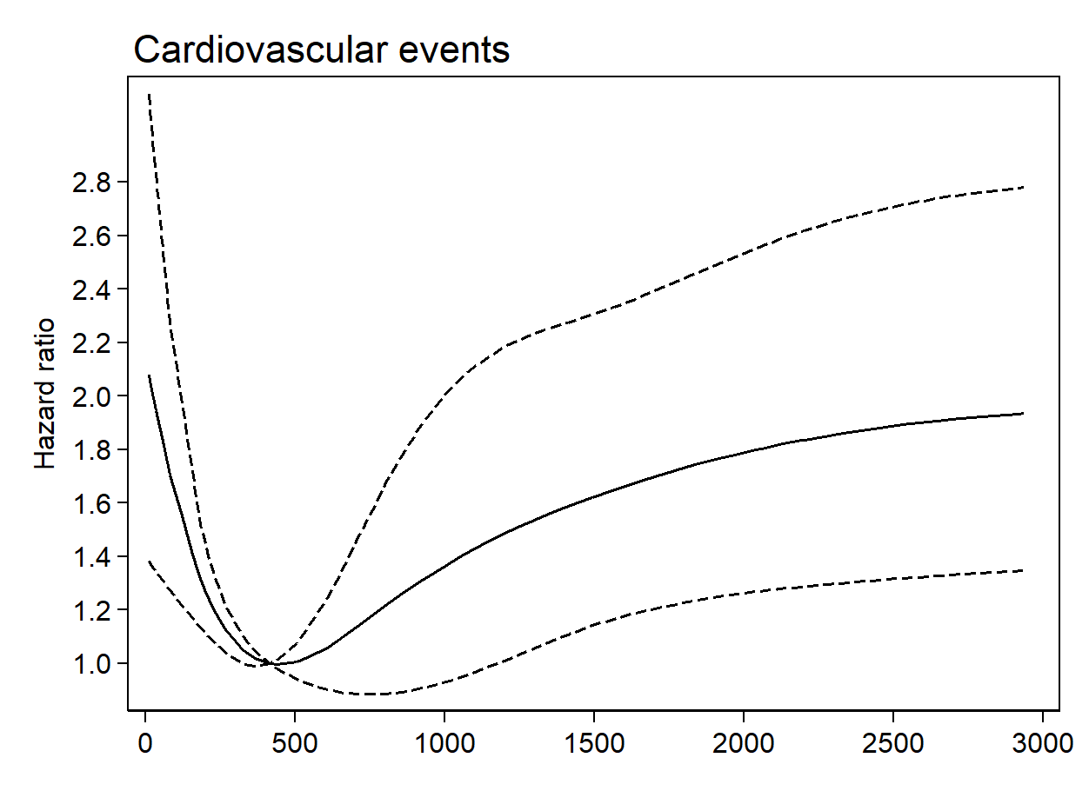

Supplementary Figure 18. Risk of Cardiovascular Events by Serum MBL Levels Excluding Individuals with CRP>10 mg/L.

Supplementary Figure 19. Time-to-Event Curves of Cardiovascular Events by Serum MBL and MBL Expression Genotype Categories Excluding Individuals with CRP>10 mg/L.
Time-to-event curves of cardiovascular events (considering death as a competing risk) excluding individuals with a CRP >10 mg/L divided into 3 groups of serum MBL (left) in 5807 individuals with type 2 diabetes. Right panel shows the association between low, intermediate, and high MBL expression genotypes in 2416 individuals with type 2 diabetes.

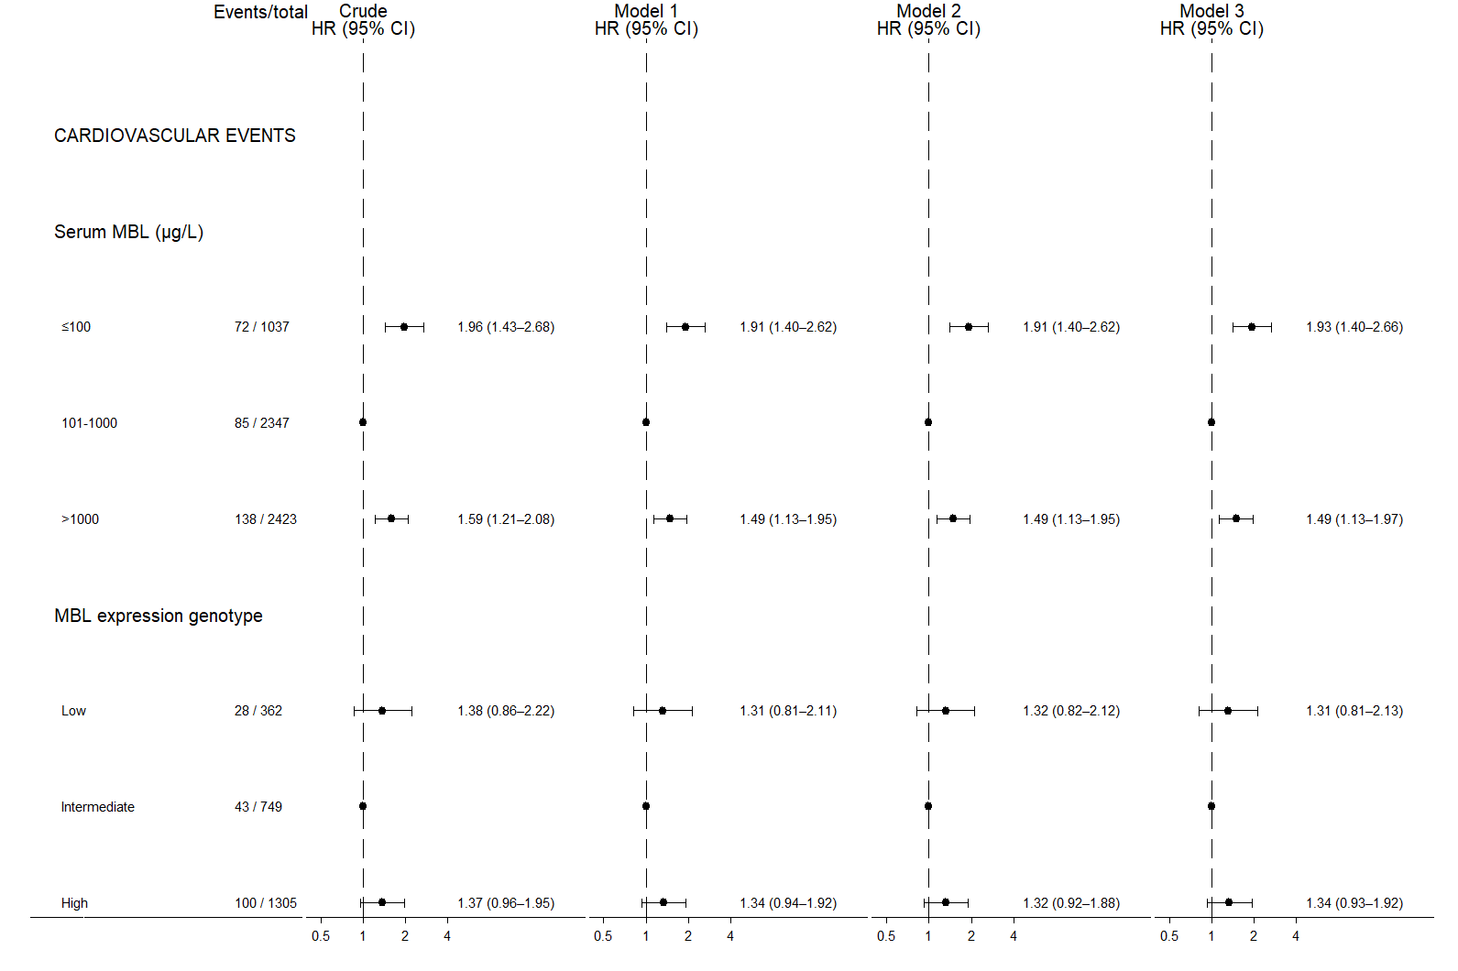

Supplementary Figure 20. Hazard Ratios of Cardiovascular Events by Serum MBL and MBL Expression Genotype Categories Excluding Individuals with CRP>10 mg/L.

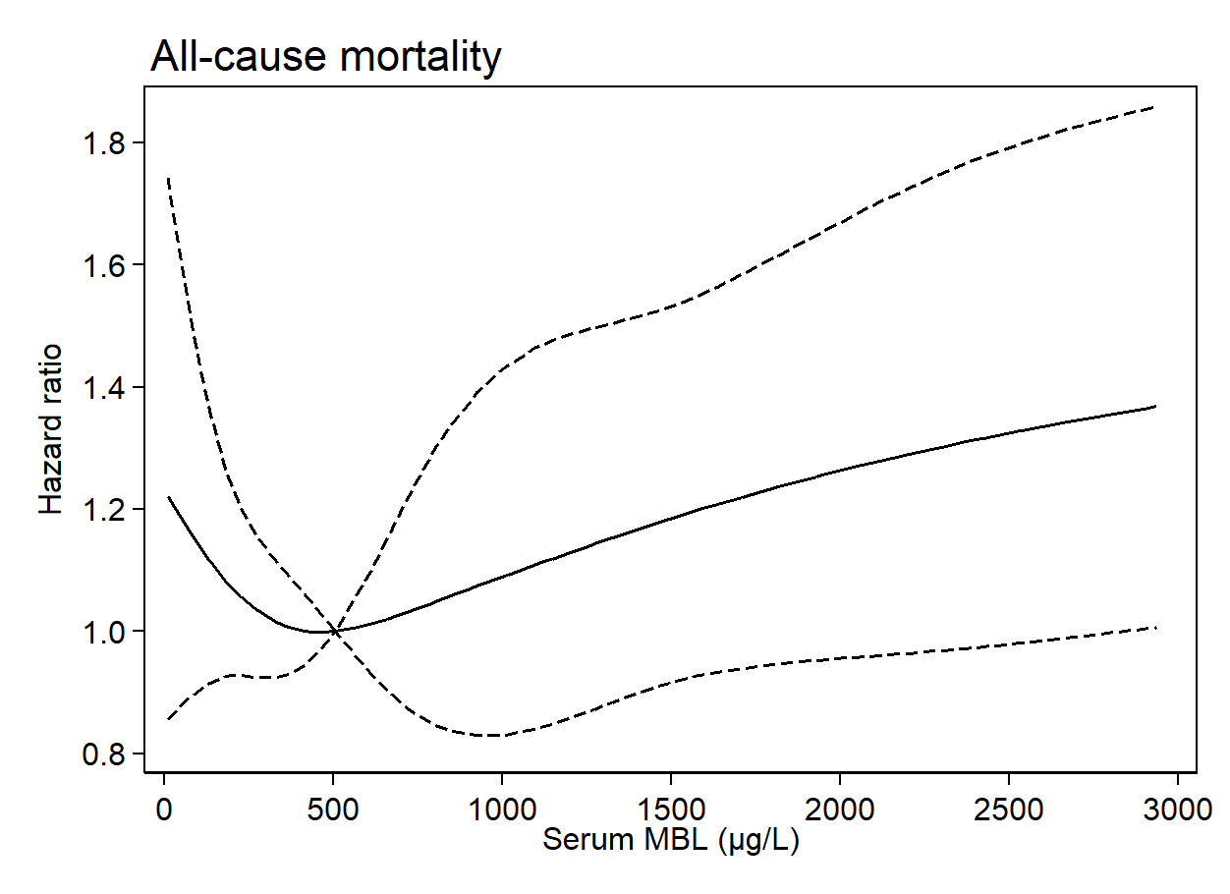

Supplementary Figure 21. Risk of All-cause Mortality by Serum MBL Levels Excluding Individuals with CRP>10 mg/L.

Supplementary Figure 22. Time-to-Event Curves of All-cause Mortality by Serum MBL and MBL Expression Genotype Categories Excluding Individuals with CRP>10 mg/L.
Time-to-event curves of all-cause mortality excluding individuals with a CRP >10 mg/L divided into 3 groups of serum MBL (left) in 6664 individuals with type 2 diabetes. Right panel shows the association between low, intermediate, and high MBL expression genotypes in 2788 individuals with type 2 diabetes.

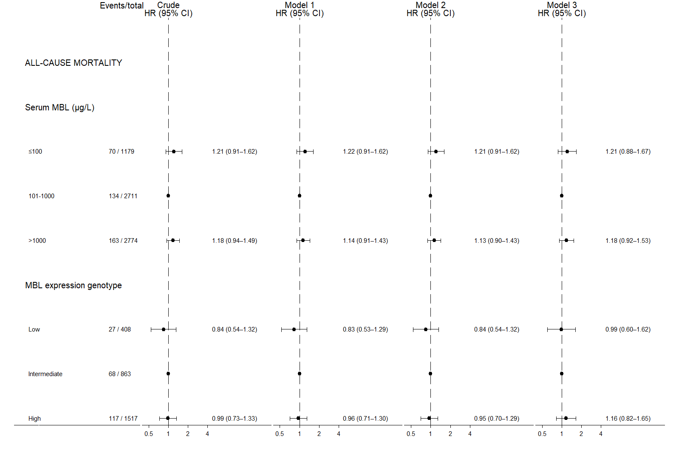

Supplementary Figure 23. Hazard Ratios of All-cause Mortality by Serum MBL and MBL Expression Genotype Categories Excluding Individuals with CRP>10 mg/L.

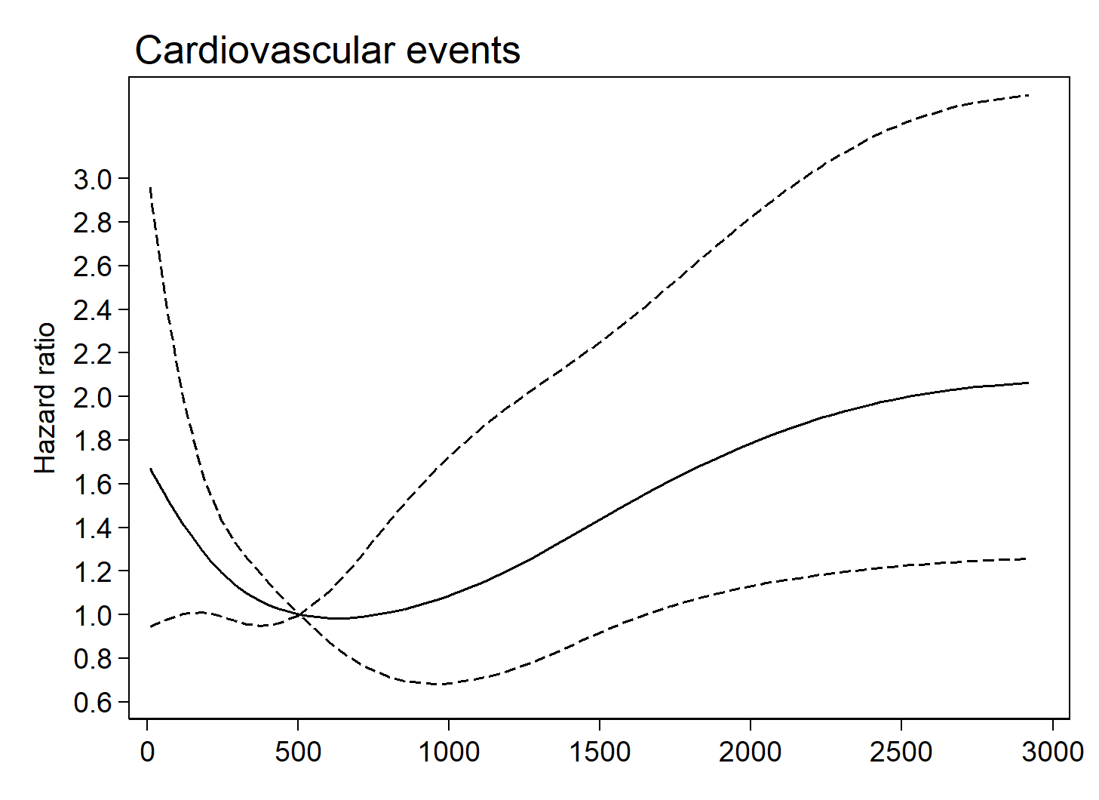

Supplementary Figure 24. Risk of Cardiovascular Events by Serum MBL Levels Excluding Individuals with Diabetes Duration >1 year.

Supplementary Figure 25. Time-to-Event Curves of Cardiovascular Events by Serum MBL and MBL Expression Genotype Excluding Individuals with diabetes duration >1year.
Time-to-event curves of cardiovascular events (considering death as a competing risk) excluding individuals with a diabetes duration >1 year divided into 3 groups of serum MBL (left) in 2890 individuals with type 2 diabetes. Right panel shows the association between low, intermediate, and high MBL expression genotypes in 1460 individuals with type 2 diabetes.

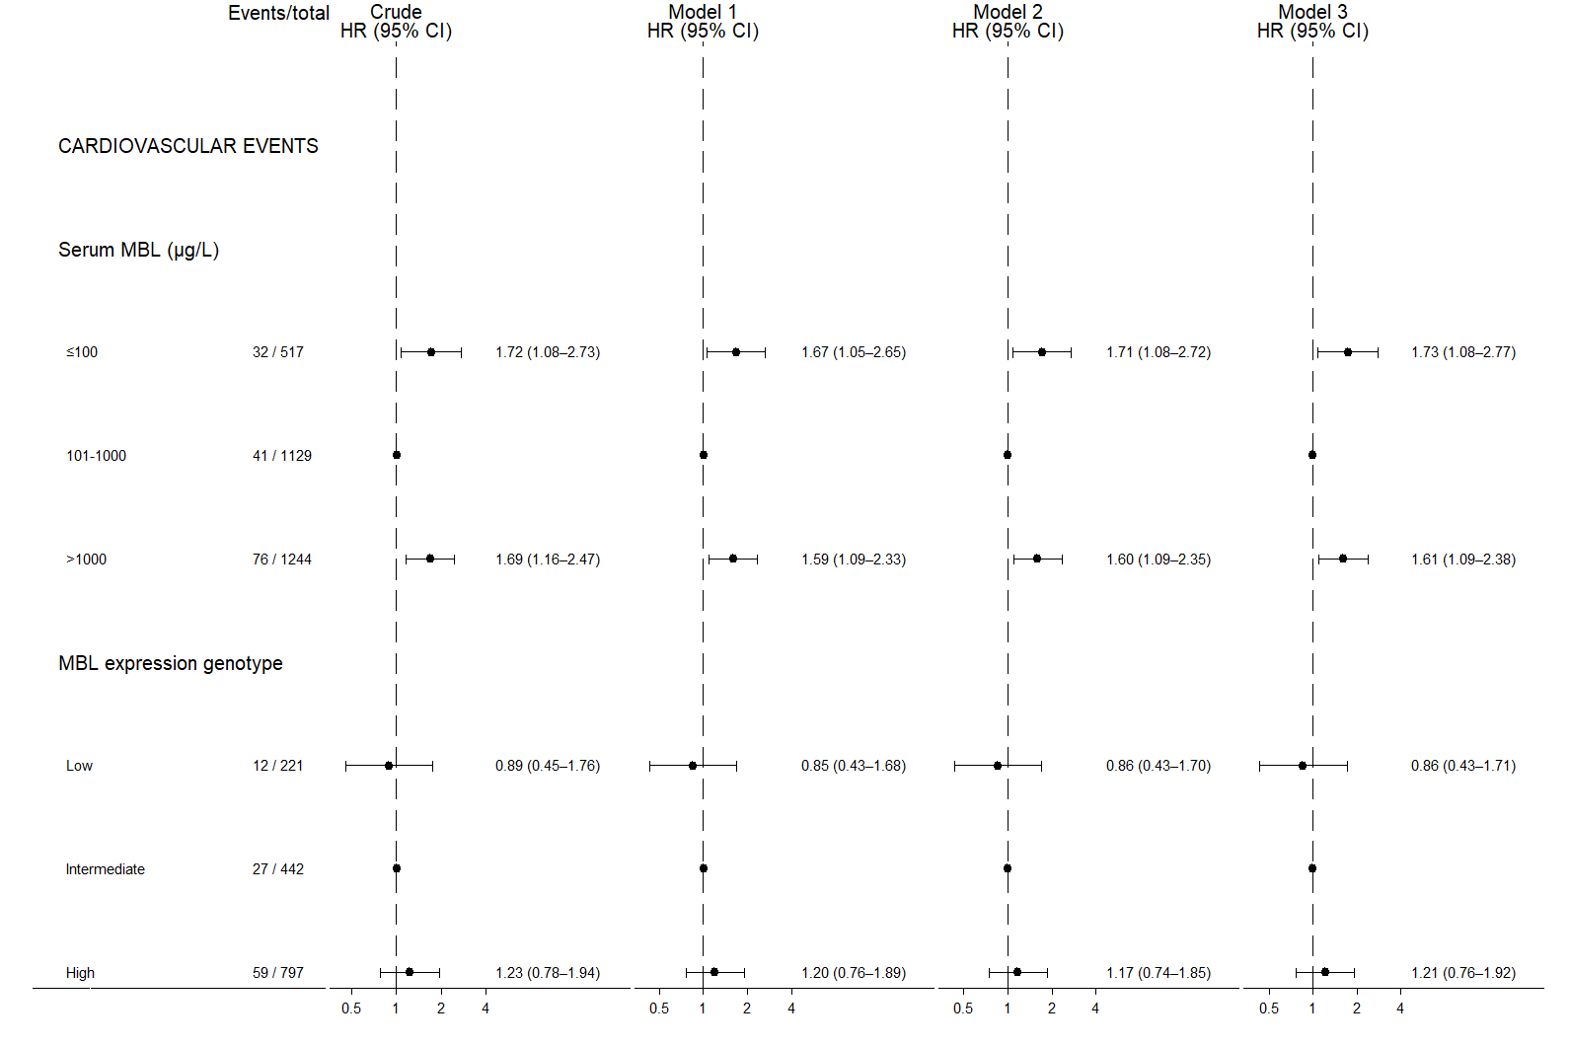

Supplementary Figure 26. Hazard Ratios of Cardiovascular Events by Serum MBL and MBL Expression Genotype Excluding Individuals with diabetes duration >1 year.

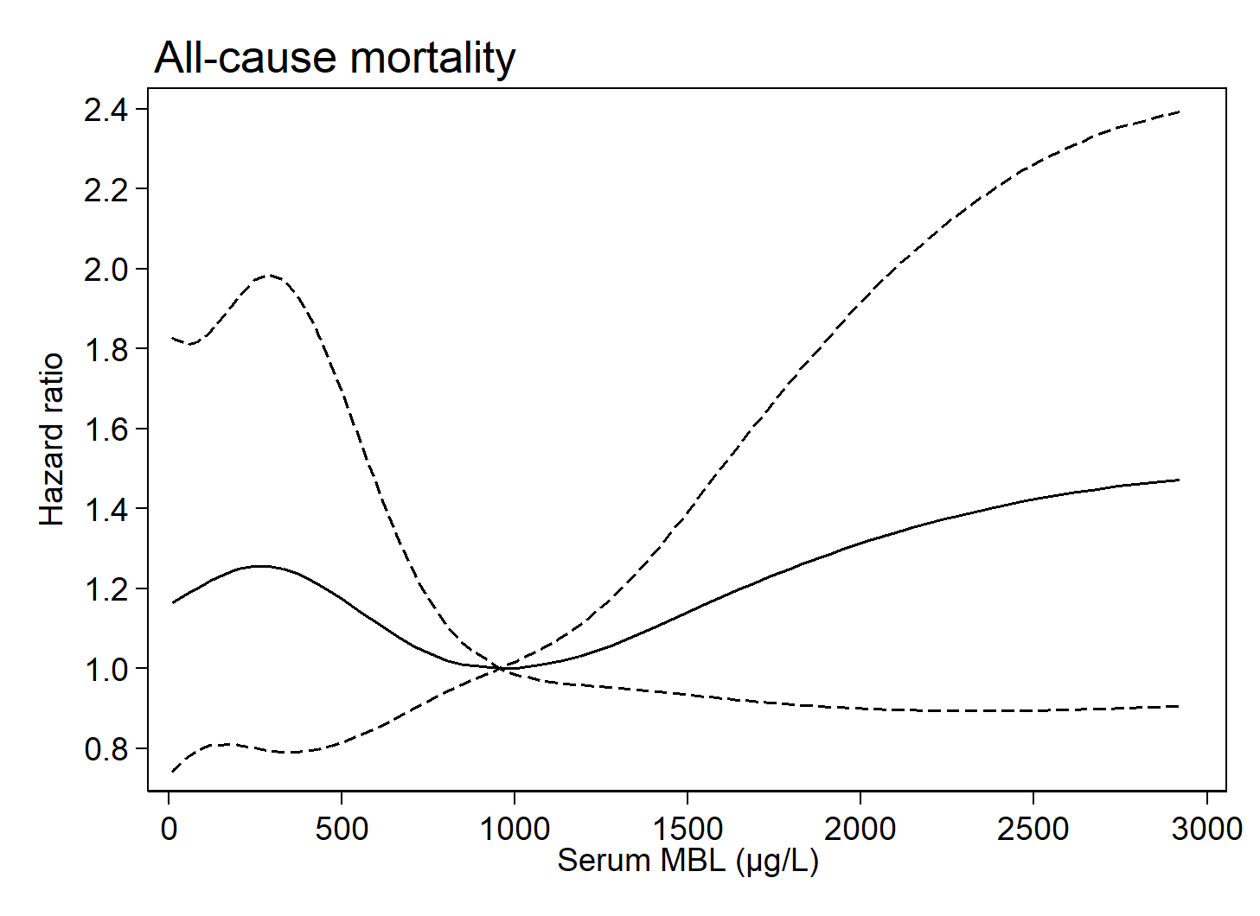

Supplementary Figure 27. Risk of All-cause Mortality by Serum MBL Levels Excluding Individuals with Diabetes Duration >1 year.

Supplementary Figure 28. Time-to-Event Curves of All-cause Mortality by Serum MBL and MBL Expression Genotype Excluding Individuals with Diabetes Duration >1year.
Time-to-event curves of all-cause mortality excluding individuals with a diabetes duration >1 year divided into 3 groups of serum MBL (left) in 3263 individuals with type 2 diabetes. Right panel shows the association between low, intermediate, and high MBL expression genotypes in 1656 individuals with type 2 diabetes.

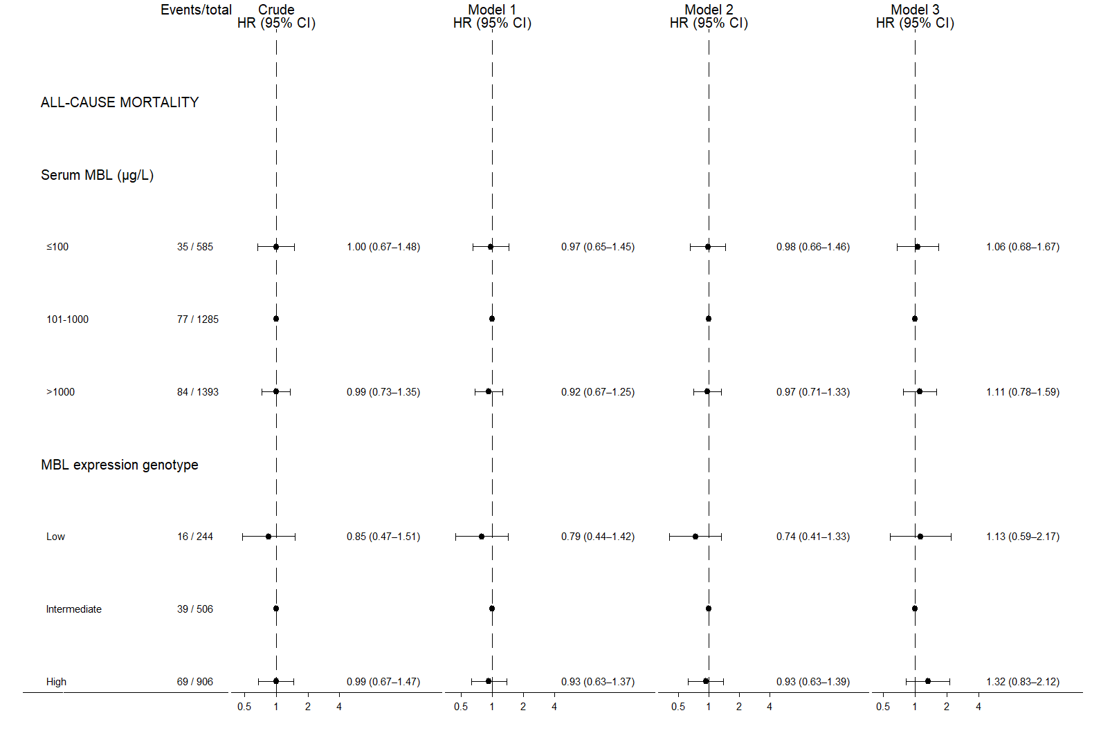

Supplementary Figure 29. Hazard Ratios of All-cause Mortality by Serum MBL and MBL Expression Genotype Excluding Individuals with Diabetes Duration >1 year.

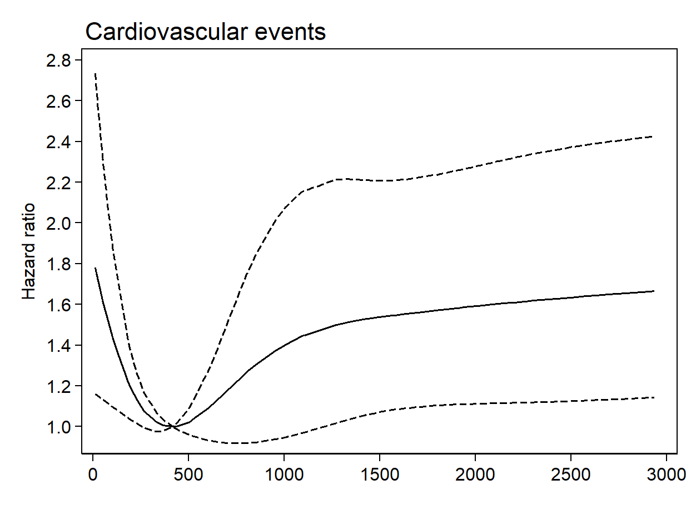

Supplementary Figure 30. Risk of Cardiovascular Events by Serum MBL Levels Excluding Individuals with Any Previous Cardiovascular Disease.

Supplementary Figure 31. Time-to-Event Curves of Cardiovascular Events by Serum MBL and MBL Expression Genotype Excluding Individuals with Any previous Cardiovascular Disease.
Time-to-event curves of cardiovascular events (considering death as a competing risk) excluding individuals with any previous cardiovascular disease divided into 3 groups of serum MBL (left) in 5854 individuals with type 2 diabetes. Right panel shows the association between low, intermediate, and high MBL expression genotypes in 2431 individuals with type 2 diabetes.

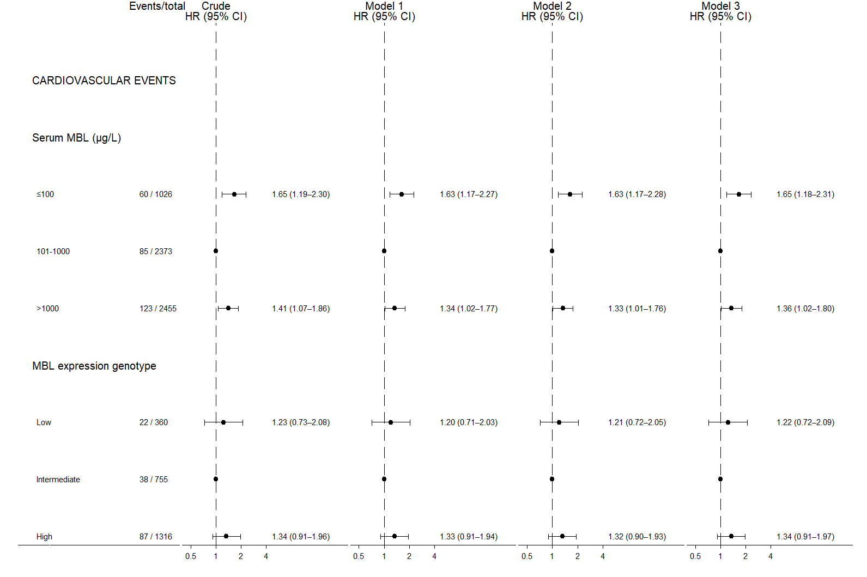

Supplementary Figure 32. Hazard Ratios of Cardiovascular Events by Serum MBL and MBL Expression Genotype Excluding Individuals with Any Previous Cardiovascular Disease.

References
1. Lee KJ, Carlin JB. Multiple imputation for missing data: fully conditional specification versus multivariate normal imputation. Am J Epidemiol 2010;171:624-32.
2. Sterne JA, White IR, Carlin JB, et al. Multiple imputation for missing data in epidemiological and clinical research: potential and pitfalls. Bmj 2009;338:b2393.
3. Bernaards CA, Belin TR, Schafer JL. Robustness of a multivariate normal approximation for imputation of incomplete binary data. Stat Med 2007;26:1368-82.

