Supplemental Table S1 Baseline diabetes history of survivors and non-survivors among COVID-19 patients with diabetes
 | Survivors (N=122) | Nonsurvivors (N=31) | P value
Diabetes classification |  |  | 0.020
Type 1 diabetes | 1 (0.8) | 0 | ..
Type 2 diabetes* | 109 (89.3) | 22 (71.0) | ..
Unclear† | 12 (9.8) | 9 (29.0) | ..
Duration of diabetes, years | 5.5 (2.0-10.3) | 10.0 (3.0-20.0) | 0.171
HbA1c, % (mmol/mol) |  |  | 0.045
<7 (<53) | 20/76 (26.3) | 3/22 (13.6)
7 to < 8 (53 to <64) | 19/76 (25.0) | 1/22 (4.5)
8 to < 9 (64 to <75) | 13/76 (17.1) | 6/22 (27.3)
>9 (>75) | 24/76 (31.6) | 12/22 (54.5)
Previous blood glucose control methods |  |  | 0.316
Uncontrolled | 7/102 (6.9) | 0 | ..
Oral medication control | 65/102(63.7) | 7/10 (70.0) | ..
Insulin control | 15/102 (14.7) | 0 | ..
Oral medication and insulin control | 15/102 (14.7) | 3/10 (30.0) | ..
Complications of diabetes
Acute complication | 1 (0.8) | 0 | 1.000
Diabetic nephropathy | 1 (0.8) | 1 (3.2) | 0.365
Diabetic foot | 1 (0.8) | 0 | 1.000
Diabetic eye complications | 0 | 0 | NA
Diabetic cardiovascular complications | 0 | 0 | NA
Diabetic neuropathy | 0 | 0 | NA
Diabetic cerebrovascular disease | 0 | 0 | NA
Data are expressed as median (IQR), n (%), or n/N (%), where N is available total cases. P<0·05 was considered statistically significant. *Seven newly diagnosed diabetes cases were included in Type 2 diabetes category. †These patients had confirmed previous history of diabetes and laboratory evidences, but we could not contact them or their family members to define the type of diabetes.

Supplemental Table S2 Cox regression analyses of risk factors for in-hospital death of all the COVID-19 patients
Variables | Univariable HR (95% CI) | P value | Multivariable HR (95% CI) | P value
Comorbidities
Diabetes | 2.00 (1.09-3.65) | 0.025 | 1.58 (0.84-2.99) | 0.155
Hypertension | 3.12 (1.69-5.76) | <0.001 | 2.50 (1.30-4.78) | 0.006
Cardiovascular disease | 3.39 (1.87-6.15) | <0.001 | 2.24 (1.19-4.23) | 0.013
Chronic pulmonary disease | 2.60 (1.16-5.81) | 0.020 | 2.51 (1.07-5.90) | 0.035
CI, confidence interval; HR, hazard ratio. P<0·05 was considered statistically significant. Age and sex were not included in this model since the patients with diabetes and those without were matched on age and sex.

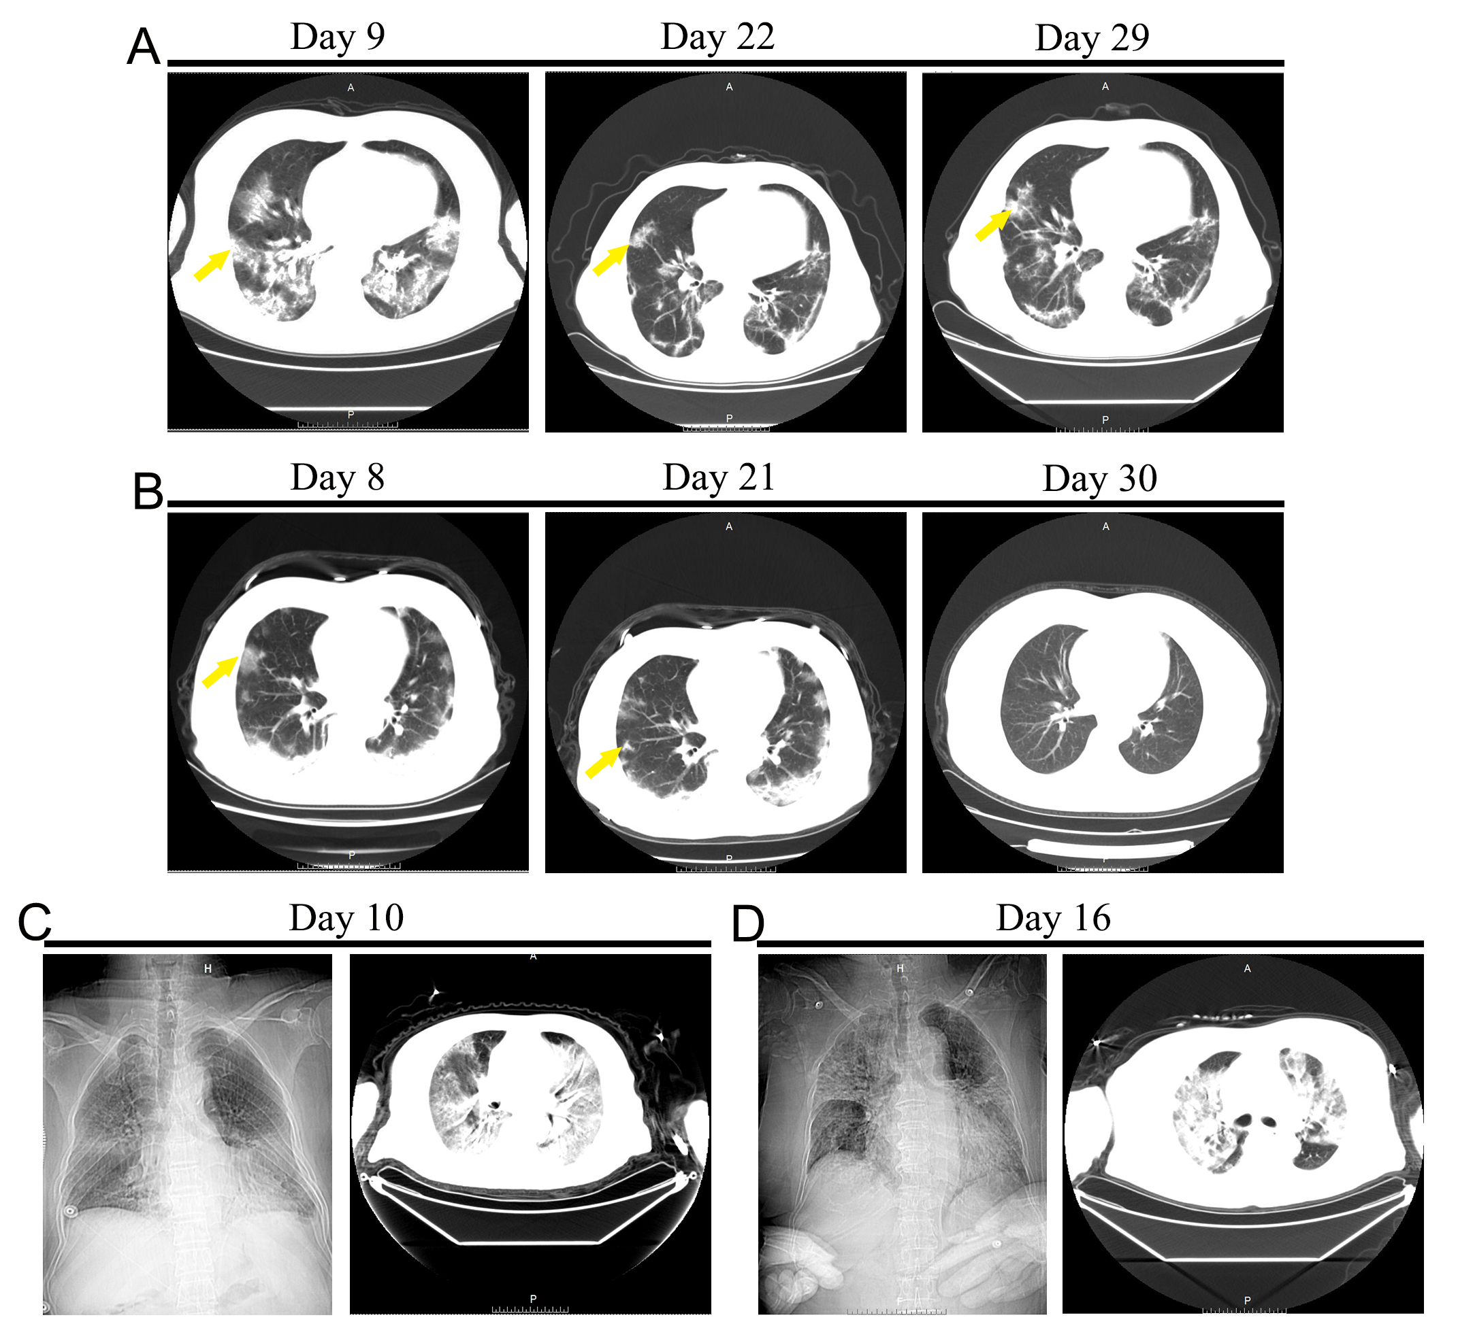
Supplemental Figure S1: A: Chest CT images obtained from a 67-year-old male survivor among COVID-19 patients with diabetes on day 9, 22 and 29 after symptom onset; B: The images obtained from a 62-year-old female survivor among COVID-19 patients without diabetes on day 8, 21 and 30 after symptom onset. Imaging features of these survivors were ground glass opacities (yellow arrow) in several lobes. C: These images were obtained from a 70-year-old male COVID-19 nonsurvivor with diabetes on day 10 after symptom onset. D: These images are from a 65-year-old female COVID-19 nonsurvivor without diabetes on day 16 after symptom onset. The imaging features of these nonsurvivors were extensive and fused ground glass opacities throughout the lungs.

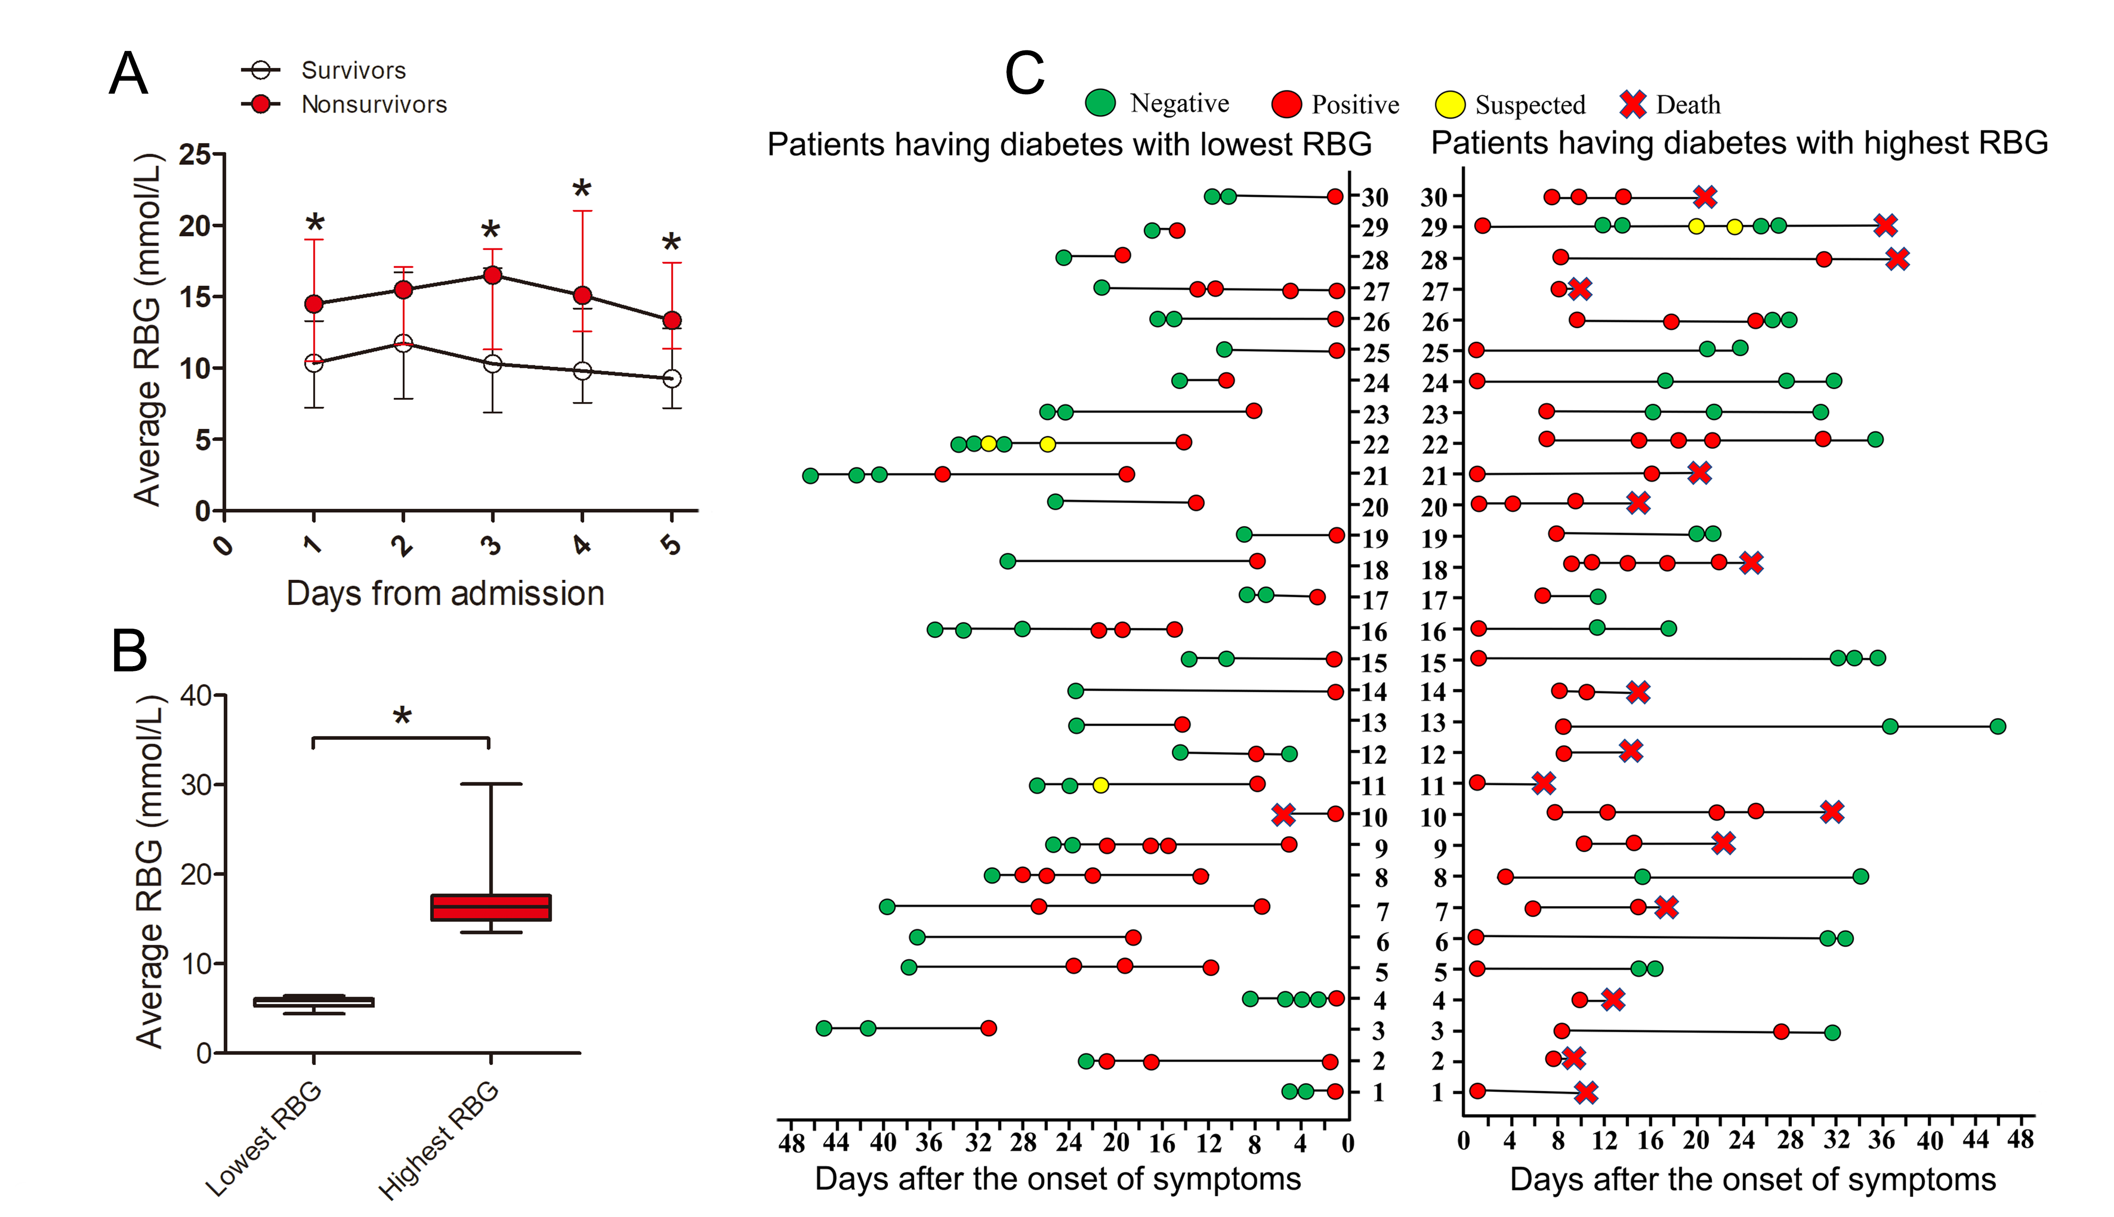

Supplemental Figure S2: A: Levels of average RBG in survivors and nonsurvivors among COVID-19 patients with diabetes during the first consecutive 5 days after admission. Thirty-two survivors and 13 nonsurvivors who had complete RBG records for the first 5 days after admissions were included. Nonsurvivors had significantly higher average RBG than survivors (except day 2). B: Levels of average RBG of 30 COVID-19 patients having diabetes with the highest average RBG and 30 with the lowest average RBG during hospitalization. C: Results of RT-PCR tests for virus RNA in 30 COVID-19 patients having diabetes with the highest average RBG and 30 with the lowest average RBG from symptom onset to death or discharge. Sixteen out of 30 patients with highest RBG died, while only 1 out of 30 patients with lowest RBG died. Half of the patients with the highest RBG had sustained detectable SARS-CoV-2 virus until death, while the RT-PCR tests turned negative in most patients with lowest RBG. RBG, random blood glucose; RT-PCR, reverse transcription-polymerase chain reaction. *P <0.05 was considered statistically significant.

