Supplemental Material

Genetic causes of severe childhood obesity: a remarkably high prevalence (≥49%) in an inbred population of Pakistan
Sadia Saeed^{1,2}, Muhammad Arslan³, Jaida Manzoor⁴, Sadia M. Din⁵, Qasim M. Janjua^{5,6}, Hina Ayesha⁷, Qura-tul Ain⁵, Laraib Inam³, Stephane Lobbens¹, Emmanuel Vaillant¹, Emmanuelle Durand¹, Mehdi Derhourhi¹, Souhila Amanzougarene¹, Alaa Badreddine¹, Lionel Berberian¹, Stefan Gaget¹, Waqas I. Khan⁸, Taeed A. Butt⁹, Amélie Bonnefond^{1,2}*, Philippe Froguel^{1,2}*
¹Université de Lille, Inserm UMR1283, CNRS, UMR 8199 – EGID, Lille, Lille University Hospital, France
²Department of Metabolism, Digestion and Reproduction, Imperial College London, London, UK
³School of Life Sciences, Forman Christian College (A Chartered University), Lahore 54600, Pakistan
⁴Department of Paediatric Endocrinology, Children’s Hospital, Lahore, Pakistan
⁵Institute of Molecular Biology and Biotechnology, University of Lahore, Lahore, Pakistan
⁶Department of Physiology, University College of Medicine and Dentistry, University of Lahore, Lahore, Pakistan
⁷Department of Paediatrics, Punjab Medical College, Faisalabad, Pakistan
⁸Children Hospital and Institute of Child Health, Multan, Pakistan
⁹Department of Pediatrics, Fatima Memorial Hospital, Lahore, Pakistan

*Correspondence: amelie.bonnefond@cnrs.fr, +33374008118 (A.B.), p.froguel@imperial.ac.uk, +442075946520 (P.F.)

Supplementary Tables
Supplementary Table 1. List of genes in which point mutations have been shown to cause monogenic obesity
Gene | Name | Location | Mendelian disorder | NM transcript
ALMS1 | ALMS1, centrosome and basal body associated protein | 2p13.1 | Obesity & syndromic features | NM_015120.4
ADCY3 | Adenylate Cyclase 3 | 2p23.3 | Obesity & syndromic features | NM_004036.4
BBS1 | Bardet-Biedl syndrome 1 | 11q13.2 | Obesity & syndromic features | NM_024649.4
BBS10 | Bardet-Biedl syndrome 10 | 12q21.2 | Obesity & syndromic features | NM_024685.3
BBS12 | Bardet-Biedl syndrome 12 | 4q27 | Obesity & syndromic features | NM_152618.2
BBS2 | Bardet-Biedl syndrome 2 | 16q13 | Obesity & syndromic features | NM_031885.3
BBS4 | Bardet-Biedl syndrome 4 | 15q24.1 | Obesity & syndromic features | NM_033028.4
BBS5 | Bardet-Biedl syndrome 5 | 2q31.1 | Obesity & syndromic features | NM_152384.2
BBS7 | Bardet-Biedl syndrome 7 | 4q27 | Obesity & syndromic features | NM_176824.2
BBS9 | Bardet-Biedl syndrome 9 | 7p14.3 | Obesity & syndromic features | NM_001033604.1
BDNF | brain derived neurotrophic factor | 11p14.1 | Obesity & syndromic features | NM_170735.5
CEP19 | centrosomal protein 19 | 3q29 | Obesity & syndromic features | NM_032898.4
CEP290 | centrosomal protein 290 | 12q21.32 | Obesity & syndromic features | NM_025114.3
LEP | leptin | 7q32.1 | Obesity | NM_000230.2
LEPR | leptin receptor | 1p31.3 | Obesity | NM_002303.5
MC4R | melanocortin 4 receptor | 18q21.32 | Obesity | NM_005912.2
MKKS | McKusick-Kaufman syndrome | 20p12.2 | Obesity & syndromic features | NM_018848.3
MKS1 | Meckel syndrome, type 1 | 17q22 | Obesity & syndromic features | NM_017777.3
MRAP2 | melanocortin 2 receptor accessory protein 2 | 6q14.2 | Obesity | NM_138409.2
NTRK2 | neurotrophic receptor tyrosine kinase 2 | 9q21.33 | Obesity & syndromic features | NM_006180.4
PCSK1 | proprotein convertase subtilisin/kexin type 1 | 5q15 | Obesity | NM_000439.4
POMC | proopiomelanocortin | 2p23.3 | Obesity | NM_001035256.1
TUB | tubby bipartite transcription factor | 11p15.4 | Obesity & syndromic features | NM_003320.4
VPS13B | vacuolar protein sorting 13 homolog B | 8q22.2 | Intellectual disability & obesity | NM_017890.4

Supplementary Table 2. Physical and endocrine characteristics of children carrying point mutations
Gene | Number of carriers | Sex | Ageª (year) | BMI SDS for age | Leptin^{b} (ng/ml) | Insulin (µIU/ml) | Cortisol (µg/ml)
LEP | 47 | M:26; F:21 | 2±0.4 | 8±0.4 | <0.2 | 21±2.6 | 17±1.1
LEPR | 15 | M:7; F:8 | 2±0.9 | 8±0.7 | 41±7.6 | 18±2.9 | 13±1.1
MC4R | 12 | M:6; F:6 | 5±0.6 | 8±0.7 | 22±5.1 | 44±11 | 12±2.4
ADCY3 | 1 | F | 1 | 7 | 14 | 9 | 11
CEP19^{c} | 1 | F | 2 | 5 | 16 | 9 | 11
BBS | 15 | M:10; F:5 | 6±1.4 | 5±0.6 | 22±3.9 | 25±5.6 | 11±0.9
ALMS1 | 4 | M | 2±0.4 | 6±0.9 | 11±1.6 | 44±5.4 | 12±1.2
Reference values: Probands with unrevealed genetic variants associated with severe obesity from the same cohort (n=20): Age (y): 2±0.3 y; BMI SDS: 6.7±0.8; Leptin (ng/ml) 7±0.8; Insulin (µIU/ml) : 28±7.5; Cortisol: (µg/ml) 13 ±1.0.
Wild-type children from the same population (n=15): Age (y): 5±0.4 y; BMI SDS: 0.2±0.3; Leptin (ng/ml): 3±0.3; Insulin (µIU/ml): 9.9±1.6; Cortisol (µg/ml): 11±0.6.
Abbreviations: BMI SDS: body mass index standard deviation score; F: female; M: male.
ªAlso see Supplementary Table 3.
^{b}Also see Supplementary Table 4.
^{c} VUS according to ACMG criteria.

Supplementary Table 3. Physical and endocrine characteristics of 4 adults carrying LEP and LEPR mutation
Gene | Code | Sex | Age (year) | BMI | Leptin (ng/ml) | Insulin (µIU/ml) | Cortisol (µg/ml)
LEP | #127 #154 | M | 21, 25 | 42, 50 | ND | 12, 36 | 31, 9
LEPR | #183 #OB1 | F:1, M:1 | 18, 19 | 64, 39 | 177, 54 | 25, 12 | 10, 11
Abbreviations: BMI: body mass index; F: female; M: male; ND: not detectable.

Supplementary Table 4. Physical and endocrine characteristics of 3 leptin deficient children with bioinactive but with immunoreactive circulating leptin levels
Gene | Code | Sex | Age (year) | BMI SDS for age | Leptin (ng/ml) | Insulin (µIU/ml) | Cortisol (µg/ml)
LEP | #300 #293 #249 | F:2, M:1 | 1±0.4 | 10±2 | 42±21.1 | 10±4.7 | 14±1.2
Abbreviations: BMI SDS: body mass index standard deviation score; F: female; M: male.

Supplementary Table 5 Genetic and phenotypic characteristics of severely obese probands with homozygous point mutations identified as VUS genes, from a consanguineous population
Gene | ID’s | Mutation | MAF (GnomAD) | Gender | Age (years) | BMI SDS for age | Other clinical features | Insulin µIU/ml | Cortisol µg/dl
BBS9 | #190 | c.2243A>T p.Q748L | 0.00006 (14/25087) | M | 19.0 | - | Hypertensive since 6 months of age | 107 | 13
CEP19 | #116 | c.113T>C p.M38T | 0 | F | 2 | 5.0 | Excessive adiposity | 9 | 11
VPS13B | #246 | c.6619C>A p.P2207T | 0.00001 (2/246040) | M | 1 | 7.9 | Hypotonia; delayed milestones | 8.9 | 2.2
Abbreviations: BMI SDS: body mass index standard deviation score; F: female; GnomAD: Genome Aggregation Database; M: male; MAF: minor allele frequency.

Supplementary Figures

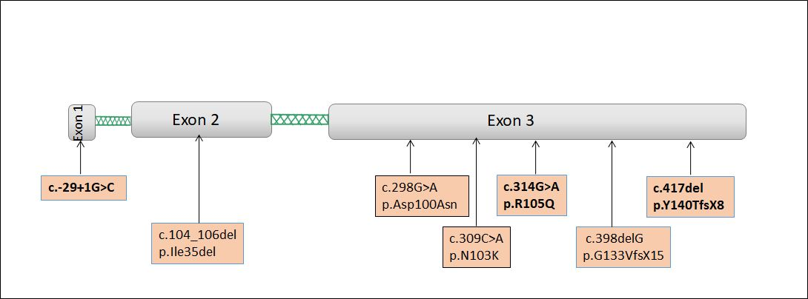
Supplementary Fig 1. Schematic presentation of homozygous LEP gene mutations identified in this study spanning three exons of the gene. The novel mutations identified are indicated in bold letters.

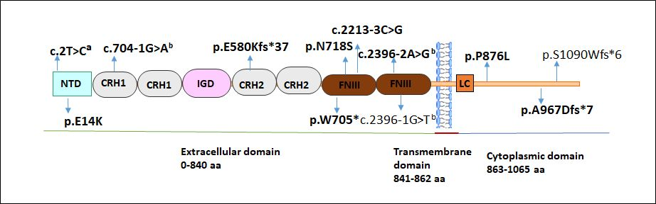
Supplementary Fig 2. Schematic presentation of full-length LEPR, indicating the location of the point mutations identified in individuals with severe early-onset obesity. The novel mutations identified in this study are indicated in bold letters.
NTD, N-terminal domain; CRH1 and CRH2, cytokine receptor homology domains; IGD, immunoglobulin-like domain; FNIII, membrane-proximal ﬁbronectin typIII domains; LC, low complexity region
ªMutation in initiation codon, ^{b}Splice site mutation.

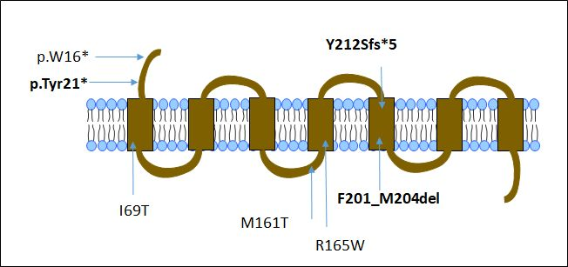
Supplementary Fig 3. Schematic presentation of full-length MC4R showing seven transmembrane domains with 3 intracellular loops (ICL) and 3 extracellular loops (ECL) indicating the location of pathogenic mutations identified in individuals with severe early-onset obesity. The novel mutations identified in this study are indicated in bold letters.

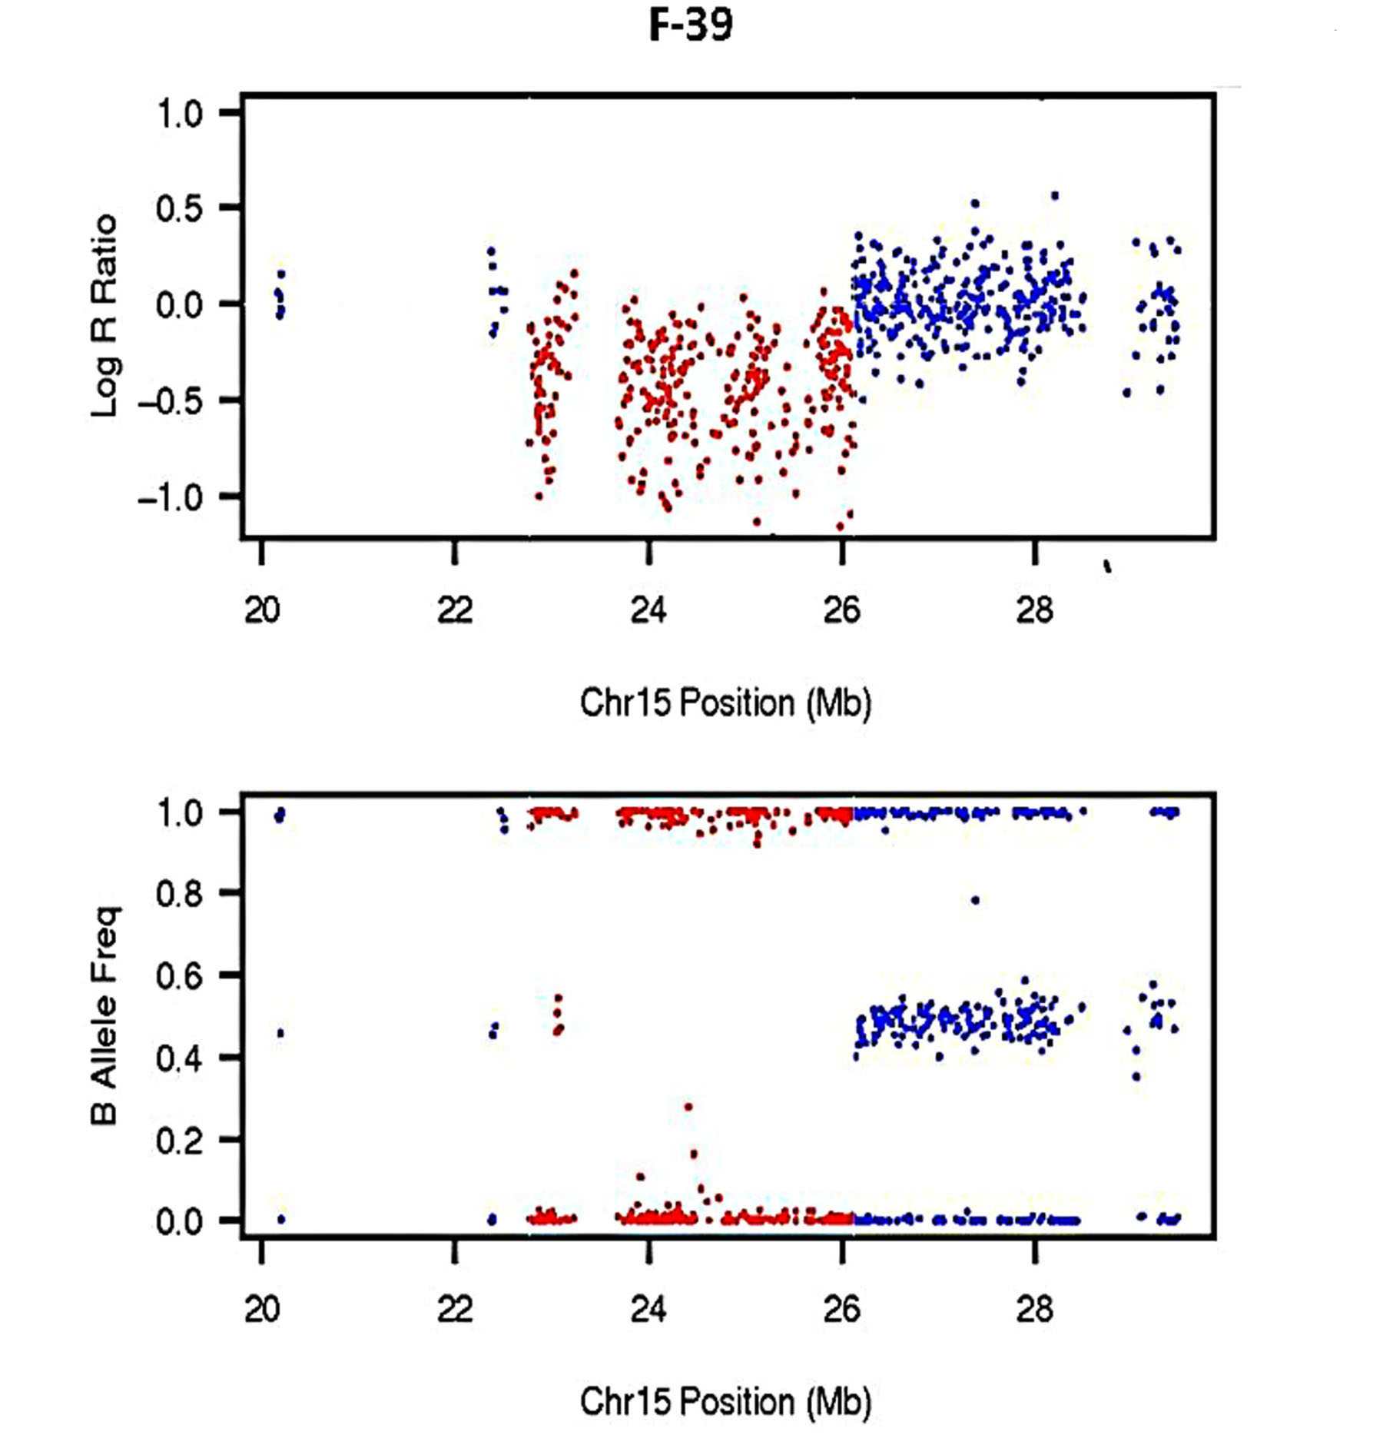

Supplementary Fig 4. Log R Ratio and B Allele Frequency Plot of a 3.3 Mb deletion in 15q11.2-q12 PWS associated region identified in #39. Multiplex Ligation-dependent Probe Amplification (MLPA) of patient DNA using P343 probemix was performed to confirm deletion breakpoint (data not shown).

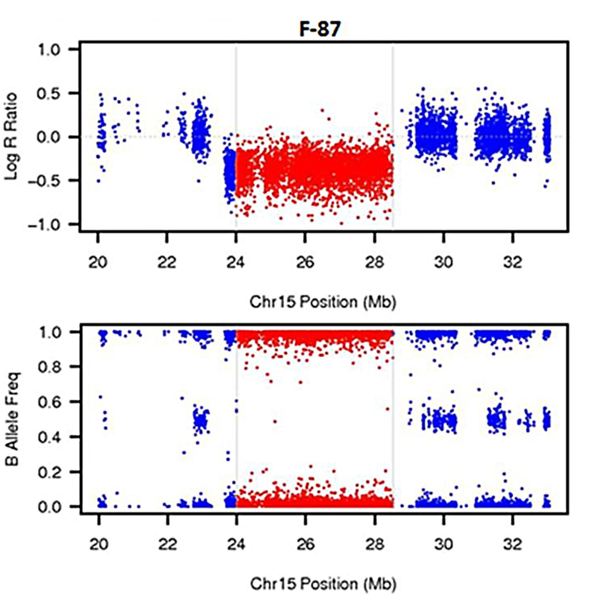

Supplementary Fig 5. Log R Ratio and B Allele Frequency plot for a 4.5 Mb copy-loss CNV in 15q11.2-q12 PWS associated region found in #87. Multiplex Ligation-dependent Probe Amplification (MLPA) of patient DNA using P343 probemix was performed to confirm deletion breakpoint (data not shown).

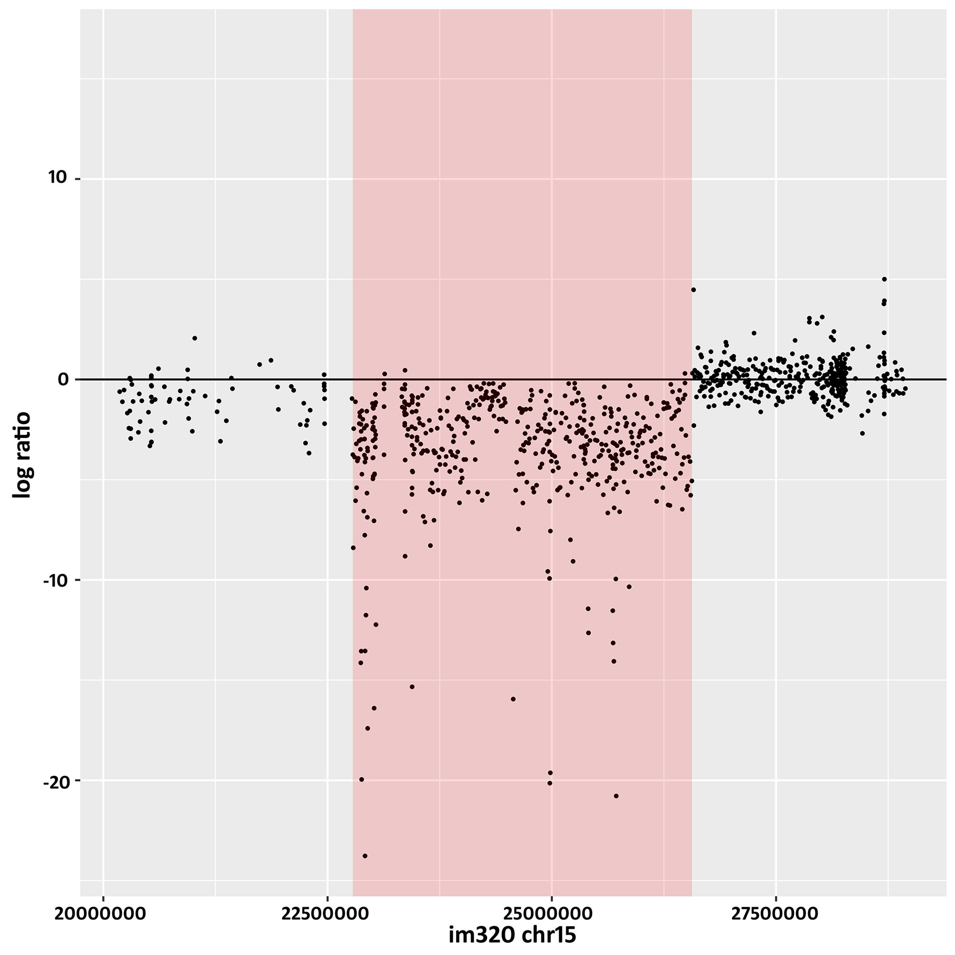
Supplementary Fig 6. Identification and validation of a ~3.8 Mb copy-loss CNV in PWS associated region found in #320 detected by CoDE-seq. Copy-loss is highlighted in red.

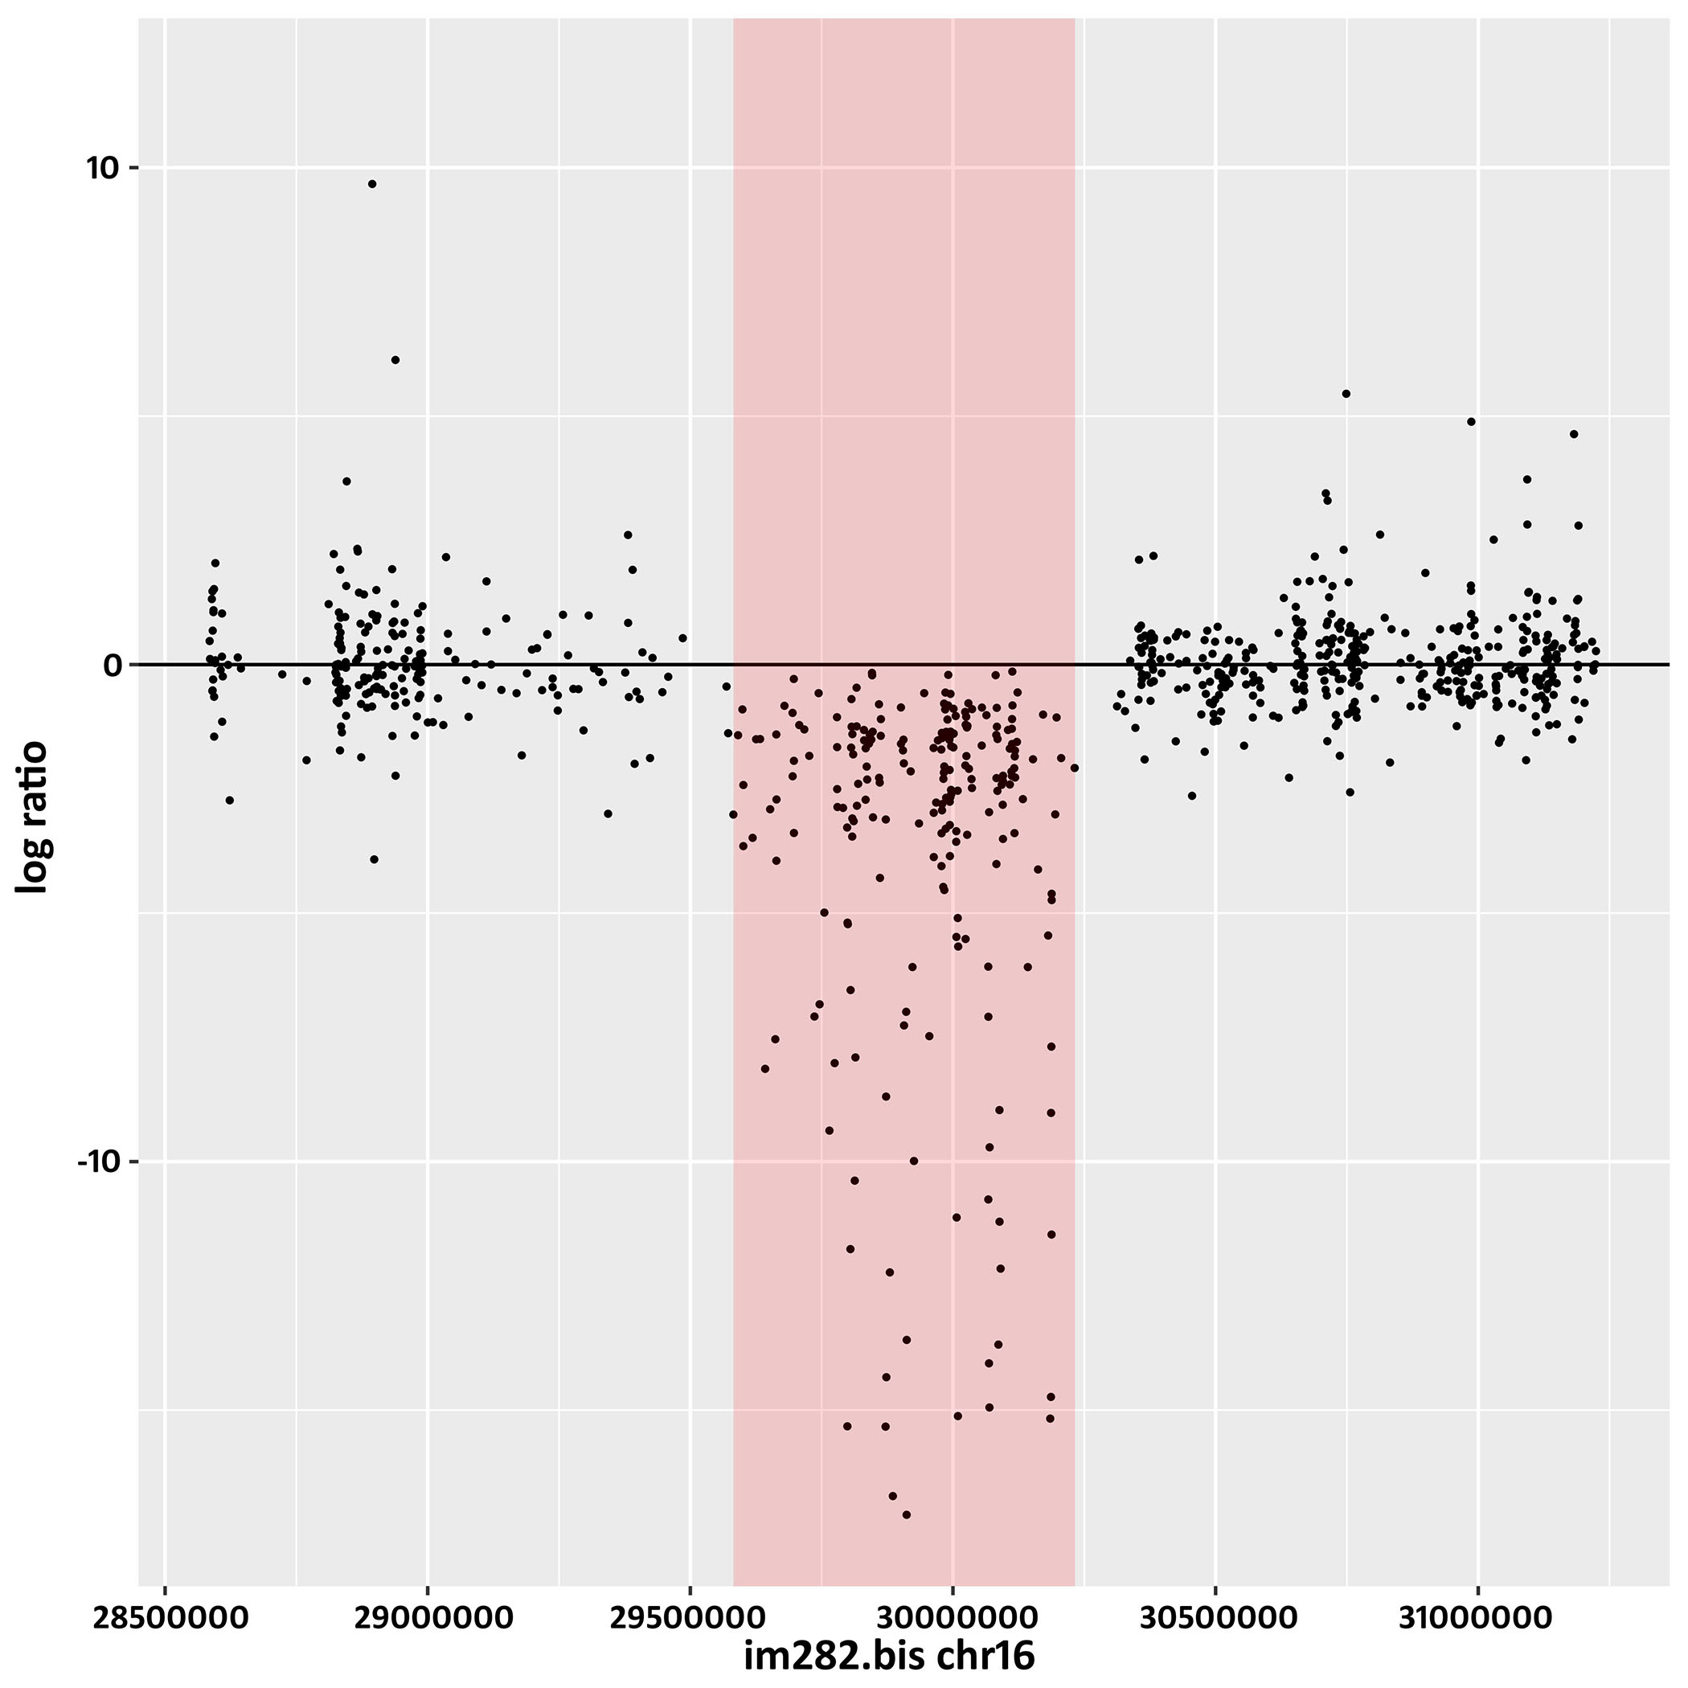
Supplementary Fig 7. Identification and validation of a copy-loss CNV in 16p11.2 obesity associated region found in #282 detected by CoDE-seq. Copy-loss is highlighted in red.

