Table S1 – Anthropometric and metabolic characteristics of the study subjects.*

|  |  |  |  |
| --- | --- | --- | --- |
|  | **Baseline** | **4 weeks** | ***p*** |
| Age (years) | 60 ± 9 | - | - |
| Body weight (kg) | 96 ± 16 | 94 ± 16 | <0.0001 |
| Body mass index (kg.m-2) | 31.6 ± 4.6 | 31.1 ± 4.5 | <0.0001 |
| HbA1c (%) | 7.2 ± 1.0 | 6.8 ± 0.8 | <0.0001 |
| Fasting plasma glucose (mmol/L) | 7.5 ± 1.6 | 6.4 ± 1.0 | <0.0001 |
| Creatinine clearance (ml.min-1.1.73m-2) | 101 ± 24 | 97 ± 24 | 0.0023 |

*entries are mean ± SD; *p* values are from Wilcoxon

Table S2 – Protein targets with an FDR *p*<0.10 adjusted for creatinine clearance.

|  |  |  |  |  |  |
| --- | --- | --- | --- | --- | --- |
| **TARGET** | **Gene** | **UniProt** | ***p*** | **Bonferroni *p*** | **FDR** |
| Ferritin | *FTH1 FTL* | P02794 P02792 | 1.44E-12 | 5.35E-09 | 5.22E-09 |
| IGFBP-1 | *IGFBP1* | P08833 | 2.81E-12 | 1.04E-08 | 5.22E-09 |
| FABPA | *FABP4* | P15090 | 1.46E-06 | 0.0054 | 0.0012 |
| FABP | *FABP3* | P05413 | 1.66E-06 | 0.0062 | 0.0012 |
| HE4 | *WFDC2* | Q14508 | 2.03E-05 | 0.075 | 0.013 |
| BSP | *IBSP* | P21815 | 2.65E-05 | 0.098 | 0.014 |
| MIC-1 | *GDF15* | Q99988 | 3.81E-05 | 0.14 | 0.018 |
| QSOX2 | *QSOX2* | Q6ZRP7 | 4.99E-05 | 0.19 | 0.021 |
| TR | *TFRC* | P02786 | 5.78E-05 | 0.22 | 0.021 |
| PTPRU | *PTPRU* | Q92729 | 0.00011 | 0.42 | 0.038 |
| FAM3B | *FAM3B* | P58499 | 0.00012 | 0.46 | 0.038 |
| TMEDA | *TMED10* | P49755 | 0.00018 | 0.65 | 0.047 |
| TFF3 | *TFF3* | Q07654 | 0.00018 | 0.65 | 0.047 |
| GDF2 | *GDF2* | Q9UK05 | 0.00025 | 0.93 | 0.062 |
| S22AG | *SLC22A16* | Q86VW1 | 0.00028 | 1 | 0.064 |
| DSC2 | *DSC2* | Q02487 | 0.00040 | 1 | 0.087 |
| SLIK3 | *SLITRK3* | O94933 | 0.00048 | 1 | 0.099 |

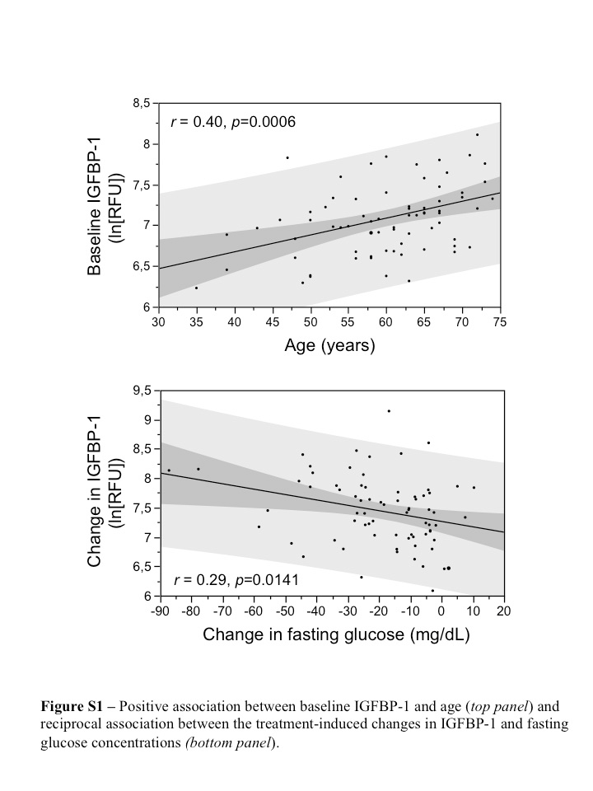

**Figure S2** – **Proteins significantly altered by empagliflozin associated with iron homeostasis.** Nodes represent gene symbol name, corresponding to protein measured. The degree of intensity of the node color (red) indicates degree of significance of *p*-value. The dashed lines correspond to the implicated function of the given proteins according to the IPA knowledge bank. The node shapes denote cytokine (), transmembrane receptor (), transporter (), transcription regulator (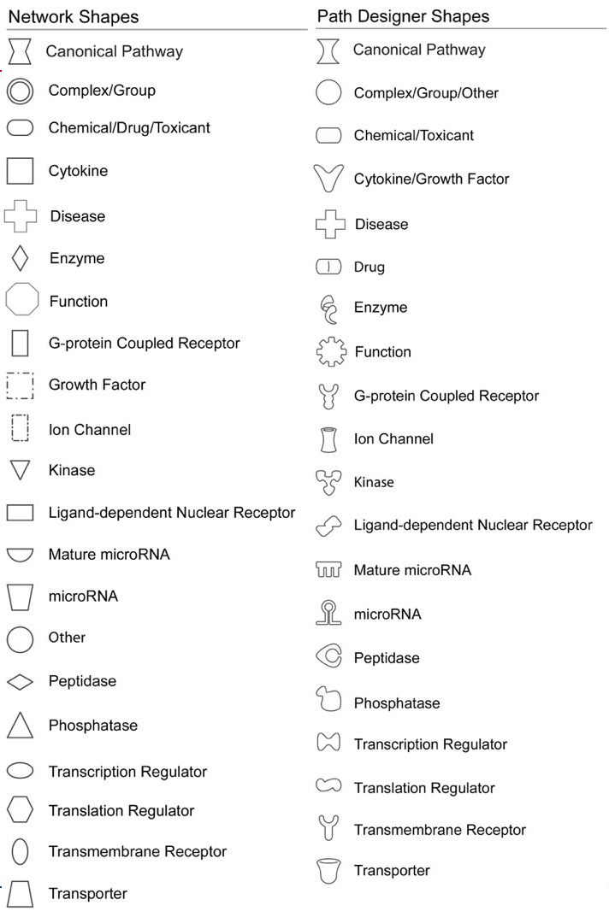), and enzyme ().

