Online-only Supplements

eTable 1: ICD-9-CM codes of diabetes-related complications
eTable 2: ICD-9-CM codes of comorbidities
eTable 3: Patient characteristics during the follow-up stratified by gender
eTable 4: Cost multipliers and associated 95% CIs for patient demographics, comorbidities, diabetes-related complications, antidiabetic drug exposure, and death: sensitivity analysis 2 in which the comorbidity status measured in the year before or at T2D diagnosis was modeled in the analysis
eTable 5: Cost multipliers and associated 95% CIs for patient demographics, comorbidities, diabetes-related complications, antidiabetic drug exposure, and death: sensitivity analysis 3 in which antidiabetic drug exposure during the follow-up was measured by medication possession ratio and modeled in the analysis
eFigure 1: Selection algorithm for study patients with type 2 diabetes (T2D)
eFigure 2: Annual crude healthcare costs of non-fatal macrovascular, microvascular, and metabolic complications over time
eFigure 3: Crude healthcare costs of non-fatal macrovascular, microvascular, and metabolic complications in the event year (in 2017 US$)
eFigure 4: Crude healthcare costs of non-fatal stroke stratified by subtype in the event year (in 2017 US$)
eFigure 5: Crude healthcare costs of nephropathy stratified by subtype in the event year (in 2017 US$)
eFigure 6: Crude healthcare costs of retinopathy stratified by subtype in the event year (in 2017 US$)
eFigure 7: Crude healthcare costs of peripheral vascular disease stratified by subtype in the event year (in 2017 US$)
eFigure 8: Crude healthcare costs of death stratified by cause in the event year (in 2017 US$)
eFigure 9: Mean annual state-year healthcare costs of non-fatal macrovascular complications over 12 years after the events occurred (in 2017 US$)
eFigure 10: Mean annual state-year healthcare costs of microvascular complications over 12 years after the events occurred (in 2017 US$)
eFigure 11: Mean annual state-year healthcare costs of non-fatal stroke by subtype over 12 years after the events occurred (in 2017 US$)
eFigure 12: Mean annual state-year healthcare costs of nephropathy by subtype over 12 years after the events occurred (in 2017 US$)
eFigure 13: Mean annual state-year healthcare costs of retinopathy by subtype over 12 years after the events occurred (in 2017 US$)
eFigure 14: Mean annual state-year healthcare costs of peripheral vascular disease by subtype over 12 years after the events occurred (in 2017 US$)

eTable 1: ICD-9-CM codes of diabetes-related complications
Condition | Code | Description
Stroke | 430 | Subarachnoid hemorrhage
 | 431 | Intracerebral hemorrhage
 | 432 | Other and unspecified intracranial hemorrhage
 | 433 | Occlusion and stenosis of precerebral arteries
 | 434 | Occlusion of cerebral arteries
 | 436 | Acute, but ill-defined, cerebrovascular disease
 | 437 | Other and ill-defined cerebrovascular disease
 | 435 | Transient cerebral ischemia
 | V12.54 | Personal history of transient ischemic attack, and cerebral infarction without residual deficits
Acute myocardial infarction | 410 | Acute myocardial infarction
 | 412 | Old myocardial infarction
Ischemic heart disease | 411 | Other acute and subacute forms of ischemic heart disease
 | 413 | Angina pectoris
 | 414 | Other forms of chronic ischemic heart disease
 | V45.81 | Aortocoronary bypass status
 | V45.82 | Percutaneous transluminal coronary angioplasty status
Heart failure | 428 | Heart failure
Arteriosclerotic cardiovascular disease | 429.2 | Arteriosclerotic cardiovascular disease
Arrhythmia | 426 | Conduction disorders
 | 427 | Cardiac dysrhythmias
Nephropathy | 250.4 | Diabetes with renal manifestations
 | 580 | Acute glomerulonephritis
 | 581 | Nephrotic syndrome
 | 582 | Chronic glomerulonephritis
 | 583 | Nephritis and nephropathy, not specified as acute or chronic
 | 584 | Acute renal failure
 | 585 | Chronic kidney disease stage with or without short-term dialysis
 |  | Chronic kidney disease stage with dialysis (end-stage renal disease)
 | V42.0 | Kidney transplant
 | 791.0 | Proteinuria
 | 586 | Renal failure, unspecified
 | 587 | Renal sclerosis, unspecified
 | 588 | Disorders resulting from impaired renal function
 | 593 | Other disorders of kidney and ureter
 | 791.0 | Proteinuria
 | V13.03 | Personal history, nephrotic syndrome
Retinopathy | 250.5 | Diabetes with ophthalmic manifestations
 | 361 | Retinal detachments and defects
 | 362 | Other retinal disorders
 | 364 | Acute and subacute iridocyclitis
 | 365 | Glaucoma
 | 368 | Other specified meningococcal infections
 | 369 | Meningococcal infection, unspecified (Blindness)
 | 377 | Disorders of optic nerve and visual pathways
 | 379.2 | Disorders of vitreous body
 | V19.0 | Family history of blindness or visual loss
 | 362.02 | Proliferative diabetic retinopathy
Neuropathy | 250.6 | Diabetes with neurological manifestations
 | 337.1 | Peripheral autonomic neuropathy in disorders classified elsewhere
 | 354 | Mononeuritis of upper limb and mononeuritis multiplex
 | 355 | Mononeuritis of lower limb
 | 357.2 | Polyneuropathy in diabetes
 | 358.1 | Myasthenic syndromes in diseases classified elsewhere
 | 302.72 | Psychosexual dysfunction with inhibited sexual excitement
 | 607.84 | Impotence of organic origin
 | 729.2 | Neuralgia, neuritis and radiculitis, unspecified
Peripheral vascular disease | V49.7 | Lower extremity amputation
84.1
(procedure code)
 | V49.6 | Upper extremity amputation
84.0
(procedure code)
 | 8921 | Diabetic foot ulcer
 | 7071
 | 250.7 | Diabetes with peripheral circulatory disorders
 | 040.0 | Gas gangrene
 | 707.1 | Ulcer of lower limbs, except decubitus
 | 785.4 | Gangrene
 | 440 | Atherosclerosis
 | 443 | Other peripheral vascular disease
 | 444 | Arterial embolism and thrombosis
 | 447.1 | Stricture of artery
 | 451 | Acute poliomyelitis with other paralysis
 | 452 | Acute nonparalytic poliomyelitis, poliovirus, unspecified type
 | 453 | Other venous embolism and thrombosis
 | 454 | Varicose veins of lower extremities
 | 459 | Acute poliomyelitis, unspecified
 | 885 | Traumatic amputation of thumb (complete) (partial) without mention of complication
 | 886 | Traumatic amputation of other fingers (complete) (partial) without mention of complication
 | 887 | Traumatic amputation, unilateral, below elbow, without mention of complication
 | 895 | Traumatic amputation of toe(s) (complete) (partial)
 | 896 | Traumatic amputation of foot (complete) (partial) , unilateral, without mention of complication
 | 897 | Traumatic amputation of leg(s) (complete) (partial)
Diabetic ketoacidosis | 250.1 | Diabetes with ketoacidosis
Hyperosmolar hyperglycemic syndrome | 250.2 | Diabetes with hyperosmolar coma
Hypoglycemia | 251.0 | Hypoglycemic coma
 | 251.1 | Other specified hypoglycemia
 | 251.2 | Hypoglycemia, unspecified
 | 250.8 | Diabetes with other specified manifestations
 | 962.3 | Poisoning by insulins and antidiabetic agents

eTable 2: ICD-9-CM codes of comorbidities
Condition | Code | Description
Hypertension | 401-405 | Hypertensive disease
Hyperlipidemia | 272 | Disorders of lipoid metabolism
Liver disease | 571 | Chronic liver disease and cirrhosis
 | 070.2 | Hepatitis B
 | 070.3
 | V02.61
 | 070.41 | Hepatitis C
 | 070.44
 | 070.51
 | 070.54
 | V02.62
Cancer | 140-208 | Malignant neoplasm
 | 210-229 | Benign neoplasm
 | 230-234 | Carcinoma in situ
 | 235-238 | Neoplasms of uncertain behavior
Depression | 311 | Depressive disorder, not elsewhere classified
 | 298.0 | Depressive type
 | 296.2 | Manic-depressive psychosis, circular type but currently manic
 | 296.3 | Manic-depressive psychosis, circular type but currently depressed
 | 300.4 | Dysthymic disorder
 | 296.82 | Atypical depressive disorder
 | 309.0 | Adjustment disorder with depressed mood
 | 309.1 | Prolonged depressive reaction
 | 309.28 | Adjustment reaction with anxiety and depression

eTable 3: Patient characteristics during the follow-up stratified by gender
Characteristics | Total population | Male | Female
Cohort size, n (%) | 802,429 (100.0) | 430,799 (53.7) | 371,630 (46.3)
Total follow-up duration (person-years) | 5,540,620 | 2,886,232 | 2,654,388
Per-person follow-up duration (years), mean (SD) | 6.90 (5.94) | 6.70 (5.73) | 7.14 (6.15)
Event rate of comorbidity (no. of events per 100 person-years)
Hypertension | 18.73 | 18.65 | 18.82
Hyperlipidemia | 20.04 | 19.90 | 20.20
Liver disease | 8.44 | 9.57 | 7.28
Cancer | 6.55 | 5.54 | 7.83
Depression | 1.48 | 1.18 | 1.82
Incidence rate of diabetes complication (no. of events per 100 person-years)
Stroke | 1.04 | 1.17 | 0.90
Ischemic stroke | 0.76 | 0.86 | 0.64
Hemorrhagic stroke | 0.21 | 0.25 | 0.16
Transient ischemic attack | 0.22 | 0.23 | 0.22
Myocardial infarction | 0.25 | 0.34 | 0.16
Ischemic heart disease | 1.09 | 1.24 | 0.94
Heart failure | 0.50 | 0.49 | 0.51
Arteriosclerotic CVD | 0.01 | 0.01 | 0.01
Arrhythmia | 0.56 | 0.59 | 0.53
Nephropathy | 4.63 | 5.00 | 4.23
CKD with or without short-term dialysis | 0.82 | 0.92 | 0.71
ESRD with dialysis | 0.15 | 0.17 | 0.13
Proteinuria | 0.62 | 0.68 | 0.56
Kidney transplant | 0.01 | 0.01 | 0.01
Other nephropathy | 2.39 | 2.51 | 2.27
Retinopathy | 6.62 | 6.05 | 7.28
Proliferative retinopathy | 0.46 | 0.47 | 0.44
Blindness | 0.02 | 0.02 | 0.02
Other retinopathy | 4.52 | 4.22 | 4.86
Neuropathy | 5.41 | 5.07 | 5.80
Peripheral vascular disease | 2.47 | 2.43 | 2.52
Diabetes foot ulcer | 0.36 | 0.42 | 0.30
Upper extremity amputation | 0.01 | 0.01 | 0.01
Lower extremity amputation | 0.07 | 0.10 | 0.05
Other peripheral vascular disease | 1.80 | 1.71 | 1.90
Hospitalized diabetic ketoacidosis | 0.25 | 0.29 | 0.19
Hospitalized HHS | 0.23 | 0.28 | 0.17
Hospitalized hypoglycemia | 0.65 | 0.68 | 0.62
Antidiabetic drug exposure rate (no. of exposure per 100 person-years)
None | 43.27 | 40.31 | 46.47
Only oral | 51.09 | 53.41 | 48.57
Only injectable | 1.30 | 1.50 | 1.08
Oral + injectable | 4.34 | 4.77 | 3.88
Death (no. of events per 100 persons)
All-cause death | 6.88 | 8.17 | 5.38
Fatal CVD | 0.93 | 1.04 | 0.81
Fatal stroke | 0.50 | 0.56 | 0.43
Fatal myocardial infarction | 0.28 | 0.32 | 0.22
Fatal ischemic heart disease | 0.28 | 0.33 | 0.23
Fatal heart failure | 0.46 | 0.48 | 0.44
Other-cause death | 5.95 | 7.13 | 4.57

Abbreviations: SD: standard deviation, CVD: cardiovascular disease, CKD: chronic kidney disease, ESRD: end-stage renal disease, HHS: hyperosmolar hyperglycemic syndrome.

Notes:

1) Injectable antidiabetic drugs included insulin and glucagon-like peptide-1 receptor agonists.

2) Fatal CVD was a composite endpoint of death from stroke, myocardial infarction, ischemic heart disease, or heart failure.

eTable 4: Cost multipliers and associated 95% CIs for patient demographics, comorbidities, diabetes-related complications, antidiabetic drug exposure, and death: sensitivity analysis 2 in which the comorbidity status measured in the year before or at T2D diagnosis was modeled in the analysis
Baseline annual healthcare cost (2017 US$), mean (95% CI) | 316.56 (315.17-317.95)
Variable | Multiplier | 95% CI
Age at T2D diagnosis, years (ref.: <50)
50-59 | 1.15 | 1.15 | 1.16
60-69 | 1.36 | 1.35 | 1.36
>=70 | 1.58 | 1.57 | 1.59
Diabetes duration, years (ref.: 1-4)
>=5 | 0.88 | 0.88 | 0.88
Female (ref.: male) | 1.05 | 1.04 | 1.05
Comorbidity at T2D diagnosis (ref.: none)
Hypertension | 1.28 | 1.28 | 1.29
Hyperlipidemia | 0.99 | 0.98 | 0.99
Liver disease | 1.15 | 1.14 | 1.15
Cancer | 1.33 | 1.32 | 1.34
Depression | 1.64 | 1.62 | 1.66
Oral antidiabetic drug exposure (ref.: none) | 1.79 | 1.78 | 1.79
Injectable antidiabetic drug exposure (ref.: none) | 1.86 | 1.85 | 1.87
Complication (event year) (ref.: none)
Stroke | 3.02 | 2.99 | 3.05
Myocardial infarction | 2.54 | 2.49 | 2.59
Ischemic heart disease | 2.54 | 2.52 | 2.57
Heart failure | 2.27 | 2.23 | 2.30
Arteriosclerotic CVD | 1.82 | 1.63 | 2.03
Arrhythmia | 2.06 | 2.03 | 2.09
Nephropathy | 1.51 | 1.50 | 1.51
Retinopathy | 1.38 | 1.38 | 1.38
Neuropathy | 1.42 | 1.42 | 1.43
Peripheral vascular disease | 1.57 | 1.56 | 1.58
Hospitalized diabetic ketoacidosis | 1.92 | 1.89 | 1.95
Hospitalized HHS | 1.72 | 1.69 | 1.76
Hospitalized hypoglycemia | 1.93 | 1.91 | 1.95
Complication (state year) (ref.: none)
Stroke | 1.45 | 1.44 | 1.46
Myocardial infarction | 1.19 | 1.17 | 1.21
Ischemic heart disease | 1.33 | 1.31 | 1.34
Heart failure | 1.49 | 1.47 | 1.52
Arteriosclerotic CVD | 1.14 | 1.04 | 1.26
Arrhythmia | 1.15 | 1.14 | 1.16
Nephropathy | 1.20 | 1.19 | 1.20
Retinopathy | 1.15 | 1.15 | 1.15
Neuropathy | 1.15 | 1.15 | 1.15
Peripheral vascular disease | 1.16 | 1.15 | 1.17
Death (ref.: none)
Fatal CVD | 18.84 | 18.34 | 19.35
Other-cause death | 15.14 | 14.96 | 15.32

Abbreviations: CI: confidence interval, T2D: type 2 diabetes, CVD: cardiovascular disease, HHS: hyperosmolar hyperglycemic syndrome.

Notes:

1) All variables in the model were statistically significant at p < 0.05.

2) Injectable antidiabetic drugs included insulin and glucagon-like peptide-1 receptor agonists.

3) Fatal CVD was a composite endpoint of death from stroke, myocardial infarction, ischemic heart disease, or heart failure.

4) All variables were treated as time-dependent variables in the model, except age, gender, and comorbidity.

eTable 5: Cost multipliers and associated 95% CIs for patient demographics, comorbidities, diabetes-related complications, antidiabetic drug exposure, and death: sensitivity analysis 3 in which antidiabetic drug exposure during the follow-up was measured by medication possession ratio and modeled in the analysis
Baseline annual healthcare cost (2017 US$), mean  (95% CI) | 275.75 (273.83-277.72)
Variable | Multiplier | 95% CI
Age at T2D diagnosis, years (ref.: <50)
50-59 | 1.19 | 1.19 | 1.20
60-69 | 1.42 | 1.41 | 1.43
>=70 | 1.67 | 1.66 | 1.68
Diabetes duration, years (ref.: 1-4)
>=5 | 0.85 | 0.85 | 0.85
Female (ref.: male) | 1.06 | 1.05 | 1.06
Comorbidity (ref.: none)
Hypertension | 1.22 | 1.21 | 1.22
Hyperlipidemia | 1.07 | 1.07 | 1.08
Liver disease | 0.98 | 0.98 | 0.99
Cancer | 1.05 | 1.05 | 1.06
Depression | 1.81 | 1.80 | 1.82
Oral antidiabetic drug exposure (ref.: none)
MPR<0.8 | 1.72 | 1.71 | 1.72
MPR>=0.8 | 2.25 | 2.24 | 2.26
Injectable antidiabetic drug exposure (ref.: none)
MPR <0.8 | 1.81 | 1.81 | 1.82
MPR ≥0.8 | 2.26 | 2.22 | 2.29
Complication (event year) (ref.: none)
Stroke | 2.95 | 2.92 | 2.98
Myocardial infarction | 2.54 | 2.49 | 2.59
Ischemic heart disease | 2.51 | 2.48 | 2.53
Heart failure | 2.25 | 2.22 | 2.28
Arteriosclerotic CVD | 1.79 | 1.60 | 2.00
Arrhythmia | 2.05 | 2.02 | 2.07
Nephropathy | 1.49 | 1.48 | 1.49
Retinopathy | 1.36 | 1.36 | 1.37
Neuropathy | 1.40 | 1.40 | 1.41
Peripheral vascular disease | 1.55 | 1.54 | 1.56
Hospitalized diabetic ketoacidosis | 1.91 | 1.88 | 1.94
Hospitalized HHS | 1.74 | 1.71 | 1.77
Hospitalized hypoglycemia | 1.90 | 1.88 | 1.92
Complication (state year) (ref.: none)
Stroke | 1.44 | 1.42 | 1.45
Myocardial infarction | 1.19 | 1.16 | 1.21
Ischemic heart disease | 1.32 | 1.31 | 1.33
Heart failure | 1.49 | 1.47 | 1.51
Arteriosclerotic CVD | 1.14 | 1.04 | 1.26
Arrhythmia | 1.14 | 1.13 | 1.16
Nephropathy | 1.18 | 1.17 | 1.18
Retinopathy | 1.13 | 1.13 | 1.13
Neuropathy | 1.13 | 1.12 | 1.13
Peripheral vascular disease | 1.14 | 1.14 | 1.15
Death (ref.: none)
Fatal CVD | 21.01 | 20.44 | 21.59
Other-cause death | 16.84 | 16.62 | 17.06

Abbreviations: CI, confidence interval, T2D: type 2 diabetes, MPR: medication possession ratio, CVD: cardiovascular disease, HHS: hyperosmolar hyperglycemic syndrome.
Notes:
1) All variables in the model were statistically significant at p < 0.05.
2) Injectable antidiabetic drugs included insulin and glucagon-like peptide-1 receptor agonists.

3) Fatal CVD was a composite endpoint of death from stroke, myocardial infarction, ischemic heart disease, or heart failure.

4) All variables were treated as time-dependent variables in the model, except age and gender. Hypertension, hyperlipidemia, liver disease, and cancer were considered as chronic diseases and assumed to be irreversible once they occurred, so the status of these comorbidities remained in the subsequent follow-up years. Depression status could be in-and-out, depending on whether patients had a diagnosis in a given year.

eFigure 1: Selection algorithm for study patients with type 2 diabetes (T2D)
Total population with diabetes diagnosis
(n=1,679,553)
Study cohort
(n=802,429)
Exclusion criteria: (n=576,043)
Patients with any vascular complications in the year before or at T2D diagnosis
Patients with T2D and without any vascular complications in the year before or at T2D diagnosis
(n=802,493)
Inclusion criteria:
Age ≥18
ICD-9-CM code=250.X0, 250.X2
(n=1,378,536)

Exclusion criteria: (n=64)
Undefined gender (n=63)
Zero medical expense (n=1)

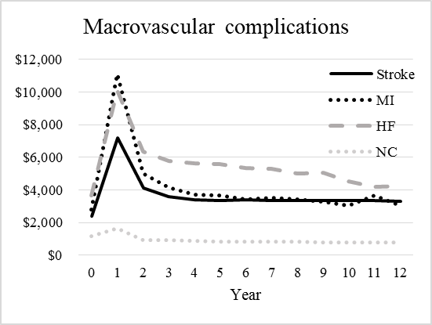
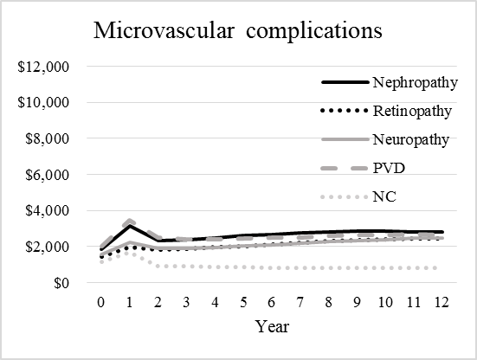
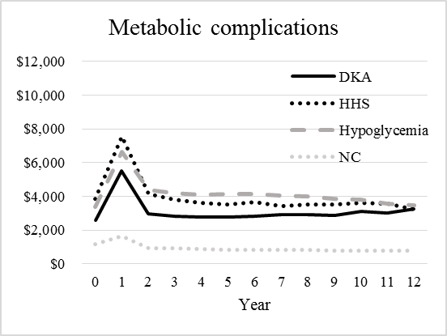
eFigure 2: Annual crude healthcare costs of non-fatal macrovascular, microvascular, and metabolic complications over time
Abbreviations: MI: myocardial infarction, HF: heart failure, PVD: peripheral vascular disease, DKA: diabetic ketoacidosis, HHS: hyperosmolar hyperglycemic syndrome, NC: no complications.
Notes:
1. Year 0: the year before the complications occurred, Year 1: the year when the complications occurred, Years 2-12: subsequent years after the complications occurred.
2. The dotted “NC” line refers to the annual crude healthcare costs for type 2 diabetes patients without any complications throughout the study follow-up period.

eFigure 3: Crude healthcare costs of non-fatal macrovascular, microvascular, and metabolic complications in the event year (in 2017 US$)
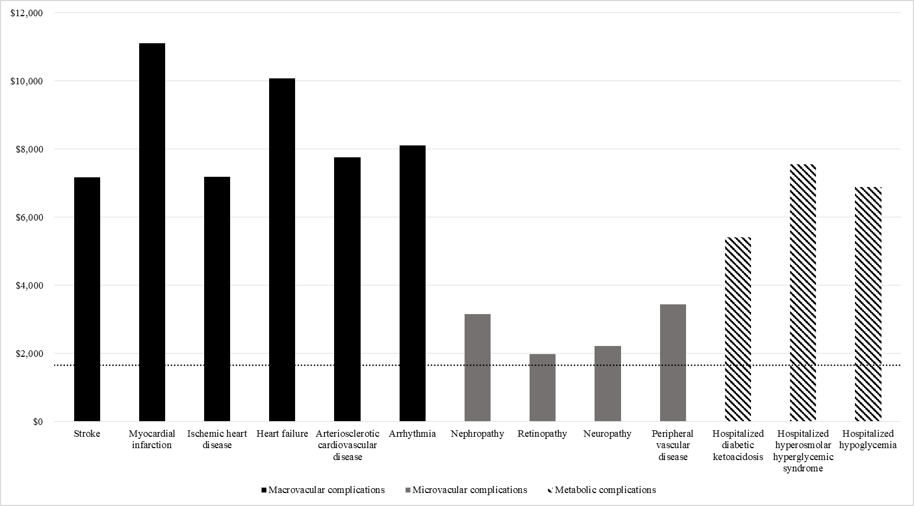
Note: The horizontal dotted line refers to the crude healthcare costs for type 2 diabetes patients without any complications.
eFigure 4: Crude healthcare costs of non-fatal stroke stratified by subtype in the event year (in 2017 US$)
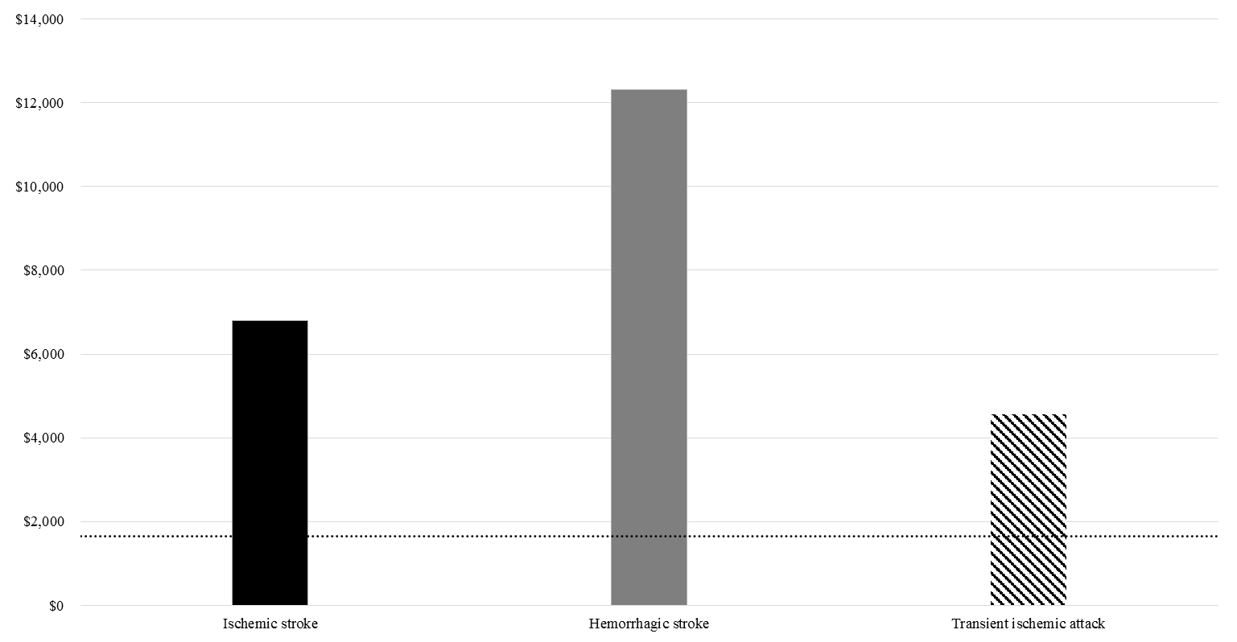
Note: The horizontal dotted line refers to the crude healthcare costs for type 2 diabetes patients without any complications.
eFigure 5: Crude healthcare costs of nephropathy stratified by subtype in the event year (in 2017 US$)
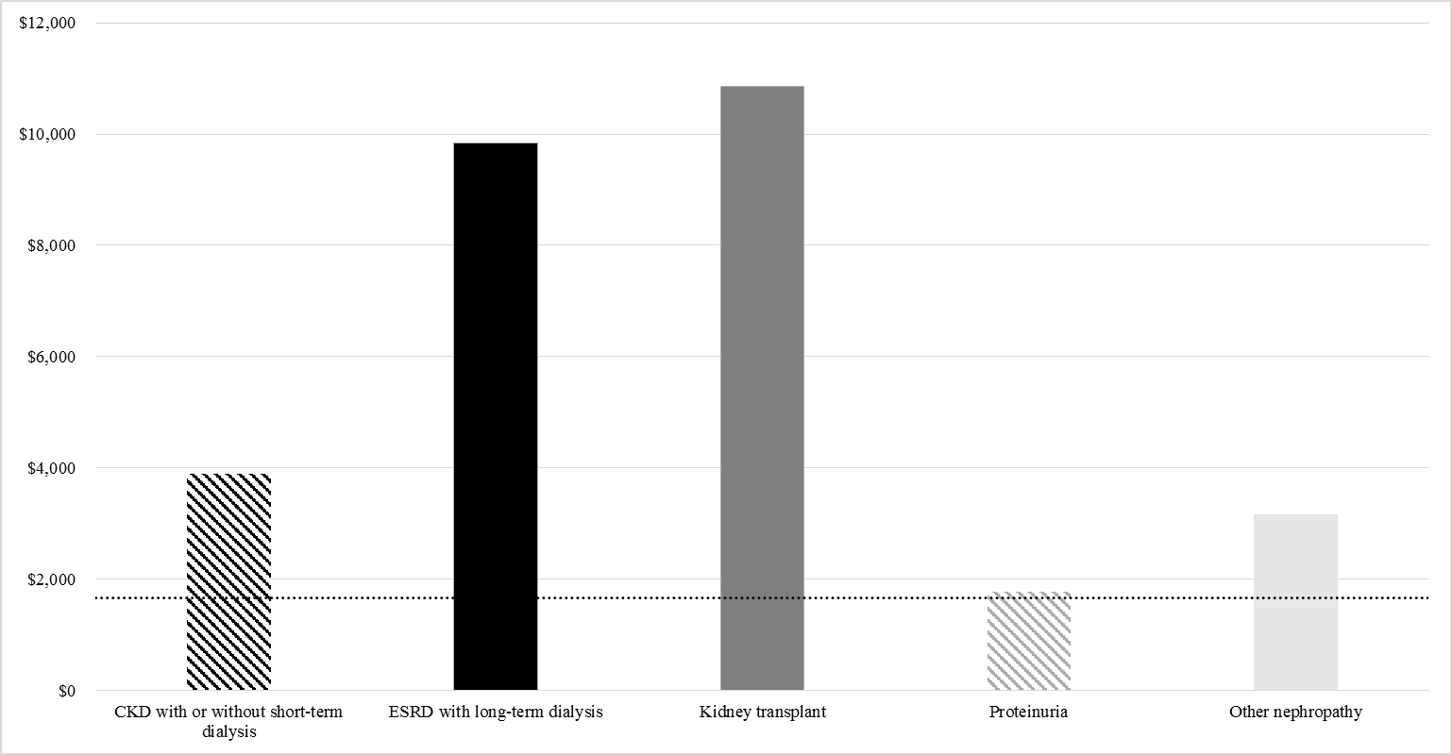
Note: The horizontal dotted line refers to the crude healthcare costs for type 2 diabetes patients without any complications.
eFigure 6: Crude healthcare costs of retinopathy stratified by subtype in the event year (in 2017 US$)
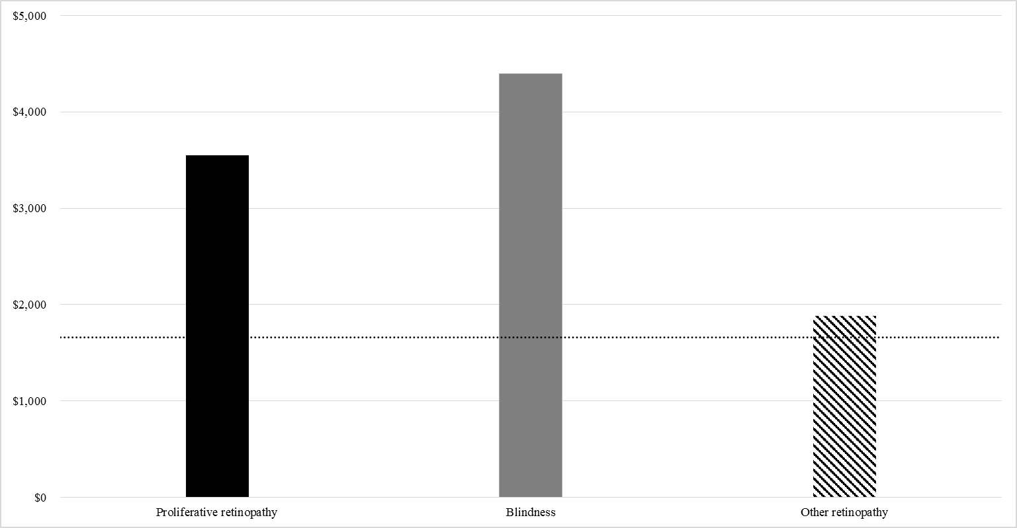
Note: The horizontal dotted line refers to the crude healthcare costs for type 2 diabetes patients without any complications.
eFigure 7: Crude healthcare costs of peripheral vascular disease stratified by subtype in the event year (in 2017 US$)
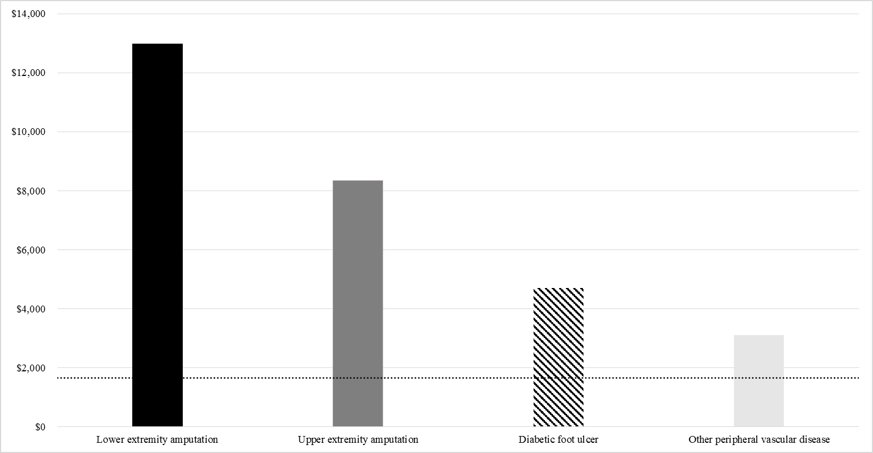
Note: The horizontal dotted line refers to the crude healthcare costs for type 2 diabetes patients without any complications.
eFigure 8: Crude healthcare costs of death stratified by cause in the event year (in 2017 US$)
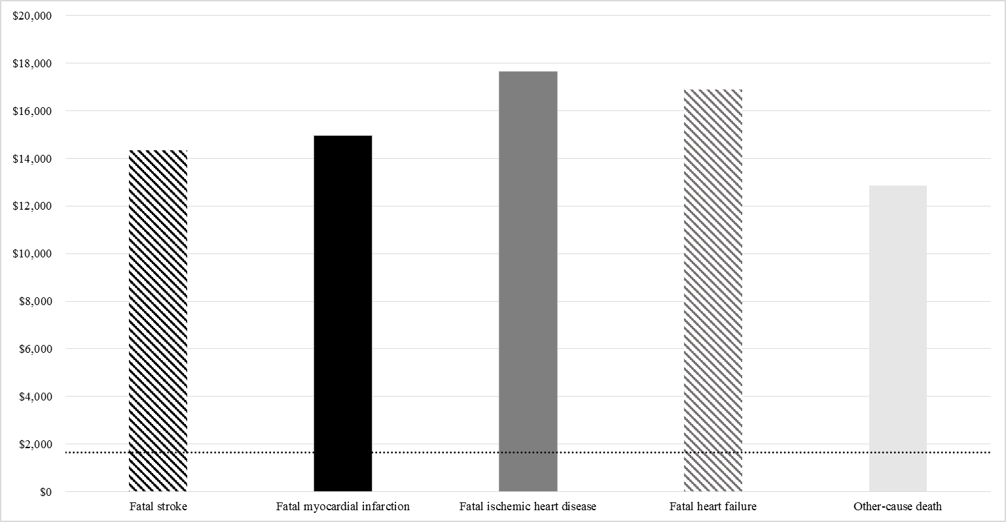
Note: The horizontal dotted line refers to the crude healthcare costs for type 2 diabetes patients without any complications.
eFigure 9: Mean annual state-year healthcare costs of non-fatal macrovascular complications over 12 years after the events occurred (in 2017 US$)
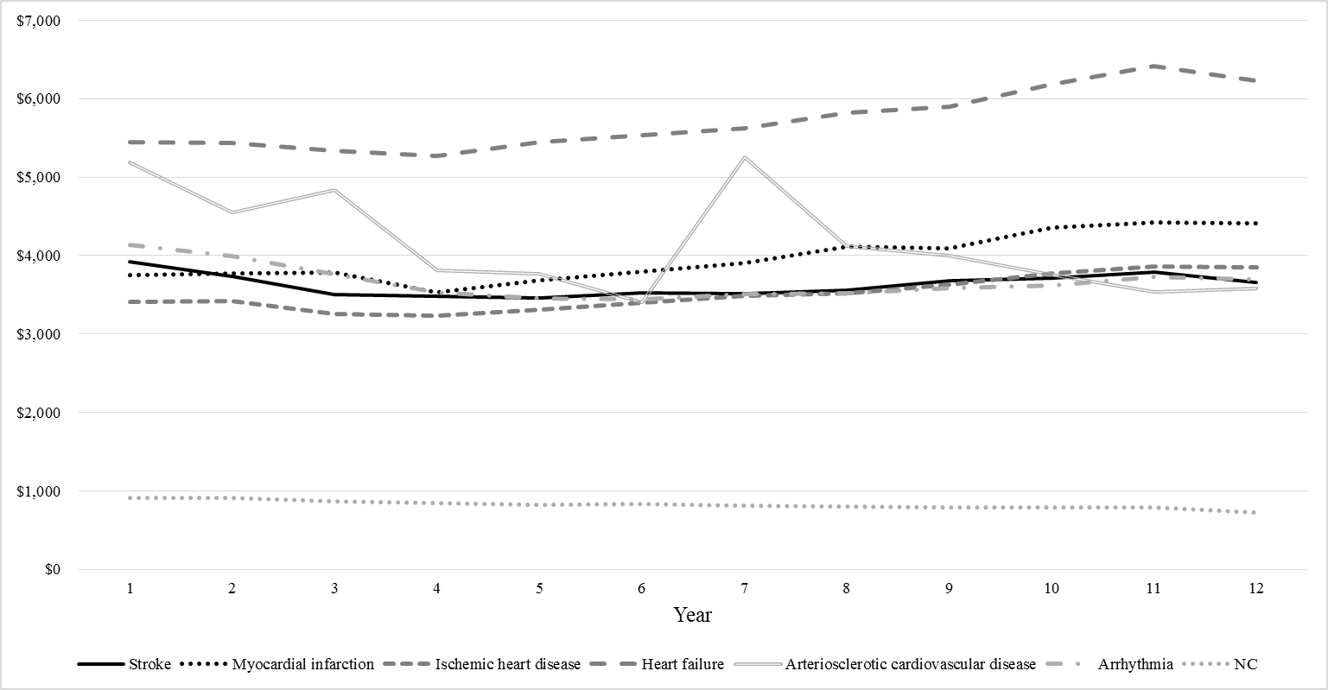
Abbreviation: NC: no complications.
Note: The dotted “NC” line refers to the annual state-year healthcare costs for type 2 diabetes patients without any complications throughout the study follow-up period.
eFigure 10: Mean annual state-year healthcare costs of microvascular complications over 12 years after the events occurred (in 2017 US$) 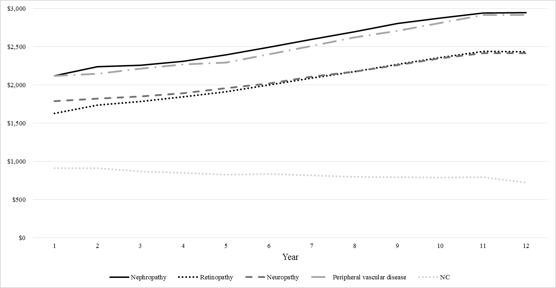
Abbreviation: NC: no complications.
Note: The dotted “NC” line refers to the annual state-year healthcare costs for type 2 diabetes patients without any complications throughout the study follow-up period.
eFigure 11: Mean annual state-year healthcare costs of non-fatal stroke by subtype over 12 years after the events occurred (in 2017 US$)
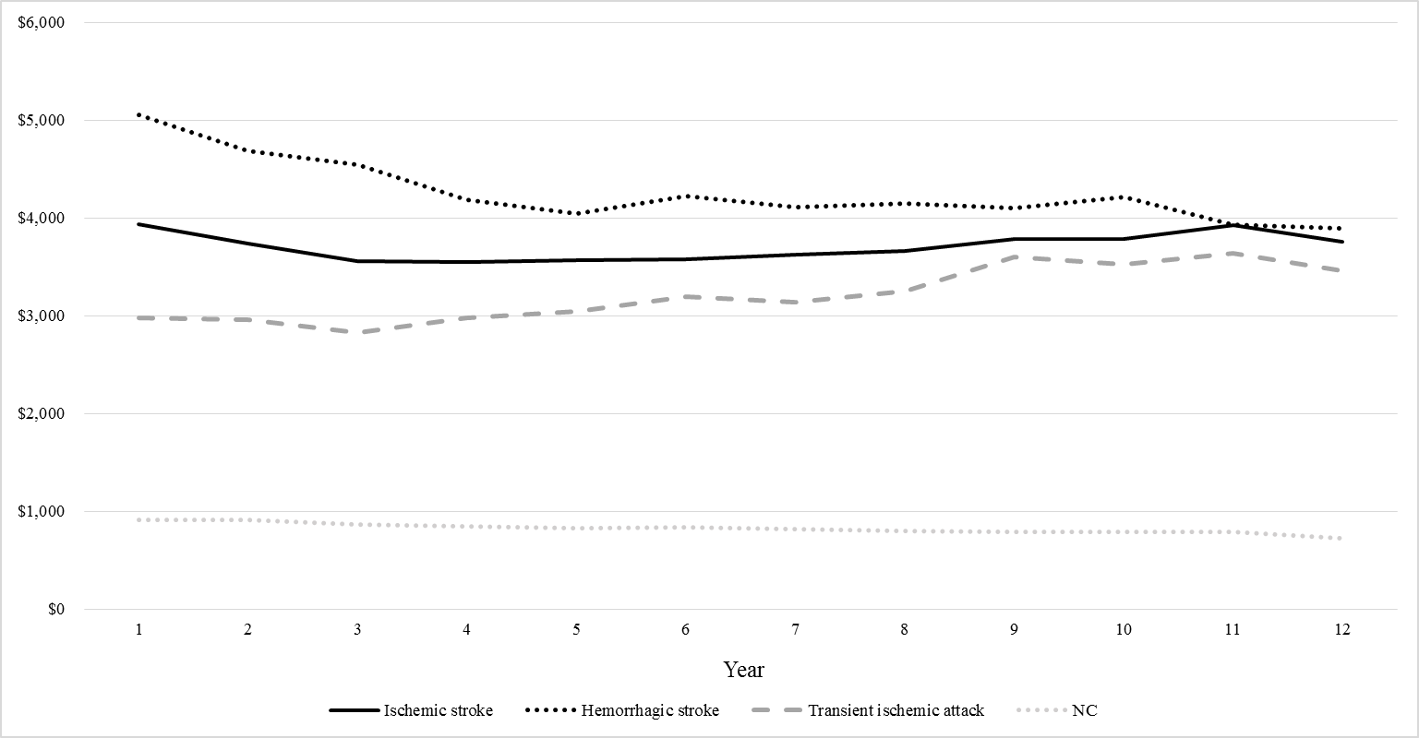
Abbreviation: NC: no complications.
Note: The dotted “NC” line refers to the annual state-year healthcare costs for type 2 diabetes patients without any complications throughout the study follow-up period.
eFigure 12: Mean annual state-year healthcare costs of nephropathy by subtype over 12 years after the events occurred (in 2017 US$)
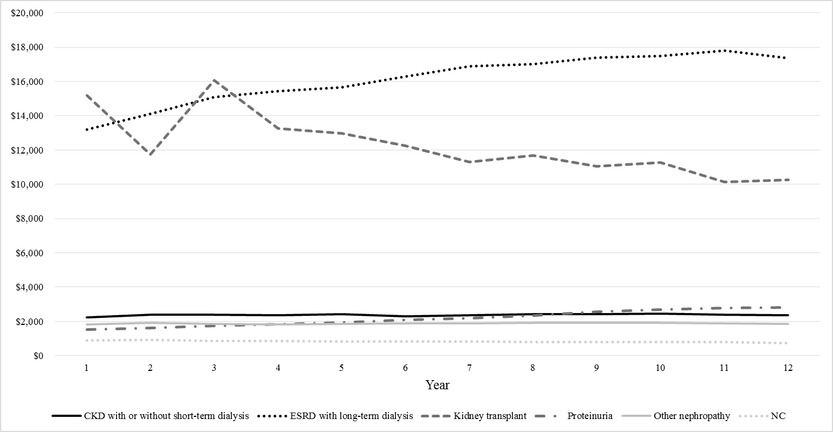
Abbreviation: NC: no complications.
Note: The dotted “NC” line refers to the annual state-year healthcare costs for type 2 diabetes patients without any complications throughout the study follow-up period.
eFigure 13: Mean annual state-year healthcare costs of retinopathy by subtype over 12 years after the events occurred (in 2017 US$)
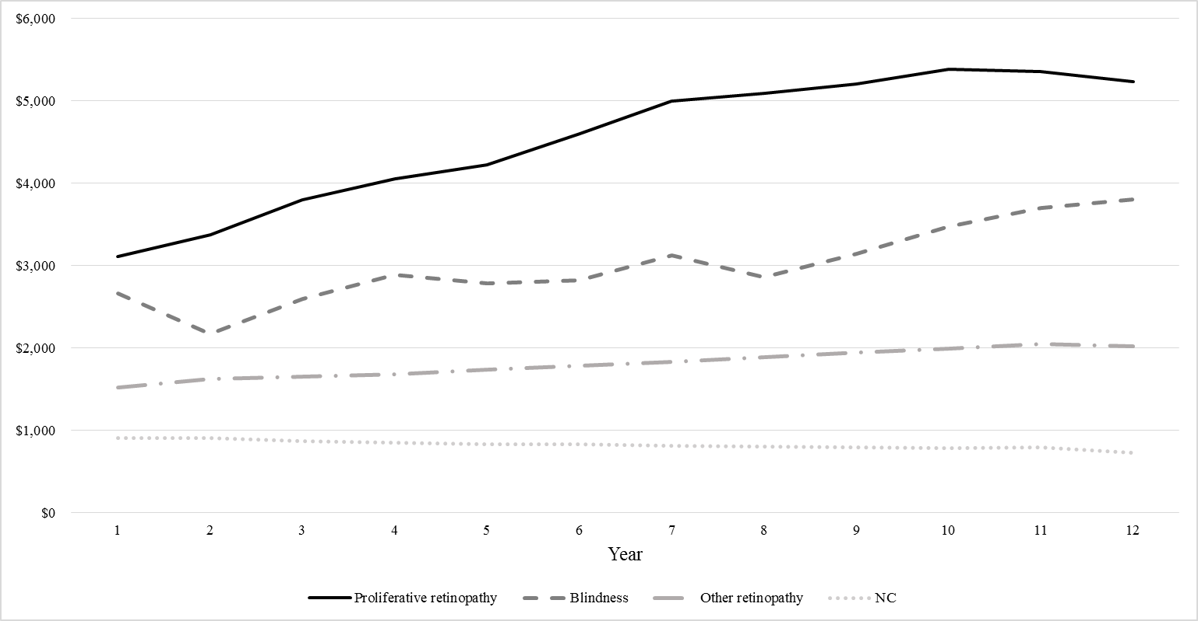
Abbreviation: NC: no complications.
Note: The dotted “NC” line refers to the annual state-year healthcare costs for type 2 diabetes patients without any complications throughout the study follow-up period.
eFigure 14: Mean annual state-year healthcare costs of peripheral vascular disease by subtype over 12 years after the events occurred (in 2017 US$)
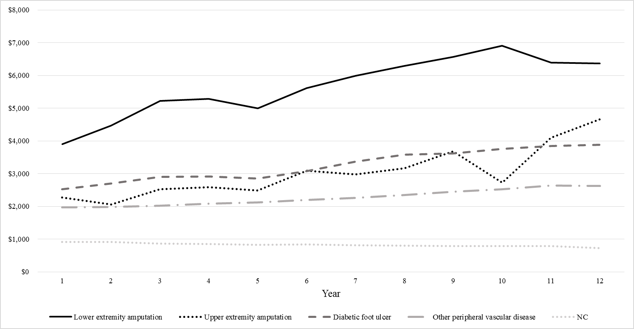
Abbreviation: NC: no complications.
Note: The dotted “NC” line refers to the annual state-year healthcare costs for type 2 diabetes patients without any complications throughout the study follow-up period.

