# Supplemental Material

## Supplemental Figure 1. Study Flow Chart.

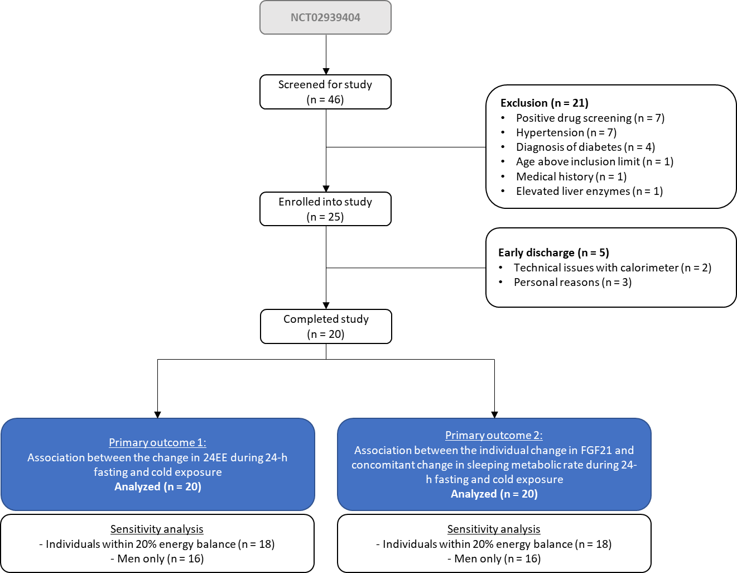

The clinical trial NCT02939404 was designed to evaluate the food intake response to short-term alteration of energy metabolism via cold exposure in humans. At the time of data analysis, 46 individuals were screened for the study, 25 were enrolled into the study, and 20 individuals completed the study. All individuals were 18 years or older and living in and nearby Phoenix, AZ. Participants self-reported to be weight stable (<10% weight variation) for at least 6 months prior to admission and were healthy by history, physical examination, and fasting blood tests. Individuals with a body mass index lower than 18.5 kg/m2 or greater than 50 kg/m2 were excluded. Participants were instructed to refrain from vigorous exercise and to restrict their activities to those available on the research unit.

Power calculations were performed prior to data analyses to calculate the minimum detectable correlation between the change in 24EE during COLD and fasting. Assuming a power=0.80 (2-sided alpha level=0.05), a total of 19 participants were needed to detect a correlation r=0.60, which is comparable to what has been previously found by Wijers *et al.* for the correlation between the change in 24EE during COLD and overfeeding (r=0.63)(1).

## Supplemental Figure 2. Association of fat-free mass with 24EE during 24-h (A) energy balance, (B) cold exposure, and (C) fasting.



24EE, 24-h energy expenditure.

**Supplemental Figure 3. Distribution of body mass index values across study participants.**



## Supplemental Figure 4. Associations between 24EE during energy balance at thermoneutrality and COLD or fasting conditions at thermoneutrality.



The bold linear regression line denotes the association between 24EE during energy balance and fasting and has a slope of 0.90 (95% CI: 0.74, 1.06), while the light linear regression line denotes the association between 24EE during energy balance and cold exposure and has a slope of 0.92 (95% CI: 0.80, 1.05). The dotted line denotes the identity line.

Two volunteers had a 24-h energy balance greater than 20%. We performed sensitivity analyses in n=18 volunteers after their exclusion and found similar results (data not shown).

24EE, 24-h energy expenditure; CI, confidence interval.

## Supplemental Figure 5. Association between (A) the change in adjusted 24EE during fasting and cold exposure, and between (B) 24EE during fasting and cold exposure adjusted by 24EE during energy balance.



Individual changes (∆) in adjusted 24EE and SLEEP were calculated as the difference between cold exposure or fasting condition minus energy balance condition.

Adjusted energy expenditure values were calculated by adding the average value calculated in the whole cohort to the residual values obtained from linear regression models with covariates fat mass and fat-free mass (for panel A), and with 24EE during energy balance (for panel B).

24EE, 24-h energy expenditure.

**Supplemental Figure 6. Changes in (A) 24EE and (B) SLEEP compared between *thrifty* and *spendthrift* individuals defined by the two lower/upper quintiles of the fasting-induced decrease in 24EE.**



Individual changes (∆) in 24EE and SLEEP were calculated as the difference between cold exposure or fasting condition minus energy balance condition.

Individuals were categorized as *thrifty* or *spendthrift* based on the two lower (< –281 kcal/day) or two upper quintiles (> –96 kcal/day) of the difference in 24EE between energy balance and fasting, respectively. Paired t-test was used to evaluate the within-group changes in energy expenditure measures between fasting/cold exposure vs. eucaloric conditions while unpaired t-test was used to compare between-group differences in energy expenditure measures.

24EE, 24-h energy expenditure; SLEEP, sleeping energy expenditure; CI, 95% confidence interval.

## Supplemental Figure 7. Hormonal changes of (A) glucose, (B) insulin, (C) FGF21, (D) leptin, (E) urinary epinephrine excretion rate, and (F) urinary norepinephrine excretion rate after 24-h energy balance at thermoneutrality, cold exposure, and fasting conditions at thermoneutrality.



Light grey columns denote pre-values, dark grey columns denote post values of each intervention. Statistical significance determined by Student’s paired t-test.

FGF21, Fibroblast Growth Factor 21.

## Supplemental Figure 8. Association between changes in 24EE during cold exposure in isocaloric conditions and changes in skin body temperatures.



During all 24EE assessments, skin temperatures were continuously measured by iButtons (iButtonLink, LLC, WI, USA), as previously described(1-3). Nine temperature sensors were attached to the skin (left/right volar wrist, left/right medial ankle, 1 cm below umbilicus, left-upper back, right-lower back, left/right mid-supraclavicular) using adhesive dressing.

Total-body skin temperature was calculated by taking the average of all nine temperature sensors. Central-skin temperature was calculated by taking the average of the sensors 1 cm below navel, left upper back, right lower back, and left/right supraclavicular; distal-skin temperature was calculated by taking the average of the sensors on left/right wrists and on left/right ankles; while supraclavicular-skin temperature was calculated by taking the average of the left/right supraclavicular sensors. The temperature gradient between central- and distal-skin temperature was calculated by subtracting distal- from central-skin temperature. The temperature gradient between core-body and central-skin temperature was calculated by subtracting central-skin from core-body temperature.

Individual changes (∆) in 24EE and skin temperatures were calculated as the difference between cold exposure or fasting condition minus energy balance condition.

A greater increase in 24EE during cold exposure was associated with a greater concomitant decrease in distal-skin temperature (panel A), a greater increase in the temperature gradient between central- and distal-skin temperature (r=0.70, p=0.002, panel C). Both associations were independent of PFAT (both partial r<0.007, data not shown). Furthermore, a greater increase in 24EE during cold exposure was associated with a greater increase in supraclavicular-skin temperature (panel B).

24EE, 24-h energy expenditure.

## Supplemental Figure 9. Association between percentage body fat and changes in skin body temperatures during (A, B) 24-h cold exposure and (C, D) 24-h fasting.



During all 24EE assessments, skin temperatures were continuously measured by iButtons (iButtonLink, LLC, WI, USA), as previously described(1-3). Nine temperature sensors were attached to the skin (left/right volar wrist, left/right medial ankle, 1 cm below umbilicus, left-upper back, right-lower back, left/right mid-supraclavicular) using adhesive dressing.

Total-body skin temperature was calculated by taking the average of all nine temperature sensors. Central-skin temperature was calculated by taking the average of the sensors 1 cm below navel, left upper back, right lower back, and left/right supraclavicular; distal-skin temperature was calculated by taking the average of the sensors on left/right wrists and on left/right ankles; while supraclavicular-skin temperature was calculated by taking the average of the left/right supraclavicular sensors. The temperature gradient between central- and distal-skin temperature was calculated by subtracting distal- from central-skin temperature. The temperature gradient between core-body and central-skin temperature was calculated by subtracting central-skin from core-body temperature.

Individual changes (∆) in skin temperatures were calculated as the difference between cold exposure or fasting condition minus energy balance condition.

Greater percentage body fat was associated with less decrease in distal-skin temperature (panel A) and less increase in the central- to distal-skin temperature gradient (panel B) during cold exposure. Greater percentage body fat was also associated with less decrease in total-skin temperature (panel C) and less increase in distal-skin temperature (panel D) during fasting.

## Supplemental Table 1. Changes in body temperatures during 24-h cold exposure in isocaloric conditions and fasting at thermoneutrality.

|  |  |  |  |  |  |  |  |
| --- | --- | --- | --- | --- | --- | --- | --- |
|  | Energy balance | Cold exposure | Fasting | Δ Cold exposure | P-value | Δ fasting | P-value |
| Core-body temperature (°C)1 | 37.04 ± 0.26  (36.73, 37.84) | 36.95 ± 0.19  (36.62, 37.31) | 36.95 ± 0.23  (36.63, 37.4) | –0.11 ± 0.25  (–0.23, 0.02) | 0.09 | –0.08 ± 0.30  (–0.23, 0.06) | 0.23 |
| Total-body skin temperature (°C)2 | 33.56 ± 0.36  (32.86, 34.37) | 33.1 ± 0.49  (32.09, 34.03) | 33.64 ± 0.31  (33.1, 34.23) | **–0.49 ± 0.47  (–0.75, –0.23)** | **0.001** | 0.08 ± 0.35  (–0.09, 0.25) | 0.35 |
| Central-skin temperature (°C)2 | 34.08 ± 0.42  (33.42, 34.92) | 33.7 ± 0.7  (32.57, 34.94) | 34.31 ± 0.40  (33.61, 34.97) | **–0.35 ± 0.61  (–0.67, –0.04)** | **0.03** | **0.23 ± 0.43  (0.02, 0.44)** | **0.03** |
| Distal-skin temperature (°C)2 | 32.93 ± 0.58  (31.91, 33.99) | 32.16 ± 0.71  (31.18, 33.34) | 32.87 ± 0.29  (32.45, 33.46) | **–0.78 ± 0.82  (–1.2, –0.36)** | **0.001** | –0.06 ± 0.57  (–0.33, 0.22) | 0.66 |
| Supraclavicular-skin temp. (°C)2 | 34.47 ± 0.66  (33.14, 35.69) | 34.44 ± 0.52  (33.31, 35.21) | 34.68 ± 0.52  (33.54, 35.47) | –0.08 ± 0.72  (–0.48, 0.32) | 0.67 | 0.1 ± 0.36  (–0.08, 0.29) | 0.26 |
| Temperature gradient (core body – central skin) (°C)2 | 2.96 ± 0.58  (2.18, 4.31) | 3.25 ± 0.71  (2.36, 4.59) | 2.64 ± 0.33  (2.24, 3.25) | 0.26 ± 0.55  (–0.03, 0.56) | 0.08 | **–0.32 ± 0.46  (–0.55, –0.09)** | **0.01** |
| Temperature gradient (central skin – distal skin) (°C)2 | 1.15 ± 0.70  (–0.22, 3.01) | 1.54 ± 0.94  (–0.77, 2.73) | 1.44 ± 0.44  (0.50, 2.35) | 0.43 ± 1.09  (–0.13, 0.99) | 0.12 | 0.29 ± 0.72  (–0.06, 0.64) | 0.1 |

During all 24EE assessments, skin temperatures were continuously measured by iButtons (iButtonLink, LLC, WI, USA), as previously described(1-3). Nine temperature sensors were attached to the skin (left/right volar wrist, left/right medial ankle, 1 cm below umbilicus, left-upper back, right-lower back, left/right mid-supraclavicular) using adhesive dressing.

Core-body temperature (CBT) was continuously measured by swallowable CorTemp sensors using the CorTemp™ CBT monitoring system (CorTemp; HQInc, Palmetto, FL, USA) that measures temperature in the intestine and transmits data to a mobile receiver, as done previously(1, 2, 4). The silicon-coated pill was ingested at 05:00AM in the morning before volunteers entered the calorimeter.

Total-body skin temperature was calculated by taking the average of all nine temperature sensors. Central-skin temperature was calculated by taking the average of the sensors 1 cm below navel, left upper back, right lower back, and left/right supraclavicular; distal-skin temperature was calculated by taking the average of the sensors on left/right wrists and on left/right ankles; while supraclavicular-skin temperature was calculated by taking the average of the left/right supraclavicular sensors. The temperature gradient between central- and distal-skin temperature was calculated by subtracting distal- from central-skin temperature. The temperature gradient between core-body and central-skin temperature was calculated by subtracting central-skin from core-body temperature.

During COLD and compared to energy balance at thermoneutrality, average total-body skin temperature decreased by 0.52°C (CI: –0.76 to –0.28, p=0.0002), central-skin temperature decreased by 0.35°C (CI: –0.67 to –0.04, p=0.03), and distal-skin temperature decreased by 0.78°C (CI: –1.2 to –0.36, p=0.001). During 24-h fasting and compared to energy balance, central-skin temperature increased by 0.23°C (CI: 0.02–0.44, p=0.03) and the temperature gradient between CBT and central-skin temperature decreased by 0.32°C (CI: –0.55 to –0.09, p=0.01).

Absolute values are presented as mean ± SD with minimum and maximum in parentheses. Changes (Δ) are presented as mean ± SD with 95% confidence interval in parentheses and P values in the right column. Statistical significance determined by Student’s paired t-test. Statistically significant results are highlighted in bold.

1Core-body temperature was not measured in n=1 participant during energy balance and in n=1 participant during COLD due to technical issues.

# References

1. Wijers SL, Saris WH, van Marken Lichtenbelt WD: Individual thermogenic responses to mild cold and overfeeding are closely related. J Clin Endocrinol Metab 2007;92:4299-4305

2. Wijers SL, Saris WH, van Marken Lichtenbelt WD: Cold-induced adaptive thermogenesis in lean and obese. Obesity (Silver Spring) 2010;18:1092-1099

3. Choi JK, Miki K, Sagawa S, Shiraki K: Evaluation of mean skin temperature formulas by infrared thermography. Int J Biometeorol 1997;41:68-75

4. Vinales KL, Begaye B, Thearle MS, Krakoff J, Piaggi P: Core body temperature, energy expenditure, and epinephrine during fasting, eucaloric feeding, and overfeeding in healthy adult men: evidence for a ceiling effect for human thermogenic response to diet. Metabolism 2019;94:59-68