ONLINE-ONLY SUPPLEMENTAL MATERIAL

Statistical Analysis Plan 2
Cognitive task data acquisition 2
Psychometric analysis 3
Neuroimaging data acquisition 4
Functional neuroimaging analysis 5
Magnetic resonance spectroscopy (MRS) analysis 7
SAP revisions 8
CONSORT Flow Chart 9
Supplemental Tables and Figures
Table S1 10
Table S2 10
Table S3 11
Figure 12
References 13

Statistical analysis plan
Demographic data are going to be expressed as the mean ± SD. Spatial working memory task is going to be analyzed using analysis of variance. A cross-over trial model will be employed with glycemic status (euglycemia or hyperglycemia) as treatment variables analyzed over the two test periods.
Cognitive task data acquisition
All participants will perform cognitive tasks while their brain activity is recorded using fMRI by two consecutive whole-brain functional volumes BOLD runs. The spatial working memory (sWM) is assessed using a spatial variation of the Sternberg item-recognition task. It consists of multiple trials in which either two or four positions are shown sequentially in random locations within a 5 × 5 matrix. After a short delay, a position is shown within the matrix, and the participant was asked to indicate by a button press whether the location shown was the same as one of the locations shown in the initial set.
The progression of the task is as follows: At the beginning of the task, a black fixation cross is shown in the middle of a white screen. After the initial 12.5 seconds, the first trial starts by replacing the fixation cross with an empty 5 × 5 matrix, which indicates the start of the trial. The first location is then shown after 0.5 seconds by changing the color of a matrix field from white to black. The change lasts for 0.3 seconds, after which an empty matrix is shown for 0.2 seconds. Four such events occur at the beginning of each trial. To ensure the same stimulus conditions in both working memory loads, in working memory load 2, each of the target positions is shown twice in succession, whereas, in working memory load 4, four different target positions are shown. After the display of the target set of locations, a 10-second delay follows, during which the empty 5 × 5 matrix is shown. After the delay, a probe location is indicated at either one of the initial locations or a new location. The participants have 2 seconds to respond, and after an additional 0.5 s, the matrix is replaced by a fixation cross indicating the start of the inter-trial interval (ITI). The ITI is either 12.5, 15, or 17.5 seconds long. The ITI duration is chosen randomly in proportion 3:2:1, respectively. There are 24 trials in each whole-brain functional volumes BOLD run, each ending after the last ITI ran out.
The memory load is kept constant during each BOLD run; two locations in the first BOLD run and four locations in the second BOLD run of the fMRI scanning session. The number of repeated and new locations across trials is the same. Their order is pseudorandom: within each sequence of four trials, two are change, and two are no-change trials.
To obtain a true measure of response due to visual stimuli and attention, participants also perform a control task. The timing and event structure of the task is the same as in the sWM task, with the only difference being that on one-half of the trials, either during the encoding or probe phase, a black square is shown within a matrix field without covering the whole field. The participants are instructed to pay attention and to press a button immediately when this target item is shown.
Psychometric analysis
To study the effect of hyperglycemia on working memory, working memory performance and working memory capacity are going to be estimated for each subject, recording session, and working memory load. Specifically, the following Cowan's formula will be used (1):
K = S (H – F)
where, K is the estimated number of remembered items, S is the size of the memory array, H is the observed hit rate, and F is the observed false alarm rate.
To estimate the effect of the experimental manipulation and control for the possible training or fatigue effects, a two-way mixed-design analysis of variance (ANOVA) with within-subject factor session (first vs. second) and between subject`s factor group (patients vs. healthy controls) is going to be computed with specific focus on the interaction between the two factors.
As the maximum K is dependent on the number of items shown, the analysis will be performed separately for spatial working memory loads (S) of two and four positions. The analysis will be performed using the ez-package, which facilitates easy analysis of factorial experiments, yielding ANOVA results (2).

Neuroimaging data acquisition
Neuroimaging data will be acquired with the Achieva 3.0T TX scanner (Philips Healthcare, Best, Netherlands). Imaging will be divided into two functional and spectroscopy recording sessions.
Each of the two functional and spectroscopy recording sessions starts with an acquisition of a T1-weighted image (TR: 9.3 ms, TE: 4.4 ms, SENSE:2, FOV: 224x235, matrix size 224x165, 165 slices, resolution 0.67x0.67x1 mm). Next, two spin-echo images (48 axial slices, voxel size = 3×3×3 mm, matrix = 80×78, TR = 2.639 s, TE = 28 ms, flip angle = 90°, SENSE factor 2) are acquired with opposite frequency readout directions (anterior-to-posterior and posterior-to-anterior) before the start of the functional scanning to support distortion correction of both structural and functional images.
Three whole-brain functional BOLD volumes are then acquired with a T2*-weighted echoplanar imaging sequence (48 axial slices, voxel size = 3×3×3 mm, matrix = 80×78, TR = 2.5 s, TE = 27 ms, flip angle = 90°, SENSE factor 2) ~12 min in duration while the participants perform a spatial working memory task. Details of the duration of complete functional sessions are presented in Table S2.
Both functional scanning sessions conclude with MRS scans. For single-voxel MRS, the signal from a 20x20x20 mm³ volume positioned in the left frontal lobe is acquired using the SV PRESS sequence with the following acquisition parameters: TR 2000ms, TE 144ms, 1024 samples. Table S3 summarizes the acquisition parameters for functional magnetic resonance imaging and spectroscopy
Functional neuroimaging analysis
The high-resolution T1- and T2-weighted structural images and whole-brain blood oxygenation level dependent (BOLD) functional volume images will be processed following Human Connectome Project (HPC) minimal preprocessing pipeline (3). To summarize, BOLD images slices will be time corrected, motion-corrected, and intensity normalized. Then they will be linearly and nonlinearly co-registered to Montreal Neurological Institute (MNI) standard space using Oxford Centre for Functional Magnetic Resonance Imaging of the Brain (FMRIB) Software Library (FSL) Linear and Non-Linear Image Registration tools (FLIRT and FNIRT) (4-8).
In the case of more than 15% of rejected frames, the participant is going to be excluded from further analysis.
Brain tissue is going to be segmented, subcortical structures will be identified, and the cortical surface will be reconstructed using FreeSurfer (9). Functional data will be transformed from a 4D volume representation to a Connectivity Informatics Technology Initiative (CIFTI).
Further analyses will be conducted using in-house software in Matlab 2014a (10).
Due to the small sample size, the analysis of brain activation during spatial working memory task will focus on the relevant a priori selected regions of interest (ROI; dorsolateral prefrontal cortex, frontal eye field, supplementary motor area, anterior insula, medial intraparietal area, anterior intraparietal area and medial temporal cortex), which have been previously reported to be engaged in representation of spatial information, their maintenance and executive control (11-15).
First, whole-brain functional data will be smoothed using a 4 mm Gaussian smoothing kernel. The smoothing will be performed separately for the left and right hemispheres and each of the subcortical structures.
A generalized linear model (GLM) will then be fitted to the signal for each grayordinate with separate assumed Hemodynamic Response Function (HRF) regressors for encoding delay and retrieval periods of the working memory tasks (16), for each task load and BOLD scanning session separately. Besides, a separate baseline and a linear drift regressor will be included for each BOLD functional volume scan. The resulting beta coefficients will then be submitted to a second-level analysis. For visualization of the task response, an unassumed generalized linear model will also be fitted to the signal in which a separate regressor for each of the 11 frames, starting with the trial onset, will be included in the generalized linear model. Separate sets of 11 unassumed regressors will be used for each working memory load and scanning session.
To perform analysis of brain responses in regions of interest, beta values of the regressors of interest (encoding, delay, and response) will first be converted to percent signal change by dividing the beta values of each grayordinate with its mean intensity value across whole-brain functional volume time series and multiplying the results by 100. The resulting values will then be averaged within each region of interest to obtain a single estimate of regional brain response for each phase (encoding, delay, and response) of the working memory task for each region of interest.
Briefly, to test the effect of hyperglycemia on brain activation during performance of the SWM task, we are going to enter the obtained beta values in a mixed-effects ANOVA (17) with within-subject factors region of interest, hemisphere (left vs. right), task phase (encoding, delay, response), load (2 vs. 4 items) and session (first vs. second) and a between-subject factor group (patients vs. healthy controls) with specific interest in session × group interactions.
Magnetic resonance spectroscopy (MRS) analysis
To obtain a relevant relaxation weighted measure proportional to the absolute metabolite concentration, surface area of the metabolites’ spectral line will be corrected for the effect of NMR relaxation: divided by the factor exp(-TE/T2) × (1-exp(-TR/T1)). Scaling factor between the measure and concentrations was equal in all sessions. The factor was not determined as solely the ratios among metabolite concentrations were studied.
Here T2 and T1 are the metabolites’ relaxation times taken from the literature for the magnetic field of 3T and parameters TE and TR will be equal to 144 and 2000 ms, respectively. Using this approach, ratios among metabolites NAA, Cho and Cr will be obtained for the patient group as well as for the control group. Comparison of the ratios between these two groups will be done before and after the psychometric testing. In every individual, the position of the voxel is going to be identical in both sessions.
The non-parametric Wilcoxon rank-sum test (between groups) and Wilcoxon signed-rank test (paired difference test inside each group between the first and second measurements) will be used inside R to test the hypotheses that the distributions of both populations are equal. Correlation between the blood sugar level and peak values of metabolites will also be compared in the patient group within R with the Linear mixed-effects model.

SAP revisions
No alterations were made to the initial SAP version.

CONSORT

Follow-Up

Enrollment
Enrolled (n=44)
Assessed for eligibility (n= 48 )

Analysis

Allocation
Analysed (n= 20 )
♦ Excluded from analysis: structural MRI (data conversion inability) (n=1)
♦ Excluded from analysis: DTI MRI (missing data) (n=3)
♦ Excluded from analysis: fMRI (movement) (n=2)
Allocated to healthy control group (n=23 )
♦ Received allocated intervention (n= 23 )
♦ Did not receive allocated intervention (n= 0 )
Lost to follow-up (n= 0 )
Discontinued intervention (discomfort during MRI) (n= 3 )
Allocated to group with type 1 diabetes (n=21 )
♦ Received allocated intervention (n=21 )
♦ Did not receive allocated intervention (n= 0 )
Lost to follow-up (n= 0)
Discontinued intervention (discomfort during MRI ) (n= 1 )
Analysed (n= 20 )
♦ Excluded from analysis: structural MRI (n=0)
♦ Excluded from analysis: DTI MRI (n=0)
♦ Excluded from analysis: fMRI (movement) (n=6)
Excluded (n= 4 )
♦ Not meeting inclusion criteria (n= 0 )
♦ Declined to participate (n= 2 )
♦ Other reasons (n= 2)

Supplemental Tables and Figures

Table S1. Participants’ characteristics. The characteristics in the table represent the data of 20 participants with T1D and 20 healthy controls. Legend: T1D=type 1 diabetes, HbA1c=glycosylated hemoglobin, DKA=diabetic ketoacidosis, CSII = continues subcutaneous insulin infusion, MDI =multiple daily injections.
 | T1D | control
Number of participants | 23 (20) | 25 (20)
Average age (years) | 14.64 ± 1.78 | 14.4 ± 2.82
Average HbA1c at the time of the study | 7.8% ±0.7% (62 mmol/mol ±16 mmol/mol) | /
Average HbA1in the last 3 years | 7.9% ± 0.6% (63 mmol/mol ± 16 mmol/mol) | /
Diabetic complications | / | /
DKA in last year | / | /
Severe hypoglycemia with seizures in the last year | / | /
Insulin therapy | 19 CSII / 1 MDI | /
Duration of diabetes (years) | 8.00± 2.45 | /
gender | 10 F, 10 M | 16 F, 4 M

Table S2: Duration of functional sessions 1 and 2:
Scan | frames | Time
T1w structural scan |  | 2min
C-BOLD: (SE) scan | 4 | 1 min
BOLD: task scan | 285 | 11.9 min
BOLD: task scan | 285 | 11.9 min
BOLD: control task scan | 285 | 11.9 min
SV_PRESS_144 |  | 5 min

Legend: BOLD=blood oxygenation level-dependent, SE= spin echo, SV_PRESS=single voxel point resolved spectroscopy
Table S3: Functional session sequence parameters for T1, C-BOLD, BOLD and Spectroscopy (SV_PRES) data acquisition
Sequence  Parameters | T1 | C-BOLD | BOLD | SV_PRESS
Matrix | 224x165x165 | 80x78x48 | 80x78x48
voxel size | 1x0.667x0.667 mm | 3x3x3 mm | 3x3x3 mm | 20x20x20 mm
TE | 4.4 ms | 28 ms | 27 ms | 144 ms
TR | 9.3 ms | 2639 ms | 2435 ms | 2000 ms
flip angle | 8° | 90° | 90°
SENSE | 2 | 1.9 | 2
sampling | / | / | / | 1024 samples

Legend: TE=the echo time, TR=the repetition time, SENSE=sensitivity encoding, BOLD=blood oxygenation level-dependent, SV_PRESS=single voxel point resolved spectroscopy

Figure. Psychometric results of the spatial working memory task. Shown are the estimates of the number of items in memory during the first and second scanning session at working memory load of two and four items for the participants with type 1 diabetes (HG) and control group. Error bars represent 95 % Cousineau-Morey within-subjects’ confidence intervals (CI) (17)

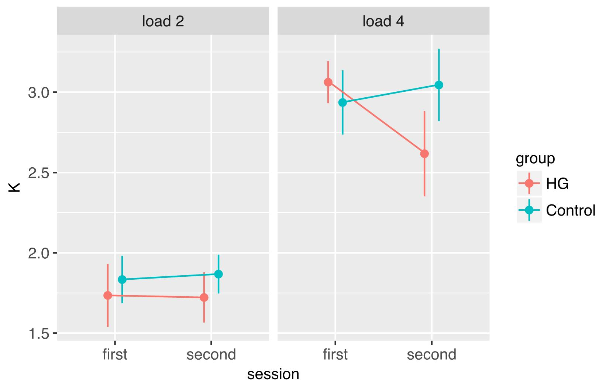

References
- Cowan, N. The magical number 4 in short-term memory: A reconsideration of mental storage capacity. Behav Brain Sci 2001;24:87–185.
- Lawrence MA. Easy analysis and visualization of factorial experiments. R package version 3.1.2. Vienna, Austria: R Foundation for statistical computing, 2013. Available at: http://cran.r-project.org/package=ez (Accessed Apr 08, 2019)
- Glasser MF, Sotiropoulos SN, Wilson JA, et al. The minimal preprocessing pipelines for the Human Connectome Project. NeuroImage 2013;80:105–124.
- Jenkinson M, Beckmann CF, Behrens TE, Woolrich MW, Smith SM. FSL. NeuroImage 2012; 62:782–90.
- Jenkinson M, Bannister P, Brady JM, Smith SM. Improved Optimization for the Robust and Accurate Linear Registration and Motion Correction of Brain Images. NeuroImage 2002; 17(2):825–841.
- Jenkinson M, Smith SM. A Global Optimization Method for Robust Affine Registration of Brain Images. Medical Image Analysis, 2001;5:143–156.
- Greve DN, Fischl B. Accurate and robust brain image alignment using boundary-based registration. NeuroImage 2009;48:63–72.
- Andersson J, Jenkinson M, Smith S. Non-linear registration, aka spatial normalization. FMRIB technical report TR07JA2, Oxford Centre for Functional Magnetic resonance Imaging of the Brain. Department of Clinical Neurology, Oxford University, Oxford, UK, 2007. Available at: http://www.fmri.ox.ac.uk/analysis/techrep (Accessed Feb 12, 2018)
- FreeSurfer. FreeSurfer Software Suite. Laboratory for Computational Neuroimaging, Athinoula A. Martinos Center for Biomedical Imaging, Human Connectome Project. 2013©. Available at:https://surfer.nmr.mgh.harvard.edu/ (Accessed Mar 16, 2019)

- MathWorks. MATLAB®. The Language of Technical Computing. Available at: https//uk.mathworks.com (Accessed Mar 03, 2019)
- Eriksson J, Vogel EK, Lansner A, Bergstrom F, Nyberg L. Neurocognitive architecture of working memory. Neuro 2015;88:33–46.
- Collette F, Salmon E, Hogge M, Van der Linden M. Expolration of the neural substrates of executive functioning by functional neuroimaging. Neuroscience 2006;139:209–21.
- Koenigs M, Barbey AK, Postle BR, Grafman J. Superior parietal cortex is critical for the manipulation of information in working memory. J Neurosci. 2009;25:29:14980–6.
- Glasser MF, Coalson TS, Robinson EC, et al. A multi-modal parcellation of human cerebral cortex. Nature 2016; 11;536:171–178.
- Libby LA, Hannula DE, Ranganath C. Medial Temporal Lobe Coding of Item and Spatial Information during Relational Binding in Working Memory. J Neurosci 2014; 34 (43): 14233-14242.
- Boynton G M, Engel S A, Glover G H, Heeger D J. Linear systems analysis of functional magnetic resonance imaging in human V1. The Journal of Neuroscience 1996;16:4207–4221.
- Baguley T. Calculating and graphing within-subject confidence intervals for ANOVA. Behavior research methods 2012;44:158–175.

