Supplementary Data
Supplementary Table 1. Study inclusion and exclusion criteria
Supplementary Table 2. Basal and prandial treat-to-target insulin dosing algorithms
Supplementary Table 3. Postprandial glucose excursions, fasting and postprandial glucose levels, and incremental AUC with meal test at week 26
Supplementary Table 4. Insulin dose at week 26
Supplementary Table 5. Overview of adverse events from randomization to week 26
Supplementary Table 6 Change from baseline to week 26 daily mean glucose and daily mean PPG levels and excursions from 10-point SMBG profile
Supplementary Table 7. List of investigators by country.
Supplementary Figure 1. PRONTO-T2D Study design
Supplementary Figure 2. Patient disposition from enrollment to week 26.
Supplementary Figure 3. Graphical approach for multiplicity adjusted objectives.

Supplementary Table 1. Study inclusion and exclusion criteria
Inclusion criteria
- Adults ≥18 years of age at screening
- Diagnosis of type 2 diabetes based on WHO classification for ≥1 year prior to screening
- Treated for ≥90 days prior to screening with
  - basal insulin (insulin glargine U-100 [Basaglar/Abasaglar or Lantus] or U 300, insulin detemir, insulin degludec U-100 or U-200, or neutral protamine Hagedorn [NPH] insulin) in combination with at least 1 prandial injection of bolus insulin (insulin lispro U-100 or U-200, insulin aspart, insulin glulisine, or regular insulin) OR
  - premixed analog or human insulin regimens with any basal and bolus insulin combination injected at least twice daily
- May have been treated with up to 3 OAMs in accordance with local regulations at stable doses for ≥90 days prior to screening
- HbA1c ≥7.0% and ≤10.0% at screening
- BMI ≤45.0 kg/m2 at screening
- For female patients of childbearing potential—were not breastfeeding, pregnant, or intending to become pregnant during the study and agreed to use a reliable method of birth control for the duration of the study
Exclusion criteria
- Had hypoglycemia unawareness as judged by the investigator
- Had >1 episode of severe hypoglycemia within 6 months prior to screening
- Had ≥1 episode of diabetic ketoacidosis or hyperglycemic hyperosmolar state within the 6 months prior to screening
- Had excessive insulin resistance at screening (total daily insulin dose >2.0 U/kg)
- Had a history of or were being evaluated for bariatric surgery
- Had significant cardiac, liver, gastrointestinal or renal disease; renal transplant; or were on renal dialysis
- Had presence or history of cancer within the previous 5 years (with the exception of basal cell or squamous cell skin cancer)
- Had a blood transfusion or severe blood loss within 90 days prior to screening or known hemoglobinopathy, anemia, or any other traits known to interfere with measurement of HbA1c
- Had used thiazolidinediones, glucagon-like peptide-1 receptor agonist, or pramlintide within 90 days prior to screening
- Were receiving chronic (lasting longer than 14 consecutive days) systemic glucocorticoid therapy at pharmacological doses (including intravenous, intramuscular, subcutaneous, or oral but excluding topical, intraocular, intranasal, intra-articular, and inhaled preparations) or had received such therapy within 8 weeks preceding screening, with the exception of replacement therapy for adrenal insufficiency

Supplementary Table 2. Basal and prandial treat-to-target insulin dosing algorithms
- Basal insulin adjustment algorithm
If Median (middle) Fasting blood glucose (FBG) from the 3 Previous FBG Values is: | Adjust Basal Insulin Dose by:
<4.4 mmol/L (<80 mg/dL) | Decrease dose to previous lower dose
4.4-6.1 mmol/L (80-109 mg/dL) | No adjustment
>6.1-7.2 mmol/L (110-129 mg/dL) | Increase by 1-2 units
>7.2-8.3 mmol/L (130-149 mg/dL) | Increase by 2-4 units
>8.3-9.9 mmol/L (150-179 mg/dL) | Increase by 4-6 units
≥10.0 mmol/L (≥180 mg/dL) | Increase by 6-8 units
Source: Adapted from Bartley et al. Diab Med. 2008;25(4):442-449 and Bolli et al. Diabetes Care. 2009;32(10):1944. Basal and prandial insulin doses could be decreased at any time if clinically indicated such as for hypoglycemia.

- Prandial insulin adjustment algorithm
If Mealtime Insulin Dose Is: | Median SMBG Value Below Target Range* | Median SMBG Value at Target Range* | Median SMBG Value Above Target Range*
<10 units | Decrease by 1 unit | No change | Increase by 1 unit
11-19 units | Decrease by 1-2 units | No change | Increase by 1-2 units
>20 units | Decrease by 2-3 units | No change | Increase by 2-3 units
Abbreviation: SMBG = self-monitored blood glucose. *Target SMBG range was: fasting or premeal, 4.4 to 6.1 mmol/L; bedtime, 5.0 to 7.2 mmol/L; 1-2 hours postmeal, <7.8 mmol/L. Source: Adapted from Bergenstal et al. Diabetes Care. 2008;31(7):1305-1310. Basal and prandial insulin doses could be decreased at any time if clinically indicated such as for hypoglycemia.

Supplementary Table 3. Postprandial glucose excursions, fasting and postprandial glucose levels, and incremental AUC with meal test at week 26
- Postprandial glucose excursions with meal test at week 26
Time Postmeal | Lispro LSM (SE), mmol/L | Lispro change from baseline, mmol/L | URLi LSM (SE), mmol/L | URLi change from baseline, mmol/L | LSM Difference URLi-Lispro (95% CI) | P-value*
15 min | 1.26 (0.09) | 0.05 (0.09) | 1.15 (0.09) | -0.06 (0.09) | -0.11 (-0.28, 0.05) | 0.174
30 min | 2.86 (0.14) | 0.11 (0.14) | 2.55 (0.14) | -0.21 (0.14) | -0.31 (-0.56, -0.06) | 0.015
1 hour | 4.16 (0.20) | -0.11 (0.20) | 3.50 (0.20) | -0.77 (0.20) | -0.66 (-1.01, -0.30) | <0.001
2 hours | 5.43 (0.25) | -0.09 (0.25) | 4.47 (0.25) | -1.06 (0.25) | -0.96 (-1.41, -0.52) | <0.001
3 hours | 5.10 (0.28) | 0.05 (0.28) | 4.28 (0.28) | -0.78 (0.28) | -0.83 (-1.31, -0.34) | <0.001
4 hours | 3.65 (0.26) | 0.34 (0.26) | 2.88 (0.26) | -0.42 (0.26) | -0.76 (-1.23, -0.30) | 0.001

- Fasting and postprandial glucose levels with meal test at week 26
Time postmeal | Lispro LSM (SE), mmol/L | Lispro change from baseline, mmol/L | URLi LSM (SE), mmol/L | URLi change from baseline, mmol/L | LSM Difference URLi-Lispro (95% CI) | P-value*
Fasting | 7.0 (0.17) | 0.14 (0.17) | 7.2 (0.17) | 0.33 (0.17) | 0.19 (-0.10, 0.47) | 0.198
15 min | 8.2 (0.19) | 0.16 (0.19) | 8.3 (0.19) | 0.24 (0.19) | 0.09 (-0.24, 0.41) | 0.612
30 min | 9.8 (0.22) | 0.25 (0.22) | 9.7 (0.22) | 0.12 (0.22) | -0.13 (-0.51, 0.24) | 0.494
1 hour | 11.0 (0.25) | -0.11 (0.25) | 10.6 (0.25) | -0.54 (0.25) | -0.43 (-0.86, 0.00) | 0.049
2 hours | 12.3 (0.28) | -0.03 (0.28) | 11.5 (0.28) | -0.80 (0.28) | -0.77 (-1.26, -0.28) | 0.002
3 hours | 11.9 (0.30) | 0.03 (0.30) | 11.3 (0.30) | -0.61 (0.30) | -0.64 (-1.16, -0.12) | 0.015
4 hours | 10.5 (0.28) | 0.29 (0.28) | 9.9 (0.28) | -0.27 (0.28) | -0.56 (-1.06, -0.06) | 0.028

- Incremental AUCs with meal test at week 26
Parameter | Lispro LSM (SE), mmol·h/L | Lispro change from baseline, mmol·h/L | URLi LSM (SE), mmol·h/L | URLi change from baseline, mmol·h/L | LSM Difference URLi-Lispro (95% CI) | P-value*
iAUC_{0-30min} | 40.4 (2.26) | 1.76 (2.26) | 36.2 (2.26) | -2.42 (2.26) | -4.18 (-8.16, -0.20) | 0.040
iAUC_{0-1h} | 146.4 (6.58) | 2.49 (6.58) | 127.1 (6.55) | -16.82 (6.55) | -19.31 (-30.89, -7.74) | 0.001
iAUC_{0-2h} | 437.9 (18.39) | -0.72 (18.39) | 367.9 (18.24) | -70.71 (18.24) | -70.0 (-102.3, -37.6) | <0.001
iAUC_{0-3h} | 762.9 (31.78) | 6.26 (31.78) | 641.3 (31.46) | -115.4 (31.46) | -121.7 (-177.2, -66.22) | <0.001
iAUC_{0-4h} | 1034 (44.67) | 18.19 (44.67) | 854.4 (44.17) | -161.1 (44.17) | -179.3 (-257.3, -101.3) | <0.001
iAUC, incremental area under the serum glucose concentration time curve. *Between treatment comparison (URLi vs Lispro). Lispro group: no statistically significant (p>0.7) within-group change from baseline to Week 26 for incremental AUC for all timepoints. URLi group: statistically significant (p≤0.001) within-group change from baseline to Week 26 in incremental AUC from 0-1h through 0-4h

Supplementary Table 4. Insulin dose at week 26
 | Lispro dose, units/kg/day | Lispro change from baseline | URLi dose, units/kg/day | URLi change from baseline | LSM Difference URLi-Lispro (95% CI)
Basal | 0.56 (0.008) | 0.04 (0.009) | 0.56 (0.008) | 0.04 (0.009) | 0.00 (-0.02, 0.02)
Prandial | 0.53 (0.014) | 0.08 (0.014) | 0.56 (0.014) | 0.12 (0.014) | 0.03 (0.00, 0.07)
Total insulin* | 1.08 (0.018) | 0.12 (0.018) | 1.13 (0.018) | 0.16 (0.018) | 0.04 (0.00, 0.09)
Data are LSM (SE). * The ratio of prandial/total insulin dose at week 26 was 48.5% with lispro and 49.7% with URLi treatment

Supplementary Table 5. Overview of adverse events from randomization to week 26
 | Lispro (N=337) n (%) | URLi (N=336) n (%) | Total (N=673) n (%)
Deaths* | 1 (0.3) | 2 (0.6) | 3 (0.4)
Serious adverse events | 25 (7.4) | 26 (7.7) | 51 (7.6)
Discontinuations from study due to an adverse event | 2 (0.6) | 3 (0.9) | 5 (0.7)
Discontinuations from study treatment due to an adverse event | 3 (0.9) | 6 (1.8) | 9 (1.3)
Treatment-emergent adverse events† | 194 (57.6) | 203 (60.4) | 397 (59.0)
Abbreviations: N = number of subjects in analysis population; n = number of subjects with at least one adverse event per event type. Note: Subjects could be counted in more than one category. * Deaths are also included as serious adverse events and discontinuations due to adverse events. † Overall, the most frequently reported TEAEs were nasopharyngitis (11.6%) and upper respiratory tract infection (6.7%).

Supplementary Table 6. Change from baseline to week 26 daily mean glucose and daily mean PPG levels and excursions from 10-point SMBG profile
 | Lispro | URLi | LSM Difference (95%CI) URLi-Lispro
Daily mean glucose, mmol/L | -0.11 | -0.28 | -0.17 (-0.42, 0.08)
Daily mean 1-h PPG levels, mmol/L | -0.15 | -0.52 | -0.37 (-0.66, -0.09)*
Daily mean 2-h PPG levels, mmol/L | -0.19 | -0.59 | -0.39 (-0.70, -0.08)*
Daily mean 1-h PPG excursions, mmol/L | -0.20 | -0.71 | -0.51 (-0.76, -0.26)†
Daily mean 2-h PPG excursions, mmol/L | -0.15 | -0.69 | -0.54 (-0.81, -0.27)†
*p<0.05 for between treatment comparison; †p<0.001 for between treatment comparison

Supplementary Table 7. List of investigators by country.
Argentina Lucas Lisandro Gutnisky, Natalia Carolina Garrido Santos, Laura Maffei, Silvia Orio, Alejandra Oviedo, Federico Perez Manghi, Susana Salzberg, Georgina Sposetti. Australia Timothy Davis, Adam Roberts, Anthony Roberts, StephenStranks, Richard Simpson. Czech Republic Juraj Divinec, Tomas Edelsberger, Emilia Malicherova, Daniel Smutek, Dagmar Bartášková. Germany Bernhard Landers, Jörg Lüdemann, Thomas Schaum, Alexander Segner, Simon Vidal, Dominik Dahl, Ludger Rose, Cornelia Marck, Heike Schlichthaar. Hungary Nóra Kesmarki, Zsuzsanna Kerenyi, Piroska Kis-Gombos, Krisztina Wudi. India Sanjay Agarwal, Ashwin Dabhi, Mala Dharmalingam, Vishwanathan Mohan, Abhay Mutha, Sanjeev Phatak, Paturi Rao. Italy Antonio Ceriello, Stefano Genovese, Manfredi Rizzo. Japan Hitomi Fujii, Shinichiro Shirabe, Masayuki Hosoi, Hideaki Jinnouchi, Arihiro Kiyosue, Shuji Nakamura, Yukiko Onishi, Takeshi Osonoi, Osamu Tomonaga, Yoko Abe, Hiroki Ikeda, Kazushi Misawa, Nobuhiro Sasaki, Yuichi Sato, Nobuyuki Sato, Masahiko Takai, Taro Asakura, Takeshi Inazawa, Yoshimitsu Yamasaki, Kazunari Matsumoto, Fuminobu Okuguchi, Yuri Ono. Mexico Maria del Rosario Arechavaleta Granell, Jose Gerardo González González, Ricardo Moresco, Sasana Pelayo. Russia Irina Dvoryashina, Marina Kunitsyna, Tatiana Markova, Natalia Vorokhobina, Larisa Zhukova. Slovakia Viera Donicova, Noman Ehsan, Ludmila Kubincová, Beata Lachova, Eva Pavleova. Spain Maria Del Carmen Cuesta Mayor, Margarita Rivas Fernández, Francisco Tinahones Madueño, Albert Lecube Torello. South Korea Kyu Jeung Ahn, Sei Hyun Baik, So-Hyeon Hong, Ji Hye Huh, Sin Gon Kim, Nan Hee Kim, Hye-Soon Kim, Sang Wook Kim, Moon-Kyu Lee, Min Kyong Moon, Kang Seo Park, Ji A Seo, Soon Jib Yoo, Kun-Ho Yoon. Taiwan Chen-Ling Huang, Chien-Ning Huang, Te-Lin Hsia, Chwen-Yi Yang. United States Samir Arora, Hanid Audish, Elizabeth Barranco-Santana, Anuj Bhargava, Thomas Blevins, Patricia Bononi, Tira Chaicha-Brom, Gregorio Cortes-Maisonet, Raymond Fink, David Fitz-Patrick, Juan Frias, Leslie Klaff, Sam Lerman, Lorena Lewy-Alterbaum, Brock McConnehey, Frank Mikell, Samer Nakhle, Paul Norwood, Michael Olivier, Ramón Ortiz-Carrasquillo, Juan Otero, Betsy Palal, Antonio Piñero Pilona, David Robbins, Julio Rosenstock, Mae Sheikh-Ali, Kanagaratnam Sivalingam, Gary Soucie, Larry Stonesifer, Joanna Van, Carl Vance, Jose Vazquez-Tanus, Ralph Wade, Michelle Welch, Alan Wynne, Susan Zweig, Sina Tebi.

Supplementary Figure 1. PRONTO-T2D Study design

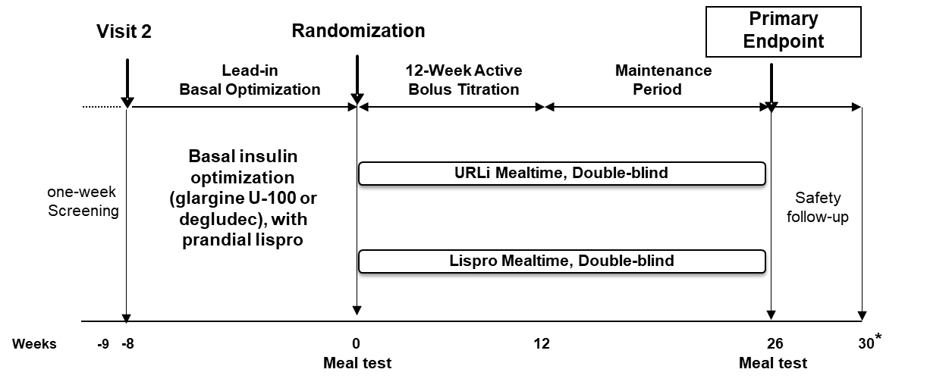
*4-week follow-up after last treatment dose.

Supplementary Figure 2. Patient disposition from enrollment to week 26.
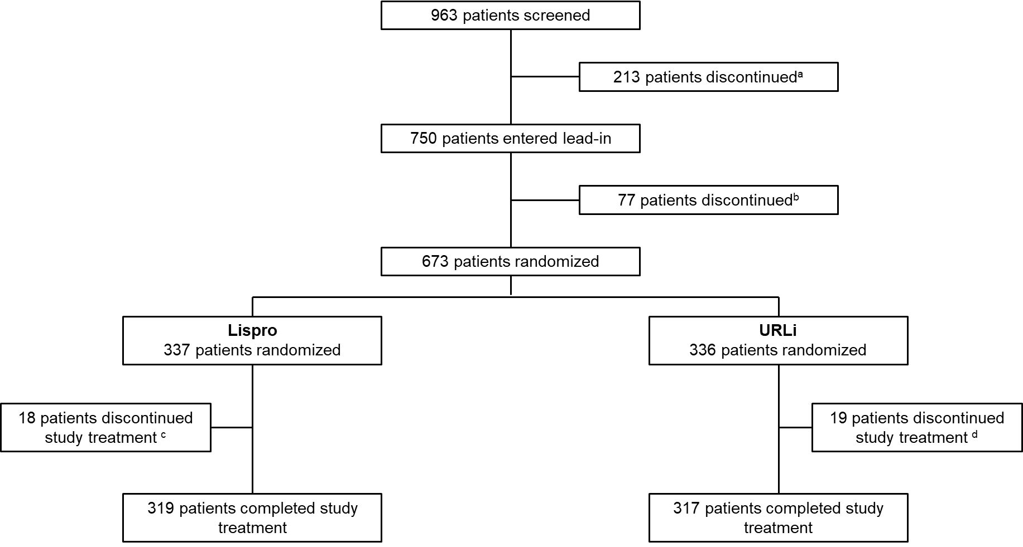

ª Reasons for discontinuation: screen failure (189 patients), withdrawal by patient (21 patients), lost to follow-up (3 patients). ^{b} Reasons for discontinuation: adverse event (3 patients), lost to follow-up (4 patients), other (20 patients), physician decision (6 patients), protocol deviation (3 patients), withdrawal by patient (41 patients). ^{c} Reasons for discontinuation of study treatment: death or adverse event (3 patients), lost to follow-up (4 patients), non-compliance with study drug (1 patient), other (1 patient), protocol deviation (1 patient), withdrawal by patient (8 patients). ^{d} Reasons for discontinuation of study treatment: death or adverse event (6 patients), lost to follow-up (1 patient) other (2 patients), protocol deviation (2), withdrawal by patient (8 patients).
Supplementary Figure 3. Graphical approach for multiplicity adjusted objectives.
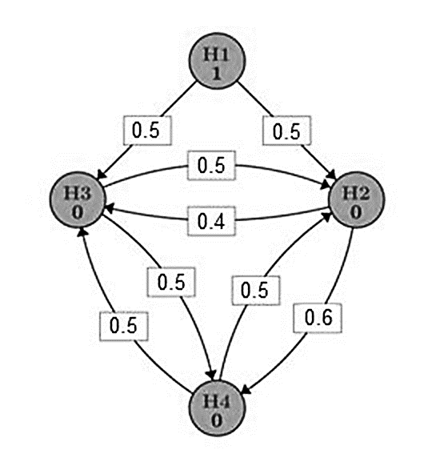
A graphical approach for multiple comparisons was used to strongly control the overall type I error (0.05) for testing the treatment effect for the primary (H1) and the following multiplicity adjusted objectives: H2, superiority of URLi compared with lispro for 1-hour PPG excursion from the meal test at the study primary endpoint; H3, superiority of URLi compared with lispro for 2-hour PPG excursion from the meal test at the study primary endpoint; H4, superiority of URLi compared with lispro for change from baseline to the study primary endpoint in HbA1c. The overall type I error (the total alpha level) was set to be 0.05. The total alpha level was all used for H1 first. Then the toal alpha level were allocated to H2 and H3 based on the weights in testing paths (the numbers in the arrowed lines) once H1 is successfully demonstrated. Either H2 or H3 was successfully demonstrated with the allocated alpha level, its allocated alpha would be allocated further to (H3 and H4) or (H2 and H4) by the weights in the paths. The iterative test procedure continued until none of the remaining objectives could be claimed with their allocated alphas or all obejctives were achieved. With this dynamic alpha allocation, the total alpha level would always be equal to 0.05 for all unclaimed objectives and thus the overall type I error was under control.

