Supplementary appendix

Supplementary appendix ………………………………………………………………………………………. 1

Contents …………………………………………………………………………………………………………. 2

Reference list of included studies ……………………………………………………………………………… 4

Studies excluded at the full text stage of screening …………………………………………………………... 6

Characteristics of included studies …………………………………………………………………………... 15

Risk of bias of included studies ……………………………………………………………………………..... 53

Baseline characteristics ……………………………………………………………………………………….. 54

Analysis for the network of diabetes management interventions for the outcome of percent time in range:
- Network map ………………………………………………………………………………………...... 57
- Direct comparisons and the number of included studies ……………………………………………... 58
- Indirect comparisons ...…………………………………………………………………………….….. 58
- Percentage contribution of direct comparisons ……………………………………………………….. 59
- Evaluation of inconsistency
  - Loops without evidence of statistical inconsistency ……………………………………….... 61
  - Side (or node) specific inconsistency ……………………………………………………….. 61
- Funnel plot …………………………………………………………………………….…….………... 62
- Treatment effects (95% confidence interval / 95% predictive interval) ……………………..……….. 63
- League table of diabetes management interventions …………………………………………...…...... 64
- Estimated probabilities (%) of ranking ……………………………………………………………….. 65
- Treatment relative ranking …………………………………………………………………………..... 65
- Rankograms of diabetes management technologies……………………………………………...…… 65
- Cumulative ranking curve plots of diabetes management technologies……………………………..... 66

Analysis for the network of diabetes management interventions for the outcome of percent time above range:
- Network map ………………………………………………………………………………………….. 67
- Direct comparisons and the number of included studies ………………………………………...…… 68
- Indirect comparisons ...…………………………………………………………………………….….. 68
- Percentage contribution of direct comparisons ……………………………………………………….. 69
- Evaluation of inconsistency
  - Loops without evidence of statistical inconsistency ………………………………………… 72
  - Side (or node) specific inconsistency ……………………………………………………….. 72
- Funnel plot …………………………………………………………………………………………..... 73
- Treatment effects (95% confidence interval / 95% predictive interval) ……………………………… 74
- League table of diabetes management interventions ……………………………………………..…... 75
- Estimated probabilities (%) of ranking ……………………………………………………………...... 76
- Treatment relative ranking …………………………………………………………………………..... 76
- Rankograms of diabetes management technologies…………………………………………………... 76
- Cumulative ranking curve plots of diabetes management technologies……………………………..... 77

Analysis for the network of diabetes management for the outcome of percent time below range:
- Network map ………………………………………………………………………………………….. 78
- Direct comparisons and the number of included studies ……………………………………………... 79
- Indirect comparisons ...…………………………………………………………………………….….. 79
- Percentage contribution of direct comparisons ……………………………………………………….. 80
- Evaluation of inconsistency
  - Loops without evidence of statistical inconsistency ………………………………………… 83
  - Side (or node) specific inconsistency ……………………………………………………….. 83
- Funnel plot …………………………………………………………………………………………..... 84
- Treatment effects (95% confidence interval / 95% predictive interval) ……………………………… 85
- League table of diabetes management interventions ……………………………………………..…... 86
- Estimated probabilities (%) of ranking ……………………………………………………………….. 87
- Treatment relative ranking …………………………………………………………………………..... 87
- Rankograms of diabetes management technologies…………………………………………………... 87
- Cumulative ranking curve plots of diabetes management technologies……………………………..... 88

Analysis for the network of diabetes management interventions comprising the same within-study co-interventions for the outcome of percent time below range (assuming correlation coefficient of 0.9 and 0.1):
Table of treatment effects (imputed correlation coefficient of 0.9)………………………………...................... 89
Table of treatment effects (imputed correlation coefficient of 0.1)………………………………...................... 91

Cluster ranking of SUCRA values for percent time in range and above range …………………………...……. 93

Cluster ranking of SUCRA values for percent time in range and below range …………………………...…… 94

Assessment of transitivity………………………………………………………………………………….….. 95

Grading of recommendations assessment, development, and evaluation (GRADE) framework.…...…… 97
Tables of reasons for downgrading quality of evidence according to the GRADE framework
- Time in range network……………………………………………………………….……………...… 98
- Time above range network…………………………………………………………………………… 100
- Time below range network…………………………………………………………………………... 102

References.…...……………………………………………………………………………………………….. 104

Reference list of included studies (and study ID):
Thabit 2014
- Thabit H, Lubina-Solomon A, Stadler M, et al. Home use of closed-loop insulin delivery for overnight glucose control in adults with type 1 diabetes: a 4-week, multicentre, randomised crossover study. Lancet Diabetes Endocrinol 2014; 2: 701–709.

Kropff 2015
- Kropff J, Del Favero S, Place J, et al. 2 month evening and night closed-loop glucose control in patients with type 1 diabetes under free-living conditions: a randomised crossover trial. Lancet Diabetes Endocrinol 2015; 3: 939–947.

Thabit 2015
- Thabit H, Tauschmann M, Allen JM, et al. Home use of an artificial beta cell in type 1 diabetes. N Engl J Med 2016; 373: 2129–2140.

Bolinder 2016
- Bolinder J, Antuna R, Geelhoed-Duijvestijn P, Kröger J, Weitgasser R. Novel glucose-sensing technology and hypoglycaemia in type 1 diabetes: a multicentre, non-masked, randomised controlled trial. Lancet 2016; 388: 2254–2263.

Van Beers 2016
- Van Beers CAJ, DeVries JH, Kleijer SJ, et al. Continuous glucose monitoring for patients with type 1 diabetes and impaired awareness of hypoglycaemia (IN CONTROL): a randomised, open-label, crossover trial. Lancet Diabetes Endocrinol 2016; 4: 899–902.

Bally 2017
- Bally L, Thabit H, Kojzar H, et al. Day-and-night glycaemic control with closed-loop insulin delivery versus conventional insulin pump therapy in free-living adults with well controlled type 1 diabetes: an open-label, randomised, crossover study. Lancet Diabetes Endocrinol 2017; 5: 261–270.

Beck 2017a
- Beck RW, Riddlesworth T, Ruedy K, et al. Effect of continuous glucose monitoring on glycemic control in adults with type 1 diabetes using insulin injections: the DIAMOND randomized clinical trial. JAMA 2017; 317: 371–378.

Beck 2017b
- Beck RW, Riddlesworth TD, Ruedy KJ, et al. Effect of initiating use of an insulin pump in adults with type 1 diabetes using multiple daily insulin injections and continuous glucose monitoring (DIAMOND): a multicentre, randomised controlled trial. Lancet Diabetes Endocrinol 2017; 5: 700–708.

Forlenza 2017
- Forlenza GP, Deshpande S, Ly TT, et al. Application of zone model predictive control artificial pancreas during extended use of infusion set and sensor: a randomized crossover-controlled home-use trial. Diabetes Care 2017; 40: 1096–1102.

Forlenza 2018
- Forlenza GP, Li Z, Buckingham BA, et al. Predictive low-glucose suspend reduces hypoglycaemia in adults, adolescents, and children with type 1 diabetes in an at-home randomized crossover study: results of the PROLOG trial. Diabetes Care 2018; 41: 2155–2161.

Heinemann 2018
- Heinemann L, Freckmann G, Ehrmann D, et al. Real-time continuous glucose monitoring in adults with type 1 diabetes and impaired hypoglycaemia awareness or severe hypoglycaemia treated with multiple daily insulin injections (HypoDE): a multicentre, randomised controlled trial. Lancet 2018; 391: 1367–1377.

Ólafsdóttir 2018
- Ólafsdóttir AF, Polonsky W, Bolinder J, et al. A randomized clinical trial of the effect of continuous glucose monitoring on nocturnal hypoglycaemia, daytime hypoglycaemia, glycemic variability, and hypoglycaemia confidence in persons with type 1 diabetes treated with multiple daily insulin injections (GOLD-3). Diabetes Techno Ther 2018; 20: 274–284.

Oskarsson 2018
- Oskarsson P, Antuna R, Geelhoed-Duijvestijn, Kröger J, Weitgasser R, Bolinder J. Impact of flash glucose monitoring on hypoglycaemia in adults with type 1 diabetes managed with multiple daily injection therapy: a pre-specified subgroup analysis of the IMPACT randomised controlled trial. Diabetologia 2018; 61: 539–550.

Reddy 2018
- Reddy M, Jugnee N, El Laboudi A, Spanudakis E, Anantharaja S, Oliver N. A randomized controlled pilot study of continuous glucose monitoring and flash glucose monitoring in people with type 1 diabetes and impaired awareness of hypoglycaemia. Diabet Med 2018; 35: 483–490.

Studies excluded at the full text stage of screening
Nathan DM, Lou P, Avruch J. Intensive conventional and insulin pump therapies in adult type 1 diabetes: a crossover study. Ann Intern Med 1982; 97: 31–36.
- Wrong study design.

Schiffrin A, Belmonte MM. Comparison between continuous subcutaneous insulin infusion and multiple injections of insulin: a one-year prospective study. Diabetes 1982; 31: 255–264.
- Wrong population.

Chiasson JL, Ducros F, Poliquin-Hamet M, Lopez D, Lecavalier L, Hamet P. Continuous subcutaneous insulin infusion (Mill-Hill Infuser) versus multiple injections (Medi-Jector) in the treatment of insulin-dependent diabetes mellitus and the effect of metabolic control on microangiopathy. Diabetes Care 1984; 7:331–37.
- Wrong outcomes.

The Kroc collaborative study group. Blood glucose control and the evolution of diabetic retinopathy and albuminuria: a preliminary multicentre trial. N Engl J Med 1984; 311: 365–372
- Wrong intervention / control.

Oslo Study Group 1985–1992
- Brinchmann-Hansen O, Dahl-Jørgensen K, Hanssen KF, Sandvik L, the Oslo study group. Effects of intensified insulin treatment on various lesions of diabetic retinopathy. Am J Ophthalmol 1985; 100: 644–653.
- Hanssen KF, Dahl-Jørgensen K, Brinchmann-Hansen O, Aker diabetes group. The influence of strict control on diabetic complications. Acta Endocrinol 1985; 110: Suppl. 272: 57–60.
- Dahl-Jørgensen K, Brinchmann-Hansen O, Hanssen KF, et al. Effect of near normoglycaemia for two years on progression of early diabetic retinopathy, nephropathy, and neuropathy: the Oslo study. BMJ 1986; 293: 1195–1199.
- Dahl-Jørgensen K, Hanssen KF, Kierulf P, Bjøro T, Sandvik L, Aagenaes O. Reduction of urinary albumin excretion after 4 years of continuous subcutaneous insulin infusion in insulin-dependent diabetes mellitus: the Oslo Study. Acta Endocrinol 1988; 117: 19–25.
- Brinchmann-Hansen O, Dahl-Jørgensen K, Hanssen KF, Sandvik L. Oscillatory potentials, macular recovery time, and diabetic retinopathy through 3 years of intensified insulin treatment. Ophthalmology 1988; 95: 1358–1366.
- Brinchmann-Hansen O, Dahl-Jørgensen K, Sandvik L, Hanssen KF. Blood glucose concentrations and progression of diabetic retinopathy: the seven year results of the Oslo study. BMJ 1992; 304: 19–22.
- Dahl-Jørgensen K, Bjøro T, Kierulf P, Sandvik L, Bangstad HJ, Hanssen KF. Long-term glycemic control and kidney function in insulin-dependent diabetes mellitus. Kidney Int 1992; 41: 920–923.
  - Wrong outcomes

Wiseman MJ, Saunders AJ, Keen H, Viberti GC. Effect of blood glucose control on increased glomerular filtration rate and kidney size in insulin-dependent diabetes. N Engl J Med 1985; 312: 617–621.
- Wrong comparator.

Peterson CM, Jovanovic L, Chanoch LH. Randomized trial of computer-assisted insulin delivery in patients with type I diabetes beginning pump therapy. Am J Med 1986; 81: 69–72.
- Wrong outcomes.

Lecavalier L, Havrankova J, Hamet P, Chiasson JL. Effects of continuous subcutaneous insulin infusion versus multiple injections on insulin receptors in insulin-dependent diabetics. Diabetes Care 1987; 10: 300–305.
- Wrong outcomes.

Saurbrey N, Arnold-Larsen S, Moller-Jensen B, Kuhl C. Comparison of continuous subcutaneous insulin infusion with multiple insulin injections using the NovoPen. Diabet Med 1988. 5: 150–153.
- Wrong outcomes.

Schmitz A, Christiansen JS, Chistensen CK, Hermansen K, Mogensen CE. Effect of pump versus pen treatment on glycaemic control and kidney function in long-term uncomplicated insulin-dependent diabetes mellitus (IDDM). Dan Med Bull 1989; 36: 176–178.
- Wrong outcomes.
Hanaire-Broutin H, Melki V, Bessières-Lacombe S, Tauber JP, the study group for the development of pump therapy in diabetes. Comparison of continuous subcutaneous insulin infusion and multiple daily injection regimens using insulin lispro in type 1 diabetic patients on intensified treatment. Diabetes Care 2000. 23: 1232–1235.
- Wrong outcomes.

Tsui E, Barnie A, Ross S, Parkes R, Zinman B. Intensive insulin therapy with insulin lispro: a randomized trial of continuous subcutaneous insulin infusion versus multiple daily insulin injection. Diabetes Care 2001; 24: 1722–1727.
- Wrong outcomes.

DeVries JH, Snoek FJ, Kostense PJ, Masurel N, Heine RJ, on behalf of the Dutch insulin pump study group. A randomized trial of continuous subcutaneous insulin infusion and intensive injection therapy in type 1 diabetes for patients with long-standing poor glycemic control. Diabetes Care 2002; 25: 2074–2080.
- Wrong outcomes.

Schrezenmeir J, Dirting K, Papazov P. Controlled multicenter study on the effect of computer assistance in intensive insulin therapy of type 1 diabetics. Comput Methods Programs Biomed 2002; 69: 97–114.
- Wrong outcomes.

Boukhors Y, Rabasa-Lhoret R, Langelier H, Soultan M, Lacroix A, Chiasson JL. The use of information technology for the management of intensive insulin therapy in type 1 diabetes mellitus. Diabetes Metab 2003; 29: 619–627.
- Wrong outcomes.

Chico A, Vidal-Ríos P, Subirà M, Novials A. The continuous glucose monitoring system is useful for detecting unrecognized hypoglycemias in patients with type 1 and type 2 diabetes but is not better than frequent capillary glucose measurements for improving metabolic control. Diabetes Care 2003; 26: 1153–1157.
- Wrong population.

Lepore G, Dodesini AR, Nosari I, Trevisan R. Both continuous subcutaneous insulin infusion and a multiple daily insulin injection regimen with glargine as basal insulin are equally better than traditional multiple daily insulin injection treatment. Diabetes Care 2003; 26: 1321.
- Wrong outcomes.

Pozzilli P, Crino A, Schiaffini R, et al. A 2-year pilot trial of continuous subcutaneous insulin infusion versus intensive insulin therapy in patients with newly diagnosed type 1 diabetes (IMDIAB 8). Diabetes Technol Ther 2003; 5: 965–974
- Wrong population

Bode B, Gross K, Rikalo N, et al. Alarms based on real-time sensor glucose values alert patients to hypo- and hyperglycaemia: the guardian continuous monitoring system. Diabetes Technol Ther 2004; 6: 105–113.
- Wrong duration.

Doyle EA, Weinzimer SA, Steffen AT, Ahern JA, Vincent M, Tamborlane WV. A randomized, prospective trial comparing the efficacy of continuous subcutaneous insulin infusion with multiple daily injections using insulin glargine. Diabetes Care 2004; 27: 1154–1558.
- Wrong population.

Tanenberg R, Bode B, Lane W, et al. Use of the continuous glucose monitoring system to guide therapy in patients with insulin-treated diabetes: a randomized controlled trial. Mayo Clin Proc 2004; 79:1521–1526.
- Wrong population.

Hoogma RPLM, Hammond PJ, Gomis R, et al. Comparison of the effects of continuous subcutaneous insulin infusion (CSII) and NPH-based multiple daily insulin injections (MDI) on glycaemic control and quality of life: results of the 5-nations trial. Diabet Med 2005; 23: 141–147.
- Wrong outcomes.

Deiss D, Bolinder J, Riveline JP, et al. Improved glycemic control in poorly controlled patients with type 1 diabets using real-time continuous glucose monitoring. Diabetes Care 2006; 29: 2730–2732.
- Wrong population.

Laffel LMB, Hsu WC, McGill JB, Meneghini L, Volkening LK, the monitoring of blood glucose study group. Continued use of an integrated meter with electronic logbook maintains improvements in glycemic control beyond a randomized, controlled trial. Diabetes Technol Ther 2007; 9: 254–264.
- Wrong population.

Lee SW, Sweeney T, Clausen D, et al. Combined insulin pump therapy with real-time continuous glucose monitoring significantly improves glycemic control compared to multiple daily injection therapy in pump naïve patients with type 1 diabetes; single center pilot study experience. J Diabetes Sci Technol 2007; 1: 400–404.
- Wrong outcomes.

Garg SK, Bookout TR, McFann KK, et al. Improved glycemic control in intensively treated adult subjects with type 1 diabetes using insulin guidance software. Diabetes Technol Ther 2008; 10: 369–375.
- Wrong outcomes.

Hirsch IB, Abelseth J, Bode BW, et al. Sensor-augmented insulin pump therapy: results of the first-randomized treat-to target study. Diabetes Technol Therp 2008; 10: 377–383.
- Wrong outcomes.

The juvenile diabetes research foundation continuous glucose monitoring study group. Continuous glucose monitoring and intensive treatment of type 1 diabetes. N Engl J Med 2008; 359: 1464–1476.
- Wrong outcomes.

Bolli GB, Kerr D, Thomas R, et al. Comparison of a multiple daily insulin injection regimen (basal once-daily glargine plus mealtime lispro) and continuous subcutaneous insulin infusion (lispro) in type 1 diabetes: a randomized open parallel multicentre study. Diabetes Care 2009; 32: 1170–1176.
- Wrong outcomes.

Langonva K, Pribylova H, Kajabova M, Luza J. Assessment of haemoglobin a1c evolution using two statistical approaches (survival analysis and linear regression) in persons with diabetes mellitus. Biomed Pap Med Fac Univ Palacky Olomouc Czech Repub 2009; 153: 137–143.
- Wrong study design.

O’Connell MA, Donath S, O’Neal DN, et al. Glycaemic impact of patient-led use of sensor-guided pump therapy in type 1 diabetes: a randomised controlled trial. Diabetologia 2009; 52: 1250–1257.
- Wrong population.

Peyrot M, Rubin RR. Patient-reported outcomes for an integrated real-time continuous glucose monitoring/insulin pump system. Diabetes Technol Ther 2009; 11: 57–62.
- Wrong outcomes.

Raccah D, Sulmont V, Reznik Y, et al. Incremental value of continuous glucose monitoring when starting pump therapy in patients with poorly controlled type 1 diabetes: the RealTrend Study. Diabetes Care 2009; 32: 2245–2250.
- Wrong population.

Bergenstal RM, Tamborlane WV, Ahmann A, et al. Effectiveness of sensor-augmented insulin-pump therapy in type 1 diabetes. N Engl J Med 2010; 363: 311–320.
- Wrong outcomes.

Juvenile diabetes research foundation continuous glucose monitoring study group. Effectiveness of continuous glucose monitoring in a clinical care environment: evidence from the juvenile diabetes research foundation continuous glucose monitoring (JDRF-CGM) trial. Diabetes Care 2010; 33: 17–22.
- Wrong study design.

Juvenile diabetes research foundation continuous glucose monitoring study group. Validation of measures of satisfaction with and impact of continuous and conventional glucose monitoring. Diabetes Technol Ther 2010; 12: 679–684.
- Wrong outcomes.

Juvenile diabetes research foundation continuous glucose monitoring study group. Quality-of-life measures in children and adults with type 1 diabetes. Diabetes Care 2010; 33: 2175–2177.
- Wrong outcomes.

Jenkins AJ, Krishnamurthy B, Best JD, et al. Evaluation of an algorithm to guide patients with type 1 diabetes treated with continuous subcutaneous insulin infusion on how to respond to real-time continuous glucose levels: a randomized controlled trial. Diabetes Care 2010; 33: 1242–1248.
- Wrong outcomes.

Radermecker RP, SantRemy A, Scheen AJ, Bringer J, Renard E. Continuous glucose monitoring reduces both hypoglycaemia and HbA1c in hypoglycaemia-prone type 1 diabetic patients treated with a portable pump. Diabetes Metab 2010; 36: 409–413.
- Wrong outcomes.

Zisser H, Wagner R, Pleus S, et al. Clinical performance of three bolus calculators in subjects with type 1 diabetes mellitus: a head-to-head-to-head comparison. Diabetes Technol Ther 2010; 12: 955–961.
- Wrong study duration.

Bohannon N, Bergenstal R, Cuddihy R, et al. Comparison of a novel insulin bolus-patch with pen/syringe injection to deliver mealtime insulin for efficacy, preference, and quality of life in adults with diabetes: a randomized, crossover, multicentre study. Diabetes Technol Ther 2011; 13: 1031–1037.
- Wrong intervention.

Charpentier G, Benhamou PY, Dardari D, et al. The Diabeo software enabling individualized insulin dose adjustements combined with telemedicine support improves HbA1c in poorly controlled type 1 diabetic patients: a 6-month, randomized, open-label, parallel-group, multicentre trial (TeleDiab 1 Study). Diabetes Care 2011; 34: 533–539.
- Wrong outcomes.

Garg SK, Voelmle MK, Beatson CR, et al. Use of continuous glucose monitoring in subjects with type 1 diabetes on multiple daily injections versus continuous subcutaneous insulin infusion therapy: a prospective 6-month study. Diabetes Care 2011; 34: 574–579.
- Wrong study design.

Hermanides J, Nørgaard K, Bruttomesso D, et al. Sensor-augmented pump therapy lowers HbA1c in suboptimally controlled type 1 diabetes; a randomized controlled trial. Diabet Med 2011; 28: 1158–1167.
- Wrong outcomes.

Hovorka R, Kumareswaran K, Harris J, et al. Overnight closed loop insulin delivery (artificial pancreas) in adults with type 1 diabetes: a crossover randomised controlled studies. BMJ 2011; 342: d1855. doi:10.1136/bmj.d1855.
- Wrong duration.

Jenkins AJ, Krishnamurthy B, Best JD, et al. An algorithm guiding patient responses to real-time-continuous glucose monitoring improves quality of life. Diabetes Technol Ther 2011; 13: 105–109.
- Wrong outcomes.

Kovatchev BP, Mendosa P, Anderson S, Hawley JS, Ritterband LM, Gonder-Frederick L. Effect of automated bio-behavioural feedback on the control of type 1 diabetes. Diabetes Care 2011; 34: 302–307.
- Wrong intervention.

Laurenzi A, Bolla AM, Panigoni G, et al. Effects of carbohydrate counting on glucose control and quality of life over 24 weeks in adults patients with type 1 diabetes on continuous subcutaneous insulin infusion: a randomized, prospective clinical trial (GIOCAR). Diabetes Care 2011; 34: 823–827.
- Wrong intervention.

Maurizi AR, Lauria A, Maggi D, et al. A novel insulin unit calculator for the management of type 1 diabetes. Diabetes Technol Ther 2011; 13: 425–428.
- Wrong outcomes.

Tansey M, Laffel L, Cheng J, et al. Satisfaction with continuous glucose monitoring in adults and youths with type 1 diabetes. Diabet Med 2011; 28: 1118–1122.
- Wrong comparator.

Xing D, Kollman C, Beck RW, et al. Optimal sampling intervals to assess long-term glycemic control using continuous glucose monitoring. Diabetes Technol Ther 2011; 13: 351–358.
- Wrong outcomes.

Battelino T, Conget I, Olsen B, et al. The use and efficacy of continuous glucose monitoring in type 1 diabetes treated with insulin pump therapy: a randomised controlled trial. Diabetologia 2012; 55: 3155–3162.
- Wrong outcomes.

Bergenstal RM, Bashan E, McShane M, Johnson M, Hodish I. Can a tool that automates insulin titration be a key to diabetes management? Diabetes Technol Ther 2012; 14: 675–682.
- Wrong study design.

Bergenstal RM, Bode BW, Tamler R, et al. Advanced meter features improve postprandial and paired self-monitoring of blood glucose in individuals with diabetes: results of the actions with the CONTOUR blood glucose meter and behaviors in frequent testers (ACT) study. Diabetes Technol Ther 2012; 14: 851–857.
- Wrong intervention.

Ibragimova LI, Philippov YI, Mayorov AY. Insulin pump therapy in type 1 diabetes mellitus: education effectiveness and quality of life. Diabetes Mellitus 2012; 15: 35–40.
- Wrong language.

Markowitz JT, Pratt K, Aggarwal J, Volkening LK, Laffel LMB. Psychosocial correlates of continuous glucose monitoring use in youth and adults with type 1 diabetes and parents of youth. Diabetes Technol Ther 2012; 14: 523–526.
- Wrong outcomes.

Rubin RR, Peyrot M, the STAR 3 study group. Health-related quality of life and treatment satisfaction in the sensor-augmented pump therapy for A1c reduction 3 (STAR 3) trial. Diabetes Technol Ther 2012; 14: 143–151.
- Wrong outcomes.

Schmidt S, Melgaard M, Serifovski N, et al. Use of an automated bolus calculator in MDI-treated type 1 diabetes: the BolusCal study, a randomized controlled pilot study. Diabetes Care 2012; 35: 984–990.
- Wrong outcomes.

Bergenstal RM, Klonoff DC, Garg SK, et al. Threshold-based insulin-pump interruption for reduction of hypoglycaemia. N Engl J Med 2013; 369: 224–232.
- Wrong population.

Ly TT, Nicholas JA, Retterath A, Lim EM, Davis EA, Jones TW. Effect of sensor-augmented insulin pump therapy and automated insulin suspension vs standard insulin pump therapy on hypoglycaemia in patients with type 1 diabetes: a randomized clinical trial. JAMA 2013; 310: 1240–1247.
- Wrong population.

Rossi MC, Nicolucci A, Lucisano G, et al. Impact of the “Diabetes Interactive Diary” telemedicine system on metabolic control, risk of hypoglycaemia, and quality of life: a randomized clinical trial in type 1 diabetes. Diabetes Technol Ther 2013; 15: 670–679.
- Wrong intervention.

Sequeira PA, Montoya L, Ruelas V, et al. Continuous glucose monitoring pilot in low-income type 1 diabetes patients. Diabetes Technol Ther 2013; 15: 855–858.
- Wrong outcomes.

Ziegler R, Cavan DA, Cranston I, et al. Use of an insulin bolus advisor improves glycemic control in multiple daily insulin injection (MDI) therapy patient with suboptimal glycemic control: first results from the ABACUS trial. Diabetes Care 2013; 36: 3613–3619.
- Wrong population.

Hommel E, Olsen B, Battelino T, et al. Impact of continuous glucose monitoring on quality of life, treatment satisfaction, and use of medical care resources: analyses from the SWITCH study. Acta Diabetol 2014; 51: 845–851.
- Wrong population / wrong outcome.

Maahs DM, Calhoun P, Buckingham BA, et al. A randomised trial of a home system to reduce nocturnal hypoglycaemia in type 1 diabetes. Diabetes Care 2014; 37: 1885–1891.
- Wrong population.

Maahs DM, Chase HP, Westfall E, et al. The effects of lowering nighttime and breakfast glucose levels with sensor-augmented pump therapy on haemoglobin A1c levels in type 1 diabetes. Diabetes Technol Ther 2014; 16: 284–291.
- Wrong study design.

Nimri R, Muller I, Atlas E, et al. MD-Logic overnight control for 6 weeks of home use in patients with type 1 diabetes: randomized crossover trial. Diabetes Care 2014; 37: 3025–3032.
- Wrong population.

Sherr JL, Palau Collazo M, Cengiz E, et al. Safety of nighttime 2-hour suspension of basal insulin in pump-treated type 1 diabetes even in the absence of low glucose. Diabetes Care 2014; 37: 773–779.
- Wrong intervention.

Walker TC, Yucha CB. Continuous glucose monitors: use of waveform versus glycemic values in the improvements of glucose control, quality of life, and fear of hypoglycaemia. J Diabetes Sci Technol 2014; 8: 488–493.
- Wrong comparator.

Drion I, Pameijer LR, van Dijk PR, Groenier KH, Kleefstra N, Bilo HJG. The effects of a mobile phone application on quality of life in patients with type 1 diabetes mellitus: a randomized controlled trial. J Diabetes Sci Technol 2015; 9: 1086–1091.
- Wrong outcomes.

New JP, Ajjan R, Pfeiffer AFH, Freckmann G. Continuous glucose monitoring in people with diabetes: the randomized controlled glucose level awareness in diabetes study (GLADIS). Diabet Med 2015; 32: 609–617.
- Wrong population.

Rosenlund S, Hansen TW, Rossing P, Andersen S. Effect of sensor-augmented pump treatment versus multiple daily injections on albuminuria: A 1-year randomized study. J Clin Endocrinol Metab 2015; 100: 4181–4188.
- Wrong outcomes.

Thabit H, Leelarathna L, Dellweg S, et al. Twelve-week unsupervised day-and-night closed loop insulin delivery during free daily living in adults with type 1 diabetes: A multicentre randomised cross-over study. Diabetologia 2015; 58: S478
- Study abstract only.

Tumminia A, Crimi S, Sciacca L, et al. Efficacy of real-time continuous glucose monitoring on glycaemic control and glucose variability in type 1 diabetic patients treated with either insulin pumps or multiple insulin injection therapy: a randomized controlled crossover trial. Diabetes Metab Res Rev 2015; 31: 61–68.
- Wrong outcomes.

Ajjan RA, Abougila K, Bellary S, et al. Sensor and software use for the glycaemic management of insulin-treated type 1 and type 2 diabetes patients. Diab Vasc Dis Res 2016; 13: 211–219.
- Wrong outcomes.

Anderson SM, Raghinaru D, Pinsker JE, et al. Multinational home use of closed-loop control is safe and effective. Diabetes Care 2016; 39: 1143–1150.
- Wrong study design.

Calhoun PM, Buckingham BA, Maahs DM, et al. Efficacy of an overnight predictive low-glucose suspend system in relation to hypoglycemia risk factors in youth and adults with type 1 diabetes. J Diabetes Sci Technol 2016; 10: 1216–1221.
- Wrong population.

Gonzalez C, Picón MJ, Tomé M, Pujol I, Fernández-Garcia JC, Chico A. Expert study: utility of an automated bolus advisor system in patients with type 1 diabetes treated with multiple daily injections of insulin – a crossover study. Diabetes Technol Ther 2016; 18: 282–287.
- Wrong outcomes.

Ruiz-De-Adana MS, Dominguez-Lopez ME, Gonzales-Molero I, et al. Comparison between a multiple daily insulin injection regimen (basal once-daily glargine plus mealtime lispro) and continuous subcutaneous insulin infusion (lispro) using continuous glucose monitoring in metabolically optimized type 1 diabetes patients: A randomized open-labelled parallel study. Med Clin 2016; 146: 239–246.
- Wrong outcomes.

Šoupal J, Petruželková L, Flekač M, et al. Comparison of different treatment modalities for type 1 diabetes, including sensor-augmented insulin regimens, in 52 weeks of follow-up; a COMISAIR Study. Diabetes Technol Ther 2016; 18: 532–538.
- Wrong study design.

Barnard KD, Wysocki T, Ully V, et al. Closing the loop in adults, children and adolescents with suboptimally controlled type 1 diabetes under free living conditions: a psychosocial substudy. J Diabetes Sci Technol 2017; 1: 1080–1088.
- Wrong outcomes.

Garg SK, Shah VN, Akturk HK, Beatson C, Snell-Bergeon JK. Role of mobile technology to improve diabetes care in adults with type 1 diabetes: the remote-T1D study iBGStar® in type 1 diabetes management. Diabetes Ther 2017; 8: 811–819.
- Wrong outcomes.

Heller S, White D, Lee E, et al. A cluster randomised trial, cost-effectiveness analysis and psychosocial evaluation of insulin pump therapy compared with multiple injections during flexible intensive insulin therapy for type 1 diabetes: the REPOSE trial. Health Technol Assess 2017; 21. DOI: 10.3310/hta21200.
- Wrong outcomes.

Hommel E, Schmidt S, Vistisen D, et al. Effects of advanced carbohydrate counting guided by an automated bolus calculator in type 1 diabetes mellitus (StenoABC): a 12-month randomized clinical trial. Diabet Med 2017; 34: 708–715.
- Wrong outcomes.

Kropff J, DeJong J, del Favero S, et al. Psychological outcomes of evening and night closed-loop insulin delivery under free living conditions in people with type 1 diabetes: a 2-month randomized crossover trial. Diabet Med 2017; 34: 262–271.
- Wrong outcomes.

Lind M, Polonsky W, Hirsch IB, et al. Continuous glucose monitoring vs conventional therapy for glycemic control in adults with type 1 diabetes treated with multiple daily insulin injections the gold randomized clinical trial. JAMA 2017; 317: 379–387.
- Wrong outcomes.

Messer LH, Calhoun P, Buckingham B, et al. In-home nighttime predictive low glucose suspend experience in children and adults with type 1 diabetes. Pediatr Diabetes 2017; 18: 332–339.
- Wrong duration.

Polonsky WH, Hessler D, Ruedy KJ, Beck RW, the DIAMOND study group. The impact of continuous glucose monitoring on markers of quality of life in adults with type 1 diabetes: further findings from the DIAMOND randomized clinical trial. Diabetes Care 2017; 40: 736–741.
- Wrong outcomes.

The REPOSE study group. Relative effectiveness of insulin pump treatment over multiple daily injections and structured education during flexible intensive insulin treatment for type 1 diabetes: cluster randomised trial (REPOSE). BMJ 2017; 356: j1285. Doi: http://dx.doi.org/10.1136/bmj.j1285.
- Wrong outcomes

Riddlesworth T, Price D, Cohen N, Beck RW. Hypoglycemic event frequency and the effect of continuous glucose monitoring in adults with type 1 diabetes using multiple daily insulin injections. Diabetes Ther 2017; 8: 947–951.
- Wrong outcomes.

Schmidt S, Vistisen D, Almdal T, Hommel E, Norgaard K. Exploring factors influencing HbA1c and psychosocial outcomes in people with type 1 diabetes after training in advanced carbohydrate counting. Diabetes Res Clin Pract 2017; 130: 61–66.
- Wrong outcomes.

Vallejo Mora MDR, Carreira M, Anarte M, Linares F, Olveira G, Gonzalez Romero S. Bolus calculator reduces hypoglycemia in the short term and fear of hypoglycemia in the long term in subjects with type 1 diabetes (CBMDI study). Diabetes Technol Ther 2017; 19: 402–409.
- Wrong study design.

Van Beers CAJ, de Wit M, Kleijer SJ, et al. Continuous glucose monitoring in patients with type 1 diabetes and impaired awareness of hypoglycemia: also effective in patients with psychological distress? Diabetes Technol Ther 2017; 19: 595–599.
- Wrong comparator.

Billings LK, Parkin CG, Price D. Baseline glycated haemoglobin values predict the magnitude of glycemic improvement in patients with type 1 and type 2 diabetes: subgroup analyses from the DIAMOND study program. Diabetes Technol Ther 2018; 20: 561–565.
- Wrong population.

Foltynski P, Ladyzynski P, Pankowska E, Mazurczak K. Efficacy of automatic bolus calculator with automatic speech recognition in patients with type 1 diabetes: a randomized cross-over trial. Journal of Diabetes 2018; 10: 600–608.
- Wrong study duration.

Howsmon DP, Baysal N, Buckingham BA, et al. Real-time detection of infusion site failures in a closed-loop pancreas. J Diabetes Sci Technol 2018; 12: 599–607.
- Wrong outcomes.

Messer LH, Forlenza GP, Sherr JL, et al. Optimizing hybrid closed-loop therapy in adolescents and emerging adults using the MiniMed 670G system. Diabetes Care 2018; 41: 789–796.
- Wrong population.

Puhr S, Calhoun P, Welsh JB, Walker TC. The effect of reduced self-monitored blood glucose testing after adoption of continuous glucose monitoring on hemoglobin a1c and time in range. Diabetes Technol Ther 2018; 20: 557–560.
- Wrong outcomes.

Ruan Y, Bally L, Thabit H, et al. Hypoglycaemia incidence and recovery during home use of hybrid closed-loop insulin delivery in adults with type 1 diabetes. Diabetes Obes Metab 2018; 20: 2004–2008.
- Wrong outcomes

Van Meijel LA, van den Heuvel-Bens SP, Zimmerman LJ, Bazelmans E, Tack CJ, de Galan BE. Effect of automated bolus calculation on glucose variability and quality of life in patients with type 1 diabetes on CSII treatment. Clin Ther 2018; 40: 862–871.
- Wrong outcomes.

Characteristics of included studies

Study ID | Thabit 2014
Methods | Randomised controlled trial (crossover).
Participants | PARTICIPANTS:  28 people invited.  27 people enrolled (2 dropped out at training).  25 participants had therapy optimisation and compliance assessment.  25 participants randomised (1 dropped out after randomisation).  - 12 randomised to control group (12 crossed over to nocturnal closed loop therapy).  - 12 randomised to nocturnal closed loop (12 crossed over to control group).  24 participants completed the study and were analysed (intention to treat).  SEX (Male % / Female %): 13 (54%) / 11 (46%).  AGE (mean (SD) years): 43 (12).  ETHNICITY (%): Not reported.  DURATION OF DIABETES (mean (SD) years): 29 (11).  INCLUSION CRITERIA: Adults (>18 years old) with type 1 diabetes per WHO criteria, C-peptide negative, >3 months of insulin pump therapy, “knowledge of insulin self-adjustment”, >4 capillary glucose tests per day, and HbA1c <10% (86mmol/mol).  During the run in phase, participants had to use the study pump and sensors for more than 2 weeks.  EXCLUSION CRITERIA: Nephropathy, neuropathy, proliferative retinopathy, >2.0 units/kg of insulin per day, continuous glucose monitoring within 1 month of enrolment, severe visual impairment, severe hearing impairment, pregnancy, or breastfeeding.  DIAGNOSTIC CRITERIA: Type 1 diabetes defined by WHO criteria, and inclusion criteria required participants to be c-peptide negative.  CO-MORBIDITIES: Not reported. Exclusion criteria prevented participants entering the study with microvascular complications.
Interventions | NUMBER OF STUDY CENTRES: 3.  COUNTRY: the United Kingdom.  SETTING: Outpatient.  INTERVENTION: Nocturnal closed loop system (The Florence automated closed-loop system)  Insulin pump (Dana R Diabecare, Sooil, Seoul, South Korea) with bolus wizard function activated.  FreeStyle Navigator device. Calibration per manufacturer’s instructions.  Participants used their regular rapid acting insulin analogue in the study devices.  Sensor threshold alarms were set at 3.5mmol/L but could be modified by participants.  - Algorithm version 0.3.24 (University of Cambridge, UK).  - System started after the evening meal and ceased prior to breakfast the next morning.  - Calibration: before evening meals, if sensor glucose >3mmol/L higher than capillary glucose, and before starting the closed-loop.  - Sensor or system failure: audible alarm produced and reverted to the participant’s usual basal rate within 30-60 minutes.  When not in ‘closed loop’, participants used CSII and CGM to make treatment adjustments.  COMPARATOR: CSII + CGM  Insulin pump (Dana R Diabecare, Sooil, Seoul, South Korea) with bolus wizard function activated.  FreeStyle Navigator device. Calibration per manufacturer’s instructions.  Participants used their regular rapid acting insulin analogue in the study devices.  Sensor threshold alarms were set at 3.5mmol/L but could be modified by participants.  TREATMENT BEFORE STUDY: Insulin pump and capillary blood glucose testing. Participants returned to this therapy during the washout period between phases of the crossover study.  CO-INTERVENTIONS:  - For the first night of closed loop intervention, participants were admitted to the local research facility, trained in how to use the system and kept under supervision.  - Education lasted 60-90 minutes and comprised initiation and cessation of the system and trouble shooting.  - There were no dietary or activity restrictions.  - A 24 hour telephone support service was provided.  - Written information and user manuals were provided for all devices.  TARGETS / ALGORITHMS:  No reported algorithms for treatment adjustments while using CSII+CGM.
Outcomes | PRIMARY (as stated in the publication):  - Time spent in range (3.9 – 8.0mmol/L [70–145mg/dL) between 00:00h and 07:00h.  SECONDARY (as stated in the publication): Two timeframes (00:00h to 07:00h, and over 24 hours).  - Mean glucose level.  - Time spent below 3.9mmol/L (70mg/dL).  - Time spent above 8.0mmol/L (144mg/dL).  - Insulin requirement.  ADDITIONAL:  - Overnight glucose variability: standard deviation and the coefficient of variation.  - Hypoglycaemia burden: area under the curve with glucose level <3.5mmol/L (63mg/dL) as well as the number of nights with sensor glucose <3.5mmol/L (63mg/dL) for >20 minutes.  - Low blood glucose index.  - Time spent in range (3.9–10.0mmol/L) [70–180mg/dL].  - Time spent above 16.7mmol/L (301mg/dL).  - Time spent below 3.5mmol/L (63mg/dL).  - Time spent below 2.8mmol/L (50mg/dL).  - Change in HbA1c and fructosamine levels.
Study details | DURATION OF INTERVENTION: 8 weeks (2 phases of 4 week duration).  DURATION OF FOLLOW UP: 11–12 weeks.  RUN-IN PERIOD: 2-4 weeks.  WASH-OUT PERIOD: 3–4 weeks.
Publication details | COMMERCIAL FUNDING: Abbott Diabetes Care supplied continuous glucose delivery devices and sensors and modified devices for real-time connectivity.  NON-COMMERCIAL FUNDING: Diabetes UK, the Juvenile Diabetes Research Foundation, the US National Institute of Diabetes and Digestive and Kidney Diseases, Seventh Framework Programme of the European Union, and the National Institute for Health Research (NIHR) Cambridge Biomedical Research Centre.
Risk of bias | SELECTION BIAS:  - Random sequence generation: Low.  - Allocation concealment: Unclear.  PERFORMANCE BIAS:  - Blinding of participants and personnel: High.  DETECTION BIAS:  - Blinding of outcome assessment: Low.  - Time below range: Low.  - Time within range: Low.  - Time above range: Low.  ATTRITION BIAS:  - Incomplete outcome data: Low.  REPORTING BIAS:  - Selective reporting: Unclear.
Reported aim of study | “Closed-loop insulin delivery is a promising option to improve glycaemic control and reduce the risk of hypoglycaemia. We aimed to assess whether overnight home use of automated closed-loop insulin delivery would improve glucose control.”
Notes

Study ID | Kropff 2015
Methods | Randomised controlled trial (crossover).
Participants | PARTICIPANTS:  35 people were enrolled (1 dropped out at training).  34 participants were randomised (2 dropped out in the first week after randomisation because of poor artificial pancreas system acceptance).  - 17 commenced SAP and 17 crossed over to AP.  - 15 commenced AP and 15 crossed over to SAP.  32 completed the study and 32 were included in the analysis.  SEX (Male % / Female %): 14 (44%) / 18 (56%).  AGE (mean (SD) years): 47.0 (11.2).  ETHNICITY (%): Not reported.  DURATION OF DIABETES (mean (SD) years): 28.6 (10.8).  INSULIN DELIVERY (CSII% / MDI%): 32 (100%) / 0.  Authors reported that 14 (43.8%) participants had previously participated in one or more ‘artificial pancreas’ studies.  INCLUSION CRITERIA: Comprised people of “age 18–69 years, a diagnosis of type 1 diabetes for at least 6 months according to the American Diabetes Association criteria, a BMI of less than 35 kg/m², and a concentration of HbA1c of between 7.5% and 10% (58–86mmol / mol).” Further, “no patient could start the intervention if not assessed as being able to manage CGM data, including prevention of insulin stacking and modification of insulin boluses according to CGM glucose trends.”  EXCLUSION CRITERIA:  Included those who were “pregnant or breastfeeding, used medication that substantially altered their glucose metabolism except for insulin, had uncontrolled hypertension (resting >140/90mmHg), or change of anthihypertensive medications in the past month, worked nightshifts or expected to be away from home for longer than 25% of the study duration, had no family member or friend nearby for assistance, had malignant disease, had an acute cardiovascular event during the previous year, had renal insufficiency (creatinine >150μmol/L), had impairment of liver function (levels of liver enzymes more than twice the upper limit of normal), or had impaired cognitive or psychological abilities.”  Additional exclusion criteria:  One or more episode of severe hypoglycaemia within 12 months. Diabetic ketoacidosis in the preceding six months.  DIAGNOSTIC CRITERIA: Type 1 diabetes was defined according to the American Diabetes Association criteria.  CO-MORBIDITIES: Not reported.
Interventions | NUMBER OF STUDY CENTRES: 3.  COUNTRY: Europe: Montpellier (France), Padua (Italy) and Amsterdam (the Netherlands).  SETTING: Outpatient.  INTERVENTION: Nocturnal closed loop.  - Accu-Chek Spirit Combo insulin pump and Aviva Combo glucose-meter (both Roche Diagnostics, Mannheim, Germany)  - Dexcom G4 Platinum CGM (Dexcom, San Diego, CA, USA).  - The ‘artificial pancreas’ comprised the Diabetes Assistant (DiAs) developed at the University of Virginia (Charlottesville, VA, USA).  - Smartphone held the control algorithm as well as wireless Bluetooth connections to the CGM and insulin pump. During closed loop control the bolus calculator function was utilised to calculated meal boluses.  COMPARATOR: CSII+CGM  - Sensor augmented pump therapy comprised the same insulin pump, glucometer and CGM, but lacked the DiAs.  TREATMENT BEFORE STUDY: CSII (type[s] not specified).  CO-INTERVENTIONS:  Lifestyle:  - No limitations were placed on diet and normal daily activities, including exercise.  - Participants were advised to keep daily patterns similar during both periods.  Monitoring:  - Instructed to test for ketones (Freestyle Precision Xtra β-Ketone, Abbott, North Chicago, IL, USA) if the capillary glucose >16.7mmol/L (301mg/dL).  - Instructed to test capillary glucose before altering insulin levels and before treating hypoglycaemia or hyperglycaemia  - Instructed to check for catheter occlusion or dislodgement and pump dysfunction if hyperglycaemia occurred without an obvious precipitant.  - Instructed to calibrate CGM twice daily, and to measure capillary glucose levels >4 times per day.  Treatment decisions:  - Participants chose meal and correction boluses during the open loop period using the bolus calculator in their bolus calculator.  - Participants could adjust their insulin bolus during all study periods.  Clinician input:  - Study authors noted that “treatment for each patient was reviewed and optimised before and at the end of the training and thereafter on the patient’s request.” Details not provided.  TARGETS / ALGORITHMS: Not reported.
Outcomes | PRIMARY (as stated in the publication):  - Percentage of time glucose 3.9–10.0mmol/L (70–180mg/dL) between 2000–0800.  SECONDARY (as stated in the publication):  - Percentage of time glucose 3.9–10.0mmol/L (70–180mg/dL) over 24 hours.  - Early morning (0600–0700) blood glucose level.  - Mean blood glucose.  - Percentage of time glucose <3.9mmol/L (70mg/dL) and >10.0mmol/L (180mg/dL).  - Total daily dose of insulin.  - Change in HbA1c.  - Percentage of time spent in closed-loop control (compared with maximum theoretical use).  - Mean early morning (0600–0700 h) blood glucose concentration.  - Time in tight glucose range (4.4–7.8mmol/L) [79–140mg/dL].  Safety:  - Frequency of moderately severe (>15min, <2.8mmol/L [50mg/dL]) and overall (>15min, <3.9mmol/L [70mg/dL]) hypoglycaemic episodes.  - Episodes of ketoacidosis.  - High and low blood glucose indexes.  - The number of clinical interventions by the study team resulting in a treatment adjustment was recorded.  - The Diabetes Treatment Satisfaction Questionnaire (DTSQc).  - Hypoglycemia Fear Survey 2 (HFS2).  - The AP acceptance questionnaire.  ADDITIONAL: Not reported.
Study details | DURATION OF INTERVENTION: 16 weeks (8 weeks duration for each phase).  DURATION OF FOLLOW UP: 16 weeks.  RUN-IN PERIOD: 2 weeks.  WASH-OUT PERIOD: 4 weeks.
Publication details | COMMERCIAL FUNDING: Yes.  NON-COMMERCIAL FUNDING: Yes.  The European Community Framework Programme 7 provided financial support for this study (FP7-ICT-2009-4 grant number 247138). Dexcom and Roche Diabetes Care also provided “research material support.”
Risk of bias | SELECTION BIAS:  - Random sequence generation: Low.  - Allocation concealment: Unclear.  PERFORMANCE BIAS:  - Blinding of participants and personnel: High.  DETECTION BIAS:  - Blinding of outcome assessment: Low.  - Time below range: Low.  - Time within range: Low.  - Time above range: Low.  ATTRITION BIAS:  - Incomplete outcome data: Unclear.  REPORTING BIAS:  - Selective reporting: Unclear.
Reported aim of study | Study authors aimed to assess “glucose control achieved with an AP used during the evening and night and patient-managed open-loop control with use of sensor-augmented pump (SAP) therapy during the day (AP period), versus continuous SAP therapy (control period), in free-living conditions in a study of sufficient duration to assess the effect on HbA1c.”
Notes

Study ID | Thabit 2015
Methods | Randomised controlled trial (crossover).
Participants | PARTICIPANTS: Relating only to the adult cohort.  61 people were invited.  46 participants were screened (9 screen failures: reasons not stated).  37 participants were trained in CSII / CGM (4 dropouts: reasons not stated).  33 participants were randomised.  • 18 were assigned closed loop and 18 crossed over to control.  • 15 were assigned control (1 dropout with reasons not stated) and 14 crossed over to closed loop.  32 participants completed the study.  33 participants were included in the intention to treat analysis.  SEX (Male % / Female %): 18 (55%) / 15 (45%).  AGE (mean (SD) years): 40.0 (9.4).  ETHNICITY (%): Not reported.  DURATION OF DIABETES (mean (SD) years): 20.9 (9.3).  INCLUSION CRITERIA: Type 1 diabetes, >18 years of age, utilising CSII >6 months and HbA1c 7.5-10% (58–86mmol/mol). Further, participants required “good knowledge of insulin self-adjustment and carbohydrate counting…and were willing to wear closed-loop system at home and workplace. Female participants of childbearing age had a negative urine human chorionic gonadotrophin pregnancy test at screening and had to be on contraception during the study period.”  Furthermore, prior to randomisation “participants were required to use the study devices for at least 10 days” in the 2 preceding weeks of the run-in period.  EXCLUSION CRITERIA: Those participants who were “living alone, lacked reliable telephone facility for contact, had random C-peptide greater than 100pmol/l with concomitant plasma glucose greater than 72mg/dl (4mmol/l), total daily insulin dose greater than 2U/kg/day, reduced hypoglycemia awareness as assessed by a Gold score greater or equal 4, more than one episode of severe hypoglycemia as defined by American Diabetes Association in preceding 12 months (severe hypoglycemia is defined as an event requiring assistance of another person to actively administer carbohydrates, glucagon or take other corrective actions including episodes of hypoglycemia severe enough to cause unconsciousness, seizures or attendance at hospital), history of clinically significant nephropathy (eGFR less than 45ml/min), neuropathy or active retinopathy (defined as presence of maculopathy or more than background diabetic retinopathy changes), and on medication known to have significant interference with glucose metabolism, such as systemic corticosteroids, as judged by the investigator.’ In Germany and Austria, additional criteria included “positive results on urine drug screen, positive alcohol breath test, positive hepatitis B surface antigen, anti-hepatitis C virus antibodies, anti-HIV 1 antibodies, anti-HIV 2 antibodies, people with significant skin conditions, documented allergy to medical adhesives, and those with eating disorders.”  DIAGNOSTIC CRITERIA: Type 1 diabetes was defined by the World Health Organization criteria.  CO-MORBIDITIES: None had known macrovascular complications but four had “stable microvascular complications”.
Interventions | NUMBER OF STUDY CENTRES: 3.  COUNTRY: Europe (United Kingdom, Germany and Austria).  SETTING: Outpatient.  INTERVENTION: Closed loop.  The FlorenceD2A closed-loop system (Unviersity of Cambridge, Cambridge, UK).  - CSII (Dana R Diabecare, Sooil, Seoul, South Korea).  - CGM (FreeStyle Navigator II, Abbott Diabetes Care, Alameda, CA, USA).  - Data upload hardware/software (Diasend).  - Algorithm within a smartphone (Nexus 4, LG, South Korea).  - Translator unit (Triteq, Hungerford, UK).  - Participants “performed insulin meal-priming bolus calculations by entering carbohydrate amount and fingerstick capillary glucose measurements into the standard bolus calculator.”  Participants were to calibrate prior to breakfast and the evening meal.  Hyperglycaemia and hypoglycaemia alarms were active.  The smartphone provided a display for participants to view CGM data.  Additional training:  - Closed loop training for 2–6 hours.  - Participants were contacted during the first two days of closed loop therapy.  COMPARATOR: CSII+CGM.  - CSII (Dana R Diabecare, Sooil, Seoul, South Korea).  - CGM (FreeStyle Navigator II, Abbott Diabetes Care, Alameda, CA, USA).  - Data upload hardware/software (Diasend).  Participants were to calibrate prior to breakfast and the evening meal.  Hyperglycaemia and hypoglycaemia alarms were active.  TREATMENT BEFORE STUDY: CSII (and SMBG assumed).  CO-INTERVENTIONS:  Contact with study staff:  - Run-in period: Weekly contact for 4–6 weeks for pump adjustment.  - Scheduled visits were equal in both study phases. Phone or email contact occurred in week 1 and 2, and then continued monthly for the remainder of the study.  - Participants were provided with a 24 hour help-line number.  Monitoring: “Participants were not remotely monitored or supervised”.  Lifestyle: “As a precaution, during the first 2 weeks of the study periods, participants were advised against international travel and the use of the closed-loop system during exercise.”  TARGETS / ALGORITHMS:  An “individually adapting, model-predictive-control treat-to-target algorithm (a control approach relying on a dynamic model of glucose regulation to calculate the insulin delivery that is predicted to achieve desirable glucose levels) was used... Every 12 minutes, the control algorithm calculated an insulin infusion rate that was automatically sent wirelessly to the study insulin pump”.  Glucose targets for the algorithm (version 0.3.30) were “between 104 and 131mg/dl (5.8 and 7.3mmol/L) and adjusted the actual level depending on fasting versus postprandial status and the accuracy of model-based glucose predictions.”  If CGM values were above capillary glucose “by more than 54mg/dl (3mmol/L), participants were advised to recalibrate the continuous glucose monitoring device.”  Safety rules in the algorithm “limited maximum insulin infusion and suspended insulin delivery at sensor glucose at or less than 77mg/dl [4.3mmol/L] or when sensor glucose was rapidly decreasing”.
Outcomes | PRIMARY (as stated in the publication):  - Proportion of time glucose 70–180mg/dL (3.9–10.0mmol/L).  SECONDARY (as stated in the publication):  - Total daily dose of insulin (basal and bolus components).  - HbA1c.  - Mean sensor glucose level.  - Glucose variability (standard deviation / coefficient of variation).  - Proportion of time glucose <70mg/dL (3.9mmol/L), <50mg/dL (2.8mmo.l/L) or >180mg/dL (10.0mmol/L) (day, night, or day-and-night periods).  - Area under the curve for glucose <63mg/dL (3.5mmol/L).  - Number of nights with sensor glucose <63mg/dL (3.5mmol/L) for >20 minutes.  ADDITIONAL  CGM and closed-loop use were also evaluated.
Study details | DURATION OF INTERVENTION: 24 weeks (12 weeks duration for each phase).  DURATION OF FOLLOW UP: 24 weeks.  RUN-IN PERIOD: 4–6 weeks.  WASH-OUT PERIOD: 4–6 weeks.
Publication details | COMMERCIAL FUNDING: Yes – “Abbott Diabetes Care supplied discounted continuous glucose-monitoring devices, sensors, and details of the communication protocol to facilitate real-time connectivity. Diasend provided discounted hardware and software platforms for data upload. Abbott Diabetes Care read the manuscript before it was submitted for publication but had no role in its revision.”  NON-COMMERCIAL FUNDING: Yes – “Grants from the JDRF (22-2011-668) and Seventh Framework Program of the European Union (ICT FP7- 247138), with additional support for the artificial pancreas work from a National Institute for Health Research Cambridge Biomedical Research Centre and Wellcome Strategic Award (100574/Z/12/Z).”
Risk of bias | SELECTION BIAS:  - Random sequence generation: Low.  - Allocation concealment: Unclear.  PERFORMANCE BIAS:  - Blinding of participants and personnel: High.  DETECTION BIAS:  - Blinding of outcome assessment: Low.  - Time below range: Low.  - Time within range: Low.  - Time above range: Low.  ATTRITION BIAS:  - Incomplete outcome data: Low.  REPORTING BIAS:  - Selective reporting: Low.
Reported aim of study | To determine if “the extended use of closed-loop insulin delivery without remote monitoring or close supervision would be feasible, improve glycemic control, and minimize the risk of hypoglycemia.”
Notes

Study ID | Bolinder 2016
Methods | Randomised controlled trial (parallel).
Participants | PARTICIPANTS:  328 were enrolled.  - 75 were excluded (65 screening failures: 60 had HbA1c >7.5% (58mmol/mol), 1 had a pacemaker, 1 had an ineligible duration of diabetes, and 3 screening failures were not described. Also 7 withdrew: 1 from incomplete consent, 3 due to supplies not being available or a sponsor decision).  252 entered baseline  - 11 withdrew or were excluded (3 due to protocol deviation, 2 had HbA1c >7.5% (58mmol/mol), 2 withdrew, 1 due to non-compliance with study device, 1 due to physician decision [erythema], and 2 due inadequate sensor data [<650 readings]).  120 were randomised to flash glucose monitoring (FGM):  • 119 were in full analysis (1 was excluded due to pregnancy).  • 9 withdrew or were excluded (1 met exclusion criteria, 7 had device associated symptoms, and 1 was due to non-compliance with the study device).  • 110 completed the study.  121 were randomised to self-monitoring of blood glucose (SMBG):  • 120 were in the full analysis (1 excluded due to pregnancy).  • 19 withdrew or were excluded (4 due to non-compliance with the study device, 1 met exclusion criteria, 3 cited their allocation to the control group, and 11 cited “other” reasons).  • 101 completed the study.  The full analysis set included 239 randomised participants.  SEX (Male % / Female %): FGM: 77 (65%) / 42 (35%). SMBG: 59 (49%) / 61 (51%).  AGE (mean (SD) years): FGM: 42 (33, 51). SMBG: 45 (33, 57).  ETHNICITY (%): FGM (100% ‘White’). SMBG: (99% ‘White’) and (1% ‘Black’).  DURATION OF DIABETES (mean (SD) years): FGM: 20 (13, 27). SMBG: 20 (12, 32).  INSULIN DELIVERY (MDI% / CSII%): FGM: 81 (68%) / 38 (32%). SMBG: 80 (67%) / 40 (33%).  INCLUSION CRITERIA: Participants had to be “aged 18 years or older who had been diagnosed with type 1 diabetes for 5 years or longer, had been on their current insulin regimen for at least 3 months before study entry, had a screening HbA1c concentration of 58mmol/mol (7.5%) or lower, reported self-monitoring of blood glucose levels on a regular basis (equivalent to ≥3 times a day) for 2 months or more before study entry, and were considered by the investigator to be technically capable of using the flash sensor-based glucose monitoring system.”  Eligibility: Participants were required to have sensor data >50% of the blinded period (or ≥650 individual sensor readings).  EXCLUSION CRITERIA: If participants had a current diagnosis of “hypoglycaemia unawareness; had diabetic ketoacidosis or myocardial infarction in the preceding 6 months; had known allergy to medical-grade adhesives; had used continuous glucose monitoring within the preceding 4 months; were currently using sensor-augmented pump therapy; were pregnant or were planning pregnancy; or were receiving oral steroid therapy for any disorders.”  DIAGNOSTIC CRITERIA: Not reported.  CO-MORBIDITIES: Not reported.
Interventions | NUMBER OF STUDY CENTRES: 23.  COUNTRY: Europe (3 diabetes centres in Sweden, 6 in Austria, 5 in Germany, 3 in Spain, and 6 in the Netherlands).  SETTING: Outpatient.  INTERVENTION: FGM+(CSII/MDI).  Freestyle Libre (Abbott Diabetes Care, Witney, Oxon, UK) with access to device software for home use (no training regarding interpretation of sensor data).  COMPARATOR: SMBG+(CSII/MDI).  Freestyle Lite meter (Abbott Diabetes Care, Witney, Oxon, UK).  TREATMENT BEFORE STUDY: Participants had to be “on their current insulin regimen for at least 3 months before study entry”. Participants were using SMBG at least for the 4 months preceding the study.  CO-INTERVENTIONS:  FGM: 81 (68%) utilised MDI and 38 (32%) utilised CSII.  SMBG: 81 (67%) utilised MDI and 40 (33%) utilised CSII.  Education: “All participants were encouraged to self-manage using current or historical glucose data to optimise glucose control.”  TARGETS / ALGORITHMS:  Study authors reported that “no standardised treatment protocols or insulin titration algorithms were used in the trial.”
Outcomes | PRIMARY (as stated in the publication):  - Time in hypoglycaemia (<3.9 mmol/L [70 mg/dL]).  SECONDARY (as stated in the publication):  - Sensor-derived glycaemic measures (194–208):  - Number and duration of hypoglycaemic episodes (glucose <3.9mmol/L [70mg/dL], <3.1mmol/L [56mg/dL], <2.2mmol/L [40mg/dL]).  - Time in euglycaemia (3.9–10.0mmol/L) [70–180mg/dL].  - Number and duration of hyperglycaemic episodes (>10.0mmol/L [180mg/dL] and >13.3mmol/L [239mg/dL]).  - Glucose variability measurements.  - Day 208 HbA1c level.  - Total daily dose of insulin (day 1–208).  - System utilisation (days 15–208): Percentage of data collected, frequency of SMBG and FGM sensor scans per day.  ADDITIONAL  Proportion with BSL <3.9mmol/L [70mg/dL] for ≤1 h/day.  Number of events of symptomatic hypoglycaemia.  Post prandial hyperglycaemia (>10.0mmol/L) [180mg/dL].  Prandial to basal insulin ratio.  Number changing from once daily to twice daily basal insulin.  Body weight and body-mass index (BMI).  Fasting cholesterol and triglycerides.  Blood pressure.  Emergency room visits or admissions.  Non-protocol related additional clinic time.  Medication usage (non-insulin related, including glucagon).  Patient-recorded outcome measures (HFS, DTSQ, DDS, and DQoL).  Adverse events and sensor insertion-site symptoms.  Number of episodes of diabetic ketoacidosis.  Number of severe hypoglycaemia events.
Study details | DURATION OF INTERVENTION: 6 months.  DURATION OF FOLLOW UP: 6 months.  RUN-IN PERIOD: 2 weeks (blinded FGM prior to randomisation).  WASH-OUT PERIOD: Not applicable.
Publication details | COMMERCIAL FUNDING: Yes – Abbott Diabetes Care. “The sponsor designed the study protocol in collaboration with the principal investigator in each country and provided all the study materials.” Further, “the sponsor also funded medical writing services”.  NON-COMMERCIAL FUNDING: Not reported.
Risk of bias | SELECTION BIAS:  - Random sequence generation: Low.  - Allocation concealment: Unclear.  PERFORMANCE BIAS:  - Blinding of participants and personnel: High.  DETECTION BIAS:  - Blinding of outcome assessment: Low.  - Time below range: Low.  - Time within range: Low.  - Time above range: Low.  ATTRITION BIAS:  - Incomplete outcome data: Low.  REPORTING BIAS:  - Selective reporting: Unclear.
Reported aim of study | “We aimed to assess whether a factory-calibrated, sensor-based, flash glucose-monitoring system compared with self-monitored glucose testing reduced exposure to hypoglycaemia in patients with type 1 diabetes”.
Notes

Study ID | Van Beers 2016
Methods | Randomised controlled trial (cross-over).
Participants | PARTICIPANTS:  57 were assessed for eligibility. 5 were ineligible (reasons not provided).  52 were enrolled / 52 were randomised.  26 were randomised to the initial CGM group:  • 3 discontinued and 3 withdrew consent.  • 23 crossed over to SMBG.  • 26 were in ITT analysis.  26 were randomised to the initial SMBG group:  • 2 discontinued and 2 withdrew consent.  • 24 crossed over to CGM.  • Extra 1 participant discontinued and 1 withdrew consent.  • 26 were in ITT analysis.  SEX (Male % / Female %): 28 (54%) / 24 (46%).  AGE (mean (SD) years): 48.6 (11.6).  ETHNICITY (%): Not reported.  DURATION OF DIABETES (mean (SD) years): 30.5 (18.5–40.8).  PUMP THERAPY (%): 23 (44%) used CSII at baseline and 18 (35%) reported utilising carbohydrate counting.  INCLUSION CRITERIA: Participants had to be “diagnosed with type 1 diabetes (based on American Diabetes Association [ADA] criteria), aged 18–75 years, be treated with either continuous subcutaneous insulin infusion (CSII) or multiple daily insulin injections (MDI), be undertaking at least three SMBG measurements per day, and have impaired awareness of hypoglycaemia as defined by Gold criteria (ie, with a Gold score ≥4).”  Eligibility: Data were utilised “if the maximum number of sensor values per day (288) for at least 4 days per week had been obtained, three to four valid calibrations per day had been done, and a daily mean absolute difference less than 18% (in case of a difference between the highest and the lowest calibration value <5.6mmol/L [101mg/dL]) or a daily mean absolute difference less than 28% (in case of a difference between the highest and the lowest calibration value ≥5.6mmol/L [101mg/dL]) was noted.”  EXCLUSION CRITERIA: Included a “history of renal, liver, or heart disease, current untreated proliferative diabetic retinopathy, current malignancy, current use of non-selective β blockers, current psychiatric disorders, current substance abuse or alcohol abuse, pregnancy, current use of CGM other than for a short period (3 consecutive months), any hearing or vision impairment that could hinder perception of the glucose display and alarms, poor command of the Dutch language or any disorder that precluded full understanding of the purpose and instructions of the study, participation in another clinical study, and any known or suspected allergy to trial-related products.”  DIAGNOSTIC CRITERIA: “American Diabetes Association [ADA] criteria” were cited for the diagnostic criteria of type 1 diabetes. Impaired awareness of hypoglycaemia was defined by the Gold score >4.  CO-MORBIDITIES:  24 (46%) had retinopathy, 14 (27%) had neuropathy and 8 (15%) had microalbuminuria.
Interventions | NUMBER OF STUDY CENTRES: 2.  COUNTRY: the Netherlands.  SETTING: Outpatient.  INTERVENTION: CGM+(CSII/MDI)  Paradigm Veo system with MiniLink transmitter (Medtronic, Northridge, CA, USA) and the Enlite glucose sensor. Low glucose suspension function was not used.  - Usage: Continuous CGM use was advised but not mandatory.  COMPARATOR: SMBG+(CSII/MDI)  The number of tests was not standardised.  Blinded CGM was also utilised in this group.  TREATMENT BEFORE STUDY: CSII or MDI, undertaking >3 blood glucose tests per day.  CO-INTERVENTIONS:  The participants’ own pumps and glucose meters were continued.  Contact with study staff: Monthly visits as well as telephone contact 2 weeks after each visit.  Education: “No specific educational issues were addressed other than those stated in the ADA Standards of Medical Care”. Prior to each phase, “the general diabetes education was repeated and patients wore a masked CGM device again for 2 weeks to gather baseline data for the second intervention period.”  - Issues covered by education included: “Basic principles of SMBG, hyperglycaemia and hypoglycaemia, glucose fluctuations, insulin and carbohydrates, impaired awareness of hypoglycaemia, and safe and effective use of CGM.”  - No carbohydrate counting education was provided.  TARGETS / ALGORITHMS:  Low blood glucose limit was set to 4.5mmol/L (81mg/dL). Furthermore, “treatment goals were equal in both study periods and in concordance with the ADA Standards of Medical Care.” Study authors reported that “no treatment or insulin titration protocols were used”.
Outcomes | PRIMARY (as stated in the publication):  - Percentage time spent in euglycaemia (4–10mmol/L) [72–180mg/dL].  SECONDARY (as stated in the publication):  - Severe hypoglycaemia.  - Time spent in euglycaemia each month.  - Percentage of time in hypoglycaemia (<3.9mmol/L) [70mg/dL].  - Percentage of time in hyperglycaemia (>10.0mmol/L) [180mg/dL].  - Average daily area under the curve of 3.9mmol/L [70mg/dL].  - Duration of hypoglycaemic episodes.  - Frequency (per night) and duration of hypoglycaemia.  - Glycaemic variability.  - HbA1c.  - Self-reported hypoglycaemia awareness.  - Quality of life (PAID-5, HFS, CIDS, EQ5D, WHO-5).  - CGM satisfaction (CGM-SAT questionnaire).  ADDITIONAL  Post hoc: frequency of hypoglycaemic episodes (<3.5mmol/L [63mg/dL] and <2.8mmol/L [50mg/dL]).
Study details | DURATION OF INTERVENTION: 32 weeks (16 weeks duration for each phase).  DURATION OF FOLLOW UP: 32 weeks of intervention.  RUN-IN PERIOD: 6 weeks. Low quality or missing CGM data lead to extension of the run-in phase to obtain at least 4 days per week.  WASH-OUT PERIOD: 12 weeks. Telephone consultations acquired medical history and screened for adverse events (every 2 weeks).
Publication details | COMMERCIAL FUNDING: Yes – “This research was supported by funding from Eli Lilly and Sanofi. Medtronic provided continuous glucose monitoring devices.”  NON-COMMERCIAL FUNDING: Not reported.
Risk of bias | SELECTION BIAS:  - Random sequence generation: Low.  - Allocation concealment: Unclear.  PERFORMANCE BIAS:  - Blinding of participants and personnel: High.  DETECTION BIAS:  - Blinding of outcome assessment: Low.  - Time below range: Low.  - Time within range: Low.  - Time above range: Low.  ATTRITION BIAS:  - Incomplete outcome data: Low.  REPORTING BIAS:  - Selective reporting: Unclear.
Reported aim of study | “Patients with type 1 diabetes who have impaired awareness of hypoglycaemia have a three to six times increased risk of severe hypoglycaemia. We aimed to assess whether continuous glucose monitoring (CGM) improves glycaemia and prevents severe hypoglycaemia compared with self-monitoring of blood glucose (SMBG) in this high-risk population.”
Notes | Study authors reported problems with data upload from the blinded iPro 2 CGM and Enlite glucose sensors. Therefore the intervention phase was extended until “at least 2 weeks of satisfactory CGM data in a 4-week period had been obtained.”

Study ID | Bally 2017
Methods | Randomised controlled trial (crossover).
Participants | PARTICIPANTS:  31 people recruited, screened, and trained on the study pump and CGM devices.  29 people were randomised (2 dropped out during the run in period)  Initial closed loop phase:  - 14 participants were assigned to the closed loop system (1 dropped out in this phase)  - 13 participants were assigned to control therapy  Initial control therapy phase:  - 15 participants were assigned to control therapy  - 15 participants were assigned to closed loop system  28 participants completed the study  29 participants were included in the analysis  SEX (Male % / Female %): 14 (48%) / 15 (52%).  AGE (mean (SD) years): 41 (13).  ETHNICITY (%): Not reported.  DURATION OF DIABETES (mean (SD) years): 24 (12).  - Duration of insulin pump therapy (mean (SD) years): 6 (4).  - Number with no previous glucose sensor use: 18 (62%).  - Number using real-time CGM: 5 (17%).  - Number using FGM: 6 (21%).  INCLUSION CRITERIA: Adults (>18 years of age), with type 1 diabetes (WHO criteria), non-hypoglycaemic C-peptide <100pmol/L, HbA1c <7.5%, insulin pump use for >6 months, having “knowledge of insulin self-adjustment”, self-monitoring blood glucose concentration >6 times per day, and attending diabetes clinics at Addenbrooke’s Hospital (Cambridge, UK) and Medical University of Graz (Graz, Austria).  EXCLUSION CRITERIA: Established nephropathy, neuropathy, proliferative retinopathy, >2.0 units/kg of total daily insulin, hypoglycaemia unawareness (determined by Gold score >4 on the basis of pre-study clinical records), severe visual impairment, severe hearing impairment, pregnancy, or breastfeeding.  DIAGNOSTIC CRITERIA: Type 1 diabetes was defined according to WHO criteria.  CO-MORBIDITIES: Not reported. A number of co-morbidities were excluded by recruitment criteria.
Interventions | NUMBER OF STUDY CENTRES: 2.  COUNTRY: UK and Austria.  SETTING: Outpatient.  INTERVENTION: Closed-loop system.  The FlorenceD2A closed-loop system (University of Cambridge, Cambridge, UK).  - Model-predictive control algorithm on a smartphone (Galaxy S4, Samsung, South Korea).  - Purpose made translator unit (Triteq, Hungerford, UK).  - Study insulin pump (DANA-R Diabecare, Sooil, Seoul, South Korea).  - CGM receiver (freeStyle Navigator II, Abbott Diabetes Care, Alameda, CA, USA) inserted into the translator (serial USB protocol into a Bluetooth communication protocol).  - System failures: Audible alarm and returned to usual insulin delivery rate within 30-60 minutes.  - Participants were asked to keep the alarm feature left on. Hypoglycaemia threshold of 3.5mmol/L could be modified by participants.  Rapid-acting insulin analogue normally applied in their usual clinical care.  Bolus wizard function was used (for meal bolus and correction bolus).  Education: Calibration check before breakfast and evening meal.  COMPARATOR: CSII + CGM/FGM/SMBG (blinded CGM).  - Study insulin pump (DANA-R Diabecare, Sooil, Seoul, South Korea).  - CGM receiver (freeStyle Navigator II, Abbott Diabetes Care, Alameda, CA, USA) – blinded.  - Usual care for glucose monitoring could be used in the control period (CGM/FGM/SMBG).  TREATMENT BEFORE STUDY: CSII and CGM/FGM/SMBG (per inclusion criteria).  CO-INTERVENTIONS:  No dietary or activity restrictions were in place.  Run-in period: All trained in use of study insulin pump and CGM device. Compliance assessment based on >10 days of CGM use in preceding 2 weeks.  Wash-out period: All used their usual devices (not the study devices).  Closed-loop period: Admitted to clinical research facility (training on starting / stopping the closed loop system and how to troubleshoot technical issues).  TARGETS / ALGORITHMS:  Closed loop therapy:  - Treat-to-target control algorithm: 5.8 – 7.3mmol/L (version 0.3.46 [University of Cambridge, Cambridge, UK]) (104–131mg/dL).  Treatment targets and algorithms guiding management decisions were not reported for the control period.
Outcomes | PRIMARY (as stated in the publication):  - Proportion of time over the entire study with glucose between 3.9–10.0mmol/L (70–180mg/dL).  SECONDARY (as stated in the publication):  - Proportion of time with sensor glucose:  - >16.7mmol/L (301mg/dL).  - >13.9mmol/L (post hoc) (250mg/dL).  - >10.0mmol/L (180mg/dL).  - <3.9mmol/L (70mg/dL)  - <3.5mmol/L (63mg/dL).  - <3.3mmol/L (post hoc) (59mg/dL).  - <2.8mmol/L (50mg/dL).  - Number of nights and mean duration of sensor glucose <3.5mmol/L for >20 minutes.  - Hypoglycaemia burden (Area under curve for sensor glucose levels <3.5mmol/L) (post hoc; 63m/dL).  - Mean, SD, and coefficient of variation (post hoc) of sensor glucose levels.  - Total daily, basal, and bolus insulin doses.  - Weekly trends in glucose control and insulin delivery.  ADDITIONAL:  - Between day coefficient of variation (calculated from daily mean glucose values).  - Frequency and duration of use of the closed-loop system.  SAFETY:  - Severe hypoglycaemic events  - Ketonaemia >3.0mmol/L  - Other adverse and serious adverse events
Study details | DURATION OF INTERVENTION: 8 weeks (2 phases of 4 week duration).  DURATION OF FOLLOW UP: 10–12 weeks.  RUN-IN PERIOD: 2–4 weeks.  WASH-OUT PERIOD: 2–4 weeks.
Publication details | COMMERCIAL FUNDING: “Abbott Diabetes Care supplied discounted CGM devices, sensors, and details of communication protocol to facilitate real-time connectivity.”  NON-COMMERCIAL FUNDING: “Swiss National Science Foundation (P1BEP3_165297), JDRF, UK National Institute for Health Research Cambridge Biomedical Research Centre, and Wellcome Strategic Award (100574/Z/12/Z).”
Risk of bias | SELECTION BIAS:  - Random sequence generation: Low.  - Allocation concealment: Unclear.  PERFORMANCE BIAS:  - Blinding of participants and personnel: High.  DETECTION BIAS:  - Blinding of outcome assessment: Low.  - Time in range: Low.  - Time below range: Low.  - Time above range: Low.  ATTRITION BIAS:  - Incomplete outcome data: Low.  REPORTING BIAS:  - Selective reporting: Unclear.
Reported aim of study | “Tight control of blood glucose concentration in people with type 1 diabetes predisposes to hypoglycaemia. We aimed to investigate whether day-and-night hybrid closed-loop insulin delivery can improve glucose control while alleviating the risk of hypoglycaemia in adults with HbA1c below 7.5% (58mmol/mol).”
Notes

Study ID | Beck 2017a
Methods | Randomised controlled trial (parallel).
Participants | PARTICIPANTS:  186 were enrolled (28 were excluded during pre-randomisation: 14 did not meet run-in eligibility, 8 requested to withdraw, 5 had HbA1c <7.5% (58mmol/mol) or >10% (86mmol/mol) and 1 person died).  158 were randomised.  105 were randomised to the CGM system.  - 3 discontinued (1 was lost to follow up, site withdrawal of 1 participant, and 1 participant requested to withdraw).  - 102 completed the study: 2 completed the study but discontinued CGM.  - 105 were in primary analysis (4 participant HbA1c values were imputed).  53 were randomised to SMBG monitoring.  - 53 completed the study: 53 were included in primary analysis.  SEX (Male % / Female %): CGM: 58 (55%) / 47 (45%). SMBG: 30 (57%) / 23 (43%).  AGE (mean (SD) years): CGM: 46 (14), range 26–72 years. SMBG: 51 (11), range 26–73 years.  ETHNICITY (%): Not reported.  DURATION OF DIABETES (mean (SD) years): CGM: 19 (IQR: 9–29). SMBG: 19 (IQR: 11–35).  INCLUSION CRITERIA:  Type 1 diabetes, age >25 years, MDI therapy >1 years, HbA1c 7.5%–10.0% (58–86mmol/mol), no CGM use 3 months prior to the trial and a negative pregnancy test for women of childbearing potential. In order to be randomised the blinded CGM must have been “worn on at least 85% of possible days, the CGM be calibrated at least 2 times per day, and blood glucose meter testing (with a study-provided meter and test strips) be performed at least 3 times daily.”  EXCLUSION CRITERIA:  Exclusion criteria from the protocol.¹  - Use of pre-mixed insulin (e.g. 70/30 or 50/50) 6 months prior to study entry.  - Current or anticipated acute uses of glucocorticoids (oral, injectable, or IV), that will affect glycemic control and impact A1C – such as frequent steroid bursts required for inflammatory arthritis or inflammatory bowel disease, recurrent lumbar epidural steroid injections, etc. (Long-term stable glucocorticoid doses are allowed, such as when used for the treatment of rheumatoid arthritis or Addison’s disease).  - Pregnancy (as demonstrated by a positive test at study entry) at time of screening or are planning to become pregnant during the study  - Medical conditions that, per investigator determination, make it inappropriate or unsafe to target an A1C of <7% (53mmol/mol). Conditions may include but are not limited to:  - Unstable. Recent cardiovascular disease.  - Recent myocardial infarction.  - Significant heart failure.  - Ventricular rhythm disturbances.  - Recent transient ischemic attack, or cerebrovascular accident.  - Significant malignancy.  - Other conditions resulting in physical or cognitive decline.  - Recurrent severe hypoglycaemia.  - History of visual impairment which would hinder subject’s participation in the study and perform all study procedures safely, as determined by investigator.  - History of psychiatric, psychological disorder, or psycho-social issues that could limit adherence to the required study tasks.  - Renal disease defined as estimated Glomerular Filtration Rate eGFR <45.  - Extensive skin changes/disease that preclude wearing the sensor on normal skin (e.g. extensive psoriasis, recent burns or severe sunburn, extensive eczema, extensive scarring, extensive tattoos, dermatitis herpetiformis).  - Known allergy to medical-grade adhesives.  - Current participation in another investigational study (must have completed any previous studies at least 30 days prior to being enrolled in this study).  - Recent hospitalization or emergency room visit in the 6 months prior to screening resulting in a primary diagnosis of uncontrolled diabetes.  - Currently abusing illicit drugs, alcohol, or prescription drugs.  - Any condition, per investigator assessment, that could impact reliability of the A1C measurement, such as (but not limited to) hemoglobinopathy, hemolytic anemia, chronic liver disease; chronic GI blood loss, red blood cell transfusion or erythropoietin administration within 3 months prior to screening.  - Use of personal RT-CGM 3 months prior to study entry (professional CGM use, blinded or un-blinded, is acceptable).  - Use of CSII 3 months prior to study entry (including patch pumps).  - Plan to use personal CGM and/or pump during the course of the study.  - Addition of any new oral or injectable hypoglycemic agents (including GLP-1 analogues, Pramlintide, and SGLT-2 inhibitors–these agents are only for T2DM subjects) within 3 months prior to study entry. (Use of these agents does not affect eligibility if used 3 or more months prior to study entry.) For GLP-1 medications, must be on stable dose and the GLP-1 medication will be maintained throughout the study.  DIAGNOSTIC CRITERIA: Not reported.  CO-MORBIDITIES: Not reported.
Interventions | NUMBER OF STUDY CENTRES: 24 (19 community-based and 5 academic centres).  COUNTRY: the United States of America.  SETTING: Outpatient.  INTERVENTION: MDI+CGM.  Dexcom G4 Platinum CGM System with an enhanced algorithm, software 505, Dexcom Inc (lasting up to 7 days per sensor).  Education: How to use the device daily (general guidelines, “individualized recommendations” and incorporation of CGM trend information into diabetes management), calibrate twice daily, and verification of glucose levels with glucose meter prior to insulin bolus.  COMPARATOR: MDI+SMBG.  Bayer Contour next USB meter. Participants were requested to perform testing at least 4 times daily.  TREATMENT BEFORE STUDY: MDI therapy for >1 year prior to the study (without using personal CGM device in the 3 months before the study).  CO-INTERVENTIONS:  Education: Both groups received general education, clinicians were “encouraged to review downloaded glucose data at each visit” but management changes were “at clinician discretion and not prescriptive in the protocol.”  Contact with study staff:  Both groups had contact at baseline, telephone contact at weeks 2 and 3, and had visits at weeks 4, 12, and 24.  CGM group: Additional visit at week 1.  SMBG group: Additional visits at week 11 and 23 (to insert blinded CGM for study data collection).  TARGETS / ALGORITHMS: Clinician discretion was reported.
Outcomes | PRIMARY (as stated in the publication):  - HbA1c  SECONDARY (as stated in the publication):  - 18 secondary or exploratory end points (15 are reported in the article):  - Duration of hypoglycemia (<70 mg/dL [3.9mmol/L], <60mg/dL [3.3mmol/L], <50mg/dL [2.8mmol/L]).  - Duration of hyperglycaemia (>180mg/dL (10.0mmol/L), >250mg/dL [13.9mmol/L], >300mg/dL [16.7mmol/L]).  - Time in range 70–180mg/dL (3.9–10.0mmol/L).  - Coefficient of variation.  - Hypoglycaemia unawareness.  - Blood glucose meter testing frequency.  ADDITIONAL:  - Pre-specified exploratory outcomes:  - Mean glucose concentration.  - HbA1c <7.5% (58mmol/mol).  - Relative HbA1c reduction (>10%).  Post hoc:  - HbA1c reduction >1% (11mmol/mol).  - HbA1c <7.0% (53mmol/mol) or reduction of >1% (11mmol/mol).  - Area above the curve 70 mg/dL (3.9mmol/L).  - Area under the curve 180 mg/dL (10mmol/L).  - Total daily insulin dose.  - Weight.  - CGM Satisfaction Survey.  - “Quality-of-life and health economic outcomes will be reported in separate articles.”  Safety:  - Severe hypoglycaemia, diabetic ketoacidosis and serious adverse events.
Study details | DURATION OF INTERVENTION: 24 weeks.  DURATION OF FOLLOW UP: 24 weeks.  RUN-IN PERIOD: 2 week pre-randomisation (‘blinded’ CGM formed part of eligibility criteria).  WASH-OUT PERIOD: Not applicable.
Publication details | COMMERCIAL FUNDING: Yes – “Sponsor: Dexcom Inc, San Diego, CA”. In addition “Dr Price, a Dexcom employee, participated in the steering committee, which was responsible for designing the study, writing the protocol, reviewing and approving the manuscript, and interpreting the data.” Also, “Dexcom staff participated in onsite audit visits. All other monitoring was performed by staff of the Jaeb Center for Health Research”.  NON-COMMERCIAL FUNDING: Not reported.
Risk of bias | SELECTION BIAS:  - Random sequence generation: Low.  - Allocation concealment: Low.  PERFORMANCE BIAS:  - Blinding of participants and personnel: High.  DETECTION BIAS:  - Blinding of outcome assessment: Low.  - Time in range: Low.  - Time below range: Low.  - Time above range: Low.  ATTRITION BIAS:  - Incomplete outcome data: Unclear.  REPORTING BIAS:  - Selective reporting: Unclear.
Reported aim of study | "To determine the effectiveness of CGM in adults with type 1 diabetes treated with insulin injections."
Notes

Study ID | Beck 2017b
Methods | Randomised controlled trial (parallel).
Participants | PARTICIPANTS:  102 were eligible (participants in the CGM group who completed the original trial): 10 utilised >100units of insulin daily, 2 had insufficient CGM utilisation, 14 chose not to continue, and 1 was withdrawn by the study site.  75 continued to the follow-on trial.  37 were randomised to CGM and CSII.  - 1 lost to follow-up (unclear details).  - 36 participants completed the study.  38 were randomised to CGM and MDI.  - 3 were lost to follow-up (unclear details).  - 35 participants completed the study.  SEX (Male % / Female %): CSII+CGM: 21 (57%) / 16 (43%). MDI+CGM: 19 (50%) / 19 (50%).  AGE (mean (SD) years): CSII+CGM: 46 (15), range 26–72 years. MDI+CGM: 45 (12), range 26–68 years.  ETHNICITY (%): Missing for 1 participant (CSII+CGM group).  CSII+CGM: 31 (86% ‘White, non-Hispanic’). MDI+CGM: 34 (89% ‘White, non-Hispanic’).  CSII+CGM: 2 (6%‘Black, non-Hispanic’). MDI+CGM: 3 (8% ‘Black, non-Hispanic’).  CSII+CGM: 2 (6% ‘Hispanic or Latino’). MDI+CGM: 0 ‘Hispanic or Latino’.  CSII+CGM: 1 (3% ‘More than race’). MDI+CGM: 1 (3% ‘More than race’).  DURATION OF DIABETES (mean (SD) years): CSII+CGM: median 22 (IQR: 12–29), range 3–57 years. MDI+CGM: median 15 (IQR: 6–29), range 3–49 years.  INCLUSION CRITERIA:  Utilisation of CGM on “21 of the last 28 days of the initial trial and used MDI of less than 100 unites per day of insulin.” Age over 25 years, HbA1c 7.5–10.0% (58–86mmol/mol), and a diagnosis of type 1 diabetes.  From the protocol.¹  - Age 25 years of age and older.  - Diagnosis of T1DM or insulin-requiring T2DM.  - Followed regularly by a physician or diabetes educator for their diabetes management –with at least 2 office visits in last year as documented by clinical history.  - Using MDI for at least 12 months prior to study entry.  - Sub-optimal glycemic control, defined as persistent hyperglycemia, confirmed initially by historical or local lab (POC or site’s lab) A1C of ≥7.7% to ≤10%, then followed with a confirmatory result by central lab of ≥7.5% to ≤10%. NOTE: Use of a historical local A1C test must be within 1 month of study entry.  - Desire to lower A1C such as a goal of 7%.  - Stable control of diabetes, as determined per investigator assessment.  - Stable diabetes medication regimen for 3 months prior to study entry.  - Stable weight maintained 3 months prior to study entry, per investigator’s assessment, and not planning any structured weight reduction interventions such as prescription weight loss medications, bariatric surgery, or protein sparing modified fast during the course of the study.  - Willing to wear a device (CGM/pump).  - Willing to avoid use of acetaminophen medications throughout the study.  - Currently performing SMBG management (by history): Type 1 – an average of 3 or more times per day; and Type 2–an average of 2 or more times per day.  - Able to speak, read, and write English.  - For Phase 2, total daily insulin dose is <100 units.  Exclusion criteria from the protocol.¹  - Use of pre-mixed insulin (e.g. 70/30 or 50/50) 6 months prior to study entry.  - Current or anticipated acute uses of glucocorticoids (oral, injectable, or IV), that will affect glycemic control and impact A1C – such as frequent steroid bursts required for inflammatory arthritis or inflammatory bowel disease, recurrent lumbar epidural steroid injections, etc. (Long-term stable glucocorticoid doses are allowed, such as when used for the treatment of rheumatoid arthritis or Addison’s disease).  - Pregnancy (as demonstrated by a positive test at study entry) at time of screening or are planning to become pregnant during the study.  - Medical conditions that, per investigator determination, make it inappropriate or unsafe to target an A1C of <7% (53mmol/mol). Conditions may include but are not limited to:  - Unstable. Recent cardiovascular disease.  - Recent myocardial infarction.  - Significant heart failure.  - Ventricular rhythm disturbances.  - Recent transient ischemic attack, or cerebrovascular accident.  - Significant malignancy.  - Other conditions resulting in physical or cognitive decline.  - Recurrent severe hypoglycaemia.  - History of visual impairment which would hinder subject’s participation in the study and perform all study procedures safely, as determined by investigator.  - History of psychiatric, psychological disorder, or psycho-social issues that could limit adherence to the required study tasks.  - Renal disease defined as estimated Glomerular Filtration Rate eGFR <45.  - Extensive skin changes/disease that preclude wearing the sensor on normal skin (e.g. extensive psoriasis, recent burns or severe sunburn, extensive eczema, extensive scarring, extensive tattoos, dermatitis herpetiformis).  - Known allergy to medical-grade adhesives.  - Current participation in another investigational study (must have completed any previous studies at least 30 days prior to being enrolled in this study).  - Recent hospitalization or emergency room visit in the 6 months prior to screening resulting in a primary diagnosis of uncontrolled diabetes.  - Currently abusing illicit drugs, alcohol, or prescription drugs.  - Any condition, per investigator assessment, that could impact reliability of the A1C measurement, such as (but not limited to) hemoglobinopathy, hemolytic anemia, chronic liver disease; chronic GI blood loss, red blood cell transfusion or erythropoietin administration within 3 months prior to screening.  - Use of personal RT-CGM 3 months prior to study entry (professional CGM use, blinded or un-blinded, is acceptable).  - Use of CSII 3 months prior to study entry (including patch pumps).  - Plan to use personal CGM and/or pump during the course of the study.  - Addition of any new oral or injectable hypoglycemic agents (including GLP-1 analogues, Pramlintide, and SGLT-2 inhibitors–these agents are only for T2DM subjects) within 3 months prior to study entry. (Use of these agents does not affect eligibility if used 3 or more months prior to study entry.) For GLP-1 medications, must be on stable dose and the GLP-1 medication will be maintained throughout the study.”  DIAGNOSTIC CRITERIA: Not reported.  CO-MORBIDITIES: Not reported.
Interventions | NUMBER OF STUDY CENTRES: 20 (“15 community-based and five academic centres”).  COUNTRY: the United States of America.  SETTING: Outpatient.  INTERVENTION: CSII+CGM.  Adding CSII (Insulet OmniPod; Insulet, Billerica, MA, USA) to CGM from the initial DIAMOND trial (G4 Platinum CGM System; Dexcom, San Diego, CA, USA).  COMPARATOR: MDI+CGM.  Continuing MDI and the CGM commenced in the initial DIAMOND trial (G4 Platinum CGM System; Dexcom, San Diego, CA, USA).  TREATMENT BEFORE STUDY: MDI for at least 1 year (CGM utilised in the initial DIAMOND randomised controlled trial of 6 months duration).  CO-INTERVENTIONS:  Education: Pump specific training “was done according to the study site’s routine practice and customised to each participant’s need”.  - An “OmniPod training checklist” was covered.  - Carbohydrate counting, CGM management guideline review and CGM use was also covered. This included principles of “not stacking insulin, of reflecting on which diabetes management decisions worked well, and of noting which decisions did not work.”  Contact with study staff: Initial education and visits at week 6, 14, and 28. The CSII plus CGM group had an additional “training visit after 2 weeks to troubleshoot any use or device issues and to modify pump settings.”  TARGETS / ALGORITHMS:  “Pump basal rate settings and bolus calculator settings were determined by the investigators or clinicians within the clinical practices and were not standardised per protocol.”
Outcomes | PRIMARY (as stated in the publication):  - Time in glycaemic range 70–180mg/dL (3.9–10.0mmol/L).  SECONDARY (as stated in the publication):  - Change in HbA1c.  - Proportion with HbA1c <7.0% (<53mmol/mol).  - Mean blood glucose.  - Time in hyperglycaemia: >180mg/dL (>10.0mmol/L), >250mg/dL (>13.9mmol/L), >300mg/dL (>16.6mmol/L).  - Time in hypoglycaemia: <70mg/dL (<3.9mmol/L), <60mg/dL (<3.3mmol/L), <50mg/dL (<2.8mmol/L).  - Coefficient of variation.  - Hypoglycaemia awareness.  - Total daily dose of insulin.  - Weight.  ADDITIONAL:  Safety: Frequency of severe hypoglycaemia, diabetic ketoacidosis and serious adverse events (“irrespective of causality”).  “Psychosocial and economic outcomes will be reported separately.”
Study details | DURATION OF INTERVENTION: 28 weeks (in addition to the initial DIAMOND trial).  DURATION OF FOLLOW UP: 28 weeks (in addition to the initial DIAMOND trial).  RUN-IN PERIOD: Not reported.  WASH-OUT PERIOD: Not applicable.
Publication details | COMMERCIAL FUNDING: Yes – Dexcom. An author (DP) “is an employee of Dexcom and holds stock ownership.”  NON-COMMERCIAL FUNDING: Not reported.
Risk of bias | SELECTION BIAS:  - Random sequence generation: Low.  - Allocation concealment: Low.  PERFORMANCE BIAS:  - Blinding of participants and personnel: High.  DETECTION BIAS:  - Blinding of outcome assessment: Low.  - Time in range: Low.  - Time below range: Low.  - Time above range: Low.  ATTRITION BIAS:  - Incomplete outcome data: Unclear.  REPORTING BIAS:  - Selective reporting: Unclear.
Reported aim of study | “Whether or not there is glycaemic benefit of CSII in adults with type 1 diabetes already using CGM has not been studied. Accordingly, the DIAMOND study was designed with a 28-week follow-on randomised trial in which participants in the CGM group were randomly assigned to continue MDI or initiate CSII”.
Notes

Study ID | Forlenza 2017
Methods | Randomised controlled trial (crossover).
Participants | PARTICIPANTS:  20 people were recruited.  19 participants completed the study.  - 1 subject excluded due to failure to comply with study protocol (further details not reported).  SEX (Male % / Female %): 8 (42%) / 11 (58%).  AGE (mean (SD) years): 23.0 (10.0).  ETHNICITY (%): Not reported.  DURATION OF DIABETES (mean (SD) years): 11.0 (11.8).  INCLUSION CRITERIA: Clinical diagnosis of type 1 diabetes, required daily insulin therapy for >12 months, >0.3units/kg/day of insulin for >3 months, used “adequate pregnancy protection”, were not pregnant, and lived with another adult who was willing to assist the participant with any safety concerns.  EXCLUSION CRITERIA: Diabetic ketoacidosis within 6 months, severe hypoglycaemia within 6 months, utilising long-acting insulin or other antidiabetic medications within 8 weeks, utilising oral or inhaled glucocorticoid, skin conditions affecting sensor placement, or “other conditions” that interfered with safe study participation (investigator opinion).  DIAGNOSTIC CRITERIA: Type 1 diabetes was considered a ‘clinical diagnosis’.  CO-MORBIDITIES: Not reported.
Interventions | NUMBER OF STUDY CENTRES: 2.  COUNTRY: the United States of America.  SETTING: Outpatient.  INTERVENTION: Closed loop system (with fault detection algorithms). Carbohydrate counting for meal bolus delivery was required.  Zone-MPC AP system: Zone- MPC algorithm for insulin delivery with Health Monitoring System for predictive hypoglycaemia alarms.  Initiated with the subjects total daily dose of insulin, insulin:carbohydrate ratios, correction factors, and basal rate profiles.  Snack of 16g carbohydrate if: CGM glucose <60mg/dL (3.3mmol/L) for >30 minutes, predicted hypoglycaemia alarm, or capillary blood glucose <80mg/dL (4.4mmol/L).  - CGM inserted 1 week prior to the 2 week study period (i.e. sensors worn for 3 weeks).  - New infusion set used for 7 days of prolonged wear (or until infusion set failure).  - Any steel or Teflon infusion set permitted.  ** Subjects spent mean (SD) 91.7 (4)% of their total time (mean 22 hours/day) in closed-loop control.  ** Subjects spent mean (SD) 94.9 (2.5)% of their total time with sensor values.  COMPARATOR: CSII+CGM.  Participants used their own CSII pump, and study-provided CGM (remotely monitored).  - Infusion sets were used for 7 days of prolonged wear.  ** Subjects spent mean (SD) 93.8 (4)% of their total time with sensor values.  TREATMENT BEFORE STUDY: CSII. Glucose monitoring prior to the study was not reported.  CO-INTERVENTIONS:  Education: Supplementary figure 1 reports ‘training’ at specific visits (8 hours for DIAS training), but does not report more details on the content of sessions.  Usual daily activities were encouraged (work, study, activity, and food).  Remote monitoring:  - Closed loop phase: DiAs monitoring system.  - CSII+CGM phase: Dexcom Share system.  Investigators contacted participants if (>1 of the following):  - CGM<60mg/dL (3.3mmol/L) for >30min (during both study phases).  - No CGM data with last CGM value <110mg/dL (6.1mmol/L) (during the closed loop phase).  - CGM value >300mg/dL (16.7mmol/L) for >60min (during both study phases).  - CGM value >390mg/dL (21.7mmol/L) (during the closed loop phase).  - Fault detection alerts (during the closed loop phase).  TARGETS / ALGORITHMS:  Infusion set failure (>1 of the following):  - Capillary blood glucose >300mg/dL (16.7mmol/L) with ketones >0.6mmol/L.  - Capillary blood glucose not dropping >50mg/dL (2.8mmol/L) with correction bolus.  - Pump occlusion alarms, erythema, or induration >10mm around infusion site.  - Pain or discomfort.  Sensor failure:  - Sensor failure notification on the receiver (“Replace sensor”).  - Error message (“???”) for >2 hours.  - Inability to calibrate sensor.  - Persistent >20% difference between capillary blood glucose and CGM value over 2 hours (with hourly readings).  - Failure to reconnect to the transmitter for 1 hour.
Outcomes | PRIMARY (as stated in the publication):  - Fault detection.  SECONDARY (as stated in the publication):  ADDITIONAL:  - Mean sensor glucose value and percent of time in range 70-180mg/dL (3.9-10.0mmol/L).  - Median blood glucose.  - Glucose variability (SD and coefficient of variation).  - Mean fasting glucose (CGM value closest to 6am).  - Time <70mg/dL (3.9mmol/L).  - Time in range (70-140mg/dL) (3.9–7.8mmol/L).  - Time below range <70mg/dL (3.9mmol/L).  - Time below range <60mg/dL (3.3mmol/L).  - Time below range <50mg/dL (2.8mmol/L).  - Time above range >180mg/dL (10mmol/L).  - Time above range >250mg/dL (13.9mmol/L).  - Time above range >300mg/dL (16.7mmol/L).  - Estimated HbA1c.  - Mean number of episodes requiring hypoglycaemic oral treatment per day (day or night).
Study details | DURATION OF INTERVENTION: 4 weeks (2 phases, each of 2 week duration).  DURATION OF FOLLOW UP: 6 weeks.  RUN-IN PERIOD: 1 week (in which the CGM sensor was inserted).  WASH-OUT PERIOD: 1 week (in which the CGM sensor was inserted).
Publication details | COMMERCIAL FUNDING: “Research device support was provided by Roche AG (Basel, Switzerland) and Dexcom, Inc. (San Diego, CA).  NON-COMMERCIAL FUNDING: “This work was funded by a grant from JDRF (17-2013-471). The Clinical Translational Research Unit at Stanford University was funded by National Institutes of Health grant UL1-TR-001085. The development of the zone-MPC system was supported by grants from the National Institute of Diabetes and Digestive and Kidney Diseases (DP3-DK-094331 and DP3-DK-104057).”
Risk of bias | SELECTION BIAS:  - Random sequence generation: Unclear.  - Allocation concealment: Unclear.  PERFORMANCE BIAS:  - Blinding of participants and personnel: High.  DETECTION BIAS:  - Blinding of outcome assessment: Low.  - Time in range: Low.  - Time below range: Low.  - Time above range: Low.  ATTRITION BIAS:  - Incomplete outcome data: Low.  REPORTING BIAS:  - Selective reporting: Unclear.
Reported aim of study | “As artificial pancreas (AP) becomes standard of care, consideration of extended use of insulin infusion sets (IIS) and continuous glucose monitors (CGMs) becomes vital. We conducted an outpatient randomized crossover study to test the safety and efficacy of a zone model predictive control (zone-MPC)–based AP system versus sensor augmented pump (SAP) therapy in which IIS and CGM failures were provoked via extended wear to 7 and 21 days, respectively.”
Notes

Study ID | Forlenza 2018
Methods | Randomised controlled trial (crossover).
Participants | PARTICIPANTS:  107 people enrolled  - 4 participants decided to withdraw during the run in period  103 people were randomised  - 1 participant decided to withdraw post-randomisation (connectivity issues and travel distance sited as the issue).  102 participants were included in primary analysis (60 participants <18 years old, 42 participants >18 years old)  Results presented for the entire cohort (not presented separately for the adult cohort).  SEX (Male % / Female %): 45 (44%) / 58 (56%).  AGE (mean (SD) years): 24 (17).  ETHNICITY (%): ‘White non-Hispanic’ 82 (80%), ‘Black non-Hispanic’ 2 (2%), ‘Hispanic or Latino’ 7 (7%), ‘Asian’ 3 (3%), ‘Native Hawaiian/other Pacific Islander’ 1 (<1%), ‘More than one race’ 8 (8%).  DURATION OF DIABETES (median (IQR); range years): 8 (3–16); 1–52 years.  ** 87 (84%) used CSII at enrolment.  ** 86 (83%) used CGM at enrolment.  INCLUSION CRITERIA: Participants >6 years of age, type 1 diabetes, daily insulin therapy for >1 year, not pregnant, and “investigator judgment that there were no medical contraindications to participation.” Run in period required >85% use of possible days. Usual Dexcom CGM users could qualify based on their personal CGM results.  EXCLUSION CRITERIA: Anticipated need to use acetaminophen, participation in another pharmaceutical or device trial, employment or family members employed by Tandem/direct supervisor at place of employment/first degree relative directly involved in conducting the clinical trial, or a condition that would put the participant or study at risk. Uncontrolled thyroid disease, renal failure, haemophilia/major bleeding disorders, or unstable cardiovascular disease were also exclusions.  DIAGNOSTIC CRITERIA: Clinical diagnosis.  CO-MORBIDITIES: Not reported beyond severe hypoglycaemia prior to enrolment.
Interventions | NUMBER OF STUDY CENTRES: 4.  COUNTRY: the United States of America.  SETTING: Outpatient.  INTERVENTION: Predictive low glucose suspend.  - Tandem Diabetes Care Basal-IQ PLGS algorithm was run on a t:slim X2 CSII pump integrated with a Dexcom G5 CGM.  - Accu-Chek Guide Blood Glucose Monitoring System (Roche Diabetes Care, Indianapolis, IN) used for CGM calibration.  - Abbott Precision Xtra meter (Abbott Diabetes Care, Alameda, CA) for measuring ketones if CGM glucose >300mgdL (16.7mmol/L) on awakening or >1 hour at other times, or >400mg/dL (22.2mmol/L) at any time.  - Suspend occurs if predicted glucose is <80mg/dL (4.4mmol/L) or the actual sensor glucose is <70mg/dL (3.9mmol/L)  - Insulin resumption occurs when a CGM glucose is higher than the previous reading, if not predicted to drop <80mg/dL (4.4mmol/L), if no CGM data are available for 10minutes, or if the insulin suspends >120minutes in 150 minute periods.  COMPARATOR: CSII+CGM.  - T:slim X2 CSII pump.  - Dexcom G5 CGM.  - System was identical to the intervention arm apart from the predictive low glucose suspend function.  TREATMENT BEFORE STUDY: Insulin delivery could be CSII or MDI. Glucose monitoring could be with CGM or not.  CO-INTERVENTIONS: Not reported.  The registered information on clinicaltrials.gov included:  “During each of the two 3-week periods, a phone, email, or text contact will occur at 2 and 14 days, and a clinic visit at 7 and 21 days.”  TARGETS / ALGORITHMS:  Treatment algorithms during the CSII+CGM phase of the study were not reported.
Outcomes | PRIMARY (as stated in the publication):  - Percentage of CGM glucose levels <70mg/dL (3.9mmol/L) in each 3 week phase.  SECONDARY (as stated in the publication):  - Percentage of CGM glucose levels:  - <60mg/dL (3.3mmol/L)  - <50mg/dL (2.8mmol/L)  - Area under the curve <70mg/dL (3.9mmol/L)  - Low blood glucose index  - Frequency of CGM hypoglycemic events (>2 values <54mg/dL [3.0mmol/L] that were >15 minutes apart plus no intervening values >54mg/dL [3.0mmol/L], with the end of the event defined as at least two sensor values >70mg/dL [3.9mmol/L] that were >30 minutes apart with no intervening values <70mg/dL [3.9mmol/L]).  ADDITIONAL:  - Post hoc: percentage CGM levels <54mg/dL (3.0mmol/L)  - Post hoc: CGM measured glucose coefficient of variation.  Safety:  - Severe hypoglycaemia, diabetic ketoacidosis, and any study or device-related event.  - Days with ketons >1.0mmol/L.  - CGM measured hyperglycaemia:  - Percent time >180mg/dL (10.0mmol/L).  - Percent time >250mg/dL (13.9mmol/L).  - Area under the curve 180mg/dL (10.0mmol/L).  - High blood glucose index.  - Mean glucose.  - Time in range 70 – 180mg/dL (3.9 – 10.0mmol/L).  - Daily insulin units (total, basal, and bolus).  Participant satisfaction with the PLGS system: System Usability Scale.
Study details | DURATION OF INTERVENTION: 6 weeks (2 phases, each of 3 weeks duration)  DURATION OF FOLLOW UP: 6 weeks.  RUN-IN PERIOD: “customized based on the participant’s prior device experience”  WASH-OUT PERIOD: Not reported.
Publication details | COMMERCIAL FUNDING: Tandem Diabetes Care, Inc.  NON-COMMERCIAL FUNDING: Not reported.
Risk of bias | SELECTION BIAS:  - Random sequence generation: Unclear.  - Allocation concealment: Unclear  PERFORMANCE BIAS:  - Blinding of participants and personnel: High.  DETECTION BIAS:  - Blinding of outcome assessment: Low.  - Time in range: Not applicable.  - Time above range: Not applicable.  - Time below range: Low.  ATTRITION BIAS:  - Incomplete outcome data: Low.  REPORTING BIAS:  - Selective reporting: Unclear.
Reported aim of study | “This study evaluated a new insulin delivery system designed to reduce insulin delivery when trends in continuous glucose monitoring (CGM) glucose concentrations predict future hypoglycemia.”
Notes

Study ID | Heinemann 2018
Methods | Randomised controlled trial (parallel).
Participants | PARTICIPANTS:  170 people were assessed for eligibility.  - 7 were excluded: 2 did not meet inclusion criteria, 3 withdrew consent, 1 was “not compliant”, and 1 was “unable to use study devices”.  163 attended the initial visit.  - 14 discontinued: 4 had adverse events, 6 withdrew consent, 1 used flash sensor based glucose monitoring system, 2 were “non-compliant”, and 1 was “unable to use study devices”.  149 participants were randomised.  74 were randomised to control.  - 66 completed the follow-up phase.  - 8 discontinued: 1 had an adverse event, 2 withdrew consent, 4 used flash sensor based glucose monitoring system, and 1 died.  75 were randomised to real time CGM.  - 75 completed the follow-up phase.  141 completed the follow-up phase overall (149 were included in intention to treat analysis).  SEX (Male % / Female %): CGM: 40 (53%) / 35 (47%). SMBG: 49 (66%) / 25 (34%).  AGE (mean (SD) years): CGM: 45.8 (12.0). SMBG: 47.3 (11.7).  ETHNICITY (%): Not reported.  DURATION OF DIABETES (mean (SD) years): CGM: 20.9 (14.0). SMBG: 21.6 (13.9).  INCLUSION CRITERIA: Type 1 diabetes, age >18 years, MDI therapy (i.e. basal insulin and prandial bolus insulin with each major meal), impaired hypoglycaemia awareness (i.e. Clarke score >4) or at least one severe hypoglycaemic event in the preceding 12 months, and an HbA1c <75.0mmol/mol (≤9.0%). Eligibility required completion of a 4-week baseline phase with blinded CGM >85% of the time.  EXCLUSION CRITERIA: CSII therapy, use of any real-time CGM system in the prior 3 months and pregnancy.  DIAGNOSTIC CRITERIA: Not reported.  CO-MORBIDITIES:  Severe hypoglycaemia in the past 12 months: CGM 47 (63%). SMBG 45 (61%).  Hypoglycaemia unawareness (Clarke score >4): CGM: 71 (95%). SMBG: 68 (92%).  Hypoglycaemia unawareness score: CGM: 5.0 (1.1). SMBG: 4.7 (1.3).
Interventions | NUMBER OF STUDY CENTRES: 12 (“All sites had experience of conducting clinical trials and of rtCGM usage”).  COUNTRY: Germany.  SETTING: Outpatient.  INTERVENTION: MDI+CGM.  Real-time CGM (Dexcom G5 Mobile system, Dexcom Inc, San Diego, CA, USA) with MDI.  COMPARATOR: MDI+SMBG.  Continuing with self-monitoring of capillary glucose levels and MDI.  - Participant devices “were assessed for accuracy” and if insufficient “an SMBG system with sufficient measurement accuracy was made available”.  - Blinded CGM was the Dexcom G4 505 system with “identical” analytical performance as the system used in the intervention arm.  TREATMENT BEFORE STUDY: MDI+SMBG.  CO-INTERVENTIONS:  All participants had attended “a structured diabetes teaching and treatment programme” presumably prior to the study.  Education:  - Comprised calibration, insertion, and securing of glucose sensors.  - CGM group: 3 sessions on “optimal use” (i.e. calibration, confirmation with SMBG, trend arrows, glucose profiles as well as use and setting of alarms for low or high glucose levels). Occurred at the initial week, 1 week visit (additional to the control group) and week-4 visit.  - Control group: additional week 22 visit (to receive masked CGM system).  - Both: Initial visit, weeks 4, 12, and 26.  - Both: Phone contact at weeks 8, 16, 20, and 24 (CGM or SMBG data was reviewed over the phone by clinicians).  The number of study visits was equal between the two groups, but were differently distributed.  TARGETS / ALGORITHMS:  Alarms for glucose levels were “individualised to each participant”.  Clinician algorithms were not reported. The article noted “a resource kit” outlining an approach to “initiating therapy modifications (eg, change of basal insulin dose, prandial insulin, change of carbohydrate factors, and adjusting insulin to exercise).” The details of this kit were not reported and utilisation was discretionary.
Outcomes | PRIMARY (as stated in the publication):  - Baseline-adjusted number of hypoglycaemic events.  SECONDARY (as stated in the publication):  - Nocturnal hypoglycaemia (0000 h to 0600 h).  - Percentage and duration of glucose readings per day in ranges:  - ≤3.0 mmol/L [≤54 mg/dL].  - ≤3.9 mmol/L [≤70 mg/dL].  - >3.9 mmol/L to ≤10.0 mmol/L [>70 mg/dL to ≤180 mg/dL].  - >10.0 mmol/L [>180 mg/dL]).  - Percentage of glucose readings based on SMBG in these ranges. Glycaemic variability.  Patient-reported outcomes:  Impaired hypoglycaemia awareness.  - Hypoglycaemia unawareness questionnaire.  Diabetes distress.  - Diabetes Distress Scale for type 1 diabetes (T1-DDS).  Fear of hypoglycaemia.  - Hypoglycaemia Fear Survey.  Self-reported health status.  - European Quality of Life 5 Dimensions questionnaire (EQ-5D).  Satisfaction with glucose measurement.  - Glucose Monitoring Satisfaction Survey.  Frequency of severe hypoglycaemia  - “Requiring third-party assistance to administer carbohydrate, glucagon, or intravenous glucose injections”.  - Events requiring medical assistance to inject glucagon or glucose or associated with hospital admission.  - Events requiring third-party assistance without medical assistance.  ADDITIONAL:  Duration of CGM wear.
Study details | DURATION OF INTERVENTION: 6 months.  DURATION OF FOLLOW UP: 6 months.  RUN-IN PERIOD: 4 week “baseline phase” (masked CGM to fulfil eligibility).  WASH-OUT PERIOD: Not applicable.
Publication details | COMMERCIAL FUNDING: Yes – “Dexcom Inc.”  NON-COMMERCIAL FUNDING: Not reported.
Risk of bias | SELECTION BIAS:  - Random sequence generation: Low.  - Allocation concealment: Unclear.  PERFORMANCE BIAS:  - Blinding of participants and personnel: High.  DETECTION BIAS:  - Blinding of outcome assessment: Low.  - Time in range: Low.  - Time above range: Low.  - Time below range: Low.  ATTRITION BIAS:  - Incomplete outcome data: Low.  REPORTING BIAS:  - Selective reporting: Low.
Reported aim of study | “The effectiveness of real-time continuous glucose monitoring (rtCGM) in avoidance of hypoglycaemia among high-risk individuals with type 1 diabetes treated with multiple daily insulin injections (MDI) is unknown. We aimed to ascertain whether the incidence and severity of hypoglycaemia can be reduced through use of rtCGM in these individuals.”
Notes

Study ID | Ólafsdóttir 2018
Methods | Randomised controlled trial (crossover).
Participants | Unless otherwise indicated, details regarding ‘Participants’ were taken from Lind 2017. ²  PARTICIPANTS:  205 were assessed for eligibility (44 were excluded: 22 declined participation, 17 did not meet inclusion criteria, 5 had 'other reasons’).  161 were randomised.  82 were randomised to CGM first: 12 discontinued (5 withdrew consent, 1 had a “safety reason”, 6 had “other reasons” including dermatological, changing from MDI to CSII therapy, paracetamol use, or unwillingness to proceed).  - 70 crossed over and received SMBG after 17 week washout (1 discontinued: due to 'study noncompliance').  - 69 were in primary analysis (13 were excluded due to “no follow-up data in both periods").  79 were randomised to SMBG first: 6 discontinued (3 withdrew consent, 1 died of prostate cancer, and 2 had other reasons).  - 73 crossed over and received CGM after 17 week washout (1 discontinued: 'lost to follow-up').  - 73 were in primary analysis (6 were excluded due to “no follow-up data in both periods”).  142 were in the full analysis set (follow-up data during both treatment phases).  SEX (Male % / Female %): CGM first: 37 (54%) / 32 (46%). SMBG first: 43 (59%) / 30 (41%).  AGE (median (minimum-maximum) years): From current publication. CGM first 46.7 (43.6–49.8). SMBG first: 42.6 (39.8–45.5).  ETHNICITY (%): CGM first: 69 (100%) ‘White’. SMBG first: 72 (98.6%) ‘White’ and 1 (1.4%) ‘Black’.  DURATION OF DIABETES (median (range) years): From current publication. CGM first: 23.4 (20.5–26.2). SMBG first: 21.0 (18.2–23.7).  INCLUSION CRITERIA: “Individuals aged 18 years or older with hemoglobin A1c (HbA1c) of at least 7.5% (58mmol/mol) treated with multiple daily insulin injections”. Participants required a “fasting C-peptide level of less than 0.91 ng/mL (to convert to nmol/L, multiply by 0.331) and diabetes duration of greater than 1 year.” Eligibility also required calibrations “on average at least 12 of 14 during a 7-day period” and belief that “they would wear the CGM sensor more than 80% of the time”.  EXCLUSION CRITERIA: “Patients treated with insulin pumps”.  DIAGNOSTIC CRITERIA: “Fasting C-peptide level of less than 0.91ng/mL”  CO-MORBIDITIES: (CGM first compared to SMBG first)  Laser photocoagulation of retina: 14 (20.3%) vs 14 (19.2%).  Myocardial infarction: 3 (4.3%) vs 0.  Stroke: 1 (1.4%) vs 1 (1.4%).  Coronary artery bypass graft: 1 (1.4%) vs 0.  Percutaneous coronary intervention: 2 (2.9%) vs 0.  Amputation: 0 vs 1 (1.4%).  Diabetic foot (or leg) ulcer: 1 (1.4%) vs 5 (6.8%).  Current diabetic foot (or leg) ulcer: 0 vs 3 (4.1%).
Interventions | NUMBER OF STUDY CENTRES: 5.  COUNTRY: Sweden.  SETTING: Outpatient.  INTERVENTION: MDI+CGM.  Dexcom G4 PLATINUM stand-alone system.  - Education: Participants “received general guidelines for interpreting glucose levels and trends obtained by CGM.”  - CGM alarms: Nil during the first week (except for <55mg/dL [3.1mmol/L]). Alarms commenced <2 weeks after randomisation.  - Participants encouraged to use CGM data “at least every 1 to 2 hours during daytime.”  - Insulin dosing was based on SMBG and not CGM.  COMPARATOR: MDI+SMBG.  - Monitoring: >4 times daily.  TREATMENT BEFORE STUDY: MDI (basal insulins included NPH, glargine, detemir and degludec / bolus insulins included lispro, aspart glulisine and regular human insulin).  CO-INTERVENTIONS:  Education: “All patients received basic instruction on insulin dosing, such as bolus correction, food choices, and the effect of physical activity on glucose control.”  Contact with study staff: Baseline, weeks 2, 4, 13, and 26. Furthermore, “to maintain an equal number of visits for both treatment periods, the study did not permit extra patient visits for improving glycemic control.”  TARGETS / ALGORITHMS: Not reported.
Outcomes | PRIMARY (as stated in the publication): Not reported.  SECONDARY (as stated in the publication): Not reported.  ADDITIONAL  Day time, nocturnal hypoglycaemia (<3.9mmol/L [70mg/dL] and <3.0mmol/L [54mg/dL]).  - Nocturnal: 22:00–05:59 and 00:00–05:59.  - Day time: 06:00–23:59 and 06:00–21:59.  - Hypoglycaemia: time below thresholds / frequency of events.  Glycaemic variability.  Hypoglycaeomia confidence questionnaire.  Severe hypoglycaemia.
Study details | Unless otherwise indicated, details regarding ‘study details’ were taken from Lind 2017. ²  DURATION OF INTERVENTION: 52 weeks (2 phases of 26 weeks duration as part of the crossover study design).  DURATION OF FOLLOW UP: 52 weeks.  RUN-IN PERIOD: Up to 6 weeks.  WASH-OUT PERIOD: 17 weeks (SMBG was utilised and masked CGM for the last 2 weeks).
Publication details | COMMERCIAL FUNDING: Yes.  NON-COMMERCIAL FUNDING: Yes.  “The trial was sponsored by the NU Hospital Group, Trollhättan and Uddevalla, Sweden.” Also, “the NU Hospital Group received financial support for the current trial and CGM systems and sensors from Dexcom Inc.” The Swedish government also provided financial support.
Risk of bias | SELECTION BIAS:  - Random sequence generation: Low.  - Allocation concealment: Low.  PERFORMANCE BIAS:  - Blinding of participants and personnel: High.  DETECTION BIAS:  - Blinding of outcome assessment: Low.  - Time in range: N/A.  - Time above range: N/A.  - Time below range: Low.  ATTRITION BIAS:  - Incomplete outcome data: Unclear.  REPORTING BIAS:  - Selective reporting: Unclear.
Reported aim of study | “There were two main aims of the current study: (1) To increase understanding of CGM’s effects on hypoglycemia in persons with type 1 diabetes treated with MDI, and (2) To improve the understanding of CGM’s effects on hypoglycaemia confidence in daily life in this population.”
Notes

Study ID | Oskarsson 2018
Methods | Randomised controlled trial (parallel).
Participants | PARTICIPANTS:  328 were enrolled.  - 75 exclusions (65 screening failures: 60 had A1c >7.5% (58mmol/mol), 1 had a pacemaker, 1 had an ineligible duration of diabetes, 3 for reasons not reported. 7 withdrew: 1 from incomplete consent, 3 due to supplies not being available or sponsor decision).  252 entered baseline.  - 85 were excluded due to CSII use or unknown insulin administration.  167 were MDI users.  - 2 withdrew and 2 had inadequate sensor data.  82 were randomised to flash glucose monitoring (FGM):  • 81 in full analysis (1 was excluded due to pregnancy).  • 6 withdrawals or exclusions (5 had device associated symptoms and 1 had non-compliance with study device).  • 75 completed the study.  81 were randomised to self-monitoring of blood glucose (SMBG):  • 80 were in the full analysis (1 was excluded due to pregnancy).  • 11 withdrawals or exclusions (2 had non-compliance with study device, 1 met exclusion criteria, 2 cited allocation to control group, and 6 cited “other” reasons).  • 69 completed the study.  The full analysis set included 163 randomised participants.  SEX (Male % / Female %): FGM: 56 (69%) / 25 (31%). SMBG: 47 (59%) / 33 (41%).  AGE (median (IQR) years): FGM: 42 (32–53). SMBG: 44 (34–53).  ETHNICITY (%): FGM 81 (100% ‘White’). SMBG: 80 (100% ‘White’).  DURATION OF DIABETES (median (IQR) years): FGM: 19 (14–25). SMBG: 19 (11–31).  INCLUSION CRITERIA: Comprised participants who were “aged 18 years or older who had been diagnosed with type 1 diabetes for 5 years or longer, had been on their current insulin regimen for at least 3 months before study entry, had a screening HbA1c concentration of 58mmol/mol (7.5%) or lower, reported self-monitoring of blood glucose levels on a regular basis (equivalent to ≥3 times a day) for 2 months or more before study entry, and were considered by the investigator to be technically capable of using the flash sensor-based glucose monitoring system.”  Eligibility: Participants with sensor data >50% of the blinded period (or ≥650 individual sensor readings).  EXCLUSION CRITERIA: Those who had a diagnosis of “hypoglycaemia unawareness; had diabetic ketoacidosis or myocardial infarction in the preceding 6 months; had known allergy to medical-grade adhesives; had used continuous glucose monitoring within the preceding 4 months; were currently using sensor-augmented pump therapy; were pregnant or were planning pregnancy; or were receiving oral steroid therapy for any disorders.”  DIAGNOSTIC CRITERIA: Not reported.  CO-MORBIDITIES: Not reported.
Interventions | NUMBER OF STUDY CENTRES: 23.  COUNTRY: Europe (3 diabetes centres in Sweden, 6 in Austria, 5 in Germany, 3 in Spain and 6 in the Netherlands).  SETTING: Outpatient.  INTERVENTION: MDI+FGM.  Freestyle Libre (Abbott Diabetes Care, Witney, Oxon, UK) with access to device software for home use (no training regarding interpretation of sensor data).  COMPARATOR: MDI+SMBG.  Freestyle Lite meter (Abbott Diabetes Care, Witney, Oxon, UK).  TREATMENT BEFORE STUDY: Participants had to be “on their current insulin regimen for at least 3 months before study entry”. Participants were using SMBG at least for the 4 months preceding the study.  CO-INTERVENTIONS:  Education: “All participants were encouraged to self-manage using current or historical glucose data to optimise glucose control.”  TARGETS / ALGORITHMS:  “No standardised treatment protocols or insulin titration algorithms were used in the trial.”
Outcomes | Unless otherwise indicated, details regarding ‘participants’ were taken from Bolinder 2016.³  PRIMARY (as stated in the publication):  - Time in hypoglycaemia (<3.9mmol/L [70mg/dL]).  SECONDARY (as stated in the publication):  - Sensor-derived glycaemic measures (days 194–208):  - Number and duration of hypoglycaemic episodes (glucose <3.9mmol/L (70mg/dL), <3.1mmol/L (56mg/dL), <2.2mmol/L (40mg/dL).  - Time in euglycaemia (3.9–10.0mmol/L) [70–180mg/dL].  - Number and duration of hyperglycaemic episodes (>10.0mmol/L [180mg/dL], >13.3mmol/L [239mg/dL], and >16.7mmol/L [300mg/dL].  - Glucose variability measurements.  - Day 208 HbA1c.  - Total daily dose of insulin (days 1–208).  - System utilisation (days 15–208): Percentage of data collected, frequency of SMBG and FGM sensor scans per day.  ADDITIONAL  - Proportion with BSL <3.9mmol/L (70mg/dL) for ≤1 h/day.  - Number of events of symptomatic hypoglycaemia.  - Post prandial hyperglycaemia (>10.0mmol/L) [180mg/dL].  - Prandial to basal insulin ratio.  - Number changing from once daily to twice daily basal insulin.  - Body weight and body-mass index (BMI).  - Fasting cholesterol and triglycerides.  - Blood pressure.  - Emergency room visits or admissions.  - Non-protocol related additional clinic time.  - Medication usage (non-insulin related, including glucagon).  - Patient-recorded outcome measures (HFS, DTSQ, DDS, and DQoL).  - Adverse events and sensor insertion-site symptoms.  - Number of episodes of diabetic ketoacidosis.  - Number of severe hypoglycaemia events.
Study details | DURATION OF INTERVENTION: 6 months.  DURATION OF FOLLOW UP: 6 months.  RUN-IN PERIOD: 2 weeks (blinded FGM prior to randomisation).  WASH-OUT PERIOD: Not applicable.
Publication details | COMMERCIAL FUNDING: Yes – Abbott Diabetes Care. “The sponsor designed the study protocol in collaboration with the principal investigator in each country and provided all the study materials.” Further, “the sponsor also funded medical writing services”.  NON-COMMERCIAL FUNDING: Not reported.
Risk of bias | SELECTION BIAS:  - Random sequence generation: Low.  - Allocation concealment: Unclear.  PERFORMANCE BIAS:  - Blinding of participants and personnel: High.  DETECTION BIAS:  - Blinding of outcome assessment: Low.  - Time in range: Low.  - Time above range: Low.  - Time below range: Low.  ATTRITION BIAS:  - Incomplete outcome data: Unclear.  REPORTING BIAS:  - Selective reporting: Unclear.
Reported aim of study | “We aimed to assess whether a factory-calibrated, sensor-based, flash glucose-monitoring system compared with self-monitored glucose testing reduced exposure to hypoglycaemia in patients with type 1 diabetes”.
Notes

Study ID | Reddy 2018
Methods | Randomised controlled trial (parallel / pilot).
Participants | PARTICIPANTS:  47 people were recruited (7 were excluded: 1 had severe hypoglycaemia in the run-in period, 3 did not comply with the visit schedule, 1 dropped out due to interference with exercise programme, and 2 dropped out “as they did not feel that could commit to the study”).  40 participants were randomised.  - 20 were randomised to CGM.  - 20 were randomised to FGM.  40 participants completed the study.  SEX (Male % / Female %): CGM: 12 (60%) / 8 (40%). FGM: 12 (60%) / 8 (40%).  AGE (median (IQR) years): CGM: 50.5 (45.0–64.5). FGM: 48.5 (34.0–63.0).  ETHNICITY (%): Not reported.  DURATION OF DIABETES (median (IQR) years): CGM: 30.0 (25.0–36.0). FGM: 28.0 (16.5–36.5).  INCLUSION CRITERIA: Type 1 diabetes for >3 years, >18 years old, utilising MDI therapy, hypoglycaemia unawareness (Gold score >4) or severe hypoglycaemia requiring third party assistance in the last 12 months.  EXCLUSION CRITERIA: Utilisation of CGM or FGM in the preceding 6 months, regular paracetamol use, pregnancy (or planning pregnancy), breastfeeding, enrolment in other trials, active malignancy or undergoing investigation for malignancy, severe visual impairment or reduced manual dexterity.  DIAGNOSTIC CRITERIA: Type 1 diabetes was “based on clinical features and a fasting c-peptide <200pmol/l.”  CO-MORBIDITIES: Not reported.
Interventions | NUMBER OF STUDY CENTRES: 1.  COUNTRY: the United Kingdom.  SETTING: Outpatient.  INTERVENTION: MDI+CGM.  Dexcom G5. Capillary blood glucose verification was not required before making a treatment decision unless there were symptoms of hypoglycaemia / hyperglycaemia, sensor failure or if the sensor was out of the device’s range.  - Changed every 7 days.  COMPARATOR: MDI+FGM.  Abbott Freestyle Libre. Capillary blood glucose verification was not required before making a treatment decision unless there were symptoms of hypoglycaemia / hyperglycaemia or sensor failure.  - Changed every 14 days.  TREATMENT BEFORE STUDY: Intensified MDI for over 6 months and SMBG. All had received education that included flexible insulin therapy from a specialist educator.  CO-INTERVENTIONS:  Education:  - All received a “brief Type 1 diabetes education refresher”.  - Both CGM and FGM groups received education about their respective interventions regarding use of absolute glucose values, rate of change arrows and the glucose trend line.  Contact with staff: Initial contact and education, telephone contact at week 2 and visits at weeks 4 and 8 (study end).  TARGETS / ALGORITHMS:  Insulin titration was performed by the participant throughout the study.  CGM: A low glucose alarm was set at 4.4mmol/L (79mg/dL) initially but could be reduced to 4.0mmol/L (72mg/dL) after the week 2 telephone consultation depending on participant preference. No protocol was in place regarding high glucose alarms.
Outcomes | PRIMARY (as stated in the publication):  - Time spent with glucose <3.3mmol/L (59mg/dL).  SECONDARY (as stated in the publication):  - Percentage time with glucose values:  - <2.8mmol/L (50mg/dL).  - <3.5mmol/L (63mg/dL).  - <3.9mmol/L (70mg/dL).  - 3.9–7.8mmol/L (70–140mg/dL).  - 3.9–10.0mmol/L (70–180mg/dL).  - >7.8mmol/L (140mg/dL).  - >10.0mmol/L (180mg/dL).  - >15.0mmol/L (270mg/dL).  - Low blood glucose index.  - Severe hypoglycaemia (requiring third party assistance).  - Hypoglycaemia risk.  - HbA1c.  - The Gold Score.  - Hypoglycaemia Fear Score II (HFS-II).  - Problem Areas in Diabetes (PAID).  ADDITIONAL: Not reported.
Study details | DURATION OF INTERVENTION: 8 weeks.  DURATION OF FOLLOW UP: 8 weeks.  RUN-IN PERIOD: 2 weeks using blinded CGM (Dexcom G4; San Diego, CA, USA).  WASH-OUT PERIOD: Not applicable.
Publication details | COMMERCIAL FUNDING: Yes.  NON-COMMERCIAL FUNDING: Yes.  “This paper presents independent research funded by Dexcom and supported by the NIHR CRF and BRC at Imperial College Healthcare NHS Trust.”
Risk of bias | SELECTION BIAS:  - Random sequence generation: Low.  - Allocation concealment: Unclear.  PERFORMANCE BIAS:  - Blinding of participants and personnel: High.  DETECTION BIAS:  - Blinding of outcome assessment: Low.  - Time in range: Low.  - Time above range: Low.  - Time below range: Low.  ATTRITION BIAS:  - Incomplete outcome data: Low.  REPORTING BIAS:  - Selective reporting: Unclear.
Reported aim of study | “This study aims to assess the impact of CGM and flash glucose monitoring on hypoglycaemia in people with Type 1 diabetes and impaired awareness of hypoglycaemia using a multiple-dose insulin injection regimen.”
Notes

Risk of bias of included studies

Study ID | Sequence generation | Allocation concealment | Performance bias | Detection bias (TIR) | Detection bias (TBR) | Detection bias (TAR) | Attrition bias | Reporting bias
Thabit 2014 | Low | Unclear | High | Low | Low | Low | Low | Unclear
Kropff 2015 | Low | Unclear | High | Low | Low | Low | Unclear | Low
Thabit 2015 | Low | Unclear | High | Low | Low | Low | Low | Low
Bolinder 2016 | Low | Unclear | High | Low | Low | Low | Low | Unclear
van Beers 2016 | Low | Unclear | High | Low | Low | Low | Low | Unclear
Bally 2017 | Low | Unclear | High | Low | Low | Low | Low | Unclear
Beck 2017a | Low | Low | High | Low | Low | Low | Unclear | Unclear
Beck 2017b | Low | Low | High | Low | Low | Low | Unclear | Unclear
Forlenza 2017 | Unclear | Unclear | High | Low | Low | Low | Low | Unclear
Forlenza 2018 | Unclear | Unclear | High | N/A | Low | N/A | Low | Unclear
Heinemann 2018 | Low | Unclear | High | Low | Low | Low | Low | Low
Ólafsdóttir 2018 | Low | Low | High | N/A | Low | N/A | Unclear | Unclear
Oskarsson 2018 | Low | Unclear | High | Low | Low | Low | Unclear | Unclear
Reddy 2018 | Low | Unclear | High | Low | Low | Low | Low | Unclear

TIR: Time in range. TBR: Time below range. TAR: Time above range.

Baseline characteristics
Study ID | Sex (male/ female) | Age: mean (SD) years | Ethnicity | Diabetes duration: mean (SD) years | Baseline therapy | HbA1c: mean (SD)
Thabit 2014 | 13 (54%) / 11 (46%). | 43 (12). | Not reported. | 29 (11). | CSII with rapid acting insulin analogue. SMBG. No regular CGM utilisation within the last month preceding enrolment. | 8.1(0.8)%.  65(8.7)mmol/mol.
Kropff 2015 | 14 (44%) / 18 (56%). | 47.0 (11.2). | Not reported | 28.6 (10.8) | CSII (types not reported). | For all participants:  8.2(0.6)%.  66(6.6)mmol/mol.
Thabit 2015 | 18 (55%) / 15 (45%). | 40.0 (9.4) | Not reported | 20.9 (9.3) | CSII (and SMBG assumed). | 8.5(0.7)%.  69(7.7)mmol/mol.
Bolinder 2016 | FGM+ (CSII/MDI): 77 (65%) / 42 (35%).  SMBG+ (CSII/MDI): 59 (49%) / 61 (51%). | FGM+(CSII/MDI): 42 (33-51).  SMBG+ (CSII/MDI): 45 (33-57) | FGM+(CSII/MDI) (100% ‘White’).  SMBG+ (CSII/MDI): (99% ‘White’) and (1% ‘Black’). | FGM+(CSII/MDI): 20 (13-27).  SMBG+ (CSII/MDI): 20 (12-32). | MDI (%) / CSII (%):  FGM: 81 (68%) / 38 (32%).  SMBG: 80 (67%) / 40 (33%). | FGM+(CSII/MDI): 6.7(0.5)%.  50(5.5)mmol/mol.  SMBG+ (CSII/MDI):  6.7 (0.6)%.  50(6.6)mmol/mol.
Van Beers 2016 | 28 (54%) / 24 (46%) | 48.6 (11.6) | Not reported | 30.5 (18.5-40.8). | CSII or MDI, undertaking >3 blood glucose tests per day. | 7.5 (0.8)% or  58(8.7)mmol/mol at baseline for the study population (crossover design).
Bally 2017 | 14 (48%) / 15 (52%). | 41 (13). | Not reported. | 24 (12). | CSII and either of CGM/FGM/SMBG. | 6.9 (0.5)%.  52 (5.5)mmol/mol.
Beck 2017a | CSII+CGM: 21 (57%) / 16 (43%).  MDI+CGM: 19 (50%) / 19 (50%) | CSII+CGM: 46 (15), range 26-72 years.  MDI+CGM: 45 (12), range 26-68 years. | CSII+CGM: 31 (86% ‘White, non-Hispanic’), 2 (6% ‘Black, non-Hispanic’), 2 (6% ‘Hispanic or Latino’), 1 (3% ‘More than one race’)  MDI+CGM: 34 (89% ‘White, non-Hispanic’), 3 (8% ‘Black, non-Hispanic’), 0 (‘Hispanic or Latino’), and 1 (3% ‘More than race’). | CSII+CGM: median 22 (IQR: 12-29), range 3-57 years.  MDI+CGM: median 15 (IQR: 6-29), range 3-49 years. | >12 months of MDI (and utilisation of CGM in the preceding DIAMOND trial). | CSII+CGM:  7.6 (0.7)%.  60 (7.7)mmol/mol.  MDI+CGM:  7.9 (0.9)%.  63 (9.8)mmol/mol.
Beck 2017b | MDI+CGM: 58 (55%) / 47 (45%).  MDI+SMBG: 30 (57%) / 23 (43%). | MDI+CGM: 46 (14), range 26-72 years.  MDI+SMBG: 51 (11), range 26-73 years. | Not reported | MDI+CGM: 19 (IQR: 9-29).  MDI+SMBG: 19 (IQR: 11-35). | MDI therapy for >1 year prior to the study (without using personal CGM device in the 3 months before the study). | MDI+CGM:  8.6 (0.7)%, range 7.5-9.9%  70 (7.7)mmol/mol, range 58–85mmol/mol  MDI+SMBG:  8.6 (0.6)%, range 7.5-9.9%  70(6.6)mmol/mol, range 58–85mmol/mol
Forlenza 2017 | 8 (42%) / 11 (58%) | 23.0 (10.0) years | Not reported. | 11.0 (11.8) years. | CSII therapy. Glucose monitoring prior to the study was not reported. | 8.0(1.7)%.  63.8(18.4)mmol/mol.
Forlenza 2018 | 45 (44%) / 58 (56%) | 24 (17) years. | ‘White non-Hispanic’ 82 (80%), ‘Black non-Hispanic’ 2 (2%), ‘Hispanic or Latino’ 7 (7%), ‘Asian’ 3 (3%), ‘Native Hawaiian/other Pacific Islander’ 1 (<1%), ‘More than one race’ 8 (8%). | Median (IQR); range: 8 (3–16); 1–52 years. | Insulin therapy: CSII or MDI.  Glucose monitoring: CGM or not. | 7.3 (0.9)%.  56 (9.8)mmol/mol.
Heinemann 2018 | MDI+CGM: 40 (53%) / 35 (47%).  MDI+SMBG: 49 (66%) / 25 (34%). | MDI+CGM: 45.8 (12.0).  MDI+SMBG: 47.3 (11.7). | Not reported | MDI+CGM: 20.9 (14.0).  MDI+SMBG: 21.6 (13.9). | SMBG and MDI. | MDI+CGM:  7.6 (1.0)%.  60 (10.9)mmol/mol.  MDI+SMBG:  7.4 (1.0)%.  57 (10.9)mmol/mol.
Ólafsdóttir 2018 | MDI+CGM first: 37 (54%) / 32 (46%).  MDI+SMBG first: 43 (59%) / 30 (41%). | MDI+CGM first 46.7 (43.6, 49.8).  MDI+SMBG first: 42.6 (39.8, 45.5). | MDI+CGM first: 69 (100%) ‘White’.  MDI+SMBG first: 72 (98.6%) ‘White’ and 1 (1.4%) ‘Black’. | MDI+CGM first: 23.4 (20.5, 26.2).  MDI+SMBG first: 21.0 (18.2, 23.7). | MDI (basal insulins included NPH, glargine, detemir and degludec / bolus insulins included lispro, aspart, glulisine and regular human insulin). | MDI+CGM first: 8.5% (8.3, 8.7) [72 (67, 72)] at randomisation.  MDI+SMBG first: 8.5% (8.2, 8.7) [72 (66, 72)] at randomisation.  Overall population: 8.7 (0.8)% [72 (8.7)mmol/mol]
Oskarsson 2018 | MDI+FGM: 56 (69%) / 25 (31%).  MDI+SMBG: 47 (59%) / 33 (41%). | MDI+FGM: 42 (32, 53).  MDI+SMBG: 44 (34, 53). | MDI+FGM 81 (100% ‘White’).  MDI+SMBG: 80 (100% ‘White’). | MDI+FGM: 19 (14, 25).  MDI+SMBG: 19 (11, 31). | MDI for at least 3 months and SMBG for at least 4 months preceding the study. | MDI+FGM:  6.8 (0.4)%.  51 (4.4)mmol/mol.  MDI+SMBG:  6.7 (0.7)%.  50(7.7)mmol/mol.
Reddy 2018 | MDI+CGM: 12 (60%) / 8 (40%).  MDI+FGM: 12 (60%) / 8 (40%) | MDI+CGM: 50.5 (45.0, 64.5).  MDI+FGM: 48.5 (34.0, 63.0). | Not reported | MDI+CGM: 30.0 (25.0, 36.0).  MDI+FGM: 28.0 (16.5, 36.5). | Intensified MDI and SMBG for 6 months prior to the study with education including flexible insulin therapy. | Results were expressed as median (inter quartile range).  MDI+CGM:  7.4% (6.6, 7.8).  57mmol/mol (49, 62)  MDI+FGM:  7.2% (6.5, 8.1).  55mmol/mol (48, 65)

Analysis for the network of diabetes management interventions for the outcome of percent time in range:

Network map of diabetes management interventions for the outcome of percent time in range.
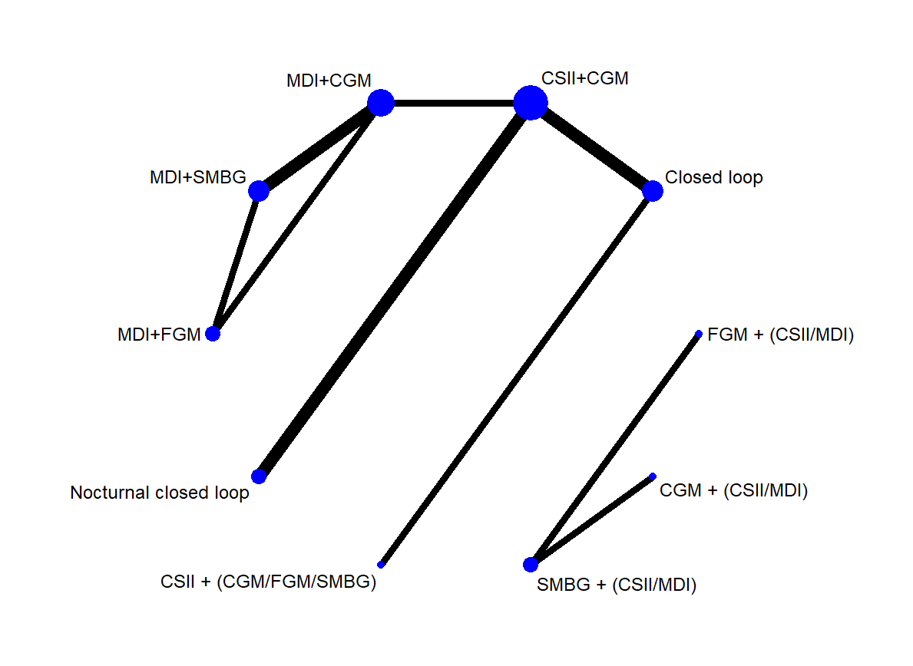
The size of each circle and the width of each line is proportional to the number of participants randomised to each intervention and the number of trials comparing each pair of treatments respectively.

Direct comparisons and the number of included studies for the percent time in range network

Direct treatment comparisons | Number of included studies
CSII + (CGM/FGM/SMBG) vs Closed loop | 1
CSII+CGM vs Closed loop | 2
CSII+CGM vs MDI+CGM | 1
CSII+CGM vs Nocturnal closed loop | 2
MDI+CGM vs MDI+FGM | 1
MDI+CGM vs MDI+SMBG | 2
MDI+FGM vs MDI+SMBG | 1

Indirect comparisons for the percent time in range network

Indirect treatment comparisons
CSII+(CGM/FGM/SMBG) vs CSII+CGM
CSII+(CGM/FGM/SMBG) vs MDI+CGM
CSII+(CGM/FGM/SMBG) vs MDI+FGM
CSII+(CGM/FGM/SMBG) vs MDI+SMBG
CSII+(CGM/FGM/SMBG) vs Nocturnal closed loop
CSII+CGM vs MDI+FGM
CSII+CGM vs MDI+SMBG
Closed loop vs MDI+CGM
Closed loop vs MDI+FGM
Closed loop vs MDI+SMBG
Closed loop vs Nocturnal closed loop
MDI+CGM vs Nocturnal closed loop
MDI+FGM vs Nocturnal closed loop
MDI+SMBG vs Nocturnal closed loop

Percentage contribution of direct comparisons
 | CSII + (CGM/FGM/SMBG)  vs  Closed loop | CSII+CGM  vs  Closed loop | CSII+CGM  vs  MDI+CGM | CSII+CGM  vs  Nocturnal closed loop | MDI+CGM vs MDI+FGM | MDI+CGM  vs MDI+SMBG | MDI+FGM  vs MDI+SMBG
CSII + (CGM/FGM/SMBG)  vs  Closed loop | 99.82 | 0.00 | 0.00 | 0.00 | 0.00 | 0.00 | 0.00
CSII+CGM  vs  Closed loop | 0.00 | 99.55 | 0.00 | 0.00 | 0.00 | 0.00 | 0.00
CSII+CGM  vs  MDI+CGM | 0.00 | 0.00 | 98.92 | 0.00 | 0.00 | 0.00 | 0.00
CSII+CGM  vs  Nocturnal closed loop | 0.00 | 0.00 | 0.00 | 99.9 | 0.00 | 0.00 | 0.00
MDI+CGM  vs  MDI+FGM | 0.00 | 0.00 | 0.00 | 0.00 | 29.61 | 35.04 | 35.04
MDI+CGM  vs  MDI+SMBG | 0.00 | 0.00 | 0.00 | 0.00 | 7.65 | 84.45 | 7.65
MDI+FGM  vs  MDI+SMBG | 0.00 | 0.00 | 0.00 | 0.00 | 7.15 | 7.15 | 85.6
CSII+(CGM/FGM/SMBG)  vs  CSII+CGM | 49.68 | 49.68 | 0.00 | 0.00 | 0.00 | 0.00 | 0.00
CSII+(CGM/FGM/SMBG)  vs  MDI+CGM | 32.84 | 32.84 | 32.84 | 0.00 | 0.00 | 0.00 | 0.00
CSII+(CGM/FGM/SMBG) vs  MDI+FGM | 21.11 | 21.11 | 21.11 | 0.00 | 7.34 | 13.76 | 13.76
CSII+(CGM/FGM/SMBG)  vs  MDI+SMBG | 23.84 | 23.84 | 23.84 | 0.00 | 2.93 | 20.91 | 2.93
CSII+(CGM/FGM/SMBG)  vs  Nocturnal closed loop | 33.11 | 33.11 | 0.00 | 33.11 | 0.00 | 0.00 | 0.00
CSII+CGM  vs  MDI+FGM | 0.00 | 0.00 | 37.77 | 0.00 | 14.72 | 23.06 | 23.06
CSII+CGM  Vs  MDI+SMBG | 0.00 | 0.00 | 46.87 | 0.00 | 4.94 | 41.92 | 4.94
Closed loop  vs  MDI+CGM | 0.00 | 49.31 | 49.31 | 0.00 | 0.00 | 0.00 | 0.00
Closed loop  vs  MDI+FGM | 0.00 | 27.02 | 27.02 | 0.00 | 9.8 | 17.23 | 17.23
Closed loop  vs  MDI+SMBG | 0.00 | 31.57 | 31.57 | 0.00 | 3.67 | 27.9 | 3.67
Closed loop  vs  Nocturnal closed loop | 0.00 | 49.75 | 0.00 | 49.75 | 0.00 | 0.00 | 0.00
MDI+CGM  vs  Nocturnal closed loop | 0.00 | 0.00 | 49.43 | 49.43 | 0.00 | 0.00 | 0.00
MDI+FGM  vs  Nocturnal closed loop | 0.00 | 0.00 | 27.09 | 27.09 | 9.81 | 17.28 | 17.28
MDI+SMBG  vs  Nocturnal closed loop | 0.00 | 0.00 | 31.64 | 31.64 | 3.70 | 27.94 | 3.70

Percentage contribution of direct comparisons for percent time in range network
 | CSII + (CGM/FGM/SMBG) vs  Closed loop | CSII+CGM  vs  Closed loop | CSII+CGM  vs  MDI+CGM | CSII+CGM  vs  Nocturnal closed loop | MDI+CGM vs MDI+FGM | MDI+CGM  vs MDI+SMBG | MDI+FGM  vs MDI+SMBG
Entire network | 12.52 | 20.09 | 22.96 | 13.99 | 4.87 | 15.23 | 10.33

Evaluation of inconsistency

Loop-specific approach:
Loops without evidence of statistical inconsistency for the percent time in range network
Loops | Inconsistency Factor | Standard error | Z value | P value | 95% Confidence Interval | Loop specific heterogeneity (tau²)
MDI+CGM  MDI+FGM  MDI+SMBG | 7.58 | 4.95 | 1.529 | 0.126 | (0.00, 17.29) | 0.000

Side (or node) specific approach:

Side (or node) specific inconsistency between direct and indirect assessment of diabetes management interventions for the percent time in range network
 | Direct coefficient | Standard Error | Indirect coefficient | Standard Error | Difference coefficient | Standard Error | P value
CSII+(CGM/FGM/SMBG) *  Closed loop | 10.60 | 2.13 | 10.58 | 33.45 | 0.02 | 33.52 | 1.000
CSII+CGM *  Closed loop | 8.77 | 2.35 | 8.54 | 36.63 | 0.23 | 36.72 | 0.995
CSII+CGM *  MDI+CGM | -4.00 | 3.29 | -2.07 | 48.63 | -1.93 | 48.73 | 0.968
CSII+CGM *  Nocturnal closed loop | 4.89 | 1.62 | 1.21 | 141.57 | 3.68 | 141.56 | 0.979
MDI+CGM  MDI+FGM | -5.90 | 4.24 | 1.68 | 2.57 | -7.58 | 4.95 | 0.126
MDI+CGM  MDI+SMBG | -4.16 | 1.71 | -11.71 | 4.64 | 7.55 | 4.95 | 0.127
MDI+FGM  MDI+SMBG | -5.84 | 1.91 | 1.73 | 4.57 | -7.57 | 4.95 | 0.126
* Data for treatment comparisons came only from the trials which directly compared them, and may have lead to large standard error.

Funnel plot of the effect size at comparison-specific pooled effect by the standard error of effect size for the percent time in range network
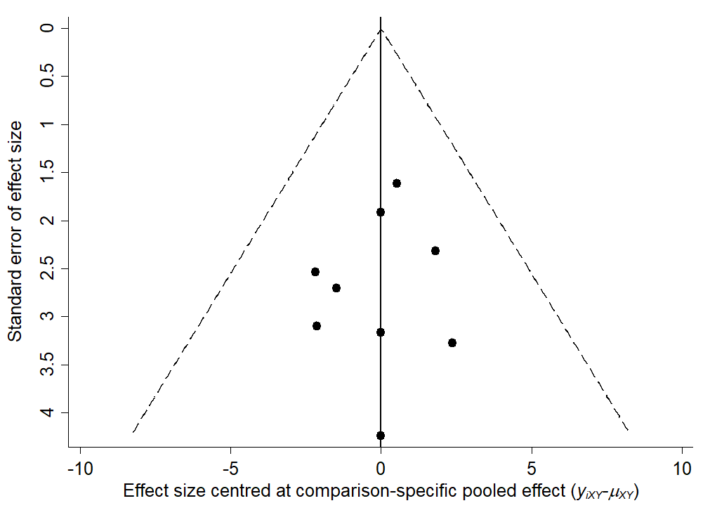

The mean difference (95% confidence interval / 95% predictive interval) for the percent time in range network
Comparison | Mean difference | 95% Confidence interval | 95% Predictive interval
CSII+CGM  vs  CSII+(CGM/FGM/SMBG) | 1.83 | (-4.33, 8.00) | (-5.71, 9.38)
Closed loop  vs  CSII+(CGM/FGM/SMBG) | 10.60 | (6.46, 14.74) | (5.30, 15.90)
MDI+CGM  vs  CSII+(CGM/FGM/SMBG) | -2.16 | (-11.05, 6.73) | (-12.82, 8.51)
MDI+FGM  vs  CSII+(CGM/FGM/SMBG) | -2.69 | (-12.97, 7.59) | (-14.96, 9.58)
MDI+SMBG  vs  CSII+(CGM/FGM/SMBG) | -7.25 | (-16.75, 2.25) | (-18.62, 4.12)
Nocturnal closed loop  vs  CSII+(CGM/FGM/SMBG) | 6.73 | (-0.22, 13.67) | (-1.7, 15.16)
Closed loop  vs  CSII+CGM | 8.77 | (4.18, 13.35) | (2.99, 14.54)
MDI+CGM  vs  CSII+CGM | -3.99 | (-10.42, 2.44) | (-11.84, 3.86)
MDI+FGM  vs  CSII+CGM | -4.52 | (-12.81, 3.76) | (-14.49, 5.45)
MDI+SMBG  vs  CSII+CGM | -9.09 | (-16.35, -1.82) | (-17.88, -0.29)
Nocturnal closed loop  vs  CSII+CGM | 4.89 | (1.73, 8.05) | (0.63, 9.15)
MDI+CGM  vs  Closed loop | -12.76 | (-20.64, -4.87) | (-22.26, -3.25)
MDI+FGM  vs  Closed loop | -13.29 | (-22.71, -3.86) | (-24.57, -2.01)
MDI+SMBG  vs  Closed loop | -17.85 | (-26.42, -9.28) | (-28.14, -7.56)
Nocturnal closed loop  vs  Closed loop | -3.87 | (-9.46, 1.71) | (-10.77, 3.02)
MDI+FGM  vs  MDI+CGM | -0.53 | (-5.77, 4.70) | (-7.03, 5.97)
MDI+SMBG  vs  MDI+CGM | -5.09 | (-8.47, -1.72) | (-9.57, -0.62)
Nocturnal closed loop  vs  MDI+CGM | 8.88 | (1.71, 16.05) | (0.20, 17.57)
MDI+SMBG  vs  MDI+FGM | -4.56 | (-8.88, -0.25) | (-10.05, 0.92)
Nocturnal closed loop  vs  MDI+FGM | 9.41 | (0.30, 18.52) | (-1.50, 20.33)
Nocturnal closed loop  vs  MDI+SMBG | 13.98 | (6.01, 21.94) | (4.38, 23.57)

League table of diabetes management interventions
CSII+  (CGM/FGM/SMBG) | 1.83  (-4.33,8.00) | 10.60 (6.46,14.74) | -2.16  (-11.05,6.73) | -2.69  (-12.97,7.59) | -7.25  (-16.75,2.25) | 6.73  (-0.22,13.67)
 | CSII+CGM | 8.77 (4.18,13.35) | -3.99  (-10.42,2.44) | -4.52  (-12.81,3.76) | -9.09 (-16.35,  -1.82) | 4.89 (1.73,8.05)
 |  | Closed loop | -12.76 (-20.64,  -4.87) | -13.29 (-22.71,  -3.86) | -17.85 (-26.42,  -9.28) | -3.87  (-9.46,1.71)
 |  |  | MDI+CGM | -0.53  (-5.77,4.70) | -5.09 (-8.47,-1.72) | 8.88 (1.71,16.05)
 |  |  |  | MDI+FGM | -4.56 (-8.88,-0.25) | 9.41 (0.30,18.52)
 |  |  |  |  | MDI+SMBG | 13.98 (6.01,21.94)
 |  |  |  |  |  | Nocturnal closed loop
Effect size (mean difference for percent time in range; 95% confidence interval) more than 1 would favour the diabetes management intervention in the column.

Estimated probabilities (%) of ranking for each diabetes management intervention for the percent time in range network
 | CSII+(CGM/FGM/SMBG) | CSII+CGM | Closed loop | MDI+CGM | MDI+FGM | MDI+SMBG | Nocturnal closed loop
Best | 0.0 | 0.0 | 91.0 | 0.0 | 0.1 | 0.0 | 8.9
2nd | 2.4 | 0.1 | 9.0 | 0.4 | 1.8 | 0.0 | 86.3
3rd | 22.3 | 59.1 | 0.0 | 5.8 | 8.7 | 0.0 | 4.0
4th | 38.2 | 30.5 | 0.0 | 16.9 | 13.7 | 0.0 | 0.7
5th | 14.1 | 8.0 | 0.0 | 48.0 | 29.1 | 0.7 | 0.1
6th | 15.9 | 2.1 | 0.0 | 28.8 | 44.9 | 8.3 | 0.0
Worst | 7.0 | 0.2 | 0.0 | 0.1 | 1.7 | 91.0 | 0.0

Treatment relative ranking (SUCRA, probability of being ranked as best, and mean rank) for the percent time in range network
Treatment | SUCRA | Probability of being ranked as best | Mean rank
CSII+(CGM/FGM/SMBG) | 43.4 | 0.0 | 4.4
CSII+CGM | 57.7 | 0.0 | 3.5
Closed loop | 98.5 | 91.0 | 1.1
MDI+CGM | 33.4 | 0.0 | 5.0
MDI+FGM | 31.5 | 0.1 | 5.1
MDI+SMBG | 1.6 | 0.0 | 6.9
Nocturnal closed loop | 83.9 | 8.9 | 2.0

Rankograms of diabetes management interventions for the percent time in range network
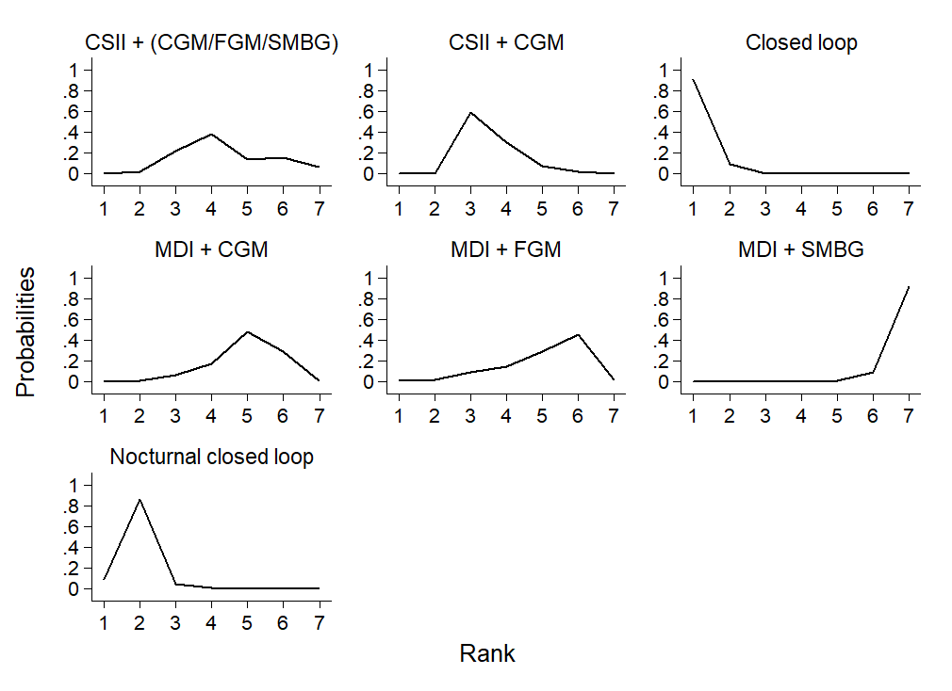

Cumulative ranking curve plots of diabetes management interventions for the percent time in range network
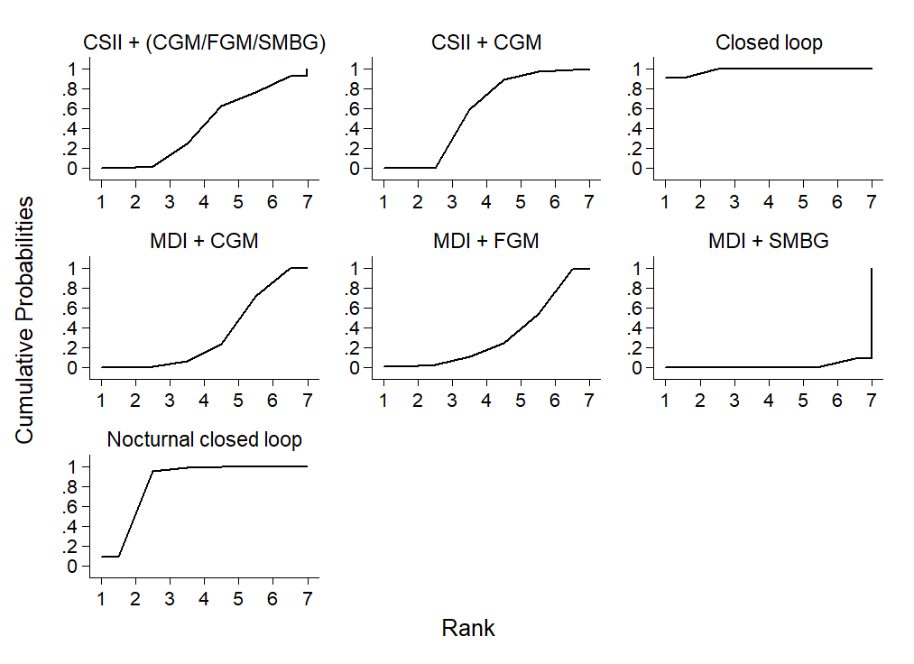

Analysis for the network of diabetes management interventions for the outcome of percent time above range:

Network map of diabetes management interventions for the outcome of percent time above range
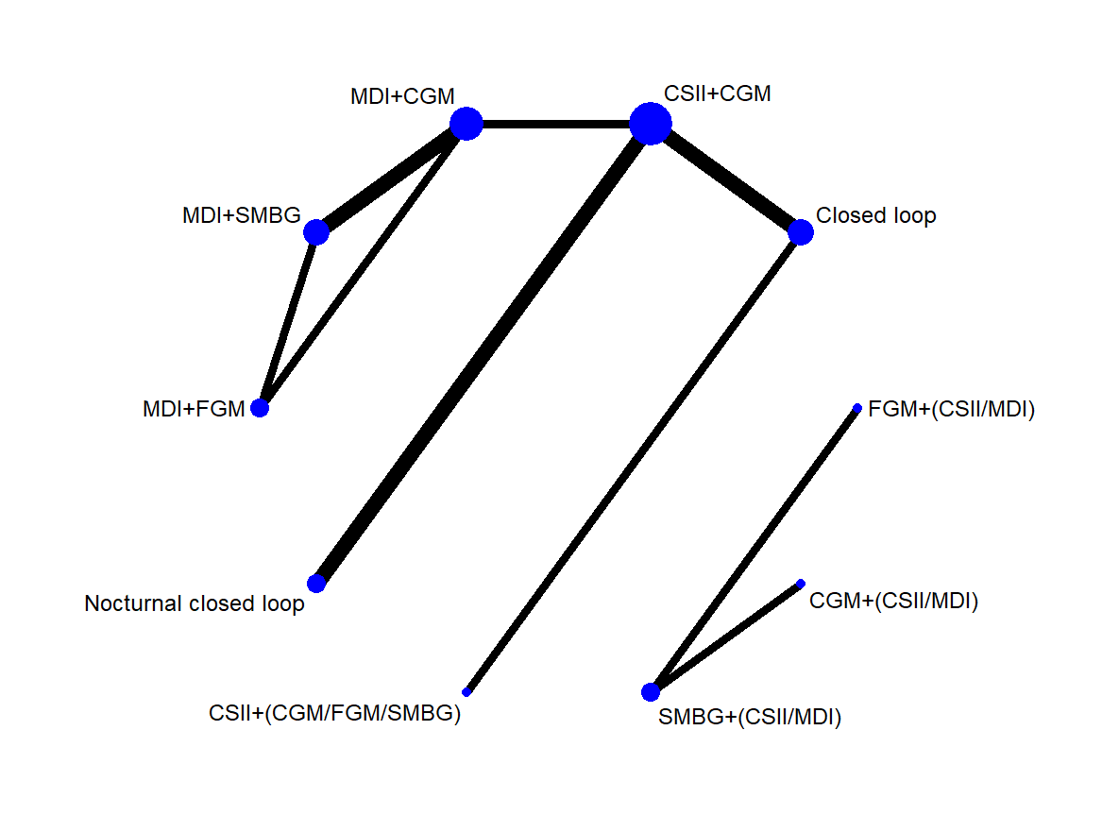

Direct comparisons and the number of included studies for the percent time above range network
Direct treatment comparisons | Number of included studies
CSII + (CGM/FGM/SMBG) vs Closed loop | 1
CSII+CGM vs Closed loop | 2
CSII+CGM vs MDI+CGM | 1
CSII+CGM vs Nocturnal closed loop | 2
MDI+CGM vs MDI+FGM | 1
MDI+CGM vs MDI+SMBG | 2
MDI+FGM vs MDI+SMBG | 1

Indirect comparisons for the percent time above range network
Indirect treatment comparisons
CSII+(CGM/FGM/SMBG) vs CSII+CGM
CSII+(CGM/FGM/SMBG) vs MDI+CGM
CSII+(CGM/FGM/SMBG) vs MDI+FGM
CSII+(CGM/FGM/SMBG) vs MDI+SMBG
CSII+(CGM/FGM/SMBG) vs Nocturnal closed loop
CSII+CGM vs MDI+FGM
CSII+CGM vs MDI+SMBG
Closed loop vs MDI+CGM
Closed loop vs MDI+FGM
Closed loop vs MDI+SMBG
Closed loop vs Nocturnal closed loop
MDI+CGM vs Nocturnal closed loop
MDI+FGM vs Nocturnal closed loop
MDI+SMBG vs Nocturnal closed loop

Percentage contribution of direct comparisons in each pairwise summary effect for the percent time above range network
 | CSII + (CGM/FGM/SMBG) vs  Closed loop | CSII+CGM vs  Closed loop | CSII+CGM vs MDI+CGM | CSII+CGM  vs  Nocturnal closed loop | MDI+CGM vs MDI+FGM | MDI+CGM  vs MDI+SMBG | MDI+FGM  vs MDI+SMBG
CSII + (CGM/FGM/SMBG)  vs  Closed loop | 99.77 | 0.00 | 0.00 | 0.00 | 0.00 | 0.00 | 0.00
CSII+CGM  vs  Closed loop | 0.00 | 99.37 | 0.00 | 0.00 | 0.00 | 0.00 | 0.00
CSII+CGM  vs  MDI+CGM | 0.00 | 0.00 | 98.49 | 0.00 | 0.00 | 0.00 | 0.00
CSII+CGM  vs  Nocturnal closed loop | 0.00 | 0.00 | 0.00 | 99.89 | 0.00 | 0.00 | 0.00
MDI+CGM  vs  MDI+FGM | 0.00 | 0.00 | 0.00 | 0.00 | 64.24 | 17.47 | 17.47
MDI+CGM  vs  MDI+SMBG | 0.00 | 0.00 | 0.00 | 0.00 | 27.78 | 43.57 | 27.78
MDI+FGM  vs  MDI+SMBG | 0.00 | 0.00 | 0.00 | 0.00 | 4.32 | 4.32 | 91.26
CSII+(CGM/FGM/SMBG)  vs  CSII+CGM | 49.57 | 49.57 | 0.00 | 0.00 | 0.00 | 0.00 | 0.00
CSII+(CGM/FGM/SMBG)  vs  MDI+CGM | 32.65 | 32.65 | 32.65 | 0.00 | 0.00 | 0.00 | 0.00
CSII+(CGM/FGM/SMBG) vs  MDI+FGM | 22.59 | 22.59 | 22.59 | 0.00 | 15.84 | 6.75 | 6.75
CSII+(CGM/FGM/SMBG)  vs  MDI+SMBG | 21.57 | 21.57 | 21.57 | 0.00 | 10.82 | 10.75 | 10.82
CSII+(CGM/FGM/SMBG)  vs  Nocturnal closed loop | 33.03 | 33.03 | 0.00 | 33.03 | 0.00 | 0.00 | 0.00
CSII+CGM  vs  MDI+FGM | 0.00 | 0.00 | 43.15 | 0.00 | 31.79 | 11.36 | 11.36
CSII+CGM  Vs  MDI+SMBG | 0.00 | 0.00 | 39.73 | 0.00 | 18.16 | 21.57 | 18.16
Closed loop  vs  MDI+CGM | 0.00 | 49.04 | 49.04 | 0.00 | 0.00 | 0.00 | 0.00
Closed loop  vs  MDI+FGM | 0.00 | 29.6 | 29.6 | 0.00 | 21.14 | 8.46 | 8.46
Closed loop  vs  MDI+SMBG | 0.00 | 27.89 | 27.89 | 0.00 | 13.55 | 14.34 | 13.55
Closed loop  vs  Nocturnal closed loop | 0.00 | 49.66 | 0.00 | 49.66 | 0.00 | 0.00 | 0.00
MDI+CGM  vs  Nocturnal closed loop | 0.00 | 0.00 | 49.21 | 49.21 | 0.00 | 0.00 | 0.00
MDI+FGM  vs  Nocturnal closed loop | 0.00 | 0.00 | 29.7 | 29.7 | 21.18 | 8.51 | 8.51
MDI+SMBG  vs  Nocturnal closed loop | 0.00 | 0.00 | 27.99 | 27.99 | 13.61 | 14.37 | 13.61

Percentage contribution of direct comparisons for the entire percent time above range network
 | CSII + (CGM/FGM/SMBG)  vs  Closed loop | CSII+CGM vs  Closed loop | CSII+CGM vs MDI+CGM | CSII+CGM vs  Nocturnal closed loop | MDI+CGM vs MDI+FGM | MDI+CGM  vs MDI+SMBG | MDI+FGM  vs MDI+SMBG
Entire network | 12.54 | 20.08 | 22.82 | 14.01 | 11.73 | 7.81 | 11.02

Evaluation of inconsistency:

Loop-specific approach:
Loops without evidence of statistical inconsistency for the percent time above range network
Loops | Inconsistency Factor | Standard error | Z value | P value | 95% Confidence Interval | Loop specific heterogeneity (tau²)
MDI+CGM  MDI+FGM  MDI+SMBG | 3.43 | 5.00 | 0.69 | 0.492 | (0.00,13.24) | 0.000

Side (or node) specific approach:

Side (or node) specific inconsistency between direct and indirect assessment of diabetes management interventions for the percent time above range network
 | Direct coefficient | Standard Error | Indirect coefficient | Standard Error | Difference coefficient | Standard Error | P value
CSII+(CGM/FGM/SMBG) *  Closed loop | -7.00 | 4.15 | -9.73 | 33.63 | 2.73 | 33.88 | 0.936
CSII+CGM *  Closed loop | -8.00 | 3.67 | -4.84 | 36.92 | -3.15 | 37.12 | 0.932
CSII+CGM *  MDI+CGM | 3.19 | 5.16 | -1.56 | 48.90 | 4.75 | 49.15 | 0.923
CSII+CGM *  Nocturnal closed loop | -4.34 | 3.00 | -6.20 | 141.92 | 1.86 | 141.93 | 0.990
MDI+CGM  MDI+FGM | 1.30 | 5.88 | 3.78 | 5.75 | -2.48 | 8.22 | 0.763
MDI+CGM  MDI+SMBG | 2.15 | 3.44 | -0.41 | 7.45 | 2.56 | 8.20 | 0.755
MDI+FGM  MDI+SMBG | -1.67 | 4.62 | 0.86 | 6.81 | -2.52 | 8.23 | 0.759
* Data for treatment comparisons came only from the trials which directly compared them, and may have lead to large standard error.

Funnel plot of the effect size at comparison-specific pooled effect by the standard error of effect size for the percent time above range network
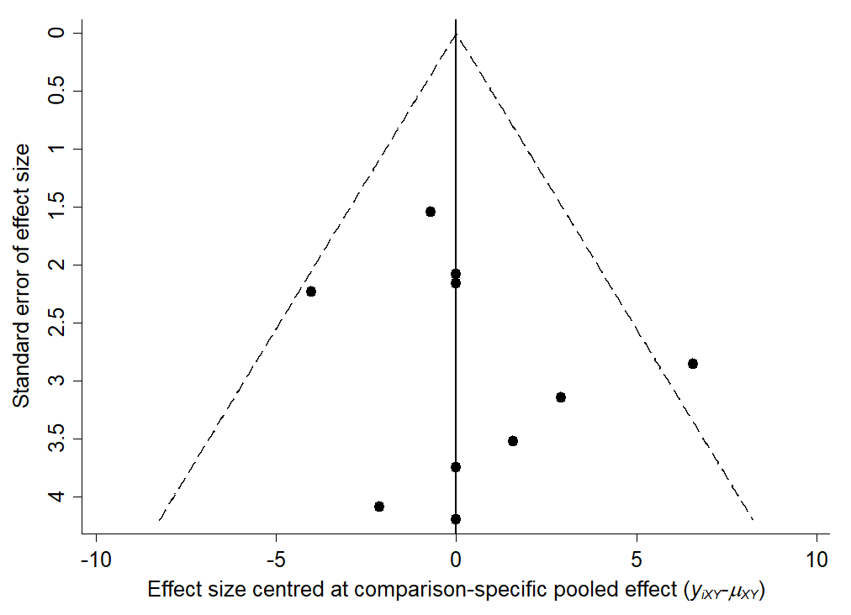

The mean difference (95% confidence interval / 95% predictive interval) for the percent time above range network

Comparison | Mean difference | 95% Confidence interval | 95% Predictive interval
CSII+CGM  vs  CSII+(CGM/FGM/SMBG) | 0.93 | (-9.77, 11.62) | (-14.06, 15.91)
Closed loop  vs  CSII+(CGM/FGM/SMBG) | -7.04 | (-15.09, 1.01) | (-19.53, 5.44)
MDI+CGM  vs  CSII+(CGM/FGM/SMBG) | 4.07 | (-10.51, 18.65) | (-14.92, 23.06)
MDI+FGM  vs  CSII+(CGM/FGM/SMBG) | 6.75 | (-9.58, 23.07) | (-14.12, 27.61)
MDI+SMBG  vs  CSII+(CGM/FGM/SMBG) | 5.86 | (-9.73, 21.45) | (-14.21, 25.92)
Nocturnal closed loop  vs  CSII+(CGM/FGM/SMBG) | -3.41 | (-15.62, 8.80) | (-19.92, 13.10)
Closed loop  vs  CSII+CGM | -7.97 | (-15.11, -0.82) | (-19.67, 3.73)
MDI+CGM  vs  CSII+CGM | 3.14 | (-6.89, 13.18) | (-11.2, 17.48)
MDI+FGM  vs  CSII+CGM | 5.82 | (-6.62, 18.26) | (-10.93, 22.57)
MDI+SMBG  vs  CSII+CGM | 4.93 | (-6.52, 16.38) | (-10.81, 20.67)
Nocturnal closed loop  vs  CSII+CGM | -4.34 | (-10.21, 1.54) | (-15.01, 6.34)
MDI+CGM  vs  Closed loop | 11.11 | (-1.17, 23.38) | (-5.47, 27.69)
MDI+FGM  vs  Closed loop | 13.79 | (-0.52, 28.10) | (-4.91, 32.49)
MDI+SMBG  vs  Closed loop | 12.90 | (-0.56, 26.36) | (-4.91, 30.70)
Nocturnal closed loop  vs  Closed loop | 3.63 | (-5.63, 12.89) | (-9.96, 17.23)
MDI+FGM  vs  MDI+CGM | 2.68 | (-4.69, 10.05) | (-9.21, 14.57)
MDI+SMBG  vs  MDI+CGM | 1.79 | (-3.74, 7.32) | (-8.63, 12.21)
Nocturnal closed loop  vs  MDI+CGM | -7.48 | (-19.11, 4.15) | (-23.4, 8.44)
MDI+SMBG  vs  MDI+FGM | -0.89 | (-7.61, 5.84) | (-12.24, 10.46)
Nocturnal closed loop  vs  MDI+FGM | -10.16 | (-23.88, 3.57) | (-28.24, 7.93)
Nocturnal closed loop  vs  MDI+SMBG | -9.27 | (-22.11, 3.57) | (-26.43, 7.89)

League table of diabetes management interventions for the time above range network
CSII+(CGM/  FGM/SMBG) | 0.93  (-9.77,11.62) | -7.04  (-15.09,1.01) | 4.07  (-10.51,18.65) | 6.75  (-9.58,23.07) | 5.86 (-9.73,21.45) | -3.41  (-15.62,8.80)
 | CSII+CGM | -7.97  (-15.11,-0.82) | 3.14 (-6.89,13.18) | 5.82  (-6.62,18.26) | 4.93 (-6.52,16.38) | -4.34  (-10.21,1.54)
 |  | Closed loop | 11.11  (-1.17,23.38) | 13.79  (-0.52,28.10) | 12.90  (-0.56,26.36) | 3.63  (-5.63,12.89)
 |  |  | MDI+CGM | 2.68  (-4.69,10.05) | 1.79 (-3.74,7.32) | -7.48  (-19.11,4.15)
 |  |  |  | MDI+FGM | -0.89 (-7.61,5.84) | -10.16  (-23.88,3.57)
 |  |  |  |  | MDI+SMBG | -9.27  (-22.11,3.57)
 |  |  |  |  |  | Nocturnal closed loop
Effect size (mean difference for percent time in range; 95% confidence interval) more than 1 would favour the diabetes management intervention in the row.

Estimated probabilities (%) of ranking for each diabetes management intervention regarding percent time above range
 | CSII+(CGM/FGM/SMBG) | CSII+CGM | Closed loop | MDI+CGM | MDI+FGM | MDI+SMBG | Nocturnal closed loop
Best | 3.5 | 0.0 | 71.8 | 1.6 | 1.4 | 1.2 | 20.4
2nd | 23.1 | 2.9 | 22.1 | 4.7 | 2.5 | 2.6 | 42.0
3rd | 24.3 | 29.3 | 3.2 | 8.8 | 4.7 | 5.4 | 24.4
4th | 19.7 | 40.8 | 1.6 | 16.5 | 7.1 | 7.8 | 6.6
5th | 7.8 | 10.7 | 1.0 | 43.1 | 14.9 | 18.9 | 3.5
6th | 7.3 | 9.7 | 0.4 | 18.3 | 23.1 | 39.2 | 2.1
Worst | 14.2 | 6.6 | 0.0 | 7.0 | 46.3 | 24.8 | 1.0

Treatment relative ranking (SUCRA, probability of being ranked as best, and mean rank) for the percent time above range network
Treatment | SUCRA | Probability of being ranked as best | Mean rank
CSII+(CGM/FGM/SMBG) | 52.7 | 3.5 | 3.8
CSII+CGM | 47.5 | 0.0 | 4.1
Closed loop | 93.5 | 71.8 | 1.4
MDI+CGM | 37.1 | 1.6 | 4.8
MDI+FGM | 19.0 | 1.4 | 5.9
MDI+SMBG | 23.8 | 1.2 | 5.6
Nocturnal closed loop | 76.5 | 20.4 | 2.4

Rankograms of diabetes management interventions for the percent time above range network
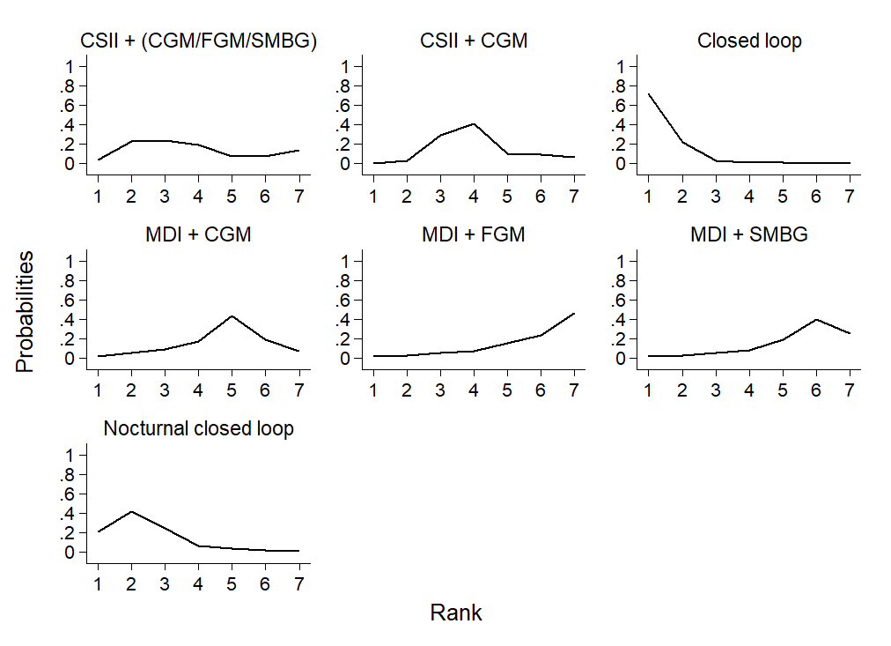

Cumulative ranking curve plots of diabetes management interventions for the percent time above range network

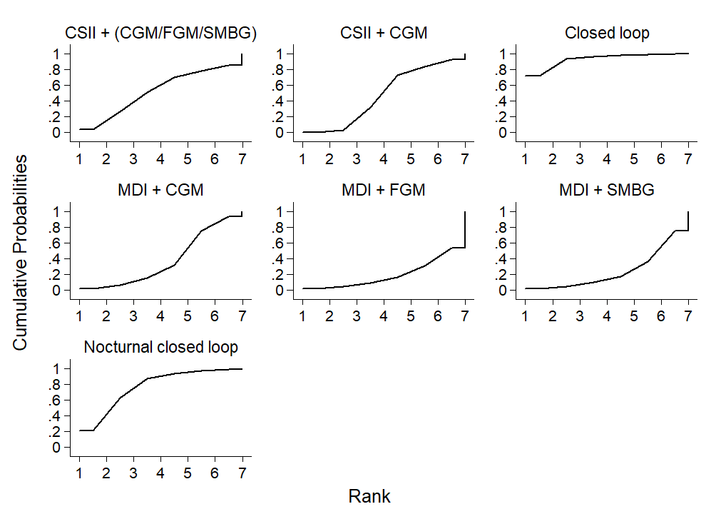

Analysis for the network of diabetes management for the outcome of percent time below range (assuming correlation coefficient of 0.5):

Network map of diabetes management interventions for the outcome of percent time below range.
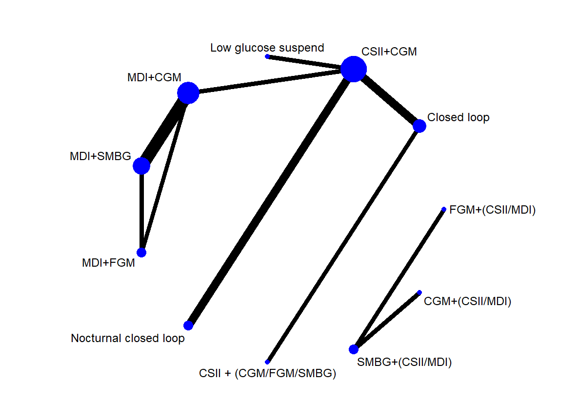

Direct comparisons and the number of included studies for the percent time below range network
Direct treatment comparisons | Number of included studies
CSII+(CGM/FGM/SMBG) vs Closed loop | 1
CSII+CGM vs Closed loop | 2
CSII+CGM vs Low glucose suspend | 1
CSII+CGM vs MDI+CGM | 1
CSII+CGM vs Nocturnal closed loop | 2
MDI+CGM vs MDI+FGM | 1
MDI+CGM vs MDI+SMBG | 3
MDI+FGM vs Nocturnal closed loop | 1

Indirect comparisons for the non-severe hypoglycaemia network comprising the same within-study co-interventions
Indirect treatment comparisons
CSII+(CGM/FGM/SMBG) vs CSII+CGM
CSII+(CGM/FGM/SMBG) vs Low glucose suspend
CSII+(CGM/FGM/SMBG) vs MDI+CGM
CSII+(CGM/FGM/SMBG) vs MDI+FGM
CSII+(CGM/FGM/SMBG) vs MDI+SMBG
CSII+(CGM/FGM/SMBG) vs Nocturnal closed loop
CSII+CGM vs MDI+FGM
CSII+CGM vs MDI+SMBG
Closed loop vs Low glucose suspend
Closed loop vs MDI+CGM
Closed loop vs MDI+FGM
Closed loop vs MDI+SMBG
Closed loop vs Nocturnal closed loop
Low glucose suspend vs MDI+CGM
Low glucose suspend vs MDI+FGM
Low glucose suspend vs MDI+SMBG
Low glucose suspend vs Nocturnal closed loop
MDI+CGM vs Nocturnal closed loop
MDI+FGM vs Nocturnal closed loop
MDI+SMBG vs Nocturnal closed loop

Percentage contribution of direct comparisons in each pairwise summary effect for the percent time below range network
 | CSII+(CGM/FGM/SMBG)  vs  Closed loop | CSII+CGM  vs  Closed loop | CSII+CGM  vs  Low glucose suspend | CSII+CGM  vs  MDI+CGM | CSII+CGM  vs  Nocturnal closed loop | MDI+CGM  vs  MDI+FGM | MDI+CGM  vs  MDI+SMBG | MDI+FGM  vs  Nocturnal closed loop
CSII+(CGM/FGM/SMBG)  vs  Closed loop | 99.95 | 0.00 | 0.00 | 0.00 | 0.00 | 0.00 | 0.00 | 0.00
CSII+CGM  vs  Closed loop | 0.00 | 99.95 | 0.00 | 0.00 | 0.00 | 0.00 | 0.00 | 0.00
CSII+CGM  vs  Low glucose suspend | 0.00 | 0.00 | 99.98 | 0.00 | 0.00 | 0.00 | 0.00 | 0.00
CSII+CGM  vs  MDI+CGM | 0.00 | 0.00 | 0.00 | 99.97 | 0.00 | 0.00 | 0.00 | 0.00
CSII+CGM  vs  Nocturnal closed loop | 0.00 | 0.00 | 0.00 | 0.00 | 99.99 | 0.00 | 0.00 | 0.00
MDI+CGM  vs  MDI+FGM | 0.00 | 0.00 | 0.00 | 0.00 | 0.00 | 41.33 | 29.29 | 29.29
MDI+CGM  vs  MDI+SMBG | 0.00 | 0.00 | 0.00 | 0.00 | 0.00 | 3.42 | 93.12 | 3.42
MDI+FGM  vs  Nocturnal closed loop | 0.00 | 0.00 | 0.00 | 0.00 | 0.00 | 17.24 | 17.24 | 65.45
CSII+(CGM/FGM/SMBG)  vs  CSII+CGM | 49.95 | 49.95 | 0.00 | 0.00 | 0.00 | 0.00 | 0.00 | 0.00
CSII+(CGM/FGM/SMBG)  vs  Low glucose suspend | 33.3 | 33.3 | 33.3 | 0.00 | 0.00 | 0.00 | 0.00 | 0.00
CSII+(CGM/FGM/SMBG)  vs  MDI+CGM | 33.3 | 33.3 | 0.00 | 33.3 | 0.00 | 0.00 | 0.00 | 0.00
CSII+(CGM/FGM/SMBG)  vs  MDI+FGM | 22.03 | 22.03 | 0.00 | 22.03 | 0.00 | 10.33 | 11.7 | 11.7
CSII+(CGM/FGM/SMBG)  vs  MDI+SMBG | 24.63 | 24.63 | 0.00 | 24.63 | 0.00 | 1.36 | 23.27 | 1.36
CSII+(CGM/FGM/SMBG)  vs  Nocturnal closed loop | 33.3 | 33.3 | 0.00 | 0.00 | 33.3 | 0.00 | 0.00 | 0.00
CSII+CGM  vs  MDI+FGM | 0.00 | 0.00 | 0.00 | 40.18 | 0.00 | 20.66 | 19.52 | 19.52
CSII+CGM  vs  MDI+SMBG | 0.00 | 0.00 | 0.00 | 48.83 | 0.00 | 2.28 | 46.55 | 2.28
Closed loop  vs  Low glucose suspend | 0.00 | 49.97 | 49.97 | 0.00 | 0.00 | 0.00 | 0.00 | 0.00
Closed loop  vs  MDI+CGM | 0.00 | 49.97 | 0.00 | 49.97 | 0.00 | 0.00 | 0.00 | 0.00
Closed loop  vs  MDI+FGM | 0.00 | 28.41 | 0.00 | 28.41 | 0.00 | 13.77 | 14.63 | 14.63
Closed loop  vs  MDI+SMBG | 0.00 | 32.73 | 0.00 | 32.73 | 0.00 | 1.7 | 31.03 | 1.7
Closed loop  vs  Nocturnal closed loop | 0.00 | 49.97 | 0.00 | 0 | 49.97 | 0.00 | 0.00 | 0.00
Low glucose suspend  vs  MDI+CGM | 0.00 | 0.00 | 49.98 | 49.98 | 0.00 | 0.00 | 0.00 | 0.00
Low glucose suspend  vs  MDI+FGM | 0.00 | 0.00 | 28.41 | 28.41 | 0.00 | 13.77 | 14.64 | 14.64
Low glucose suspend  vs  MDI+SMBG | 0.00 | 0.00 | 32.74 | 32.74 | 0.00 | 1.71 | 31.03 | 1.71
Low glucose suspend  vs  Nocturnal closed loop | 0.00 | 0.00 | 49.99 | 0.00 | 49.99 | 0.00 | 0.00 | 0.00
MDI+CGM  vs  Nocturnal closed loop | 0.00 | 0.00 | 0.00 | 49.98 | 49.98 | 0.00 | 0.00 | 0.00
MDI+FGM  vs  Nocturnal closed loop | 0.00 | 0.00 | 0.00 | 28.41 | 28.41 | 13.77 | 14.64 | 14.64
MDI+SMBG  vs  Nocturnal closed loop | 0.00 | 0.00 | 0.00 | 32.74 | 32.74 | 1.71 | 31.03 | 1.71

Percentage contribution of direct comparisons for the entire percent time below range network
 | CSII+(CGM/FGM/SMBG)  vs  Closed loop | CSII+CGM  vs  Closed loop | CSII+CGM  vs  Low glucose suspend | CSII+CGM  vs  MDI+CGM | CSII+CGM  vs  Nocturnal closed loop | MDI+CGM  vs  MDI+FGM | MDI+CGM  vs  MDI+SMBG | MDI+FGM  vs  Nocturnal closed loop
Entire network | 10.60 | 18.14 | 12.31 | 21.53 | 12.31 | 5.11 | 13.50 | 6.51

Evaluation of inconsistency

Loop-specific approach:

Loop with evidence of statistical inconsistency for the percent time below range network
Loops | Inconsistency Factor | Standard error | Z value | P value | 95% Confidence Interval | Loop specific heterogeneity (tau²)
MDI+CGM  MDI+FGM  MDI+SMBG | 9.30 | 3.35 | 2.778 | 0.005 | (2.74, 15.87) | 0.980

Side (or node) specific approach:

Side (or node) specific inconsistency between direct and indirect assessment of diabetes management interventions for the percent time below range network

 | Direct coefficient | Standard Error | Indirect coefficient | Standard Error | Difference coefficient | Standard Error | P value
CSII+(CGM/FGM/SMBG) *  Closed loop | -2.40 | 2.31 | -0.13 | 30.21 | -2.27 | 30.30 | 0.940
CSII+CGM *  Closed loop | -0.76 | 1.56 | -3.21 | 32.57 | 2.46 | 32.60 | 0.940
CSII+CGM *  Low glucose suspend | -0.90 | 2.19 | 2.35 | 200.12 | -3.25 | 200.13 | 0.987
CSII+CGM *  MDI+CGM | -1.18 | 2.17 | 1.85 | 43.75 | -3.03 | 43.81 | 0.945
CSII+CGM *  Nocturnal closed loop | -0.50 | 1.52 | 2.75 | 141.57 | -3.25 | 141.58 | 0.982
MDI+CGM  MDI+FGM | 4.80 | 2.10 | -4.53 | 1.82 | 9.32 | 2.78 | 0.001
MDI+CGM  MDI+SMBG | 2.97 | 0.62 | 12.30 | 2.70 | -9.33 | 2.78 | 0.001
MDI+FGM  MDI+SMBG | 7.50 | 1.71 | -1.83 | 2.19 | 9.33 | 2.78 | 0.001
* Data for treatment comparisons came only from the trials which directly compared them, and may have lead to large standard error.

Funnel plot of the effect size at comparison-specific pooled effect by the standard error of effect size for the percent time below range network

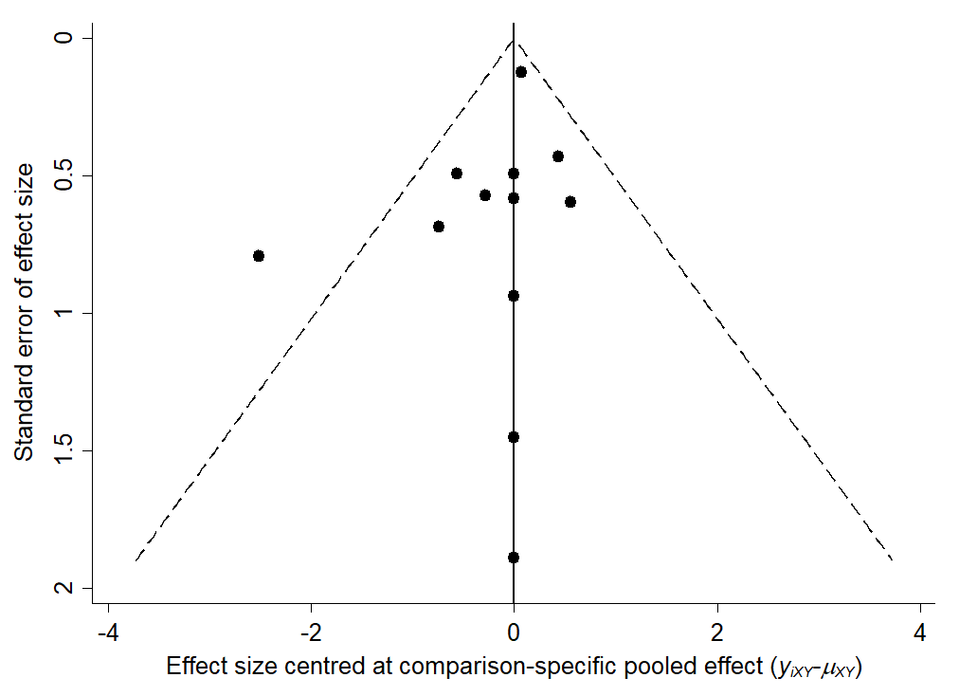

The mean difference (95% confidence interval / 95% predictive interval) for the percent time below range network

Comparison | Mean difference | 95% Confidence interval | 95% Predictive interval
CSII+CGM  vs  CSII+(CGM/FGM/SMBG) | -1.62 | (-7.05, 3.81) | (-9.38, 6.13)
Closed loop  vs  CSII+(CGM/FGM/SMBG) | -2.39 | (-6.89, 2.12) | (-9.33, 4.56)
Low glucose suspend  vs  CSII+(CGM/FGM/SMBG) | -2.52 | (-9.44, 4.39) | (-11.68, 6.63)
MDI+CGM  vs  CSII+(CGM/FGM/SMBG) | -2.80 | (-9.67, 4.08) | (-11.91, 6.32)
MDI+FGM  vs  CSII+(CGM/FGM/SMBG) | -2.54 | (-10.5, 5.41) | (-12.74, 7.65)
MDI+SMBG  vs  CSII+(CGM/FGM/SMBG) | 1.24 | (-6.04, 8.52) | (-8.28, 10.76)
Nocturnal closed loop  vs  CSII+(CGM/FGM/SMBG) | -2.13 | (-8.32, 4.07) | (-10.59, 6.34)
Closed loop  vs  CSII+CGM | -0.76 | (-3.81, 2.28) | (-6.6, 5.07)
Low glucose suspend  vs  CSII+CGM | -0.90 | (-5.18, 3.38) | (-7.66, 5.86)
MDI+CGM  vs  CSII+CGM | -1.17 | (-5.41, 3.06) | (-7.89, 5.55)
MDI+FGM  vs  CSII+CGM | -0.92 | (-6.75, 4.91) | (-9.04, 7.20)
MDI+SMBG  vs  CSII+CGM | 2.86 | (-2.01, 7.73) | (-4.39, 10.12)
Nocturnal closed loop  vs  CSII+CGM | -0.50 | (-3.49, 2.48) | (-6.29, 5.29)
Low glucose suspend  vs  Closed loop | -0.14 | (-5.39, 5.12) | (-7.73, 7.46)
MDI+CGM  vs  Closed loop | -0.41 | (-5.62, 4.80) | (-7.97, 7.15)
MDI+FGM  vs  Closed loop | -0.16 | (-6.73, 6.42) | (-8.98, 8.67)
MDI+SMBG  vs  Closed loop | 3.63 | (-2.11, 9.37) | (-4.41, 11.66)
Nocturnal closed loop  vs  Closed loop | 0.26 | (-4.01, 4.53) | (-6.49, 7.01)
MDI+CGM  vs  Low glucose suspend | -0.27 | (-6.29, 5.75) | (-8.57, 8.02)
MDI+FGM  vs  Low glucose suspend | -0.02 | (-7.26, 7.21) | (-9.49, 9.45)
MDI+SMBG  vs  Low glucose suspend | 3.76 | (-2.72, 10.25) | (-4.97, 12.50)
Nocturnal closed loop  vs  Low glucose suspend | 0.40 | (-4.82, 5.62) | (-7.17, 7.96)
MDI+FGM  vs  MDI+CGM | 0.25 | (-3.76, 4.26) | (-6.29, 6.79)
MDI+SMBG  vs  MDI+CGM | 4.04 | (1.63, 6.44) | (-1.39, 9.47)
Nocturnal closed loop  vs  MDI+CGM | 0.67 | (-4.51, 5.85) | (-6.86, 8.20)
MDI+SMBG  vs  MDI+FGM | 3.79 | (-0.08, 7.66) | (-2.65, 10.22)
Nocturnal closed loop  vs  MDI+FGM | 0.42 | (-6.13, 6.97) | (-8.38, 9.22)
Nocturnal closed loop  vs  MDI+SMBG | -3.37 | (-9.08, 2.35) | (-11.38, 4.64)

League table of diabetes management interventions for the percent below range network
CSII+ (CGM/FGM/SMBG) | -1.62  (-7.05,3.81) | -2.39  (-6.89,2.12) | -2.52  (-9.44,4.39) | -2.80  (-9.67,4.08) | -2.54  (-10.50,5.41) | 1.24  (-6.04,8.52) | -2.13  (-8.32,4.07)
 | CSII+CGM | -0.76  (-3.81,2.28) | -0.90  (-5.18,3.38) | -1.17  (-5.41,3.06) | -0.92  (-6.75,4.91) | 2.86  (-2.01,7.73) | -0.50  (-3.49,2.48)
 |  | Closed loop | -0.14  (-5.39,5.12) | -0.41  (-5.62,4.80) | -0.16  (-6.73,6.42) | 3.63  (-2.11,9.37) | 0.26  (-4.01,4.53)
 |  |  | Low glucose suspend | -0.27  (-6.29,5.75) | -0.02  (-7.26,7.21) | 3.76  (-2.72,10.25) | 0.40  (-4.82,5.62)
 |  |  |  | MDI+CGM | 0.25  (-3.76,4.26) | 4.04 (1.63,6.44) | 0.67  (-4.51,5.85)
 |  |  |  |  | MDI+FGM | 3.79  (-0.08,7.66) | 0.42  (-6.13,6.97)
 |  |  |  |  |  | MDI+SMBG | -3.37  (-9.08,2.35)
 |  |  |  |  |  |  | Nocturnal closed loop
Effect size (mean difference for percent time below range; 95% confidence interval) more than 1 would favour the diabetes management intervention in the row.

Estimated probabilities (%) of ranking for each diabetes management intervention regarding percent time below range
 | CSII+ (CGM/FGM/SMBG) | CSII+CGM | Closed loop | Low glucose suspend | MDI+CGM | MDI+FGM | MDI+SMBG | Nocturnal closed loop
Best | 5.0 | 0.7 | 14.3 | 24.6 | 17.8 | 24.8 | 0.0 | 12.9
2nd | 5.7 | 5.2 | 16.9 | 14.3 | 25.8 | 17.2 | 0.1 | 14.7
3rd | 6.3 | 13.7 | 18.4 | 13.3 | 16.8 | 10.7 | 2.9 | 17.8
4th | 7.0 | 24.2 | 16.8 | 11.3 | 12.2 | 8.7 | 4.3 | 15.5
5th | 8.6 | 26.6 | 14.3 | 10.6 | 11.3 | 9.4 | 5.4 | 13.8
6th | 11.8 | 20.2 | 12.6 | 10.9 | 11.4 | 13.3 | 7.5 | 12.2
7th | 23.1 | 8.0 | 5.7 | 9.5 | 4.7 | 14.4 | 25.1 | 9.5
Worst | 32.4 | 1.3 | 0.9 | 5.5 | 0.0 | 1.5 | 54.7 | 3.6

Estimated probabilities (%) of ranking for each diabetes management intervention for the percent time below range network
Treatment | SUCRA | Probability of being ranked as best | Mean rank
CSII+(CGM/FGM/SMBG) | 28.8 | 5.0 | 6.0
CSII+CGM | 47.1 | 0.7 | 4.7
Closed loop | 62.2 | 14.3 | 3.6
Low glucose suspend | 61.8 | 24.6 | 3.7
MDI+CGM | 67.7 | 17.8 | 3.3
MDI+FGM | 62.1 | 24.8 | 3.7
MDI+SMBG | 12.6 | 0.0 | 7.1
Nocturnal closed loop | 57.8 | 12.9 | 4.0

Rankograms of diabetes management interventions for the percent time below range network
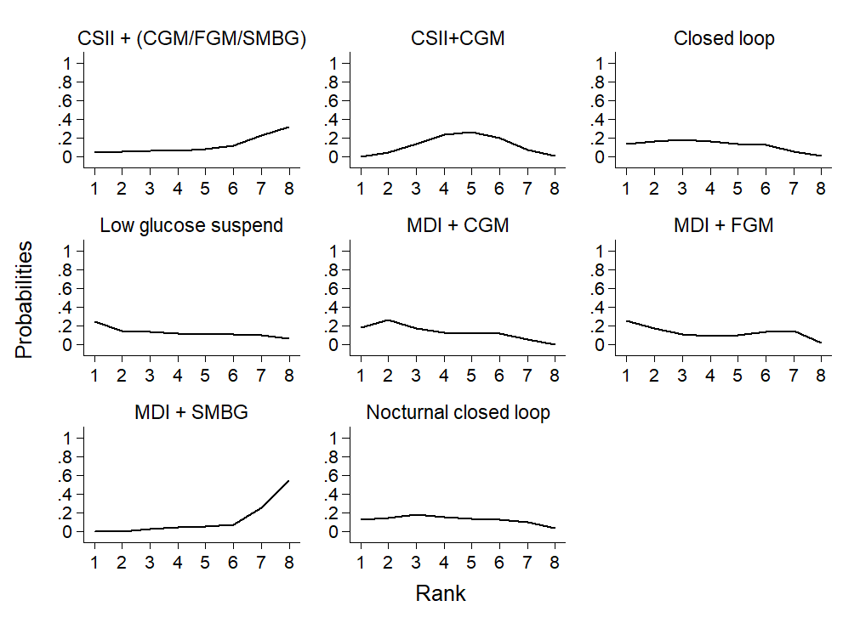

Cumulative ranking curve plots of diabetes management interventions for the percent time below range network
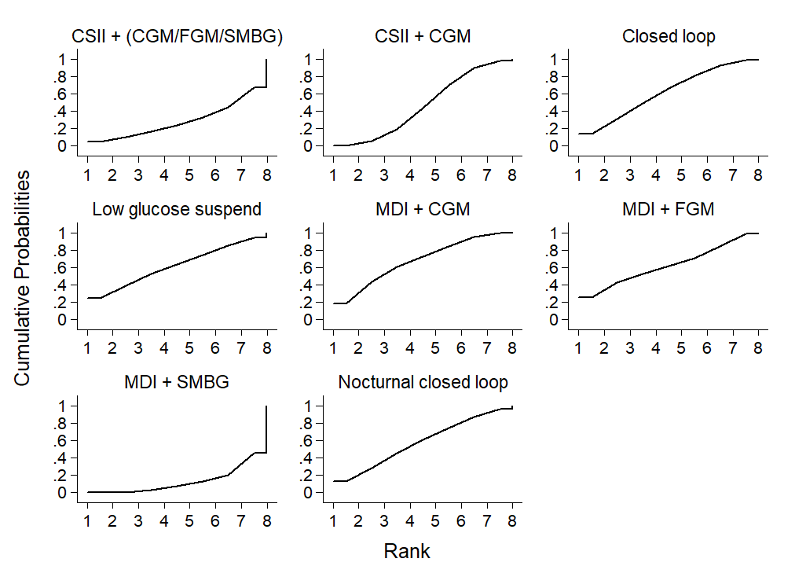

Analysis for the network of diabetes management interventions for the percent time below range network (assuming correlation coefficient of 0.9 and 0.1):

The mean difference (95% confidence interval / 95% predictive interval) for the percent time below range network (assuming correlation coefficient of 0.9):

Comparison | Mean difference | 95% Confidence interval | 95% Predictive interval
CSII+CGM  vs  CSII+(CGM/FGM/SMBG) | -1.62 | (-7.05, 3.81) | (-9.38, 6.13)
Closed loop  vs  CSII+(CGM/FGM/SMBG) | -2.39 | (-6.89, 2.12) | (-9.33, 4.56)
Low glucose suspend  vs  CSII+(CGM/FGM/SMBG) | -2.52 | (-9.44, 4.39) | (-11.68, 6.63)
MDI+CGM  vs  CSII+(CGM/FGM/SMBG) | -2.80 | (-9.67, 4.08) | (-11.91, 6.32)
MDI+FGM  vs  CSII+(CGM/FGM/SMBG) | -2.55 | (-10.51, 5.41) | (-12.74, 7.65)
MDI+SMBG  vs  CSII+(CGM/FGM/SMBG) | 1.24 | (-6.05, 8.52) | (-8.28, 10.76)
Nocturnal closed loop  vs  CSII+(CGM/FGM/SMBG) | -2.13 | (-8.32, 4.07) | (-10.59, 6.34)
Closed loop  vs  CSII+CGM | -0.76 | (-3.81, 2.28) | (-6.6, 5.07)
Low glucose suspend  vs  CSII+CGM | -0.90 | (-5.18, 3.38) | (-7.66, 5.86)
MDI+CGM  vs  CSII+CGM | -1.17 | (-5.41, 3.06) | (-7.9, 5.55)
MDI+FGM  vs  CSII+CGM | -0.92 | (-6.75, 4.91) | (-9.04, 7.20)
MDI+SMBG  vs  CSII+CGM | 2.86 | (-2.01, 7.73) | (-4.4, 10.12)
Nocturnal closed loop  vs  CSII+CGM | -0.50 | (-3.49, 2.49) | (-6.3, 5.29)
Low glucose suspend  vs  Closed loop | -0.14 | (-5.39, 5.12) | (-7.73, 7.46)
MDI+CGM  vs  Closed loop | -0.41 | (-5.62, 4.80) | (-7.97, 7.15)
MDI+FGM  vs  Closed loop | -0.16 | (-6.73, 6.42) | (-8.98, 8.67)
MDI+SMBG  vs  Closed loop | 3.63 | (-2.11, 9.37) | (-4.41, 11.66)
Nocturnal closed loop  vs  Closed loop | 0.26 | (-4.01, 4.53) | (-6.49, 7.01)
MDI+CGM  vs  Low glucose suspend | -0.27 | (-6.3, 5.75) | (-8.57, 8.03)
MDI+FGM  vs  Low glucose suspend | -0.02 | (-7.26, 7.21) | (-9.49, 9.45)
MDI+SMBG  vs  Low glucose suspend | 3.76 | (-2.72, 10.25) | (-4.98, 12.50)
Nocturnal closed loop  vs  Low glucose suspend | 0.40 | (-4.82, 5.62) | (-7.17, 7.96)
MDI+FGM  vs  MDI+CGM | 0.25 | (-3.76, 4.26) | (-6.29, 6.79)
MDI+SMBG  vs  MDI+CGM | 4.04 | (1.63, 6.44) | (-1.40, 9.47)
Nocturnal closed loop  vs  MDI+CGM | 0.67 | (-4.51, 5.85) | (-6.86, 8.20)
MDI+SMBG  vs  MDI+FGM | 3.78 | (-0.09, 7.66) | (-2.65, 10.22)
Nocturnal closed loop  vs  MDI+FGM | 0.42 | (-6.13, 6.97) | (-8.38, 9.22)
Nocturnal closed loop  vs  MDI+SMBG | -3.37 | (-9.08, 2.35) | (-11.38, 4.65)

The mean difference (95% confidence interval / 95% predictive interval) for the percent time below range network (assuming correlation coefficient of 0.1):
Comparison | Mean difference | 95% Confidence interval | 95% Predictive interval
CSII+CGM  vs  CSII+(CGM/FGM/SMBG) | -1.62 | (-7.05, 3.81) | (-9.38, 6.13)
Closed loop  vs  CSII+(CGM/FGM/SMBG) | -2.39 | (-6.89, 2.12) | (-9.33, 4.56)
Low glucose suspend  vs  CSII+(CGM/FGM/SMBG) | -2.52 | (-9.44, 4.39) | (-11.67, 6.63)
MDI+CGM  vs  CSII+(CGM/FGM/SMBG) | -2.80 | (-9.67, 4.08) | (-11.91, 6.32)
MDI+FGM  vs  CSII+(CGM/FGM/SMBG) | -2.54 | (-10.50, 5.41) | (-12.73, 7.64)
MDI+SMBG  vs  CSII+(CGM/FGM/SMBG) | 1.24 | (-6.04, 8.52) | (-8.27, 10.76)
Nocturnal closed loop  vs  CSII+(CGM/FGM/SMBG) | -2.13 | (-8.32, 4.07) | (-10.59, 6.34)
Closed loop  vs  CSII+CGM | -0.76 | (-3.81, 2.28) | (-6.59, 5.07)
Low glucose suspend  vs  CSII+CGM | -0.90 | (-5.18, 3.38) | (-7.66, 5.86)
MDI+CGM  vs  CSII+CGM | -1.17 | (-5.41, 3.06) | (-7.89, 5.55)
MDI+FGM  vs  CSII+CGM | -0.92 | (-6.75, 4.91) | (-9.04, 7.20)
MDI+SMBG  vs  CSII+CGM | 2.86 | (-2.00, 7.73) | (-4.39, 10.12)
Nocturnal closed loop  vs  CSII+CGM | -0.50 | (-3.49, 2.48) | (-6.29, 5.29)
Low glucose suspend  vs  Closed loop | -0.14 | (-5.39, 5.12) | (-7.73, 7.46)
MDI+CGM  vs  Closed loop | -0.41 | (-5.62, 4.80) | (-7.96, 7.15)
MDI+FGM  vs  Closed loop | -0.16 | (-6.73, 6.42) | (-8.98, 8.66)
MDI+SMBG  vs  Closed loop | 3.63 | (-2.11, 9.37) | (-4.41, 11.66)
Nocturnal closed loop  vs  Closed loop | 0.26 | (-4.00, 4.53) | (-6.49, 7.01)
MDI+CGM  vs  Low glucose suspend | -0.27 | (-6.29, 5.75) | (-8.57, 8.02)
MDI+FGM  vs  Low glucose suspend | -0.02 | (-7.25, 7.21) | (-9.49, 9.44)
MDI+SMBG  vs  Low glucose suspend | 3.76 | (-2.72, 10.25) | (-4.97, 12.50)
Nocturnal closed loop  vs  Low glucose suspend | 0.40 | (-4.82, 5.62) | (-7.17, 7.96)
MDI+FGM  vs  MDI+CGM | 0.25 | (-3.76, 4.26) | (-6.29, 6.79)
MDI+SMBG  vs  MDI+CGM | 4.04 | (1.63, 6.44) | (-1.39, 9.47)
Nocturnal closed loop  vs  MDI+CGM | 0.67 | (-4.51, 5.85) | (-6.86, 8.20)
MDI+SMBG  vs  MDI+FGM | 3.79 | (-0.08, 7.66) | (-2.64, 10.22)
Nocturnal closed loop  vs  MDI+FGM | 0.42 | (-6.13, 6.97) | (-8.38, 9.22)
Nocturnal closed loop  vs  MDI+SMBG | -3.37 | (-9.08, 2.34) | (-11.38, 4.64)

Cluster ranking of SUCRA values for time in range and time above range
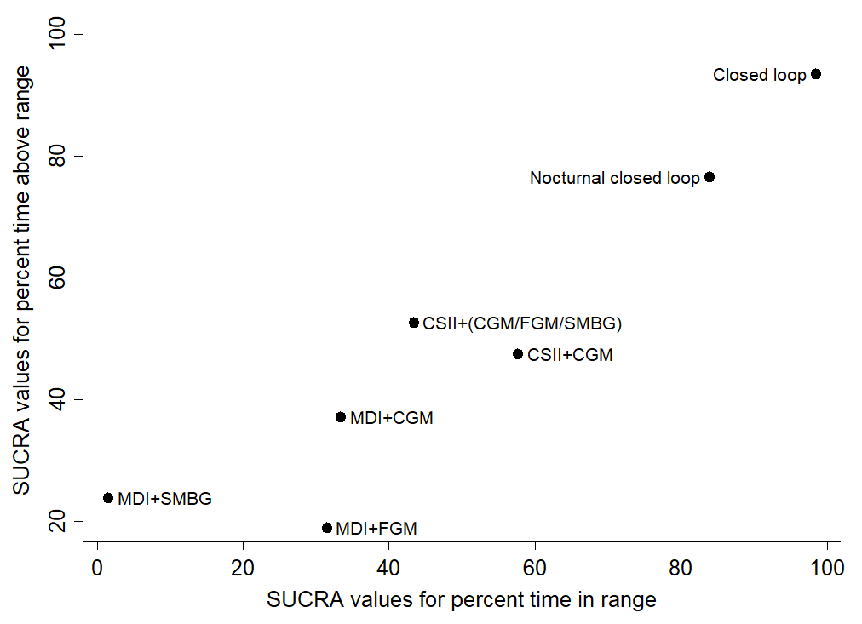
Best linkage method: averagelinkage
Best distance metric: Canberra
Cophenetic Correlation Coefficient c = 0.88
Maximum value of clustering gain = 3497.19
Optimal number of clusters = 3

Cluster ranking of SUCRA values for time in range and time below range
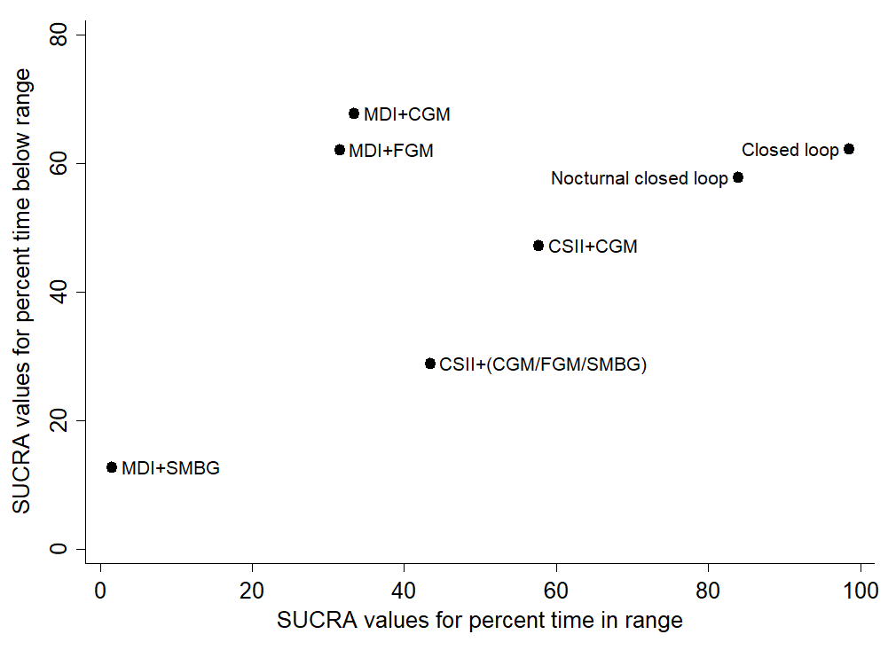
Best linkage method: averagelinkage
Best distance metric: Canberra
Cophenetic Correlation Coefficient c = 0.99
Maximum value of clustering gain = 2605.28
Optimal number of clusters = 4

Transitivity assessment:

Average age of participants in trials retrieved by our systematic review.

Median (IQR) or mean (range/no variance) age was presented if mean (SD) was not available or could not be calculated.

Average diabetes duration of participants in trials retrieved by our systematic review.

Median (IQR) or mean (range/no variance) diabetes duration was presented if mean (SD) was not available or could not be calculated.

Average HbA1c of participants in trials retrieved by our systematic review.

Median (IQR) or mean (range/no variance) HbA1c was presented if mean (SD) was not available or could not be calculated.

Proportion of each sex in trials retrieved by our systematic review.

Proportions of each sex refer to the overall study populations or baseline proportions for the first phase of each arm of the study based on reporting.

GRADE framework:
As part of the GRADE approach to evidence, we considered study limitations, inconsistency, indirectness, imprecision, and publication bias.^{4,5} For each component of the GRADE framework, the quality of the evidence was either maintained or downgraded by one to two levels. Across the five components, the maximum level of downgrading could be three which, represents ‘very low quality evidence’.

Reasons for downgrading the quality of evidence:
The following criteria were applied to the five components of the GRADE framework:

Study limitations:
Two independent reviewers assessed risk of bias of each study for time-in-range, time below range, and time above range in the following domains: selection bias, performance bias, detection bias, attrition bias, and reporting bias. As part of the GRADE framework, we rated the overall risk of bias for relevant outcomes in each study as follows: ^{4,5,7}
- Studies were classified as having on overall low risk of bias if none of the domains were rated as having high risk of bias and three or less were rated as having unclear risk of bias.
- Studies were classified as having moderate risk of bias if one was rated as having high risk of bias, or none were rated as having high risk of bias but four or more were rated as having an unclear risk of bias.
- Studies were classified as having high risk of bias if two or more were rated as having high risk of bias, or if one was rated as having high risk of bias and four or more were rated as having an unclear risk of bias.

We took the weighted average risk of bias score from direct evidence contributing to each pairwise comparison in the network. We rounded this result to the nearest integer and downgraded the estimate of evidence quality accordingly.

Imprecision:
We downgraded the quality of evidence rating by one level if the confidence intervals for mean difference or standardised mean difference included zero, or if the confidence interval for rate ratios included one. We also downgraded comparisons by one level if imputed correlation coefficients of 0.1 or 0.9 had a significant impact on the confidence intervals.

Inconsistency:
We rated heterogeneity and inconsistency as part of this component. For network heterogeneity, we calculated the Tau² and I² with 95% confidence intervals. We used the guide to I² interpretation provided by the Cochrane Handbook for Systematic Reviews of interventions (chapter 9.5.2).⁶ We downgraded networks with moderate heterogeneity by one level, and networks with substantial or considerable heterogeneity by two levels. Consensus opinion was reached with a senior statistician (AE) utilising the I² value and 95% confidence intervals. If network heterogeneity was low or moderate and we had not already downgraded for imprecision, we downgraded comparisons with inconsistency (p value < 0.10) based on the results of side splitting and loop specific inconsistency.

Indirectness:
We have assumed transitivity in our network. Potential treatment modifiers including baseline HbA1c, participant age, and duration of diabetes were presented graphically to assess for transitivity (appendix p 95–96). However, not every study presented was included in network meta-analysis for every outcome. Network meta-regression could not be performed in the absence of patient level data. Due to uncertainty we downgraded every treatment comparison by one level for indirectness.

Publication bias:
Comparison-adjusted funnel plots were generated with the control arm representing ‘older management options’. Consensus opinion for interpretation of funnel plots was reached with an experienced statistician (AE).

Reasons for downgrading quality of evidence according to the GRADE framework for the percent time in range network
 | Limitations | Imprecision | Inconsistency | Indirectness | Publication bias | GRADE
CSII + (CGM/FGM/SMBG)  vs  Closed loop | Downgrade -1 | No downgrade | Downgrade -1 | Downgrade -1 | No downgrade | Very low
CSII+CGM  vs  Closed loop | Downgrade -1 | No downgrade | Downgrade -1 | Downgrade -1 | No downgrade | Very low
CSII+CGM  vs  MDI+CGM | Downgrade -1 | Downgrade -1 | Downgrade -1 | Downgrade -1 | No downgrade | Very low
CSII+CGM  vs  Nocturnal closed loop | Downgrade -1 | No downgrade | Downgrade -1 | Downgrade -1 | No downgrade | Very low
MDI+CGM  vs  MDI+FGM | Downgrade -1 | Downgrade -1 | Downgrade -1 | Downgrade -1 | No downgrade | Very low
MDI+CGM  vs  MDI+SMBG | Downgrade -1 | No downgrade | Downgrade -1 | Downgrade -1 | No downgrade | Very low
MDI+FGM  vs  MDI+SMBG | Downgrade -1 | No downgrade | Downgrade -1 | Downgrade -1 | No downgrade | Very low
CSII+(CGM/FGM/SMBG) vs  CSII+CGM | Downgrade -1 | Downgrade -1 | Downgrade -1 | Downgrade -1 | No downgrade | Very low
CSII+(CGM/FGM/SMBG) vs  MDI+CGM | Downgrade -1 | Downgrade -1 | Downgrade -1 | Downgrade -1 | No downgrade | Very low
CSII+(CGM/FGM/SMBG) vs  MDI+FGM | Downgrade -1 | Downgrade -1 | Downgrade -1 | Downgrade -1 | No downgrade | Very low
CSII+(CGM/FGM/SMBG) vs  MDI+SMBG | Downgrade -1 | Downgrade -1 | Downgrade -1 | Downgrade -1 | No downgrade | Very low
CSII+(CGM/FGM/SMBG) vs  Nocturnal closed loop | Downgrade -1 | Downgrade -1 | Downgrade -1 | Downgrade -1 | No downgrade | Very low
CSII+CGM  vs  MDI+FGM | Downgrade -1 | Downgrade -1 | Downgrade -1 | Downgrade -1 | No downgrade | Very low
CSII+CGM  vs  MDI+SMBG | Downgrade -1 | Downgrade -1 | Downgrade -1 | Downgrade -1 | No downgrade | Very low
Closed loop  vs  MDI+CGM | Downgrade -1 | No downgrade | Downgrade -1 | Downgrade -1 | No downgrade | Very low
Closed loop  vs  MDI+FGM | Downgrade -1 | No downgrade | Downgrade -1 | Downgrade -1 | No downgrade | Very low
Closed loop  vs  MDI+SMBG | Downgrade -1 | No downgrade | Downgrade -1 | Downgrade -1 | No downgrade | Very low
Closed loop  vs  Nocturnal closed loop | Downgrade -1 | Downgrade -1 | Downgrade -1 | Downgrade -1 | No downgrade | Very low
MDI+CGM  vs  Nocturnal closed loop | Downgrade -1 | No downgrade | Downgrade -1 | Downgrade -1 | No downgrade | Very low
MDI+FGM  vs  Nocturnal closed loop | Downgrade -1 | No downgrade | Downgrade -1 | Downgrade -1 | No downgrade | Very low
MDI+SMBG  vs  Nocturnal closed loop | Downgrade -1 | No downgrade | Downgrade -1 | Downgrade -1 | No downgrade | Very low
Ranking of treatments
Entire network | Downgrade -1 | No downgrade | Downgrade -2 | Downgrade -1 | No downgrade | Very low

Reasons for downgrading quality of evidence according to the GRADE framework for the percent time above range network
 | Limitations | Imprecision | Inconsistency | Indirectness | Publication bias | GRADE
CSII + (CGM/FGM/SMBG)  vs  Closed loop | Downgrade -1 | Downgrade -1 | Downgrade -1 | Downgrade -1 | No downgrade | Very low
CSII+CGM  vs  Closed loop | Downgrade -1 | No downgrade | Downgrade -1 | Downgrade -1 | No downgrade | Very low
CSII+CGM  vs  MDI+CGM | Downgrade -1 | Downgrade -1 | Downgrade -1 | Downgrade -1 | No downgrade | Very low
CSII+CGM  vs  Nocturnal closed loop | Downgrade -1 | Downgrade -1 | Downgrade -1 | Downgrade -1 | No downgrade | Very low
MDI+CGM  vs  MDI+FGM | Downgrade -1 | Downgrade -1 | Downgrade -1 | Downgrade -1 | No downgrade | Very low
MDI+CGM  vs  MDI+SMBG | Downgrade -1 | Downgrade -1 | Downgrade -1 | Downgrade -1 | No downgrade | Very low
MDI+FGM  vs  MDI+SMBG | Downgrade -1 | Downgrade -1 | Downgrade -1 | Downgrade -1 | No downgrade | Very low
CSII+(CGM/FGM/SMBG) vs  CSII+CGM | Downgrade -1 | Downgrade -1 | Downgrade -1 | Downgrade -1 | No downgrade | Very low
CSII+(CGM/FGM/SMBG) vs  MDI+CGM | Downgrade -1 | Downgrade -1 | Downgrade -1 | Downgrade -1 | No downgrade | Very low
CSII+(CGM/FGM/SMBG) vs  MDI+FGM | Downgrade -1 | Downgrade -1 | Downgrade -1 | Downgrade -1 | No downgrade | Very low
CSII+(CGM/FGM/SMBG) vs  MDI+SMBG | Downgrade -1 | Downgrade -1 | Downgrade -1 | Downgrade -1 | No downgrade | Very low
CSII+(CGM/FGM/SMBG) vs  Nocturnal closed loop | Downgrade -1 | Downgrade -1 | Downgrade -1 | Downgrade -1 | No downgrade | Very low
CSII+CGM  vs  MDI+FGM | Downgrade -1 | Downgrade -1 | Downgrade -1 | Downgrade -1 | No downgrade | Very low
CSII+CGM  vs  MDI+SMBG | Downgrade -1 | Downgrade -1 | Downgrade -1 | Downgrade -1 | No downgrade | Very low
Closed loop  vs  MDI+CGM | Downgrade -1 | Downgrade -1 | Downgrade -1 | Downgrade -1 | No downgrade | Very low
Closed loop  vs  MDI+FGM | Downgrade -1 | Downgrade -1 | Downgrade -1 | Downgrade -1 | No downgrade | Very low
Closed loop  vs  MDI+SMBG | Downgrade -1 | Downgrade -1 | Downgrade -1 | Downgrade -1 | No downgrade | Very low
Closed loop  vs  Nocturnal closed loop | Downgrade -1 | Downgrade -1 | Downgrade -1 | Downgrade -1 | No downgrade | Very low
MDI+CGM  vs  Nocturnal closed loop | Downgrade -1 | Downgrade -1 | Downgrade -1 | Downgrade -1 | No downgrade | Very low
MDI+FGM  vs  Nocturnal closed loop | Downgrade -1 | Downgrade -1 | Downgrade -1 | Downgrade -1 | No downgrade | Very low
MDI+SMBG  vs  Nocturnal closed loop | Downgrade -1 | Downgrade -1 | Downgrade -1 | Downgrade -1 | No downgrade | Very low
Ranking of treatments
Entire network | Downgrade -1 | No downgrade | Downgrade -2 | Downgrade -1 | No downgrade | Very low

Reasons for downgrading quality of evidence according to the GRADE framework for the percent time below range network
 | Limitations | Imprecision | Inconsistency | Indirectness | Publication bias | GRADE
CSII+(CGM/FGM/SMBG) vs  Closed loop | Downgrade -1 | Downgrade -1 | Downgrade -1 | Downgrade -1 | No downgrade | Very low
CSII+CGM  vs  Closed loop | Downgrade -1 | Downgrade -1 | Downgrade -1 | Downgrade -1 | No downgrade | Very low
CSII+CGM  vs  Low glucose suspend | Downgrade -1 | Downgrade -1 | Downgrade -1 | Downgrade -1 | No downgrade | Very low
CSII+CGM  vs  MDI+CGM | Downgrade -1 | Downgrade -1 | Downgrade -1 | Downgrade -1 | No downgrade | Very low
CSII+CGM  vs  Nocturnal closed loop | Downgrade -1 | Downgrade -1 | Downgrade -1 | Downgrade -1 | No downgrade | Very low
MDI+CGM  vs  MDI+FGM | Downgrade -1 | Downgrade -1 | Downgrade -1 | Downgrade -1 | No downgrade | Very low
MDI+CGM  vs  MDI+SMBG | Downgrade -1 | No downgrade | Downgrade -1 | Downgrade -1 | No downgrade | Very low
MDI+FGM  vs  Nocturnal closed loop | Downgrade -1 | Downgrade -1 | Downgrade -1 | Downgrade -1 | No downgrade | Very low
CSII+(CGM/FGM/SMBG) vs  CSII+CGM | Downgrade -1 | Downgrade -1 | Downgrade -1 | Downgrade -1 | No downgrade | Very low
CSII+(CGM/FGM/SMBG) vs  Low glucose suspend | Downgrade -1 | Downgrade -1 | Downgrade -1 | Downgrade -1 | No downgrade | Very low
CSII+(CGM/FGM/SMBG) vs  MDI+CGM | Downgrade -1 | Downgrade -1 | Downgrade -1 | Downgrade -1 | No downgrade | Very low
CSII+(CGM/FGM/SMBG) vs  MDI+FGM | Downgrade -1 | Downgrade -1 | Downgrade -1 | Downgrade -1 | No downgrade | Very low
CSII+(CGM/FGM/SMBG) vs  MDI+SMBG | Downgrade -1 | Downgrade -1 | Downgrade -1 | Downgrade -1 | No downgrade | Very low
CSII+(CGM/FGM/SMBG) vs  Nocturnal closed loop | Downgrade -1 | Downgrade -1 | Downgrade -1 | Downgrade -1 | No downgrade | Very low
CSII+CGM  vs  MDI+FGM | Downgrade -1 | Downgrade -1 | Downgrade -1 | Downgrade -1 | No downgrade | Very low
CSII+CGM  vs  MDI+SMBG | Downgrade -1 | Downgrade -1 | Downgrade -1 | Downgrade -1 | No downgrade | Very low
Closed loop  vs  Low glucose suspend | Downgrade -1 | Downgrade -1 | Downgrade -1 | Downgrade -1 | No downgrade | Very low
Closed loop  vs  MDI+CGM | Downgrade -1 | Downgrade -1 | Downgrade -1 | Downgrade -1 | No downgrade | Very low
Closed loop  vs  MDI+FGM | Downgrade -1 | Downgrade -1 | Downgrade -1 | Downgrade -1 | No downgrade | Very low
Closed loop  vs  MDI+SMBG | Downgrade -1 | Downgrade -1 | Downgrade -1 | Downgrade -1 | No downgrade | Very low
Closed loop  vs  Nocturnal closed loop | Downgrade -1 | Downgrade -1 | Downgrade -1 | Downgrade -1 | No downgrade | Very low
Low glucose suspend  vs  MDI+CGM | Downgrade -1 | Downgrade -1 | Downgrade -1 | Downgrade -1 | No downgrade | Very low
Low glucose suspend  vs  MDI+FGM | Downgrade -1 | Downgrade -1 | Downgrade -1 | Downgrade -1 | No downgrade | Very low
Low glucose suspend  vs  MDI+SMBG | Downgrade -1 | Downgrade -1 | Downgrade -1 | Downgrade -1 | No downgrade | Very low
Low glucose suspend  vs  Nocturnal closed loop | Downgrade -1 | Downgrade -1 | Downgrade -1 | Downgrade -1 | No downgrade | Very low
MDI+CGM  vs  Nocturnal closed loop | Downgrade -1 | Downgrade -1 | Downgrade -1 | Downgrade -1 | No downgrade | Very low
MDI+FGM  vs  Nocturnal closed loop | Downgrade -1 | Downgrade -1 | Downgrade -1 | Downgrade -1 | No downgrade | Very low
MDI+SMBG  vs  Nocturnal closed loop | Downgrade -1 | Downgrade -1 | Downgrade -1 | Downgrade -1 | No downgrade | Very low
Ranking of treatments
Entire network | Downgrade -1 | Downgrade -1 | Downgrade -2 | Downgrade -1 | No downgrade | Very low

References:
1. Beck RW, Riddlesworth T, Ruedy K, et al. Protocol and statistical analysis plan (supplement 1). In: Effect of continuous glucose monitoring on glycemic control in adults with type 1 diabetes using insulin injections: the DIAMOND randomized clinical trial. JAMA 2017; 317: doi: 10.1001/jama.2016.19975.
2. Lind M, Polonsky W, Hirsch IB, et al. Continuous glucose monitoring vs conventional therapy for glycemic control in adults with type 1 diabetes treated with multiple daily insulin injections: the GOLD randomized clinical trial. JAMA 2017; 317: 379–387.
3. Bolinder J, Antuna R, Geelhoed-Duijvestijn P, Kröger J, Weitgasser R. Novel glucose-sensing technology and hypoglycaemia in type 1 diabetes: a multicentre, non-masked, randomised controlled trial. Lancet 2016; 388: 2254–2263.
4. Salanti G, Del Giovane C, Chaimani A, Caldwell DM, Higgins JP. Evaluating the quality of evidence from a network meta-analysis. PLoS One 2014; 9: doi: 10.1371/journal.pone.0099682..
5. Guyatt GH, Oxman AD, Vist GE, et al. GRADE: an emerging consensus on rating quality of evidence and strength of recommendations. BMJ 2008; 336: 924–926.
6. Deeks JJ, Higgins JPT, Altman DG (eds). Chapter 9: Analysing data and undertaking meta-analyses. In: Higgins JPT, Green S (eds). Cochrane handbook for systematic reviews of interventions version 5.1.0 (updated March 2011). The cochrane collaboration, 2011. www.handbook.cochrane.org (accessed July 12, 2019).
7. Cipriani A, Furukawa TA, Salanti G, et al. Supplementary appendix. In: Comparative efficacy and acceptability of 21 antidepressant drugs for the acute treatment of adults with major depressive disorder: a systematic review and network meta-analysis. Lancet 2018; published online Feb 21. doi: http://dx.doi.org/10.1016/S0140-6736(17)32802-7.

