Online-only Supplemental Material Files
Supplementary Figure S1. Flow of practices and patients through trial.

Practices assessed for eligibility (n=24)
Excluded (n=0)
♦ Not meeting inclusion criteria (n=0)
♦ Declined to participate (n=0)
♦ Other reasons (n=0)
Practices allocated to intervention (n=12)
Patients included (n=1422)
◻ Received allocated intervention (n=10 )
◻ Did not receive allocated intervention (give reasons) (n=2 )
- 2 practices taken over by larger consortia, existing patient list could no longer be accessed.
Practices allocated to control group (n=12)
Patients included (n=1299)

Allocation
24 Months

Practices lost to follow-up (n= 0)
Practices discontinued intervention (n= 0)

12 Months

Practices lost to follow-up (n= 0)
Practices discontinued intervention (n= 0)

12 Months
Practices lost to follow-up (n= 0)
Practices discontinued intervention (n= 0)
24 Months

Practices lost to follow-up (n= 0)
Practices discontinued intervention (n= 0)

Practices randomized (n= 24)

Enrollment

Follow-Up

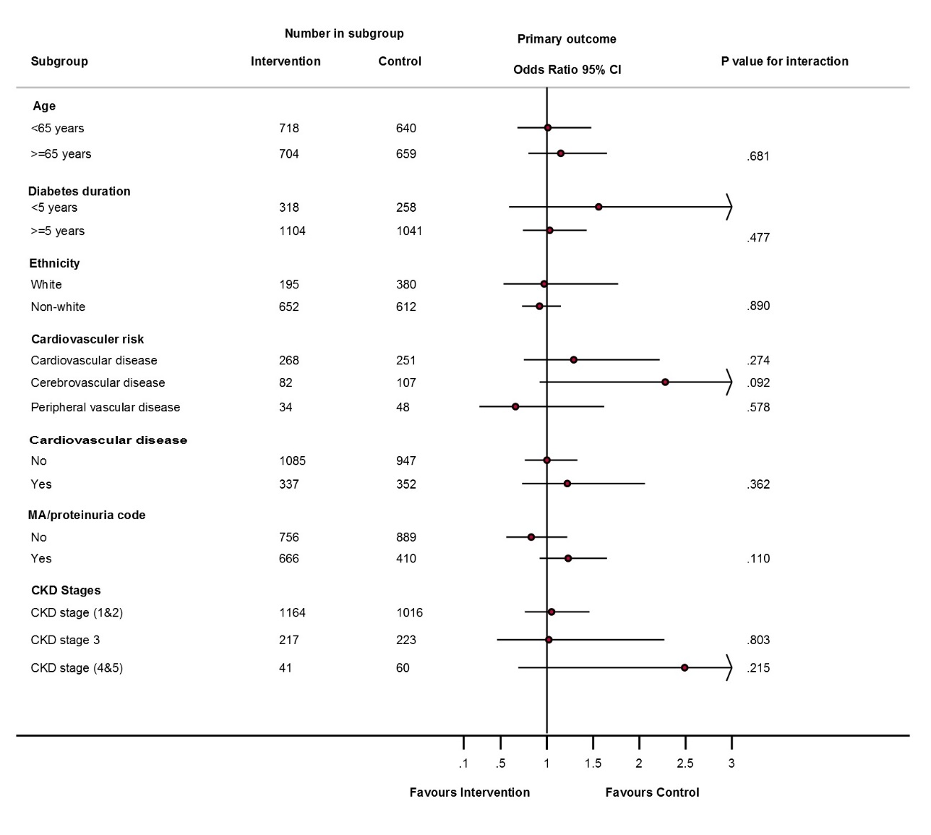
Supplementary Figure S2. Forest plot of the intervention at 24 months by subgroup.

Supplementary Table S3 Cardiovascular outcomes for patients with microalbuminuria and type 2 diabetes allocated to a software based intervention or to usual care (control).
 | Number of patients  (Percentage) |  | Model summary†
Outcome | Control group | Intervention group | Hazard Ratio (95% CI)ⱡ | P values§
Composite outcome ª | 33 (2.55) | 35 (2.47) | 0.96 (0.65 to 1.43) | 0.843
Nonfatal myocardial infarction | 6 (0.46) | 7 (0.49) | 0.81* (0.31 to 2.08) | 0.660
Nonfatal stroke | 19 (1.47) | 20 (1.41) | 0.94* (0.56 to 1.56) | 0.812
Death from cardiovascular causes | 9 (0.69) | 9 (0.63) | 0.91 (0.36 to 2.29) | 0.842
Death from any cause | 30 (2.31) | 23 (1.62) | 0.67 (0.35 to 1.29) | 0.235

* Results are adjusted for baseline values
†Estimates are derived using Cox proportional hazards model. Results are adjusted for cluster effect.
§Significance of intervention term in model
ª The composite outcome was the first occurrence of death from cardiovascular causes, nonfatal myocardial infarction, or nonfatal stroke.

Supplementary Table S4 Drug prescriptions used by eligible study participants with type 2 diabetes and microalbuminuria at follow-up.
Drug | Total n (%) | Control n (%) | Intervention n (%) | P-values
ACE
12 months | 1241 (45.61) | 599 (46.11) | 642 (45.15) | 0.614
24 months | 1143 (42.01) | 543 (41.80) | 600 (42.19) | 0.836
ARB
12 months | 642 (23.59) | 317 (24.40) | 325 (22.86) | 0.342
24 months | 574 (21.10) | 288 (22.17) | 286 (20.11) | 0.189
Anti-hypertensives | 2044 (86.72) | 1005 (88.47) | 1039 (85.09) | 0.016
12 months | 2158 (79.31) | 1054 (81.14) | 1104 (77.64) | 0.024
24 months | 1982 (72.84) | 964 (74.21) | 1018 (71.59) | 0.125
Lipid lowering
12 months | 1922 (70.64) | 893 (68.75) | 1029 (72.36) | 0.038
24 months | 1769 (65.01) | 825 (63.51) | 944 (66.39) | 0.116
Anti-platelet
12 months | 957 (35.17) | 443 (34.10) | 514 (36.15) | 0.265
24 months | 843 (30.98) | 393 (30.25) | 450 (31.65) | 0.433
Oral antidiabetics
12 months
Mono therapy | 954 (49.90) | 454 (48.66) | 500 (51.07) | 0.292
Dual therapy | 650 (34.00) | 329 (35.26) | 321 (32.79) | 0.254
Triple therapy | 289 (15.12) | 142 (15.22) | 147 (15.02) | 0.901
>=four therapies | 19 (0.99) | 8 (0.86) | 11 (1.12) | 0.558
24 months
Mono therapy | 881 (50.00) | 404 (46.92) | 477 (52.94) | 0.012
Dual therapy | 585 (33.20) | 312 (36.24) | 273 (30.30) | 0.008
Triple therapy | 277 (15.72) | 139 (16.14) | 138 (15.32) | 0.633
>=four therapies | 19 (1.08) | 6 (0.70) | 13 (1.44) | 0.130
Insulin
12 months | 499 (18.34) | 225 (17.32) | 274 (19.27) | 0.190
24 months | 469 (17.24) | 201 (15.47) | 268 (18.85) | 0.020

Supplementary table S5: Incidence rate per 1000 person-year by treat group
 | Total  IR(95% CI) | Control  IR(95% CI) | Intervention  IR(95% CI) | IRR  (95% CI) | p-value
Myocardial infarction | 2.40 (1.38 to 4.15) | 2.32 (1.12 to 4.80) | 2.47 (1.09 to 5.59) | 1.06 (0.37 to 3.09) | 0.908
Acute coronary syndrome | 4.42 (3.03 to 6.46) | 5.03 (2.93 to 8.63) | 3.87 (2.32 to 6.45) | 0.77 (0.37 to 1.59) | 0.479
Angina | 4.80 (3.24 to 7.12) | 3.87 (1.85 to 8.12) | 5.65 (3.55 to 9.01) | 1.46 (0.62 to 3.43) | 0.387
Ischemic heart disease | 18.40 (14.86 to 22.79) | 19.36 (12.83 to 29.21) | 17.54 (14.71 to 20.92) | 0.91 (0.58 to 1.40) | 0.659
Transient ischemic attack | 3.13 (1.90 to 5.16) | 3.47 (2.23 to 5.39) | 2.82 (1.14 to 6.96) | 0.81 (0.31 to 2.16) | 0.677
Stroke | 7.23 (5.43 to 9.63) | 7.40 (5.00 to 10.94) | 7.08 (4.64 to 10.81) | 0.96 (0.55 to 1.68) | 0.878
PVD | 4.24 (2.97 to 6.06) | 4.25 (2.65 to 6.82) | 4.23 (2.44 to 7.34) | 0.99 (0.49 to 2.02) | 0.992
Revascularisation procedure | 2.21 (1.07 to 4.57) | 1.93 (0.88 to 4.20) | 2.47 (0.77 to 7.85) | 1.28 (0.33 to 4.98) | 0.722
Bypass graft | 1.66 (0.74 to 3.72) | 0.77 (0.23 to 2.57) | 2.47 (1.14 to 5.33) | 3.21 (0.79 to 12.98) | 0.102
CKD Stages | 19.08 (13.69 to 26.59) | 19.31 (11.99 to 31.11) | 18.87 (11.61 to 30.70) | 0.98 (0.50 to 1.90) | 0.947

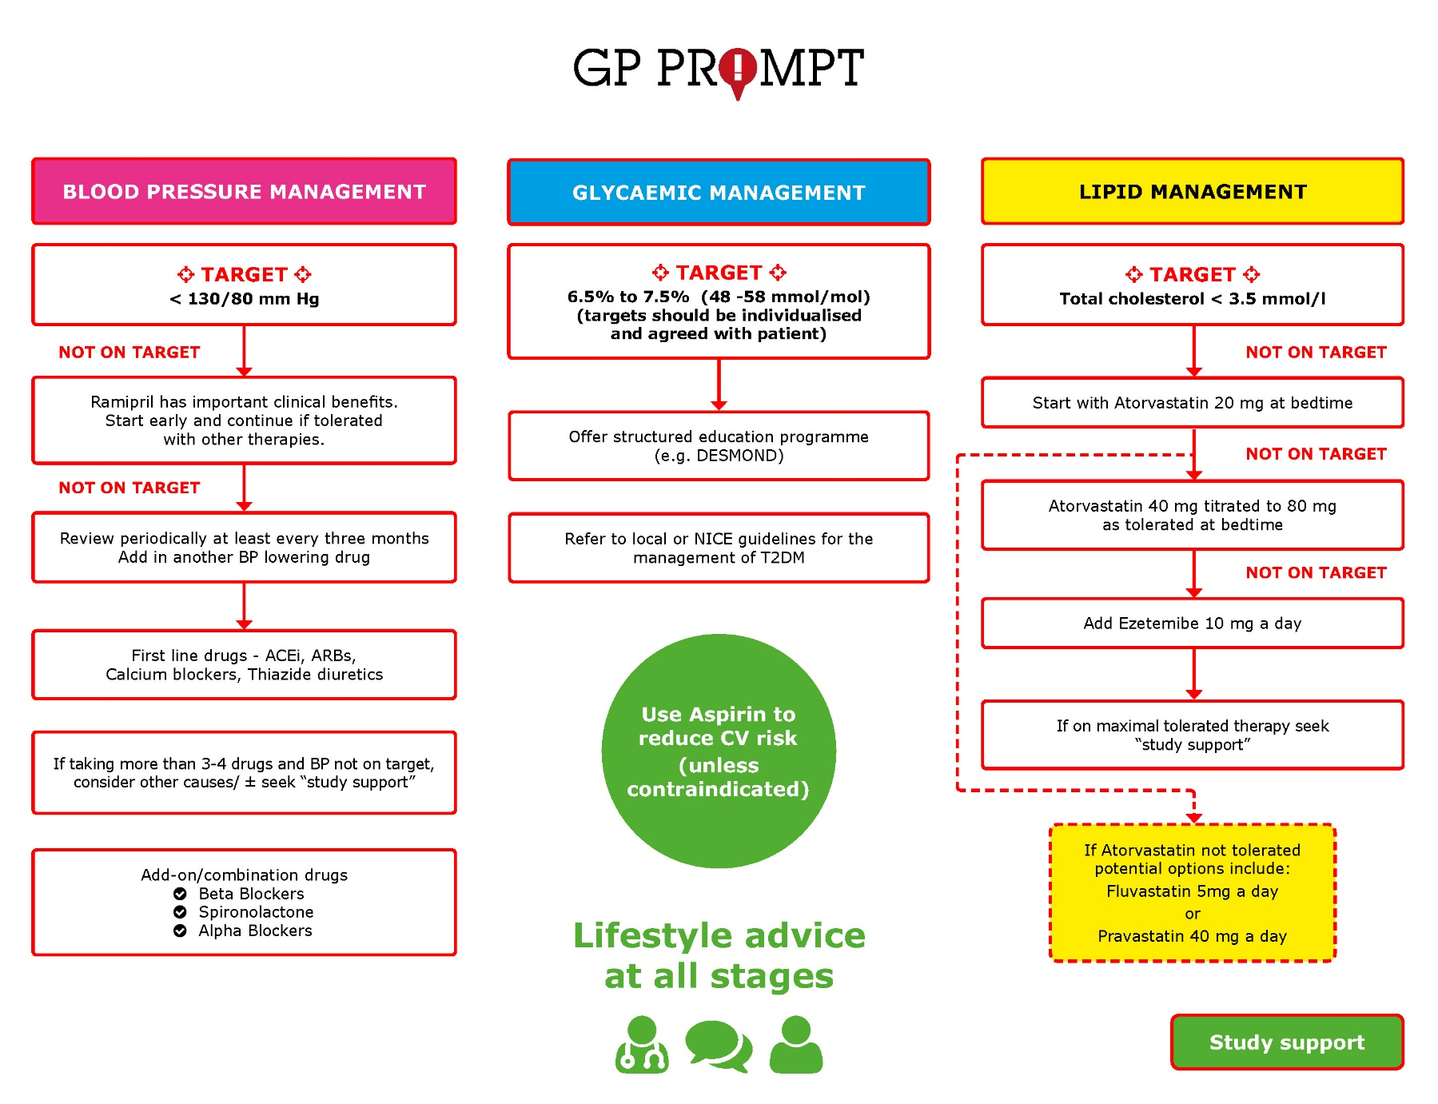
Supplementary figure. Cardiovascular risk factor treatment algorithm S6.

