Supplementary Figures
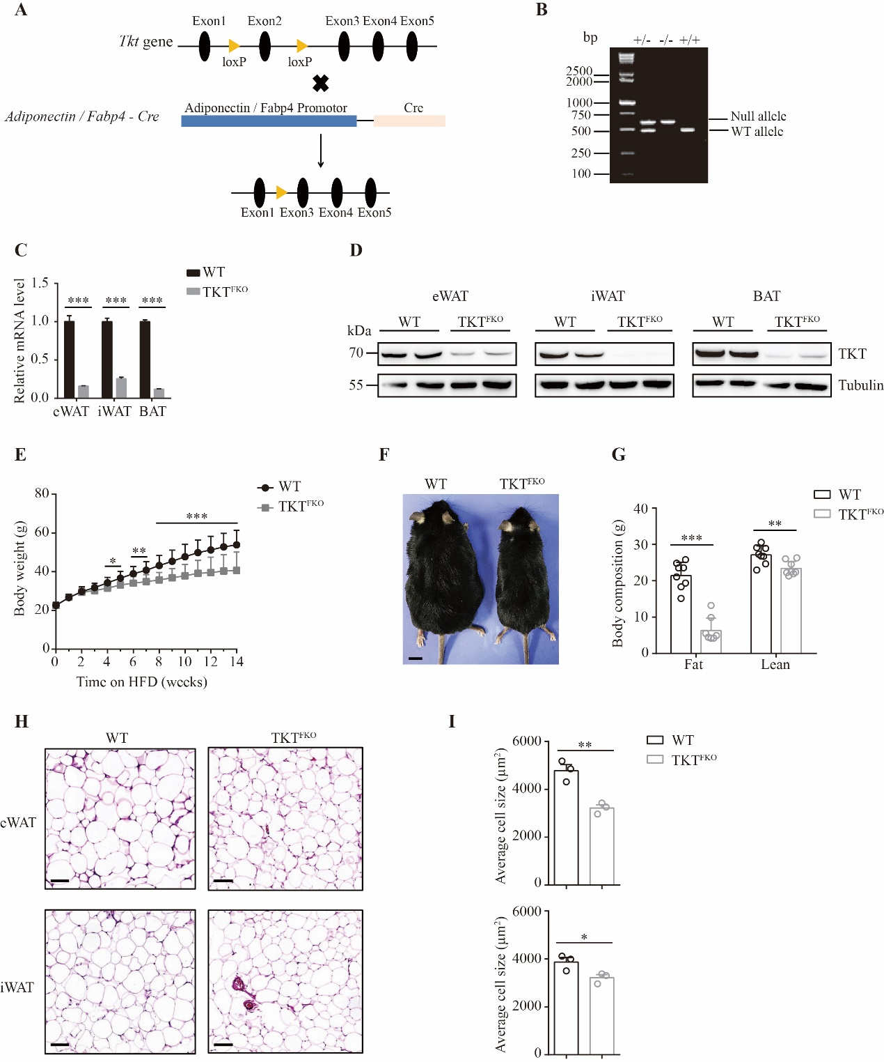
Supplementary Fig. 1 TKT deficiency in adipocytes protects mice from HFD-induced obesity. (A) Schematic diagram of the strategy to generate TKT^{AKO} and TKT^{FKO} mice. (B) PCR analysis for TKT WT and null alleles. (C) qPCR analysis of TKT mRNA expression in adipose tissues from WT and TKT^{FKO} mice (n=3). (D) Western blotting analysis of TKT protein levels in tissues from WT and TKT^{FKO} mice. (E) Body weight of WT and TKT^{FKO} mice on HFD (n=13). (F) Representative images of WT and TKT^{FKO} mice on 14-week HFD from 6-week old. Scale bars, 1 cm. (G) Body composition of WT and TKT^{FKO} mice on 14-week HFD from 6-week old (n=8). (H) Representative H&E images of eWATs and iWATs from WT and TKT^{FKO} mice on 14-week HFD from 6-week old. Scale bars, 100 μm. (I) Quantification of adipocyte size (n=3). Data are represented as mean ± SEM. Significance is determined by Student’s t test analysis, *P < 0.05, **P<0.01, ***P<0.001.

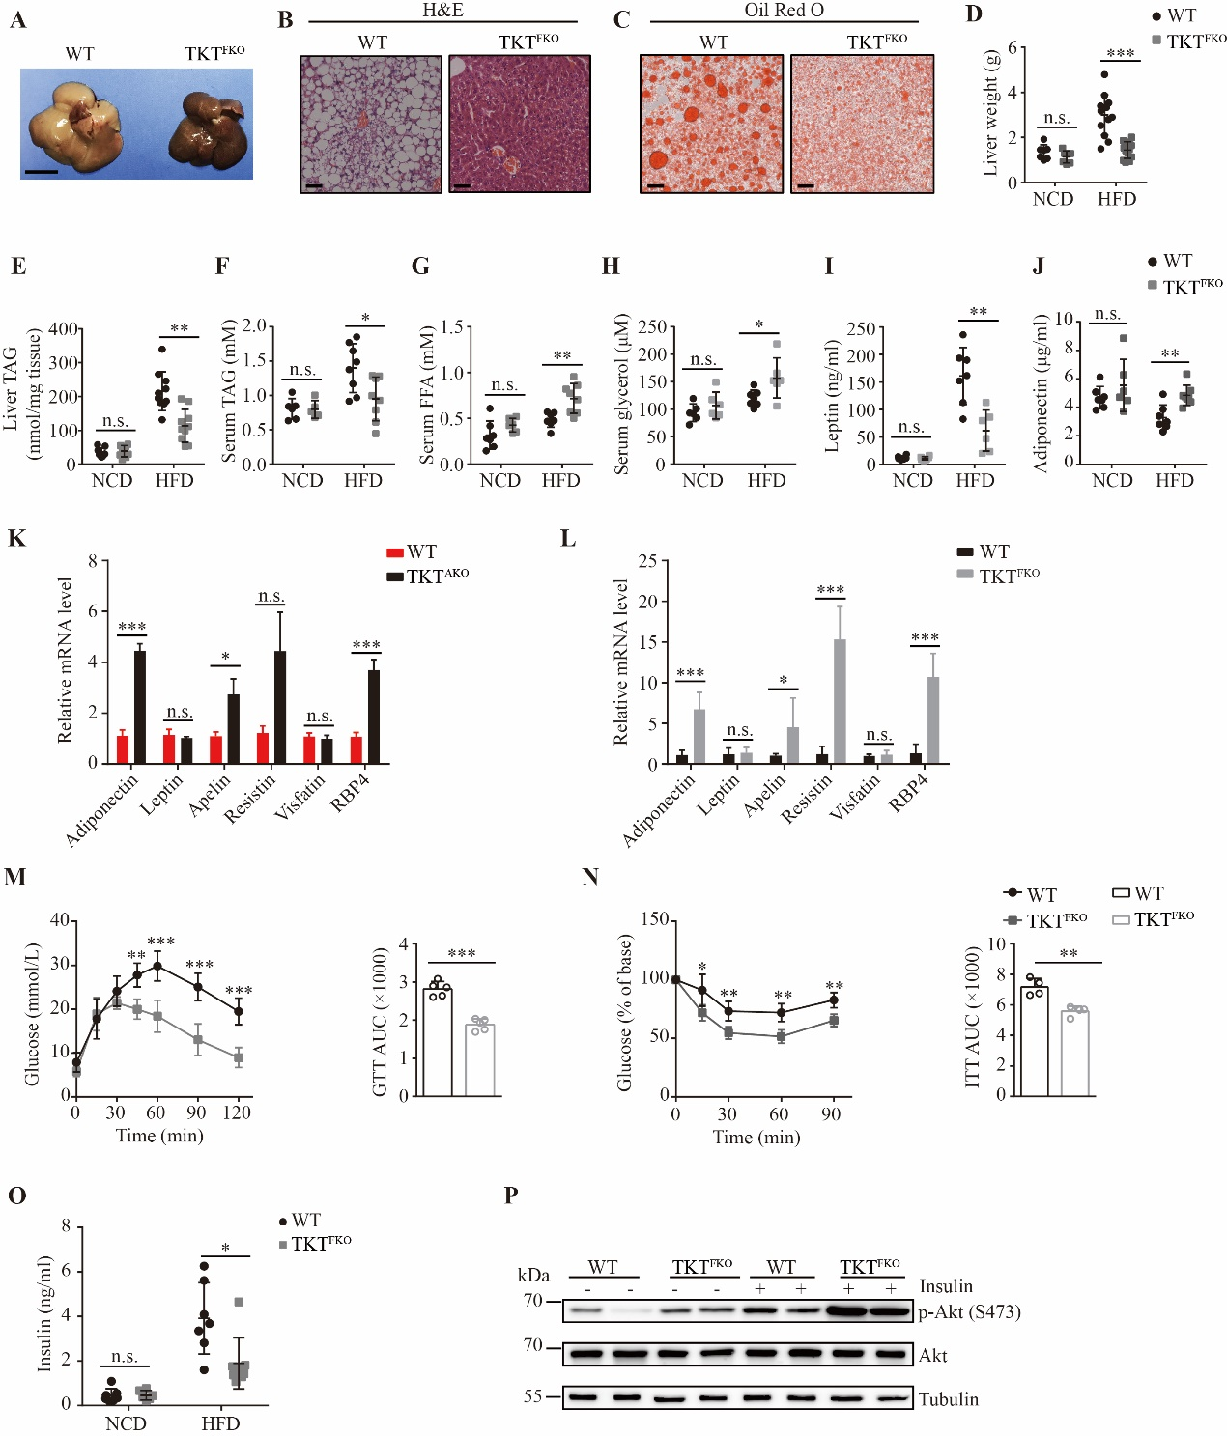
Supplementary Fig. 2 Adipocyte-specific TKT abrogation ameliorates HFD-induced metabolic disorders. NCD represents 5-month old mice on NCD. 10- or 14-week HFD represents mice fed with HFD from 6-week old for 10 or 14 weeks, respectively. (A) Representative images of livers from WT and TKT^{FKO} mice fed with 14-week HFD. Scale bars, 1 cm. (B) Representative images of H&E stained liver sections from WT and TKT^{FKO} mice on 14-week HFD. Scale bars, 50 μm. (C) Representative images of Oil Red O stained liver sections from WT and TKT^{FKO} mice on 14-week HFD. Scale bars, 50 μm. (D) Liver weight of WT and TKT^{FKO} mice fed with NCD (n=7) and 14-week HFD (n=13). (E) Levels of hepatic TAG of WT and TKT^{FKO} mice fed with NCD (n=9) and 14-week HFD (n=10). (F) Serum levels of TAG of WT and TKT^{FKO} mice fed with NCD (n=6 for WT mice, n=5 for TKT^{FKO} mice) and 14-week HFD (n=8). (G) Serum levels of FFA of WT and TKT^{FKO} mice fed with NCD (n=7 for WT mice, n=6 for TKT^{FKO} mice) and 14-week HFD (n=7 for WT mice, n=8 for TKT^{FKO} mice). (H) Levels of serum glycerol of WT and TKT^{FKO} mice fed with NCD (n=6) and 14-week HFD (n=7 for WT mice, n=6 for TKT^{FKO} mice). (I) Levels of serum leptin of WT and TKT^{FKO} mice fed with NCD (n=6) and 14-week HFD (n=7 for WT mice, n=6 for TKT^{FKO} mice). (J) Serum levels of adiponectin of WT and TKT^{FKO} mice fed with NCD (n=7 for WT mice, n=6 for TKT^{FKO} mice) and 14-week HFD (n=7 for WT mice, n=8 for TKT^{FKO} mice). (K) qPCR analysis of adipokine mRNA levels in adipose tissues from WT and TKT^{AKO} mice fed with 10-week HFD (n=8). (L) qPCR analysis of adipokine mRNA levels in adipose tissues from WT and TKT^{FKO} mice fed with 14-week HFD (n=8). (M) Glucose tolerance test (GTT) of WT and TKT^{FKO} mice fed with 14-week HFD (n=5). (N) Insulin tolerance test (ITT) of WT and TKT^{FKO} mice fed with 14-week HFD (n=4). (O) Serum levels of insulin of WT and TKT^{FKO} mice fed with NCD (n=7 for WT mice, n=6 for TKT^{FKO} mice) and 14-week HFD (n=7 for WT mice, n=8 for TKT^{FKO} mice). (P) Western blotting analysis of Akt phosphorylation in eWATs of WT and TKT^{FKO} mice on 14-week HFD. Data are represented as mean ± SD. Significance is determined by Student’s t test analysis, *P < 0.05, **P<0.01, ***P<0.001.
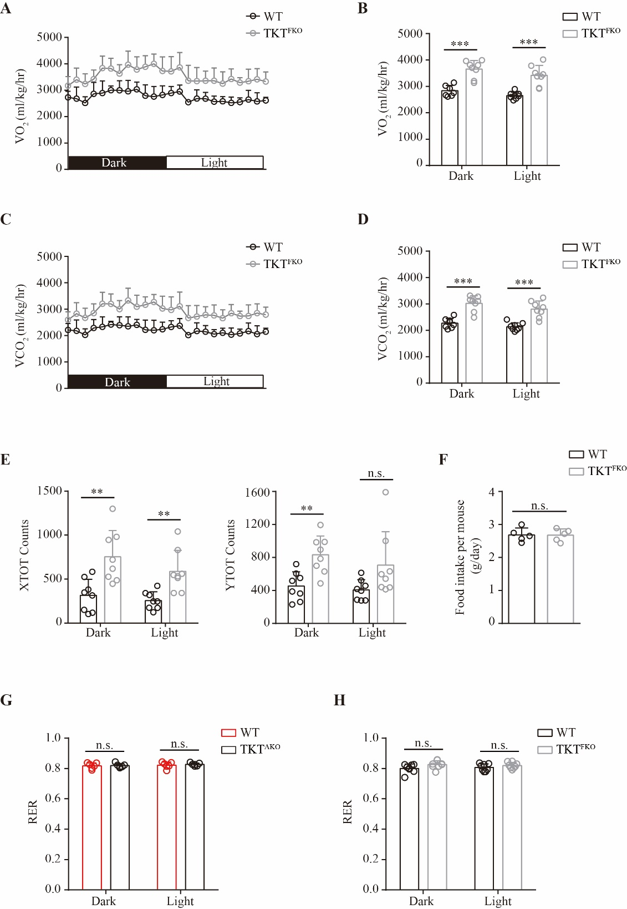
Supplementary Fig. 3 Loss of TKT in adipose tissues increases energy expenditure. 14-week HFD represents mice fed with HFD from 6-week old for 14 weeks. (A, B) Oxygen consumption (VO₂) monitored over a 24 h period (A) and shown as averaged values (B) of WT and TKT^{FKO} mice fed with 14-week HFD (n=8). (C, D) Carbon dioxide production (VCO₂) monitored over a 24 h period (C) and shown as averaged values (D) of WT and TKT^{FKO} mice on 14-week HFD (n=8). (E) Locomotor activity measured over a 24 h period shown as averaged XTOT counts (left) and YTOT counts (right) of WT and TKT^{FKO} mice on 14-week HFD (n=8). (F) Food intake of WT and TKT^{FKO} mice on 14-week HFD (n=5). (G) RER of WT and TKT^{AKO} mice on 10-week HFD (n=6). (H) RER of WT and TKT^{FKO} mice on 14-week HFD (n=8). Data are represented as mean ± SD. Significance is determined by Student’s t test analysis, *P < 0.05, **P<0.01, ***P<0.001.

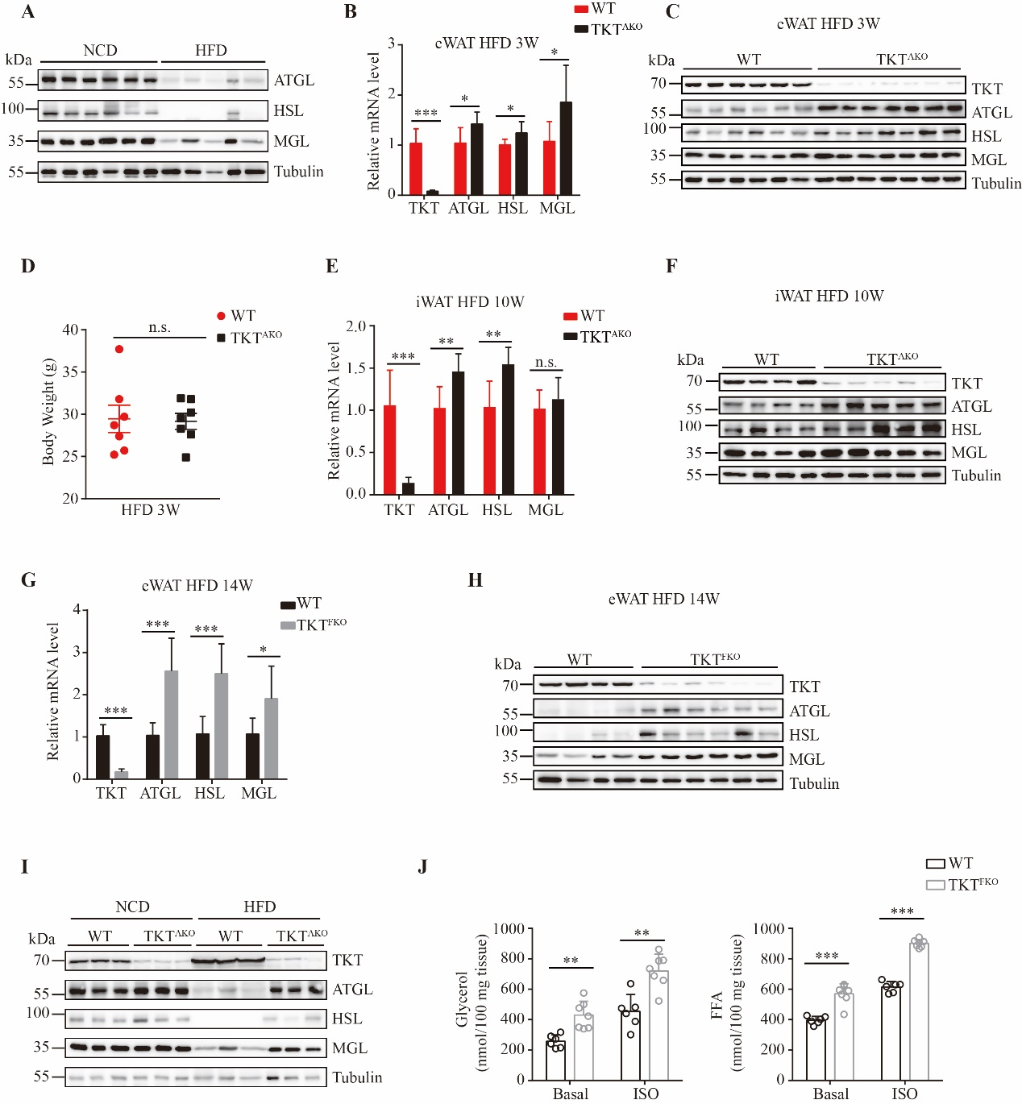
Supplementary Fig. 4 Adipocyte TKT ablation promotes lipolysis. 3-, 10- or 14-week HFD represents mice fed with HFD from 6-week old for 3, 10 or 14 weeks, respectively. (A) Western blotting analysis of protein levels of lipolytic genes in eWATs from WT mice fed with NCD and HFD. (B) qPCR analysis of mRNA levels of lipolytic genes in eWATs from WT and TKT^{AKO} mice fed with 3-week HFD (n=7). (C) Western blotting analysis of protein levels of lipolytic genes in eWATs from WT and TKT^{AKO} mice fed with 3-week HFD. (D) Body weight of WT and TKT^{AKO} mice fed with 3-week HFD (n=7). (E) qPCR analysis of mRNA levels of lipolytic genes in iWATs from WT and TKT^{AKO} mice on 10-week HFD (n=7). (F) Western blotting analysis of protein levels of lipolytic genes in iWATs from WT and TKT^{AKO} mice on 10-week HFD. (G) qPCR analysis of mRNA levels of lipolytic genes in eWATs from WT and TKT^{FKO} mice on 14-week HFD (n=7). (H) Western blotting analysis of protein levels of lipolytic genes in eWATs from WT and TKT^{FKO} mice fed with 14-week HFD. (I) Western blotting analysis of protein levels in eWATs from WT and TKT^{AKO} fed with NCD and HFD. (J) Ex vivo lipolysis assay for eWAT explants from WT and TKT^{FKO} mice fed with 14-week HFD in the absence or presence of 10 μM ISO. FFA and glycerol release were measured (n=6 for WT mice, n=7 for TKT^{FKO} mice). Data are represented as mean ± SD. Significance is determined by Student’s t test analysis, *P < 0.05, **P<0.01, ***P<0.001.
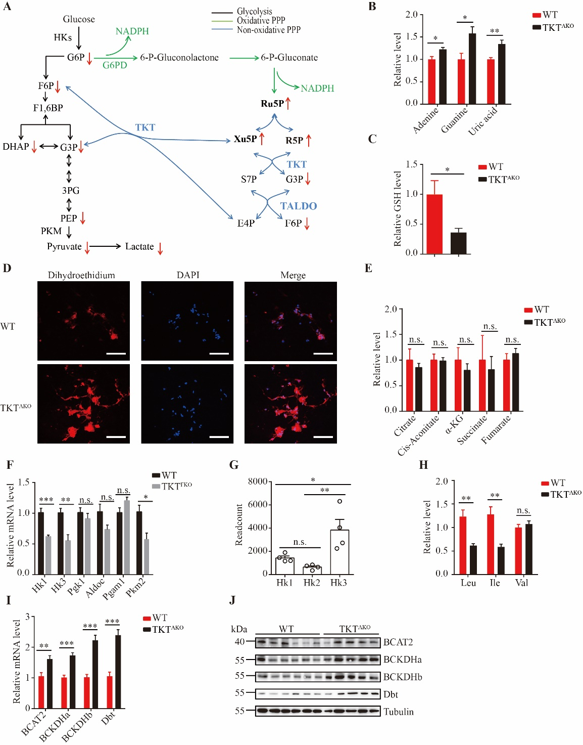
Supplementary Fig. 5 Adipocyte-specific TKT deletion causes metabolic rewriting. 5-week or 14-week HFD represents mice fed with HFD from 6-week old for 5 weeks or 14 weeks, respectively. (A) Schematic diagram of the glycolysis pathway and PPP. The increase and decrease of metabolites are represented by arrows going up and down, respectively. (B) Relative levels of adenine, guanine and uric acid in eWATs from WT and TKT^{AKO} mice fed with 5-week HFD (n=5). (C) Relative GSH levels in eWATs from WT and TKT^{AKO} mice fed with 5-week HFD (n=5). (D) Representative images of DHE staining of eWATs from WT and TKT^{AKO} mice fed with HFD. (E) Relative levels of metabolites in TCA cycle in eWATs from WT and TKT^{AKO} mice fed with 5-week HFD (n=5). (F) qPCR analysis of mRNA levels of glycolytic genes in eWATs from WT and TKT^{FKO} mice on 14-week HFD (n=5). (G) Readcount of Hk1, Hk2 and Hk3 in eWATs of WT mice from RNA-seq data. (H) Relative levels of Leu, Ile and Val in eWATs from WT and TKT^{AKO} mice fed with 5-week HFD (n=5). (I) qPCR analysis of enzyme genes for branched chain amino acid (BCAA) catabolism including branched chain amino acid transaminase 2 (BCAT2), branched chain keto acid dehydrogenase E1 subunit alpha (BCKDHa) and beta (BCKDHb), and dihydrolipoamide branched chain transacylase E2 (Dbt) in eWATs from WT and TKT^{AKO} mice on 10-week HFD (n=8). (J) Western blotting analysis of BCAT2, BCKDHa, BCKDHb and Dbt in eWATs from WT and TKT^{AKO} mice on 10-week HFD. Data are represented as mean ± SEM. Significance is determined by Student’s t test analysis or one-way ANOVA analysis. *P < 0.05, **P<0.01, ***P<0.001.

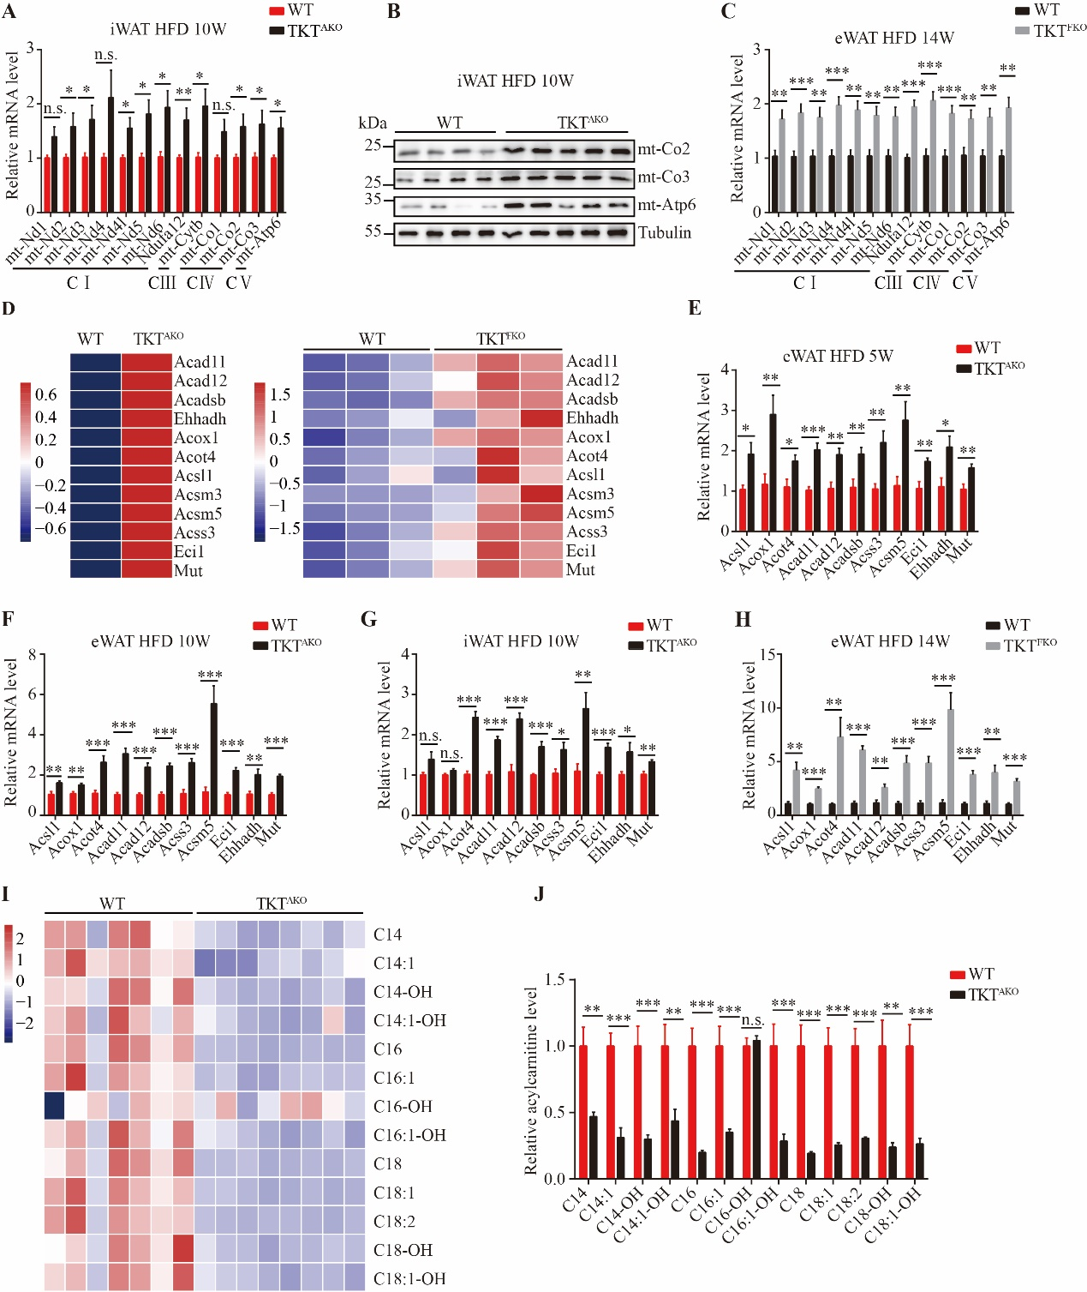
Supplementary Fig. 6 TKT-deficient adipocytes exhibit enhanced mitochondrial function and FAO. 5-, 10- or 14-week HFD represents mice fed with HFD from 6-week old for 5, 10 or 14 weeks, respectively. (A) qPCR analysis of mRNA levels of ETC genes in iWATs from WT and TKT^{AKO} mice on 10-week HFD (n=7). (B) Western blotting analysis of ETC genes in iWATs from WT and TKT^{AKO} mice on 10-week HFD. (C) qPCR analysis of mRNA levels of ETC genes in eWATs from WT and TKT^{FKO} mice fed with 14-week HFD (n=8). (D) Heat maps of fatty acid oxidation (FAO) genes in eWATs from WT and TKT^{AKO} mice on 10-week (left) or WT and TKT^{FKO} mice on 14-week HFD (right). (E) qPCR analysis of mRNA levels of FAO genes in eWATs from WT and TKT^{AKO} mice fed with 5-week HFD (n=7). (F) qPCR analysis of mRNA levels of FAO genes in eWATs from WT and TKT^{AKO} mice fed with 10-week HFD (n=8). (G) qPCR analysis of mRNA levels of FAO genes in iWATs from WT and TKT^{AKO} mice fed with 10-week HFD (n=7). (H) qPCR analysis of mRNA levels of FAO genes in eWATs from WT and TKT^{FKO} mice fed with 14-week HFD (n=8). (I) Heat map of C14-C18 long-chain acylcarnitine species in eWATs from WT and TKT^{AKO} mice fed with 10-week HFD (n=7 for WT mice, n=8 for TKT^{AKO} mice). (J) Relative levels of C14-C18 long-chain acylcarnitine species in eWATs from WT and TKT^{AKO} mice fed with 10-week HFD (n=7 for WT mice, n=8 for TKT^{AKO} mice). Data are represented as mean ± SEM. Significance is determined by Student’s t test analysis, *P < 0.05, **P<0.01, ***P<0.001.
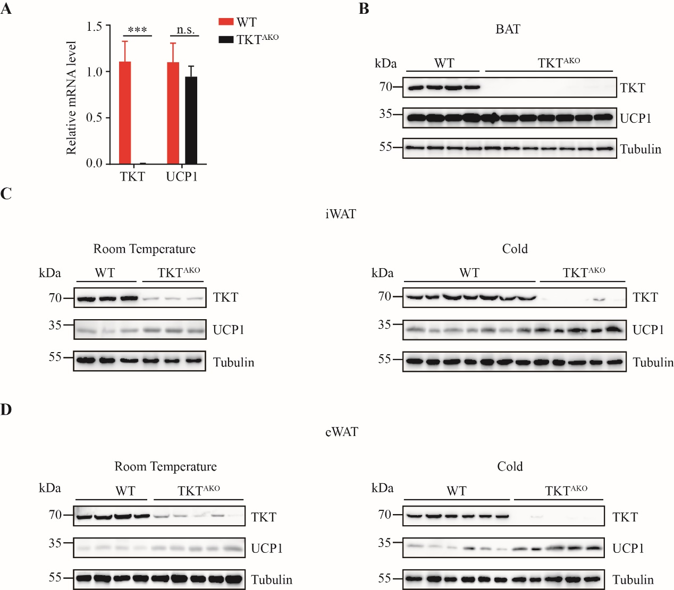
Supplementary Fig. 7 Adipocyte TKT deficiency does not affect BAT UCP1-dependent thermogenesis but promotes WAT browning. 10-week HFD represents mice fed with HFD from 6-week old for 10 weeks. (A) qPCR analysis of mRNA levels of TKT and UCP1 in BATs from WT and TKT^{AKO} mice fed with 10-week HFD (n=8). (B) Western blotting analysis of protein levels of TKT and UCP1 in BATs from WT and TKT^{AKO} mice fed with 10-week HFD. (C) Western blotting analysis of protein levels of TKT and UCP1 in iWATs from WT and TKT^{AKO} mice fed with 10-week HFD at room temperature and upon cold exposure. (D) Western blotting analysis of protein levels of TKT and UCP1 in eWATs from WT and TKT^{AKO} mice fed with 10-week HFD at room temperature and upon cold exposure. Data are represented as mean ± SEM. Significance is determined by Student’s t test analysis, *P < 0.05, **P<0.01, ***P<0.001.

Supplementary Table S1
REAGENT | COMPANY | CAT#
Kits
Triglyceride Quantification Colorimetric/Fluorometric Kit | BioVision | K622
Ultra Sensitive Mouse Insulin ELISA Kit | Crystal Chem | 90080
Mouse Adiponectin/Acrp30 Quantikine ELISA Kit | R&D Systems | MRP300
Free Glycerol Reagent | Sigma | F6428
Free Fatty Acid Quantification Colorimetric/Fluorometric Kit | BioVision | K612
Mouse/Rat Leptin Quantikine ELISA Kit | R&D Systems | MOB00
Antibodies
HRP-conjugated α-tubulin | Proteintech | HRP-66031
Anti-TKT | Cell Signaling Technology | 8616
Anti-ATGL | Cell Signaling Technology | 2138
Anti-HSL | Cell Signaling Technology | 4107
Anti-MGL | Abcam | ab24701
Anti-mt-Co1 | Signalway Antibody | 45586
Anti-mt-Co2 | Proteintech | 55070-1-AP
Anti-mt-Co3 | Proteintech | 55082-1-AP
Anti-mt-Atp6 | Proteintech | 55313-1-AP
Anti-Akt | Cell Signaling Technology | 4691
Anti-p-Akt (s473) | Cell Signaling Technology | 4060
Dbt | ThermoFisher | PA5-29727
BCKDHa | Santa Cruz | SC271538
BCKDHb | Santa Cruz | SC374630
BCAT2 | Proteintech | 16417-1-AP

Supplementary Table S2
Primers for qPCR
Gene name | Forward primer | Reverse primer
18s rRNA | TTGACTCAACACGGGAAACC | AGACAAATCGCTCCACCAAC
ATGL | TTCACCATCCGCTTGTTGGAG | AGATGGTCACCCAATTTCCTC
HSL | ACGCTACACAAAGGCTGCTT | TCGTTGCGTTTGTAGTGCTC
MGL | CGGACTTCCAAGTTTTTGTCAGA | GCAGCCACTAGGATGGAGATG
mt-Nd1 | GGCCCTAACATTGTTGGTCC | TGGGTGTGGTATTGGTAGGG
mt-Nd2 | TCCTGTTAGTGGTGGAAGGC | CCTTACAACCCATCCCTCACT
mt-Nd3 | CTAGTTGCATTCTGACTCCCC | TGCTCATGGTAGTGGAAGTAGA
mt-Nd4 | CTAATAATCGCACATGGCCTC | CGTAGTTGGAGTTTGCTAGG
mt-Nd4l | TCTTCAACCTCACCATAGCCT | AGATGGTGATGGGGATTGGT
mt-Nd5 | CATCCTTCTCAACTTTACTGGG | TTTATGGGTGTAATGCGGT
mt-Nd6 | GGGATGTTGGTTGTGTTTGGA | CTACCCCAATCCCTCCTTCC
Ndufa12 | TCCTGAGTGGCACCGC | CTCTGGAGTGGCAGACACATT
mt-Co1 | ACACAACTTTCTTTGATCCCG | AGAATCAGAACAGATGCTGG
mt-Co2 | ATAATCCCAACAAACGACCT | CTCGGTTATCAACTTCTAGCA
mt-Co3 | GGTATAATTCTATTCATCGTCTCGG | AGAACGCTCAGAAGAATCCT
mt-Cytb | CCATTCTACGCTCAATCCCCA | AGGCTTCGTTGCTTTGAGGTA
mt-Atp6 | CCTTCAATCCTATTCCCATCC | GTTGGAAAGAATGGAGACGG
Hk1 | GGCCTAGACCACCTGAATGT | CTCTTAGGCGTTCGTAGGGT
Hk3 | GTGTGAAGTCGGGCTGATTG | CAGAGTCGAAGGTGGTCAGT
Aldoc | AGATGCCCTCCCATGTTTGA | ATAAGGAGCACGAGTCAGGG
Pgk1 | TCGTGATGAGGGTGGACTTC | GGCCCACACAATCCTTCAAG
Pgam1 | ATCAGCAAGGATCGCAGGTA | CAGATGCTTAACGATGCCCC
PKM2 | GTCTGGAGAAACAGCCAAGG | CGGAGTTCCTCGAATAGCTG
Acox1 | ACGCCACTTCCTTGCTCTTC | AGATTGGTAGAAATTGCTGCAAA
Acsl1 | TGGGGTGGAAATCATCAGCC | CACAGCATTACACACTGTACAACGG
Acad11 | GAACATGTGCAGGGTCGGAT | GAATGTAGCCATGCCAGGGT
Acad12 | GCGCTGAGTCTTCTGGTTTG | AGATGGAGGCTGCAGAAAGTT
Acadsb | TTATGCATCTGAGGTCGCTGG | GGTGTTCAGCTGGATGTTGG
Acss3 | CATTGGTGGCAAACAGAGACT | CCAGGTGGTAATGGCAACTT
Ehhadh | GGCGCAGGATACCTTGAGAA | TGATTACAGTTGGACTGATGGCA
Eci1 | TCTGCCATCAATGGAGCCTCT | GCCCGATGGTGTTCACATAC
Mut | CCCAAACACTGACCGTTCTCAT | GCTTCAGGTAATGGGGCGATA
Acot4 | GGAGGCCTGTTGGAATACCG | TGGGCCTTTTACCTTTGGATGT
Acsm5 | GGCTTCTCCAGAGCACAACT | CCATCCACCTCCTTCCACTG
BCAT2 | TTCATTCGTCAGAGCCTGGATA | ACTACTCCAGGCAAGATGACGC
Bckdha | AACCAGCCCTTCCTCATTGA | GGCCTTCTCCTGTTCCTCAT
Bckdhb | TTCCATGGCCCAAGAAAAGC | AAGATGTGAGGAAACGGGGT
Dbt | CAAAGACCGAACAGAGCCAG | ACGGAGGCATTGAGGATAGG
Resistin | TTCCTTGTCCCTGAACTGCT | TCTTCACGAATGTCCCACGA
Visfatin | CGAGAAGTACAGAGGCACCA | CCACGCCATCTCCTTGAATG
RBP4 | GAGCAACTGGGAAGTGTGTG | AGGAGTACTGCAGAGCGAAG
Apelin | GAGAAACTGTCCCCTTCCCA | AAGCACTCACCTCCCTACAC
Adiponectin | GCACTGGCAAGTTCTACTGCAA | GTAGGTGAAGAGAACGGCCTTGT
Leptin | TCATGCCAGCACTCAAAAAC | AGCACCACAAAACCTGATCC
UCP1 | GTGAACCCGACAACTTCCGAA | TGCCAGGCAAGCTGAAACTC

Primers for mitochondrial DNA quantification
Gene name | Forward primer | Reverse primer
β-Actin | GGCTGTATTCCCCTCCATCG | CCAGTTGGTAACAATGCCATGT
mt-Co1 | TTGGTCCCCTCCTCCAGC | CCAGTGCTAGCCGCAGGCA

