Supplementary material
Table S1. ROC_AUC for four different machine learning models during the model development process (prediction of biochemical hypoglycemia)
 | Model
Dataset | Logistic regression | XG Boost | Decision trees | Gradient Boosting
Baseline dataset (IH) | 0.71 | 0.78 | 0.72 | 0.78
Insulin dose dataset (IH+) | 0.72 | 0.81 | 0.75 | 0.80
Previous hypo dataset (PH) | 0.73 | 0.96 | 0.81 | 0.96

Table S2. Variable ranking by their contributions to the predictions of the XGBoost model.
Variable | Ranking score (from highest to lowest)
previousLowGlucose<4mmol/l | 0.8282
previousLowGlucose<3mmol/l | 0.6599
Albumin level | 0.6361
Type 2 diabetes | 0.6044
Intravenous insulin | 0.5954
Long acting insulin analogue | 0.5922
Dose of long acting insulin analogue | 0.5909
Procedure | 0.5835
Rapid acting insulin analogue | 0.5710
Dose of rapid acting insulin analogue | 0.5706
Oxygen saturation* | 0.5619
Temperature* | 0.5526
Weight | 0.5518
Type 1 diabetes | 0.5512
Ethnicity_White | 0.5507
Dose of rapid human insulin | 0.5457
Rapid human insulin | 0.5456
BMI | 0.5446
Metformin | 0.5428
Age | 0.5418
Heart rate* | 0.5409
Gender | 0.5361
Morphine* | 0.5330
Height | 0.5258
Long human insulin | 0.5232
Dose of long human insulin | 0.5218
Dose of mixed human insulin | 0.5207
Systolic blood pressure* | 0.5198
Mixed human insulin | 0.5195
Dose of mixed human insulin | 0.5141
Mixed insulin analogue | 0.5137
Sulfonylurea | 0.5134
Prednisolone | 0.5051
Diastolic blood pressure* | 0.5050
Amitriptyline* | 0.5040
Ethnicity_Asian | 0.5027
Pregabalin* | 0.5009
Dexamethasone | 0.5009
GLP-1 | 0.5002
Bisoprolol* | 0.5002
DPP-4 | 0.5000
Pioglitazone | 0.4998
Ethnicity_Black | 0.4992
Ethnicity_Mixed | 0.4973
Creatinine | 0.4925
Hemoglobin | 0.4885
CRP | 0.4884
Potassium | 0.4853
Sodium | 0.4840
White cells | 0.4780
eGFR | 0.4777

Variables designated (*) are novel predictors of inpatient hypoglycaemia, not investigated in previous studies.

Table S3. Coefficient of the logistic regression model (arranged in descending order of statistical significance for clinically significant hypoglycemia)
Predictors | Biochemical hypoglycemia (blood glucose < 4 mmol/l) |  |  |  | Clinically significant hypoglycemia (blood glucose <3 mmol/l)
 | Coefficient | Standard error | P-value | z | Coefficient | Standard error | P-value | z
(+)PrevLowGlucose3 | 3.842 | 0.086 | <0.001 | 28.42 | 4.021 | 0.047 | <0.001 | 20.39
(-)Albumin | -0.078 | 0.003 | <0.001 | -27.22 | -0.074 | 0.004 | <0.001 | -19.51
(+)Intravenous insulin | 0.639 | 0.041 | <0.001 | 15.43 | 0.501 | 0.051 | <0.001 | 9.82
(-)Type of diabetes(type 2) | -0.820 | 0.060 | <0.001 | -13.68 | -0.656 | 0.083 | <0.001 | -7.88
(+)Procedure indication | 0.485 | 0.033 | <0.001 | 14.87 | 0.339 | 0.050 | <0.001 | 6.81
(-)Weight | -0.010 | 0.001 | <0.001 | -7.42 | -0.012 | 0.002 | <0.001 | -6.38
(+)Sulfonylurea | 0.572 | 0.040 | <0.001 | 14.24 | 0.311 | 0.058 | <0.001 | 5.35
(+)Insulin (long human) | 0.011 | 0.002 | <0.001 | 4.77 | 0.010 | 0.003 | <0.001 | 5.35
(+)Oxygen saturation | 0.059 | 0.009 | <0.001 | 6.31 | 0.067 | 0.013 | <0.001 | 5.30
(-)Metformin | -0.212 | 0.035 | <0.001 | -6.02 | -0.258 | 0.051 | <0.001 | -5.02
(-)Temperature | -0.061 | 0.027 | 0.022 |  | -0.163 | 0.036 | <0.001 | -4.45
(-)Diastolic blood pressure | -0.008 | 0.003 | 0.005 |  | -0.014 | 0.004 | <0.001 | -3.68
(+)Amitriptyline | 0.192 | 0.059 | 0.001 |  | 0.227 | 0.076 | 0.003
(+)Ethnicity(black) | 0.377 | 0.114 | 0.001 |  | 0.424 | 0.154 | 0.006
(-)Sex | -0.061 | 0.033 | 0.068 |  | -0.126 | 0.047 | 0.007
(+)Insulin (long analogue) | 0.003 | 0.001 | 0.047 |  | 0.005 | 0.002 | 0.008
(-)Height | -0.000 | 0.002 | 0.980 |  | 0.006 | 0.003 | 0.020
(+)Insulin (mixed analogue) | 0.007 | 0.002 | <0.001 | 3.67 | 0.004 | 0.002 | 0.060
(+)Insulin (mixed human) | 0.006 | 0.002 | 0.007 |  | 0.005 | 0.003 | 0.060
(+)Morphine | 0.101 | 0.036 | 0.005 |  | 0.087 | 0.048 | 0.070
(-)Dexamethasone | -0.234 | 0.091 | 0.010 |  | -0.211 | 0.122 | 0.084
(-)Age | -0.001 | 0.001 | 0.160 |  | 0.002 | 0.002 | 0.150
(-)Potassium | -0.005 | 0.003 | 0.090 |  | -0.004 | 0.004 | 0.230
(+)Insulin (rapid human) | 0.023 | 0.006 | <0.001 | 4.11 | 0.007 | 0.006 | 0.285
(+)Insulin (rapid analogue) | 0.005 | 0.002 | 0.022 |  | 0.002 | 0.003 | 0.370
(+)PrevLowGlucose4 | 0.030 | 0.086 | 0.750 |  | 0.059 | 0.049 | 0.420
(-)White cells | -0.003 | 0.003 | 0.230 |  | -0.003 | 0.004 | 0.470
(-)Bisoprolol | -0.027 | 0.036 | 0.460 |  | -0.030 | 0.049 | 0.530
(+)Pregabalin | 0.088 | 0.091 | 0.330 |  | 0.070 | 0.117 | 0.553
(-)Hemoglobin | -0.002 | 0.003 | 0.440 |  | 0.002 | 0.004 | 0.610
(-)Sodium | -0.001 | 0.003 | 0.650 |  | -0.002 | 0.004 | 0.680
(-)Creatinine | -0.002 | 0.003 | 0.480 |  | -0.001 | 0.004 | 0.710
(-)Pioglitazone | -0.033 | 0.160 | 0.840 |  | 0.070 | 0.221 | 0.750
(-)eGFR | -0.003 | 0.003 | 0.350 |  | -0.001 | 0.004 | 0.760
(+)C-Reactive Protein | 0.001 | 0.003 | 0.680 |  | 0.001 | 0.004 | 0.800
(-)Systolic blood pressure | -0.001 | 0.001 | 0.443 |  | -0.001 | 0.000 | 0.800
(-)GLP-1 | -0.273 | 0.151 | 0.071 |  | -0.050 | 0.203 | 0.807
(-)Heart rate | -0.005 | 0.002 | 0.001 |  | -0.001 | 0.000 | 0.810
(-)DPP-4 | -0.122 | 0.075 | 0.102 |  | 0.018 | 0.103 | 0.863
(+)Prednisolone | 0.032 | 0.053 | 0.540 |  | 0.003 | 0.071 | 0.970
Predictors with P-values less than 0.001 are highlighted in bold-face. The Coefficient reflects the effect size of the variable and the z score reflects the statistical significance of the variable
PrevLowGlucose3 indicates previous admission within 6 months with glucose below 3mmol/L
PrevLowGlucose4 indicates previous admission within 6 months with glucose below 4mmol/L
Factors with a positive Coefficient value increase the risk of hypoglycaemia and factors with a negative Coefficient value decrease the risk of hypoglycaemia. Eg an increase in albumin value reduces the risk of hypoglycaemia and people with Type 2 diabetes have an decreased risk of hypoglycaemia. A (+) or (–) sign is given to each of the factors to indicate the effect direction.
Figure S1. Data flow from the electronic health records to the final dataset used in the predictions models. EPR: electronic patient records; LIMS: laboratory information management system.

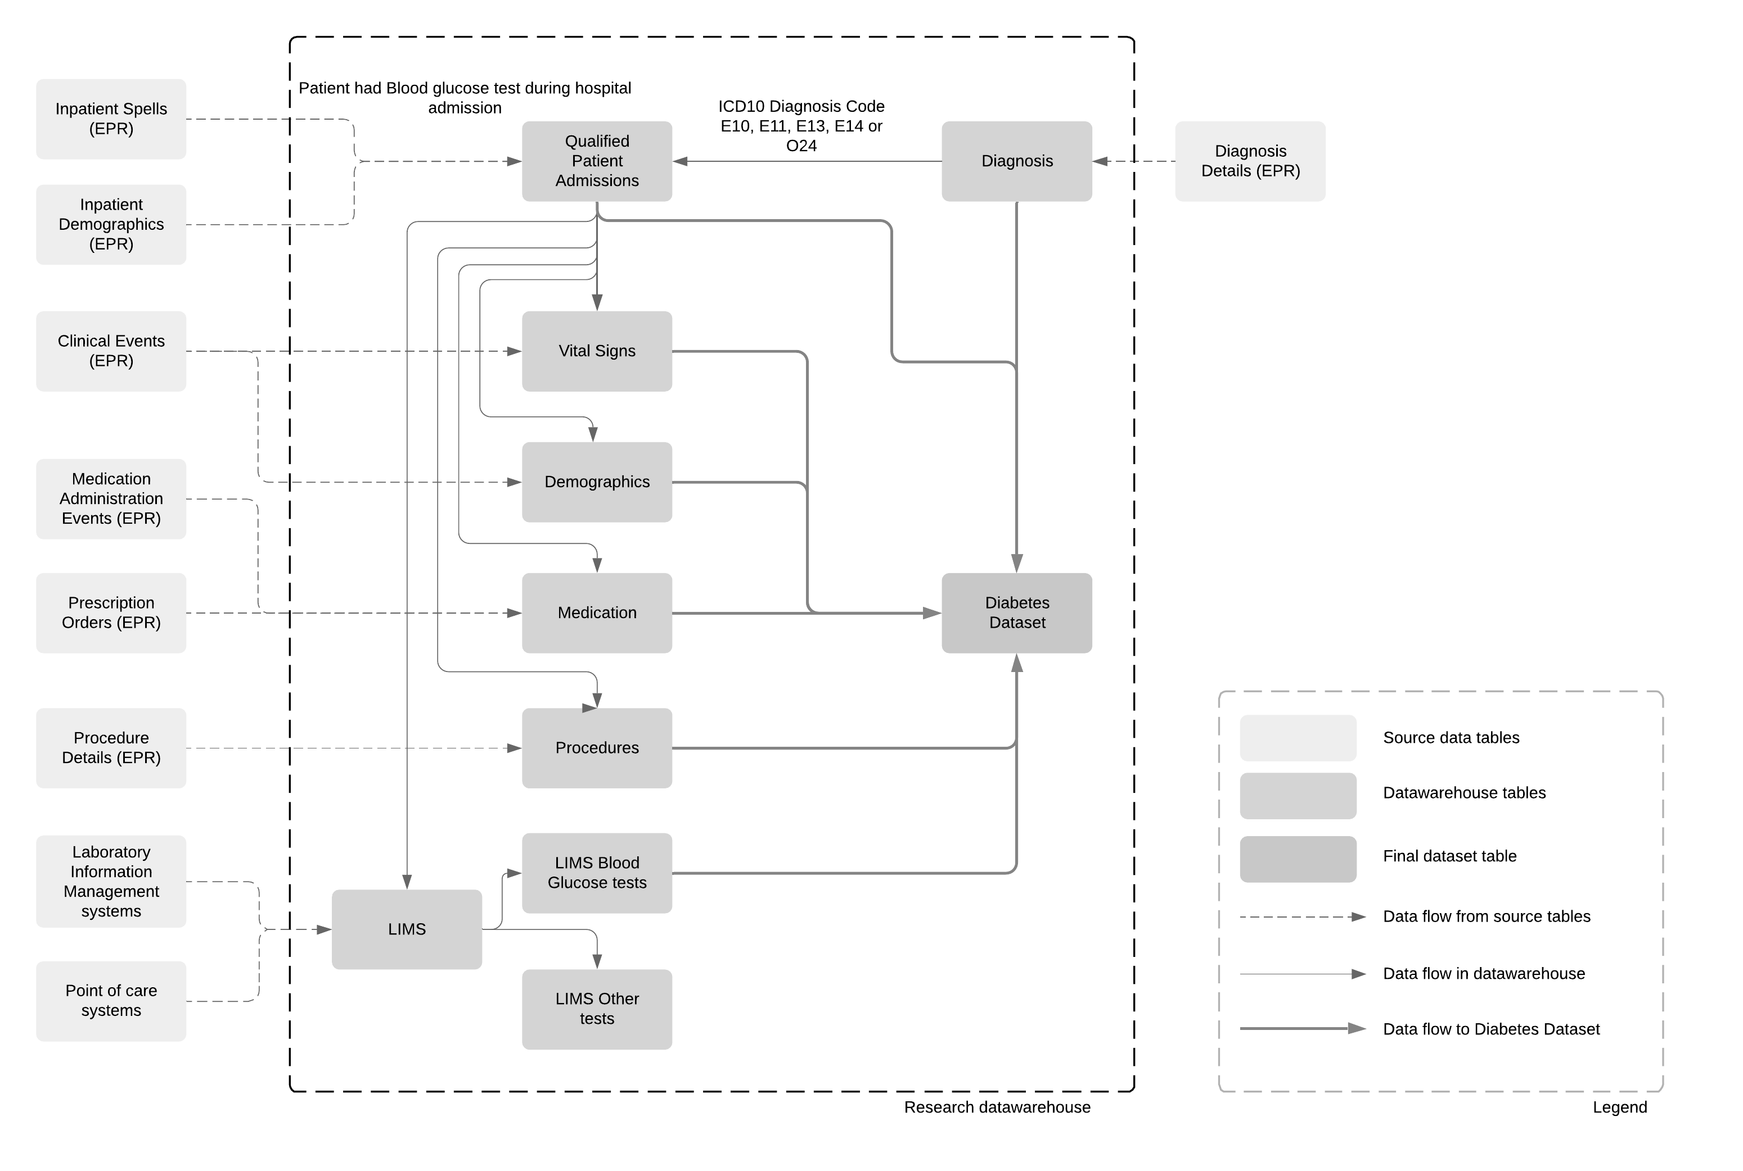

Table S4. Normalized confusion matrix for logistic regression, gradient boosting, XGBoost and decision trees models. True positive and true negative rate are shown at coordinates (0,0) and (1,1), respectively, in each confusion matrix.

Logistic regression Gradient boosting
 |  | predicted label
 |  | 0 | 1
true label | 0 | 0.94 | 0.06
 | 1 | 0.32 | 0.68
 |  | predicted label
 |  | 0 | 1
true label | 0 | 0.97 | 0.03
 | 1 | 0.29 | 0.71

XGBoost Decision trees
 |  | predicted label
 |  | 0 | 1
true label | 0 | 0.98 | 0.02
 | 1 | 0.29 | 0.71
 |  | predicted label
 |  | 0 | 1
true label | 0 | 0.92 | 0.08
 | 1 | 0.29 | 0.71

