**SUPPLEMENTARY DATA**

**Supplementary Table S1. Stratified analysis for the associations of AAMA FPG, 8-iso-PGF2α and 8-OHdG (N=3270)**

|  |  |  |  |  |  |  |  |  |  |
| --- | --- | --- | --- | --- | --- | --- | --- | --- | --- |
| **Stratification**  **characteristics** | **FPG** | | | **8-iso-PGF2α** | | | **8-OHdG** | | |
| **Estimated change (mmol/l) (95% *CI*)\*** | ***P* for trend†** | ***P* for modification‡** | **Adjusted β (95% *CI*)\*** | ***P* for trend†** | ***P* for modification‡** | **Adjusted β (95% *CI*)\*** | ***P* for trend†** | ***P* for modification‡** |
| **Gender** |  |  | 0.501 |  |  | 0.335 |  |  | 0.069 |
| Male (n=977) | 0.26 (-0.08, 0.61) | 0.359 |  | 0.39 (0.33, 0.45) | <0.001 |  | 0.11 (-0.01, 0.22) | 0.016 |  |
| Female (n=2293) | 0.14 (-0.04, 0.31) | 0.026 |  | 0.41 (0.37, 0.45) | <0.001 |  | 0.22 (0.15, 0.30) | <0.001 |  |
| **Age, years** |  |  | 0.307 |  |  | 0.391 |  |  | 0.726 |
| <55 (n=1702) | 0.26 (0.06, 0.46) | 0.025 |  | 0.43 (0.38, 0.47) | <0.001 |  | 0.17 (0.08, 0.26) | <0.001 |  |
| ≥55 (n=1568) | 0.10 (-0.15, 0.36) | 0.090 |  | 0.39 (0.34, 0.43) | <0.001 |  | 0.22 (0.13, 0.30) | <0.001 |  |
| **BMI, kg/m2** |  |  | 0.379 |  |  | 0.158 |  |  | 0.390 |
| <24 (n=1722) | 0.13 (-0.09, 0.34) | 0.013 |  | 0.43 (0.38, 0.47) | <0.001 |  | 0.22 (0.14, 0.30) | <0.001 |  |
| ≥24 (n=1548) | 0.19 (-0.05, 0.43) | 0.184 |  | 0.38 (0.33, 0.43) | <0.001 |  | 0.17 (0.08, 0.27) | <0.001 |  |
| **Smoking status** |  |  | 0.317 |  |  | 0.356 |  |  | 0.057 |
| Smokers (n=485) | 0.01 (-0.52, 0.53) | 0.783 |  | 0.45 (0.35, 0.54) | <0.001 |  | 0.03 (-0.14, 0.19) | 0.555 |  |
| Nonsmokers (n=2785) | 0.19 (0.02, 0.35) | 0.005 |  | 0.40 (0.36, 0.43) | <0.001 |  | 0.22 (0.15, 0.29) | <0.001 |  |
| **Drinking status** |  |  | 0.115 |  |  | 0.648 |  |  | 0.058 |
| Drinkers (n=418) | 0.57 (0.05, 1.08) | 0.215 |  | 0.39 (0.29, 0.49) | <0.001 |  | 0.04 (-0.14, 0.22) | 0.955 |  |
| Nondrinkers (n=2852) | 0.12 (-0.04, 0.29) | 0.044 |  | 0.40 (0.37, 0.44) | <0.001 |  | 0.22 (0.16, 0.29) | <0.001 |  |
| **Physical activity** |  |  | 0.682 |  |  | 0.563 |  |  | 0.834 |
| Active (n=1595) | 0.10 (-0.15, 0.35) | 0.221 |  | 0.39 (0.34, 0.44) | <0.001 |  | 0.18 (0.10, 0.27) | <0.001 |  |
| Inactive (n=1675) | 0.24 (0.04, 0.44) | 0.012 |  | 0.41 (0.37, 0.46) | <0.001 |  | 0.20 (0.11, 0.29) | <0.001 |  |

Abbreviations: BMI, body mass index; CI, confidence interval; AAMA, urinary acrylamide metabolite of N-Acetyl-S-(2-carbamoylethyl)-L-cysteine; FPG, fasting plasma glucose; 8-iso-PGF2α, 8-iso-prostaglandin-F2α; 8-OHdG, 8-hydroxydeoxyguanosine.

*Adjusted for age, gender (male/female), body mass index, smoking status (smokers/nonsmokers), drinking status (drinkers/nondrinkers), physical activity (active/inactive), education level (low/high), family income (low/high), family history of diabetes (yes/no), total cholesterol, triglycerides and mean arterial pressure, and included city (Wuhan/Zhuhai) as a random effect in the linear mixed models.

**†***P* for trend across quartiles of AAMA in each subgroup was tested by including the median of each AAMA quartile as a continuous variable in the linear mixed models.

‡*P* for modification of each characteristic was calculated by including a product term of AAMA with each stratified characteristic in the linear mixed models.

**Supplementary Table S2. Stratified analysis for the associations of GAMA with FPG, 8-iso-PGF2α and 8-OHdG (N=3270)**

|  |  |  |  |  |  |  |  |  |  |
| --- | --- | --- | --- | --- | --- | --- | --- | --- | --- |
| **Stratification**  **characteristics** | **FPG** | | | **8-iso-PGF2α** | | | **8-OHdG** | | |
| **Estimated change (mmol/l) (95% *CI*)\*** | ***P* for trend†** | ***P* for modification‡** | **Adjusted β (95% *CI*)\*** | ***P* for trend†** | ***P* for modification ‡** | **Adjusted β (95% *CI*)\*** | ***P* for trend\*** | ***P* for modification.‡** |
| **Gender** |  |  | 0.729 |  |  | 0.029 |  |  | 0.068 |
| Male (n=977) | 0.09 (-0.31, 0.48) | 0.743 |  | 0.42 (0.35, 0.49) | <0.001 |  | 0.16 (0.03, 0.29) | 0.001 |  |
| Female (n=2293) | 0.02 (-0.18, 0.21) | 0.489 |  | 0.50 (0.46, 0.54) | <0.001 |  | 0.30 (0.22, 0.38) | <0.001 |  |
| **Age, years** |  |  | 0.442 |  |  | 0.565 |  |  | 0.464 |
| <55 (n=1702) | 0.13 (-0.09, 0.35) | 0.529 |  | 0.50 (0.45, 0.55) | <0.001 |  | 0.24 (0.13, 0.34) | <0.001 |  |
| ≥55 (n=1568) | -0.04 (-0.33, 0.25) | 0.827 |  | 0.47 (0.42, 0.52) | <0.001 |  | 0.31 (0.21, 0.40) | <0.001 |  |
| **BMI, kg/m2** |  |  | 0.980 |  |  | 0.057 |  |  | 0.376 |
| <24 (n=1722) | 0.04 (-0.21, 0.28) | 0.536 |  | 0.52 (0.46, 0.57) | <0.001 |  | 0.31 (0.21, 0.40) | <0.001 |  |
| ≥24 (n=1548) | 0.01 (-0.26, 0.28) | 0.907 |  | 0.45 (0.39, 0.50) | <0.001 |  | 0.24 (0.14, 0.34) | <0.001 |  |
| **Smoking status** |  |  | 0.937 |  |  | 0.535 |  |  | 0.152 |
| Smokers (n=485) | 0.02 (-0.55, 0.60) | 0.570 |  | 0.50 (0.40, 0.60) | <0.001 |  | 0.13 (-0.05, 0.32) | 0.204 |  |
| Nonsmokers (n=2785) | 0.02 (-0.16, 0.21) | 0.510 |  | 0.48 (0.44, 0.52) | <0.001 |  | 0.29 (0.21, 0.36) | <0.001 |  |
| **Drinking status** |  |  | 0.034 |  |  | 0.214 |  |  | 0.094 |
| Drinkers (n=418) | 0.47 (-0.09, 1.03) | 0.402 |  | 0.43 (0.32, 0.53) | <0.001 |  | 0.15 (-0.04, 0.35) | 0.033 |  |
| Nondrinkers (n=2852) | -0.04 (-0.23, 0.15) | 0.957 |  | 0.49 (0.45, 0.53) | <0.001 |  | 0.29 (0.21, 0.36) | <0.001 |  |
| **Physical activity** |  |  | 0.327 |  |  | 0.741 |  |  | 0.216 |
| Active (n=1595) | -0.11 (-0.40, 0.17) | 0.758 |  | 0.49 (0.43, 0.54) | <0.001 |  | 0.31 (0.21, 0.41) | <0.001 |  |
| Inactive (n=1675) | 0.16 (-0.06, 0.38) | 0.217 |  | 0.48 (0.43, 0.53) | <0.001 |  | 0.22 (0.12, 0.32) | <0.001 |  |

Abbreviations: BMI, body mass index; CI, confidence interval; GAMA, urinary acrylamide metabolite of N-Acetyl-S-(2-carbamoyl-2-hydroxyethyl)-L-cysteine; FPG, fasting plasma glucose; 8-iso-PGF2α, 8-iso-prostaglandin-F2α; 8-OHdG, 8-hydroxydeoxyguanosine.

**\***Adjusted for age, gender (male/female), body mass index, smoking status (smokers/nonsmokers), drinking status (drinkers/nondrinkers), physical activity (active/inactive), education level (low/high), family income (low/high), family history of diabetes (yes/no), total cholesterol, triglycerides and mean arterial pressure, and included city (Wuhan/Zhuhai) as a random effect in the linear mixed models.

**†***P* for trend across quartiles of GAMA in each subgroup was tested by including the median of each GAMA quartile as a continuous variable in the linear mixed models.

‡*P* for modification of each characteristic was calculated by including a product term of GAMA with each stratified characteristic in the linear mixed models.

**Supplementary Table S3. Associations of 8-iso-PGF2α with FPG in all participants and stratified by major characteristics (N=3270)**

|  |  |  |  |  |  |  |  |
| --- | --- | --- | --- | --- | --- | --- | --- |
| **Variables** | **Estimated FPG change (mmol/l) (95% *CI*) by continuous 8-iso-PGF2α** | ***P* for modification\*** | **Estimated FPG change (mmol/l) (95% *CI*) by quartiles of 8-iso-PGF2α** | | | | ***P* for trend†** |
| **Q1** | **Q2** | **Q3** | **Q4** |
| **All participants (N=3270)** | 0.23 (0.08, 0.38) |  | 0 (Ref.) | -0.01 (-0.15, 0.13) | 0.18 (0.04, 0.33) | 0.18 (0.02, 0.33) | 0.004 |
| **Gender** |  | 0.341 |  |  |  |  |  |
| Male (n=977) | 0.07 (-0.25, 0.40) |  | 0 (Ref.) | 0.01 (-0.29, 0.30) | 0.17 (-0.13, 0.47) | 0.04 (-0.27, 0.36) | 0.557 |
| Female (n=2293) | 0.30 (0.13, 0.47) |  | 0 (Ref.) | -0.07 (-0.23, 0.09) | 0.18 (0.01, 0.34) | 0.25 (0.08, 0.42) | <0.001 |
| **Age, years** |  | 0.867 |  |  |  |  |  |
| <55 (n=1702) | 0.19 (0.01, 0.37) |  | 0 (Ref.) | -0.02 (-0.19, 0.15) | 0.14 (-0.03, 0.32) | 0.08 (-0.10, 0.27) | 0.176 |
| ≥55 (n=1568) | 0.29 (0.05, 0.53) |  | 0 (Ref.) | -0.01 (-0.24, 0.22) | 0.20 (-0.04, 0.43) | 0.28 (0.03, 0.53) | 0.011 |
| **BMI, kg/m2** |  | 0.367 |  |  |  |  |  |
| <24 (n=1722) | 0.23 (0.03, 0.43) |  | 0 (Ref.) | -0.01 (-0.20, 0.19) | 0.15 (-0.05, 0.35) | 0.19 (-0.02, 0.40) | 0.040 |
| ≥24 (n=1548) | 0.23 (0.01, 0.46) |  | 0 (Ref.) | 0.00 (-0.21, 0.21) | 0.24 (0.02, 0.45) | 0.18 (-0.05, 0.41) | 0.035 |
| **Smoking status** |  | 0.179 |  |  |  |  |  |
| Smokers (n=485) | 0.08 (-0.39, 0.54) |  | 0 (Ref.) | -0.07 (-0.52, 0.37) | 0.18 (-0.27, 0.64) | -0.01 (-0.48, 0.46) | 0.765 |
| Nonsmokers (n=2785) | 0.26 (0.10, 0.42) |  | 0 (Ref.) | 0.02 (-0.12, 0.15) | 0.19 (0.04, 0.34) | 0.26 (0.09, 0.42) | <0.001 |
| **Drinking status** |  | 0.845 |  |  |  |  |  |
| Drinkers (n=418) | 0.44 (-0.05, 0.92) |  | 0 (Ref.) | 0.38 (-0.05, 0.82) | 0.59 (0.15, 1.04) | 0.46 (0.00, 0.92) | 0.036 |
| Nondrinkers (n=2852) | 0.21 (0.05, 0.37) |  | 0 (Ref.) | -0.05 (-0.20, 0.10) | 0.14 (-0.01, 0.29) | 0.18 (0.01, 0.34) | 0.008 |
| **Physical activity** |  | 0.808 |  |  |  |  |  |
| Active (n=1595) | 0.27 (0.04, 0.50) |  | 0 (Ref.) | -0.04 (-0.26, 0.18) | 0.13 (-0.10, 0.35) | 0.21 (-0.03, 0.45) | 0.050 |
| Inactive (n=1675) | 0.20 (0.01, 0.39) |  | 0 (Ref.) | 0.12 (-0.06, 0.29) | 0.23 (0.04, 0.41) | 0.22 (0.03, 0.41) | 0.012 |

Abbreviations: BMI, body mass index; CI, confidence interval; FPG, fasting plasma glucose; 8-iso-PGF2α, 8-iso-prostaglandin-F2α.

Adjusted for age, gender (male/female), body mass index, smoking status (smokers/nonsmokers), drinking status (drinkers/nondrinkers), physical activity (active/inactive), education level (low/high), family income (low/high), family history of diabetes (yes/no), total cholesterol, triglycerides and mean arterial pressure, and included city (Wuhan/Zhuhai) as a random effect in the linear mixed models.

\**P* for interaction of each characteristic was calculated by including a product term of 8-iso-PGF2α with each stratification characteristic linear mixed models.

**†***P* for trend across quartiles of 8-iso-PGF2α in all participants or each subgroup was tested by including the median of each 8-iso-PGF2α quartile as a continuous variable in the linear mixed models.

**Supplementary Figure S1. Dose-response relationships of urinary acrylamide metabolites with FPG, 8-iso-PGF2α and 8-OHdG (N=3270)**

Curves were plotted by using restricted cubic splines with 3 knots at the 25th, 50th and 75th percentiles of log-transformed urinary acrylamide metabolites levels. The solid lines and short dashed lines represent the estimations and its 95% confidence intervals, respectively.

Abbreviations: AAMA, urinary acrylamide metabolite of N-Acetyl-S-(2-carbamoylethyl)-L-cysteine; GAMA, urinary acrylamide metabolite of N-Acetyl-S-(2-carbamoyl-2-hydroxyethyl)-L-cysteine; ΣUAAM, total urinary acrylamide metabolites, i.e., AAMA+GAMA; FPG, fasting plasma glucose; 8-OHdG, 8-hydroxydeoxyguanosine; 8-iso-PGF2α, 8-iso-prostaglandin-F2α.

Adjusted for age, gender (male/female), body mass index, smoking status (smokers/nonsmokers), drinking status (drinkers/nondrinkers), physical activity (active/inactive), education level (low/high), family income (low /high), city (Wuhan/Zhuhai), family history of diabetes (yes/no), total cholesterol, triglycerides and mean arterial pressure.

**Supplementary Figure S2. Dose-response relationship between 8-iso-PGF2α and FPG (N=3270)**

Curves were plotted by using restricted cubic splines with 3 knots at the 25th, 50th and 75th percentiles of log-transformed 8-iso-PGF2α levels. The solid lines and short dashed lines represent the estimations and its 95% confidence intervals, respectively.

Abbreviations: FPG, fasting plasma glucose; 8-iso-PGF2α, 8-iso-prostaglandin-F2α.

Adjusted for age, gender (male/female), body mass index, smoking status (smokers/nonsmokers), drinking status (drinkers/nondrinkers), physical activity (active/inactive), education level (low/high), family income (low /high), city (Wuhan/Zhuhai), family history of diabetes (yes/no), total cholesterol, triglycerides and mean arterial pressure.

**Supplementary Figure S1.**

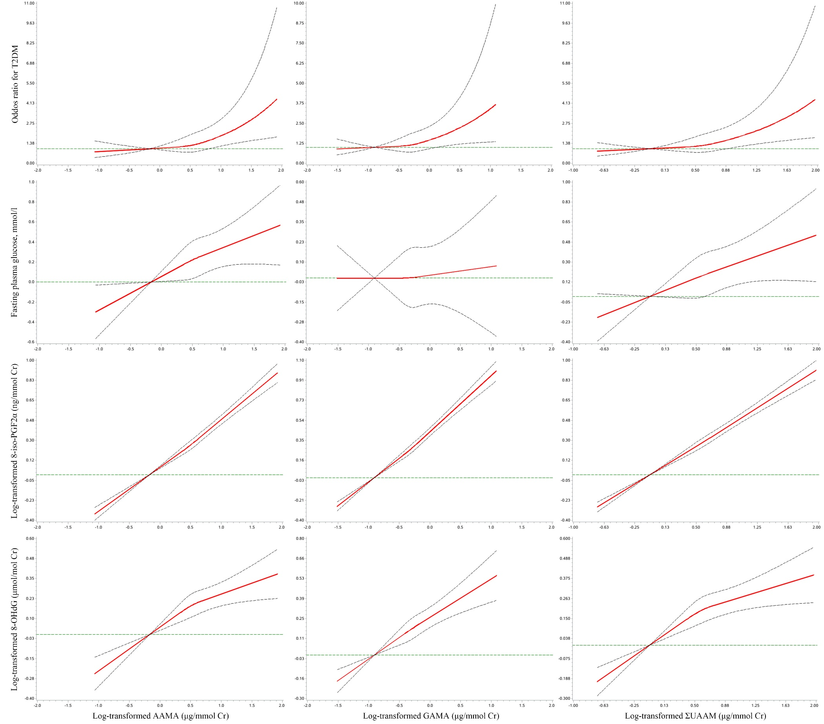

**Supplementary Figure S2.**

