**Supplemental Figure 1.** Estimated pooled prevalence for abnormal glucose tolerance, prediabetes and newly diagnosed diabetes

1. Abnormal glucose tolerance (AGT)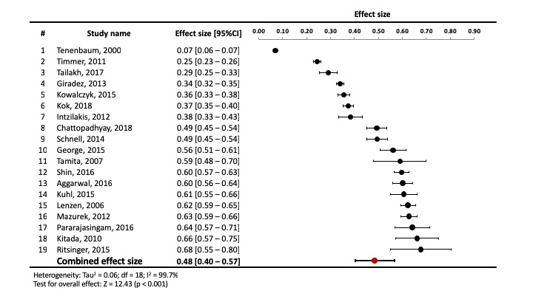
2. Prediabetes

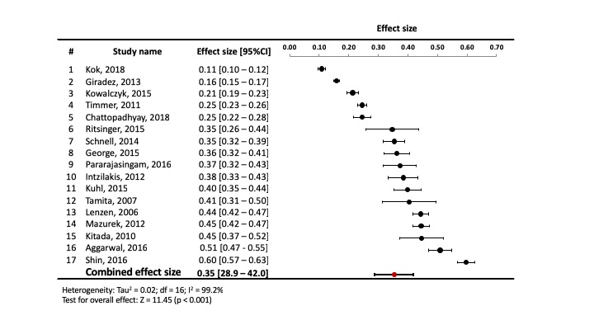

1. Newly diagnosed diabetes

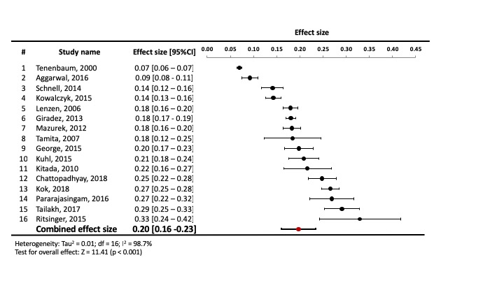

**Supplemental Figure 2.** All-cause mortality, MACE, cardiovascular (CV) death, and hospitalization for heart failure in subjects with newly diagnosed diabetes versus normal glucose tolerance

1. **All-cause mortality**



1. **MACE**



1. **CV death**



1. **Hospitalization for heart failure**



**Supplemental Figure 3.** All-cause mortality, MACE, cardiovascular (CV) death, and hospitalization for heart failure in subjects with prediabetes versus newly diagnosed diabetes

1. **All-cause mortality**



1. **MACE**



1. **CV death**



1. **Hospitalization for heart failure**



**Supplemental Figure 4.** All-cause mortality, MACE, in subjects with abnormal glucose tolerance versus normal glucose tolerance: subgroup analysis between studies using OGTT and non-OGTT for determining glucose tolerance status

1. Mortality



1. MACE



**Supplemental table 1.** Pooled prevalence of AGT across the study period

|  |  |  |
| --- | --- | --- |
| **Prevalence of AGT in each time period** | **Prevalence (%)** | **95%CI** |
| 1990 - Early 2000 | 49.93 | 20.96-78.90 |
| Early 2000 - 2009 | 48.36 | 23.38-73.33 |
| 2009 - 2015 | 47.15 | 15.58-78.72 |

**Supplemental table 2** Hazard ratios for all-cause mortality and MACE across the study period

|  |  |  |  |
| --- | --- | --- | --- |
| **Hazard ratio (95%CI)** | **1990-early 2000 (6 studies)** | **early 2000 – 2009 (8 studies)** | **2009 – 2015 (5 studies)** |
| All-cause mortality | 1.60 (1.41-1.86) | 1.65 (1.29-2.12) | 1.39 (1.1-1.74) |
| MACE | 1.43 (1.17-1.73) | 1.31 (1.18-1.46) | 1.43 (1.22-1.68) |

**Supplemental Table 3.** Risk of bias of the studies included in the analysis

|  |  |  |  |  |  |  |  |  |  |
| --- | --- | --- | --- | --- | --- | --- | --- | --- | --- |
|  | **Selection** | | | | **Comparability of Cohorts** | **Outcome** | | | |
| **Reference** | **Representativeness of Exposed Cohort** | **Selection of Nonexposed Cohort** | **Ascertainment of Exposure** | **Outcome Not present at Baseline** | **Assessment of Outcome** | **Sufficient Follow-up Duration** | **Adequate Follow-up** | **Total score** |
| (17) | Yes | Yes | Yes | Yes | Yes | Yes | Yes | Yes | 9 |
| (21) | Yes | Yes | Yes | Yes | Yes | Yes | Yes | Yes | 9 |
| (14) | Yes | Yes | Yes | Yes | Yes | Yes | Yes | Yes | 9 |
| (15) | Yes | Yes | Yes | Yes | Yes | Yes | Yes | Yes | 9 |
| (16) | Yes | Yes | Yes | Yes | Yes | Yes | Yes | Yes | 9 |
| (18) | Yes | Yes | Yes | Yes | Yes | Yes | Yes | Yes | 9 |
| (19) | Yes | Yes | Yes | Yes | Yes | Yes | Yes | Yes | 9 |
| (20) | Yes | Yes | Yes | Yes | Yes | Yes | Yes | Yes | 9 |
| (22) | Yes | Yes | Yes | Yes | Yes | Yes | Yes | Yes | 9 |
| (23) | Yes | Yes | Yes | Yes | Yes | Yes | Yes | Yes | 9 |
| (24) | Yes | Yes | Yes | Yes | Yes | Yes | Yes | Yes | 9 |
| (25) | Yes | Yes | Yes | Yes | No | Yes | Yes | Yes | 7 |
| (26) | Yes | Yes | Yes | Yes | Yes | Yes | Yes | Yes | 8 |
| (27) | Yes | Yes | Yes | Yes | Yes | Yes | Yes | Yes | 8 |
| (28) | Yes | Yes | Yes | Yes | Yes | Yes | Yes | Yes | 8 |
| (29) | Yes | Yes | No | Yes | Yes | Yes | Yes | Yes | 7 |
| (30) | Yes | Yes | No | Yes | Yes | Yes | Yes | Yes | 7 |
| (31) | Yes | Yes | Yes | Yes | Yes | Yes | Yes | Yes | 8 |
| (32) | Yes | Yes | No | Yes | Yes | Yes | Yes | Yes | 7 |

**Supplemental table** 4. Calculated E-value for each outcome

|  |  |  |  |  |
| --- | --- | --- | --- | --- |
|  | **HR (95%CI)** | **E-value point estimate** | **CI lower limit** | **E-value for the confidence limit** |
| **AGT vs. NGT** |  |  |  |  |
| Mortality | 1.51 (1.34-1.70) | 2.39 | 2.02 | 3.46 |
| MACE | 1.44 (1.23-1.68) | 2.24 | 1.76 | 2.91 |
| **Prediabetes vs. NGT** |  |  |  |  |
| Mortality | 1.36 (1.13-1.63) | 2.06 | 1.51 | 2.38 |
| MACE | 1.42 (1.20-1.68) | 2.19 | 1.67 | 2.73 |

**Supplemental Table 5.** Meta-analysis of Observational Studies in Epidemiology (MOOSE) Checklist

|  |  |  |
| --- | --- | --- |
| **Criteria** | | **Brief description of how the criteria were handled in the meta-analysis** |
| **Reporting of background should include** | | |
| √ | Problem definition | Previous data suggested that individuals with acute myocardial infarction (MI) without prior history of diabetes have a high prevalence of unrecognized abnormal glucose tolerance (AGT), but this has not been systematically examined. Further, the incidence of recurrent cardiovascular events in this population has not been evaluated. Discovery of AGT in this population can identify a high-risk group for recurrent events, that would likely benefit from aggressive risk reduction strategies. |
| √ | Hypothesis statement | Acute MI patients with newly discovered AGT are at higher risk of developing recurrent cardiovascular events, compared to individuals with normal glucose tolerance. |
| √ | Description of study outcomes | Prevalence of newly discovered AGT in acute MI patients and incidence of recurrent cardiovascular events |
| √ | Type of exposure or intervention used | Newly discovered abnormal glucose tolerance |
| √ | Type of study designs used | Prospective cohort studies that reported the prevalence of newly discovered abnormal glucose tolerance status in acute MI patients and provided the incidence of recurrent cardiovascular events in this population compared to normal glucose tolerance subjects. |
| √ | Study population | Acute myocardial infarction patients without known history of diabetes |
| **Reporting of search strategy should include** | | |
| √ | Qualifications of searchers | The two investigators (NL and RAD) are indicated in the authors list. |
| √ | Search strategy, including time period included in the synthesis and keywords | We searched electronic databases (MEDLINE, Embase, Cochrane library, and Google Scholar) for articles published in English up to November 30, 2018 using a combined MeSH heading and text search strategy with the following terms: hyperglycemia, MACE, mortality, undiagnosed, newly diagnosed, diabetes, diabetes mellitus, myocardial infarction, heart failure. |
| √ | Databases and registries searched | MEDLINE, Embase, Cochrane library, and Google Scholar |
| √ | Search software used, name and version, including special features | We searched the electronic databases using MeSH terms and did not employ a search software. Endnote was used to merge retrieved citations. |
| √ | Use of hand searching | We manually reviewed reference lists and review articles for additional citations and obtained the full text of all potentially relevant publications. |
| √ | List of citations located and those excluded, including justifications | Figure 1 |
| √ | Method of addressing articles published in languages other than English | We obtained all articles potentially eligible for inclusion in English language. |
| √ | Method of handling abstracts and unpublished studies | We did not include unpublished or abstract only publications. |
| √ | Description of any contact with authors | We contacted the original author for clarification, if needed. |
| **Reporting of methods should include** | | |
| √ | Description of relevance or appropriateness of studies assembled for assessing the hypothesis to be tested | Detailed inclusion and exclusion criteria are described in the paper. |
| √ | Rationale for the selection and coding of data | We abstracted the number of participants in each group, duration of follow-up, method of measurement of AGT status, number of cardiovascular events, adjusted effect estimates (odds ratio, relative risks, or relative hazards) for the association between cardiovascular risk and baseline glucose tolerance status. |
| √ | Assessment of confounding | We conducted a sensitivity analysis to assess the relative influence of each study in each subgroup analysis, by omitting one study at a time, to assess the influence of any single study on the pooled estimate. Also, we did the subgroup analyses between studies using OGTT and non-OGTT methods. |
| √ | Assessment of study quality, including blinding of quality assessors; stratification or regression on possible predictors of study results | We used the Newcastle Ottawa Scale (NOS) to assess the quality of each study. |
| √ | Assessment of heterogeneity | We used Cochran’s Q test and I2 value to assess heterogeneity |
| √ | Description of statistical methods in sufficient detail to be replicated | We mentioned the type of analysis that we used and type of software we used (Review Manager [RevMan] Version 5.3 and Meta-Essentials) |
| √ | Provision of appropriate tables and graphics | Table1 shows characteristics of included studies; Figure 1 showing literature search flow diagram, Figures 2-3 show forest plots of risk of recurrent cardiovascular outcomes; Supplement table 1 shows results of quality assessment, Supplement figure 1 shows estimated pool prevalence of prevalence of abnormal glucose tolerance, prediabetes and newly diagnosed diabetes; Supplement figures 2-3 show forest plots of risk of recurrent cardiovascular outcome in prediabetes and newly diagnosed diabetes and supplement figures 4 shows subgroup analysis between studies using OGTT and non-OGTT for determining glucose tolerance status |
| **Reporting of results should include** | | |
| √ | Graph summarizing individual study estimates and overall estimate | Figures 2-3 and supplement figures 1 - 3 |
| √ | Table giving descriptive information for each study included | Table 1 |
| √ | Results of sensitivity testing | We conducted sensitivity analyses by omitting 1 study at a time to assess the influence of any single study on the pooled estimate. These analyses indicated that all of the studies included in the pooled estimate contributed relatively equally. |
| √ | Indication of statistical uncertainty of findings | 95% CI and I2 |
| **Reporting of discussion should include** | | |
| √ | Quantitative assessment of bias | Results of Funnel plot are discussed on pages 10 and 14. |
| √ | Justification for exclusion | See above |
| √ | Assessment of quality of included studies | Supplement table 1 |
| **Reporting of conclusions should include** | | |
| √ | Consideration of alternative explanations for observed results | First, the method to determine abnormal glucose tolerance status varied between studies. The majority used the OGTT to detect abnormal glucose tolerance which has higher sensitivity to detect abnormal glucose tolerance. Consequently, studies using fasting plasma glucose or HbA1c alone might lead to an underestimation of AGT prevalence in the cohorts. Nonetheless, the subgroup analysis showed similar risk ratios for recurrent CV events in the prediabetic and diabetic groups. Second, we saw some risk of possible publication bias, and a relatively small number of studies reported CV death and hospitalization for heart failure outcomes. |
| √ | Generalization of the conclusions | Abnormal glucose tolerance, including prediabetes and diabetes, is common in patients who present with acute myocardial infarction and are previously unknown to have any disturbance in glucose homeostasis. These individuals are at very high risk for recurrent MACE, CV mortality and all-cause mortality compared to normal-glucose-tolerant individuals who present with acute MI. Early and aggressive intervention, both lifestyle and pharmacologic, is important for prevention of prediabetes progression to diabetes and recurrent cardiovascular events. Also, we recommend that all hospitalized acute MI patients be screened with at least one of the following measurements: fasting plasma glucose concentration, HbA1c, or OGTT. |
| √ | Guidelines for future research | Formal evaluation of anti-diabetic agents with proven CV benefit among patients with established diabetes should be extended to high-risk patients with pre-diabetes, given their high residual risk. |
| √ | Disclosure of funding source | The author(s) received no specific funding for this work. |

Adapted from: Stroup DF, Berlin JA, Morton SC, et al. Meta-analysis of Observational Studies in Epidemiology: A Proposal for Reporting. *JAMA.* 2000;283(15):2008–2