Supplementary Figure 1 Associations of genetic liability to adult type 2 diabetes with metabolic traits at different early life stages among a complete-case sample (N=699)
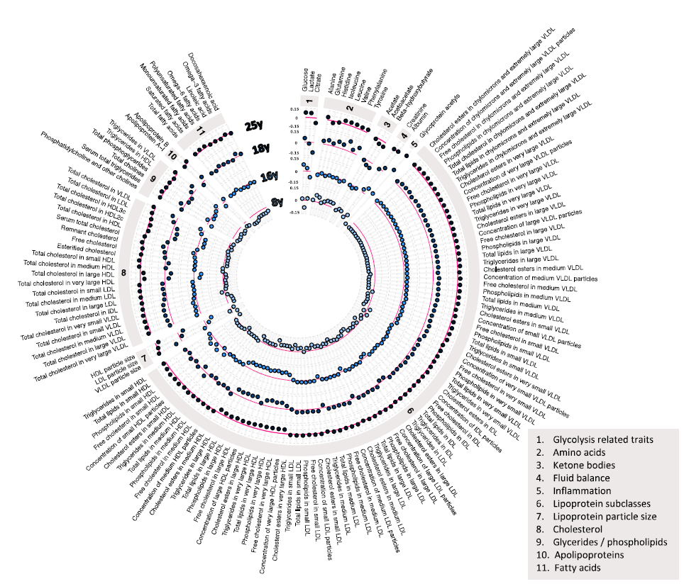
Estimates shown are beta coefficients representing SD difference in metabolic trait per SD higher GRS for type 2 diabetes, ordered concentrically (inner circle to outer circle) by increasing age at measurement. Six metabolic traits were not measured at the 25y time point: diacylglycerol, ratio of diacylglycerol to triglycerides, fatty acid chain length, degree of unsaturation, conjugated linoleic acid, and ratio of conjugated linoleic acid to total fatty acids.

