Supplemental Material
Justification for Supplemental Materials

Dear Editorial team,
Supplemental materials for this manuscript include the inclusion and exclusion criteria for the study, a summary of safety data and adverse events, and a breakdown of adverse events that were reported during the trial and the trial CONSORT diagram. We feel that these are helpful to readers, and reviewers, to fully understand the conduct of the trial as well as key outcome and safety data related to this study.

Study Site Investigators
Site | Principal Investigator
The Hospital for Sick Children (SickKids) | Dr. Farid Mahmud
Children's Hospital of Eastern Ontario (CHEO) | Dr. Margaret Lawson
The Ottawa Hospital | Dr. Heather Lochnan
St. Joseph’s Hospital | Dr. Charlotte MacDonald
Kingston General Hospital | Dr. Robyn Houlden
McMaster Hospital | Dr. Zubin Punthakee

Supplemental Tables
Supplemental Table 1. Eligibility criteria for CD-DIET Study.
Inclusion Criteria
- Males and females aged 8 to 45 years
- T1D duration ≥ 1 year
- Positive CD screen (TTG-IgA serology)
- Positive duodenal biopsy for CD (Modified Marsh score ≥ 2)
- Ability of the subject or legal representative to speak and read English or French
- Written informed consent with assent of child if applicable

Exclusion Criteria
- Prior diagnosis of CD
- Symptoms or evidence of overt CD
  - Gastrointestinal symptoms
  - Anemia
  - Abnormal growth or weight loss
- Already following GFD
- History of osteoporosis
- Recurrent aphthous ulcers or dermatitis herpetiformis
- Pregnancy or breastfeeding
- Menopausal or post-menopausal females
- Participating in another intervention study
- Any condition which the investigator considered may interfere with the individual’s ability to participate in the study

Supplemental Table 2. Between-group differences in Anthropometrics, Insulin dosage and Safety labs at Baseline and 12 months in the GCD and GFD groups. Values represent means ± SD or percentages. BMI categories are abbreviated as N (Normal weight), Ov (Overweight), and Ob (Obese)
 |  |  | Baseline |  |  |  | 12 Months
 |  |  | GCD | GFD | p |  | GCD | GFD | p
N |  |  | 24 | 27 |  |  | 22 | 25
Anthropometrics
<19 years | Height Z Score |  | 0.63 ± 1.22 | 0.27 ± 1.27 | 0.57 |  | 0.35 ± 0.84 | 0.25 ± 1.38 | 0.89
 | Weight Z Score |  | 0.80 ± 0.96 | 0.76 ± 1.36 | 0.94 |  | 0.61 ± 1.07 | 0.59 ± 1.51 | 0.98
 | BMI Z Score |  | 0.76 ± 0.77 | 0.88 ± 1.14 | 0.81 |  | 0.66 ± 0.94 | 0.67 ± 1.17 | 0.99
≥19 years | Height (cm) |  | 170.6 ± 10.9 | 171.1 ± 11.6 | 0.90 |  | 169.6 ± 10.6 | 171.8 ± 10.9 | 0.57
 | Weight (kg) |  | 80.1 ± 18.8 | 81.4 ± 14.4 | 0.83 |  | 79.1 ± 17.9 | 82.4 ± 14.2 | 0.57
 | BMI (kg/m²) |  | 27.5 ± 6.0 | 28.0 ± 5.1 | 0.79 |  | 27.5 ± 6.3 | 27.9 ± 4.1 | 0.84
BMI Category [%N|%Ov|%Ob] |  |  | 58.3|16.7|25.0 | 37.0|26.0|37.0 | 0.31 |  | 40.9|31.8|27.3 | 36.0|32.0|32.0 | 0.92
Waist Circumference (cm) |  |  | 85.4 ± 21.3 | 90.7 ± 16.1 | 0.38 |  | 86.9 ± 14.2 | 92.1 ± 14.9 | 0.26
Hip Circumference (cm) |  |  | 95.1 ± 22.2 | 98.9 ± 15.5 | 0.52 |  | 98.0 ± 11.4 | 100.8 ± 15.2 | 0.50
Waist-to-Hip Ratio |  |  | 0.91 ± 0.11 | 0.91 ± 0.08 | 0.81 |  | 0.88 ± 0.07 | 0.91 ± 0.07 | 0.18
Systolic Blood Pressure (mmHg) |  |  | 122 ± 10.0 | 122 ± 13.8 | 0.93 |  | 116 ± 11.5 | 119 ± 13.8 | 0.62
Diastolic Blood Pressure (mmHg) |  |  | 72.8 ± 6.6 | 72.1 ± 8.3 | 0.79 |  | 70.9 ± 7.3 | 70.3 ± 9.3 | 0.84
Insulin Dosage
Total Daily Insulin Dose (IU) |  |  | 51.3 ± 21.5 | 55.2 ± 26.9 | 0.57 |  | 56.6 ± 35.7 | 56.1 ± 29.7 | 0.97
Total Daily Insulin Dose per kg |  |  | 0.75 ± 0.35 | 0.72 ± 0.26 | 0.70 |  | 0.78 ± 0.42 | 0.72 ± 0.26 | 0.62
Safety Labs
Red Blood Cells |  |  | 4.82 ± 0.48 | 4.99 ± 0.50 | 0.23 |  | 4.77 ± 0.52 | 5.01 ± 0.52 | 0.12
White Blood Cells |  |  | 6.28 ± 1.39 | 6.33 ± 1.93 | 0.92 |  | 6.59 ± 2.06 | 5.85 ± 1.31 | 0.17
Platelet Count |  |  | 271.09 ± 58.80 | 261.15 ± 60.27 | 0.56 |  | 266.10 ± 61.38 | 247.96 ± 59.06 | 0.33
Neutrophils |  |  | 3.73 ± 1.25 | 3.86 ± 1.91 | 0.78 |  | 3.82 ± 1.48 | 3.52 ± 1.07 | 0.45
Lymphocytes |  |  | 1.93 ± 0.62 | 1.93 ± 0.89 | 0.99 |  | 2.04 ± 0.65 | 1.76 ± 0.51 | 0.12
Monocytes |  |  | 0.42 ± 0.18 | 0.40 ± 0.13 | 0.71 |  | 0.44 ± 0.19 | 0.36 ± 0.19 | 0.17
Eosinophils |  |  | 0.16 ± 0.11 | 0.12 ± 0.08 | 0.15 |  | 0.20 ± 0.16 | 0.17 ± 0.20 | 0.59
Basophils |  |  | 0.032 ± 0.032 | 0.023 ± 0.031 | 0.34 |  | 0.036 ± 0.04 | 0.031 ± 0.03 | 0.63
Cholesterol |  |  | 4.23 ± 1.13 | 4.04 ± 0.96 | 0.52 |  | 4.08 ± 0.96 | 4.06 ± 0.86 | 0.95
Triglycerides |  |  | 0.91 ± 0.44 | 1.29 ± 0.14 | 0.12 |  | 1.08 ± 0.74 | 1.05 ± 0.71 | 0.88
HDL |  |  | 1.47 ± 0.45 | 1.39 ± 0.33 | 0.51 |  | 1.42 ± 0.46 | 1.53 ± 0.36 | 0.37
LDL Calculated |  |  | 2.34 ± 0.98 | 2.00 ± 0.52 | 0.14 |  | 2.17 ± 0.86 | 2.05 ± 0.72 | 0.63
Hemoglobin |  |  | 136.22 ± 14.29 | 143.07 ± 15.57 | 0.11 |  | 133.25 ± 19.31 | 145.24 ± 13.68 | 0.025
Hematocrit |  |  | 0.41 ± 0.04 | 0.43 ± 0.04 | 0.11 |  | 0.40 ± 0.05 | 0.44 ± 0.04 | 0.009
Ferritin |  |  | 58.83 ± 52.11 | 73.96 ± 67.84 | 0.39 |  | 62.38 ± 59.66 | 80.92 ± 73.44 | 0.36
AST |  |  | 24.00 ± 7.70 | 25.33 ± 16.80 | 0.73 |  | 24.38 ± 6.42 | 22.08 ± 9.68 | 0.36
ALT |  |  | 22.09 ± 11.35 | 24.12 ± 24.43 | 0.72 |  | 22.05 ± 10.42 | 18.80 ± 9.46 | 0.28
Parathyroid Hormone |  |  | 3.14 ± 1.37 | 6.02 ± 15.03 | 0.38 |  | 3.51 ± 1.63 | 3.13 ± 1.28 | 0.41
25-OH Vitamin D |  |  | 60.87 ± 28.11 | 61.22 ± 16.26 | 0.96 |  | 68.71 ± 31.98 | 70.08 ± 19.52 | 0.86
Calcium |  |  | 2.37 ± 0.09 | 2.41 ± 0.12 | 0.23 |  | 2.35 ± 0.08 | 2.37 ± 0.13 | 0.50
Phosphorus |  |  | 1.37 ± 0.58 | 1.28 ± 0.53 | 0.59 |  | 1.24 ± 0.25 | 1.36 ± 0.84 | 0.52
Magnesium |  |  | 0.80 ± 0.08 | 0.82 ± 0.07 | 0.45 |  | 0.78 ± 0.04 | 0.79 ± 0.08 | 0.55
Microalbumin RU |  |  | 8.53 ± 10.61 | 251.88 ± 717.64 | 0.20 |  | 12.32 ± 20.79 | 65.38 ± 250.57 | 0.35
Albumin-Creatinine Ratio |  |  | 1.0 ± 1.5 | 50.92 ± 157.26 | 0.32 |  | 1.23 ± 2.10 | 6.49 ± 18.30 | 0.30
βhCG (% Positive) |  |  | 0.0% | 0.0% | 0.24 |  | 0.0% | 0.0% | 1.00

Supplemental Table AE1. Number of Participants who reported at least 1 Adverse Event over the course of the CD-DIET trial.
Preferred Term | Gluten-Containing  Diet (n=24) |  | Gluten-Free  Diet (n=27) |  | p
 | n | % | n | %
Any adverse event | 13 | 54.2 | 16 | 59.3 | 0.714
Nasopharyngitis | 4 | 16.7 | 6 | 22.2 | 0.732
Hypoglycaemia | 3 | 12.5 | 0 | 0.0 | 0.097
Vitamin D Deficiency | 1 | 4.2 | 3 | 11.1 | 0.612
Diarrhea | 2 | 8.3 | 1 | 3.7 | 0.596
Streptococcal Pharyngitis | 1 | 4.2 | 2 | 7.4 | 1.00
Low Serum Ferritin | 1 | 4.2 | 1 | 3.7 | 1.00
Myalgia | 2 | 8.3 | 0 | 0.0 | 0.217
Radius Fracture* | 0 | 0.0 | 1 | 3.7 | -
 | ALL OTHER AEs WERE REPORTED ONCE
*Serious Adverse Event

Supplemental Table AE2. Number of Adverse Events Reported by each TREATMENT Arm by System Organ Class. *Denotes Serious Adverse Event.

System Organ Class  Preferred Term |  | GCD | GFD |  | Overall
All Adverse Events |  | 26 | 31 |  | 57
Infections and Infestations |  | 7 | 15 |  | 21
Nasopharyngitis |  | 6 | 7 |  | 13
Pharyngitis Streptococcal |  | 1 | 2 |  | 3
Gastroenteritis Viral |  | 0 | 1 |  | 1
Vaginal Yeast Infection |  | 0 | 1 |  | 1
Sinusitis |  | 0 | 1 |  | 1
Flu Symptoms |  | 0 | 1 |  | 1
Skin Infection |  | 0 | 1 |  | 1
Nail Infection |  | 0 | 1 |  | 1
Gastrointestinal System |  | 6 | 4 |  | 10
Diarrhea |  | 4 | 1 |  | 5
Vomiting |  | 1 | 0 |  | 1
Tooth Pain |  | 1 | 0 |  | 1
Impacted Wisdom Tooth |  | 0 | 1 |  | 1
Food Poisoning |  | 0 | 1 |  | 1
Gingival Recession |  | 0 | 1 |  | 1
Musculoskeletal/Connective Tissue |  | 5 | 3 |  | 8
Myalgia |  | 2 | 0 |  | 2
Arthralgia |  | 1 | 0 |  | 1
Bursitis |  | 1 | 0 |  | 1
Carpal Tunnel Syndrome |  | 1 | 0 |  | 1
Leg Cramps |  | 0 | 1 |  | 1
Radius Fracture* |  | 0 | 1 |  | 1
Rib Fracture |  | 0 | 1 |  | 1
Metabolism/Nutrition |  | 4 | 3 |  | 7
Vitamin D Deficiency |  | 1 | 3 |  | 4
Hypoglycaemia |  | 3 | 0 |  | 3
Respiratory/Thoracic/Mediastinal System |  | 2 | 2 |  | 4
Cough |  | 1 | 0 |  | 1
Sore Throat |  | 1 | 0 |  | 1
Viral Upper Respiratory Tract Infection |  | 0 | 1 |  | 1
Chest Cold |  | 0 | 1 |  | 1
Investigations |  | 2 | 1 |  | 3
Serum Ferritin Decreased |  | 1 | 1 |  | 2
Blood Calcium Decreased |  | 1 | 0 |  | 1
Injury/Poison |  | 0 | 1 |  | 1
Adductor Strain |  | 0 | 1 |  | 1
Nervous System |  | 0 | 1 |  | 1
Sleep Apnea |  | 0 | 1 |  | 1
Renal/Urinary System |  | 0 | 1 |  | 1
Urinary Tract Infection |  | 0 | 1 |  | 1

Supplemental Figures

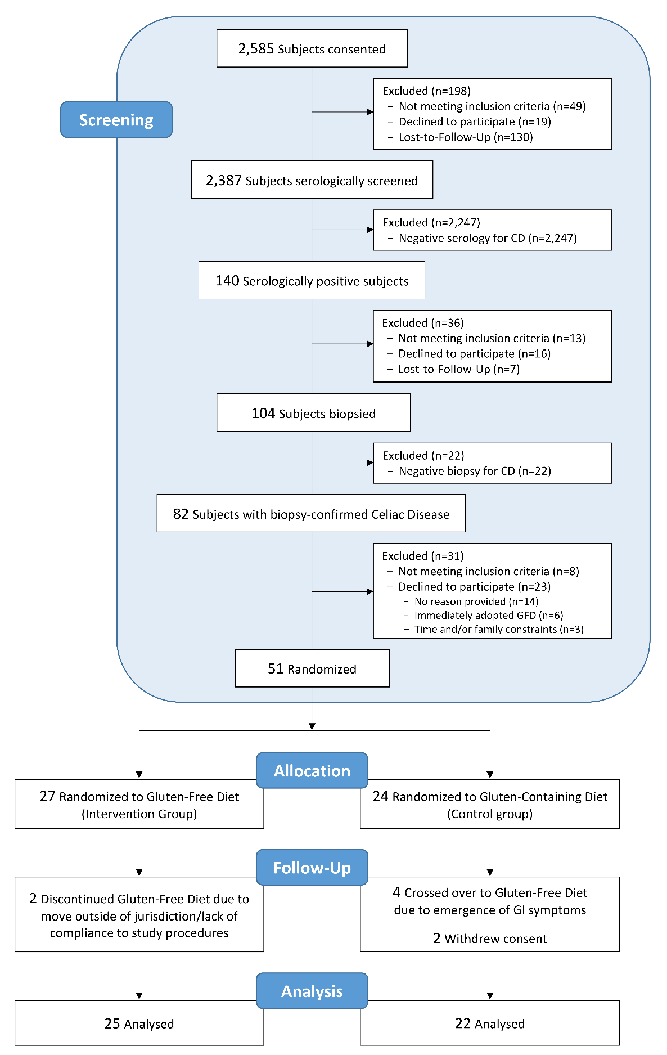

Supplemental Figure 1. CONSORT diagram for CD-DIET study

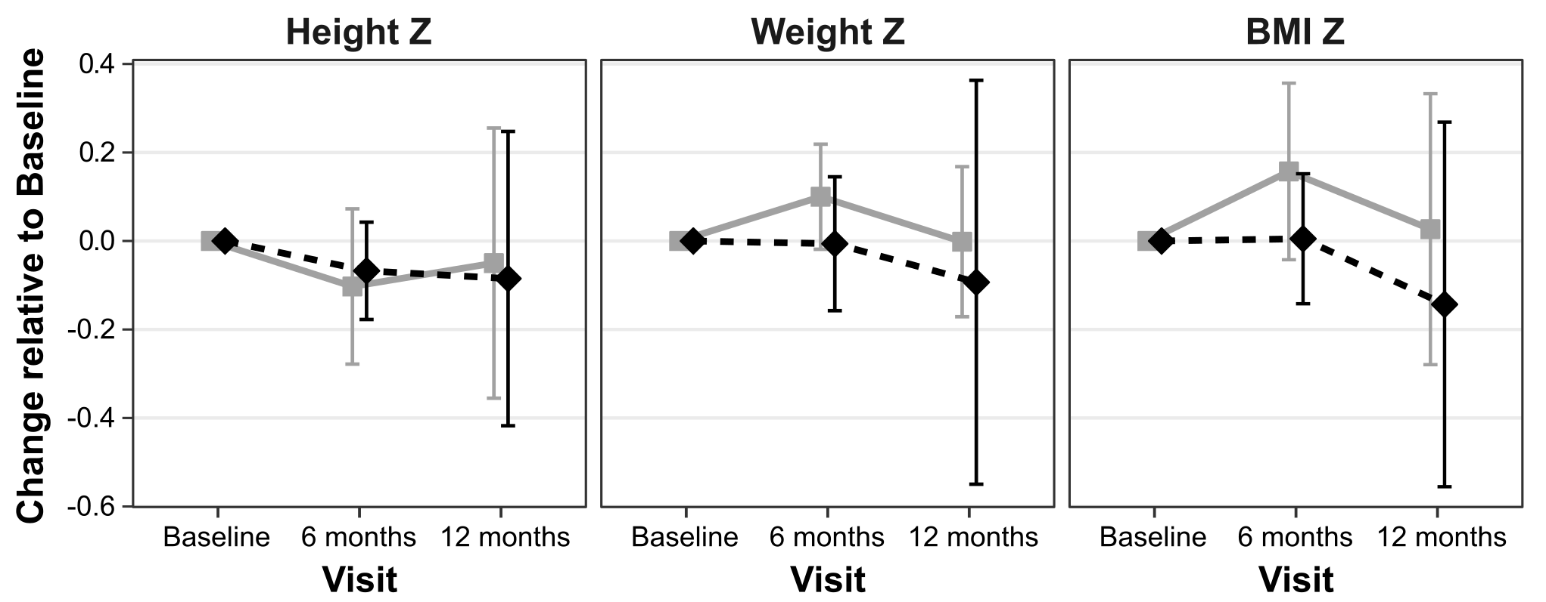

Supplemental Figure 2. Change in Height, Weight and BMI Z Scores relative to Baseline ± 95%CI among pediatric participants (<19 years, n=16) in CD-DIET. Data for participants randomized to the GCD (n=8) are summarized in grey (■), while those in the GFD arm (n=8) are presented in black (⬧).

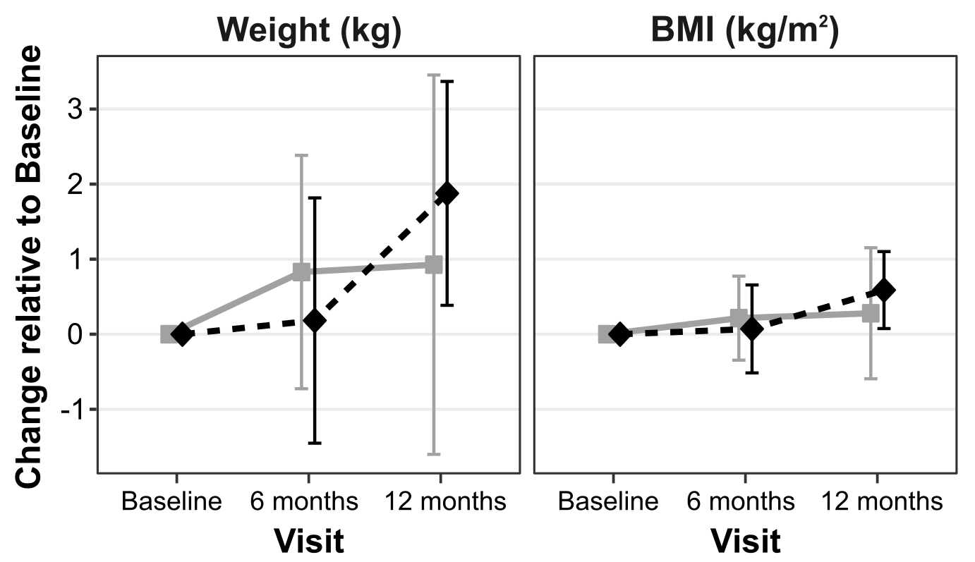
Supplemental Figure 3. Change in Weight in kg and BMI in kg/m² relative to Baseline ± 95%CI among adult participants (n=35) in CD-DIET. Data for participants randomized to the GCD (n=16) are summarized in grey (■), while those in the GFD arm (n=19) are presented in black (⬧).

