Appendix 1
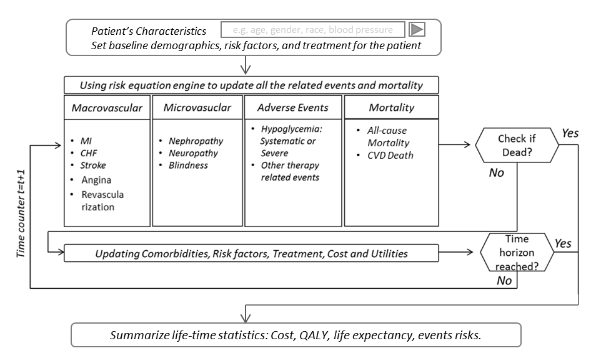
Figure A1 Simulation Flow Chart for the BRAVO model

Each person went through the simulation individually, as appose to other Markov-based cohort level simulations. For each person, the simulation was conducted at an annual circle, and each complication will be examined at a random order every year. To decide the encounter of each complication, we first calculated the probability of encountering the corresponding complication using the BRAVO risk equations. These risk equations take into account the patient’s characteristics and treatment regimen to estimate the likelihood of the complication. After that, a random number from a uniform distribution (0-1) was extracted and compared with the estimated likelihood of the complication. If the random number was smaller than the estimated likelihood, the person was counted as encountering this complication at the corresponding year during the simulation. After all the complications were checked, we examined if any of the complications lead to a death event. If not, the person will go through the next year, and these iterations will be continued until a death event occurred, or the simulation reached its time horizon.
After simulations were completed for all the individuals from the target population, we summarized the simulated outcomes and produced the predicted cumulative incidence of each complication.

Appendix 2

eTable 1. Mount Hood Challenge Newtwork's checklist for model input
Model Input |  | Checkbox | Comments
Simulation cohort
 | Baseline age | √
 | Ethnicity/race | √
 | BMI/weight | √
 | Duration of diabetes | √
 | Baseline HbA1c, lipids, and blood pressure | √
 | Smoking status | √
 | Comorbidities | √
 | Physical activity | N/A | Information unavailable in the CV trials
 | Baseline treatment | √
Treatment intervention
 | Type of treatment | √
 | Treatment algorithm for HbA1c evolution over time | √
 | Treatment algorithm for other conditions | √
 | Treatment initial effects on baseline biomarkers | √
 | Rules for treatment intensification | √
 | Long-term effects, adverse effects, treatment adherence and persistence, and residual effects after the discontinuation of the treatment | √
 | Trajectory of biomarkers, BMI, smoking, and any other factors that are affected by treatment | √
Cost
 | Differentiated by acute event in first year and subsequent years | NA | Not relevant
 | Cost of intervention and other costs | NA
 | Please report unit prices and resource use separately and give information on discount rates applied | NA
Health state utilities
 | Operational mechanics of the assignment of utility values (i.e., utility- or disutility-oriented) | NA
 | Management of multihealth conditions | NA
General model characteristics
 | Choice of mortality table and any specific event-related mortality | √
 | Choice and source of risk equations | √
 | If microsimulation: number of Monte-Carlo simulations conducted and justification | √
 | Components of model uncertainty being simulated (e.g., risk equations, risk factor trajectories, costs, and treatment effect); number of simulations and justification | NA | Not relevant

eTable 2. The baseline demographic of patients in each trial
Variables |  | EMP-REG |  | CANVAS |  | DECLARE
Age (yrs) |  | 63.20 |  | 63.40 |  | 63.90
Proportion Female (0-1) |  | 0.28 |  | 0.37 |  | 0.37
Duration Diabetes (yrs) |  | 13.00 |  | 14.00 |  | 11.00
White |  | 0.54 |  | 0.79 |  | 0.80
Black |  | 0.05 |  | 0.04 |  | 0.03
Hispanic |  | 0.18 |  | 0.00 |  | 0.00
Others |  | 0.23 |  | 0.17 |  | 0.17
Proportion Smokers (0-1) |  | 0.14 |  | 0.14 |  | 0.14
Education |  | 0.26 |  | 0.26 |  | 0.26
Stroke (%) |  | 24% |  | 6% |  | 24%
CHF (%) |  | 11% |  | 14% |  | 10%
MI (%) |  | 46% |  | 16% |  | 46%
Angina (%) |  | 30% |  | 30% |  | 30%
Revascularization (%) |  | 25% |  | 24% |  | 25%
Nuropathy (%) |  | 0% |  | 0% |  | 0%
Blind (%) |  | 0% |  | 0% |  | 0%
ESRD (%) |  | 0% |  | 0% |  | 0%
US |  | 20% |  | 25% |  | 32%
EU |  | 41% |  | 35% |  | 44%
Asian |  | 19% |  | 0% |  | 13%
Others |  | 15% |  | 40% |  | 11%

eTable 3. The biomarker trajectories in each trial

 |  | Treatment Group |  |  |  |  |  |  |  | Control Group
 |  | A1c (%) |  | SBP (mmHg) |  | LDL (mg/dl) |  | BMI |  | A1c (%) |  | SBP (mmHg) |  | LDL (mg/dl) |  | BMI
EMP-REG Trial
Baseline |  | 8.10 |  | 135.8 |  | 90.0 |  | 30.7 |  | 8.08 |  | 135.8 |  | 87.0 |  | 30.7
Year 1 |  | 7.40 |  | 130.0 |  | 90.0 |  | 29.0 |  | 8.08 |  | 135.8 |  | 87.0 |  | 30.5
Year 2 |  | 7.40 |  | 130.0 |  | 90.0 |  | 29.0 |  | 8.08 |  | 135.8 |  | 87.0 |  | 30.5
Year 3 |  | 7.50 |  | 130.0 |  | 90.0 |  | 29.0 |  | 8.08 |  | 135.8 |  | 87.0 |  | 30.5
CANVAS Trial
Baseline |  | 8.20 |  | 136.0 |  | 88.0 |  | 31.9 |  | 8.20 |  | 136.0 |  | 89.0 |  | 31.9
Year 1 |  | 7.60 |  | 130.0 |  | 93.0 |  | 30.8 |  | 8.20 |  | 136.0 |  | 89.0 |  | 31.9
Year 2 |  | 7.70 |  | 130.0 |  | 92.0 |  | 30.8 |  | 8.20 |  | 136.0 |  | 89.0 |  | 31.9
Year 3 |  | 7.80 |  | 130.0 |  | 92.0 |  | 30.8 |  | 8.30 |  | 136.0 |  | 88.0 |  | 31.9
Year 4 |  | 7.90 |  | 130.0 |  | 92.0 |  | 30.8 |  | 8.30 |  | 136.0 |  | 88.0 |  | 31.9
DECLARE
Baseline |  | 8.30 |  | 135.0 |  | NA |  | 32.1 |  | 8.30 |  | 135.0 |  | NA |  | 32.0
Year 1 |  | 7.83 |  | 133.0 |  | NA |  | 31.5 |  | 8.23 |  | 135.7 |  | NA |  | 31.8
Year 2 |  | 7.70 |  | 132.5 |  | NA |  | 31.0 |  | 8.22 |  | 135.5 |  | NA |  | 31.7
Year 3 |  | 7.85 |  | 132.0 |  | NA |  | 30.8 |  | 8.22 |  | 135.0 |  | NA |  | 31.5
Year 4 |  | 7.90 |  | 132.0 |  | NA |  | 30.6 |  | 8.15 |  | 135.0 |  | NA |  | 31.3

