Supplemental Materials:

Supplemental Table 1: Interactions of intensive SBP lowering, intensive glycemic control and baseline DBP on expanded CVD composite endpoint, non-stroke CVD outcome and heart failure during the entire duration of follow-up and before the termination of the glycemia intervention

Supplemental Text 1: ACCORD BP Inclusion and Exclusion criteria

Supplemental Figure 1. CONSORT Flow-diagram of study participants

Supplemental Figure 2. Box plots of mean follow-up mean arterial pressure (Panel A) and pulse pressure (Panel B) by SBP intervention and baseline DBP tertiles. Mean arterial pressure was calculated as (SBP + 2 x DBP)/ 3 and pulse pressure as SBP minus DBP. 1st quartile – 1.5 IQR, 1st quartile, median, 3rd quartile and 3rd quartile + 1.5 IQR, IQR=3rd quartile - 1st quartile are shown.
Supplemental Figure 3. Spline regressions relating baseline DBP with the effects of intensive SBP lowering on CVD composite outcome and all-cause mortality before the termination of glycemia intervention. X-axis depicts 5th to 95th percentile of baseline DBP. Panel A: CVD composite endpoint in standard glycemia arm, the linear interaction p = 0.37
Panel B: CVD composite endpoint in intensive glycemia arm, the linear interaction p = 0.46
Panel C: All-cause mortality in standard glycemia arm, the linear interaction p = 0.21
Panel D: All-cause mortality in intensive glycemia arm, the linear interaction p = 0.12

Supplemental Figure 4. Cox regression models relating the effects of intensive SBP lowering on CVD composite endpoint and all-cause mortality by baseline DBP groups and glycemia arms during the entire follow-up duration
Panel A: Standard glycemia arm
Panel B: Intensive glycemia arm

Supplemental Table 1: Interactions* of intensive SBP lowering, intensive glycemic control and baseline DBP on expanded CVD composite, non-stroke expanded CVD outcome and heart failure during the entire duration of follow-up and before the termination of the glycemia intervention
 | Standard Glycemia Arm |  |  | Intensive Glycemia Arm
 | Total | DBP ≤70 | DBP > 70 | Total | DBP ≤70 | DBP > 70
Entire follow-up duration
Expanded CVD composite | 0.77 (0.63, 0.95) | 0.70 (0.50, 0.99) | 0.81 (0.63, 1.05) | 1.04 (0.84, 1.29) | 1.03 (0.73, 1.45) | 1.04 (0.78, 1.38)
Non-Stroke expanded CVD outcome | 0.81 (0.62, 1.07) | 0.74 (0.46, 1.18) | 0.87 (0.61, 1.23) | 1.08 (0.80, 1.46) | 1.21 (0.76, 1.92) | 1.00 (0.68, 1.49)
Heart failure | 0.71 (0.45, 1.11) | 0.53 (0.25, 1.15) | 0.78 (0.45, 1.35) | 1.18 (0.79, 1.77) | 1.48 (0.84, 2.63) | 0.95 (0.53, 1.69)
Before intensive glycemia intervention termination
Expanded CVD composite | 0.74 (0.59, 0.93) | 0.65 (0.44, 0.95) | 0.80 (0.60, 1.06) | 1.14 (0.90, 1.46) | 1.10 (0.75, 1.63) | 1.18 (0.86, 1.62)
Non-Stroke expanded CVD outcome | 0.74 (0.54, 1.01) | 0.49 (0.28, 0.86) | 0.90 (0.61, 1.33) | 1.18 (0.83, 1.67) | 1.15 (0.66, 1.98) | 1.23 (0.78, 1.94)
Heart failure | 0.81 (0.48, 1.35) | 0.67 (0.29, 1.57) | 0.83 (0.43, 1.60) | 1.42 (0.89, 2.26) | 1.84 (0.94, 3.59) | 1.14 (0.59, 2.19)
*3-way interaction p-values for expanded CVD composite, non-Stroke expanded CVD outcome and heart failure are 0.94, 0.0.50 and 0.36 for entire follow-up duration and 0.77, 0.49 and 0.94 for the follow-up time before intensive glycemia intervention termination

Supplemental Text 1: ACCORD BP Inclusion and Exclusion Criteria

Inclusion Criteria
- Type 2 diabetes mellitus defined according to the 1997 ADA criteria:
  - Fasting plasma glucose >126 mg/dl (>7.0 mmol/l), or
  - Symptoms of hyperglycemia with casual plasma glucose > 200 mg/dl (>11.1 mmol/l), or
  - 2 hour plasma glucose > 200 mg/dl (>11.1 mmol/l) after a 75 gram oral glucose load
- HbA1c (obtained within 3 months prior to anticipated date of randomization):
  - 7.5 to 11%
    - if on insulin, < 1 u/kg plus on 0 or 1 oral agent, or
    - if not on insulin, on 0, 1, or 2 oral agents
  - 7.5 to 9%
    - if on insulin < 1 u/kg plus on 2 oral agents, or
    - if not on insulin plus on 3 oral agents, or
    - if on insulin > 1 u/kg plus 0 oral agents
- Known diabetes duration > 3 months
- Stable diabetes therapy for > 3 months (dose of any 1 antihyperglycemic drug has not changed by more than two-fold and new agents have not been added within the previous 3 months)
- Age at Randomization:
  - 40 to 79 years (inclusive) for anyone with a history of clinical cardiovascular disease (defined below in Item #6A), or
  - 55 to 79 years (inclusive) for anyone without a history of clinical cardiovascular disease (defined below in Item #6A)
- At high risk of CVD events, defined as:
  - Presence of clinical cardiovascular disease.
    - previous myocardial infarction (MI)
    - previous stroke
    - History of coronary revascularization (e.g., coronary artery bypass graft surgery, stent placement, percutaneous transluminal coronary angioplasty, or laser atherectomy)
    - History of carotid or peripheral revascularization (e.g., carotid endarterectomy, lower extremity atherosclerotic disease atherectomy, repair of abdominal aorta aneurysm, femoral or popliteal bypass)
    - angina with ischemic changes (resting ECG), ECG changes on a graded exercise test (GXT), or positive cardiac imaging study
or
  - If no clinical cardiovascular disease, evidence in the last 2 years suggesting a high likelihood of cardiovascular disease. Specifically, the presence of one of the following:
    - Microalbuminuria
    - Ankle brachial index < 0.9 (by simple palpation)
    - LVH by ECG or ECHO
    - > 50% stenosis of a coronary, carotid, or lower extremity artery
or
  - The presence of at least 2 of the following factors that increase CVD risk: • On lipid lowering medication or untreated LDL-C >130 mg/dl (3.38 mmol/l)
    - Low HDL-C (< 40 mg/dl (1.04 mmol/l) for men and < 50 mg/dl (1.29 mmol/l) for women)
    - On BP lowering medication or untreated SBP >140 mm Hg or DBP > 95 mm Hg.
    - Current cigarette smoking
    - Body mass index > 32 kg/m²
Exclusion Criteria
- History of hypoglycemic coma/seizure within last 12 months
- Hypoglycemia requiring 3rd party assistance in last 3 months with concomitant glucose < 60 mg/dl (3.3 mmol/l)
- History consistent with type 1 diabetes
- Unwilling to do frequent capillary blood glucose self-monitoring or unwilling to inject insulin several times a day
- BMI > 45 kg/m2
- Serum Creatinine > 1.5 mg/dl (132.6 umol/l) obtained within the previous 2 months
- Transaminase >2 times upper limit of normal or active liver disease
- Any ongoing medical therapy with known adverse interactions with the glycemic interventions (e.g., corticosteroids, protease inhibitors)
- Cardiovascular event or procedure (as defined for study entry) or hospitalization for unstable angina within last 3 months
- Current symptomatic heart failure, history of NYHA Class III or IV congestive heart failure at any time, or ejection fraction (by any method) < 25%
- A medical condition likely to limit survival to less than 3 years or a malignancy other than non-melanoma skin cancer within the last 2 years
- Any factors likely to limit adherence to interventions. For example,
  - dementia
  - alcohol or substance abuse
  - plans to move in the next 2 years
  - history of unreliability in medication taking or appointment keeping
  - significant concerns about participation in the study from spouse, significant other, or family members
  - lack of support from primary health care provider
- Failure to obtain informed consent from participant
- Currently participating in another clinical trial. Note: Patient must wait until the completion of his/her activities or the completion of the other trial before being screened for ACCORD
- Living in the same household as an already randomized ACCORD participant
- Any organ transplant
- Weight loss > 10% in last 6 months
- Pregnancy, currently trying to become pregnant, or of child-bearing potential and not practicing birth control
- Participants with recurrent requirements for phlebotomy or transfusion of red blood cells.

Additional Eligibility Criteria for Participants in the Blood Pressure Component of ACCORD
Participants eligible for the glycemic component of the trial will also be eligible for the blood pressure component:
- If the systolic blood pressure is between 130 and 160 mm Hg, inclusive, and the patient is on 0, 1, 2, or 3 antihypertensive medications, or
- If the systolic blood pressure is between 161 to 170 mm Hg, inclusive, and the patient is on 0, 1, or 2 antihypertensive medications, or
- If the systolic blood pressure is between 171 to 180 mm Hg, inclusive, and the patient is on 0 or 1 antihypertensive medication.
and
- If: dipstick protein in a spot urine is < 2+, or the protein-to-creatinine ratio in a spot urine is <700

Supplemental Figure 1. CONSORT Flow-diagram of study participants
Supplemental Figure S2. Box plots of mean follow-up mean arterial pressure (Panel A) and pulse pressure (Panel B) by SBP intervention and baseline DBP tertiles.
Analysis cohort (n=4731)

ACCORD Trial
Assessed for eligibility (n=19,716)

Excluded (n=9465)
- Did not meet eligibility criteria (n=1915)
- Did not complete screening n=6774)
- Eligible, but ultimately not randomized (n=776)

Randomized in overarching Glycemia trial (n=10,251)

Intensive glycemia intervention (n=2370)
Standard BP intervention (n=1193)
Intensive BP intervention (n=1177)

Standard glycemia intervention (n=2361)
Standard BP intervention (n=1177)
Intensive BP intervention (n=1184)

Randomized in BP trial (n=4733)

Randomized in Lipid trial (n=5518)

Excluded missing baseline DBP (n=2)

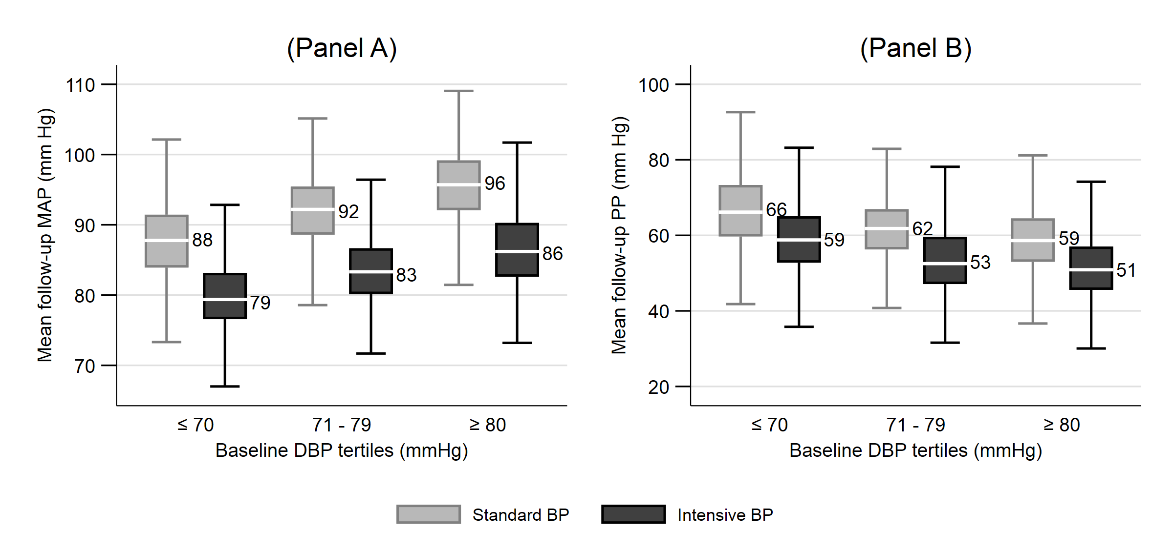

Mean arterial pressure was calculated as (SBP + 2 x DBP)/ 3 and pulse pressure as SBP minus DBP. 1st quartile – 1.5 IQR, 1st quartile, median, 3rd quartile and 3rd quartile + 1.5 IQR, IQR=3rd quartile - 1st quartile are shown.
Supplemental Figure S3. Spline regressions relating baseline DBP with the effects of intensive SBP lowering on CVD composite outcome and all-cause mortality before the termination of glycemia intervention. X-axis depicts 5th to 95th percentile of baseline DBP.
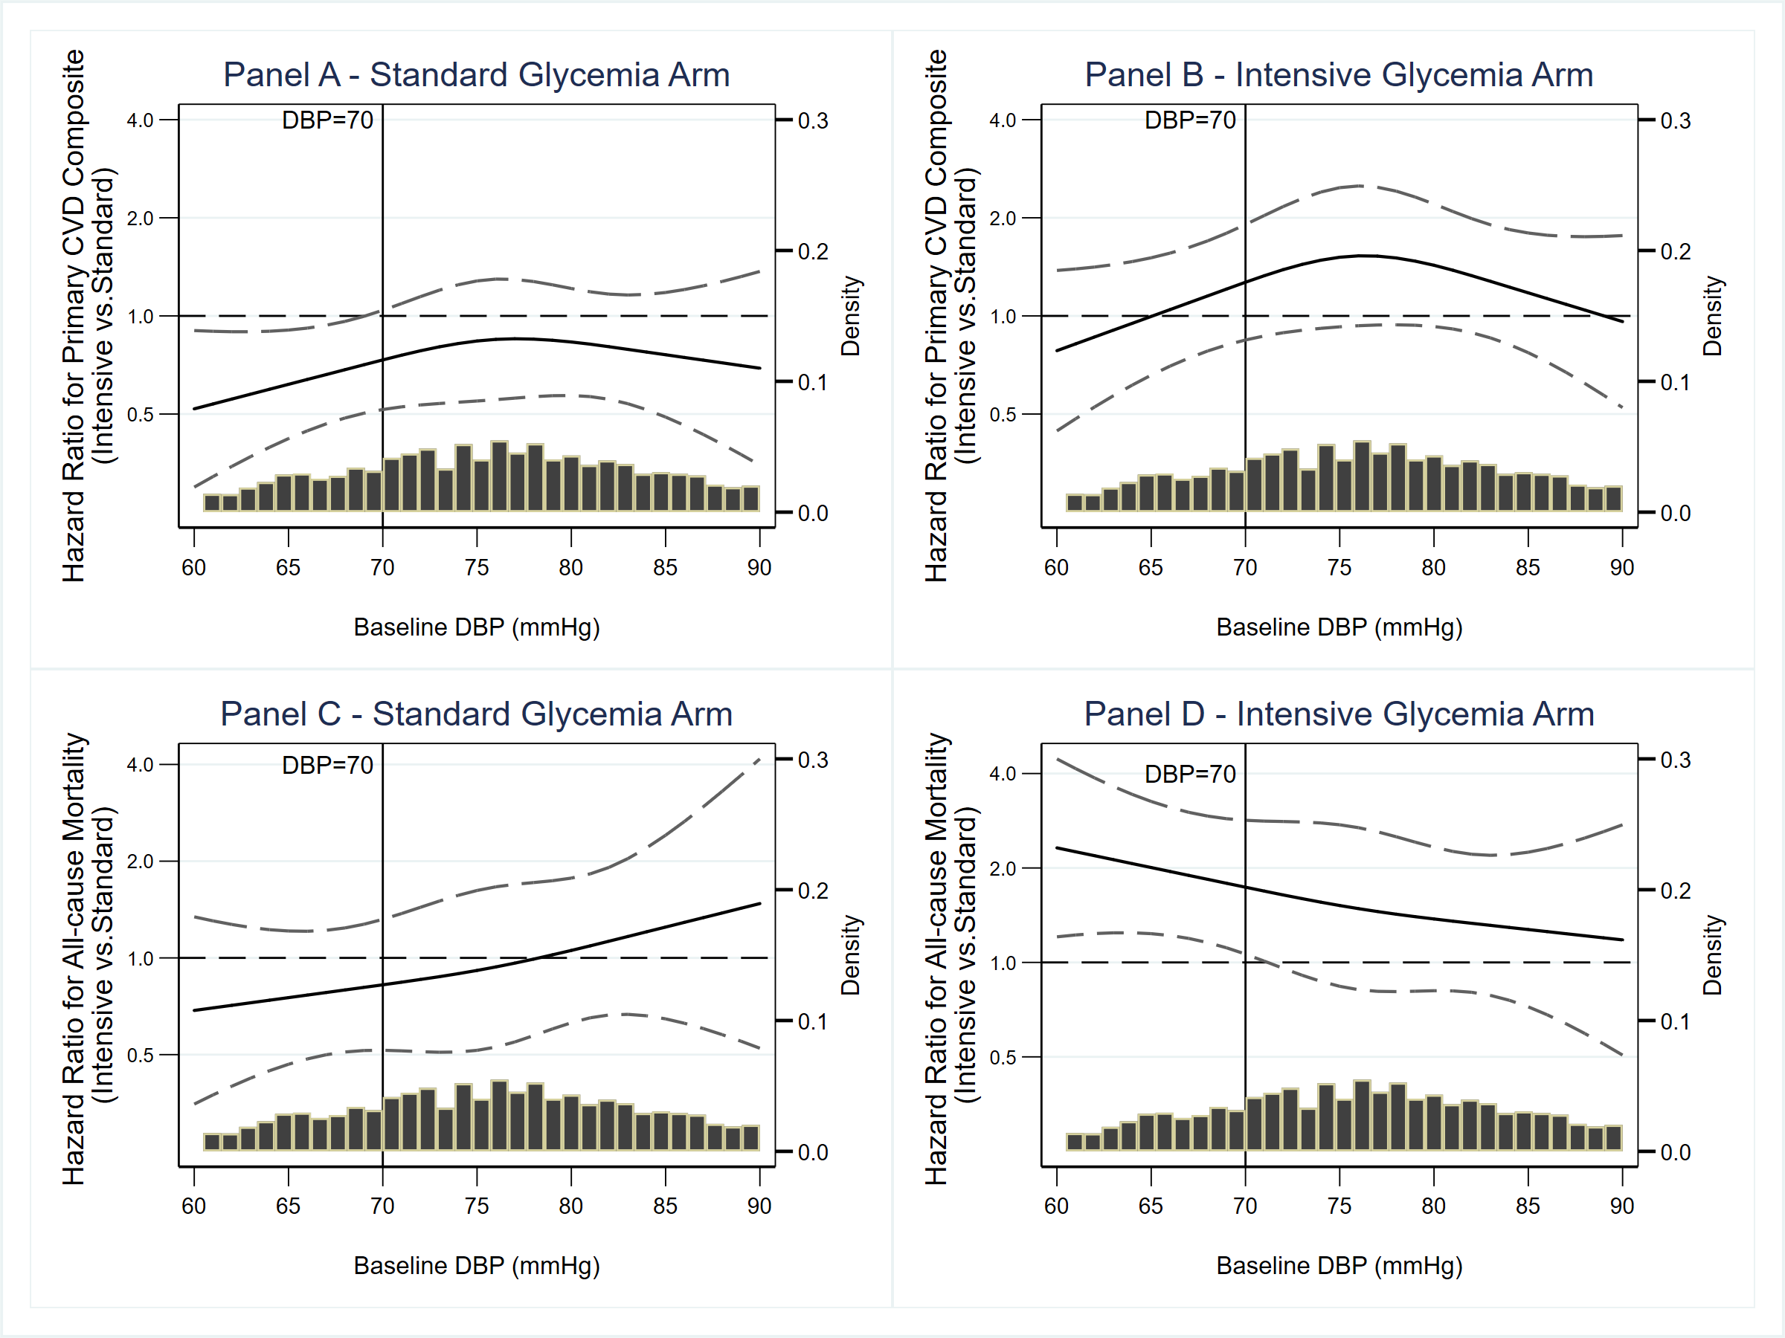
Panel A: CVD composite endpoint in standard glycemia arm, the linear interaction p = 0.37
Panel B: CVD composite endpoint in intensive glycemia arm, the linear interaction p = 0.46
Panel C: All-cause mortality in standard glycemia arm, the linear interaction p = 0.21
Panel D: All-cause mortality in intensive glycemia arm, the linear interaction p = 0.12
Supplemental Figure S4. Cox regression models relating the effects of intensive SBP lowering on CVD composite endpoint and all-cause mortality by baseline DBP groups and glycemia arms during the entire follow-up duration

